final report
Intestinal absorption assay of SD rats gavage-administered with sbk002 and clopidogrel sulfate

test facility
name: | Suzhou Huace Biological Technology Co., Ltd.
Address: | Jiangsu Province Kunshan City New & Hi-tech Industrial Development Zone Yuanfeng Road No. 166
Telephone: | 0512-36801688

Sponsor
name: | Chengdu Shibeikang Biomedicine Technology Co., Ltd.
Address: | Chengdu Shibeikang Biomedicine Technology Co., Ltd.;
Telephone: | 028-62532315

Research period: 2019-09-11 ~ 2019-11-28

Signature Page

Leng Minghong, M.S. date
Study director

ABBREVIATION INDEX
Abbreviation | Definition
AUC_{last}, AUC_{0-t} | From 0 h to the last measurable concentration blood concentration-time area under curve
AUC_{inf}, AUC_{0-∞} | From 0 h to infinite time blood concentration-time area under curve
BLOQ | lower than the lower limit of quantification
CL | Clearance rate
C_{max} | Peak concentration
CV | Coefficient of variation
°C | Degree Celsius
h | hour
LC-MS/MS | Liquid chromatography-mass spectrometry
LLOQ | Lower limit of quantification
Mean | Mean
mg | Milligram
mg/mL | Milligram per Milliliter
min | meeting record
mL | Milliliter
mL/min | Milliliter per Minute
MRT | Mean residence time
NA, N/A | Not Applicable
R² | Regression Coefficient
RE | relative deviation
SD | Standards deviation
SOP | Standard Operating Procedures
T_{1/2} | Half-life
T_{max} | time to reach maximum
V_{d} | Apparent distribution volume
µg/mL | Micrograms per milliliter
µL | microliter

Table of Contents
Signature Page 2
ABBREVIATION INDEX 3
Table of Contents 4
Abstract 5
1. General Information 6
1.1. Study Name and code 6
1.2. Research objective 6
1.3. test facility 6
1.4. Sponsor 6
1.5. Study Personnel composition 7
1.6. Regulations and technical guidelines followed 7
1.7. Assay time arrangement 8
2. Study Materials 9
2.1. Test article 9
2.2. Operational/Safety measures 11
2.3. metastasis of dose formulations in the experimental institution 11
2.4. Major Instruments equipment 11
3. testing system 11
3.1. Variety/strain/level 11
3.2. sex and number 11
3.3. source 12
3.4. body weight and age 12
3.5. Animal Identification 12
3.6. justification for laboratory animals selection and number 12
4. Housing and management of animals 12
4.1. animal management and use 12
4.2. Animal Receipt and Acclimation 13
4.3. Animal Housing 13
4.4. Housing Environment 13
4.5. Environmental Enrichment 13
4.6. feed 13
4.7. bedding 14
4.8. Drinking Water 14
4.9. Animal Selection 15
5. Research design 15
5.1. Dosing Information 15
5.2. assay method 16
6. observation 16
6.1. General states observation 16
6.2. body weight 16
7. Blood sample collection and testing analyzed 16
7.1. blood sample collection 16
7.2. Blood drug concentration testing 17
7.3. result analyzed 17
8. Data acquisition and analysis 17
8.1. The system for collecting and reporting electron data is as follows: 17
8.2. Metabolism products and metabolism pathways of clopidogrel in humans: 18
9. result 19
9.1. Comparison of blood concentration between the portal vein and cervical vein after oral administration of sbk002 and clo in rats 19
9.2. Study of metabolism products in the portal vein and jugular vein of rats gavaged with sbk002 and clo 20
10. Conclusion 25
11. Study protocol, deviations, and amendments 25
12. Storage of Relevant Data 25
12.1. Archiving Time and archives storage time 25
12.2. Archiving of data 25
12.3. Storage locations and storage conditions 26
13. Appendix 27
Appendix I: Study protocol 27
Appendix one: study protocol 28

Summary
Objective: To gavage SD rats with sbk002 and clopidogrel sulfate (clo), determine the sbk002 blood drug concentration, qualitatively determine the presence of active metabolic products [conduct semi-quantitative studies (i.e., the mass spectrometry signal ratio of active metabolic products to sbk002)], and Calculate the blood drug concentration ratio of sbk002 and its metabolic products between the portal vein and the cervical vein.
Method: Each group of 8, half male and half female, a total of 16 SD rats; groups were divided into sbk002 dose group and clo dose group. Single dosage for sbk002 dose group was 10 mg/kg, and for clo dose group was 30 mg/kg. After dosing for 3 hours, CO2 anesthesia was performed immediately, surgery was performed to collect blood from the portal vein and jugular vein (each 0.4 mL), and testing was performed using liquid chromatography-mass spectrometry.
result:
The ratio of mean blood concentration of metabolism product sbk002 in the portal vein to the jugular vein: After SD rats were gavaged with sbk002 10 mg/kg, the mean blood concentration ratio of sbk002 in the portal vein/jugular vein was 1.82; after SD rats were gavaged with 30 mg/kg of clo, the mean blood concentration ratio of sbk002 in the portal vein/jugular vein was 1.40, with no significant difference between the two dose groups.
Mean mass spectrometry signal ratio of H4 portal vein/cervical vein metabolic products: The mean mass spectrometry response ratio of H4 portal vein/cervical vein metabolic products after SD rats gavage-administered with sbk002 was 0.91; the mean mass spectrometry response ratio after gavage-administered with clo was 1.16. There was no significant difference between the two dose groups.
Mean mass spectrometry signal ratio of metabolism product SM3 in the portal vein/jugular vein: After SDrats were gavaged with sbk002, the mean mass spectrometry response ratio of the metabolism product SM3 in the portal vein/jugular vein was 0.85. After SDrats were gavaged with clo, the mean mass spectrometry response ratio of the metabolism product SM3 in the portal vein/jugular vein was 1.12. There is no significant difference between the two dose groups.
Conclusion: Under the conditions of this study, after rats were gavaged with doses of sbk002 and clo, sbk002, metabolism products H4 and SM3 could be produced in the portal vein (speculated to undergo intestinal metabolism). The mean blood concentration ratio of sbk002 in the portal vein/jugular vein, and the mean mass spectrometry signal ratio of metabolism products H4 and SM3 in the portal vein/jugular vein showed no significant difference between the two dose groups.
Thus, the trends of intestinal absorption or metabolism of sbk002 and clo are basically the same.
It is speculated that H4 and SM3 are active metabolic products and further methylated metabolites of metabolism.

General Information
  - Study name and number
Study Name: SDrats gavage administration of sbk002 and Clopidogrel Bisulfate intestinal absorption assay
study number: B2019023-K09-01.
  - Study Objective
Using healthy SD rats as test animals, the study investigated the intestinal absorption and metabolism of sbk002 and Clopidogrel Bisulfate in SD rats, evaluating their metabolism targets.
  - test facility
Name: Suzhou Huace Bio-Tech Co., Ltd.;
Address: No. 166 Yuanfeng Road, New & Hi-tech Industrial Development Zone, Kunshan City, Jiangsu Province;
Postal Code: 215300;
contact person: Xia Yuye;
Telephone：0512-36801688；
Fax: 0512-36802288;
e-mail: xiayuye@cti-cert.com.
  - Sponsor
Name: Chengdu Shibeikang Biomedicine Technology Co., Ltd.
Address: No. 17, Xixin Avenue, New & Hi-tech Industrial Development Zone (West Zone), Chengdu;
Postal code: 611731;
Contact person: Mu Xia;
Telephone: 028-62532315;
e-mail: 779061281@qq.com.
  - Study Personnel composition
    - Study director
Name: Leng Minghong;
Address: No. 166 Yuanfeng Road, New & Hi-tech Industrial Development Zone, Kunshan City, Jiangsu Province;
Telephone: 17312661834;
Fax: 0512-36802288;
email: lengminghong@cti-cert.com.
    - assay mainly composed personnel
assay operation: Kong Weichen, Ji Jiajia, et al.;
Veterinarian: Wang Haiyang, Xu Kun;
Animal Housing management: Li Yongchao;
Test article management: Chen Xiaoyan;
Preparation of test article: Liu Lulu;
sample analyzed: Wu Jinjin, Wu Zongbin;
Data collation and statistical analysis: Leng Minghong, Shuangshuang Ye, Ge Mingyu.
  - Regulations and technical guidelines followed
The regulations and technical guidelines followed by this assay, including but not limited to:
‘Pharmaceutical Registration Administration Measures’ (CFDA, October 2007);
"Medication Non-clinical Study Good Laboratory Practices (GLPs)" (fCFDA, September 2017);
"Medication Non-clinical Pharmacokinetic Study Technical Guidelines" (fCFDA, May 2014);
‘Guidelines for Validation of Quantitative Analysis Methods of Biological Samples’ (Chinese Pharmacopoeia Commission, Pharmacopoeia of the People’s Republic of China 2015 Edition);
ICH M10: Bioanalytical Method Validation. Draft Version, February 2019。
The implementation of this assay complied with the standard operating procedures of the testing facility (Standard Operating Procedures, SOPs), unless otherwise specified in the protocol.
  - Assay time arrangement
dose date: 2019-09-16.

Study Materials

  - test article
    - test article 1 General Information
Name/Code: sbk002;
Characterization: off-white crystalline powder;
Size: 2 g/bag;
content: 99.4 %;
Batch number: 190603;
Expiry date: 2021-06-10 (tentative);
Storage condition: 15 ℃~ 25 ℃, airtight, protected from light, dry;
Manufacturer: Chengdu Shibang Kang Biotechnology Co., Ltd.;
Supplier: Chengdu Shibeikang Biopharmaceutical Technology Co., Ltd.;
    - test article 2 General Information
Name/Code: Clopidogrel Bisulfate/clo
Characterization: White-like powder;
size: 2.2 g/bag;
content: 98.8 %;
batch number: 196766001;
expiry date: 2021-06-24 (reinspection date);
Storage condition: 15 ℃~ 25 ℃, airtight, protected from light, dry;
Manufacturer: Zhejiang Chemsynth Pharma Co., Ltd.;
Supplier: Chengdu Shibeikang Biopharmaceutical Technology Co., Ltd.;
    - Carrier general information
Name/Code: Carboxymethylcellulose Sodium;
Characterization: white to gray powder or crystals;
size: 500 g;
batch number: C1814029;
expiry date: 2022-03-14;
Storage condition: room temperature;
Manufacturer: Aladdin;
    - Preparation of test article
sbk002 dose formulations preparation method: Based on the most recent body weight of SD rats and the dosage calculation required for the test article, calculate the amount of test article and the prepared volume according to the preparation concentration (prepared volume = amount of test article × content/preparation concentration). At room temperature, protected from excessive light, accurately weigh a certain amount of the test article into a mortar, add an appropriate amount of vehicle, fully grind, and completely transfer to a container of a certain volume, use vehicle to make up to the scale, thus obtaining the required concentration of test article dose formulations.
clodose formulations preparation method: according to the most recent body weight of SD rats and the dosage calculation of the test article required, calculate the prepared volume based on the amount of test article and the preparation concentration (prepared volume = amount of positive reference item × content/preparation concentration). Accurately weigh a certain amount of test article into a mortar under room temperature and protect from excessive light conditions, add an appropriate amount of vehicle and grind fully, then completely transfer to a container of a certain volume, and use the vehicle to make up to the scale to obtain the desired concentration of the test article dose group dose formulations.
Preparation of test article method: Example of preparation of 10 mL dose formulations as follows:
Group | concentration  （mg/mL） | preparation method
sbk002  dose group | 10 | Accurately weigh 100.6 mg of sbk002 into a mortar, add an appropriate amount of 0.5% CMC-Na solution and grind fully under room temperature and protected from excessive light conditions, then completely transfer to a container of calibrated volume, use 0.5% CMC-Na to make up to the calibrated scale, stir evenly to obtain the concentration of 10 mg/mL sbk002 dose group dose formulations 10 mL.
clodose group | 30 | At room temperature, protected from excessive light conditions, accurately weigh 303.6 mg of clo into a mortar, add an appropriate amount of 0.5% CMC-Na solution, grind fully, transfer completely to a calibrated volumetric container, add 0.5% CMC-Na to the calibrated mark, stir well to obtain a concentration of 30 mg/mL clo dose group dose formulations of 10 mL.
Identification method: use green and red labels respectively for the prepared sbk002 dose group and clo dose group, and specify the study number, name, concentration, number, preparation date, preparer, storage conditions, expiry date, and finished product number.
    - Preparation of vehicle (0.5% CMC-Na) solution
preparation method: Accurately weigh a certain amount of CMC-Na powder, use a measuring cylinder to measure a certain volume of pure water and transfer it to a beaker, uniformly disperse the CMC-Na powder in the beaker, add a stirring bar, and use a magnetic stirrer to stir until complete dissolution to obtain a 0.5 % CMC-Na solution.
Preparation method: For example, to prepare 1000 mL of carrier: Accurately weigh 5.0 g of CMC-Na powder, measure 1000 mL of pure water with a graduated cylinder, transfer to a beaker, uniformly disperse the CMC-Na powder in the beaker, add a stirring bar, and stir with a magnetic stirrer until fully dissolved to obtain 0.5% CMC-Na solution 1000 mL. Store at room temperature, effective within 8 days.
    - retention samples and remaining dose formulations/test article disposal
Test article retention samples: Non-product formulation retention samples;
Remaining dose formulations disposal: return to the test article management department, dispose of according to medication/chemical waste regulations;
Disposal of remaining assay materials: The remaining research materials will be returned to the sponsor after the completion of this project.

Supplier: Chengdu Shibeikang Biopharmaceutical Technology Co., Ltd.;

  - Operational/Safety measures
The test facility operates according to the "Occupational Health Safety and Protection Manual." During the assay operations, wear appropriate personal protective equipment (PPE) and goggles.
  - dose formulation metastasis within the test institution
Test article dose formulations transferred from the Test article management department to the Animal Housing room under room temperature, airtight, and light-protected conditions. Dose formulations received from the Test article management department should be stored under room temperature and light-protected conditions when not in use.
  - Major Instruments equipment
equipment name | Manufacturer | Model
Liquid chromatography-mass spectrometry instrument | SCIEX | QTRAP 5500

test system
  - variety/strain/level
Strain: SD rats;
grade: SPF grade.
  - sex and number
Entered pretest phase animal number and sex: 20 rats, half male and half female;
Number and sex of animals used: 16 in total, half male and half female;
Disposal of remaining animals: The remaining laboratory animals from this assay were transferred to the Toxicology Operations Department within one week after the first dose.
  - source
Supplier：Zhejiang Weitong Lihua Laboratory Animals Technique Co., Ltd.;
Production license No: SCXK (Zhejiang) 2019-0001;
Animal Qualification Certificate No: No.1909060025.
  - Body Weight and Age
Body weight at purchase: Males 314.4 ~ 335.8 g, females 202.2 ~ 214.8 g, Body weight at Group Assignment: Males 331.9 ~ 350.8 g, females 214.1 ~ 224.5 g, Individual body weight at Group Assignment within ± 20% of the same sex mean body weight;
age: 8 ~ 11 weeks old at purchase, 9 ~ 12 weeks old at Group Assignment.
  - Animal Identification
According to the SOPs of the test facility, cage cards are formulated. Each animal is labeled through tail labeling and cage card as animal identification labeling.
  - Laboratory animals' selection justification and number
Reason for selection of laboratory animals: Refer to the "Technical Guidelines for Non-Clinical Pharmacokinetic Studies of Drugs" (CFDA, May 2014) and preliminary experimental data, SD rats were found to be the sensitive animals for this experiment. Therefore, SD rats were also selected as the test animals for this assay, as their genetic and biological backgrounds (including anatomy, physiology, and various clinical pathology data in the normal range) are relatively clear.
Justification for selection of the number of laboratory animals: Under the premise of meeting the research objectives, scientific standards, and regulations, as few animals as possible were used. The assay is divided into 2 groups, each with 8 rats, half male and half female, using a total of 16 SDrats, which is the minimum number of animals required to obtain enough experimental data. To prevent situations where the purchased laboratory animals do not meet the assay requirements due to unknown reasons, 2 extra animals/sex were additionally purchased.

Housing and management of animals
  - animal management and use
Suzhou Huace Bioscience Co., Ltd. is an institution certified by the "International Association for Assessment and Accreditation of Laboratory Animal Care (AAALAC International)", and the use of laboratory animals has been approved by the Jiangsu Province Science and Technology Department.
This assay is not a simple repetition of any previous assay. There is no other alternative assay that can solve the issues addressed by this assay. And according to the literature review, there is no other method that can be used to cause less pain and tension than the methods mentioned in this assay to replace it.
All content and procedures related to animal experiments involved in this assay comply with the relevant laws, regulations on the use and management of laboratory animals, and the relevant provisions of the Institutional Animal Care and Use Committee (IACUC) of this institution. The number of animals, study design, and disposal of animals have been approved by the IACUC of this institution (approval batch number: IACUC-B2019023-K09-01), and are strictly carried out according to the content approved by the IACUC.
  - animal Animal Receipt and Acclimation
Laboratory animals were first acclimated for 7 days after reception.
  - Animal Housing
The laboratory animal use license number of this institution: SYXK(Su) 2018-0051;
Laboratory animal use license No.: Within the barrier system of Building 1, Floor 2, Suzhou Huace Bioscience Co., Ltd.;
Cage type: Polysulfone rat cage, size (L×W×H): 50 cm × 36 cm × 20 cm;
Housing density: ≤4 per cage.
  - Housing Environment
Housing Environment Conditions Standards: National Standards of the People's Republic of China GB14925-2010;
Housing Environment Control System: MSEA-MVE 6.0 Johnson Animal House Environment Monitoring System;
temperature: 20 ~ 26 ℃ (daily temperature difference ≤ 4 ℃);
Relative humidity: 40% ~ 70%;
lighting: Artificial lighting, 12-hour light-dark cycle;
Ventilation rate: no less than 15 air changes per hour.
  - Environmental Enrichment
To provide toys for laboratory animals as a measure of environmental enrichment.
  - feed
type: SPF large mouse maintenance feed;
Feed batch number: 19083213;
Manufacturer: Beijing Keao Xieli Feed Co., Ltd.;
Production license No.: SCXK (Beijing) 2019-0003;
feeding method: ad libitum (except for special assay requirements);
Supplier provided feed quality certificate, certificate numbers: 1112621900011137, 1112621900011785;
Nutritional components: Testing report provided by Pony Testing (Report No.: GNALX2IA1S1068944), testing items including moisture, crude protein, crude fat, crude fiber, crude ash, calcium, and total phosphorus. The testing results meet national standards.
Chemical pollutants: with a testing report provided by Pony Testing (report number: GNALX2IA1S1068945), the testing indicators include arsenic, lead, cadmium, mercury, BHC, DDT, and aflatoxin B1. The testing results meet national standards.
Microbial indicators: with a testing report provided by Poni Testing (report number: GNALX2IA1S1068946), the testing indicators include total bacterial count, large intestine flora, mold and yeast count, and Salmonella. The testing results meet the national standard.
  - bedding
Bedding type: Corncob
bedding batch number: AWR-20190408;
Manufacturer: Suzhou Anweike Laboratory Animals Supplies Co., Ltd.;
Storage and use: low temperature, dry, hygienic; spread sterilized bedding at the bottom of the rats' cage, covering the entire bottom as appropriate;
Bedding testing: Suzhou Anweike Laboratory Animals Supplies Co., Ltd. provided bedding, with testing report provided by Pony Testing International Group (report number: BNAY0TLL8I072508), testing items include arsenic, lead, cadmium, mercury, hexachlorocyclohexane, DDT, aflatoxin B1. Testing results meet the requirements.
  - Drinking Water
type: reverse osmosis water (domestic drinking water);
water supply method: Drinking water bottles provided, ad libitum;
Testing of routine indicators of water quality: Testing report provided by Jiangsu Huaceping Standard Testing Technology Co., Ltd. (report number: A20190208613101) includes: pH, chroma, turbidity, odor and taste, visible substances, total hardness, oxygen consumption, total dissolved solids, anionic synthetic detergents, volatile phenols, cyanide, hexavalent chromium, sulfate, chloride, fluoride, nitrate nitrogen, chlorate, chlorite, bromate, total coliform group, thermotolerant coliform group, Escherichia coli, total bacteria count, aluminum, iron, manganese, copper, zinc, arsenic, cadmium, lead, selenium, mercury, formaldehyde, chloroform (trichloromethane), carbon tetrachloride, total alpha radioactivity, total beta radioactivity, testing results meet national standards.
  - Animal Selection
Selecting healthy (female non-pregnant, nulliparous) rats as test animals;
Pre-dose general state observation was performed on all rats that entered the pre-assay phase, animals that do not pass the examination were not included in the assay.

study design
Group design: sbk002 dose group, clo dose group;
animal number: 8 per group, totaling 16 animals;
sex ratio: 50% male, 50% female;
Group allocation method: Randomly group by body weight and sex.
Animal group allocation and dose information are shown in the following table:
Group | test article | dose (mg/kg) | animal number
Group | test article | dose (mg/kg) | female | Male
sbk002 dose group | sbk002 | 10 | 1F001~1F004 | 1M001~1M004
clodose group | clo | 30 | 2F001~2F004 | 2M001~2M004
Note: The first digit of the animal number represents the group (1 and 2 represent the sbk002 dose group and the clo dose group respectively). The second letter F represents female, and M represents male. The last 3 digits represent the animal's sequence number.
  - Dosing Information
Dosage: sbk002 dose group dosage is 10 mg/kg. Clo dose group dosage is 30 mg/kg;
Dose volume: The single dose volume is 1 mL/kg. The dose for each animal was adjusted based on the most recent body weight measurement.
Dose Concentration: sbk002 dose group dose concentration is 10 mg/kg. Clo dose group dose concentration is 30 mg/kg;
route of administration: gavage;
Reason for selection: consistent with clinical medication route;
fasted feeding: fast for more than 12 hours pre-dose, no water restriction during the assay;
Frequency of administration and period: Single dose;
The first day of the pretest phase is defined as P1, and the first day of dosing is defined as the first day of the dosing phase (day 1, D1).
  - assay method
This assay aims to explore the main metabolism site of sbk002 and clo in rats in vivo. After dosing for 3 hours, immediately perform CO2 anesthesia, perform surgery, expose the portal vein and jugular vein, and collect 0.4 mL of blood from each of the portal vein and jugular vein. Determine the blood concentration of sbk002, qualitatively determine the presence of active metabolism products [perform semi-quantitative study (i.e., the mass spectrometry signal ratio of active metabolism products to sbk002)], and additionally calculate the blood concentration ratio of sbk002 and metabolism products in the portal vein/jugular vein of rats.

- observation
  - general states observation
observation time: observe once every morning or afternoon;
Observation items: including but not limited to general conditions, behavioral status, eyes, oral cavity, muzzle, ears, hair and skin, feces, urine, genitalia, and other toxicity symptoms;
Animals to be observed: all surviving assay animals.
  - body weight
Measurement time: Determined once pre-dose.
to be tested animal: all surviving assay animals.

- Blood sample collection and testing analyzed
  - Blood sample collection
Pharmacokinetics assay Blood Sampling Time and animal number are shown in the table below:
Group | after dosing 3 h
sbk002 dose group | (♀4/♂4)  1F001 ~ 1F004  1M001 ~ 1M004
clodose group | (♀4/♂4)  2F001 ~ 2F004  2M001 ~ 2M004
total | 16 in total
Sampling time for all dose groups: 3 hours (± 15 min) after dosing.
Sampling method and sampling volume: Approximately 0.4 mL of blood was collected from both the portal vein and the cervical vein, and the whole blood collected was put into an EDTA-K2 anticoagulant tube and gently mixed well.
Blood sample disposal: whole blood samples placed in an ice box before being centrifuged, transported in the ice box, centrifuged at 2 ~ 8 ℃, 4000 r/min for 10 min; plasma separated into 2 tubes for storage, EP tube label format example as follows:
B2019023-K09-01
D1-1F001-3h
190910-PK (Plasma-2)
B2019023-K09-01
D1-1F001-3h
190910-PK (Plasma-1)

Among them, “Plasma-1” was the first testing sample, sub-packaged plasma volume was 100 μL, and the remaining plasma sample was stored as backup in the "Plasma-2" tube. Store at ≤ -60 ℃. After the analysis is completed, the remaining plasma samples will be destroyed or transferred to the sponsor according to the authorization of the sponsor 6 months after the end of the assay.
  - Blood concentration testing
Using LC-MS/MS method to test the concentration of sbk002 in plasma samples and the mass spectrometry signals of metabolism products.
  - result analyzed
Determination of sbk002 blood concentration, qualitative determination of the presence of active metabolism products [perform semi-quantitative studies (i.e. the mass spectrometry signal ratio of active metabolism products to sbk002)], and calculation of the blood concentration ratio of sbk002 and metabolism products between rat portal vein and jugular vein.

- Data acquisition and analysis
All raw data within the facility is manually collected according to the study protocol and the SOP of Suzhou Huace Biological Technology Co., Ltd., or collected using a data acquisition system. Manually collected data are transcribed to Excel tables for analysis and reporting.
  - The system for collecting and reporting electron data is as follows:
system | version | purpose
Johnson Control | MSEA-MVE 6.0 | Environmental control in the animal room and testing
AB Analyst | 1.7.1 | LC-MS/MS testing concentration
Calculation of the mean plasma concentration and mean mass spectrometry signal of the tested substance in the portal vein and jugular vein. The ratio of the mean plasma concentration is used to evaluate the differences in blood collection positions and dose groups. A ratio between 0.5 and 2 is considered to show no significant difference, while a ratio of <0.5 or >2 is considered to show a significant difference;
  - Human metabolic products and metabolic pathways of clopidogrel:
Referring to the Phase I single-dose oral PK/PD clinical trials of clopidogrel and vicagrel published by Professor Zhong Dafang at the Medicinal Metabolism Research Center of the Shanghai Institute of Materia Medica (Clinical Registration No. CTR20150346), further studies were conducted on the metabolism products and metabolism pathways of clopidogrel in humans.
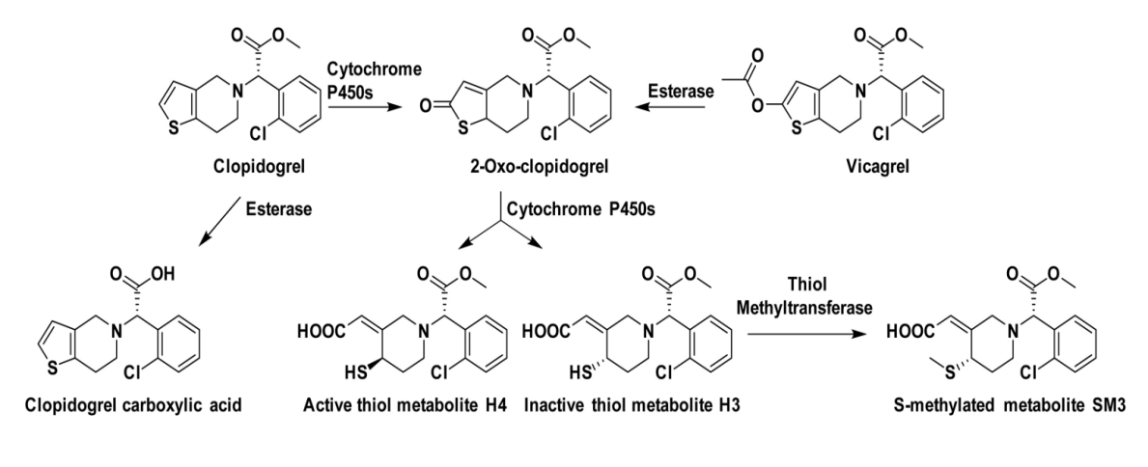
Since clopidogrel is a prodrug, in human in vivo, it undergoes two-step metabolism in the liver by CYP450 enzymes to produce the active metabolism product. Clopidogrel is first oxidized to 2-oxo-clopidogrel, which has two isomers, one of which is sbk002. 2-oxo-clopidogrel is further metabolized to form the only active thiol metabolism product H4 and inactive metabolism product H3. The active ingredients H4 and H3 can be further methylated to form SM3.
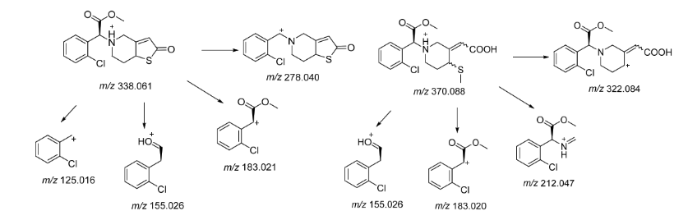
H4 Molecular weight: 355, [M+H]+=356; SM3 Molecular weight: 369, [M+H]+=370. Through mass spectrometry testing of plasma samples, compounds with mass-to-charge ratios of 356 and 370 are preliminarily suspected of being the active metabolism product H4 and the further metabolized product SM3 based on their retention time relative to sbk002 and their mass-to-charge ratio. Their mass spectrometry response values were obtained.
It is suspected that the compounds 356 and 370 studied in this assay are the active metabolism product H4 and the further metabolized methylated product SM3.

result
  - Comparison of blood drug concentrations between the portal vein and cervical vein in rats gavage-administered with sbk002 and clo
After SD rats were gavage-administered with sbk002 and clo, the sbk002 and clo blood drug concentrations in the portal vein and cervical vein can be seen in Table 1-1, and the mean blood drug concentrations of sbk002 and clo in the portal vein and cervical vein can be seen in Table 1-2.
Table 1-1: Plasma sbk002 individual blood concentration (ng/mL) after SDrats were gavaged with sbk002 and clo
individual number | sbk002 dose group
individual number | portal vein | jugular vein
1F001 | 415 | 254
1F002 | 206 | 429
1F003 | 634 | 253
1F004 | 463 | 271
1M001 | 337 | 93.5
1M002 | 175 | 65.8
1M003 | 134 | 52.6
1M004 | 421 | 115
individual number | clodose group
individual number | portal vein | jugular vein
2F001 | 109 | 73.4
2F002 | 222 | 215
2F003 | 204 | 119
2F004 | 213 | 146
2M001 | 28.3 | 17.6
2M002 | 48.3 | 24.6
2M003 | 20.9 | 10.1
2M004 | 10.7 | 8.02

Table 1-2 shows the mean blood drug concentrations of sbk002 in plasma (ng/mL, n = 8) after SD rats were gavage-administered with sbk002 and clo.
Group | dose | portal vein |  |  | jugular vein |  |  | portal vein/jugular vein
Group | dose | Mean | ± | SD | Mean | ± | SD | portal vein/jugular vein
sbk002 dose group | 10 mg/kg | 348.1 | ± | 169.4 | 191.7 | ± | 131.5 | 1.82
clodose group | 30 mg/kg | 107.0 | ± | 92.7 | 76.7 | ± | 76.6 | 1.40
After rats were gavaged with sbk002, the mean blood concentration ratio of sbk002 in the portal vein to the mean blood concentration in the jugular vein was 1.82; after rats were gavaged with clo, the mean blood concentration ratio of sbk002 in the portal vein to the mean blood concentration in the jugular vein was 1.40.
The results showed that:
(1) After gavage with sbk002, it is absorbed through the intestines, and there is no significant difference in the blood concentration between the portal vein and the cervical vein.
(2) After oral administration of clo, sbk002 could be generated in the portal vein (speculated to be metabolized in the intestines). Comparing the blood concentration in the portal vein and cervical vein, there was no significant difference.
(3) The mean blood drug concentration ratio of portal vein/cervical vein for the sbk002 dose group was 1.82, and for the clo group, it was 1.40. The comparison between the two showed no significant difference.
(4) Three hours after oral administration of sbk002 (10 mg/kg), the mean blood concentration of sbk002 in the portal vein and cervical vein was significantly higher than that of the clo group (30 mg/kg), indicating that the conversion rate of clo to sbk002 in the intestines or liver is relatively low, consistent with literature reports. Since sbk002 itself is absorbed through the intestines, it is normal for the blood concentration of sbk002 in the portal vein of the sbk002 group to be higher.
  - Study of metabolism products in the portal vein and jugular vein of rats gavaged with sbk002 and clo
After oral administration of sbk002 and clo to SD rats: the mass spectrometry responses of sbk002 and H4 in plasma are shown in 1-3, the mean mass spectrometry response ratio of H4 and sbk002 is shown in 1-4; the mass spectrometry response of sbk002 and SM3 is shown in 1-5, the mean mass spectrometry response ratio of SM3 and sbk002 is shown in 1-6.
Table 1-3 SD rats gavaged with sbk002 and clo plasma sbk002 and H4 mass spectrometry signals
individual number | sbk002 dose group
individual number | portal vein |  |  | jugular vein
individual number | sbk002 | H4 |  | sbk002 | H4
1F001 | 2764330 | 25367500 |  | 1687950 | 22820120
1F002 | 1370810 | 13551380 |  | 2860073 | 11354032
1F003 | 4225010 | 47412870 |  | 1684690 | 18787320
1F004 | 3082500 | 37506400 |  | 1805310 | 23748290
1M001 | 2245539 | 4247194 |  | 623569 | 2057838
1M002 | 1168508 | 3001930 |  | 438758 | 1652197
1M003 | 896708 | 2100957 |  | 350297 | 1270865
1M004 | 2806316 | 5902774 |  | 768691 | 2667137
individual number | clodose group
individual number | portal vein |  | portal vein
2F001 | 726974 | 3264148 |  | 489129 | 1822264
2F002 | 1478260 | 5462231 |  | 1431319 | 4426443
2F003 | 1360586 | 5517268 |  | 794657 | 2827213
2F004 | 1423888 | 5933182 |  | 973840 | 3511848
2M001 | 188518 | 555877 |  | 117205 | 358258
2M002 | 321739 | 968640 |  | 163897 | 502557
2M003 | 138872 | 440477 |  | 67261 | 211396
2M004 | 71194 | 182939 |  | 53140 | 134875

Table 1-4 comparison of the mean mass spectrometry signal ratio of H4 and sbk002 in the plasma of SD rats orally administered with sbk002 and clo
Group | portal vein | jugular vein | portal vein/jugular vein
Group | H4/sbk002 | H4/sbk002 | portal vein H4/jugular vein H4
sbk002 dose group | 7.49 | 8.25 | 0.91
clodose group | 3.91 | 3.37 | 1.16

Table 1-5 SD rats gavaged with sbk002 and clo plasma sbk002 and SM3 mass spectrometry signals
individual number | sbk002 dose group
individual number | portal vein |  | jugular vein
individual number | sbk002 | SM3 | sbk002 | SM3
1F001 | 2764330 | 20589940 | 1687950 | 18492480
1F002 | 1370810 | 7890140 | 2860073 | 10034776
1F003 | 4225010 | 35369980 | 1684690 | 20496330
1F004 | 3082500 | 30676370 | 1805310 | 19770430
1M001 | 2245539 | 5611187 | 623569 | 3818120
1M002 | 1168508 | 9877860 | 438758 | 3477336
1M003 | 896708 | 4668652 | 350297 | 2955023
1M004 | 2806316 | 18850556 | 768691 | 7387580
individual number | clodose group
individual number | portal vein |  | jugular vein
2F001 | 726974 | 3696962 | 489129 | 2158480
2F002 | 1478260 | 5686207 | 1431319 | 5598604
2F003 | 1360586 | 4007247 | 794657 | 2203575
2F004 | 1423888 | 8172727 | 973840 | 3853860
2M001 | 188518 | 3060926 | 117205 | 2063017
2M002 | 321739 | 1750678 | 163897 | 1318983
2M003 | 138872 | 1371054 | 67261 | 456285
2M004 | 71194 | 950973 | 53140 | 686131

Table 1-6 SD rats gavaged with sbk002 and clo plasma SM3 and sbk002
mean mass spectrometry response ratio
Group | portal vein | jugular vein | portal vein/jugular vein
Group | SM3/sbk002 | SM3/sbk002 | portal vein SM3/cervical vein SM3
sbk002 dose group | 7.19 | 8.46 | 0.85
clodose group | 5.03 | 4.48 | 1.12

After oral administration of sbk002 to SD rats, the relative ratio of the mean mass spectrometry response of H4 in the portal vein to the mean mass spectrometry response in the cervical vein was 0.91; after oral administration of clo to SD rats, the ratio was 1.16.
The relative ratio of the mean mass spectrometry response of the portal vein to the mean mass spectrometry response of the cervical vein for the metabolism product SM3 in SD rats gavage-administered with sbk002 was 0.85; the relative ratio for those gavage-administered with clo was 1.12.
Typical spectra of sbk002 dose group portal vein plasma samples are shown in Figure 1-1, typical spectra of cervical vein plasma samples are shown in Figure 1-2; typical spectra of clo dose group portal vein plasma samples are shown in Figure 1-3, typical spectra of cervical vein plasma samples in the clo dose group are shown in Figure 1-4.
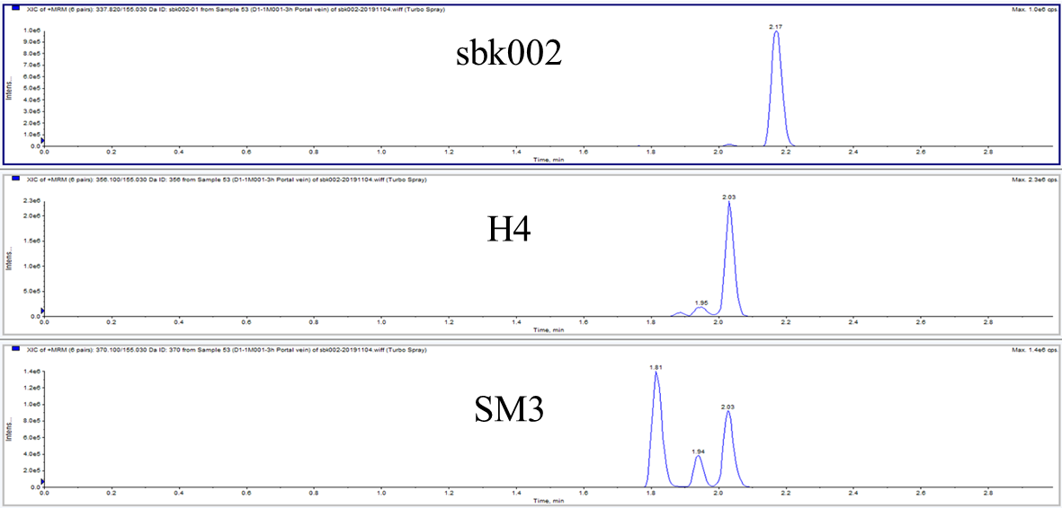
Figure 1-1 Typical spectrum of portal vein plasma samples from sbk002 dose group 1M001
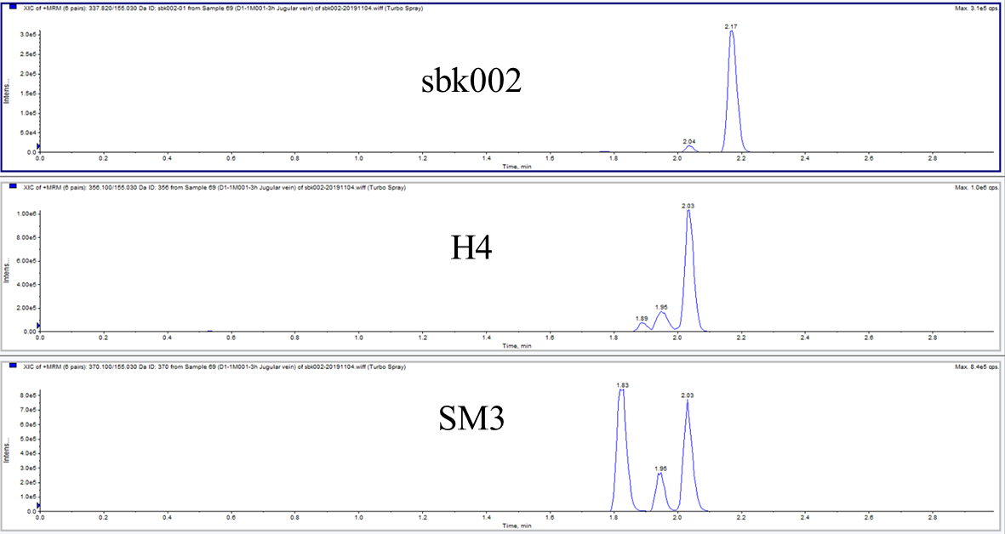
Figure 1-2 typical graph of 1M001 jugular vein plasma sample in sbk002 dose group
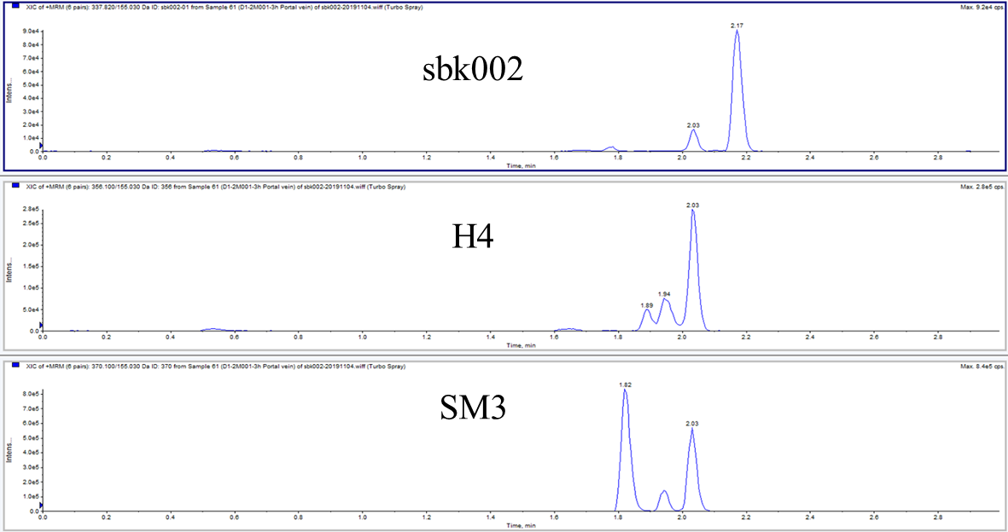
Figure 1-3 typical graph of 2M001 portal vein plasma sample in clo dose group
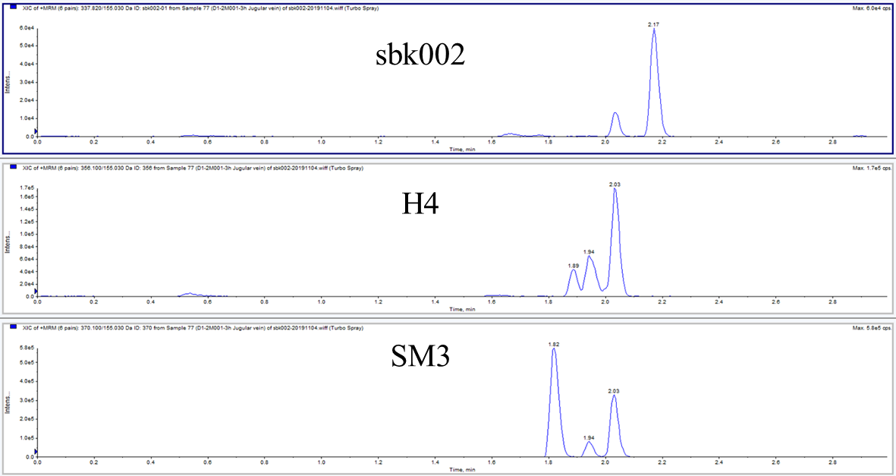
Figure 1-4 typical graph of 2M001 jugular vein plasma sample in clo dose group
The results showed that:
Metabolism product H4
(1) After SDrats were gavaged with dose sbk002, metabolism product H4 was generated in the portal vein (suspected intestinal metabolism). Comparing the mass spectrometry response between the portal vein and the jugular vein, there is no significant difference;
(2) After SD rats were gavage-administered with clo, it is speculated that the intestinal metabolism will produce the metabolic product H4. Comparison of mass spectrometry responses between the portal vein and the cervical vein showed no significant difference.
(3) The mean mass spectrometry response ratios of the metabolism product H4 in the portal vein/jugular vein for the sbk002 dose group was 0.91, and for the clo group was 1.16, showing no significant difference between the two.
(4) In the sbk002 group (10 mg/kg), 3 hours after gavage, the mean mass spectrometry responses of the metabolism product H4 in both the portal vein and the jugular vein were significantly higher than those of the clo group (30 mg/kg), indicating that the conversion rate of clo to the metabolism product H4 in the intestine or liver is low, consistent with literature reports.
metabolism product SM3
(1) After SD rats were orally administered with sbk002, metabolism product SM3 was generated in the portal vein (speculated to be metabolized in the intestines). Comparing the mass spectrometry response of the portal vein and the cervical vein, there was no significant difference;
(2) After SDrats were gavaged with dose clo, metabolism product SM3 was generated in the portal vein (suspected intestinal metabolism). Comparing the mass spectrometry response between the portal vein and the jugular vein, there is no significant difference;
(3) The mean mass spectrometry response ratio of the metabolism product SM3 in the portal vein/jugular vein for the sbk002 dose group was 0.85, while it was 1.12 for the clo group, showing no significant difference between the two.
(4) After 3 hours of gavage with the sbk002 group (10 mg/kg), the mean mass spectrometry response of the metabolism product SM3 in the portal vein and jugular vein is significantly higher than that in the clo group (30 mg/kg), indicating a lower conversion rate of clo to the metabolism product SM3 in the intestine or liver, consistent with literature reports.

Conclusion
Under the conditions of this study, after rats were gavaged with doses of sbk002 and clo, sbk002, metabolism products H4 and SM3 could be produced in the portal vein (speculated to undergo intestinal metabolism). The mean blood concentration ratio of sbk002 in the portal vein/jugular vein, and the mean mass spectrometry signal ratio of metabolism products H4 and SM3 in the portal vein/jugular vein showed no significant difference between the two dose groups.
Therefore, the trends of sbk002 and clo intestinal absorption or metabolism are basically consistent. It is speculated that H4 and SM3 are active metabolism products and further methylated metabolism products.

study protocol, deviation, and amendments
This assay did not produce any deviations from the study protocol. There were no amendments to the study protocol in this assay; see Appendix II for the study protocol.

- Storage of Relevant Data
  - Archiving Time and archives storage time
(1) Within two weeks after the final report is signed, the study director ensures that all study materials are transferred to the archives room for archiving.
(2) If this study is for registration application, its archive storage period is at least five years after the medication is marketed; if not for registration application, its archive storage period is at least five years after the assay report approval date.
  - Archived Data
Including but not limited to the following content:
- study director appointment letter
- study protocol and protocol amendments
- Various writing documents or reports related to the assay
- assay raw data (including electronic data)
- final report and related data
- Copies of feed, bedding, and drinking water testing reports; animal room temperature and humidity reports, etc.
- Retained test articles
- Other materials
  - Storage places and storage conditions
Storage place: Suzhou Huace Bio-Tech Co., Ltd. Archives Management Department;
Storage condition: routine;
contact person: Wu Li;
Contact Telephone: 0512-36801688.

- Appendix

Appendix One: study protocol

Appendix One: study protocol

Study Name: SDrats gavage administration of sbk002 and clo for intestinal absorption
assay
study number: B2019023-K09-01

