final report
SD rats gavage administration of sbk002 and phosphoric acid dioxaproline gut absorption experiment

Test Facility
name： | Suzhou Huace Biotechnology Co., Ltd.
Address： | 166 Yuanfeng Road, New & Hi-tech Industrial Development Zone, Kunshan City, Jiangsu Province
Telephone: | 0512-36801688

Sponsor
name： | Chengdu Shibeikang Biopharmaceutical Technology Co., Ltd.
Address： | Chengdu Sbicon Biopharmaceutical Technology Co., Ltd.
Telephone: | 028-62532315

Study period: 2019-09-11 ~ 2019-11-28

Signature page

Cold Light Red, M.S. Date
study director

ABBREVIATION INDEX
Abbreviation | Chinese name
AUC_{last}, AUC_{0-t} | Area under the blood drug concentration-time curve from 0 h to the last quantifiable concentration
AUC_{inf}, AUC_{0-∞} | From 0 h to infinite time plasma concentration-time area under curve
BLOQ | Below the lower limit of quantification
CL | clearance rate
C_{max} | Peak concentration
CV | Coefficient of variation
°C | Degree Celsius
h | hour
LC-MS/MS | Liquid chromatography-mass spectrometry (LC-MS)
LLOQ | Lower Limit of Quantification
Mean | Mean
mg | Milligram
mg/mL | Milligram per Milliliter
min | Minute
mL | milliliter
mL/min | Milliliters per minute
MRT | mean residence time
NA, N/A | Not Applicable
R² | Regression Coefficient
RE | Relative deviation
SD | Standards Deviation
SOP | standard operating procedures
T_{1/2} | half-life
T_{max} | Time to reach maximum
V_{d} | Apparent distribution volume
µg/mL | Microgram per milliliter
µL | μL

Contents
Signature Page 2
Abbreviation Index 3
Contents 4
Summary 5
1. Basic Information 6
1.1. Study Name and Number 6
1.2. Study Objective 6
1.3. Test Facility 6
1.4. Sponsor 6
1.5. Study Personnel composition 7
1.6. Regulations and technical guidelines followed 7
1.7. Assay schedule 8
2. Study Materials 9
2.1. Test article 9
2.2. Operations/Safety measures 11
2.3. Metabolism of dose formulations within the experimental structure 11
2.4. Major Instruments 11
3. Test system 11
3.1. Species/strain/grade 11
3.2. Sex and Number 11
3.3. Source 12
3.4. Body Weight and Age 12
3.5. Animal Identification 12
3.6. Laboratory animals selection rationale and quantity 12
4. Animal feeding and management 12
4.1. Animal Management and Use 12
4.2. Animal Receipt and Acclimation 13
4.3. Animal Housing 13
4.4. Housing Environment 13
4.5. Environmental Enrichment 13
4.6. Feed 13
4.7. bedding 14
4.8. Drinking Water 14
4.9. Animal Selection 15
5. study design 15
5.1. Dosing Information 15
5.2. assay method 16
6. Observation 16
6.1. General State Observation 16
6.2. Body weight 16
7. Blood Sampling and Test Analysis 16
7.1. Blood sample collection 16
7.2. Blood Concentration Testing 17
7.3. Result Analysis 17
8. Data Collection and Analysis 17
8.1. The collection system of collected and reported electronic data is as follows: 17
8.2. The human metabolites and metabolic pathways of Ticagrelor: 18
9. Results 19
9.1. Comparison of portal vein and jugular vein drug concentrations in rats after gavage with sbk002 and clo 19
9.2. rats gavage sbk002 and clo portal vein and jugular vein metabolite study 20
10. Conclusion 25
11. Study protocol, deviation, and amendments 25
12. Storage of Data 25
12.1. Archiving Time and Archive Storage Duration 25
12.2. Archived Data 25
12.3. Storage Location and Storage Condition 26
13. Appendixes 27
Appendix One: Study Protocol 27
Appendix One: Study Protocol 28

Summary
Objective: SD rats gavaged with sbk002 and chlorogenic acid (clo), determining sbk002 blood drug concentration, qualitative determination of active metabolites' existence [conducting semi-quantitative research (the content ratio of active metabolites to sbk002)]. Additionally, the blood drug concentration ratio of sbk002 and metabolites in the portal vein and jugular vein of rats was calculated.
Method: Each group of 8, half female, half male, a total of 16 SD rats; groups are divided into sbk002 dose group and clo dose group. SBK002 dose group single dose of 10 mg/kg, clo dose group single dose of 30 mg/kg. After dosing for 3 hours, immediate CO2 anesthesia, perform surgery, portal vein and cervical vein each collect blood 0.4 mL, use lipid conjunction for testing.
Results:
Mean blood drug concentration ratio of sbk002 metabolic product in portal vein/cervical vein: After gavage administration of sbk002 10 mg/kg in SD rats, the average blood drug concentration ratio of sbk002 in portal vein/cervical vein is 1.82; after gavage administration of 30 mg/kg of clo in SD rats, the average blood drug concentration ratio of sbk002 in portal vein/cervical vein is 1.40. There is no significant difference between the two administration groups.
H4 metabolite portal vein/carotid vein mean mass signal ratio: After SD rats oral sbk002, H4 metabolite portal vein mean mass response/carotid vein mean mass response ratio is 0.91; after SD rats oral clo, H4 metabolite portal vein mean mass response/carotid vein mean mass response ratio is 1.16, with no significant difference between the two dosing groups.
The mean conductivity signal ratio of SM3 metabolic products in the portal vein/jugular vein: After gavage of sbk002 in SD rats, the mean conductivity response of SM3 metabolic products in the portal vein/the mean conductivity response in the jugular vein ratio is 0.85; After gavage of clo in SD rats, the mean conductivity response ratio of SM3 metabolic products in the portal vein/the mean conductivity response in the jugular vein is 1.12. There were no significant differences between the two drug administration groups.
Conclusion: Under the conditions of this study, after gavage administration of sbk002 and clo to rats, metabolites sbk002, H4 metabolite, and SM3 metabolite were produced in the portal vein (presumed to imply gastrointestinal metabolism). Moreover, the mean blood concentration ratio of sbk002 in the portal vein/jugular vein, and the mean conductivity signal ratio of H4 metabolite and SM3 metabolite in the portal vein/jugular vein, showed no significant differences between the two dosing groups.
Therefore, sbk002 and clo gastrointestinal absorption or metabolism trends are basically consistent.
It is estimated that H4 and SM3 are active metabolites and further methylated metabolites.

General Information
  - Study Name and Number
Study Name：SD rats gavage administered with SBK002 and Chlorogenic Acid Investigation on Intestinal Absorption of Ticagrelor;
Study number: B2019023-K09-01.
  - Study Objective
Using healthy SD rats as test subjects, studying sbk002 and chlorogenic acid in terms of intestinal absorption and metabolism in SD rats, and evaluating their metabolism targets.
  - Test Facility
Name: Suzhou Huace Biotechnology Co., Ltd.;
Address: Yuanfeng Road 166, New & Hi-tech Industrial Development Zone, Kunshan City, Jiangsu Province
Postcode: 215300;
Contact person: Xia Yuye;
Telephone: 0512-36801688;
Fax: 0512-36802288;
Email: xiayuye@cti-cert.com.
  - Sponsor
name: Chengdu Sbicon Biopharmaceutical Technology Co., Ltd.;
Address: Chengdu New & Hi-tech Industrial Development Zone (West Area), 17 West Core Road;
Postal code: 611731;
Contact: Mur Xian;
Telephone: 028-62532315;
Email: 779061281@qq.com.
  - Composition of study personnel
    - study director
Name: Leng Minghong
Address: Yuanfeng Road 166, New & Hi-tech Industrial Development Zone, Kunshan City, Jiangsu Province
Telephone: 17312661834;
Fax: 0512-36802288;
Email: lengminghong@cti-cert.com。
    - Principal study personnel
Assay operation: Weiwei Kong, Jia Jia Deng, et al;
Veterinarian: Wang Haiyang, Xu Jian;
Animal husbandry management: Li Yongchao;
Test article management: Chen Xiaoyan
Preparation of test article: Liu Lulu;
Sample Analyzed by：Wu Jinjing, Wu Zongyan；
Data management and statistical analysis: Leng Minghong, Ye Shuangshuang, Ge Mingyu.
  - Following regulations and technical guidelines
This assay complies with the regulations and technical guidelines, including but not limited to:
《Pharmaceuticals Registration Management Measures》(Former CFDA, October 2007);
《Good Laboratory Practice for Non-clinical Studies》(formerly CFDA, September 2017);
Principles for Nonclinical Drug Metabolism Kinetics Study Techniques (originally CFDA, May 2014)
《Bio-Sample Quantitative Analysis Method Validation Guidelines》(Chinese Pharmacopoeia Commission, Pharmacopoeia of the People’s Republic of China, 2015 Edition);
ICH M10: Bioanalytical Method Validation. Draft Version, February 2019。
The implementation of this assay, except for the special explanations in the protocol, complied with the standard operating procedures of the testing facility (Standard Operating Procedures, SOPs).
  - Assay time arrangement
Dose date: 2019-09-16.

Study Materials

  - Test article
    - Basic Information of Test Article 1
Name/Code: sbk002;
Characterization: white crystalline powder;
Size: 2 g/bag;
content: 99.4 %；
Batch Number: 190603;
Expiry date: 2021-06-10 (tentative);
Storage condition: 15 ℃~ 25 ℃, airtight, protected from light, and dry
Manufacturer: Chengdu Sibekang Biomedical Co., Ltd.;
Supplier: Chengdu Siprecon Biomedicine Technology Co., Ltd.
    - Test article 2 Basic Information
Name/Code: Citric acid omeprazole/clo;
Characterization: white powder;
Specification: 2.2 g/bag;
Content: 98.8 %；
Batch number: 196766001;
Expiry date: 2021-06-24 (Reinspection date)；
Storage condition: 15 ℃~ 25 ℃, airtight, protected from light, and dry
Manufacturer: Zhejiang CheTou Pharmaceutical Co., Ltd.;
Supplier: Chengdu Siprecon Biomedicine Technology Co., Ltd.
    - vehicle General Information
Name/Code: BrdU;
Characterization: White to gray powder or crystals;
Size: 500 g；
batch number: C1814029；
Expiry date: 2022-03-14；
Storage condition: room temperature
Manufacturer: Aladdin ）;
    - Preparation of test article
sbk002 dose formulation preparation method: According to the most recent body weight of SD rats, calculate the amount of test article required based on the dosage. Calculate the prepared volume based on the amount of test article and the preparation concentration (prepared volume = test article amount × content/preparation concentration). Under room temperature and light-protected conditions, accurately weigh a certain amount of test article into a mortar, add an appropriate amount of solvent and grind thoroughly. Completely transfer it to a container of specified volume, use the solvent to make up to the mark, to obtain the required concentration of the test article dose formulation.
clo dose formulation preparation method: According to the most recent body weight of SD rats, calculate the amount of test article required based on the dosage. Calculate the prepared volume based on the amount of test article and the preparation concentration (prepared volume = positive reference item amount × content/preparation concentration). Under room temperature and light-protected conditions, accurately weigh a certain amount of test article into a mortar, add an appropriate amount of solvent and grind thoroughly. Completely transfer it to a container of specified volume, use the solvent to make up to the mark, to obtain the required concentration of the test article dose group dose formulation.
Preparation of test article method: an example is given for preparing a 10 mL dose formulation as follows:
group | concentration  （mg/mL） | preparation method
sbk002  dose group | 10 | Under room temperature and light-protected conditions, accurately weigh 100.6 mg of sbk002 into a mortar, add an appropriate amount of 0.5% CMC-Na solution, and grind thoroughly. Completely transfer to a container of specified volume, use 0.5% CMC-Na to make up to the mark, stir well to obtain 10 mL of sbk002 dose group dose formulation with a concentration of 10 mg/mL.
clo dose group | 30 | At room temperature and protected from light, accurately weigh 303.6 mg of clo into a mortar, add an appropriate amount of 0.5 % CMC-Na solution, grind thoroughly, transfer completely to a container calibrated for volume, use 0.5 % CMC-Na to make up to the calibration mark, stir well to obtain a clo dose formulation with a concentration of 30 mg/mL, 10 mL.
Identification method: The prepared sbk002 dose group and clo dose group are labeled with green and red tags respectively, and the study number, name, concentration, quantity, preparation date, preparer, storage conditions, expiry date, and finished product number are indicated.
    - Vehicle (0.5 % CMC-Na) solution preparation
Preparation method: Accurately weigh a certain amount of CMC-Na powder, use a measuring cylinder to measure a certain volume of pure water and transfer it to a beaker, evenly disperse the CMC-Na powder in the beaker, add a stirring rod, and stir with a magnetic stirrer until completely dissolved, obtaining a 0.5% CMC-Na solution.
Preparation method: Using 1000 mL vehicle as an example: Weigh exactly 5.0 g of CMC-Na powder, measure 1000 mL of pure water with a graduated cylinder and transfer to a beaker, evenly disperse the CMC-Na powder into the beaker, add a stirring rod, and stir with a magnetic stirrer until completely dissolved, resulting in a 1000 mL 0.5% CMC-Na solution. Store at room temperature, effective within 8 days.
    - Handling of retained samples and remaining dose formulations/test articles
Test article retention samples: Retention samples according to non-final formulation;
Disposal of remaining dose formulations: Return to Test Article Management department, disposed of as medication/chemical waste;
Remaining test article handling: Return to the sponsor after all studies in this project are completed.

Supplier: Chengdu Siprecon Biomedicine Technology Co., Ltd.

  - Operation/Safety measures
The test facility operates according to the 'Occupational Health Safety and Protection Manual'. During the assay operations, appropriate personal protective equipment (PPE) and goggles should be worn.
  - Transfer of dose formulations within the experimental institution
The test article dose formulations were transferred from the Test Article Management department to the Animal Housing under room temperature, airtight, and light-shielding conditions. Dose formulations retrieved from the Test Article Management department were stored at room temperature, and light-shielding conditions when not in use.
  - Major Instruments and Equipment
equipment name | Manufacturer | Model
Liquid chromatography-mass spectrometry (LC-MS) system | SCIEX | QTRAP 5500

test system
  - Breed/strain/grade
strain: SD rats;
Grade: SPF grade.
  - Sex and Number
Number and sex of animals entering the acclimation period: 20, half male and half female;
Number and sex of animals used: 16, half female and half male;
Disposal of remaining animals: The remaining laboratory animals from this assay will be transferred to the Toxicology Operations Department within one week after the first dose.
  - Source
Supplier: Zhejiang Vitonlihua Laboratory Animal Technology Co., Ltd.;
Production license No: SCXK (Zhejiang) 2019-0001
Animal Quality Certificate No.: No.1909060025。
  - Body Weight and Age
Body weight at purchase: males 314.4 ~ 335.8 g, females 202.2 ~ 214.8 g; body weight at group assignment: males 331.9 ~ 350.8 g, females 214.1 ~ 224.5 g. Individual body weights at group assignment were within the same sex mean body weight ± 20% range;
Age: 8 ~ 11 weeks at purchase, 9 ~ 12 weeks at group assignment.
  - Animal identification
According to the SOPs of the research facility, each animal is identified by tail labeling and a cage card as its identification marker.
  - Laboratory Animals Selection Justification and Number
Reasons for selecting laboratory animals: According to the CFDA's 'Guiding Principles for Non-Clinical Pharmacokinetic Research of Drugs', May 2014, and previous experimental data, SD rats are the sensitive animals for this experiment. Therefore, SD rats were also chosen for this assay, as their genetic and biological backgrounds (including anatomical, physiological, and clinical pathology data within the normal range) are relatively clear.
Justification for selection of the number of laboratory animals: To meet the research objectives, scientific standards, and regulatory requirements, the study will use the minimum number of animals necessary. The experiment consists of 2 groups, with 8 animals per group, half male and half female, totaling 16 SD rats. This number is sufficient to obtain adequate experimental data, while extra 2 animals/sex are procured to prevent any unforeseen circumstances where animals fail to meet experimental needs.

animal feeding and management
  - animal management and use
Suzhou Huace Biotechnology Co., Ltd. is an organization accredited by the “Association for Assessment and Accreditation of Laboratory Animal Care (AAALAC International)” and the use of laboratory animals has been approved by the Jiangsu Provincial Department of Science and Technology.
This experiment is not a simple repetition of any previous experiments, nor can other replacement experiments solve it; and after literature searches, there are no other methods that can replace the manipulations mentioned in this test with methods that cause less pain and tension.
The contents and procedures related to animal experiments involved in this test comply with relevant laws, regulations, and rules for the use and management of experimental animals, and the relevant regulations of the Institutional Animal Care and Use Committee (IACUC). The number of animals, study design, and disposal of animals were approved by the IACUC of the institution (Approval No: IACUC-B2019023-K09-01) and were strictly implemented according to the approved content.
  - Animal Receipt and Acclimation
Laboratory animals were acclimated to the environment for 7 days after reception.
  - Animal Housing
Laboratory animals used in this institution are licensed under certification number: SYXK(Su)2018-0051;
Housing location: Inside the barrier system, 2nd floor, Building 1, Suzhou Huace Biotechnology Co., Ltd.;
Cage type: polysulfone rat cage, size (L×W×H): 50 cm × 36 cm × 20 cm;
Housing density: ≤4 rats per cage.
  - Housing Environment
Housing environment condition standards: National Standards of the People's Republic of China GB14925-2010;
Housing Environment Control System: MSEA-MVE 6.0 Johnson Animal Room Environment Monitoring System;
Temperature: 20 ~ 26 ℃ (daily temperature variation ≤ 4 ℃);
Relative humidity: 40 % ~ 70 %;
Lighting: Artificial lighting, 12-hour light-dark alternation;
Ventilation Rate: No less than 15 air changes per hour.
  - Environmental Enrichment
Provide toys for laboratory animals as environmental enrichment measures.
  - Feed
type: SPF large and small mouse maintenance feed;
Feed batch number: 19083213;
Manufacturer: Beijing Keao Xieli Feed Co., Ltd.;
Production license No: SCXK(Beijing)2019-0003;
Feeding method: Ad libitum (except when the assay has special requirements);
The supplier provided feed quality certificates, qualification certificate numbers: 1112621900011137, 11126219000111785;
Nutritional Components: Equipped with the testing report provided by Eurofins (Report Number: GNALX2IA1S1068944), the test indicators include moisture, crude protein, crude fat, crude fiber, crude ash, calcium, and total phosphorus. The test results comply with national standards.
Chemical pollutants: includes a testing report provided by Eurofins (report number: GNALX2IA1S1068945), with testing parameters including arsenic, lead, cadmium, mercury, Hexachlorobenzene, Polychlorinated biphenyls, and Aflatoxin B1. The test results comply with national standards.
Microbial Indicators: Testing report from Jinri Testing provided (Report Number: GNALX2IA1S1068946), including indicators such as total bacterial count, coliform bacteria, mold and yeast count, and Salmonella spp. Test results meet national standards.
  - Bedding
Bedding type: Corn cob;
bedding batch number：AWR-20190408；
Manufacturer: Suzhou Anweierkang Laboratory Animal Products Co., Ltd.;
Storage and use: low temperature, dry, hygienic; sterilized bedding should be spread at the bottom of the rat cage, enough to cover the entire bottom;
Bedding Testing: The bedding provided by Suzhou Anweierkang Laboratory Animal Products Co., Ltd., includes a testing report from Jinri Testing (Report Number: BNAY0TLL8I072508), with indicators such as arsenic, lead, mercury, cadmium, HCB, DDX, and Aflatoxin B1. Testing results meet the requirements.
  - Drinking Water
type: reverse osmosis water (domestic drinking water);
Water supply method: Drinking water bottles provided, ad libitum;
Routine Water Quality Testing: Equipped with the testing report provided by Jiangsu Huace Quality Testing Technology Co., Ltd. (Report Number: A20190208613101), the test items include: pH value, color, turbidity, odor and taste, visible substances, total hardness, oxygen consumption, total dissolved solids, anionic synthetic detergents, volatile phenols, trihalomethanes, hexavalent chromium, cyanide, iron, silicon dioxide, copper, manganese, hexachlorobutadiene, nitrite, arsenic, nitrate, permanganate value (three-valent arsenic), total radioactive alpha, total radioactive beta; the test results meet national standards.
  - Animal Selection
Selection of healthy (female non-pregnant, nulliparous) rats as test animals;
General state observation was performed on all rats entering the acclimation period before dosing; animals that did not pass the examination were not included in the study.

Study Design
Group design: sbk002 dose group, clo dose group;
Animal quantity: 8 per group, total of 16 animals;
Sex ratio: equal male and female;
Grouping method: random grouping by body weight and sex.
Animal Group Assignment and Dose Information see table below:
group | Test article | dose  (mg / kg) | animal number
group | Test article | dose  (mg / kg) | egg | Male
sbk002 dose group | sbk002 | 10 | 1F001~1F004 | 1M001~1M004
clo dose group | clo | 30 | 2F001~2F004 | 2M001~2M004
Note: The first digit of the animal number represents the group (1 and 2 represent sbk002 dose group and clo dose group respectively), the second letter F represents female, M represents male. The last 3 digits represent the animal sequence number.
  - Dosing Information
Dosage: sbk002 dose group dosage is 10 mg/kg. clo dose group dosage is 30 mg/kg;
Dose volume: Single dose volume is 1 mL/kg. The dose for each animal is adjusted based on the most recent body weight measurement;
Dose Concentration: sbk002 dose group concentration is 10 mg/kg. clo dose group concentration is 30 mg/kg;
Route of Administration: Gavage;
Reason for selection: Consistent with clinical medication route;
Fasting: No food for at least 12 hours before dosing; water not restricted during the assay period;
Frequency of administration and period: single dose;
the first day of the adaptation period is defined as P1, and the first day of dosing is defined as day 1, D1.
  - Study method
This experiment aims to explore the main sites of metabolism of sbk002 and clo in rats. Three hours after dosing, CO2 anesthesia was immediately administered, and surgery was performed to expose the portal vein and jugular vein. Blood was collected from the portal vein and jugular vein, 0.4 mL each. sbk002 blood drug concentration was determined, qualitative determination of active metabolites' existence [conducting semi-quantitative research (the content ratio of active metabolites to sbk002)]. Additionally, the blood drug concentration ratio of sbk002 and metabolites in the portal vein and jugular vein of rats was calculated.

- observation
  - General Condition Observation
Observation time: Observe once every morning or afternoon;
Observation items: Including but not limited to general conditions, behavioral status, eyes, oral cavity, muzzle, ears, hair and skin, feces, urine, genitalia toxicity symptoms;
Animals to be observed: all surviving assay animals.
  - body weight
Measurement time: determination once before dosing.
Animals to be measured: all surviving assay animals.

- Blood sample collection and testing analysis
  - Blood sample collection
Pharmacokinetic assay blood sampling time and animal number as shown in the table below:
group | 3 hours post-dosing
sbk002 dose group | (♀4/♂4)  1F001 ~ 1F004  1M001 ~ 1M004
clo dose group | (♀4/♂4)  2F001 ~ 2F004  2M001 ~ 2M004
Subtotal | 16
Sampling Time for All Dose Groups: 3 h after dosing (± 15 min).
Sampling method and quantity: Collect blood from portal vein and jugular vein, each 0.4 mL. Collected whole blood was placed into an anticoagulant tube containing EDTA-K2, gently mixed.
Blood sample processing: whole blood samples centrifuged and stored on ice box, transported in ice box, at 2 ~ 8 ℃, 4000 r/min, centrifuged for 10 min; plasma separated, stored in 2 tubes, EP tube label format example as follows:
B2019023-K09-01
D1-1F001-3h
190910-PK (Plasma-2)
B2019023-K09-01
D1-1F001-3h
190910-PK (Plasma-1)

Among them, “Plasma-1” is the first testing sample, with a plasma volume of 100 μL. The remaining plasma sample is stored as a backup in the “Plasma-2” tube. Stored at ≤ -60 ℃. Residual plasma samples after analysis are destroyed or transferred to the sponsor 6 months after the assay’s end, based on the sponsor's authorization.
  - Blood drug concentration testing
Using LC-MS/MS method to test the concentration of sbk002 and its metabolite profile in plasma samples.
  - Result analysis
Measurement of sbk002 blood drug concentration, determining the presence of active metabolites [conducting a semi-quantitative study (i.e., the ratio of qualitative signals of active metabolites and sbk002)], and calculating the blood drug concentration ratio in the portal vein/jugular vein of rats for sbk002 and metabolites.

- Data acquisition and analysis
All raw data in the facility is manually collected or gathered using a data acquisition system based on the study protocol and SOPs of Suzhou Huace Biotech Co., Ltd. Manually collected data is transcribed into Excel sheets for analysis and reporting.
  - The collection system for collecting and reporting electronic data is as follows:
system | Version | Purpose
Johnson Control | MSEA-MVE 6.0 | Animal room environment control and testing
AB Analyst | 1.7.1 | LC-MS/MS Testing Concentration
Calculation of portal vein and jugular vein mean blood drug levels and mean quality signals. Mean blood drug concentration ratios are used to evaluate differences in blood collection positions and dose groups, with a ratio of 0.5 to 2 indicating no significant difference, and < 0.5 or > 2 indicating significant difference;
  - Dioxaproline human metabolites and metabolic pathways:
According to the results published by Professor Zhong D.F. at the Shanghai Institute of Materia Medica, Chinese Academy of Sciences, on the Phase I single oral dose PK/PD clinical study (Clinical Trial Registration Number: CTR20150346) of Ticagrelor and Wiclazimab, further investigations were conducted on the human metabolites and metabolic pathways of Ticagrelor [1].
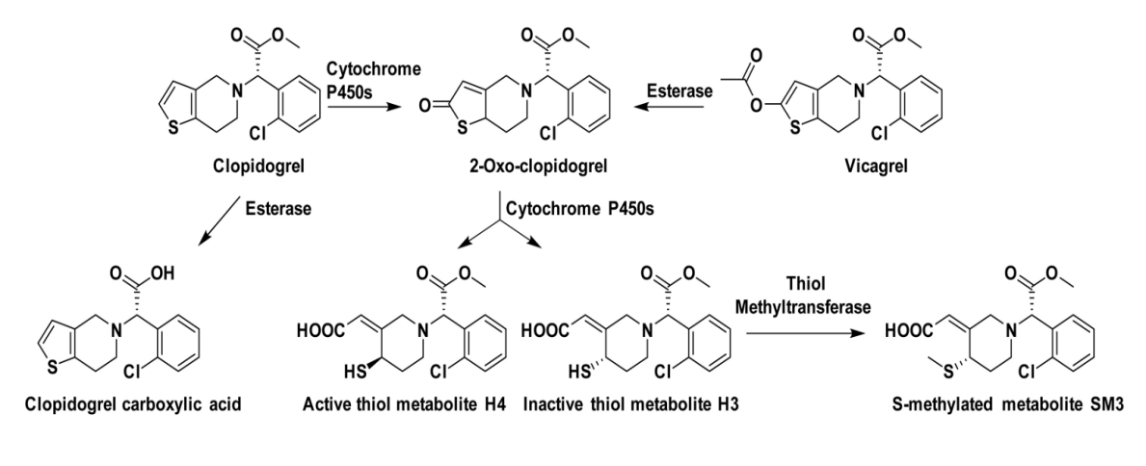
Because dioxaproline is a prodrug, it undergoes liver CYP450 enzyme two-step metabolism in the human body to form active metabolites. Dioxaproline is first oxidized to 2-oxy-dioxaproline, which has 2 isomers, one of which is sbk002; 2-oxy-dioxaproline further metabolizes to form unique active metabolite H4 and inactive metabolite H3, with active components H4 and H3 possibly further methylated to SM3.
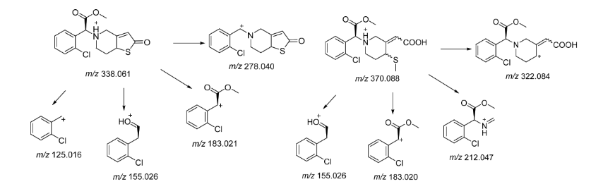
H4molecular weight is 355, [M+H]+=356, SM3 has molecular weight of 369, [M+H]+=370; through mass spectrometry examination of plasma samples of esters with mass 356 and 370 compounds, based on relative retention time of sbk002 and mass spectrometry, it is predicted whether it is possible to produce the active metabolites H4 and further metabolites SM3, and obtain their mass spectrometry response values.
It is estimated that the synthetic compounds 356 and 370 observed in this test are the active metabolites H4 and further metabolite carbamate derivations SM3.

Result
  - Comparison of portal vein and jugular vein blood drug concentration after rats were gavaged with sbk002 and clo
After gavaging SD rats with sbk002 and clo, individual portal vein and jugular vein blood drug concentrations of sbk002 and clo were shown in Figure 1-1, and mean portal vein and jugular vein blood drug concentrations of sbk002 and clo were shown in Figure 1-2.
Table 1-1: SD rats intragastrically administered sbk002 and clo afterward, individual plasma concentration of sbk002 (ng/mL)
individual ID number | sbk002 dose group
individual ID number | Portal vein | jugular vein
1F001 | 415 | 254
1F002 | 206 | 429
1F003 | 634 | 253
1F004 | 463 | 271
1M001 | 337 | 93.5
1M002 | 175 | 65.8
1M003 | 134 | 52.6
1M004 | 421 | 115
individual ID number | clo dose group
individual ID number | Portal vein | jugular vein
2F001 | 109 | 73.4
2F002 | 222 | 215
2F003 | 204 | 119
2F004 | 213 | 146
2M001 | 28.3 | 17.6
2M002 | 48.3 | 24.6
2M003 | 20.9 | 10.1
2M004 | 10.7 | 8.02

Table 1-2: SD rats intragastrically administered sbk002 and clo afterward, sbk002 average plasma concentration (ng/mL, n = 8)
group | dose | Portal vein |  |  | jugular vein |  |  | Portal vein/neck vein
group | dose | Mean | ± | SD | Mean | ± | SD | Portal vein/neck vein
sbk002 dose group | 10 mg/kg | 348.1 | ± | 169.4 | 191.7 | ± | 131.5 | 1.82
clo dose group | 30 mg/kg | 107.0 | ± | 92.7 | 76.7 | ± | 76.6 | 1.40
After gavage administration of sbk002 in rats, the mean blood drug concentration ratio between portal vein and cervical vein for sbk002 is 1.82; after gavage administration of clo in rats, the mean blood drug concentration ratio between portal vein and cervical vein for sbk002 is 1.40.
The results showed that:
(1) After gavage administration of sbk002, it is absorbed through the intestine, and there is no significant difference between the blood drug concentration in the portal vein and the cervical vein.
(2) After clo gavage, sbk002 can be produced in the portal vein (estimated intestinal metabolism), and there is no significant difference between the blood drug concentration in the portal vein and the jugular vein.
(3) The mean blood drug concentration ratio of portal vein/neck vein in sbk002 dose group is 1.82, and clo group is 1.40, with no significant difference between the two.
(4) After 3 hours of gavage in the sbk002 group (10 mg/kg), the mean blood drug concentration of sbk002 in the portal vein and jugular vein was significantly higher than that in the clo group (30 mg/kg), indicating that the conversion rate of clo to sbk002 in the intestine or liver was relatively low, consistent with literature reports. Since sbk002 itself is absorbed through the intestine, the higher blood drug concentration of sbk002 in the portal vein in the sbk002 group is also normal.
  - Study on portal vein and jugular vein metabolites in rats gavaged with sbk002 and clo
SD rats intragastrically administered sbk002 and clo afterward: sbk002 and H4 dose-response in plasma shows Table 1-3, H4 and sbk002 mean dose-response ratio shows Table 1-4; sbk002 and SM3 dose-response shows Table 1-5, SM3 and sbk002 mean dose-response ratio shows Table 1-6.
Several 1-3 SD rats gavage administration of sbk002 and clo, then sbk002 and H4 profile signals
individual ID number | sbk002 dose group
individual ID number | Portal vein |  |  | jugular vein
individual ID number | sbk002 | H4 |  | sbk002 | H4
1F001 | 2764330 | 25367500 |  | 1687950 | 22820120
1F002 | 1370810 | 13551380 |  | 2860073 | 11354032
1F003 | 4225010 | 47412870 |  | 1684690 | 18787320
1F004 | 3082500 | 37506400 |  | 1805310 | 23748290
1M001 | 2245539 | 4247194 |  | 623569 | 2057838
1M002 | 1168508 | 3001930 |  | 438758 | 1652197
1M003 | 896708 | 2100957 |  | 350297 | 1270865
1M004 | 2806316 | 5902774 |  | 768691 | 2667137
individual ID number | clo dose group
individual ID number | Portal vein |  | Portal vein
2F001 | 726974 | 3264148 |  | 489129 | 1822264
2F002 | 1478260 | 5462231 |  | 1431319 | 4426443
2F003 | 1360586 | 5517268 |  | 794657 | 2827213
2F004 | 1423888 | 5933182 |  | 973840 | 3511848
2M001 | 188518 | 555877 |  | 117205 | 358258
2M002 | 321739 | 968640 |  | 163897 | 502557
2M003 | 138872 | 440477 |  | 67261 | 211396
2M004 | 71194 | 182939 |  | 53140 | 134875

Table 1-4: SD rats intragastric administration of sbk002 and clo afterwards, H4 and sbk002 average quality signal ratio in plasma
group | Portal vein | jugular vein | Portal vein/neck vein
group | H4/sbk002 | H4/sbk002 | portal vein H4/jugular vein H4
sbk002 dose group | 7.49 | 8.25 | 0.91
clo dose group | 3.91 | 3.37 | 1.16

Figure 1-5 SD rats gavaged with sbk002 and clo, sbk002 and SM3 content ratios in plasma
individual ID number | sbk002 dose group
individual ID number | Portal vein |  | jugular vein
individual ID number | sbk002 | SM3 | sbk002 | SM3
1F001 | 2764330 | 20589940 | 1687950 | 18492480
1F002 | 1370810 | 7890140 | 2860073 | 10034776
1F003 | 4225010 | 35369980 | 1684690 | 20496330
1F004 | 3082500 | 30676370 | 1805310 | 19770430
1M001 | 2245539 | 5611187 | 623569 | 3818120
1M002 | 1168508 | 9877860 | 438758 | 3477336
1M003 | 896708 | 4668652 | 350297 | 2955023
1M004 | 2806316 | 18850556 | 768691 | 7387580
individual ID number | clo dose group
individual ID number | Portal vein |  | jugular vein
2F001 | 726974 | 3696962 | 489129 | 2158480
2F002 | 1478260 | 5686207 | 1431319 | 5598604
2F003 | 1360586 | 4007247 | 794657 | 2203575
2F004 | 1423888 | 8172727 | 973840 | 3853860
2M001 | 188518 | 3060926 | 117205 | 2063017
2M002 | 321739 | 1750678 | 163897 | 1318983
2M003 | 138872 | 1371054 | 67261 | 456285
2M004 | 71194 | 950973 | 53140 | 686131

Figure 1-6 SD rats gavaged with sbk002 and clo, SM3 and sbk002 in plasma
Mean mass spectrometry response ratio
group | Portal vein | jugular vein | Portal vein/neck vein
group | SM3/sbk002 | SM3/sbk002 | portal vein SM3/cervical vein SM3
sbk002 dose group | 7.19 | 8.46 | 0.85
clo dose group | 5.03 | 4.48 | 1.12

SD rats gavage with sbk002, the relative ratio of metabolite H4 portal vein mean mass spectrometry response/neck vein mean mass spectrometry response is 0.91; SD rats gavage with clo, the ratio is 1.16.
After gavage with sbk002 in SD rats, the relative ratio of the mean qualitative response of metabolite SM3 in the portal vein to the jugular vein is 0.85. After gavage with clo, the relative ratio is 1.12.
Typical chromatograms of portal vein plasma samples for sbk002 dose group are shown in Figure 1-1, and typical chromatograms of cervical vein plasma samples are shown in Figure 1-2; typical chromatograms of portal vein plasma samples for clo dose group are shown in Figure 1-3, and typical chromatograms of cervical vein plasma samples for clo dose group are shown in Figure 1-4.
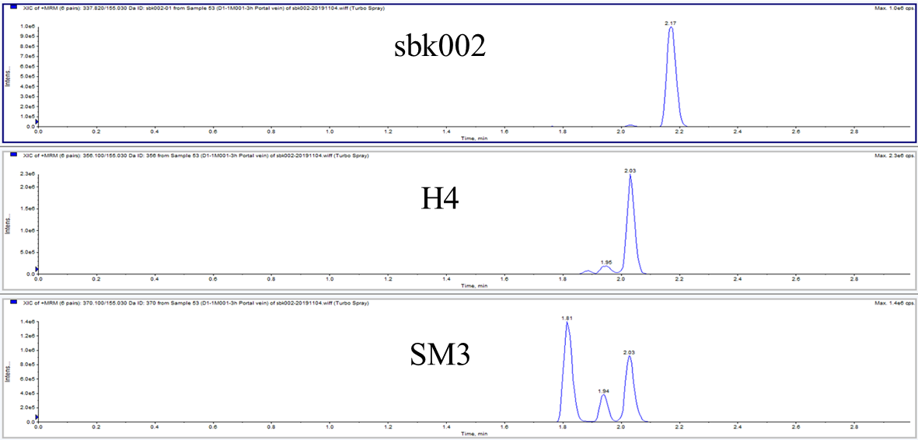
Figure 1-1 Typical plot of sbk002 dose group 1M001 portal vein plasma sample
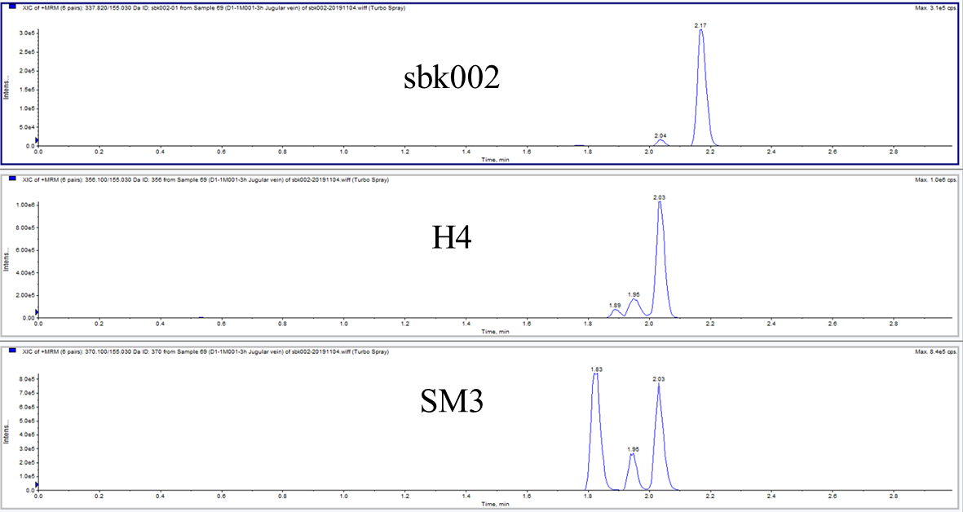
Figure 1-2 sbk002 dose group 1M001 jugular vein plasma sample typical picture
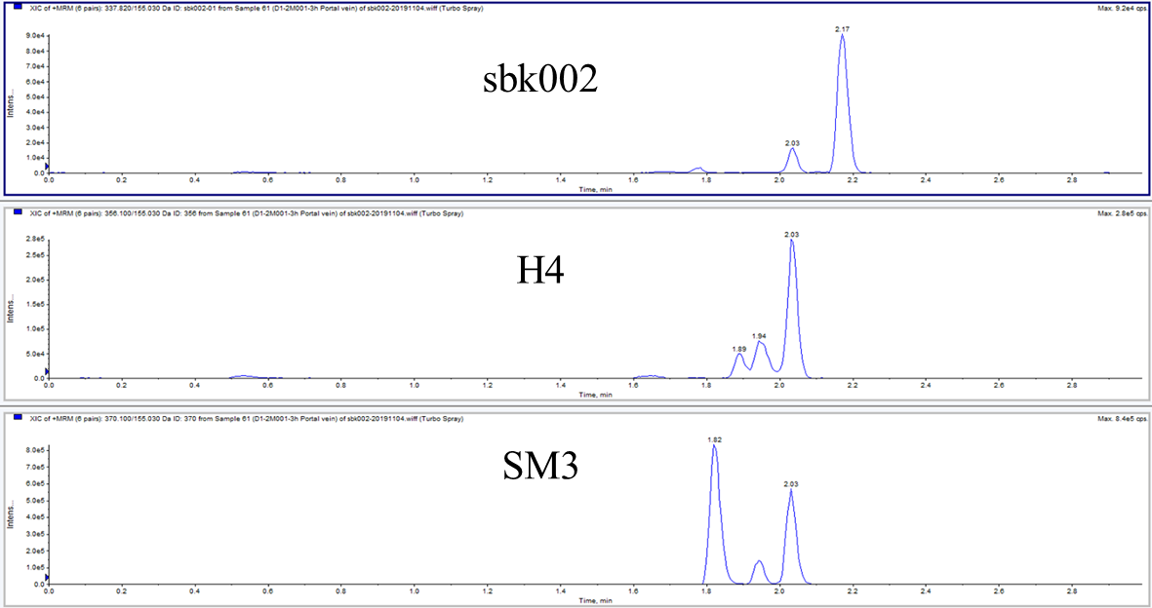
Figure 1-3 Typical graph of 2M001 portal vein plasma samples in the clo dose group
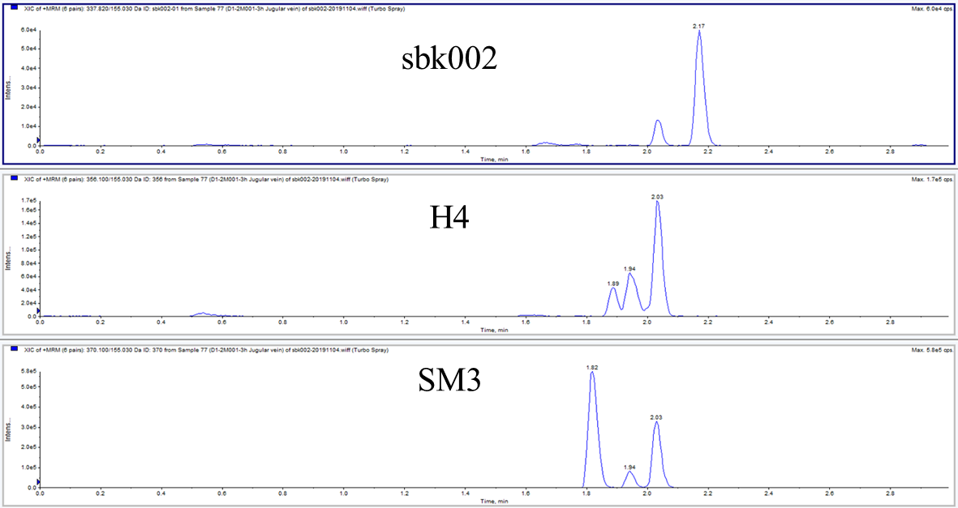
Figure 1-4 clo dose group 2M001 jugular vein plasma sample typical picture
The results showed that:
metabolite H4
(1) After gavaging SD rats with sbk002, metabolism in the portal vein (assessing intestinal metabolism) will generate the metabolic product H4. The quality responses of the portal vein and the jugular vein are comparable, with no significant differences observed;
(2) After gavage administration of clo to SD rats, it is inferred that metabolic product H4 will be produced in the portal vein (suggesting intestinal metabolism), and there is no significant difference between the mass response of the portal vein and the cervical vein;
(3) The mean mass spectrometric response ratio of the metabolite H4 in the portal vein/jugular vein was 0.91 for the sbk002 dose group and 1.16 for the clo group, with no significant difference between the two.
(4) The mean conductivity response of H4 metabolite in the portal vein and jugular vein of the sbk002 group (10 mg/kg) 3 hours after gavage was significantly higher than that of the clo group (30 mg/kg), indicating that the conversion rate of clo to H4 metabolite in the intestine or liver is low, consistent with literature reports.
Metabolite SM3
(1) After gavaging SD rats with sbk002, the metabolism product SM3 is produced in the portal vein (speculated to be metabolized by the gut), with no significant difference in mass spectrometry response between the portal vein and cervical vein;
(2) After gavage dosing with clo in SD rats, the portal vein (hypothesized gastrointestinal metabolism) produces metabolite SM3. The qualitative response comparison between the portal vein and the jugular vein shows no significant difference.
(3) Mean mass spectrum response ratio of SM3 metabolic product in portal vein/cervical vein: The ratio is 0.85 in the sbk002 dose group and 1.12 in the clo group, with no significant difference between the two.
(4) The sbk002 group (10 mg/kg) showed higher mean quality response of the metabolite SM3 in the portal vein and jugular vein 3 hours after gavage compared to the clo group (30 mg/kg), indicating that the conversion rate of clo into the metabolite SM3 in the intestines or liver is low, consistent with literature reports.

Conclusion
Under the conditions of this study, after gavaging rats with dose sbk002 and clo, sbk002, and its metabolites H4 and SM3 could all be measured in the portal vein (predicted intestinal pathway metabolism). There was no significant difference in the mean blood drug concentration ratio of sbk002 portal vein/jugular vein and the mean quantitative signal ratio of metabolites H4 and SM3 in portal vein/jugular vein between the two dosage groups.
Therefore, sbk002 and clo intestinal absorption or metabolism trends are basically consistent. It is inferred that H4 and SM3 are active metabolites and further methylated products of metabolism.

Study Protocol, Deviations, and Amendments
No deviations from the study protocol occurred in this experiment. There were no amendments to the study protocol; see Appendix 2 for the study protocol.

- Data storage
  - Archiving Time and Archives Storage Time
(1) Within 2 weeks after final report signing, the study director ensures all research materials are transferred to the archives room for filing.
(2) If this study is used for registration application, the retention period of its files shall be at least five years after the drug is marketed; if this study is not used for registration application, the retention period of its files shall be at least five years from the date of approval of the test report.
  - Archived Data
Including but not limited to the following:
- Study Director Appointment Letter
- Study Protocol and Protocol Amendments
- Various written documents or reports related to the assay
- Original assay data (including electronic data)
- Final report and related materials
- feed, bedding, drinking water testing report copies; animal room temperature and humidity report, etc.
- Retained test articles
- Other Materials
  - Storage location and storage condition
Storage location: Archives Management Department, Suzhou Huace Biotechnology Co., Ltd.;
Storage condition: routine;
Contact person: Wu Li;
Contact Telephone: 0512-36801688

- Appendixes

Appendix 1: Study Protocol

Appendix 1: Study Protocol

Study Name: Intestinal absorption of SD rats gavaged with sbk002 and clo
assay
Study Number: B2019023-K09-01

