Enter into <http://nkggstds.eng.citrite.net/>

1. Create a project in Projects Tab of Administrator page

Note: Receiver is the testers’ email who want to receive build update notification

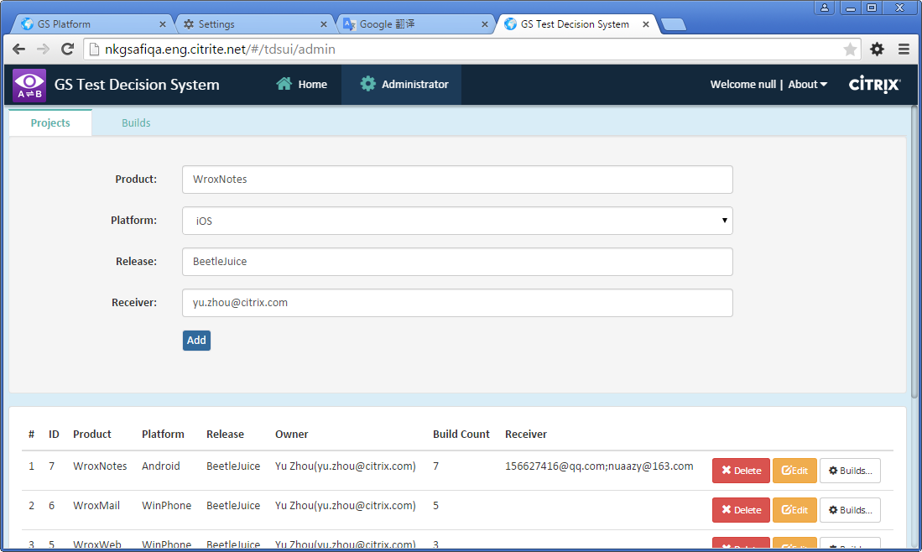

1. After project created, find it in below table, click “Builds …” button to admin its builds

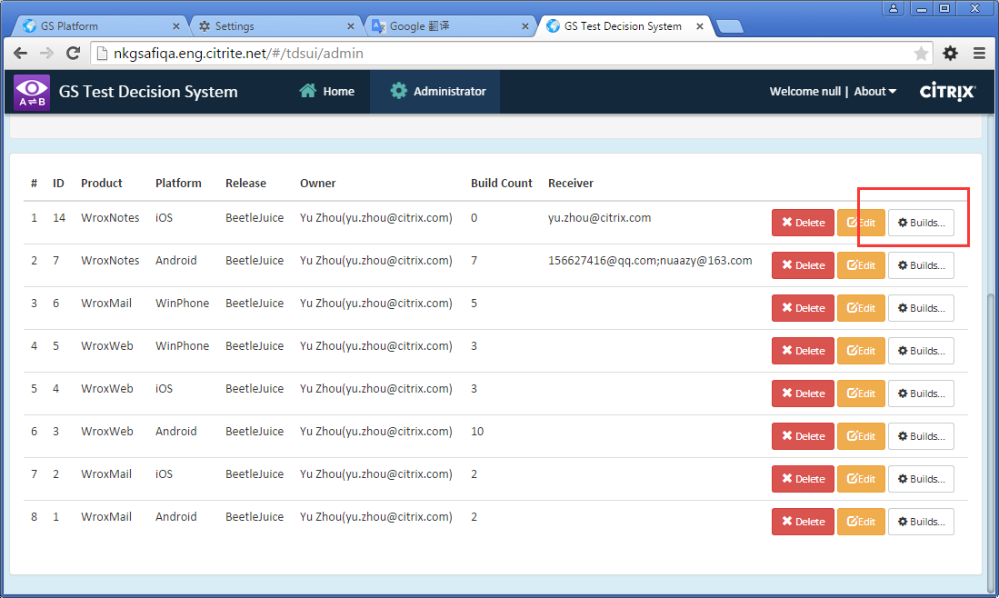

1. In Builds Admin Tab, create a build with its build# and build file

Note: The build uploading need to take several minutes because the build file will be parsed to extract L10N resource strings, please wait withpatience

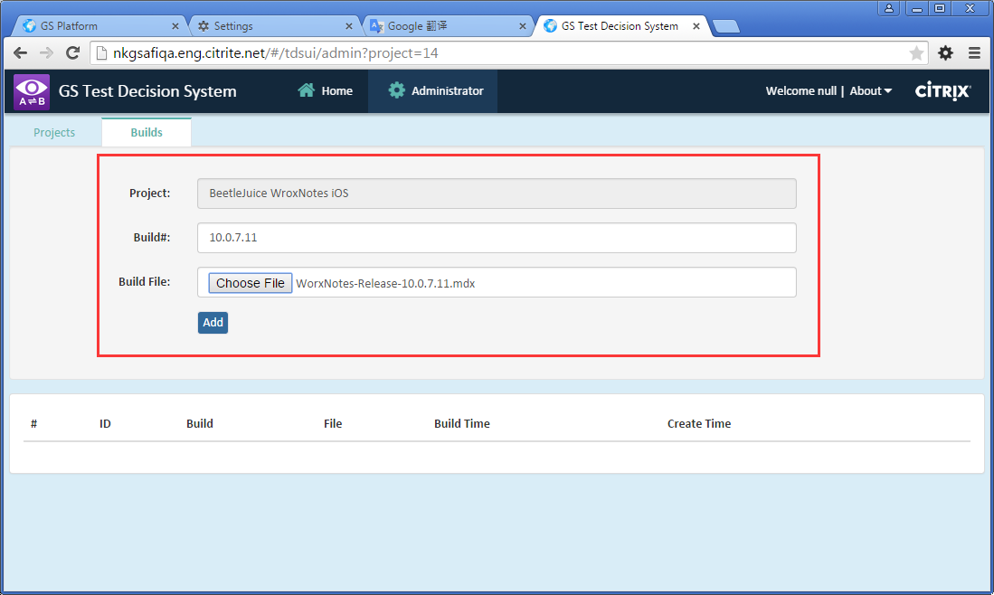

1. After one build is uploaded, it will be compared with last build automatically, and send a mail to project owner and other receivers filled in project setting, which notify user how many keys in latest build are updated.

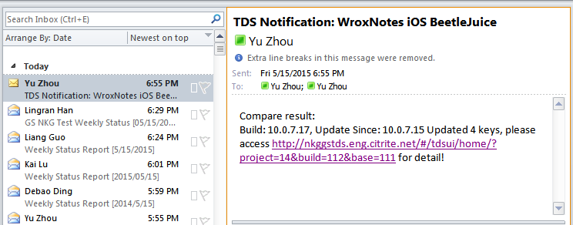

1. Back to Home tab and open build tree list. After select one build you want to check, its L10N resource strings compared with last build will be loaded into grid. You can select elder build to compare from update since list.

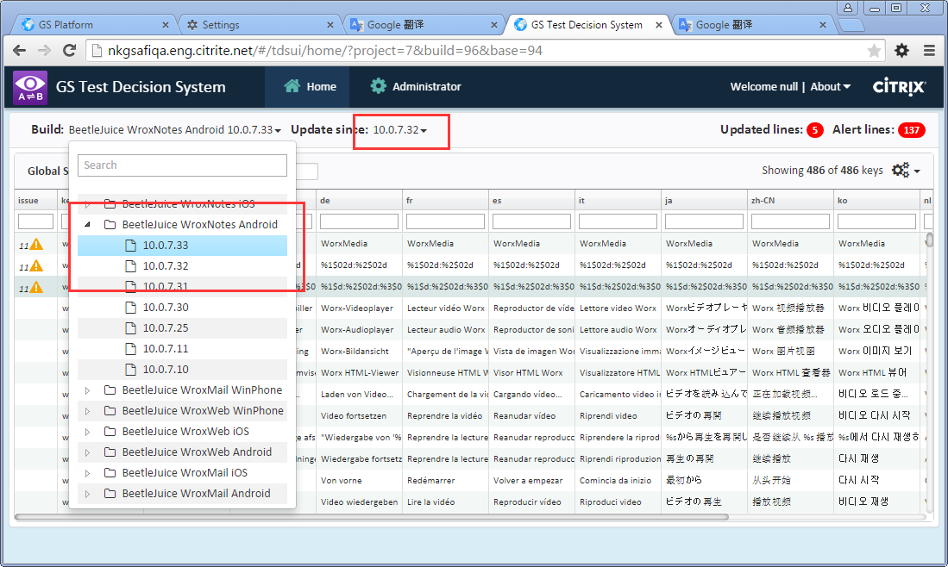

1. The updated line count and line count with l10n issue alerts are marked in the top right corner.

You can filter updated line only from grid setting menu. From the setting menu, you can also toggle grid columns or filter by other options.

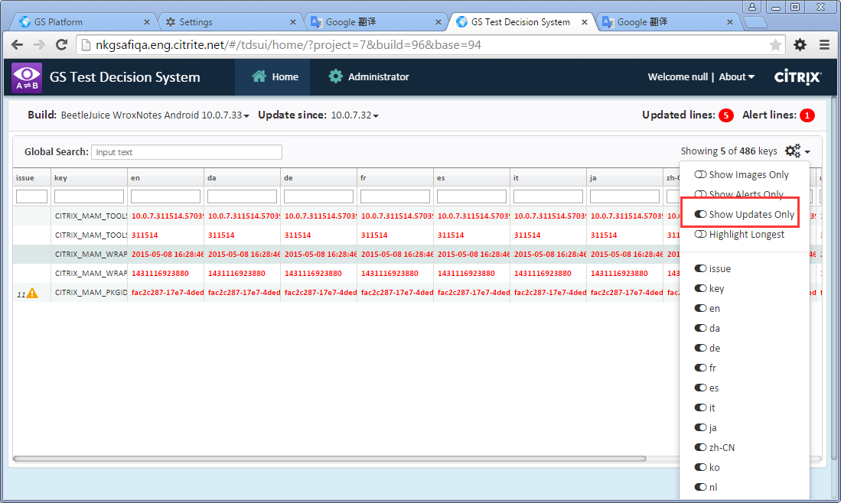

1. By click alert icon in issue column, you can check possible l10n issues detected.

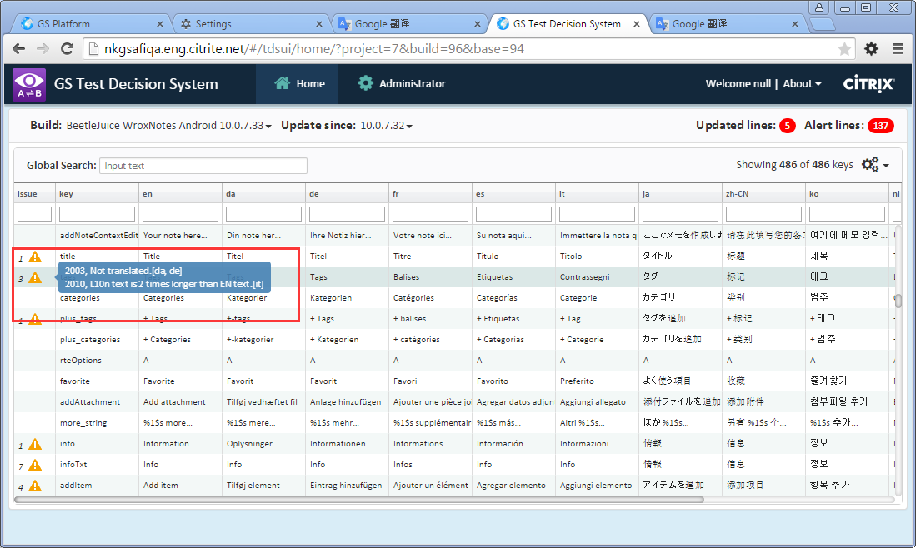

1. The issues could be detected by TDS are listed as below

2001: 'Resource not found.'

2003: 'Not translated.'

2008: 'Incorret count of % .'

2010: 'L10n text is 2 times longer than EN text.'

2011: 'L10n resource has not been updated yet.'