HIVE Cloud

Authenticated Interface Cockpit

STATUS  Proposed |  | OWNER  HIVE Cloud |  | LAST UPDATED  July 16, 2026

Authors | Codex
Reviewers | HIVE Cloud product and engineering owner
Related docs | github.com/yuzuruu29/hive-cloud; Obsidian HIVE Cloud project notes
Scope | Authenticated shell, Chat, Build, provider control, API keys, usage, and beta administration

1. Abstract
This proposal defines the authenticated HIVE Cloud interface as a focused AI operations cockpit. It keeps the existing Next.js routes and backend contracts while consolidating navigation, conversation history, transcript, composer, Build Council progress, and provider evidence into a coherent product shell.
The design supports streaming chat, persisted conversations, file and search context, Build Council jobs, provider configuration, API keys, usage, and beta administration. It does not change routing policy, authentication, storage schemas, or provider execution. The central guarantee is that routing evidence remains visible without exposing prompt content or secrets in operational logs.

2. Goals and Non-Goals
Goals | Non-goals
Create one focused cockpit with a compact global rail and readable work area. | Do not change authenticated route slugs or primary navigation labels.
Attach provider, model, fallback, latency, token, policy, and request evidence to the response. | Do not change HIVE 0.1 routing policy or provider selection logic.
Represent loading, empty, streaming, complete, failure, offline, cancellation, and regeneration states. | Do not replace Auth.js, PostgreSQL, Redis, or existing API schemas.
Support keyboard navigation, 390px mobile layouts, both themes, and reduced motion. | Do not copy 21st.dev components or introduce a second design system.

3. Background and Problem Statement
The prior interface exposed all functional surfaces, but its wide navigation rail, permanent route inspector, narrow history list, uniform borders, and weak message hierarchy fragmented the workspace. The cost was most visible in Chat: routing transparency consumed permanent space while the transcript and composer lacked the hierarchy expected from a premium developer product.
The browser owns presentation and ephemeral interaction state. Next.js enforces the authenticated boundary and proxies cloud calls. The API authenticates the tenant, validates inputs, persists lifecycle records, invokes the HIVE router, and emits response and receipt data. The worker owns bounded Build Council execution. The implementation rule is to evolve the interface around these boundaries without changing route slugs or request contracts.

4. Proposed Architecture

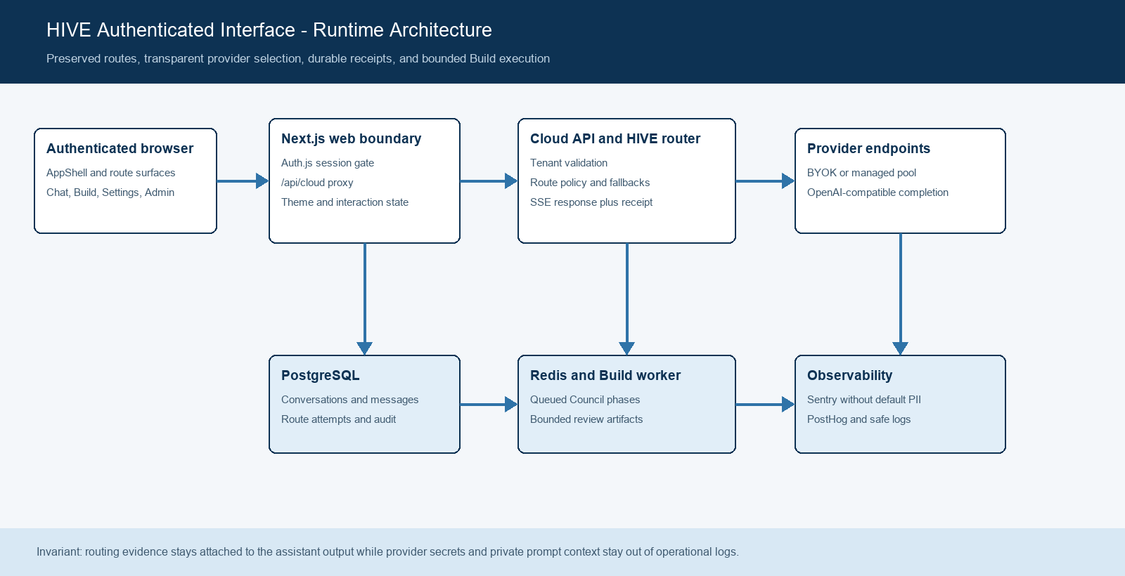
Figure 1. HIVE authenticated interface runtime architecture.

Core components

Component | Responsibility | Primary storage | Failure behavior
AppShell | Authenticated rail, top bar, themes, account access, command navigation, and mobile product drawer. | localStorage for theme; React state | Routes remain usable through direct URLs if transient shell state resets.
ChatSurface | Conversation discovery, optimistic messages, attachments, search context, streaming, receipts, and evidence drawer. | PostgreSQL through cloud API; ephemeral React state | Shows contextual errors, reloads persisted state, and keeps transcript readable offline.
BuildSurface | Queues bounded Council jobs, polls phase status, supports cancellation, and renders artifacts. | Redis queue and PostgreSQL Build records | Stops polling at terminal state and exposes failed reason or cancellation.
Settings surfaces | Provider sovereignty, reveal-once API keys, usage limits, and owner-only beta operations. | Encrypted provider data, API key digests, credit ledger | Fails closed with safe inline errors and never reads secrets back.
Cloud API, router, worker | Validates tenant requests, persists lifecycle state, selects providers, streams output, and runs Build phases. | PostgreSQL, Redis, provider endpoints | Uses bounded attempts, safe errors, cancellation, and audited terminal records.

5. Request Lifecycle
- 1. An authenticated user enters Chat, Build, Settings, or Beta Admin through the shared AppShell. Chat accepts text, optional files, images, and an explicit web-search toggle.
- 2. Next.js requireSubject validates the Auth.js session. The /api/cloud proxy forwards the request with internal subject context so API authorization remains tenant scoped.
- 3. The API loads conversation state, healthy provider connections, managed routing eligibility, quota policy, and any requested Build job state from PostgreSQL and Redis-backed services.
- 4. For Chat, HIVE 0.1 evaluates eligible provider candidates under the free-first-balanced policy. For Build, the worker advances the fixed Council phase sequence and records phase receipts.
- 5. The API persists the conversation message, router request, attempt metadata, and idempotency key before or alongside terminal accounting. Build status and artifacts are stored against the job lifecycle.
- 6. Provider calls use bounded attempts, safe endpoint validation, upstream timeouts, and fallback accounting. Streaming output is forwarded as SSE; cancellation aborts the browser request or queued Build job.
- 7. The UI reconciles persisted conversation state, attaches the final RouteReceipt to the assistant message, updates Build progress, and exposes contextual errors. Safe request IDs, latency, fallback count, and token metadata remain available for inspection.

6. API and Data Contracts

Primary data contract

Field | Type | Required | Description
model | string | Yes | The browser sends hive-0.1; the router selects the concrete provider model.
messages | array | Yes | OpenAI-compatible message content; attachment context may be text or image parts.
hive.display_content | string | Yes for UI chat | User-visible prompt persisted without private attachment context.
x-hive-conversation-id | UUID header | For persisted chat | Associates input, output, citations, and receipts with one tenant conversation.
idempotency-key | string header | Yes | Unique per send; protects router request and managed-credit accounting.
RouteReceipt | SSE event and headers | Yes on routed output | Request, provider, model, policy, fallbacks, latency, attempts, and optional usage.
BuildState | JSON object | For Build | Queued through terminal status with active phase, completed count, results, and safe failure reason.

Contract guarantees

- A conversation identifier is established before persisted chat output is associated with a thread. The UI may optimistically render, but the API remains the durable source of truth.
- Each chat send uses a fresh idempotency-key. Router requests and credit-ledger changes use unique tenant-scoped keys so retries cannot debit the same managed completion twice.
- The request ID, route policy, provider, model, fallback count, attempt outcome, latency, and reported usage are captured for audit. Build phases retain their provider and model receipt where available.
- The RouteReceipt explains execution metadata. It is not a source of truth for provider credentials, private prompt context, or billing beyond the durable ledger and request records.
The versioned implementation contracts are maintained in
packages/contracts/src/index.ts, apps/api/src/app.ts, and packages/database/src/schema.ts. Update interface rendering when those contracts change.

7. Consistency, Idempotency, and Replay

Client state may be optimistic during streaming, but persisted conversations are reloaded after completion, cancellation, or failure. A repeated idempotency key resolves against the stable router request and credit mutation boundary. Duplicate UI actions may repeat harmless reads, while provider output and managed credit debits require unique request identity. A route receipt remains bound to the assistant message that produced it, even when the detail drawer is closed.
Scenario | Expected behavior | Reasoning
Repeated send with the same idempotency key | Return or reconcile against the stable request boundary; do not debit twice. | Tenant-scoped uniqueness protects request and credit records.
Conversation persistence write fails | Return a safe error and avoid claiming durable completion. | The persisted transcript remains the source of truth after reconciliation.
Provider timeout or stream failure | Use bounded fallback before output; emit a terminal stream error after output begins. | Attempt records preserve explainability without inventing a successful response.
Provider or policy changes mid-request | The captured request receipt remains authoritative for that execution. | The transcript explains the route that actually ran, not current configuration.

8. Security and Privacy Considerations

- Authentication uses the existing Auth.js database session. Every authenticated route calls requireSubject, and API operations use tenant and user subject context. Beta Admin retains its owner-email and role gate.
- The interface sends only the requested prompt and selected attachment context. Display content excludes private file context from persisted user-visible text. Operational logs omit prompt content and provider secrets.
- Provider credentials are encrypted at rest and never returned to the browser. API keys are reveal-once values; only their digest and prefix remain available after creation.
- Custom provider URLs fail closed for private, local, metadata, embedded-credential, redirect, or non-HTTPS targets. Administrative credit changes require an audit reason and unique idempotency key.
- Conversation deletion, archival behavior, attachment retention, route-attempt retention, and analytics consent remain governed by the existing backend and deployment policy. Sentry is configured without default PII.

9. Operational Readiness
Signal | SLO or alert | Owner | Launch gate
Authenticated route availability | All six primary surfaces load without safe-error regressions | Web and API | Required
Chat start and streaming | Successful start, visible streaming state, terminal receipt, no stuck composer | Web, API, router | Required
Fallback and upstream failure | Fallback count and safe failure are visible; no duplicate managed debit | API and router | Required
Responsive and theme parity | No horizontal overflow at 390px; dark and light maintain hierarchy | Web | Required
Error and telemetry safety | No prompt, secret, callback credential, or default PII in operational logs | Web, API, worker | Required
Rollout constraint: verify typecheck, tests, production build, authenticated desktop and 390px mobile flows, theme parity, reduced motion, and rollback through the prior frontend commit before expanding the beta audience.

10. Alternatives Considered

Alternative | Why it was considered | Why it was not selected
Keep four persistent columns | All metadata remains visible without interaction. | It permanently taxes transcript width and makes the product feel fragmented.
Adopt 21st.dev Agent Elements directly | It provides mature chat and agent primitives. | It would add shadcn and a second visual system, change message contracts, and weaken HIVE identity.
Remove routing evidence from Chat | The transcript becomes visually simpler. | It removes HIVE's core premium differentiator and provider-sovereignty story.
Full backend and IA rewrite | A unified protocol could simplify future feature work. | It adds migration and auth risk without being required for the interface outcome.

11. Open Questions
- Should conversation history add server-side search or virtualization before the current 100-conversation API limit becomes a product constraint?
- Should offline composer drafts persist locally, or should offline mode remain read-only to avoid retaining prompt content on the device?
- Which RouteReceipt fields should remain permanently visible in the transcript versus available only in the evidence drawer?
- Should the command menu emit navigation analytics, and if so, which events are necessary without recording user queries?

12. Decision and Next Steps
Adopt the compact cockpit shell and contextual routing-evidence model while preserving all authenticated routes and backend contracts. The first milestone is the shared shell and Chat redesign, followed by Build and settings polish, automated verification, and limited beta observation. Broader rollout requires stable streaming, drawer and mobile behavior, theme parity, no accessibility regression, and no increase in safe-error or authentication failures.
Milestone | Deliverable | Exit criteria
M1 | Compact shell, Chat hierarchy, composer, contextual receipts, drawers, and state feedback | Typecheck passes and authenticated desktop plus mobile geometry are verified
M2 | Build and settings polish, loading states, accessibility review, and regression coverage | Tests and production build pass with no route or contract change
M3 | Limited owner and beta-user rollout | Stable streaming and safe errors with no high-severity accessibility or auth issue
M4 | Broader authenticated rollout | Operational gates hold, rollback is tested, and owner approval is recorded

Use footnotes for definitions, assumptions, or terms that need precision without interrupting the main narrative.

