XI’AN JIAOTONG-LIVERPOOL UNIVERSITY
西 交 利 物 浦 大 学
COURSEWORK SUBMISSION COVER SHEET
Name | Ying Huang | Student Number | 2253303
Name | Xingjian Lu | Student Number | 2251737
Name | Wangyu Li | Student Number | 2252341
Name | Yidi Tang | Student Number | 2252681
Name | Jingwei Liu | Student Number | 2253336
Name | Tianyu Zhou | Student Number | 2252665
Programme | Accounting
Module Title | Corporate Reporting, Analysis
Module Code | ACC302
Assignment Title | Financial and ESG Risk Analysis of Volkswagen, BMW and Toyota
Submission Deadline | Sunday, 3 May 2026, 23:59
Module Leader | Zhiying Huang

By uploading or submitting this coursework submission cover sheet, I certify the following:
- I have read and understood the definitions of collusion, copying, plagiarism, dishonest use of data, and academic offences involving Artificial Intelligence (AI) as outlined in the Academic Integrity Policy of Xi’an Jiaotong-Liverpool University.
- This work is my own, original work produced specifically for this assignment. It does not misrepresent the work of another person or institution, nor does it present the work generated by AI as my own. Additionally, it is a submission that has not been previously published, or submitted to another module.
- This work is not the product of unauthorized collaboration between myself and others.
- This work is free of embellished or fabricated data.

I understand that collusion, copying, plagiarism, dishonest use of data, academic offences involving AI, and submitting procured work are serious academic misconduct. By uploading or submitting this cover sheet, I acknowledge that I am subject to disciplinary action if I am found to have committed such acts.

Signature ………Ying Huang………… Date …………2026/5/3………………………

Signature ………Xingjian Lu………… Date …………2026/5/3………………………

Signature ………Wangyu Li………… Date …………2026/5/3………………………

Signature ………Yidi Tang…………… Date …………2026/5/3………………………

Signature ………Jingwei Liu………… Date …………2026/5/3………………………

Signature ………Tianyu Zhou……… Date …………2026/5/3………………………

For  Academic  Office use: | Date Received | Working Days Late | Penalty

ACC302 - Group Report
Peer Review of Individual Contribution

You are required to evaluate the effort that was put into the group report by all the group members.This form should be completed in consultation with all group members and should add up to 100%.
 | Student Name | % of Contribution | Remarks (if any)
1. | Ying Huang | 16.67 | Q1+Q3+Q6
2. | Xingjian Lu | 16.67 | Q1+Q3+Q5
3. | Wangyu Li | 16.67 | Q2+Q3
4. | Yidi Tang | 16.67 | Q2+Q3
5. | Jingwei Liu | 16.67 | Q3+Q4+Q6
6. | Tianyu Zhou | 16.67 | Q3+Q4
 | Total | 100 | Total
Notes:
- Each group should only submit one (1) form.
- There are 5-6 people in your group. Obviously you may split the % equally if you all feel that everyone contributed equally to the group report.
- Please copy and paste the form and incorporate it in your group report and submit the report, together with this form and a cover page (copy also on ICE), as one single file.
- I would expect students to come to me in confidence if there were any issues of engagement and participation of any group members in the very first instance when a problem arose. The earlier you came to me the better it would be as I could try to help, advise and intervene if necessary as early as possible.

Signed: ___Ying Huang_____ ___Xingjian Lu______ ____Wangyu Li_____
____Yidi Tang_____ ___Jingwei Liu______ ____Tianyu Zhou____
Date: ___2026/5/3_______
Table of Contents
1. Industrial-level Overview 4
1.1 Challenge 4
1.2 Industry Risk Map 5
1.3 Automotive-specific IFRS S1/S2 Disclosure Checklist 6
2. Financial Ratio Diagnosis 8
2.1 Operating margin 8
2.2 ROCE 8
2.3 Debt-to-equity ratio 9
2.4 Asset turnover ratio 9
2.5 Capital Expenditure to Revenue Ratio 10
2.6 Account Receivable Collection Days 11
2.7 Overall diagnosis 11
3. Value Chain with a Risk Map, Materiality Assessment 12
3.1 Battery/Critical minerals 12
3.2 Steel/Aluminium 12
3.3 Logistics and supply chain resilience 13
3.4 Manufacturing energy use 13
3.5 Use-phase emissions 13
3.6 End-of-life recycling 13
3.7 Materiality statement 14
4. Consistency and Greenwashing Risk 15
4.1 Volkswagen Group 15
4.2 BMW Group 15
4.3 Toyota 16
4.4 Overall assessment 16
5. Summary of financial and ESG findings and further implications 17
References 18
Appendix 22

Industrial-level Overview
The auto industry faces three major forces: electrification, carbon neutrality and sustainability disclosure requirements. According to IPCC (2022), transport accounts for approximately 20% of global CO₂ emissions. From 2025, the EU requires new cars to emit ≤95g CO₂/km (European Hydrogen Observatory, 2025).

Challenge
Four core challenges exist:

1. EV battery production emits 1.5-2.0 times more CO₂ than petrol cars, raising manufacturing emissions.
2. Scope 3 emissions (use-phase and supply chain) exceed 90% of total emissions for most automakers.
3. Green trade barriers like CBAM and the Critical Raw Materials Act impose new compliance costs.
4. Physical climate events and product responsibility risks may disrupt production and increase warranty litigation and operational costs.

The first challenge raises carbon costs under EU ETS and CBAM, adding hundreds of euros per electric car (Voltbahn Editor, 2026). This increases cost of sales, compressing gross margin and operating margin. For investors, this means lower profitability and reduced EPS, directly lowering stock returns.
The second challenge poses a more severe threat to profitability: use-phase emissions may trigger €95/g/km fines (European Commission, n.d.), directly reducing net profit margin and EPS. Supply chain emissions cause CBAM charges on imported parts, meanwhile Scope 3 transparency of automobile industry also lowers ESG ratings (Graf-Vlachy and Hettler, 2024), raising the cost of debt and increasing WACC, which reduces equity valuation. Investors should be aware since higher WACC lowers the PV of future cash flows, affecting share prices.
The third challenge adds CBAM costs and creates asset impairment risk for overseas plants (Wang, 2026). Non-compliance with local content rules may create liabilities, increasing costs and worsening leverage ratios. These risks may worsen leverage ratios and affect margins, ROE and cost of capital.
The fourth challenge affects operational resilience and liability exposure. Physical climate events and product responsibility risks may disrupt production, damage assets and increase recall, warranty, litigation and cybersecurity-related costs. These effects may reduce cash flows, increase provisions and damage reputation.

1.2 Industry Risk Map
In line with IFRS S1/S2’s focus on financially material sustainability information, Table 1 develops the four core challenges into an industry risk map for Volkswagen, BMW and Toyota.

Table 1: Risk map
Risk area | Financial impact | Disclosure evidence
EV battery production and manufacturing emissions | Higher energy and carbon costs; cleaner production investment. | Scope 1 and 2 emissions, energy intensity, renewable electricity use.
Scope 3 and product-use emissions | Higher R&D and Capex, regulatory penalties, revenue mix changes, ICE impairment risk and higher WACC. | Scope 3 use-phase emissions, fleet CO₂, EV / hybrid / ICE sales mix.
Green trade barriers and critical material compliance | Raw material volatility, supply disruption, procurement costs and reputational risk. | Battery sourcing policy, supplier due diligence, mineral traceability.
Physical climate and product responsibility risks | Production delays, asset damage, recall costs, warranty provisions, litigation and cybersecurity exposure. | Scenario analysis, site-level risk assessment, recall data, product safety and cybersecurity controls.

1.3 Automotive-specific IFRS S1/S2 Disclosure Checklist
Based on the industry risk map above, Table 2 adapts the IFRS S1/S2 disclosure logic to the automotive sector. It focuses on governance, strategy, risk management, and metrics and targets, while covering industry-specific issues such as Scope 3 use-phase emissions, EV transition, battery sourcing, manufacturing emissions, recycling and product safety.

Table 2 : Automotive-specific IFRS S1/S2 Disclosure Checklist

IFRS S1/S2 area | Automotive-specific focus | Investor relevance
Governance | Board oversight of climate transition, emissions, supply-chain risks, product responsibility and reporting controls. | Shows whether sustainability risks are controlled at decision-making level.
Strategy | Impact of EV transition, hybrid strategy, ICE phase-down, battery sourcing and hydrogen development on revenue mix, production capacity, R&D and Capex plans. | Helps assess revenue mix, capital needs and competitiveness.
Risk management | Processes for identifying and managing transition, supply-chain, product safety, cybersecurity and physical climate risks across production, suppliers and vehicle use. | Helps investors assess whether key risks are monitored, controlled and linked to financial planning, provisions and operational resilience.
Metrics and targets | Scope 1, 2 and 3 emissions, use-phase emissions, EV share, fleet CO₂, energy use, recycling data, baselines and calculation methods. | Shows whether targets are measurable, comparable and supported by evidence.
Financial effects and data quality | Link to Capex, R&D, impairment, provisions, liabilities, WACC, assumptions and assurance. | Shows whether disclosure is decision-useful, traceable and auditable.

Financial Ratio Diagnosis

2.1 Operating margin
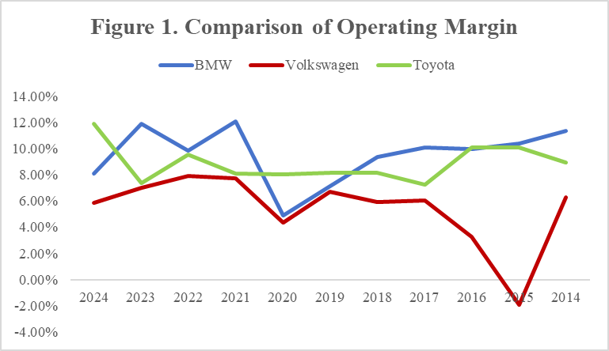
Figure 1. Comparison of Operating Margin

Volkswagen’s operating margin has declined from 7.92% in 2022 to 5.87% in 2024 (Volkswagen Group, 2025), significantly lower than Toyota (11.87% in 2024) and BMW (8.08% in 2024). High transition costs towards electric vehicle production could have contributed to margin pressure. IEA's report on global EV also points out that the rising prices of critical raw minerals and supply chain instability are increasing production costs, which further put pressure on operating margins (IEA, 2025). To address these challenges, Volkswagen and BMW need to engage their operations departments to focus on improving production efficiency. Using Toyota Production System as a benchmark, Volkswagen and BMW may reduce waste and improve EV production efficiency (Toyota Motor Corporation, 2026).

2.2 ROCE
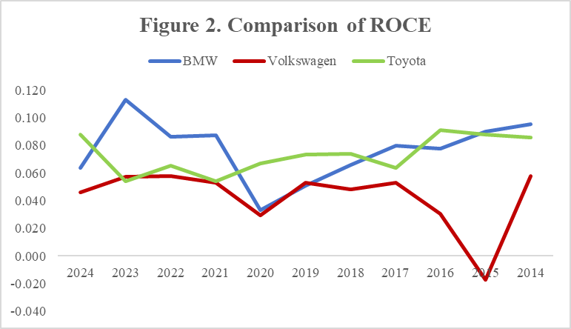
Figure 2. Comparison of ROCE

Volkswagen’s ROCE has declined from 0.078 in 2022 to 0.046 in 2024, and consistently below both Toyota (0.088 in 2024) and BMW (0.064 in 2024). Substantial capitalized investments in electric vehicle production and product updates may lead to this decline. For example, Volkswagen's automotive department’s R&D expenditure totalled approximately €21.0 billion, with 48.8% capitalized for future model and platform development (Volkswagen Group, 2025) . These long-term investments do not generate immediate profits to support the growth of ROCE. The three companies should engage finance and manufacturing teams to improve capital allocation, asset efficiency and production technologies such as gigacasting, which may reduce manufacturing costs (Huang, 2022).

2.3 Debt-to-equity ratio
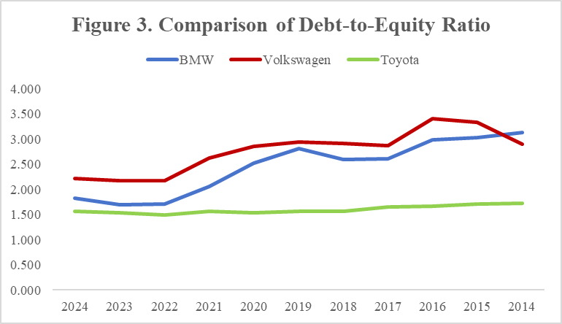
Figure 3. Comparison of Debt-to-Equity Ratio

Volkswagen’s Debt-to-Equity Ratio has remained high among its peer firms, reaching 2.217 in 2024 while Toyota's figure stays around 1.500 and BMW's reaching 1.818 in 2024. In this capital-intensive industry, debt financing supports large-scale investment in EV production, R&D and infrastructure (Volkswagen Group, 2025). While this allows Volkswagen to fund its transition to electric vehicles, it also increases financial leverage and exposes the company to higher financial risk. To manage this risk, the three companies’ treasury departments should review debt maturity, funding mix and refinancing exposure, while Volkswagen should emphasise leverage control given its higher ratio (Treasury Today, 2020).

2.4 Asset turnover ratio

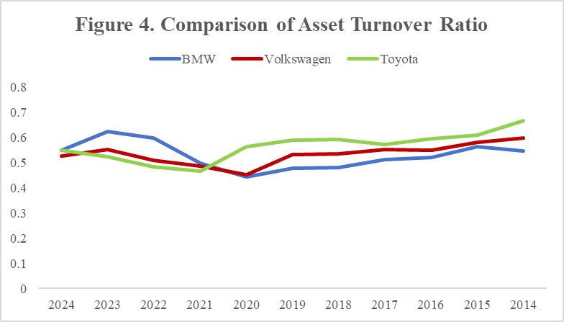
Figure 4. Comparison of Asset Turnover Ratio

Across 2014 to 2024, BMW’s asset turnover stayed near 0.55, while Toyota’s fell from 0.67 to 0.55 and Volkswagen’s from 0.60 to 0.53. The decline may reflect transition-related investment, as EV platforms, battery facilities and new technologies expand the asset base before related revenue is fully realised. However, the trend should not be read simply as operating inefficiency, as differences in R&D capitalisation, production disruptions and asset utilisation may affect comparability across the three companies. Finance, operations and R&D teams should review asset utilisation, production ramp-up and project-level returns, consistent with capital allocation guidance on strategic budgeting, project selection and investment governance (BCG, 2023; McKinsey & Company, 2022).

2.5 Capital Expenditure to Revenue Ratio
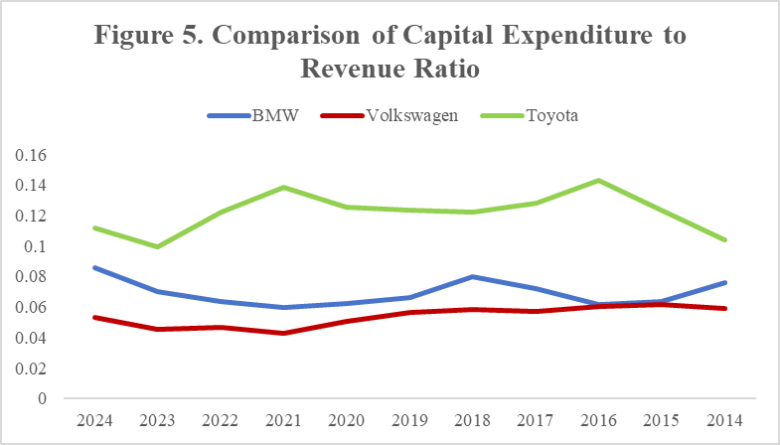
Figure 5. Comparison of Capital Expenditure to Revenue Ratio

Capital expenditure to revenue shows different transition-investment profiles in 2024: Toyota reached 11.2%, BMW 8.6%, and Volkswagen 5.3%. Toyota’s higher ratio suggests stronger investment intensity. However, as its asset turnover is falling, the company needs to pay closer attention to whether each major project can generate reasonable returns. Volkswagen’s lower ratio does not necessarily mean under-investment, but clearer disclosure of growth and maintenance Capex would help investors judge whether its spending is enough for the EV transition. BMW appears more balanced but should still monitor Capex returns. Finance teams should work with R&D and investor relations to connect Capex plans with budgeting, project selection and investment review, so that transition spending can be assessed against strategic relevance and expected returns (BCG, 2023; McKinsey & Company, 2022).

2.6 Account Receivable Collection Days
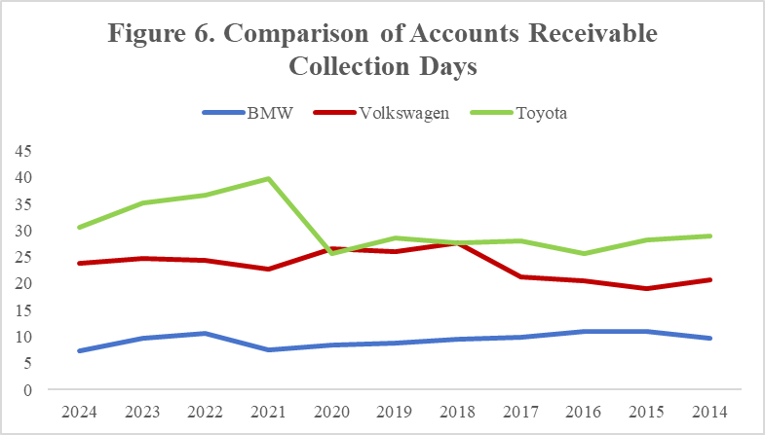
Figure 6. Comparison of Accounts Receivable Collection Days

Receivable collection days reveal different levels of working-capital efficiency across the three companies. BMW improved from 9.8 days to 7.3 days, which suggests better dealer payment discipline and credit control. Volkswagen stayed relatively stable at about 24 days. By contrast, Toyota’s collection period increased from 29 days to 31 days, pointing to slower cash conversion, possibly linked to post-pandemic dealer support and longer credit terms. Since DSO shows how quickly a company collects cash from customers and affects liquidity, regular receivables review is still necessary (PwC, 2024). Toyota should strengthen credit-term control and ageing-report checks, while BMW and Volkswagen should continue monitoring receivables as EV sales and financing models change.

2.7 Overall diagnosis
Taken together, the ratio analysis points to four main concerns: Volkswagen’s weaker margin and ROCE, its higher leverage, Toyota’s high Capex-to-revenue ratio with declining asset turnover, and Toyota’s longer receivable collection period. These issues show that ratio movements should not be viewed as isolated accounting results. Finance teams need to work with operations, treasury, R&D, investor relations and sales finance teams to convert these findings into practical actions on cost control, capital allocation, funding management and working-capital improvement.

Value Chain with a Risk Map, Materiality Assessment
This section maps the main ESG risk hotspots across the automotive value chain for Volkswagen, BMW and Toyota, from raw materials to vehicle use and recycling. Figure 7 summarises these hotspots and their related KPIs.

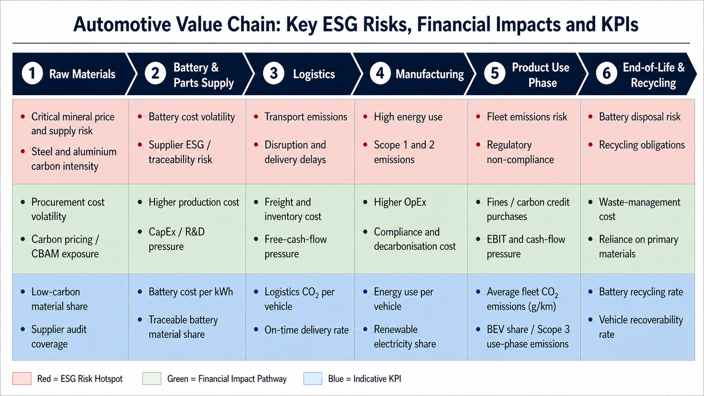
Figure 7. Automotive Value Chain: Key ESG Risks, Financial Impacts and KPIs

3.1 Battery/Critical minerals
The automotive value chain for electric vehicles relies heavily on batteries and critical minerals such as lithium, cobalt and nickel, as these materials are essential for battery production and vehicle electrification. For investors, this issue is financially material because mineral price volatility and supply disruptions can directly affect production costs and profitability. Tesla’s 2025 10-K notes that critical mineral prices are exposed to market volatility. At the same time, Home (2024) shows that battery prices continued to fall from 2023 to 2024, which may create inventory write-down risks for earlier high-cost contracts. To manage supply risks, EV firms may also need long-term supplier agreements, increasing future cash outflows (Tesla, 2025; Home, 2024; BMW Group, 2024).

3.2 Steel/Aluminium
The use of steel and aluminium contributes to a large proportion of an EV’s carbon footprint. Every ton of steel emits 18.9-27.8g CO2/km and aluminium up to 33.1gCO2/km (Li, Zhu and Ding, 2025), making both highly exposed to carbon pricing. With EU ETS prices forecast to reach €122/t by 2030 (BloombergNEF, 2025), embedded carbon costs will rise sharply. Moreover, CBAM plans to expand coverage across the full value chain (Climease, 2025), meaning carmakers may face direct carbon charges on imported components and eventually finished vehicles. Investors should pay more attention to carmakers using green steel/aluminium and localised supply, as such manufacturers will better manage cost of sales and avoid contingent liabilities, while those relying on high-emission imports may face margin compression.

3.3 Logistics and supply chain resilience
For Volkswagen, BMW and Toyota, resilient logistics and supply chains are financially material because they support production continuity, cost control and regulatory compliance. BMW plans to increase BEV deliveries to 26.1% by 2025 while improving production energy efficiency (BMW Group, 2025). Volkswagen also aims to raise electrified vehicle deliveries while managing Scope 1 and Scope 2 emissions (Volkswagen Group, 2025). Toyota focuses on resource efficiency and supplier collaboration to manage battery materials and critical minerals (Toyota Motor Corporation, 2025b). Secure logistics and supply chains therefore help reduce disruption risks and support long-term shareholder value.

3.4 Manufacturing energy use
Manufacturing energy use is financially material because decarbonising production can affect operating costs, Capex and exposure to carbon regulation (Volkswagen Group, 2025; BMW Group, 2025; Toyota Motor Corporation, 2025b). Volkswagen aims to achieve annual energy savings of 4.9 million MWh by 2030 and had reached 3.5 million MWh by 2024, with 94% of production-site electricity sourced from external renewables (Volkswagen Group, 2025). BMW targets a 25% reduction in energy use per vehicle by 2030, while Toyota aims for carbon neutrality across global manufacturing plants by 2035 (BMW Group, 2025; Toyota Motor Corporation, 2025b). These targets matter to investors because they influence cost efficiency, investment needs and regulatory risk.

3.5 Use-phase emissions
Stricter emission rules have made use-phase emissions a more important financial concern for Volkswagen, BMW and Toyota. Carmakers with higher average fleet emissions may face extra compliance costs, such as fines, carbon credit purchases or pooling arrangements. These costs could reduce EBIT and free cash flow, and may also push companies to invest more in EV development, battery technology and charging infrastructure. BMW appears to be in a stronger position because of its higher BEV share and lower fleet emissions. By comparison, Volkswagen and Toyota may face higher transition costs if their EV sales mix improves more slowly.

3.6 End-of-life recycling
End-of-life recycling is financially material for Volkswagen, BMW and Toyota because vehicles and EV batteries contain valuable metals and critical materials. As EV production grows, weak collection, dismantling and battery recycling could raise compliance and waste-management costs, increase reliance on primary materials, and expose firms to raw material price volatility. Unclear recovery rates or recycled-content data may also weaken circular economy claims. For investors, effective recycling supports supply-chain resilience and long-term cost control. Key KPIs include vehicle recoverability rate, battery recycling rate and recycled material input.

3.7 Materiality statement
Overall, these ESG issues are financially material because they affect procurement costs, operating expenses, Capex, provisions, free cash flow and long-term value. Battery minerals, steel and aluminium mainly influence supply costs and production continuity, while manufacturing, logistics and use-phase emissions affect operational resilience and regulatory exposure. Recycling adds further risks through compliance costs and dependence on primary materials, so investors should assess these areas using the KPIs in Figure 7.

Consistency and Greenwashing Risk
Narratives of sustainability transition can only be credible when they are backed by observable investment decisions, operational planning and verifiable reporting controls. In the case of automotive companies, the electrification, carbon reduction and clean mobility claims should be evaluated against Capex, R&D, capacity planning and evidence quality. This section discusses Volkswagen, BMW and Toyota using selected greenwashing cases and assesses whether their claims are clearly defined, financially consistent and auditable.

4.1 Volkswagen Group
The Dieselgate scandal of Volkswagen Group represents a say-do gap and compliance-control risk in environmental disclosure. The defeat devices showed an imbalance between environmental assertions and operational management, which resulted in direct financial impacts. In 2016 and 2017, Volkswagen reported special charges of €7.52 billion and €3.22 billion respectively, predominantly relating to settlements with the US authorities and compensation to its affected customers (Volkswagen AG, 2017a; Volkswagen AG, 2017b). It also agreed to pay up to $14.7 billion in order to settle the claims of emissions in the United States (CCTV, 2016). This demonstrates that a low degree of assurance over environmental assertions may have an impact on provisions, litigation exposure, cash outflows and investor confidence.

It also extended to operations: in 2017, Volkswagen incurred an extra €2.8 billion special expense for Tiguan and Golf recalls, demonstrating greater operational and reputational risks in a complex manufacturing network (Volkswagen AG, 2017b). Volkswagen has responded to this through internal reforms, such as the Special Committee on Diesel Engines, compliance training and internal-control improvements (Volkswagen AG, 2017a; Volkswagen AG, 2017b). To minimize the risk in the future, it should maintain the independent emissions testing, enhance the whistleblowing provisions, and the responsibility of reviewing the emissions-related claims.

4.2 BMW Group
The decision of the UK Advertising Standards Authority on the advertisement of BMW on their “Zero Emissions Cars” emphasizes claim-boundary greenwashing risk. The ASA concluded that the wording might have an implication of zero emissions more generally, although the manufacturing process, charging, and the wider lifecycle may still contribute to emissions (ASA, 2024). This suggests claim-boundary risk, as opposed to an extensive say-do gap.

The report issued by BMW continue to favour its electrification story. From 2023 to 2025, the share of all-electric cars in deliveries increased from 14.7% to 17.4% and then 17.9%, while BEV deliveries rose from 375,716 to 426,536 and 442,059 units. Nonetheless, financial pressure is also evident: Automotive EBIT margin decreased from 9.8% to 6.3% and then 5.3%, while Automotive free cash flow dropped from €6.942 billion to €4.852 billion and €3.240 billion, respectively (BMW Group, 2024, 2025, 2026). Thus, ambiguous wording of zero emissions can undermine investor confidence when transition costs are already having a significant impact on margins and cash flow.

BMW should therefore define such claims as “battery electric vehicles with zero tailpipe emissions during driving, while lifecycle emissions depend on electricity mix, battery production and supply-chain inputs.” Legal, sustainability, finance and IR teams should approve these claim boundaries before public communication.

4.3 Toyota
The complaint to the Australian Competition and Consumer Commission by Greenpeace Australia Pacific poses selective-disclosure risk for Toyota. The complaint argued that the public messaging of Toyota might give the impression that the company was on the leadership of the clean-car transition, while its product strategy was still highly dependent on hybrids and internal-combustion-related technology (Greenpeace Australia Pacific, 2023). This creates risk in the way Toyota’s multi-pathway approach is introduced and supported.

The reports by Toyota demonstrate why this risk is financially relevant. The company announced that the sales of BEV base-unit would total 1.5 million units in 2026 and 3.5 million units in 2030, but stated that sales would be flexible based on customer demand (Toyota Motor Corporation, 2024). Automotive operating income grew to ¥4,621.4 billion in FY2024 but declined to ¥3,940.2 billion in FY2025, although automotive revenue grew to ¥43,199.8 billion (Toyota Motor Corporation, 2024; Toyota Motor Corporation, 2025a). This implies that investors require more convincing information on whether the multi-pathway approach can cushion margins amid tightening emissions regulation.

General terms such as electrified vehicles can decrease the disclosure level since HEVs, PHEVs, BEVs and FCEVs have diverse emissions profiles, regulatory risks and capital needs. Toyota ought to isolate these groups and align each of the pathway to Capex, R&D allocation, regional milestones and emissions impact. Legal, sustainability, finance and IR teams are also advised to check consistency between public claims, lobbying positions and investment plans.

4.4 Overall assessment
In general, the three cases show different types of disclosure and control risk, rather than the same level of inconsistency. Volkswagen reflects a serious say-do gap and compliance-control failure. BMW mainly faces claim-boundary risk in lifecycle-emissions wording, while Toyota faces selective-disclosure risk in presenting its multi-pathway strategy. Therefore, disclosure quality depends on clear claim boundaries, reliable evidence and assigned review responsibility. Companies also need to show that Capex, R&D and capacity planning are consistent with their public transition claims.

Summary of financial and ESG findings and further implications
In addressing the key financial ratios, the pressure experienced by Volkswagen is the most evident: its operating margin dropped to 5.87% in 2024, ROCE to 0.046, and its debt-to-equity ratio reached 2.217, the highest of the three companies. This represents EV transition costs, capitalised spending on research and development, and investment financed by debt. Toyota remains relatively strong in profitability, but declining asset turnover and increasing receivable collection days, reflect pressure on capital efficiency and cash conversion. BMW has better receivables management and comparatively stable asset turnover, but its EBIT margin has been squeezed by spending on electrification.

In ESG and materiality terms, the Scope 3 use-phase emissions remain the most financially material issue since they influences compliance costs, Capex allocation, free cash flow and WACC. Relatively high fleet emissions at Volkswagen potentially expose the company to EU CO₂ penalties, low BEV share at Toyota may increase reliance on credits or pooling arrangements, and BMW’s stronger BEV progress may lower compliance pressure. Battery minerals, steel/aluminium carbon costs and end-of-life recycling also influence cost of sales, procurement resilience, Capex and long-term value. The risk of greenwashing also vary: Volkswagen reflects a historical say-do gap and compliance-control risk, BMW faces claim-boundary risk in its “zero emissions” wording, and Toyota faces selective-disclosure risk in its multi-pathway strategy.

For investors, the findings imply that financial models should include Scope 3 emissions, carbon compliance costs, transition Capex and working-capital pressure, instead of just using traditional profitability ratios. The leverage and ROCE of Volkswagen, the asset efficiency and the trend in receivables of Toyota, and whether the Capex and R&D allocation of each of the companies supports the transition narrative should be given particular attention.

For regulators, the analysis shows a need to strengthen the financial materiality linkage to IFRS S1/S2, ensure a clearer separation of BEV, PHEV, HEV and FCEV indicators, and provide a better understanding of use-phase emissions and cross-border carbon cost allocation under CBAM and EU ETS. More open assumptions, boundaries and evidence trails would enhance comparability and mitigate the risk of greenwashing.

Structured extraction, preliminary calculation and wording refinement can be supported by GenAI, but results must be verified against original reports and reliable sources. As demonstrated in this project, professional judgement is crucial in defining the boundaries of claims, verifying evidence and translating non-financial information into auditable disclosures.

References
Advertising Standards Authority (ASA) (2024) ASA Ruling on BMW (UK) Ltd. Available at: https://www.asa.org.uk/rulings/bmw--uk--ltd-a23-1209400-bmw--uk--ltd.html (Accessed: 3 May 2026).
BloombergNEF (2025) EU ETS II pricing scenarios. Available at: https://about.bnef.com/insights/commodities/eu-ets-ii-pricing-scenarios/ (Accessed: 3 May 2026).
BMW Group (2024) BMW Group Report 2023. Available at: https://www.bmwgroup.com/en/report/2023/downloads/BMW-Group-Report-2023-en.pdf (Accessed: 3 May 2026).
BMW Group (2025) BMW Group Report 2024. Available at: https://www.bmwgroup.com/en/report/2024/downloads/BMW-Group-Report-2024-en.pdf (Accessed: 3 May 2026).
BMW Group (2026) BMW Group Report 2025. Available at: https://www.bmwgroup.com/content/dam/grpw/websites/bmwgroup_com/ir/downloads/en/2026/bericht/BMW-Group-Report-2025-en.pdf (Accessed: 3 May 2026).
Boston Consulting Group (BCG) (2023) The art of capital allocation. Available at: https://www.bcg.com/publications/2023/corporate-development-finance-function-excellence-art-of-capital-allocation (Accessed: 3 May 2026).
CCTV (2016) Volkswagen “排放门”147 亿和解协议获法官批准 [Volkswagen “emissions scandal” RMB 14.7 billion settlement agreement approved by judge]. Available at: https://m.news.cctv.com/2016/10/26/ARTI4GkBVEaiMaqn3l38uyl7161026.shtml (Accessed: 3 May 2026).
Climease (2025) The CBAM scope expansion - what to expect next. Available at: https://climease.com/en/the-cbam-scope-expansion-what-to-expect-next/ (Accessed: 3 May 2026).
European Commission (n.d.) EU action: transport decarbonisation, road transport, cars and vans. Available at: https://climate.ec.europa.eu/eu-action/transport-decarbonisation/road-transport/cars-and-vans_en (Accessed: 3 May 2026).
European Hydrogen Observatory (2025) CO2 emission performance standards for passenger cars and light duty vehicles. Available at: https://observatory.clean-hydrogen.europa.eu/eu-policy/co2-emission-performance-standards-passenger-cars-and-light-duty-vehicles (Accessed: 3 May 2026).
Graf-Vlachy, L. and Hettler, M. (2024) Why firms are not reporting their Scope 3 CO2 emissions. California Management Review. Available at: https://cmr.berkeley.edu/2024/03/why-firms-are-not-reporting-their-scope-3-co2-emissions/ (Accessed: 3 May 2026).
Greenpeace Australia Pacific (2023) Greenpeace files ACCC greenwashing complaint against Toyota. Available at: https://www.greenpeace.org.au/news/greenpeace-files-accc-greenwashing-complaint-against-toyota/ (Accessed: 3 May 2026).
Home, A. (2024) Electric dreams turn into a nightmare for battery metals. Reuters, 23 December. Available at: https://www.reuters.com/markets/commodities/electric-dreams-turn-into-nightmare-battery-metals-andy-home-2024-12-20/ (Accessed: 3 May 2026).
Huang, X. (2022) 一体压铸方兴未艾，推动车身制造变革 [Integrated die-casting is emerging and promoting transformation in vehicle body manufacturing]. Dongguan Securities. Available at: https://pdf.dfcfw.com/pdf/H3_AP202210311579673450_1.pdf (Accessed: 3 May 2026).
IEA (2025) Global EV Outlook 2025. Available at: https://www.iea.org/reports/global-ev-outlook-2025 (Accessed: 3 May 2026).
IFRS Foundation (2023a) IFRS S1 General Requirements for Disclosure of Sustainability-related Financial Information. Available at: https://www.ifrs.org/issued-standards/ifrs-sustainability-standards-navigator/ifrs-s1-general-requirements/ (Accessed: 3 May 2026).
IFRS Foundation (2023b) IFRS S2 Climate-related Disclosures. Available at: https://www.ifrs.org/issued-standards/ifrs-sustainability-standards-navigator/ifrs-s2-climate-related-disclosures/ (Accessed: 3 May 2026).
IPCC (2022) Climate Change 2022: Mitigation of Climate Change. Contribution of Working Group III to the Sixth Assessment Report of the Intergovernmental Panel on Climate Change. Cambridge: Cambridge University Press. Available at: https://www.ipcc.ch/report/ar6/wg3/chapter/chapter-10/ (Accessed: 3 May 2026).
Li, M., Zhu, Z. and Ding, S. (2025) 电动车制造离“绿”还远 [Electric vehicle manufacturing is still far from being green]. The Paper. Available at: https://m.thepaper.cn/newsDetail_forward_31534907 (Accessed: 3 May 2026).
McKinsey & Company (2022) How capital expenditure management can drive performance. Available at: https://www.mckinsey.com/capabilities/strategy-and-corporate-finance/our-insights/how-capital-expenditure-management-can-drive-performance (Accessed: 3 May 2026).
PwC (2024) Working capital study 24/25. Available at: https://www.pwc.co.uk/services/value-creation/insights/working-capital-study/2024.html (Accessed: 3 May 2026).
Tesla, Inc. (2025) Tesla 2025 10-K filing. Available at: https://www.sec.gov/Archives/edgar/data/1318605/000162828026003952/tsla-20251231.htm (Accessed: 3 May 2026).
Toyota Motor Corporation (2024) Integrated Report 2024. Available at: https://global.toyota/pages/global_toyota/ir/library/annual/2024_001_integrated_en.pdf (Accessed: 3 May 2026).
Toyota Motor Corporation (2025a) Integrated Report 2025. Available at: https://global.toyota/pages/global_toyota/ir/library/annual/2025_001_integrated_en.pdf (Accessed: 3 May 2026).
Toyota Motor Corporation (2025b) Sustainability Data Book 2025. Available at: https://global.toyota/pages/global_toyota/sustainability/report/sdb/sdb25_en.pdf (Accessed: 3 May 2026).
Toyota Motor Corporation (2026) Toyota Production System. Available at: https://global.toyota/en/company/vision-and-philosophy/production-system/index.html (Accessed: 3 May 2026).
Treasury Today (2020) Managing capital structure. Available at: https://treasurytoday.com/treasury-practice/managing-capital-structure/ (Accessed: 3 May 2026).
Volkswagen AG (2017a) Annual Report 2017. Wolfsburg: Volkswagen AG. Available at: https://www.volkswagen-group.com/en/publications/more/annual-report-2017-2397 (Accessed: 3 May 2026).
Volkswagen AG (2017b) Sustainability Report 2017. Wolfsburg: Volkswagen AG. Available at: https://www.volkswagen-group.com/en/publications/corporate/sustainability-report-2017-2355 (Accessed: 3 May 2026).
Volkswagen Group (2025) Annual Report 2024. Available at: https://annualreport2024.volkswagen-group.com/ (Accessed: 3 May 2026).
Voltbahn Editor (2026) CBAM impact EV prices Europe 2026: why your next car will cost more. Available at: https://voltbahn.com/cbam-impact-ev-prices-europe-2026/ (Accessed: 3 May 2026).
Wang, D. (2026) CBAM会影响汽车行业吗？——碳边境调节机制下的产业链重构与汽车产业的战略选择 [Will CBAM affect the automotive industry? Industrial chain restructuring under the Carbon Border Adjustment Mechanism and strategic choices for the automotive sector]. Available at: https://res.cenews.com.cn/hjw/news.html?aid=1781657 (Accessed: 3 May 2026).

Appendix
Table Q1-1: AI tool-prompt-output

Example | AI Tool | Prompt | Key AI output
1 | ChatGPT | List some common sustainability risk areas that may be relevant to the automotive industry for my reference. | AI provided several possible sustainability risk areas for the automotive industry, including climate transition, product emissions, manufacturing energy use, battery supply-chain risks and physical climate risks.
2 | ChatGPT | Explain how sustainability risks can be linked to financial materiality from investors’ perspective. | AI explained that sustainability risks may be linked to financial materiality through costs, capital expenditure, asset values, liabilities, WACC and investor confidence.
3 | ChatGPT | Check whether my existing disclosure checklist headings are clear and relevant to IFRS S1/S2, and whether they deviate from the assignment requirements. | AI suggested that the checklist headings were generally aligned with IFRS S1/S2 and should focus on governance, strategy, risk management, metrics and targets, while also linking disclosure evidence to investor relevance.
Table Q1-2: Human revision-rationale-final usable version

Item | AI original statement | Problem identified | Evidence source | How you revised | Final sentence usable in main text
1. Sustainability risk areas | AI suggested several common sustainability risk areas for the automotive industry, such as climate transition, product emissions, manufacturing energy use, battery supply-chain risks and physical climate risks. | The output was useful as a reference, but it was still too broad and needed to be linked more clearly to the automotive sector and the selected companies. | IFRS Foundation (2023a; 2023b), Volkswagen Group, BMW Group and Toyota Motor Corporation reports. | We selected the most relevant risk areas and grouped them into a concise industry risk map, rather than using all suggested points directly. | Table 1 shows the key sustainability risks for Volkswagen, BMW and Toyota by linking each risk area to its potential financial impact and disclosure evidence.
2. Financial materiality | AI explained that sustainability risks may affect costs, capital expenditure, asset values, liabilities, WACC and investor confidence. | The explanation was general and did not show clearly how these impacts should be used in an investor-focused risk map. | IFRS Foundation (2023a; 2023b)； company annual and sustainability reports reviewed for Q1. | We revised the wording to focus more directly on financial materiality, especially costs, Capex, asset values, liabilities and investor confidence. | Overall, these risks may not only affect costs, Capex, asset values, liabilities and investor confidence, but also shape the companies’ long-term competitiveness in the transition to low-carbon mobility.
3. Disclosure checklist headings | AI suggested that the checklist should be organised around governance, strategy, risk management, metrics and targets, with links to disclosure evidence and investor relevance. | The headings were relevant, but they were too close to a general IFRS structure and needed to be made more automotive-specific. | IFRS Foundation (2023a; 2023b)；Volkswagen Group, BMW Group and Toyota Motor Corporation sustainability disclosures. | We kept the main IFRS areas but added automotive-specific focus areas, such as Scope 3 use-phase emissions, EV transition, battery sourcing, manufacturing emissions, recycling and product safety. | In the automotive sector, these areas should be applied to industry-specific issues such as Scope 3 use-phase emissions, EV transition, battery sourcing, manufacturing emissions, recycling and product safety.

Q1 AI Reflection

In Q1, we used GPT as a supporting tool mainly to organise initial ideas and check the structure of the tables. The AI provided some reference points on sustainability risks in the automotive industry and the disclosure areas under IFRS S1/S2, but the output was relatively general and could not be used directly as the final answer.
Therefore, we reviewed and revised the AI output based on IFRS, the IFRS S2 industry-based guidance for automobiles, and the relevant reports of Volkswagen, BMW and Toyota. This process helped us understand that sustainability disclosure should not remain at the level of general ESG description. Instead, it should explain why these issues matter to investors’ judgement and companies’ future performance.

Table Q2-1: AI tool-prompt-output

Example | AI Tool | Prompt | Key AI output
1 | ChatGPT | What kinds of data do I need if I would like to analyse cash flow of one company? | Revenue and sales, Cost and outflow, Capex, Working capital, fund-raising activities, etc.
2 | ChatGPT | When analysing ROCE, what potential improvements could I discover with data of financial statements? | Capital structure optimisation by balance sheet, Inventory management and account receivable optimisation, Capex efficiency, Control of working capital, Cash flow management.
3 | ChatGPT | How to demonstrate one company's ROCE is relatively low when the company may not use its capital efficiently, or that excessive capital investment has been made without generating expected returns? | capital utilization efficiency, waste of resources, irrational capital expenditure, excessive expansion, poor, incorrect investment decisions, low short-term returns, long-term capital occupation.

Table Q2-2: Human revision-rationale-final usable version

Item | AI original statement | Problem identified | Evidence source | How you revised | Final sentence usable in main text
1. Transition costs | The drop in Volkswagen’s ROCE is primarily due to higher transition costs. | AI attributes the decline in Volkswagen’s ROCE to increased transition costs, yet there could be more straightforward or alternative reasons in practice. | Industry reports and company annual report | Replace higher transition costs with inefficient asset utilisation | Volkswagen and BMW should address this problem with its finance department, focusing on optimizing capital allocation and improving asset efficiency.
2. Toyota production system | To improve capital efficiency and production performance, Volkswagen should adopt lean manufacturing practices akin to the Toyota Production System (TPS). | AI has overstated the effectiveness of TPS; in reality, other improvement methods also exist. | Dongguan securities report | Introduce technology named Gigacasting | Three companies should focus on optimizing capital allocation and improving asset efficiency by introducing gigacasting, led by the manufacturing department, as it may help reduce manufacturing costs (Huang, 2022).
3.Operating margin | Higher transition costs, Fixed cost pressure and Mass-market brand weakness may lead to lower operating margin | AI propose several statements which do not connect much with conclusion | Volkswagen's annual report and IEA report | Keep core reason-higher transition costs, rising prices of critical minerals like lithium and cobalt and supply chain instability | High transition costs related to Volkswagen’s shift towards electric vehicle production could have impact on the decline. IEA's report on global EV points out that the rising prices of critical minerals like lithium and cobalt and supply chain instability are increasing EV production costs.

Q2 AI Reflection

We mainly use chatGPT for initial ideas collection, and material reading and summary. GenAI could provide a basic understanding of the topic and guide writing from the beginning. However, GenAI usually does not provide sufficiently insightful content on its own. We still need to search for more articles, reports, data to support specific statements like defining the cause for poor financial performance. From this perspective, GenAI could help us read and summary core content from those references. Although GenAI does not provide really helpful views, it can assist with a more thorough understanding of the sources and eventually your own output. GenAI could also correct your ways of informal writing as long as setting the right prompt. Wisely using AI is more efficient while abusing it may be harmful to critical thinking.

Table Q3-1: AI tool-prompt-output

Example | AI Tool | Prompt | Key AI output
1 | ChatGPT | Suggest a structure for assessing ESG risk hotspots across the automotive value chain, including raw materials, battery supply, logistics, manufacturing, use phase and end-of-life recycling. | AI suggested general automotive ESG issues, including critical minerals, logistics, manufacturing energy use, use-phase emissions and recycling.
2 | ChatGPT | Check whether this Q3 draft clearly links automotive ESG risks with financial impacts, investor relevance and measurable KPIs. | AI suggested linking each value-chain issue more clearly with financial impacts, KPIs and investor relevance.
3 | ChatGPT | Help polish the wording of the Q3 value-chain materiality assessment while keeping the original meaning and group members’ main ideas. | AI suggested minor wording changes to improve clarity, reduce repetition and keep a consistent academic tone.

Table Q3-2: Human revision-rationale-final usable version

Item | AI original statement | Problem identified | Evidence source | How we revised | Final sentence usable in main text
Value-chain topics | AI listed several general ESG issues in the automotive industry. | Some points were too broad and not directly linked to the required value-chain stages. | ACC302 guideline; company reports of Volkswagen, BMW and Toyota. | We selected only the topics most relevant to Q3: critical minerals, steel/aluminium, logistics, manufacturing energy use, use-phase emissions and recycling. | This section maps the main ESG risk hotspots across the automotive value chain for Volkswagen, BMW and Toyota.
Financial materiality | AI stated that ESG risks may affect business performance. | The statement was too general and needed clearer financial impact pathways. | Volkswagen Group, BMW Group and Toyota Motor Corporation reports. | We revised the wording to link ESG issues with procurement costs, operating costs, Capex, EBIT, free cash flow and long-term value. | Overall, these ESG topics are financially material because they affect procurement costs, operating costs, Capex, provisions, free cash flow and long-term value.
KPIs and figure | AI suggested using KPIs to support the value-chain analysis. | The initial suggestion lacked a clear visual structure. | Figure 7; company sustainability and annual reports. | We organised the selected risks into a value-chain figure showing ESG risks, financial impacts and KPIs. | Investors should assess these risks through the KPIs shown in Figure 7.

Q3 AI reflection

For Q3, GenAI was used mainly as a supporting tool for brainstorming, structure checking and language polishing. It helped us identify common ESG risk areas across the automotive value chain and suggested that each topic should be linked to financial impact and KPIs. However, we did not directly copy the AI output. The initial suggestions were broad, so we revised them based on the ACC302 requirement and evidence from Volkswagen, BMW and Toyota reports.
We kept only the topics that were relevant to the required value-chain stages, including critical minerals, steel/aluminium, logistics, manufacturing energy use, use-phase emissions and end-of-life recycling. We also added financial impact pathways such as procurement costs, operating costs, Capex, EBIT and free cash flow. This process helped us understand that AI can support early organisation, but professional judgement and evidence checking are still necessary for materiality assessment.

Table Q4-1: AI tool-prompt-output

Example | AI Tool | Prompt | Key AI output
1 | ChatGPT | Suggest a structure for assessing greenwashing risk using external cases, annual report evidence, financial impact and rewriting suggestions. | A case-based structure: external case, company evidence, financial implication, rewriting suggestion and control measure.
2 | ChatGPT | Identify possible greenwashing risk types for automotive sustainability claims without writing company-specific conclusions. | Suggested risk types including claim-boundary risk, selective-disclosure risk, lifecycle-emissions ambiguity and weak linkage to Capex/R&D evidence.
3 | ChatGPT | Suggest general control measures for improving the auditability of sustainability and environmental claims. | Suggested legal, sustainability, finance and investor-relations review, documented evidence files, claim boundaries and approval responsibility.

Table Q4-2: Human revision-rationale-final usable version

Item | AI original statement | Problem identified | Evidence source | How you revised | Final sentence usable in main text
1. Case-based structure | Use external cases to test whether sustainability claims create greenwashing risk. | Useful as a structure but too generic for company-specific analysis. | ASA ruling on BMW; Greenpeace complaint against Toyota; BMW and Toyota reports. | Applied the structure separately to BMW and Toyota, then checked each case against company financial and operational evidence. | External cases were used to identify greenwashing risk, while annual report data were used to assess whether the risk affected financial credibility.
2. Risk classification | Broad environmental claims may create claim-boundary or selective-disclosure risk. | Needed clearer distinction between BMW and Toyota. | ASA (2024); Greenpeace Australia Pacific (2023). | Classified BMW as claim-boundary risk and Toyota as selective-disclosure risk. | BMW’s risk relates mainly to unclear lifecycle boundaries, while Toyota’s risk relates to the presentation of its multi-pathway strategy.
3. Financial impact link | Greenwashing risk may affect reputation, compliance cost and investor trust. | Too broad without report-based financial support. | BMW Group Reports 2023-2025; Toyota reports 2024-2025. | Added company-specific financial indicators such as EBIT margin, free cash flow, operating income and revenue. | The financial impact was linked to actual report data rather than stated only as a general reputational risk.
4. Volkswagen risk classification | Volkswagen’s Dieselgate case shows greenwashing risk. | Too broad and may imply that all current Volkswagen sustainability claims are unreliable. | Volkswagen annual reports; Dieselgate-related special charges; US settlement information. | Reclassified Volkswagen as a historical say-do gap and compliance-control risk, rather than making a general judgement on all current ESG claims. | Volkswagen’s Dieselgate case shows a historical say-do gap between environmental claims and operational controls, creating continuing compliance, reputational and investor-confidence risks.
5. Volkswagen financial impact and controls | Volkswagen should improve governance and compliance after Dieselgate. | Too general and not sufficiently linked to measurable financial impact or auditability. | Volkswagen reported special charges of €7.52 billion in 2016 and €3.22 billion in 2017, and reached a US settlement of up to $14.7 billion. | Added financial evidence and made the control measures more specific, including independent testing, whistleblower protection, transparent reporting and audit trails. | Volkswagen should strengthen independent emissions testing, whistleblower protection, transparent environmental-risk reporting and documented audit trails to reduce future disclosure and compliance risk.

Q4 AI reflection

For Q4, we used GenAI only as a supporting tool to organise the analysis rather than to produce the final judgement. It helped us draft a case-based structure for comparing external greenwashing-related cases with company disclosures, financial indicators and possible rewriting suggestions. We also used it to generate preliminary risk categories, such as claim-boundary risk and selective-disclosure risk, and to suggest general control measures for improving auditability. However, the AI outputs were too generic to be used directly. We therefore revised them by checking each point against external sources and company reports. For BMW, the ASA ruling was compared with BEV delivery, EBIT margin and free cash flow data. For Toyota, the Greenpeace complaint was compared with BEV targets, automotive revenue and operating income. This process showed us that sustainability disclosure should not only sound persuasive; it should be supported by clear boundaries, financial evidence, and review procedures linking public claims to reportable data and management responsibility.

Group Task Allocation Table (Student ID)

Question | Main responsibility (Student ID)
Q1 Industry-level overview | 2253303, 2251737
Q2 Financial ratio diagnosis (2014-2024) | 2252341, 2252681
Q3 Value chain & risk map + materiality assessment | 2253303, 2251737, 2252341, 2252681, 2253336, 2252665
Q4 Consistency & greenwashing risk | 2253336, 2252665
Q5 Integrated summary & further implications | 2251737
Q6 Professional presentation (formatting, figures,  referencing, appendix indexing) | 2253303, 2253336

Please refer to clause 43 (i), (ii) and (iii) of the Code of Practice on Assessment for the standard system of penalties for the late submission of assessment work based on working days.

