ACC202 Accounting Theory - Individual Coursework
Bibliometric Analysis on Earnings Management and Voluntary Disclosures

Student Name: Jingwei Liu
Student ID: 2253336

Word count:
- Bibliometric analysis: 1,995 words
- Self-reflection report: 418 words

Table of contents
1. Introduction 2
2. Research Methodology 3
3. Bibliometric Analysis 5
3.1 RQ1. The total volume and growth trajectory of research on this topic 5
3.2 RQ2. The key authors in the literature of this topic 8
3.3 RQ3. The most influential papers, journals, and leading institutions on this topic 10
3.4 RQ4. The main schools or classifications in this topic 15
3.5 RQ5. The latest emerging topics in this research area 18
4. Conclusion 20
Self-reflection report 21
References 23
Appendix: Most Cited Papers 31

1. Introduction

Earnings management and voluntary disclosures are often viewed as opposing mechanisms: the former possibly distorts financial information (Schipper, 1989), while the latter enhances transparency (Verrecchia, 2001). However, both are shaped by managerial discretion and external constraints, and may jointly serve strategic goals, such as reducing information asymmetry and shaping investor expectations (Beyer et al., 2010).

Despite their interconnection, existing studies examine these topics in isolation, lacking a systematic review of their overlap. Key aspects such as the field’s evolution, core contributors, clustering patterns, and the emerging topics remain insufficiently explored.

To address this gap, this study applies Bibliometrix and VOSviewer to analyze 255 articles. It not only uncovers the interplay between manipulation and disclosures, but also traces how accounting research evolves under changing market, regulatory, and technological conditions.

2. Research Methodology

In this study, “Earnings Management” and “Voluntary Disclosures” were selected as key terms, corresponding to Positive Accounting Theory (PAT) in Lectures 7-8 and Capital Market Research (CMR) in Lectures 9-10, respectively. Under the PAT framework, earnings management reflects managerial responses to agency conflicts and information asymmetry (Watts and Zimmerman, 1990). On the other hand, voluntary disclosures, central to CMR, serve to transmit private information, guide market expectations, and respond to external pressures (Healy and Palepu, 2001). Therefore, the combination of these two keywords enables a comprehensive exploration of how earnings manipulation interacts with disclosure strategies, ultimately shaping financial transparency and market outcomes.

During the screening process, no restriction was placed on publication year, as the focus was on citation impact and academic quality. Only peer-reviewed journal articles in the “Business, Management and Accounting” category were retained to ensure academic rigor and topical relevance, yielding an initial dataset of 257 records.

During data cleaning, no duplicate or missing entries were identified, but two documents published from the Journal of Industrial Engineering and Engineering Management were excluded due to limited relevance. Consequently, 255 articles were retained for subsequent bibliometric analysis.

3. Bibliometric Analysis

3.1 RQ1. The total volume and growth trajectory of research on this topic

As illustrated in Figure 1, research on earnings management and voluntary disclosures received limited attention before 2000. From 2000 to 2010, publication volume remained low, possibly due to the lack of formal disclosure regulations within accounting standards (Healy and Palepu, 2001).

Since 2011, the number of publications has steadily increased, peaking between 2016 and 2019. This trend reflects growing academic interest in transparency and earnings quality (Leuz and Wysocki, 2016).

A significant surge occurred after 2021, with 2022 and 2023 being the most productive years. This increase was potentially driven by pandemic-related financial disruptions (Goodell, 2020) and strengthened ESG disclosure regulations (Krueger et al., 2024).
Overall, the field has experienced steady growth over the past decades, highlighting its increasing importance and relevance in contemporary accounting research and practice.

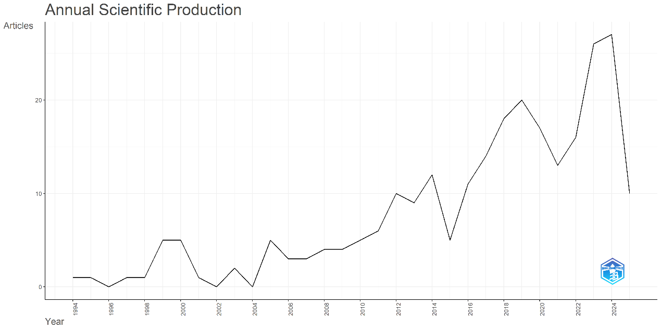
Figure 1. Annual scientific production during 1994-2025. Source: Extracted from Bibliometrix.

As shown in Figure 2, Review of Accounting Studies and Contemporary Accounting Research, two leading journals in the accounting field, rank among the most relevant sources on this topic, indicating strong recognition by highly regarded outlets.

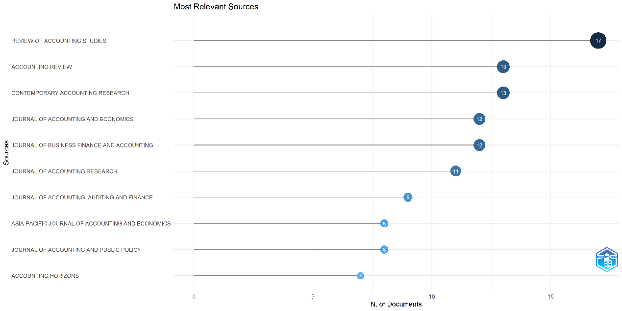
Figure 2. Most relevant sources. Source: Extracted from Bibliometrix.

Figure 3 further illustrates a marked increase in publication output from these journals since 2020. This trend suggests that the rising popularity of this topic is not only driven by less influential outlets but is also supported by top ones, reflecting robust growth powered by both academic attention and research quality.

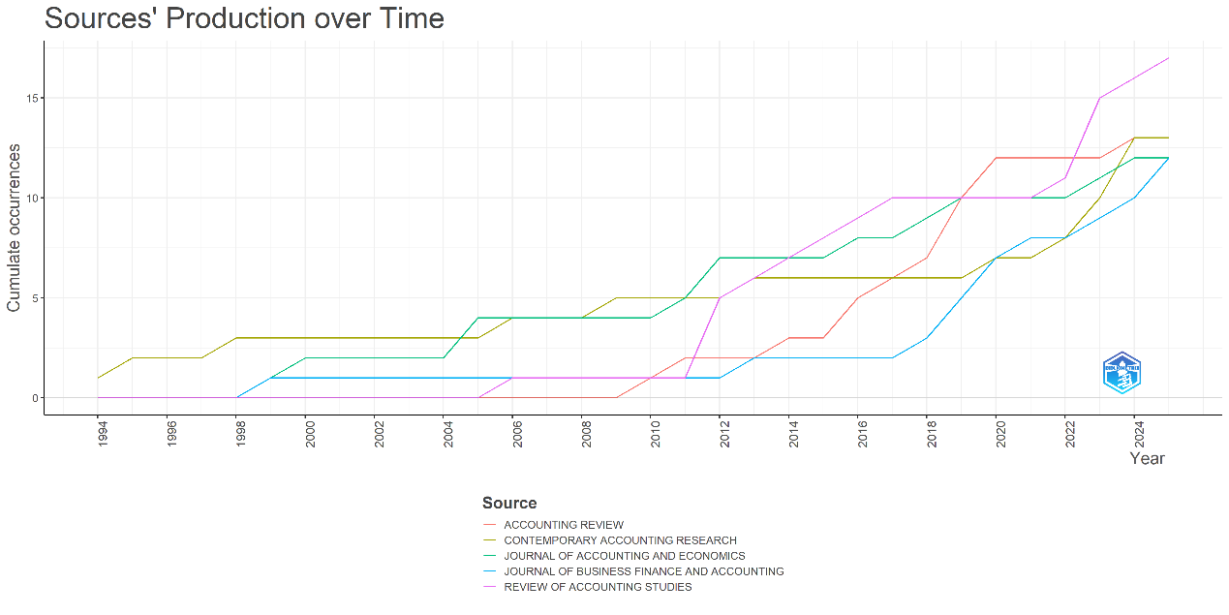
Figure 3. Sources’ production over time. Source: Extracted from Bibliometrix.

3.2 RQ2. The key authors in the literature of this topic

Table 1 highlights three of the most frequently cited scholars: Graham, Harvey, and Rajgopal. Their co-authored article, The Economic Implications of Corporate Financial Reporting, investigated how managers adjust financial decisions to influence stock prices and market expectations, based on surveys with over 400 senior executives.

All three authors are highly influential in this field. Graham’s publications are widely cited, with many ranking in the global top 25%. Harvey is known for international collaboration and theory development, while Rajgopal focuses on accounting choices and governance. Their collaboration bridges diverse perspectives on earnings management and voluntary disclosures.

Table 1. Key authors by TC.
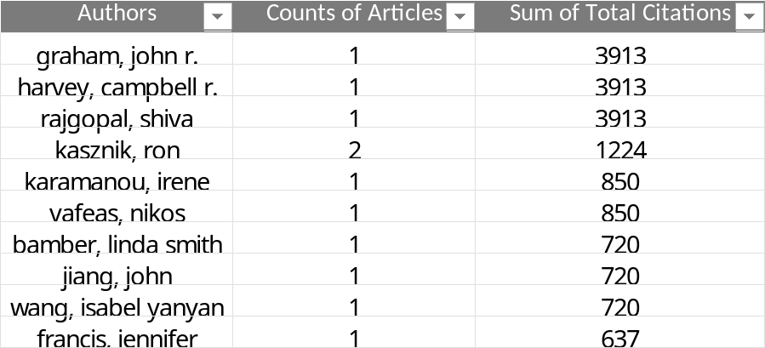
Source: Extracted from VOSviewer.

Figure 4 reveals several stable co-authorship groups. Baginski and Hassell have frequently collaborated on studies of investor responses, with a representative work examining how attribution types affect market reactions (Baginski et al., 2000). Another active group includes Tucker and Gao, whose recent work explored management earnings forecasts impact in the private loan market (Gao et al., 2024). These collaborations reflect a tightly connected network focused on how firms adjust disclosure strategies in response to market expectations and competitive pressures.

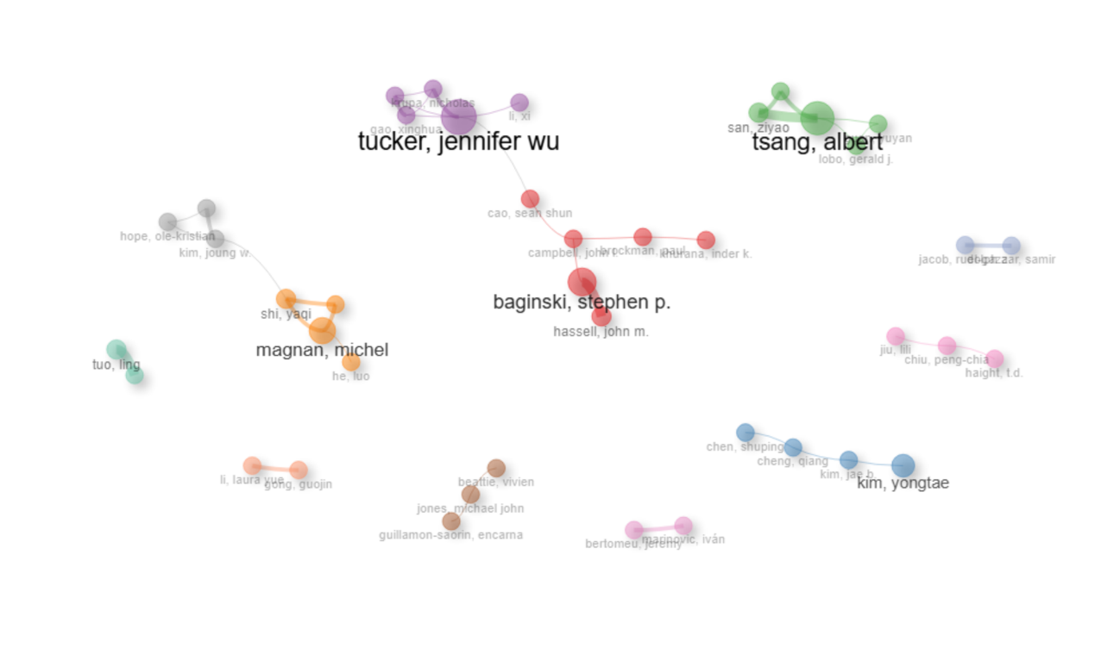
Figure 4. Collaboration network. Source: Extracted from Bibliometrix.

Emerging scholars have attracted attention through their research on corporate governance reforms (Liao et al., 2024) and auditor changes (Jia & Gao, 2024). They focus on governance mechanisms previously underexplored, suggesting that future disclosure research may increasingly explore decision-making patterns shaped by governance incentives and external accountability.

3.3 RQ3. The most influential papers, journals, and leading institutions on this topic

As shown in Figures 5 and 6, The Economic Implications of Corporate Financial Reporting (Graham et al., 2005) ranks first by both TC and TCpY, with 3,913 citations, demonstrating its exceptional academic impact on earnings management and voluntary disclosures.

Since it has been discussed in the previous section, this part will highlight three other influential studies. Karamanou and Vafeas (2005) revealed that firms with stronger governance structures release more regular and precise earnings forecasts. Bamber et al. (2010) emphasized that executives’ traits significantly shape disclosure practices. Francis et al. (2008) further discovered that greater voluntary disclosures, when combined with high earnings quality, are linked to lower capital cost.

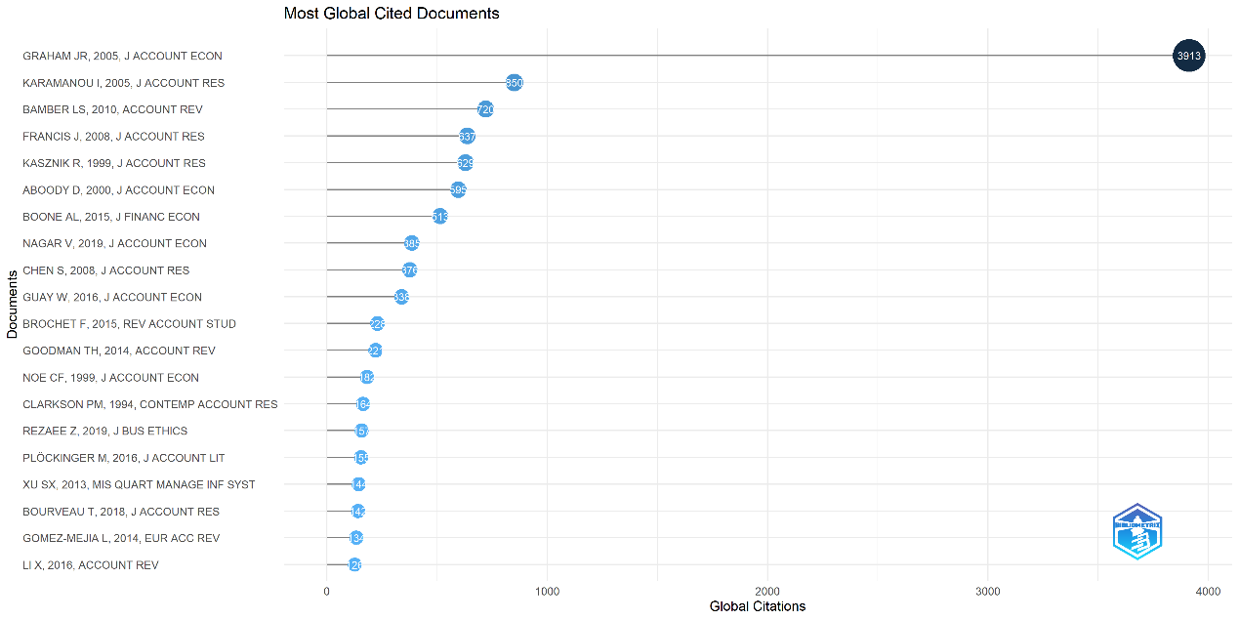
Figure 5. Top-cited papers by TC. Source: Extracted from Bibliometrix.

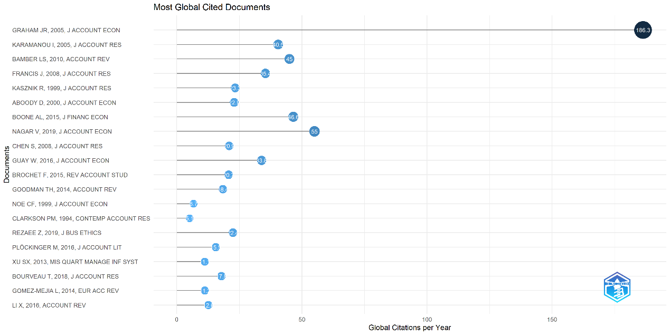
Figure 6. Top-cited papers by TCpY. Source: Extracted from Bibliometrix.

According to Table 2 and Figure 7, Journal of Accounting and Economics and Journal of Accounting Research stand out as the most influential journals, consistently publishing research that integrates accounting practices with market responses and corporate governance. These journals occupy central positions in the citation network, reflecting their enduring impact in the field.

Table 2. Top 10 most cited Journals.
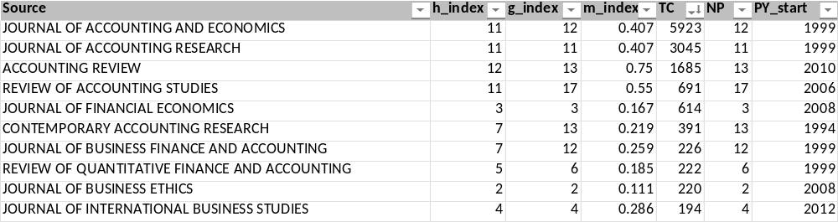
Source: Extracted from Bibliometrix.

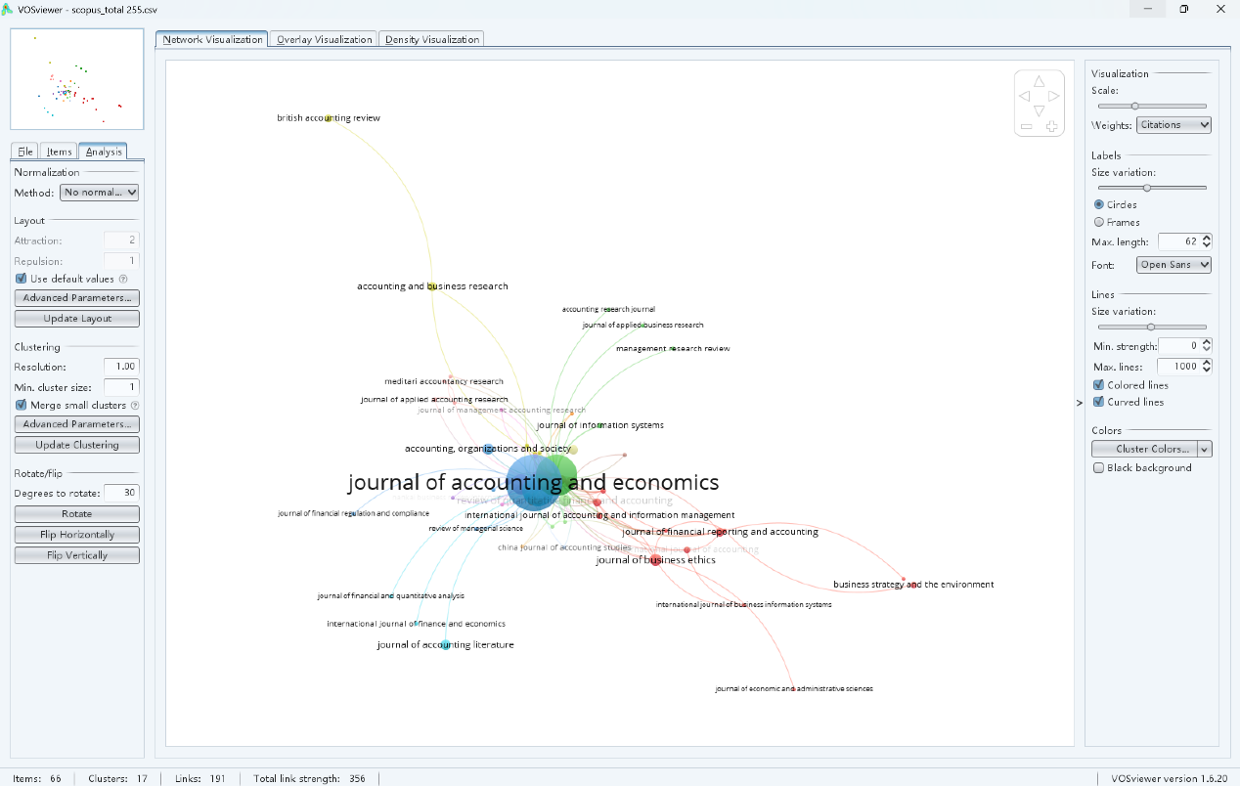
Figure 7. Top Journals. Source: Extracted from VOSviewer.

In terms of institutions, the dominance of U.S. universities is evident, with Duke University and the University of Washington leading in citations. Meanwhile, the rising impact of institutions from Cyprus and Singapore signals the global expansion of research in this field.

Table 3. Leading institutions by TC.
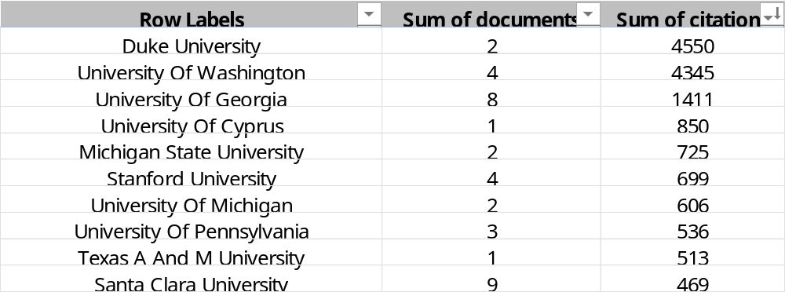
Source: Extracted from VOSviewer.

Table 4. Leading institutions by regions.
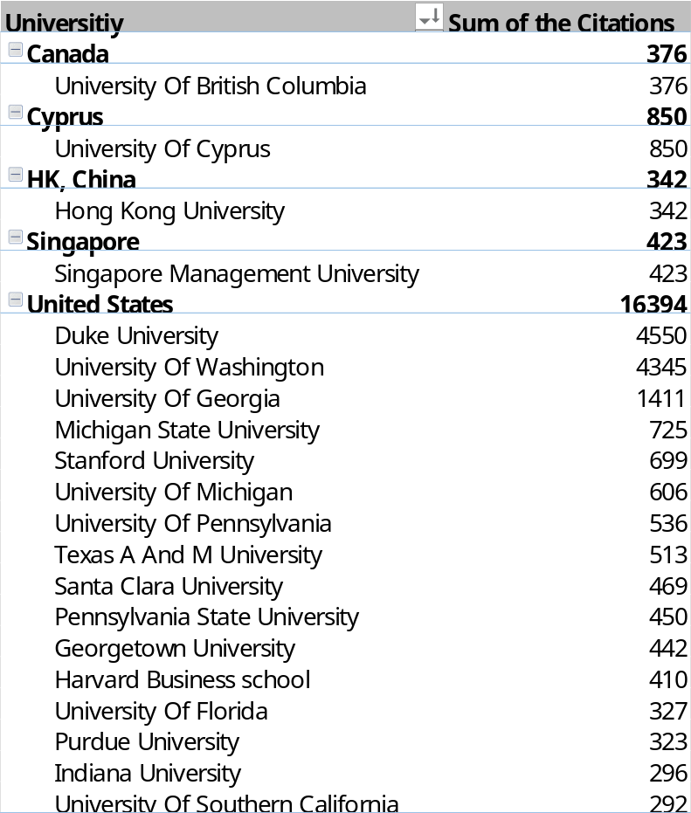
Source: Extracted from VOSviewer.

Figure 8. Leading institutions by TC. Source: Extracted from VOSviewer.

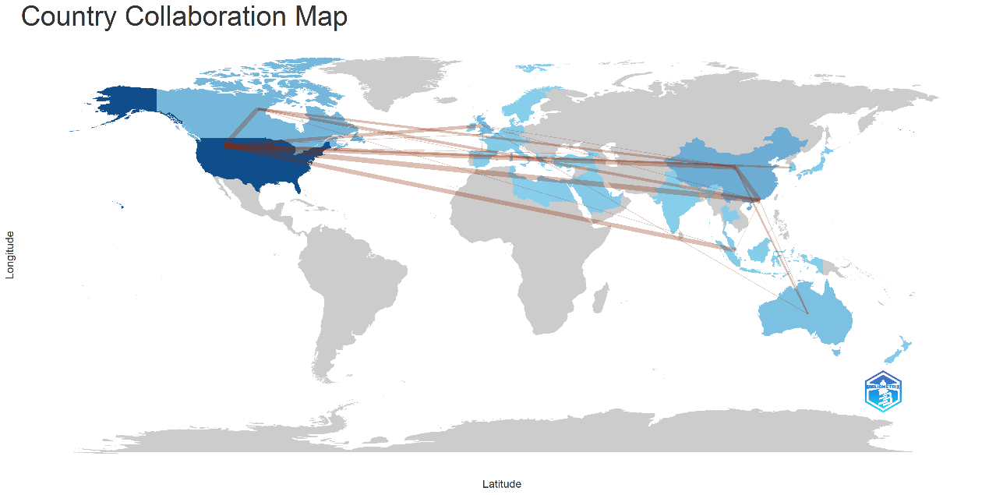
Figure 9. Country collaboration map. Source: Extracted from Bibliometrix.

3.4 RQ4. The main schools or classifications in this topic

Table 5. Top 10 most cited articles.
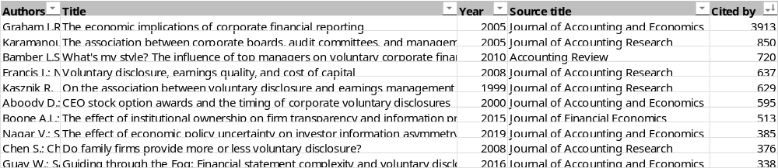
Source: Extracted from VOSviewer.

Table 5 presents the 10 most cited articles on earnings management and voluntary disclosures. Using VOSviewer under the method of association strength with a resolution of 1.00, I generated a network map (Figure 10), where the papers were grouped into three clusters based on co-citation patterns.

Cluster 1 (red) explores internal governance and managerial behaviors. For instance, Graham et al. (2005) found that managers might compromise long-term value to stabilize reported earnings, while Aboody and Kasznik (2000) reported that disclosure timing was adjusted considering stock-based compensation. Karamanou and Vafeas (2005) further pointed out the role of the board in improving forecast quality. Chen et al. (2008) extended the discussion to family firms, which tend to issue warnings due to stronger reputational sensitivity.

Cluster 2 (green) emphasizes external institutional and environmental factors. Bamber et al. (2010) linked executive style with society, institutions, and industries, while Boone and White (2015) argued that institutional shareholding can enhance transparency. In terms of increased uncertainty, Nagar et al. (2019) assessed the impact of unstable policies on information asymmetry. Similarly, Guay et al. (2016) examined managers‘ responses to reporting complexity under regulatory oversight.

Cluster 3 (blue) examines the market consequences of voluntary disclosures. For example, Francis et al. (2008) found that improved transparency can help lower the cost of capital. From a managerial perspective, Kasznik (1999) investigated the use of earnings management as a strategy to mitigate potential legal liabilities and reputational harm caused by inaccurate forecasts.

Cluster 1 and Cluster 2 represent two core perspectives: managerial structures and external constraints. While conceptually distinct, they jointly shape companies’ financial performances regarding earnings management and voluntary disclosures. These considerations were ultimately integrated in Cluster 3, which illustrates how enterprises respond to both organizational and environmental pressures in the capital market.

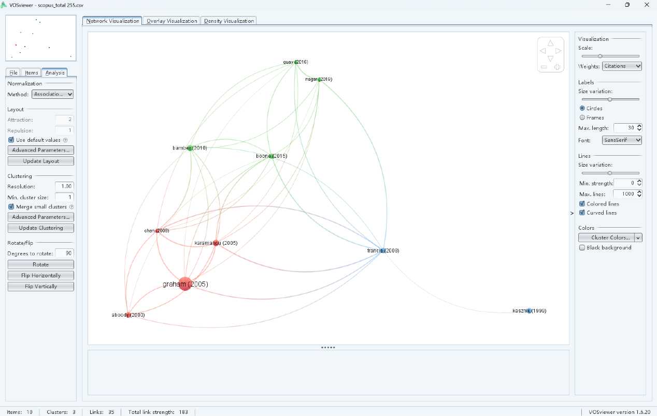
Figure 10. Network visualization. Source: Extracted from VOSviewer.

To facilitate comparison, I have manually marked my proposed classification on Figure 10. Although my classification aligns with the three clusters identified by VOSviewer, the grouping of some papers remains debatable. For instance, the article by Chen et al. (2008) was classified into Cluster 1, likely due to its focus on litigation risks, reputational pressure, and institutional oversight. However, from my perspective, the study primarily illustrated how managers influence the disclosure practices under such circumstances, which aligned more closely with the external factors of Cluster 2.

Conversely, the study by Bamber et al. (2010) was assigned to Cluster 2, possibly because of some references to legal and industry backgrounds. However, I would argue that the central theme of the study was how executives’ traits systematically shape financial choices. External drivers served merely to explain individual differences, while the theoretical focus remained on internal mechanisms of Cluster 1.

Overall, these differences reveal some limitations of purely algorithmic clustering. VOSviewer’s method is generally based on co-citation networks, which reflect structural topic similarities. In contrast, my classification emphasizes core arguments and analytical focus of each study. For papers with overlapping themes, manual interpretation remains essential to fully grasp their nuanced insights.

3.5 RQ5. The latest emerging topics in this research area

Recent years have seen a diversification in research on earnings management and voluntary disclosures, giving rise to five emerging topics: textual analysis, investment efficiency, analyst forecasts, accuracy, and information demand.

First of all, textual analysis has become a key research direction. Baginski et al. (2018) introduced the concept of residual tone to quantify language subjectivity and its influence on trading behaviors. Al-Shaer and Zaman (2021) further showed that the linguistic tone of audit committee statements is significantly associated with earnings manipulation, using computer-assisted analysis.

Secondly, regarding investment efficiency, Li et al. (2019) found that a country’s institutional environment can impact the accuracy of management earnings forecasts, and consequently, the effectiveness of capital allocation. Similarly, Chiu et al. (2022) revealed that forward-looking customer disclosures can help suppliers make more effective investment decisions.

Furthermore, in terms of analyst forecasts and accuracy, Francoeur et al. (2023) highlighted that earnings forecasts issued by female CEOs tend to be more precise, helping to bridge the analyst coverage gap. Preussner and Aschauer (2022) emphasized that forecasts with greater information volume and credibility are more likely to motivate stronger market reactions.

Eventually, concerning information demand, Li and Yang (2016) documented that the mandatory adoption of IFRS, as an external institutional force, raised investors’ expectations for transparency, thus encouraging firms to disclose more proactively. In contrast, Bentley-Goode et al. (2019) approached the issue from an internal strategic perspective, finding that innovation-oriented firms, driven by greater information needs, are more inclined to provide disclosures.

In conclusion, recent studies are shifting from the question of “whether to disclose” toward exploring “how disclosure content and structure shape market outcomes.” Multiple factors have jointly influenced disclosure behaviors, which have also impacted how earnings management is identified and studied. Future research could further examine whether ESG-related disclosures serve similar information functions (Nagar et al., 2019) and explore how AI-based analysis can assist in detecting predictive bias and manipulation (Rezaee & Tuo, 2019).

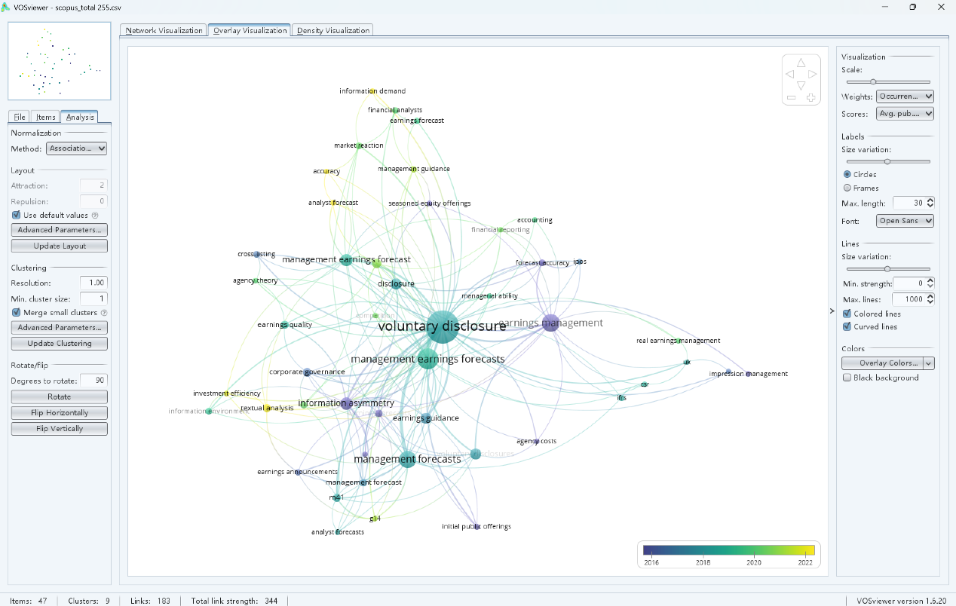
Figure 11. Overlay visualization. Source: Extracted from VOSviewer.

4. Conclusion

This study finds that the literature volume of earnings management and voluntary disclosures has grown significantly since 2011, with most studies published in top-tier accounting journals. Influential scholars such as Graham and Rajgopal have shaped the field, with academic impact mainly concentrated in U.S. institutions. Highly cited research tends to focus on governance, information quality, and market responses. Building on this, cluster analysis identifies three key themes: internal governance, external constraints, and market feedback, jointly helping to explain the underlying mechanisms of this topic. Moreover, recent studies have shifted toward investigating language tone, subjective expression, and rising information demand, emphasizing the role of managers in shaping investor perceptions.

However, this study has several limitations to acknowledge. Firstly, VOSviewer’s clustering algorithm may misunderstand overlapping topics. Secondly, the dataset is restricted to English-language publications from Scopus. Thirdly, the emphasis on top-cited papers might overlook emerging contributions. Future research could integrate multilingual sources and apply dynamic citation analysis to better capture evolving trends in this field.

Self-reflection report

Factors | Concept Mapping | Bibliometric Analysis
1. Main  Characteristics | • Visual and hierarchical  • Based on Ausubel’s theory  • Shows concept links | • Data-driven and objective  • Uses co-citation networks  • Identifies research structure
2. Benefits  for  Learning | • Clarifies abstract concepts  • Encourages integration  • Diagnoses misconceptions | • Identifies key authors/topics  • Tracks trends and gaps  • Aids in critical reading
3. Least  Liked  Aspects | • Time-consuming to construct  • Hard to structure concepts  • Software is hard to use | • Interface is not beginner-friendly  • Requires mutually cleaned data  • Clusters are relatively confusing
4. Challenges  Or  Difficulties | • Difficult to design a hierarchy  • Labeling links is challenging  • Lacked mapping experience | • VOSviewer settings are hard  • Dataset cleaning is complex  • Co-citation logic is unclear
5. Suggestions  For  Improvement | • Add basic training  • Provide templates/examples  • Use in small group tasks | • Simplify user guides  • Enable cluster labeling  • Link with content summaries

During my study of ACC202, I was introduced to two analytical tools: concept mapping and bibliometric analysis, each offering unique strengths and presenting distinct limitations.

Concept mapping is a visual and hierarchical technique based on Ausubel’s meaningful learning theory (Simon, 2015). It helps students to clarify complex theories by constructing logical links between concepts, which enhances both comprehension and memory retention. However, creating effective maps can be time-consuming and challenging, particularly for beginners lacking proper training or technical support.

In contrast, bibliometric analysis provides a data-driven approach to identify research trends, author collaborations, and thematic clusters, making it especially useful for large-scale literature reviews (Ball, 2018). However, as Donthu et al. (2021) emphasized, substantial familiarity with parameter settings and clustering logic is required for application. Tools like VOSviewer demand strong technical and analytical skills, and their outputs can be difficult to interpret without adequate background knowledge.

In this coursework, I applied bibliometric analysis to explore the literature on earnings management and voluntary disclosures. This method helped me to uncover influential publications, identify key research themes, and improve my ability to critically engage with academic sources. Although I did not directly use concept mapping in my project, after attending the lectures and reviewing Simon’s work, I have recognized its value in supporting accounting theory learning and conceptual organization.

Overall, concept mapping tends to be more effective for deeper comprehension at a micro level, whereas bibliometric analysis is better suited for synthesizing knowledge across a broader scale. From my perspective, I suggest that future courses integrate both tools into the teaching framework, supported by more skills training and group collaborations. This combined approach can facilitate both deeper conceptual understanding and the practical application of analytical techniques in literature interpretation.

References

Aboody, D. and Kasznik, R., (2000). ‘CEO stock option awards and the timing of corporate voluntary disclosures’. Journal of Accounting and Economics, 29(1), pp.73-100. Available at: https://www.sciencedirect.com/science/article/abs/pii/S0165410100000148 (Accessed: 20 May 2025).

Al-Shaer, H. and Zaman, M., (2021). ‘Audit committee disclosure tone and earnings management’. Journal of Applied Accounting Research, 22(5), pp.780-799. Available at: https://www.scopus.com/inward/record.uri?eid=2-s2.0-85106206961&doi=10.1108%2fJAAR-12-2020-0243&partnerID=40&md5=405736130c33ac8abc228f60f8bfd336 (Accessed: 20 May 2025).

Baginski, S.P., Demers, E., Kausar, A. and Yu, Y.J., (2018). ‘Linguistic tone and the small trader’. Accounting, Organizations and Society, 68-69, pp.21-37. Available at: https://www.scopus.com/record/display.uri?eid=2-s2.0-85045709493&doi=10.1016%2fj.aos.2018.03.005&origin=inward&txGid=2cbe6d83b9182adf2b4f904a6875f5b6 (Accessed: 20 May 2025).

Baginski, S. P., Hassell, J. M., & Hillison, W. A. (2000). ‘Voluntary causal disclosures: Tendencies and capital market reaction’. Journal of Accounting and Economics, 30(3), 259-282. Available at: https://www.scopus.com/record/display.uri?eid=2-s2.0-0347347165&doi=10.1023%2fA%3a1012002608615&origin=inward&txGid=00f531f92faef75fa472dd7480ff4f4a (Accessed: 20 May 2025).

Ball, R. (2018). An Introduction to Bibliometrics: New Developments and Trends, Elsevier, ISBN: 978-0-08-102150-7. DOI: 10.1016/C2016-0-03695-1.

Bamber, L.S., Jiang, J. and Wang, I.Y., (2010). ‘What’s my style? The influence of top managers on voluntary corporate financial disclosure’. The Accounting Review, 85(4), pp.1131-1162. Available at: https://publications.aaahq.org/accounting-review/article-abstract/85/4/1131/3226/What-s-My-Style-The-Influence-of-Top-Managers-on?redirectedFrom=fulltext (Accessed: 20 May 2025).

Bentley-Goode, K.A., Omer, T.C. and Twedt, B.J., (2019). ‘Does business strategy impact a firm’s information environment?’ Journal of Accounting, Auditing and Finance, 34(4), pp.563-587. Available at: https://www.scopus.com/record/display.uri?eid=2-s2.0-85083767817&doi=10.1177%2f0148558X17726893&origin=inward&txGid=6a6889fe4727cfdda38b37286e815644 (Accessed: 20 May 2025).

Beyer, A., Cohen, D.A., Lys, T.Z. and Walther, B.R., (2010). ‘The financial reporting environment: Review of the recent literature’. Journal of Accounting and Economics, 50(2-3), pp.296-343. Available at: https://www.sciencedirect.com/science/article/pii/S0165410110000431 (Accessed: 20 May 2025).

Boone, A.L. and White, J.T., (2015). ‘The effect of institutional ownership on firm transparency and information production’. Journal of Financial Economics, 117(3), pp.508-533. Available at: https://www.sciencedirect.com/science/article/pii/S0304405X15000914 (Accessed: 20 May 2025).

Chen, S., Chen, X. and Cheng, Q., (2008). ‘Do family firms provide more or less voluntary disclosure?’ Journal of Accounting Research, 46(3), pp.499-536. Available at: https://onlinelibrary.wiley.com/doi/abs/10.1111/j.1475-679X.2008.00288.x (Accessed: 20 May 2025).

Chiu, P.C., Jiu, L. and Yu, P.H., (2022). ‘How do suppliers benefit from customers’ voluntary disclosure? The effect of customers’ earnings guidance on upstream firms’ investment efficiency’. Journal of Accounting and Public Policy, 41(1), Article 106880. Available at: https://www.scopus.com/record/display.uri?eid=2-s2.0-85112708083&doi=10.1016%2fj.jaccpubpol.2021.106880&origin=inward&txGid=6592e82b418ea4c210c8d4cc67379eda (Accessed: 20 May 2025).

Donthu, N., Kumar, S., Mukherjee, D., Pandey, N. and Lim, W.M. (2021). ‘How to conduct a bibliometric analysis: An overview and guidelines’. Journal of Business Research, 133, pp.285-296. DOI: 10.1016/j.jbusres.2021.04.070.

Francis, J., Nanda, D. and Olsson, P., (2008). ‘Voluntary disclosure, earnings quality, and cost of capital’. Journal of Accounting Research, 46(1), pp.53-99. Available at: https://onlinelibrary.wiley.com/doi/10.1111/j.1475-679X.2008.00267.x (Accessed: 20 May 2025).

Francoeur, C., Li, Y., Singer, Z. and Zhang, J., (2023). ‘Earnings forecasts of female CEOs: quality and consequences’. Review of Accounting Studies, 28(3), pp.1721-1764. Available at: https://www.scopus.com/record/display.uri?eid=2-s2.0-85122792104&doi=10.1007%2fs11142-021-09669-7&origin=inward&txGid=5f623551785a2da3924abc8a41b29a54 (Accessed: 20 May 2025).

Gao, X., Jia, Y., Krupa, N.R. and Tucker, J.W., (2024). ‘The corroboration role of management earnings forecasts in private loan markets’. Journal of Accounting, Auditing and Finance, 39(3), pp.903-930. Available at: https://www.scopus.com/record/display.uri?eid=2-s2.0-85131712707&doi=10.1177%2f0148558X221102218&origin=inward&txGid=e37108856d724066dc91782fdf6dc6ef (Accessed: 20 May 2025).

Goodell, J.W., (2020). ‘COVID-19 and finance: Agendas for future research’. Finance Research Letters, 35, 101512. Available at: https://www.sciencedirect.com/science/article/pii/S1544612320303974 (Accessed: 20 May 2025).

Graham, J.R., Harvey, C.R. and Rajgopal, S., (2005). ‘The economic implications of corporate financial reporting’. Journal of Accounting and Economics, 40(1-3), pp.3-73. Available at: https://www.sciencedirect.com/science/article/abs/pii/S0165410105000571 (Accessed: 20 May 2025).

Guay, W., Samuels, D. and Taylor, D., (2016). ‘Guiding through the fog: Financial statement complexity and voluntary disclosure’. Journal of Accounting and Economics, 62(2-3), pp.234-269. Available at: https://www.sciencedirect.com/science/article/pii/S0165410116300489 (Accessed: 20 May 2025).

Healy, P.M. and Palepu, K.G., (2001). ‘Information asymmetry, corporate disclosure, and the capital markets: A review of the empirical disclosure literature’. Journal of Accounting and Economics, 31(1-3), pp.405-440. Available at: https://www.sciencedirect.com/science/article/abs/pii/S0165410101000180 (Accessed: 20 May 2025).

Jia, Y. and Gao, X., (2024). ‘Auditor changes and management’s issuance of earnings forecasts’. Contemporary Accounting Research, 41(2), pp.748-780. Available at: https://www.scopus.com/record/display.uri?eid=2-s2.0-85184164166&doi=10.1111%2f1911-3846.12922&origin=inward&txGid=9f337b8b6e93dac93c12f3470a58ca0a (Accessed: 20 May 2025).

Karamanou, I. and Vafeas, N., (2005). ‘The association between corporate boards, audit committees, and management earnings forecasts: An empirical analysis’. Journal of Accounting Research, 43(3), pp.453-486. Available at: https://onlinelibrary.wiley.com/doi/10.1111/j.1475-679X.2005.00177.x (Accessed: 20 May 2025).

Kasznik, R., (1999). ‘On the association between voluntary disclosure and earnings management’. Journal of Accounting Research, 37(1), pp.57-81. doi:10.2307/2491396. Available at: https://www.scopus.com/record/display.uri?eid=2-s2.0-0033463501&doi=10.2307%2f2491396&origin=inward&txGid=28d12b63279b6b7531900bae1e379f96 (Accessed: 20 May 2025).

Krueger, P., Sautner, Z., Tang, D.Y. and Zhong, R., (2024). ‘The effects of mandatory ESG disclosure around the world’. Journal of Accounting Research, 62(5), pp.1795-1847. Available at: https://onlinelibrary.wiley.com/doi/full/10.1111/1475-679X.12548?msockid=2f0c9dc52e666def3cd68f4f2f256cb4 (Accessed: 20 May 2025).

Leuz, C. and Wysocki, P.D., (2016). ‘The economics of disclosure and financial reporting regulation: Evidence and suggestions for future research’. Journal of Accounting Research, 54(2), pp.525-622. Available at: https://onlinelibrary.wiley.com/doi/epdf/10.1111/1475-679X.12115 (Accessed: 20 May 2025).

Li, W., Ng, J., Tsang, A. and Urcan, O., (2019). ‘Country-level institutions and management earnings forecasts’. Journal of International Business Studies, 50(1), pp.48-82. Available at: https://www.scopus.com/record/display.uri?eid=2-s2.0-85056635762&doi=10.1057%2fs41267-018-0190-4&origin=inward&txGid=edd921d5e6a6fff030a7500fa8e7eb4d (Accessed: 20 May 2025).

Li, X. and Yang, H., (2016). ‘Mandatory financial reporting and voluntary disclosure: The effect of mandatory IFRS adoption on management forecasts’. Accounting Review, 91(3), pp.933-953. Available at: https://www.scopus.com/record/display.uri?eid=2-s2.0-84964412460&doi=10.2308%2faccr-51296&origin=inward&txGid=39f0ae8c8d1f43041c46eb78f12a4677 (Accessed: 20 May 2025).

Liao, C.-H., San, Z. and Tsang, A., (2024). ‘Corporate governance reforms and voluntary disclosure: International evidence on management earnings forecasts’. Journal of International Accounting, Auditing and Taxation, 54, Article 100602. Available at: https://www.scopus.com/record/display.uri?eid=2-s2.0-85184017556&doi=10.1016%2fj.intaccaudtax.2024.100602&origin=inward&txGid=ec3fe9defe841728c815e353d71b94c1 (Accessed: 20 May 2025).

Nagar, V., Schoenfeld, J. and Wellman, L., (2019). ‘The effect of economic policy uncertainty on investor information asymmetry and management disclosures’. Journal of Accounting and Economics, 67(1), pp.36-57. Available at: https://www.sciencedirect.com/science/article/pii/S0165410118300958 (Accessed: 20 May 2025).

Preussner, N.A. and Aschauer, E., (2022). ‘The accuracy and informativeness of management earnings forecasts: A review and unifying framework’. Accounting Perspectives, 21(2), pp.273-330. Available at: https://www.scopus.com/record/display.uri?eid=2-s2.0-85130106545&doi=10.1111%2f1911-3838.12294&origin=inward&txGid=18b332938a0a9a634ab09cfccd960bf3 (Accessed: 20 May 2025).

Rezaee, Z. and Tuo, L., (2019). ‘Are the quantity and quality of sustainability disclosures associated with the innate and discretionary earnings quality?’ Journal of Business Ethics, 155(3), pp.763-786. Available at: https://www.scopus.com/record/display.uri?eid=2-s2.0-85018816389&doi=10.1007%2fs10551-017-3546-y&origin=inward&txGid=43ebedea04ab67dee49b1b8035ebe6c8 (Accessed: 20 May 2025).

Schipper, K., (1989). ‘Commentary on earnings management’. Accounting Horizons, 3(4), pp.91-102. Available at: https://research.ebsco.com/c/d63bsg/search/details/ndgolg5w6j?db=bsu (Accessed: 20 May 2025).

Simon, J. (2015). Concept mapping in a financial accounting theory course. In Accounting Education Research. pp. 350-385. Routledge.

Verrecchia, R.E., (2001). ‘Essays on disclosure’. Journal of Accounting and Economics, 32(1-3), pp.97-180. Available at: https://www.sciencedirect.com/science/article/abs/pii/S0165410101000258 (Accessed: 20 May 2025).

Watts, R.L. and Zimmerman, J.L., (1990). ‘Positive accounting theory: A ten year perspective’. The Accounting Review, 65(1), pp.131-156. Available at: https://www.jstor.org/stable/247880 (Accessed: 20 May 2025).

Appendix: Most Cited Papers

1. Graham, J.R., Harvey, C.R. and Rajgopal, S., (2005). ‘The economic implications of corporate financial reporting’. Journal of Accounting and Economics, 40(1-3), pp.3-73. Available at: https://www.sciencedirect.com/science/article/abs/pii/S0165410105000571 (Accessed: 20 May 2025).
“We survey and interview more than 400 executives to determine the factors that drive reported earnings and disclosure decisions. We find that managers would rather take economic actions that could have negative long-term consequences than make within-GAAP accounting choices to manage earnings. A surprising 78% of our sample admits to sacrificing long-term value to smooth earnings. Managers also work to maintain predictability in earnings and financial disclosures. We also find that managers make voluntary disclosures to reduce information risk and boost stock price but at the same time, try to avoid setting disclosure precedents that will be difficult to maintain.”

2. Karamanou, I. and Vafeas, N., (2005). ‘The association between corporate boards, audit committees, and management earnings forecasts: An empirical analysis’. Journal of Accounting Research, 43(3), pp.453-486. Available at: https://onlinelibrary.wiley.com/doi/10.1111/j.1475-679X.2005.00177.x (Accessed: 20 May 2025).
“We study how corporate boards and audit committees are associated with voluntary financial disclosure practices, proxied here by management earnings forecasts. We find that in firms with more effective board and audit committee structures, managers are more likely to make or update an earnings forecast, and their forecast is less likely to be precise, it is more accurate, and it elicits a more favorable market response. Together, our empirical evidence is broadly consistent with the notion that effective corporate governance is associated with higher financial disclosure quality.”

3. Bamber, L.S., Jiang, J. and Wang, I.Y., (2010). ‘What’s my style? The influence of top managers on voluntary corporate financial disclosure’. The Accounting Review, 85(4), pp.1131-1162. Available at: https://publications.aaahq.org/accounting-review/article-abstract/85/4/1131/3226/What-s-My-Style-The-Influence-of-Top-Managers-on?redirectedFrom=fulltext (Accessed: 20 May 2025).
“Financial economics has posited a limited role for idiosyncratic noneconomic manager-specific influences, but the strategic management literature suggests such individual influences can affect corporate outcomes. We investigate whether individual managers play an economically significant role in their firms’ voluntary financial disclosure choices. Tracking managers across firms over time, we find top executives exert unique and economically significant influence (manager-specific fixed effects) on their firms’ voluntary disclosures, incremental to known economic determinants of disclosure, and firm- and time-specific effects. Managers’ unique disclosure styles are associated with observable demographic characteristics of their personal backgrounds: managers promoted from finance, accounting, and legal career tracks, managers born before World War II, and those with military experience develop disclosure styles displaying certain conservative characteristics; and managers from finance and accounting and those with military experience favor more precise disclosure styles. These plausible associations confirm that our estimated manager-specific fixed effects capture systematic long-lived differences in managers’ unique disclosure styles.”

4. Francis, J., Nanda, D. and Olsson, P., (2008). ‘Voluntary disclosure, earnings quality, and cost of capital’. Journal of Accounting Research, 46(1), pp.53-99. Available at: https://onlinelibrary.wiley.com/doi/10.1111/j.1475-679X.2008.00267.x (Accessed: 20 May 2025).
“We investigate the relations among voluntary disclosure, earnings quality, and cost of capital. We find that firms with good earnings quality have more expansive voluntary disclosures (as proxied by a self-constructed index of coded items found in 677 firms' annual reports and 10-K filings in fiscal 2001) than firms with poor earnings quality. In unconditional tests, we find that more voluntary disclosure is associated with a lower cost of capital. However, consistent with the complementary association between disclosure and earnings quality, we find that the disclosure effect on cost of capital is substantially reduced or disappears completely (depending on the cost of capital proxy) once we condition on earnings quality. Extensions probing alternative proxies show that our findings are robust to measures of earnings quality and cost of capital, but not to other measures of voluntary disclosure. In particular, we find opposite relations for voluntary disclosure measures based on management forecasts and conference calls, and we find no relations for a press release based measure.”

5. Kasznik, R., (1999). ‘On the association between voluntary disclosure and earnings management’. Journal of Accounting Research, 37(1), pp.57-81. doi:10.2307/2491396. Available at: https://www.scopus.com/record/display.uri?eid=2-s2.0-0033463501&doi=10.2307%2f2491396&origin=inward&txGid=28d12b63279b6b7531900bae1e379f96 (Accessed: 20 May 2025).
“This article presents a study of whether managers who issue annual earnings forecasts manage reported earnings toward their forecasts, fearing legal actions by investors and loss of reputation for accuracy. The author hypothesizes that managers make income-increasing accounting decisions when earnings would otherwise be below management forecasts and that the earnings management activity is increasing in expected forecast error costs. The author also assumes that litigation costs are associated with share-price changes at the time of forecast's proximity to fiscal year-end, and the extent of analyst coverage. The author estimates discretionary accruals for each firm-year and examines the association between estimated discretionary accruals and the proxies for forecast error costs.”

6. Aboody, D. and Kasznik, R., (2000). ‘CEO stock option awards and the timing of corporate voluntary disclosures’. Journal of Accounting and Economics, 29(1), pp.73-100. Available at: https://www.sciencedirect.com/science/article/abs/pii/S0165410100000148 (Accessed: 20 May 2025).
“We investigate whether CEOs manage the timing of their voluntary disclosures around stock option awards. We conjecture that CEOs manage investors’ expectations around award dates by delaying good news and rushing forward bad news. For a sample of 2,039 CEO option awards by 572 firms with fixed award schedules, we document changes in share prices and analyst earnings forecasts around option awards that are consistent with our conjecture. We also provide more direct evidence based on management earnings forecasts issued prior to award dates. Our findings suggest that CEOs make opportunistic voluntary disclosure decisions that maximize their stock option compensation.”

7. Boone, A.L. and White, J.T., (2015). ‘The effect of institutional ownership on firm transparency and information production’. Journal of Financial Economics, 117(3), pp.508-533. Available at: https://www.sciencedirect.com/science/article/pii/S0304405X15000914 (Accessed: 20 May 2025).
“We examine the effects of institutional ownership on firms׳ information and trading environments using the annual Russell 1000/2000 index reconstitution. Characteristics of firms near the index cutoffs are similar, except that firms in the top of the Russell 2000 have discontinuously higher proportional institutional ownership than firms in the bottom of the Russell 1000 primarily due to indexing and benchmarking strategies. We find that higher institutional ownership is associated with greater management disclosure, analyst following, and liquidity, resulting in lower information asymmetry. Overall, indexing institutions׳ predilection for lower information asymmetries facilitates information production, which enhances monitoring and decreases trading costs.”

8. Nagar, V., Schoenfeld, J. and Wellman, L., (2019). ‘The effect of economic policy uncertainty on investor information asymmetry and management disclosures’. Journal of Accounting and Economics, 67(1), pp.36-57. Available at: https://www.sciencedirect.com/science/article/pii/S0165410118300958 (Accessed: 20 May 2025).
“Investor uncertainty about firm value drives investors’ information collection and trading activities, as well as managers’ disclosure choices. This study examines an important source of uncertainty that likely cannot be influenced by most managers and investors: uncertainty about government economic policy. We find that this uncertainty is associated with increased bid-ask spreads and decreased stock price reactions to earnings surprises. Managers respond to this uncertainty by increasing their voluntary disclosures, but these disclosures only partly mitigate the bid-ask spread increase. We conclude that government economic policy uncertainty is an important component of firms’ information environments and managers’ voluntary disclosure decisions.”

9. Chen, S., Chen, X. and Cheng, Q., (2008). ‘Do family firms provide more or less voluntary disclosure?’ Journal of Accounting Research, 46(3), pp.499-536. Available at: https://onlinelibrary.wiley.com/doi/abs/10.1111/j.1475-679X.2008.00288.x (Accessed: 20 May 2025).
“We examine the voluntary disclosure practices of family firms. We find that, compared to nonfamily firms, family firms provide fewer earnings forecasts and conference calls, but more earnings warnings. Whereas the former is consistent with family owners having a longer investment horizon, better monitoring of management, and lower information asymmetry between owners and managers, the higher likelihood of earnings warnings is consistent with family owners having greater litigation and reputation cost concerns. We also document that family ownership dominates nonfamily insider ownership and concentrated institutional ownership in explaining the likelihood of voluntary disclosure. Using alternative proxies for the founding family's presence in the firm leads to similar results.”

10. Guay, W., Samuels, D. and Taylor, D., (2016). ‘Guiding through the fog: Financial statement complexity and voluntary disclosure’. Journal of Accounting and Economics, 62(2-3), pp.234-269. Available at: https://www.sciencedirect.com/science/article/pii/S0165410116300489 (Accessed: 20 May 2025).
“A growing literature documents that complex financial statements negatively affect the information environment. In this paper, we examine whether managers use voluntary disclosure to mitigate these negative effects. Employing cross-sectional and within-firm designs, we find a robust positive relation between financial statement complexity and voluntary disclosure. This relation is stronger when liquidity decreases around the filing of the financial statements, is stronger when firms have more outside monitors, and is weaker when firms have poor performance and greater earnings management. We also examine the relation between financial statement complexity and voluntary disclosure using two quasi-natural experiments. Employing a generalized difference-in-differences design, we find firms affected by the adoption of complex accounting standards (e.g., SFAS 133 and SFAS 157) increase their voluntary disclosure to a greater extent than unaffected firms. Collectively, these findings suggest managers use voluntary disclosure to mitigate the negative effects of complex financial statements on the information environment.”

