ACC310 Part C Group Report Coursework
Accounting Fraud Detection and Regulatory Analysis of Kang Dexin

Group 33
Student ID Student Name
2253303 Ying Huang
2253335 Zihan Zhou
2253336 Jingwei Liu
2254747 Miao Wang

Table of Contents
1. Company Background and CSRC Investigation 1
2. Financial Ratio Analysis 2
2.1 Simple Fraud Pattern 2
2.2 Complex Fraud Pattern 4
2.3 Cost-inflating Fraud Pattern 7
2.4 Cash Fraud Pattern 11
3. Presentation and summary of flow charts 14
4. CSRC Punishments and Overall Conclusion 16
References 17

Company Background and CSRC Investigation
Kang Dexin Composite Material Group Co., Ltd. (002450.SZ) was a China-based company mainly engaged in the research, development, manufacture and distribution of high-polymer materials. Its products included pre-coated materials, optoelectronic materials and carbon materials, which were used in printing, packaging, automobiles, construction and wind power (MarketScreener, no date). The company was once listed on the Shenzhen Stock Exchange, but later became involved in a major financial fraud case.
The CSRC investigation started after Kang Dexin was suspected of information disclosure violations. The company received the CSRC investigation notice on 22 January 2019 and then received the advance notice of administrative penalty and market-entry ban on 5 July 2019 (Kang Dexin Composite Material Group Co., Ltd., 2019). According to the CSRC, from 2015 to 2018 Kang Dexin fabricated sales, purchases, production, R&D expenses and transportation costs, which resulted in false records in its annual reports. The CSRC also found false bank deposit balances, undisclosed related-party guarantees and misused raised funds (China Securities Regulatory Commission, 2020). Therefore, this report applies financial ratio analysis to examine whether the company’s simple fraud, complex fraud, cost-inflating fraud and cash fraud patterns can be detected from its financial data.

Financial Ratio Analysis

2.1 Simple Fraud Pattern
For simple fraud, the key issue is whether reported sales were genuine and supported by normal cash collection. Kang Dexin’s figures show several signs that sales revenue and receivables did not move in a healthy way during the fraud period.
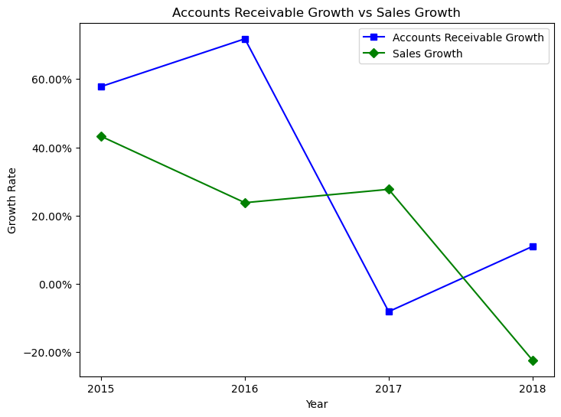
Figure 1. Growth in Accounts Receivable vs Growth in Sales

Accounts Receivable Growth vs Sales Growth shows an early warning signal. Accounts receivable grew faster than sales in 2015 and 2016, especially in 2016. This means that the company recorded a large increase in receivables, but this was not matched by the same level of sales growth. In 2018, sales growth turned negative, while accounts receivable continued to increase. This inconsistency suggests that some reported sales may not have been supported by timely cash collection.

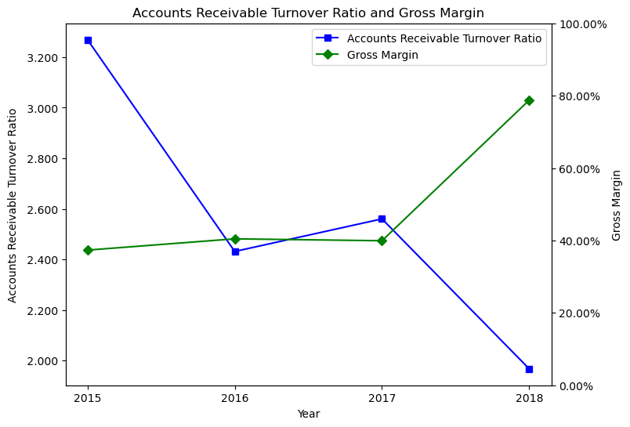
Figure 2. Accounts Receivable Turnover Ratio and Gross Margin

Accounts Receivable Turnover Ratio and Gross Margin also raises concerns. The receivables turnover ratio fell from about 3.27 in 2015 to about 1.97 in 2018, suggesting that the company collected receivables more slowly. However, gross margin increased sharply in 2018. This combination is unusual because stronger profitability was not supported by better sales quality or collection efficiency.
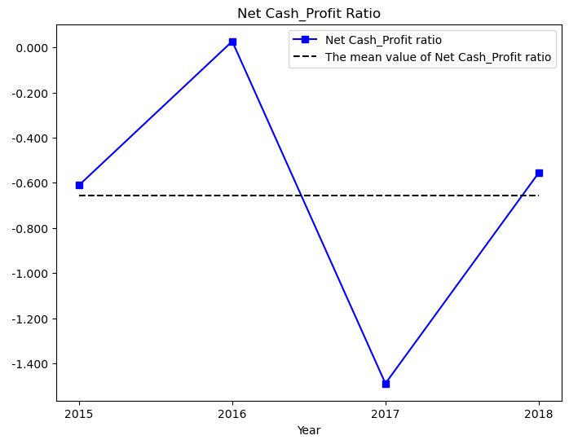
Figure 3. Ratio of Net Cash Flow from Operations over Net Profits and Mean Value

Net Cash Flow from Operations to Net Profit Ratio further weakens the reliability of reported profit. The ratio was negative in most years and reached its lowest point in 2017, indicating that accounting profit was not supported by operating cash inflows.
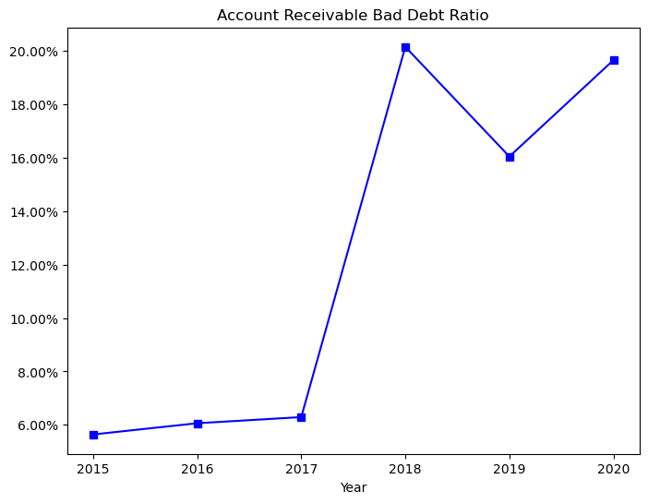
Figure 4. Accounts Receivable Bad Debt Ratio

Accounts Receivable Bad Debt Ratio increased sharply in 2018 and remained high afterwards, suggesting that the collectability of receivables became worse. Overall, these indicators support a possible simple fraud pattern, where inflated sales increased reported revenue and profit but did not generate matching cash collection.

2.2 Complex Fraud Pattern
The complex fraud pattern is assessed through other receivables and prepayments, which may capture unusual fund flows outside normal sales. Since Kang Dexin’s disclosed fraud mainly focused on fabricated sales and inflated costs and expenses, these ratios are treated as supplementary warning signals rather than direct proof of fraud.
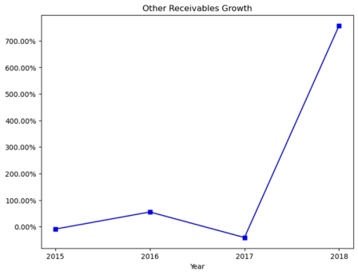
Figure 5. Other Receivables Growth

Figure 5 shows the growth rate of other receivables. It fluctuated moderately from 2015 to 2017, but rose sharply in 2018 to over 700%. This sudden increase suggests that large balances may have been transferred into other receivables in the final year. Since other receivables are not directly tied to sales, this abnormal growth may indicate unusual fund flows or transactions lacking clear commercial substance.

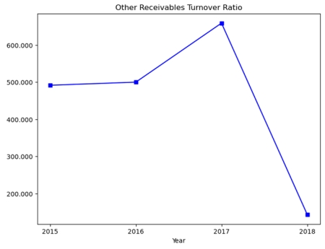
Figure 6. Other Receivables Turnover Ratio

Figure 6 presents the other receivables turnover ratio. The ratio stayed high from 2015 to 2017, but fell significantly in 2018. This means that other receivables were collected or settled more slowly. Together with Figure 5, it suggests that the balance increased while recovery efficiency weakened, which may signal fund occupation, delayed settlement, or hidden transactions.

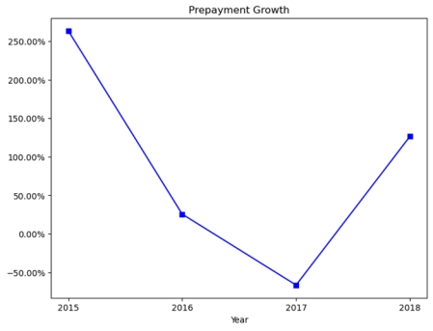
Figure 7. Prepayment Growth

Figure 7 shows prepayment growth. It was high in 2015, declined in 2016, turned negative in 2017, and increased again in 2018. This unstable pattern suggests that advance payments did not follow a normal operating trend. Given Kang Dexin’s fabricated procurement and production costs, abnormal prepayments may reflect unusual payment arrangements.

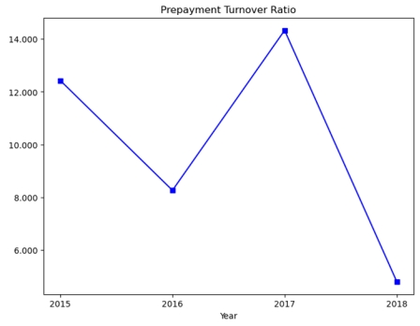
Figure 8. Prepayment Turnover Ratio

Figure 8 shows the prepayment turnover ratio. Although it increased in 2017, it dropped sharply in 2018, suggesting that prepayments were converted into goods, services, or expenses less efficiently. Together with the rebound in prepayment growth, this may indicate that more funds were tied up in prepayments.
Overall, these ratios do not prove fraud independently, but they provide supplementary warning signals. The sharp rise in other receivables, weaker turnover efficiency and volatile prepayments suggest that asset-side accounts may have been used to absorb or disguise abnormal transactions during the fraud period.

2.3 Cost-inflating Fraud Pattern
For the detection of potential cost-inflating fraud, this section will examine Accounts Payable, COGS, Inventory and Sales trends to assess whether the company Kang Dexin inflates COGS.

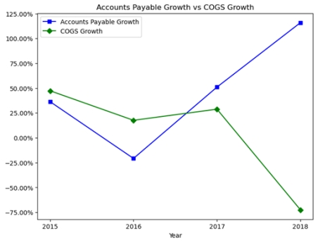
Figure 9. Growth in Accounts Payable vs Growth in COGS

Figure 9 shows that in 2015 and 2016, the growth in Accounts Payable is consistently lower than the growth in COGS. For the period of 2015-2017, more detection should be done on the Inventory side since there is no clear signal for cost inflating in the Accounts Payable side. However, after 2016, there is an increase in the growth of the former one while the latter one declines from 2017 to 2018. In normal business operation, the changes in Accounts Payable should be in a similar proportion of that of COGS and suppliers can hardly allow the Accounts Payable to increase that significantly. The significant excess of Accounts Payable growth over COGS growth in 2018 suggests that at least part of the inflated purchase of Inventory is transferred to COGS.

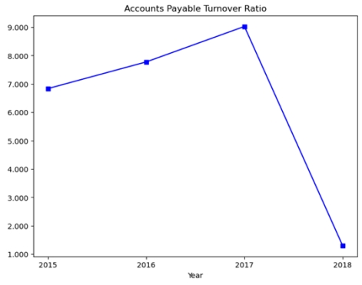
Figure 10. Accounts Payable Turnover Ratio

From 2015 to 2017, there is a consistent increase in the Accounts Payable Turnover Ratio while in 2018, the ratio drops sharply from nearly 9 to around 1 (see Figure 10). For the period of 2015-2017, there are still limited evidence that suggests an abnormal trend of Accounts Payable which may lead to an inflated purchase. However, the dramatic decrease in 2018 is quite significant and abnormal, further suggesting that in 2018, the growth in Accounts Payable is larger than that in COGS and the Accounts Payable Turnover Ratio is deflating. Together with Figure 9, it indicates that the company inflates the purchase of Inventory and partly transfers them to COGS.

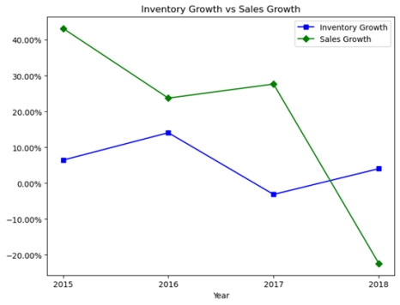
Figure 11. Growth in Inventory vs Growth in Sales

A further detection on the ending balance of Inventory should also be conducted. For the comparison between the growth in Inventory and the growth in Sales, the former one is significantly lower than the latter one from 2015 to 2017, while in 2018, Sales growth drops dramatically and is lower than Inventory growth (see Figure 11). Normally, the Inventory growth should be aligned with the Sales growth to guarantee a healthy operation of the business. Yet the growth of Inventory is significantly smaller than the growth of Sales from 2015 to 2017, indicating that the ending balance of Inventory is deflating. While beginning balance of Inventory + purchase of Inventory = COGS + ending balance of Inventory, a deflated ending Inventory can lead to an inflated COGS. That is consistent with Figure 9 where the growth of COGS is higher than the growth of Inventory. For the year 2018, the inflated purchase of Inventory is highly possible to transfer into the ending balance of Inventory, causing an inflated ending Inventory.

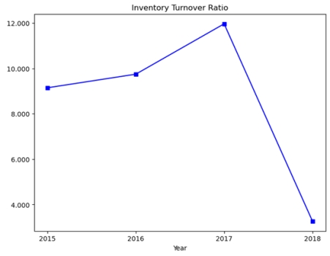
Figure 12. Inventory Turnover Ratio

Figure 12 suggests a similar situation with Figure 10. The Inventory Turnover Ratio also increases from 2015 to 2017 and then declines sharply from around 12 to below 4. The increase from 2015 to 2017 suggests a deflated ending Inventory to inflate COGS, which is consistent with Figure 11. In 2018, the dramatic decline is abnormal, indicating an inflated Inventory. Together with the previous figure showing inventory growth larger than sales growth, it suggests that part of the inflated purchase is retained in the ending inventory.

2.4 Cash Fraud Pattern
Cash fraud is assessed by whether high reported cash coexists with high debt and high financial expenses. This contradiction may indicate that the reported cash is overstated or not fully available. Figure 13 shows the four indicators: CASH_T, DEBT_T, FINEXP_T and CASH_FRAUD.

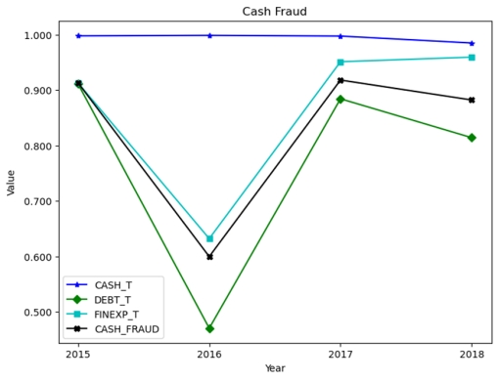
Figure 13. Cash Fraud Indicators: CASH_T, DEBT_T, FINEXP_T, CASH_FRAUD

CASH_T: It is clear that the data of CASH_T for the company remained stable above 0.99 from 2015 to 2018, far exceeding the critical threshold of 0.7. The proportion of monetary funds to total assets was relatively high. Meanwhile,
DEBT_T: Although the figure dropped to 0.47 in 2016, it significantly increased to 0.88 in 2017 and remained above 0.80 in 2018. This suggests that DEBT_T also exceeded the value of 0.7 in the crucial fraud year.
FINEXP_T: The data showed the same trend as DEBT_T, plummeting from 0.91 in 2015 to 0.63 in 2016 and then rebounding to about 0.95 in the remaining two years.
CASH_FRAUD: Its data was 0.91 in the first year, then dropped to 0.60 in the second year, but it remained above 0.88 in the end.
Cash fraud is indicated when all four ratios exceed the 0.7 threshold simultaneously, reflecting the high cash + high debt paradox and abnormal financial costs. The persistence of an exceptionally high cash ratio alone raises a red flag for potential cash overstatement. In normal business activities, such substantial liquidity would reduce both debt and financial expenses. However, this did not appear to be the case for Kang Dexin. In 2017 and 2018, the other three ratios all exceeded 0.7, which indicates the high possibility of accounting fraud because of the high cash, high debt, and high financial expenses. A possible justification for a high-cash, high-debt structure would be that the company borrowed at low interest rates and invested the funds in short-term assets with higher returns, which should reduce net financial expenses. However, this explanation does not fit Kang Dexin, because its financial expenses remained high despite the reported high cash balance.

Presentation and summary of flow charts
Based on the ratio analysis above, the main fraud warning signals can be summarised in the following flow charts. The charts show how different indicators are connected across the four fraud patterns: simple fraud, complex fraud, cost-inflating fraud and cash fraud.

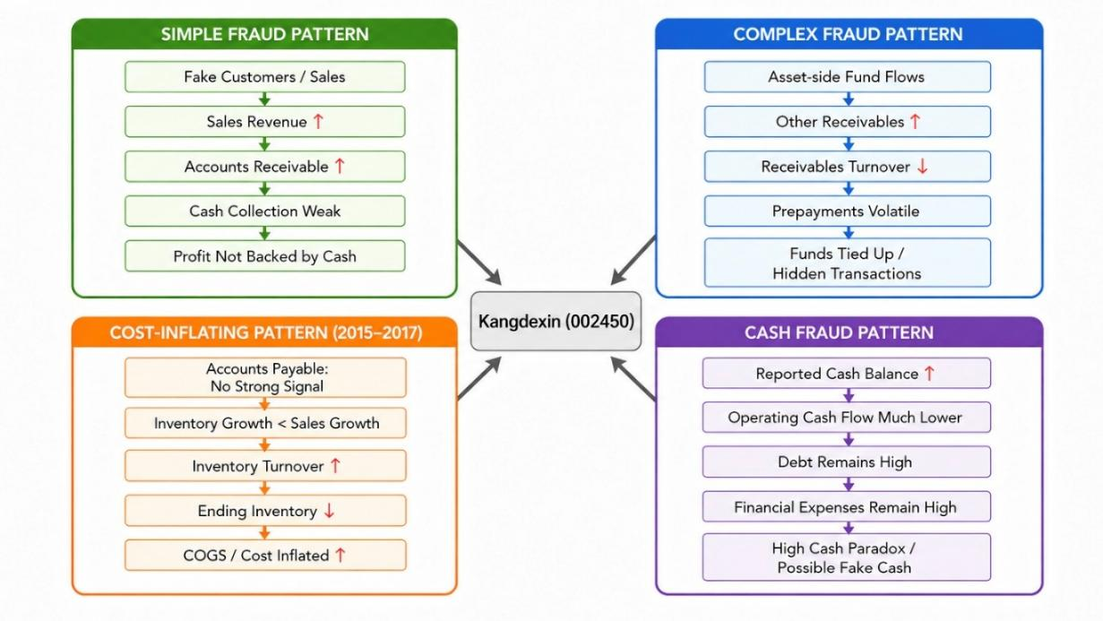
Figure 14. Fraud Indicator Summary for 2015-2017

For 2015-2017, the flow chart shows that simple fraud may begin with false sales, which increased reported sales revenue and accounts receivable. However, weak cash collection and poor operating cash flow suggest that the reported profit has not been fully realised as cash.
The various fraud patterns are shown in abnormal asset accounts, such as other receivables and prepayments. These accounts may be abnormal fund flows, but they are only auxiliary warning signals.
The principal type of cost-inflating fraud during this period was inventory. Accounts payable did not show a strong abnormal signal, and the growth rate of inventory was significantly lower than that of sales; inventory turnover increased. Therefore, the ending inventory may have been underestimated and thus COGS.
Cash fraud is shown by the high-cash, high-debt and high-financial-expense contradiction. If the stated cash on hand was readily available for use, then debt and other financing expenses would be relatively low.

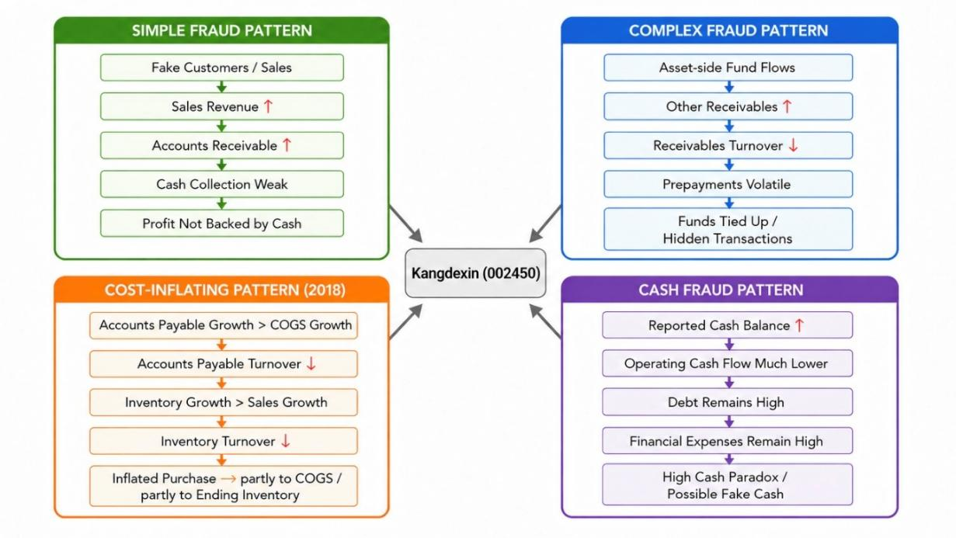
Figure 15. Fraud Indicator Summary for 2018

The Cost-of-Living Adjustment has changed in 2018. Accounts payable is now a more significant warning indicator because its growth has fallen short of the increase in COGS, and the accounts payable turnover rate has declined.
At the same time, inventory increased at a faster rate than sales and the inventory turnover ratio fell sharply. Thus, the excess purchase amount may have been recognised as cost of goods sold and included in the end-of-period inventory figures. Therefore, compared with 2015-2017, the pattern in 2018 was no longer mainly a decrease in ending inventory but rather a mixed pattern of inflated accounts payable, increased purchases, increased cost of goods sold and higher ending inventory.
The two flowcharts show that Kang Dexin's fraud indicators were interlinked to some extent. Several ratios can be used in combination to detect an abnormal development of the company.

CSRC Punishments and Overall Conclusion
The CSRC issued administrative penalties against Kang Dexin and its responsible individuals. The company was ordered to make corrections, received a warning and was fined RMB 600,000. Zhong Yu, the actual controller and former chairman, was warned and fined RMB 900,000; other responsible persons, such as Yu, Xu Shu, Zhang Lixiong and Xiao Peng, also received warnings and fines (China Securities Regulatory Commission, 2020).
Generally speaking, the CSRC's punishment confirms the severity of Kang Dexin's financial fraud and supports the warning signals that ratio analysis uncovered. Simple fraud indicators suggest inflated sales and weak cash collection; complex fraud indicators reveal abnormal movements in assets; cost-inflation indicators show suspicious patterns of inventory and payables; and the cash fraud model indicates the contradiction among high cash, high debt and high financial expenses. This case shows that fraud detection should consider multiple financial ratios rather than relying on a single indicator.

References
China Securities Regulatory Commission (2020) 中国证监会行政处罚决定书（康得新、钟玉等13人） [Administrative Penalty Decision of the China Securities Regulatory Commission: Kang Dexin, Zhong Yu and others]. Available at: https://www.csrc.gov.cn/csrc/c101928/c1042302/content.shtml (Accessed: 29 May 2026).

Kang Dexin Composite Material Group Co., Ltd. (2019) 康得新复合材料集团股份有限公司关于收到中国证监会行政处罚及市场禁入事先告知书的公告 [Announcement on receipt of the CSRC advance notice of administrative penalty and market-entry ban]. Available at: https://www.cninfo.com.cn/new/disclosure/detail?plate=szse&orgId=9900013433&stockCode=002450&announcementId=1206430456&announcementTime=2019-07-06 (Accessed: 29 May 2026).

MarketScreener (no date) Company Kangde Xin Composite Material Group Co., Ltd. Available at: https://www.marketscreener.com/quote/stock/KANGDE-XIN-COMPOSITE-MATE-6660664/company/ (Accessed: 29 May 2026).

