XI’AN JIAOTONG-LIVERPOOL UNIVERSITY
西 交 利 物 浦 大 学
COURSEWORK SUBMISSION COVER SHEET
Name | Liu (Surname) | Jingwei (Other Names)
Student Number | 2253336
Programme | Bachelor of Accounting (BA)
Module Title | FYP - ACCOUNTING
Module Code | ACC304
Assignment Title | CASE A REPORT
Submission Deadline | MAY 31st, 2026
Module Leader | Mohamed Omran

By uploading or submitting this coursework submission cover sheet, I certify the following:
- I have read and understood the definitions of collusion, copying, plagiarism, dishonest use of data, and academic offences involving Artificial Intelligence (AI) as outlined in the Academic Integrity Policy of Xi’an Jiaotong-Liverpool University.
- This work is my own, original work produced specifically for this assignment. It does not misrepresent the work of another person or institution, nor does it present the work generated by AI as my own. Additionally, it is a submission that has not been previously published, or submitted to another module.
- This work is not the product of unauthorized collaboration between myself and others.
- This work is free of embellished or fabricated data.
I understand that collusion, copying, plagiarism, dishonest use of data, academic offences involving AI, and submitting procured work are serious academic misconduct. By uploading or submitting this cover sheet, I acknowledge that I am subject to disciplinary action if I am found to have committed such acts.
Signature ………Jingwei Liu………………… Date ………2026/5/31…………………

For Academic Office use: | Date Received | Working Days Late | Penalty1

1 Please refer to clause 43 (i), (ii) and (iii) of the Code of Practice on Assessment for the standard system of penalties for the late submission of assessment work based on working days.
Table of Contents
Section 1: Introduction 5
Section 2: Financial Performance Analysis of Sinopec Group 7
2.1 Profitability 7
2.2 Liquidity 9
2.3 Solvency 11
2.4 Efficiency 13
2.5 Integrated Financial Summary 14
Section 3: Non-Financial (ESG) Performance Analysis 15
3.1 Environmental (E) 15
3.2 Social (S) 18
3.3 Governance (G) 19
3.4 Integrated ESG Summary 21
Section 4: Synthesis and Integrated Conclusion 22
4.1 Overall Assessment 22
4.2 Financial Strengths and ESG Tensions 22
4.3 Forward-looking Recommendation 23
References 24

Table of Tables
Table 1. Profitability Ratios of Sinopec and CNOOC, 2020-2024 8
Table 2. Liquidity Ratios and Net Working Capital of Sinopec and CNOOC, 2020-2024 9
Table 3. Solvency Ratios of Sinopec and CNOOC, 2020-2024 11
Table 4. Efficiency Ratios of Sinopec and CNOOC, 2020-2024 13
Table 5. ESG Rating Heatmap of Sinopec and CNOOC, 2020-2024 15
Table 6. Shareholder Governance Signals of Sinopec and CNOOC, 2020-2024 20
Table 7. Sustainability Reporting Quality Checklist of Sinopec and CNOOC, 2024 21

Table of Figures
Figure 1. Sinopec Segment Revenue and Operating Profit/(Loss), 2024 5
Figure 2. Profitability Ratio Trends of Sinopec and CNOOC, 2020-2024 8
Figure 3. Liquidity Ratios and Net Working Capital of Sinopec and CNOOC, 2020-2024 10
Figure 4. Solvency Ratio Trends of Sinopec and CNOOC, 2020-2024 12
Figure 5. Efficiency Ratio Trends of Sinopec and CNOOC, 2020-2024 13
Figure 6. Indexed Combined Scope 1 and Scope 2 Emissions of Sinopec and CNOOC, 2020-2024 (2020=100) 16
Figure 7. 2024 Low-carbon Transition Evidence of Sinopec and CNOOC 17
Figure 8. Indexed Fresh Water Withdrawal of Sinopec and CNOOC, 2020-2024 (2020=100) 17
Figure 9. Safety and Employee Development Indicators of Sinopec and CNOOC, 2020-2024 18
Figure 10. Diversity and Community Evidence of Sinopec and CNOOC, 2020-2024 19
Figure 11. Board Independence of Sinopec and CNOOC, 2020-2024 20

Section 1: Introduction
China Petrochemical Corporation (Sinopec Group) is one of China’s largest state-owned integrated energy and petrochemical groups, with businesses spanning upstream exploration and production, pipeline transportation, refining, chemicals, petroleum product marketing and emerging energy services. Its listed subsidiary, China Petroleum & Chemical Corporation (Sinopec Corp.), was established in 2000 through the reorganisation of Sinopec Group’s core petroleum and petrochemical assets, and Sinopec Group remains Sinopec Corp.’s largest and controlling shareholder (Sinopec Corp., 2025a). With significant refining capacity and a broad role in petroleum and chemical supply chains, Sinopec has relevance beyond the domestic market. The group’s state-owned background may support strategic stability and alignment with national energy priorities, while also requiring investment assessment to consider shareholder value alongside policy-driven transition objectives. Its performance is therefore sensitive to oil-price volatility, refining and chemical margins, working-capital pressure and energy-transition execution.
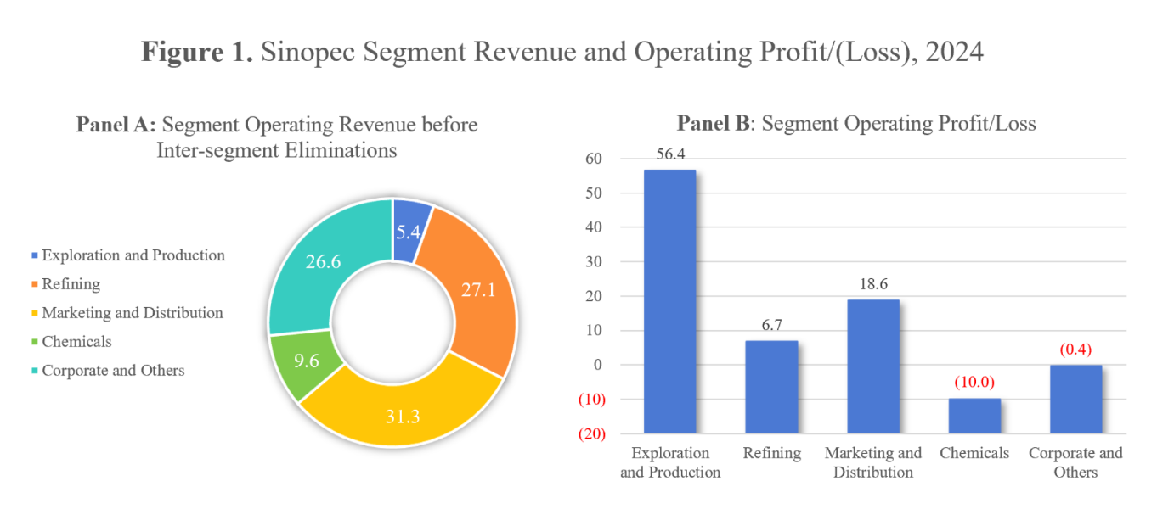
Figure 1. Sinopec Segment Revenue and Operating Profit/(Loss), 2024
Source: Compiled from Sinopec Corp. (2025a).
On a pre-elimination basis, Sinopec’s segment operating revenue in 2024 was primarily generated by Marketing and Distribution, Refining, and Corporate and Others, as illustrated in Figure 1. Operating profit did not follow the same pattern: Exploration and Production was the largest profit contributor, whereas Chemicals posted an operating loss. For client-facing investment assessment, this comparison reveals that Sinopec’s revenue size does not guarantee shareholder value, because its integrated model is dominated by downstream businesses and faces risks from refining margins, petrochemical cycles, inventory movements and transport-fuel substitution. The report therefore uses CNOOC Limited as a benchmark, since it is another major Chinese listed energy company with a more upstream-focused business profile and is subject to a broadly similar industry and regulatory environment. This benchmark helps differentiate general oil and gas industry conditions from Sinopec-specific exposure arising from its downstream-heavy model.
The review period of 2020-2024 is especially telling, as it encompasses both the post-pandemic recovery and a more challenging stage of structural adjustment. China’s petroleum fuel-demand growth has decelerated as energy efficiency improves and new energy vehicle adoption increasingly substitutes gasoline and diesel consumption (IEA, 2025; Reuters, 2025a). Meanwhile, global oil demand growth is likely to level off toward the end of the decade, and oil and gas firms face pressure to balance profitability, energy security, capital discipline and decarbonisation investment (IEA, 2024; McKinsey & Company, 2024). The effect of these pressures is already evident in Sinopec’s 2024 performance, where lower crude prices, reduced refining margins and demand shifts contributed to weaker profits (Reuters, 2025b).
For this reason, Sinopec’s financial and non-financial (ESG) performance is assessed over 2020-2024 to provide investment recommendations and advice to clients. Instead of treating financial and ESG performance as separate checklists, the report combines both strands to evaluate Sinopec’s resilience, transition readiness and investment implications. Section 2 compares Sinopec with CNOOC in terms of profitability, liquidity, solvency and efficiency to assess relative financial resilience. Section 3 analyses environmental, social and governance performance for assessing transition readiness, stakeholder exposure and reporting credibility. Finally, Section 4 brings together the findings to form an overall assessment of Sinopec’s long-term viability, strategic direction and investment implications for clients.

Section 2: Financial Performance Analysis of Sinopec Group
Evaluating Sinopec’s earnings capacity, liquidity flexibility and funding resilience is key to assessing whether its financial performance can support both traditional business operations and energy-transition investment. Based on Sinopec Corp. as the practical financial proxy and CNOOC as the benchmark, this section reviews the company’s performance from 2020 to 2024 in terms of profitability, liquidity, solvency and efficiency. Since Sinopec and CNOOC operate in the same broad industry and regulatory environment, but differ in business profile, with Sinopec being more downstream-focused, CNOOC is an appropriate comparator for filtering out wider energy-cycle effects and identifying Sinopec-specific downstream exposure (CNOOC Limited, 2025a). Each subsection discusses the ratio category, provides a summary table of the key ratios and an integrated figure, and draws conclusions based on business drivers such as refining margins, chemical performance, working-capital pressure, capital expenditure needs and supply-chain efficiency.

2.1 Profitability
Profitability measures Sinopec’s ability to generate returns from its large asset base, capital resources and revenue scale. Profitability ratios assess profit generation from revenue and assets, including ROA, ROE, net profit margin and operating profit margin (CFA Institute, 2026). For Sinopec, this depends not only on higher sales volume, but also on oil-price cycles, refining margins, petrochemical spreads, and marketing and chemical segment performance. Table 1 lists Sinopec’s and CNOOC’s profitability ratios from 2020 to 2024, while Figure 2 shows the five-year trends.
Table 1. Profitability Ratios of Sinopec and CNOOC, 2020-2024
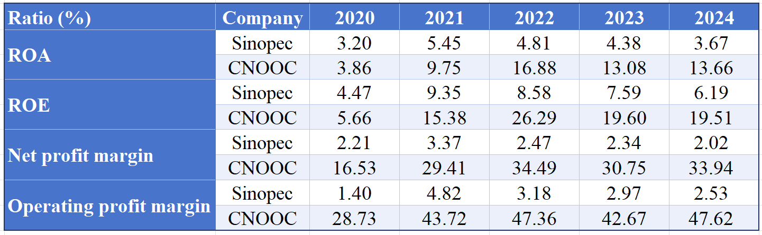
Source: Financial data for Tables 1-4 and Figures 2-5 are calculated from Sinopec Corp. and CNOOC Limited annual reports, 2020-2024; see Excel Appendix for ratio calculations.
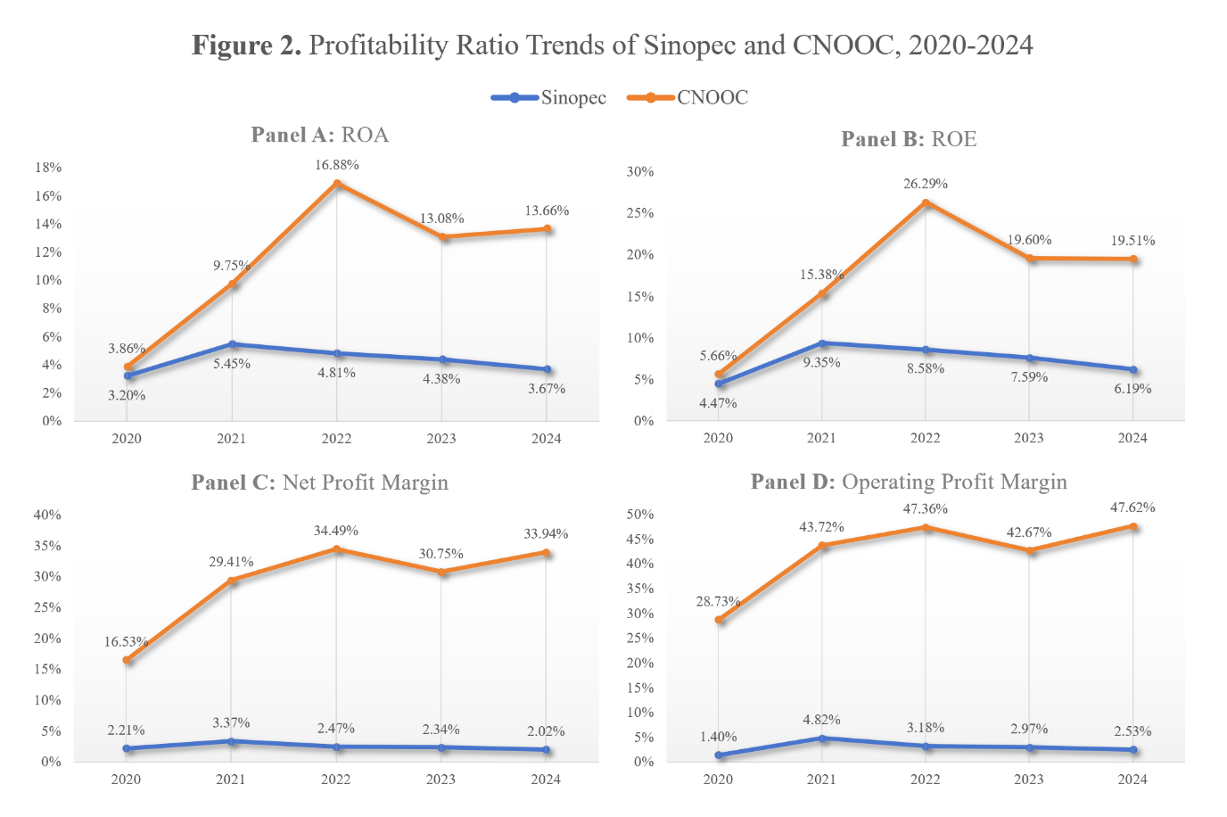
Figure 2. Profitability Ratio Trends of Sinopec and CNOOC, 2020-2024
As shown in Table 1 and Figure 2, Sinopec’s profitability improved sharply in 2021 but weakened thereafter across all four indicators. ROA increased from 3.20% in 2020 to 5.45% in 2021 before falling to 3.67% in 2024, while ROE rose from 4.47% to 9.35% and then declined to 6.19%. These return-based ratios suggest that Sinopec became more effective in converting assets and shareholders’ equity into profit during the post-pandemic recovery, but this ability softened after 2021. The margin-based indicators show a similar pattern: net profit margin rose to 3.37% in 2021 but fell to 2.02% in 2024, while operating profit margin declined from 4.82% to 2.53%. This indicates that profitability pressure was not limited to capital returns, but also reflected weaker earnings conversion from revenue.
This deterioration appears closely linked to Sinopec’s downstream-heavy business model. The company benefited from stronger demand recovery and improved refining economics in 2021, when refining margin increased to RMB532 per tonne. However, refining margin later fell to RMB344 per tonne in 2022 and RMB304 per tonne in 2024, while the chemicals segment became loss-making and remained weak (Sinopec Corp., 2022a, 2023a, 2025a). Relative to CNOOC, Sinopec remained materially less profitable across all four indicators. This comparison suggests that Sinopec’s scale and integration provided some operating resilience, but its lower-margin downstream exposure made its profitability less robust than CNOOC’s upstream-focused model.

2.2 Liquidity
Liquidity evaluates Sinopec’s ability to meet short-term obligations without relying excessively on refinancing or delayed payments. For an integrated energy and petrochemical company, working-capital flexibility is influenced by inventories, receivables, payables and short-term borrowings. Therefore, the current and quick ratios should be interpreted in the context of net working capital quality rather than in isolation (CFA Institute, 2026). Sinopec’s and CNOOC’s liquidity measures for 2020-2024 are summarised in Table 2 and presented graphically in Figure 3.
Table 2. Liquidity Ratios and Net Working Capital of Sinopec and CNOOC, 2020-2024
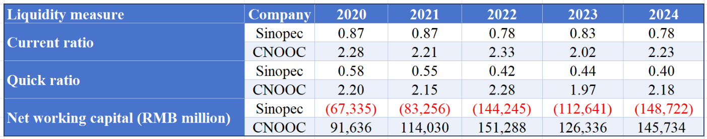
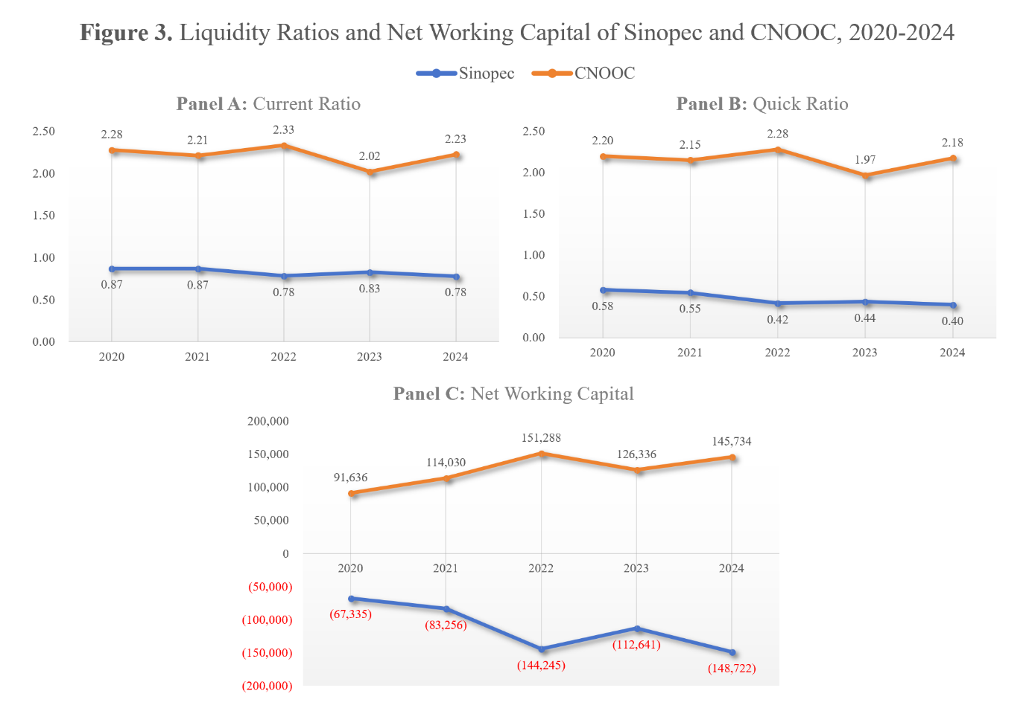
Figure 3. Liquidity Ratios and Net Working Capital of Sinopec and CNOOC, 2020-2024
As shown in Table 2 and Figure 3, Sinopec’s liquidity remained consistently tight throughout the period. Its current ratio stayed below 1.0 in every year, falling from 0.87 in 2020 to 0.78 in 2024, which indicates that current assets did not fully cover current liabilities. The quick ratio presents a stricter picture, declining from 0.58 in 2020 to 0.40 in 2024. This suggests that Sinopec’s immediate liquidity position was weaker than the current ratio alone implies, especially because inventories are significant in refining, chemicals and marketing operations and may be exposed to price and demand conditions before conversion into cash.
Net working capital reinforces this assessment and links the ratio results to working-capital management, which focuses on the balance between current assets and liabilities and affects a company’s ability to meet obligations as they fall due (ACCA, no date). Sinopec recorded negative net working capital throughout 2020-2024, with the deficit widening from RMB67.3 billion to RMB148.7 billion. This suggests that working capital management remained functional but constrained: the company continued to operate at scale, but short-term flexibility depended heavily on inventory turnover, supplier credit and liability management rather than a strong liquid-asset cushion. Sinopec’s annual reports also indicate pressure from inventories, bills payable, short-term loans and liabilities due within one year (Sinopec Corp., 2022a, 2023a, 2024a, 2025a). Compared with CNOOC, which maintained current and quick ratios above 1.9 and positive net working capital, Sinopec showed materially weaker short-term flexibility. For clients, this does not necessarily indicate immediate liquidity distress, but it reduces financial headroom if margins weaken or working-capital needs rise.

2.3 Solvency
Solvency measures whether Sinopec’s long-term capital structure and debt-servicing capacity can sustain a capital-intensive business. Capital structure reflects the mix of debt and equity used to finance assets, while financial leverage may affect financial strength and funding flexibility under different cost, growth and strategic conditions (Zhao and Wijewardana, 2012; CFA Institute, 2026). This is especially critical for Sinopec, which requires substantial and ongoing capital expenditure for refining, chemicals, upstream development and energy-transition activities. Table 3 presents Sinopec’s and CNOOC’s solvency ratios during 2020-2024, while Figure 4 shows the five-year solvency trends.
Table 3. Solvency Ratios of Sinopec and CNOOC, 2020-2024
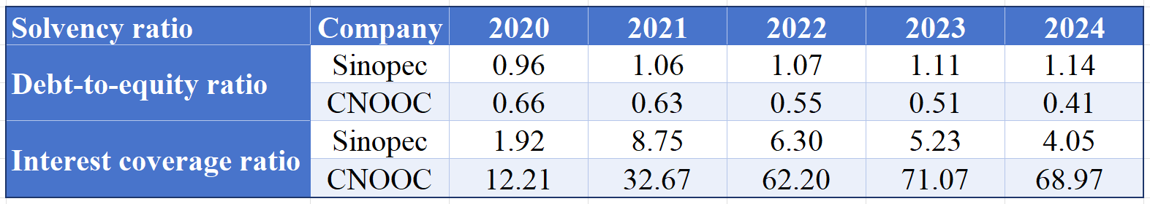
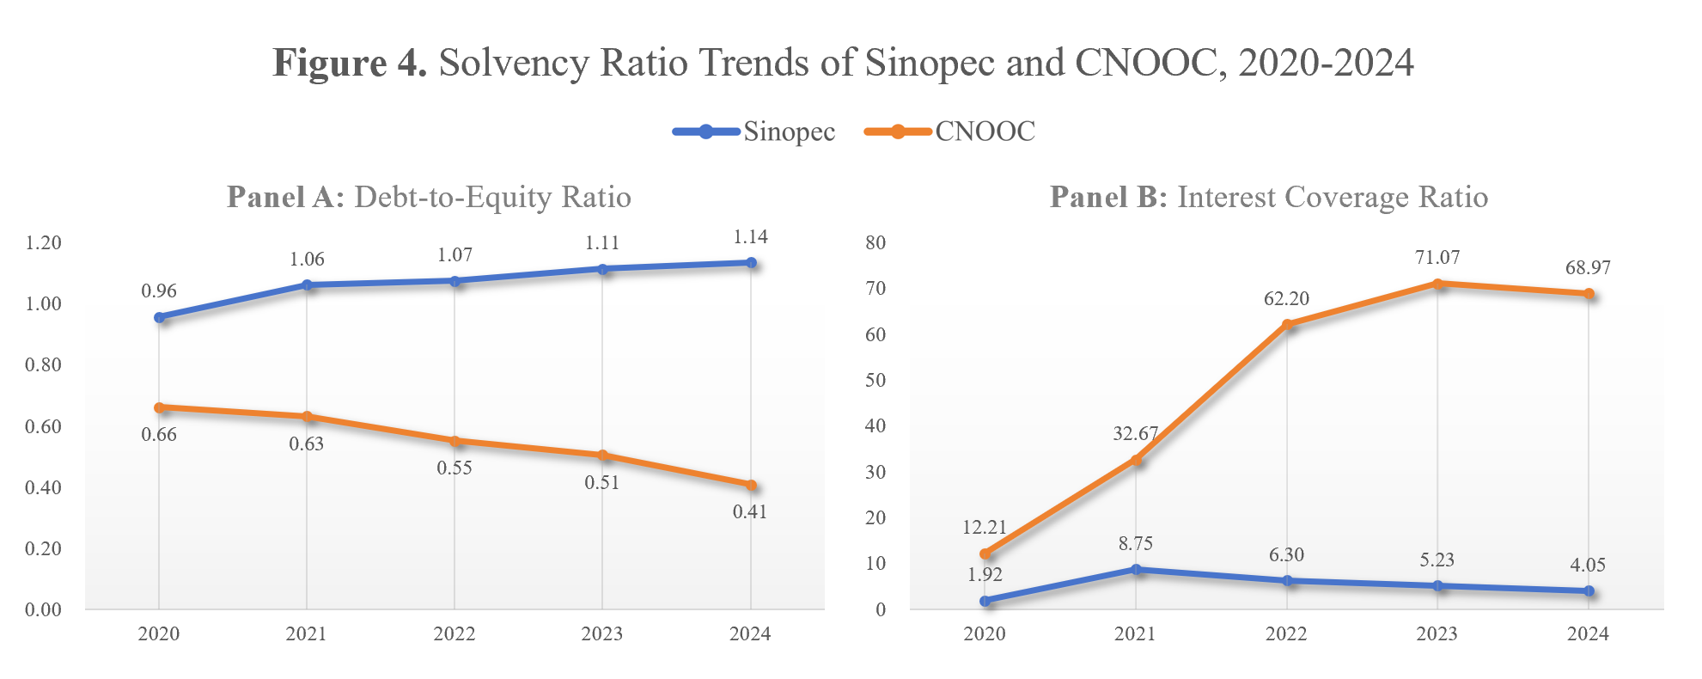
Figure 4. Solvency Ratio Trends of Sinopec and CNOOC, 2020-2024
As shown in Table 3 and Figure 4, Sinopec’s leverage increased gradually over the period. Its debt-to-equity ratio rose from 0.96 in 2020 to 1.14 in 2024, indicating greater reliance on liabilities relative to shareholders’ equity. This does not suggest immediate solvency weakness, but it implies reduced long-term financial flexibility, especially as higher gearing can increase financial risk and make further borrowing more difficult or costly. In contrast, CNOOC’s debt-to-equity ratio declined from 0.66 to 0.41, showing a more conservative capital structure.
Interest coverage provides a more earnings-based view of solvency. Sinopec’s interest coverage ratio improved sharply from 1.92 in 2020 to 8.75 in 2021, but then declined to 4.05 by 2024. Although this remained above 1.0, the downward trend suggests that its debt-servicing buffer narrowed as earnings weakened and financing costs became more relevant. This matters because Sinopec still needs to fund high capital expenditure in upstream development, refining upgrades, integrated energy stations and low-carbon projects, while its annual reports indicate continued investment and active adjustment of capital structure according to operating and investment needs (Sinopec Corp., 2022a, 2023a, 2024a, 2025a). Compared with CNOOC, whose interest coverage remained substantially stronger, Sinopec had less headroom to absorb margin pressure while financing transition-related investment. For clients, Sinopec’s solvency remains manageable, but its funding flexibility is more constrained than CNOOC’s.

2.4 Efficiency
Efficiency measures how effectively Sinopec utilises its asset base and inventory cycle to generate revenue and operating flow. Activity ratios assess the efficiency of using assets and converting resources into sales or cash, with asset turnover and inventory turnover commonly used for this purpose (CFA Institute, 2026). This is particularly applicable to Sinopec, which relies on high asset utilisation in refining, chemicals and marketing, as well as stable throughput and coordinated procurement, storage and distribution. Table 4 shows the efficiency ratios of Sinopec and CNOOC from 2020 to 2024, while Figure 5 presents the full five-year time series.
Table 4. Efficiency Ratios of Sinopec and CNOOC, 2020-2024
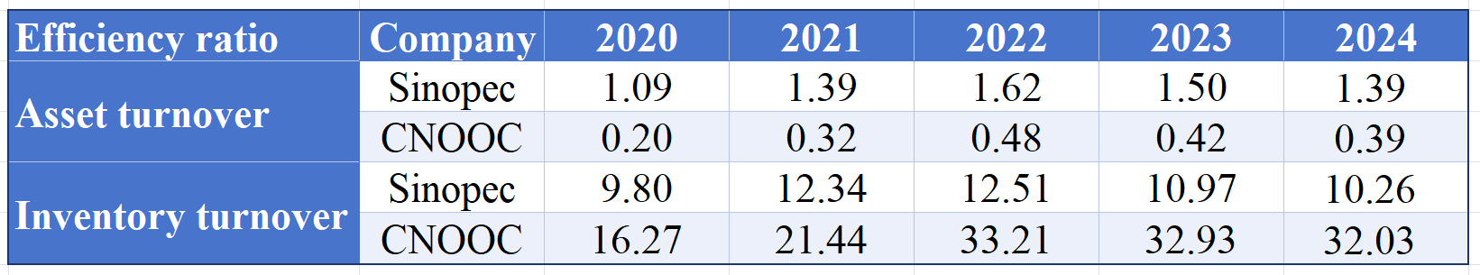
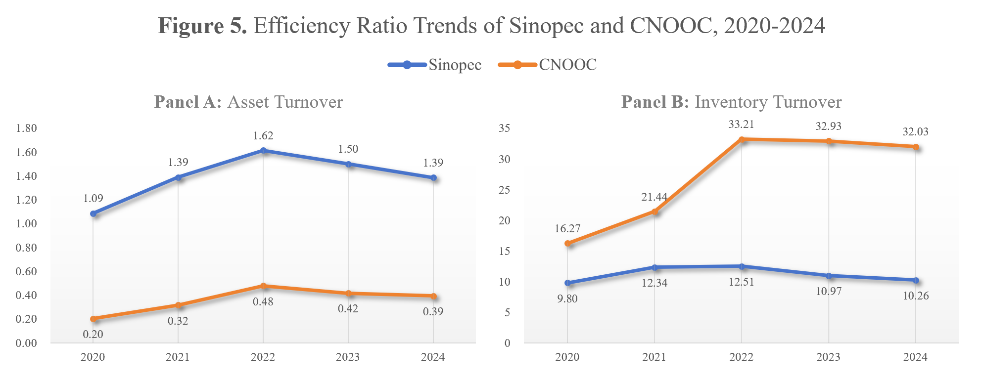
Figure 5. Efficiency Ratio Trends of Sinopec and CNOOC, 2020-2024
As shown in Table 4 and Figure 5, Sinopec’s asset turnover improved during the recovery period but weakened after 2022. It rose from 1.09 in 2020 to 1.39 in 2021 and peaked at 1.62 in 2022, before declining to 1.39 in 2024. This suggests stronger revenue generation from its asset base during the early recovery, but softer efficiency as demand conditions became more challenging. The trend is consistent with Sinopec’s annual reports, which reported stronger refinery throughput and refined-oil sales, including record crude throughput in 2023, before weaker refined-oil demand in 2024 (Sinopec Corp., 2022a, 2024a, 2025a).
Inventory turnover shows a similar but more operationally specific pattern. Sinopec’s inventory turnover increased from 9.80 in 2020 to 12.51 in 2022, before falling to 10.26 in 2024. This indicates stronger inventory use during the recovery phase but weaker efficiency afterward, consistent with softer refined-oil demand, weak chemical margins and inventory-management difficulty in a volatile downstream environment (Sinopec Corp., 2024a, 2025a). Compared with CNOOC, Sinopec had much higher asset turnover, reflecting its sales-intensive downstream model, but its substantially lower inventory turnover suggests a heavier inventory structure and greater dependence on refinery and supply-chain efficiency. For clients, the implication is mixed: Sinopec’s asset base supports revenue generation, but weakening inventory efficiency may limit cash conversion and reinforce working-capital pressure.

2.5 Integrated Financial Summary
Taken together, Tables 1-4 and Figures 2-5 suggest that Sinopec’s financial position in 2020-2024 was serviceable but becoming more constrained. The company maintained advantages in operating scale and revenue-generation efficiency, supported by its downstream marketing network and refining operations. However, these strengths were offset by weaker profitability after the 2021 recovery, persistently tight liquidity, rising leverage and declining inventory efficiency. Compared with CNOOC, Sinopec was less profitable, less liquid and more leveraged, although it had higher asset turnover because of its more downstream-oriented business model. This benchmark indicates that Sinopec’s issue is not immediate financial weakness, but reduced financial headroom. For clients, Sinopec remains investable as a strategically important integrated energy company, but margin performance, working-capital management and the ability to finance transition investment without further impairing financial flexibility remain key conditions.

Section 3: Non-Financial (ESG) Performance Analysis
Sinopec’s investment assessment is materially affected by the company’s environmental, social and governance (ESG) performance, as Sinopec operates in a carbon-intensive, safety-sensitive and highly regulated energy and petrochemical sector where non-financial factors may influence regulatory exposure, operating resilience and long-term value creation. From an investment point of view, the environmental pillar represents transition readiness, emissions management and resource efficiency; the social pillar reflects employee safety, human-capital management and stakeholder relations; and governance indicates the quality of oversight, accountability and disclosure. Thus, ESG factors must be considered in responsible investment because they may affect the risk and return of long-term investments (Principles for Responsible Investment [PRI], no date). In this section, Sinopec’s ESG performance from 2020 to 2024 is assessed using both rating evidence and indicator evidence, with CNOOC used as the comparator. Sinopec’s relative ESG position is first shown in the overall heatmap in Table 5. It reveals that Sinopec’s overall ESG profile improved over the period, but performance across the three pillars remained uneven, while the CNOOC benchmark also helps identify whether the changes reflect company-specific performance or wider industry conditions.
Table 5. ESG Rating Heatmap of Sinopec and CNOOC, 2020-2024
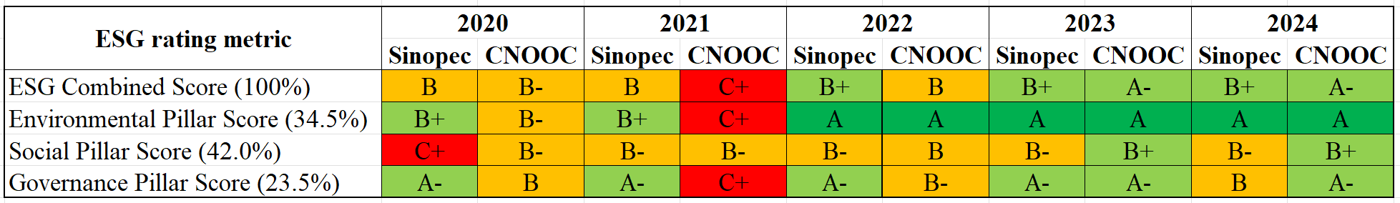
Source: ESG data for Tables 5-7 and Figures 6-11 are compiled from Sinopec Corp. and CNOOC Limited sustainability/ESG reports, 2020-2024.

3.1 Environmental (E)
The environmental pillar refers to how Sinopec manages emissions, resource use and the transition towards lower-carbon energy activities. For a refining, chemicals and fuel-marketing company, this pillar is material to carbon exposure, water pressure and transition risk; therefore, it is assessed through emissions progress, clean-energy strategy and wider environmental management issues (IFRS Foundation, 2023; IEA, 2023).

Figure 6. Indexed Combined Scope 1 and Scope 2 Emissions of Sinopec and CNOOC, 2020-2024 (2020=100)
Sinopec has set a phased decarbonisation pathway, including peaking carbon emissions before 2030, reducing emissions by more than 25% from the peak by 2040 and aiming for carbon neutrality around 2050 (Sinopec Corp., 2025a). As shown in Figure 6, Sinopec’s indexed Scope 1 and Scope 2 emissions remained broadly stable from 2020 to 2024, ending slightly below the 2020 baseline at 98.25. In contrast, CNOOC’s index increased to 136.88, suggesting stronger operational emissions control by Sinopec. However, this should be interpreted cautiously because Sinopec’s absolute emissions base remains larger due to its refining and petrochemical scale.
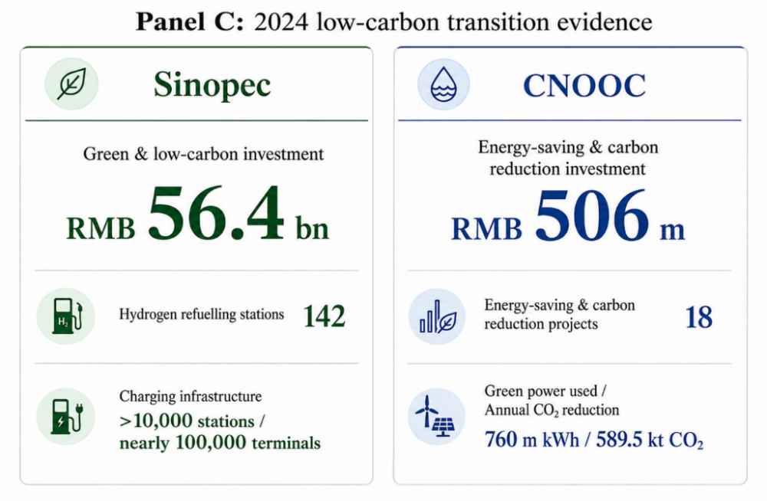
Figure 7. 2024 Low-carbon Transition Evidence of Sinopec and CNOOC
For clean energy, Figure 7 shows RMB56.4 billion of green and low-carbon investment, 142 hydrogen refuelling stations and more than 10,000 charging/swapping stations, supporting Sinopec’s expansion into green hydrogen and electric vehicle (EV) charging infrastructure. Sinopec also discloses initiatives in biofuels, geothermal energy, carbon capture, utilisation and storage (CCUS) and methane reduction, while CNOOC’s 2024 evidence is more operation-based, focusing on energy-saving projects, green power replacement and annual CO₂ reduction (Sinopec Corp., 2025a; CNOOC Limited, 2025a).

Figure 8. Indexed Fresh Water Withdrawal of Sinopec and CNOOC, 2020-2024 (2020=100)
For wider environmental issues, Figure 8 shows Sinopec’s fresh-water withdrawal declined to 95.9 of the 2020 level, while CNOOC’s increased to 116.0, supporting a more favourable view of Sinopec’s water management. Nevertheless, flaring reduction and circular economy/plastic waste initiatives remain important for oil and petrochemical companies (World Bank, 2024; OECD, 2022). Overall, Sinopec’s environmental profile is improving, but its transition progress still needs to offset the carbon and resource intensity of its traditional businesses.

3.2 Social (S)
The social pillar captures how Sinopec manages its responsibilities towards employees, contractors, communities and other affected stakeholders. In this report, it is assessed through workplace safety, employee development, diversity and inclusion, and community relations, as these issues affect operational resilience, workforce quality and social licence to operate (International Labour Organization, 2022; International Finance Corporation [IFC], 2012).
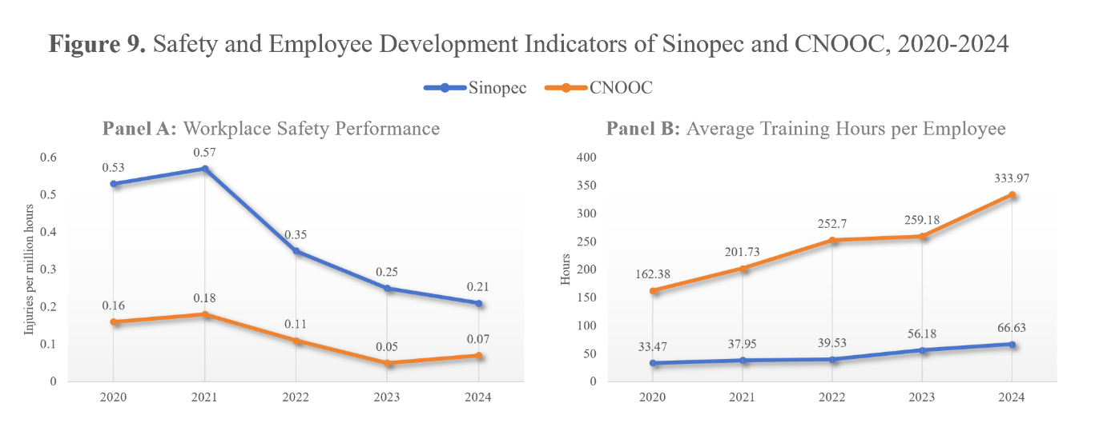
Figure 9. Safety and Employee Development Indicators of Sinopec and CNOOC, 2020-2024
In workplace safety, Figure 9 shows that Sinopec’s injuries per million working hours dropped from 0.53 in 2020 to 0.21 in 2024, indicating stronger safety control. CNOOC, however, maintained a lower injury rate, which decreased from 0.16 to 0.07 over the same period. In terms of employee development, Figure 9 reveals that Sinopec increased its human-capital investment by raising average training hours from 33.47 to 66.63. However, this was still much lower than CNOOC’s 333.97 hours in 2024, suggesting that Sinopec still lagged behind the benchmark in training depth.
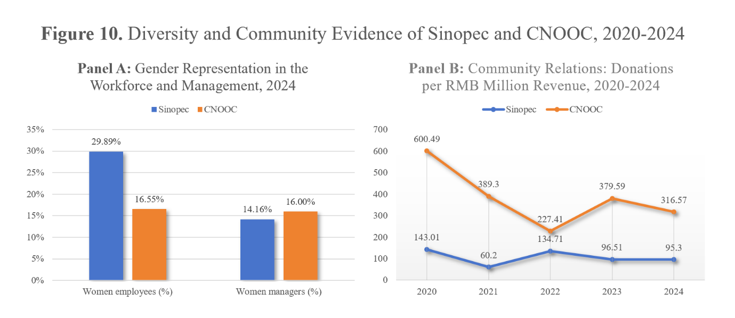
Figure 10. Diversity and Community Evidence of Sinopec and CNOOC, 2020-2024
For diversity and inclusion, Figure 10 shows that Sinopec had a higher proportion of women employees than CNOOC in 2024, at 29.89% compared with 16.55%. However, its women managers ratio was only 14.16%, slightly below CNOOC’s 16.00%, suggesting that workforce-level diversity has not fully translated into leadership inclusion. This gap is relevant because gender diversity in senior management is widely viewed as an important workforce equality and governance issue (OECD, 2022). In community relations, as shown in Figure 10, Sinopec’s community contribution intensity was lower than CNOOC’s from 2020 to 2024, with donations per RMB million of revenue remaining below the benchmark throughout the period. Sinopec’s social performance has improved, but it is still weaker than CNOOC in areas such as safety intensity, training depth, leadership inclusion and community engagement, all of which are important for gaining and sustaining social licence to operate (IFC, 2012).

3.3 Governance (G)
The governance pillar concerns how Sinopec is directed, monitored and held accountable through board oversight, ownership influence and reporting systems. For investors, it is material to strategic decision-making, minority-shareholder protection and ESG information reliability, especially where climate governance and state ownership may affect corporate objectives and capital allocation (IFRS Foundation, 2023; OECD, 2024).

Figure 11. Board Independence of Sinopec and CNOOC, 2020-2024
In terms of board structure, Figure 11 shows that Sinopec’s independent board members increased to 50.00% in 2024, compared with CNOOC’s 36.36%. This suggests stronger formal board independence for Sinopec, which may support oversight of ESG and climate-related risks. This is also consistent with Sinopec’s disclosure that the Board is responsible for ESG governance and that its Sustainability Committee oversees key issues such as climate change, safety and social responsibility (Sinopec Corp., 2025b). However, formal independence should still be interpreted with actual control structures, as governance constraints may remain in state-linked companies.
Table 6. Shareholder Governance Signals of Sinopec and CNOOC, 2020-2024
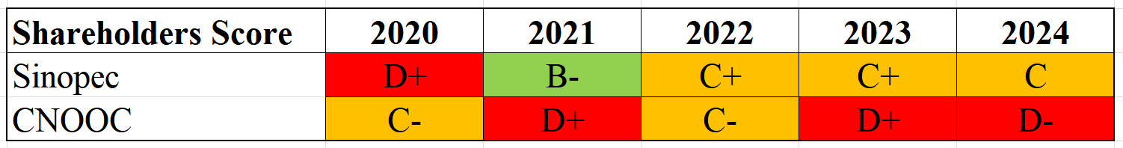
Table 6 shows that both companies remained state-owned enterprises during 2020-2024, but Sinopec’s shareholders score was stronger in 2024, at C compared with CNOOC’s D-. This indicates a relatively stronger shareholder-governance signal for Sinopec, although it remains controlled by Sinopec Group. State ownership may support policy alignment and long-term strategic stability, especially in energy-transition investment, but it may also create minority-shareholder and policy-driven capital-allocation concerns (OECD, 2024; Sinopec Corp., 2025b; CNOOC Limited, 2025b).
Table 7. Sustainability Reporting Quality Checklist of Sinopec and CNOOC, 2024
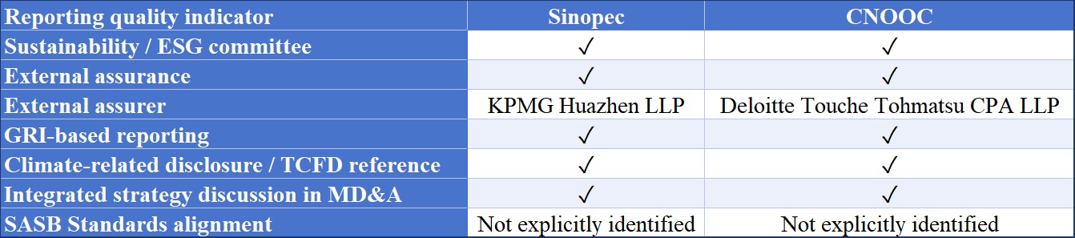
Note: GRI = Global Reporting Initiative; TCFD = Task Force on Climate-related Financial Disclosures; MD&A = Management Discussion and Analysis; SASB = Sustainability Accounting Standards Board.
Regarding reporting transparency, Table 7 shows that both companies disclosed ESG governance arrangements, external assurance by named accounting firms and framework-based reporting. These mechanisms enhance non-financial information credibility, as GRI Standards support structured reporting and IFRS S2 emphasises investor-useful climate disclosures (GRI, 2023; IFRS Foundation, 2023). However, no explicit reference to SASB was found in the ESG data or sustainability reports reviewed, which may affect sector-specific comparability. With state ownership remaining an important governance factor, Sinopec still appears to have an edge over CNOOC in board independence and shareholder score.

3.4 Integrated ESG Summary
Sinopec’s ESG performance profile shows overall improvement, but with mixed trends across the three pillars. Environmentally, relatively stable Scope 1 and Scope 2 emissions, water-use improvement and visible low-carbon infrastructure investment show positive transition signals. Socially, Sinopec still trailed CNOOC in injury intensity, training depth, leadership inclusion and community contribution intensity. In governance, Sinopec exhibited stronger formal board independence and shareholder-governance signals, but state ownership has mixed effects because it can support policy alignment while also raising minority-shareholder and capital-allocation concerns. Thus, Sinopec has a reasonable ESG profile, but its sustainability case relies on whether transition investment can counterbalance the risks from traditional oil, refining and chemical activities (Sinopec Corp., 2025a; CNOOC Limited, 2025a; OECD, 2024).

Section 4: Synthesis and Integrated Conclusion

4.1 Overall Assessment
This section consolidates the financial and ESG data and analysis by evaluating Sinopec’s investment attractiveness, the tension between its traditional business model and sustainability goals, and the opportunities and challenges it may face over the next five years. Overall, Sinopec appears to be a strategically important but increasingly conditional investment case. It has a large downstream network, a closely integrated refining and chemicals base, and visible low-carbon infrastructure investment within China’s energy system (Sinopec Corp., 2025a). However, the investment thesis should still be viewed with caution, as the company’s profitability remains exposed to oil-price cycles, weaker refining margins and chemical-sector weakness. Relative to CNOOC, Sinopec appears less profitable and weaker in several social indicators, although it has stronger formal governance signals and broader downstream transition infrastructure (CNOOC Limited, 2025a; Sinopec Corp., 2025a).

4.2 Financial Strengths and ESG Tensions
The main tension is that Sinopec’s financial resilience still depends heavily on traditional refining, chemicals and petroleum-product demand, while its long-term sustainability requires continued investment in lower-carbon businesses. Its operating scale and manageable solvency position may help fund hydrogen, EV charging, geothermal and other transition initiatives, creating a possible synergy between legacy cash flows and gradual decarbonisation (Sinopec Corp., 2025a). Commitments alone are unlikely to make an energy transition strategy credible; investors also need decision-useful information on climate-related risks, opportunities, metrics and targets (IFRS Foundation, 2023). However, this synergy should not be overstated. The same asset base remains carbon- and resource-intensive, and the oil and gas sector continues to face pressure to reduce operational emissions, methane and flaring while scaling credible low-emission solutions (IEA, 2023). Therefore, Sinopec’s transition strategy appears financially feasible, but does not yet seem strong enough to materially reduce exposure to carbon regulation, fossil-fuel demand uncertainty and margin volatility.

4.3 Forward-looking Recommendation
Over the next five years, Sinopec’s main opportunities are likely to come from China’s energy-security needs, expansion of integrated energy services and potential recovery in refining and chemical margins. Its transition infrastructure, especially hydrogen refuelling and EV charging/swapping stations, may also strengthen its relevance as customer demand gradually shifts towards cleaner mobility and lower-carbon energy services (Sinopec Corp., 2025a). However, these opportunities remain conditional. The main risks are likely to come from weaker profitability than CNOOC, social-performance gaps in safety, training depth and leadership inclusion, and uncertainty over whether low-carbon projects can generate commercially meaningful returns. Governance offers some support, as board independence and reporting infrastructure are relatively strong, although state ownership remains a mixed factor. According to OECD guidance, state ownership may affect the objectives and governance role of state-owned enterprises (SOEs), so investors need to consider both the policy-alignment benefits and the minority-shareholder or capital-allocation concerns (OECD, 2024). While GRI-based reporting and external assurance can enhance the credibility of ESG information, investors should remain mindful of assurance scope, comparability and decision-usefulness (GRI, 2023). Hence, a cautious hold / selective investment recommendation, rather than a strong buy, is more suitable. Clients may maintain exposure to Sinopec, but any increase should be contingent on clearer signs of margin improvement, transition-project returns, reduced emissions intensity, better social metrics and consistent shareholder-governance quality.

References
ACCA (no date) Working capital management. Available at: https://www.accaglobal.com/gb/en/student/exam-support-resources/fundamentals-exams-study-resources/f9/technical-articles/wcm.html (Accessed: 31 May 2026).
CFA Institute (2026) Financial analysis techniques. Available at: https://www.cfainstitute.org/insights/professional-learning/refresher-readings/2026/financial-analysis-techniques (Accessed: 31 May 2026).
CNOOC Limited (2021a) Annual Report 2020. Hong Kong: CNOOC Limited. Available at: https://www.cnoocltd.com/english/investorrelations/reports/annualreport/202409/P020240925659556694484.pdf (Accessed: 31 May 2026).
CNOOC Limited (2021b) Environmental, Social and Governance Report 2020. Hong Kong: CNOOC Limited. Available at: https://www.cnoocltd.com/english/sustainability/environmentalsocialandgovernancereports/202409/P020240925661396771350.pdf (Accessed: 31 May 2026).
CNOOC Limited (2022a) Annual Report 2021. Hong Kong: CNOOC Limited. Available at: https://www.cnoocltd.com/english/investorrelations/reports/annualreport/202409/P020240925659599448565.pdf (Accessed: 31 May 2026).
CNOOC Limited (2022b) Environmental, Social and Governance Report 2021. Hong Kong: CNOOC Limited. Available at: https://www.cnoocltd.com/english/sustainability/environmentalsocialandgovernancereports/202409/P020241216399987105594.pdf (Accessed: 31 May 2026).
CNOOC Limited (2023a) Annual Report 2022. Hong Kong: CNOOC Limited. Available at: https://www.cnoocltd.com/english/investorrelations/reports/annualreport/202409/P020240925659649817016.pdf (Accessed: 31 May 2026).
CNOOC Limited (2023b) Environmental, Social and Governance Report 2022. Hong Kong: CNOOC Limited. Available at: https://www.cnoocltd.com/english/sustainability/environmentalsocialandgovernancereports/202409/P020241216471641747961.pdf (Accessed: 31 May 2026).
CNOOC Limited (2024a) Annual Report 2023. Hong Kong: CNOOC Limited. Available at: https://www.cnoocltd.com/english/investorrelations/reports/annualreport/202409/P020240925659674329475.pdf (Accessed: 31 May 2026).
CNOOC Limited (2024b) Environmental, Social and Governance Report 2023. Hong Kong: CNOOC Limited. Available at: https://www.cnoocltd.com/english/sustainability/environmentalsocialandgovernancereports/202409/P020241216473769449925.pdf (Accessed: 31 May 2026).
CNOOC Limited (2025a) Annual Report 2024. Hong Kong: CNOOC Limited. Available at: https://www.cnoocltd.com/english/investorrelations/reports/annualreport/202504/P020250408585333246566.pdf (Accessed: 31 May 2026).
CNOOC Limited (2025b) Environmental, Social and Governance Report 2024. Hong Kong: CNOOC Limited. Available at: https://www.cnoocltd.com/english/sustainability/environmentalsocialandgovernancereports/202504/P020250408542745334285.pdf (Accessed: 31 May 2026).
Global Reporting Initiative (GRI) (2023) GRI Universal Standards. Available at: https://www.globalreporting.org/standards/standards-development/universal-standards/ (Accessed: 31 May 2026).
IEA (2023) Emissions from Oil and Gas Operations in Net Zero Transitions. Paris: International Energy Agency. Available at: https://www.iea.org/reports/emissions-from-oil-and-gas-operations-in-net-zero-transitions (Accessed: 31 May 2026).
IEA (2024) Oil 2024: Executive summary. Paris: International Energy Agency. Available at: https://www.iea.org/reports/oil-2024/executive-summary (Accessed: 31 May 2026).
IEA (2025) Oil demand for fuels in China has reached a plateau. Paris: International Energy Agency. Available at: https://www.iea.org/commentaries/oil-demand-for-fuels-in-china-has-reached-a-plateau (Accessed: 31 May 2026).
IFRS Foundation (2023) IFRS S2 Climate-related Disclosures. London: IFRS Foundation. Available at: https://www.ifrs.org/content/dam/ifrs/publications/pdf-standards-issb/english/2023/issued/part-a/issb-2023-a-ifrs-s2-climate-related-disclosures.pdf (Accessed: 31 May 2026).
International Finance Corporation (IFC) (2012) Performance Standard 1: Assessment and Management of Environmental and Social Risks and Impacts. Washington, DC: International Finance Corporation. Available at: https://www.ifc.org/content/dam/ifc/doc/2010/2012-ifc-performance-standard-1-en.pdf (Accessed: 31 May 2026).
International Labour Organization (2022) A safe and healthy working environment is a fundamental principle and right at work. Available at: https://www.ilo.org/topics-and-sectors/safety-and-health-work/safe-and-healthy-working-environment-fundamental-principle-and-right-work (Accessed: 31 May 2026).
McKinsey & Company (2024) The State of Energy Organizations 2024. Available at: https://www.mckinsey.com/~/media/mckinsey/industries/oil%20and%20gas/our%20insights/the%20state%20of%20energy%20organizations%202024/the-state-of-energy-organizations-2024.pdf (Accessed: 31 May 2026).
OECD (2022) Enhancing Gender Diversity on Boards and in Senior Management of Listed Companies. Paris: OECD Publishing. Available at: https://www.oecd.org/content/dam/oecd/en/publications/reports/2022/09/enhancing-gender-diversity-on-boards-and-in-senior-management-of-listed-companies_50213bfe/4f7ca695-en.pdf (Accessed: 31 May 2026).
OECD (2024) OECD Guidelines on Corporate Governance of State-Owned Enterprises 2024. Paris: OECD Publishing. Available at: https://www.oecd.org/content/dam/oecd/en/publications/reports/2024/06/oecd-guidelines-on-corporate-governance-of-state-owned-enterprises-2024_68fa05cd/18a24f43-en.pdf (Accessed: 31 May 2026).
Principles for Responsible Investment (PRI) (no date) What are the Principles for Responsible Investment? Available at: https://www.unpri.org/about-PRI/what-principles-for-responsible-investment (Accessed: 31 May 2026).
Reuters (2025a) ‘China’s fuel demand may have passed its peak, IEA says’, Reuters, 13 February. Available at: https://www.reuters.com/business/energy/chinas-fuel-demand-may-have-passed-its-peak-iea-says-2025-02-13/ (Accessed: 31 May 2026).
Reuters (2025b) ‘Sinopec’s 2024 net profit drops 16.8% due to falling oil prices, NEVs’, Reuters, 24 March. Available at: https://www.reuters.com/business/energy/sinopecs-2024-net-profit-plunges-168-due-falling-oil-prices-nevs-2025-03-23/ (Accessed: 31 May 2026).
Sinopec Corp. (2021a) 2020 Annual Report and Accounts. Beijing: China Petroleum & Chemical Corporation. Available at: http://www.sinopec.com/listco/en/annualreport/index.shtml (Accessed: 31 May 2026).
Sinopec Corp. (2021b) 2020 Sinopec Corp. Sustainability Report. Beijing: China Petroleum & Chemical Corporation. Available at: http://www.sinopec.com/u/cms/gfyw/202411/27093617gm73.pdf (Accessed: 31 May 2026).
Sinopec Corp. (2022a) 2021 Annual Report and Accounts. Beijing: China Petroleum & Chemical Corporation. Available at: http://www.sinopec.com/u/cms/gfyw/202411/26140623giq8.pdf (Accessed: 31 May 2026).
Sinopec Corp. (2022b) 2021 Sinopec Corp. Sustainability Report. Beijing: China Petroleum & Chemical Corporation. Available at: http://www.sinopec.com/u/cms/gfyw/202411/27093615cusz.pdf (Accessed: 31 May 2026).
Sinopec Corp. (2023a) 2022 Annual Report and Accounts. Beijing: China Petroleum & Chemical Corporation. Available at: http://www.sinopec.com/u/cms/gfyw/202411/27092756kosx.pdf (Accessed: 31 May 2026).
Sinopec Corp. (2023b) 2022 Sinopec Corp. Sustainability Report. Beijing: China Petroleum & Chemical Corporation. Available at: http://www.sinopec.com/u/cms/gfyw/202411/27093615d6xm.pdf (Accessed: 31 May 2026).
Sinopec Corp. (2024a) 2023 Annual Report and Accounts. Beijing: China Petroleum & Chemical Corporation. Available at: http://www.sinopec.com/u/cms/gfyw/202411/26140620pc04.pdf (Accessed: 31 May 2026).
Sinopec Corp. (2024b) 2023 Sinopec Corp. Sustainability Report. Beijing: China Petroleum & Chemical Corporation. Available at: http://www.sinopec.com/u/cms/gfyw/202411/27093613cz2n.pdf (Accessed: 31 May 2026).
Sinopec Corp. (2025a) 2024 Annual Report and Accounts. Beijing: China Petroleum & Chemical Corporation. Available at: http://www.sinopec.com/u/cms/gfyw/202503/23195200ff76.pdf (Accessed: 31 May 2026).
Sinopec Corp. (2025b) 2024 Sustainability Report. Beijing: China Petroleum & Chemical Corporation. Available at: http://www.sinopec.com/u/cms/gfyw/202503/23204822pyvg.pdf (Accessed: 31 May 2026).
World Bank (2024) 2024 Global Gas Flaring Tracker Report. Washington, DC: World Bank. Available at: https://www.worldbank.org/en/programs/gasflaringreduction/publication/2024-global-gas-flaring-tracker-report (Accessed: 31 May 2026).
Zhao, B. and Wijewardana, W.P. (2012) ‘Financial leverage, firm growth and financial strength in the listed companies in Sri Lanka’, Procedia - Social and Behavioral Sciences, 40, pp. 709-715. doi: 10.1016/j.sbspro.2012.03.253.

