目录
Symmetric key cryptosystem 1
Asymmetric key ciphers 1
Integer Factorisation 2
RSA 2
Signing using RSA 5
Diffie-Hellman and ElGamal-type 5
RSA vs DH 7
Hashing 7
Blockchain 8
Cryptocurrency（ 11
ECC-Elliptic Curve Cryptography 14
Summary 16

:using 1 key to encrypt and decryp for one edge.(DES,AES)
Given n users, how many different keys do we need to establish connected between every pair of users? O(n^2）

public key cryptography system:
TWO keys public and private, only one key for one point
Others who wish to communicate with you can use your public key to encrypt their messages.
Only you can decrypt to reveal the message using your private key.
You only need to provide 1 key to communicate with anyone!

Normal usage
P(A)-(Bob public key)-ciphertext-(Bob private key)-P(B)

Validating your identity
P(A)-(Alice private key)-ciphertext-(Alice public key)-P(B)

Asymmetric key ciphers

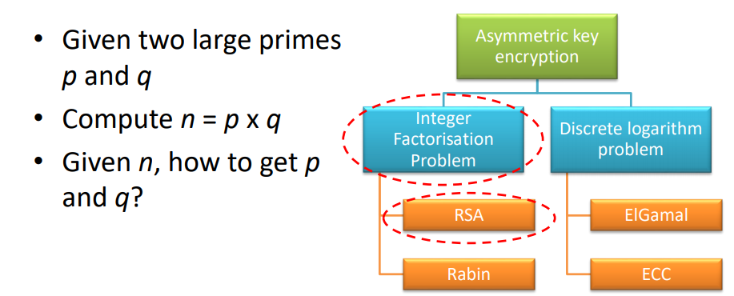

Integer Factorisation
Integer Factorisation Problem



Brute force to solve the problem. X = 1.2.3.4.5.....

RSA
only divisible by 1 and itself
GCD(45, 18) =(3^2*5,3^2*2),=3^2 =9

Euclidean Algorithm:
- Given gcd(a, b) = d
- a = b*q + r (b is smaller than a)
- gcd(a, b) ≡ gcd(b, r) = d
- GCD(33,18) ≡ GCD(18,15) ≡ GCD(15,3) = 3
a*204 + b*72 = d first calculate d
GCD(204,72)≡ GCD(72,60) ≡ GCD(60,12) = 12
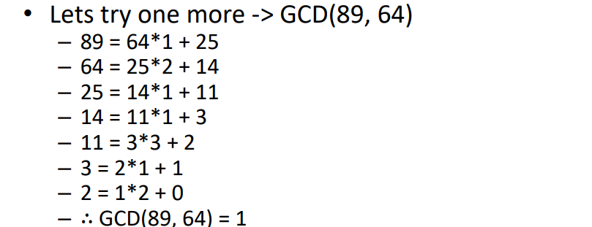
Extended Euclidean Algorithm (Reverse):
a*204 + b*72 = 12
12= 72-60 = 72-(204-2*72)=-204+3*72
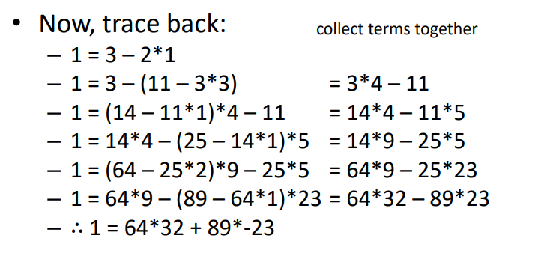
no common divisors > 1 gcd(a, b) = 1
– a = 8 divisors 1, 2, 4, 8
– b = 15 divisors 1, 3, 5, 15
Having the same remainder when divided by a specific integer
a ≡ b mod n ：12≡2 mod 5 -> 12 and 2 are congruent modulo 5
：not all numbers have multiplicative inverse
x*y ≡1 mod n
Calculate multiplicative inverse of 37*x%60 =1
37*x%60 =1: 13*37- 8*60 =1 ---> x= 13
60*x%37 =1: 13*37- 8*60 =1 ---> 13*37- 8*60 +37*60-37*60 =1 ---> -47*37+ 29*60 =1 x= 29

Key generation
- two large (> 1024 bits) primes p, q
- Compute modulus n = p*q
- Compute ϕ(n) = (p-1)*(q-1)：ϕ is Euler’s Totient Function
- Pick an integer e relatively prime to ϕ(n)：gcd(e, ϕ(n)) = 1; 1 < e < ϕ(n)
- Compute d such that e*d = 1 mod ϕ(n)
- Public key (e, n) Private key (d, n)
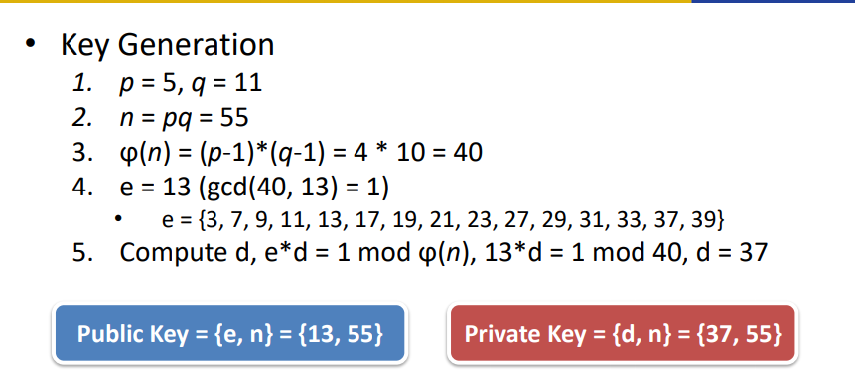
Encryption Decryption

Example
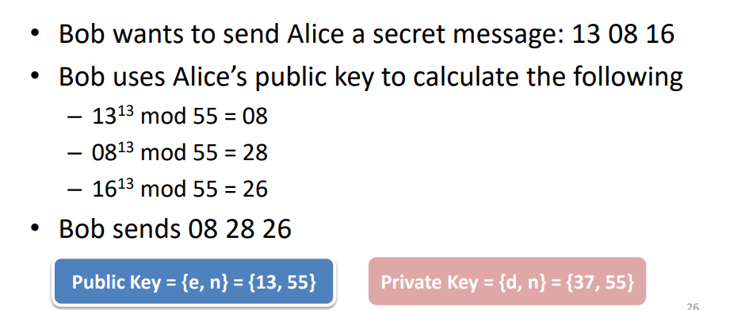
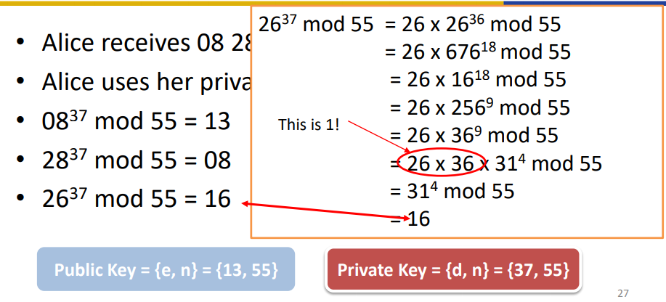

CONS：slow(RSA-768 is the largest subprime)
- Use modular operations to reduce intermediate results
• [(a mod n) × (b mod n)] mod n = (a × b) mod n
- Use fast exponent computational algorithms
RSA uses p and q both 1024 bits as basic mode, up to 2048 bits
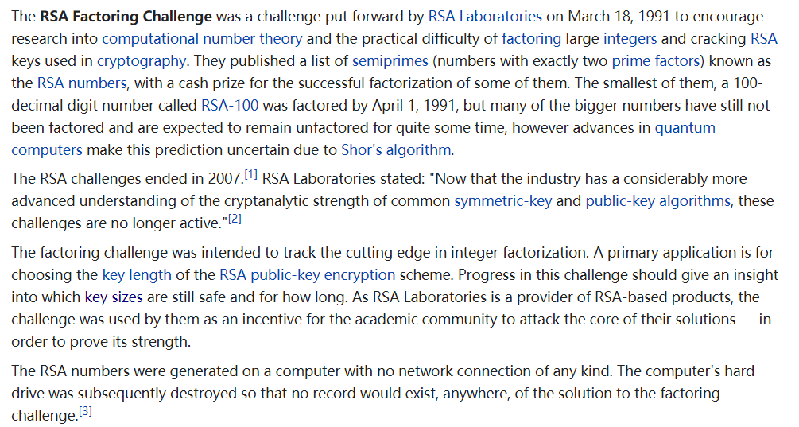

Signing using RSA
- A gets the hash of the message h(m)
- A sign using her private key d ：s = (h(m))^ d mod n
- A sends the encrypted message and the signature to Bob with Bob’S public key
- The receiver: comparing the message m and s e mod n
- d is Alice’s private key
- e is Alice’s public key

Discrete Logarithm problem：
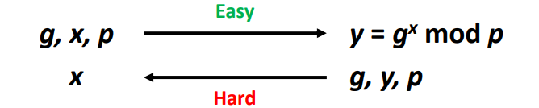

Diffie-Hellman and ElGamal-type
DH Key Exchange
- Users can exchange a secret key
- Requires no prior secrets, can be established in real time over untrusted network
- Based on discrete logarithms of large numbers
- 
- Required numbers are
– p: one prime
– g: a primitive root of p (or a base)
– x: a secret key

DP process
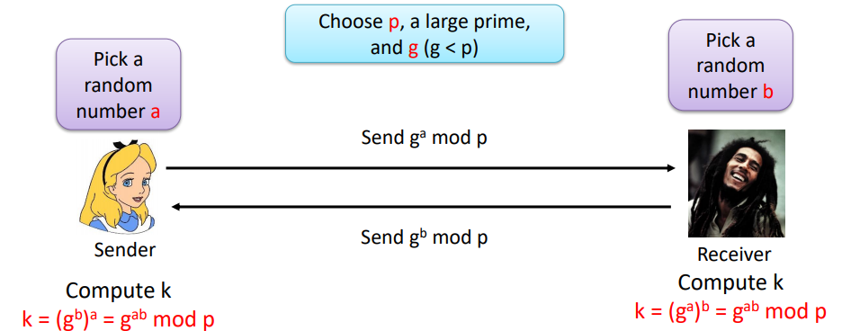

Example：
P =17 g=6 a=5 b=3--->6^5 mod 17 = 7 & 6^3mod 17 = 12---> k = (6^a)^b mod 17 =3
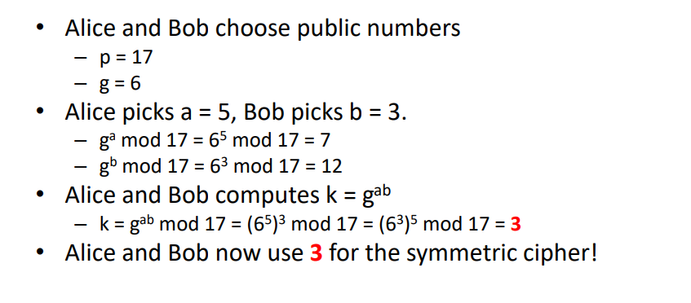

（identity misuse attacks）
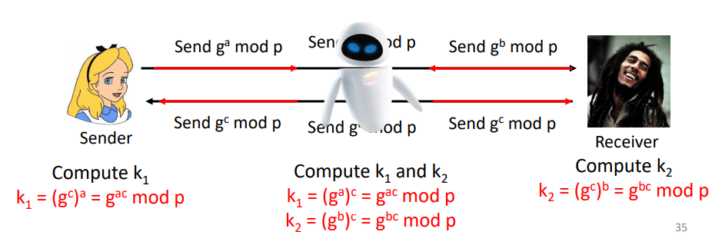
• Attacker can exploit DH with MITM attack
• The problem is the lack of authentication
• To prevent MITM, use authentication – E.g., using signatures

DH MITM mitigation（?）
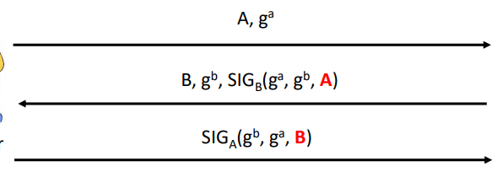
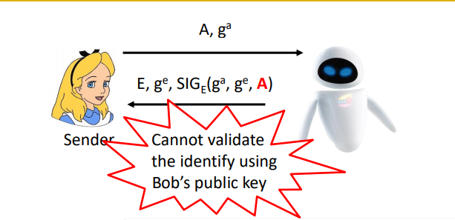
Include the identify in the signature. Even cannot forge Bob’s public key without knowing Bob’s private key. We assume Bob’s public key is known to Alice.
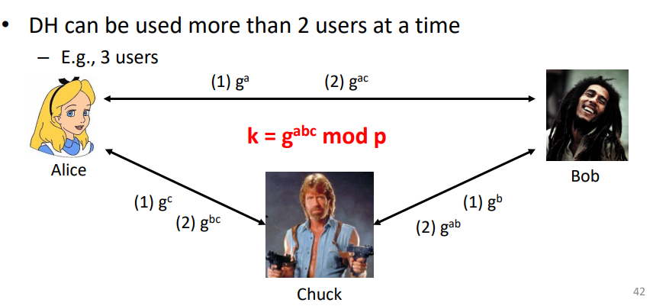

RSA vs DH
RSA
– Can be used for message encryption decryption
– Can provide authentication
– Allow anyone to communicate with me
DH
– Only exchange shared key, typically for symmetric ciphers
– Requires authentication to thwart attacks
– Already identified who I want to communicate with

Hashing
- one-way transformation
- Generate a message of fixed length given an arbitrary length of the message.
- Examples include – MD5 (message digest) – 128 bits output – SHA-2 (secure hashing algorithm) 256/224, 512/384 bits
- The primary goal/application is to generate and verify digital signature
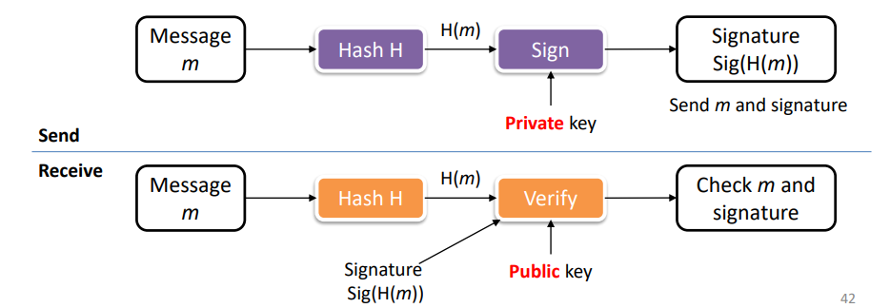
Decode signature with public key to see if it is the same as H(m)?
Do not store the raw password
Password with salt with salt(make dictionary attack more difficult)
Message integrity using message authentication code (MAC)
– Agree on a secret key k
– Compute H(m|k) and send with m
– Does not require encryption algorithm
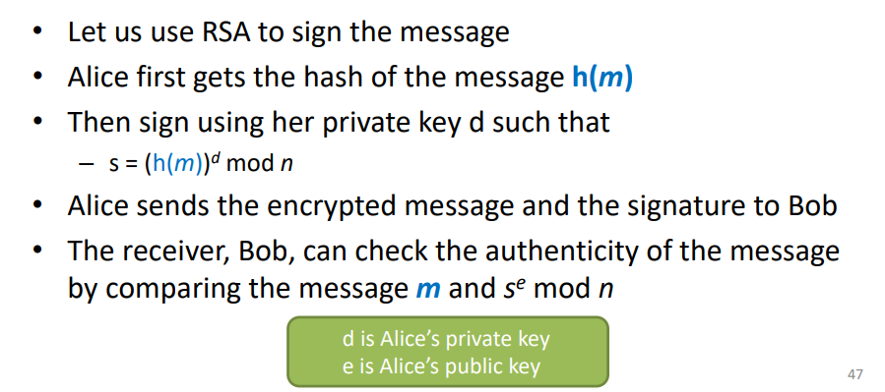
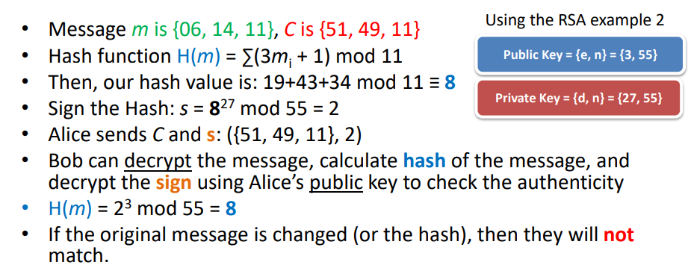

Blockchain
– A distributed ledger technology to connect different untrusted parties over the internet and store data securely from tampering
– Uses chained hash blocks for authenticity
– Core technology for cryptocurrency• E.g., Bitcoin, Ethereum etc.
– Blockchain allows different untrusted people to agree on the state of the system
– The history blocks (of transactions) are stored in distributed storage nodes -> Decentralisation!

Traditionally, we have a single entity (e.g., Bank) to keep track of the transactions.
In Blockchain, everyone keeps the record of transactions，If an error occurs in one record, it can be checked against others for validation.
- When a transaction happens, everyone in the network records the transaction
- Each node records a list of transactions – called Block
- The next block is chained from the previous block hash
Merkle tree
Merkle tree is simply a tree of hashed values of each transaction computed bottom up
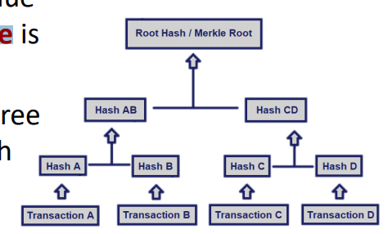
– Summarise all the transactions with a digital fingerprint
– Quick/simple test to verify a transaction is included or not
– Each branch can be downloaded on its own for verification
– Provide integrity and validity of data
– Repeat the last hash value twice(if it is odd)
All nodes have the same blockchain, so you can easily find the error
- Blockchain is just a sequence of hash-chained records
- These records are immutable, stored in distribution
- When a transaction occurs, the transaction is recorded to peer blocks (can be an arbitrary number) using the hash-chain
- – That is, you cannot modify the transaction
- All nodes have the same blockchain, so you can easily find the error
Addresses are used only ONCE – why?
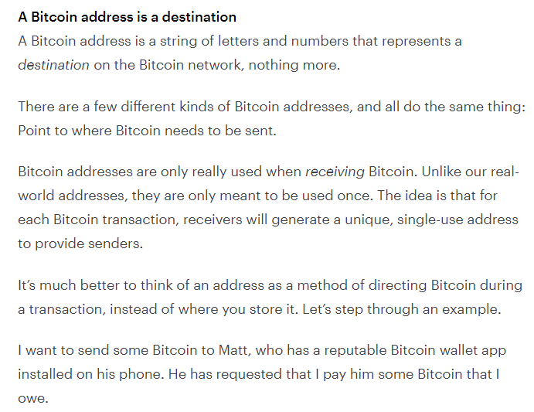
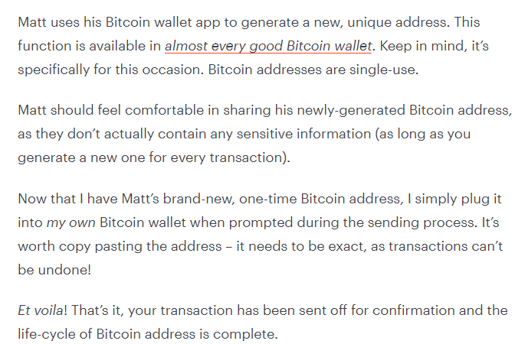
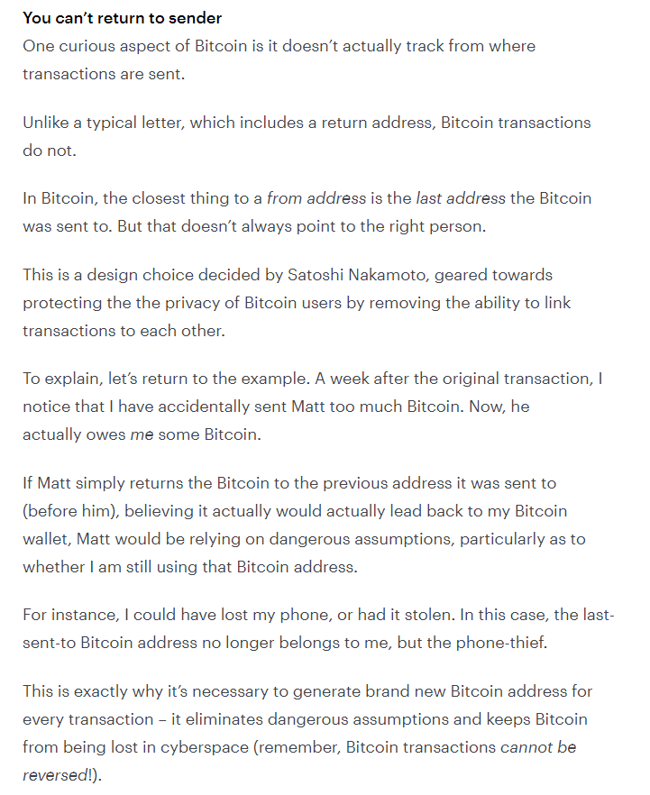

bitcoin）
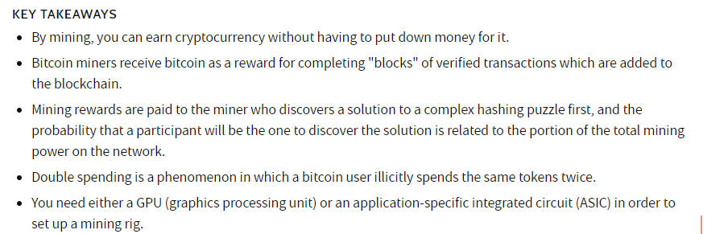
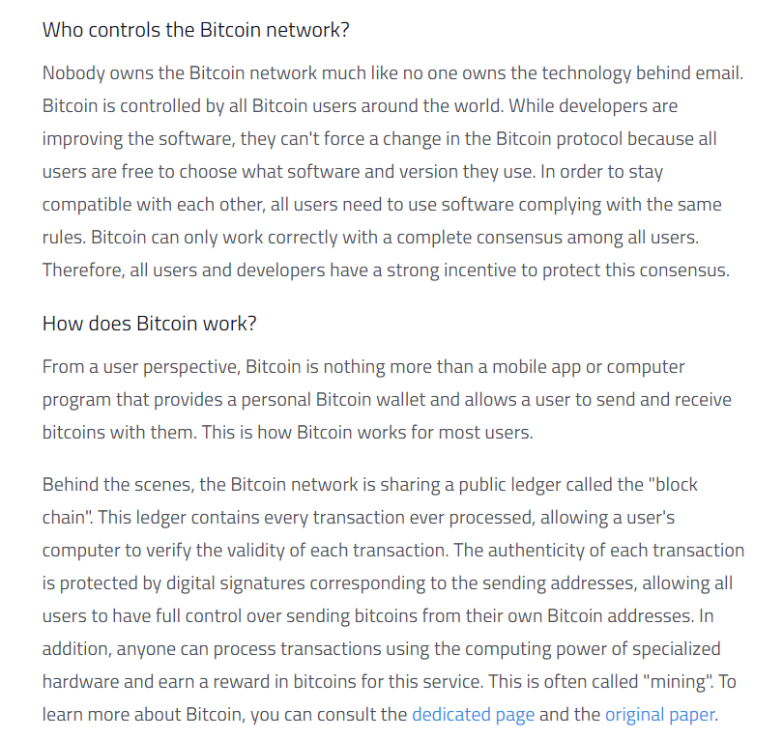

- Cryptocurrency is generated through mining– This is the only way to release new cryptocurrency
- Mining is done by validating the block– i.e. calculating that hash value for the next block
- To earn cryptocurrency, you have to be the first one to mine the block, as well as be part of the longest link
What could go wrong?
• Double spend attack
- When a transaction happens, all the nodes will vote.
- The transaction that has the majority of votes will be recorded in the Blockchain.
- Sybil attack:
- 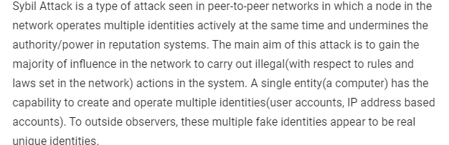
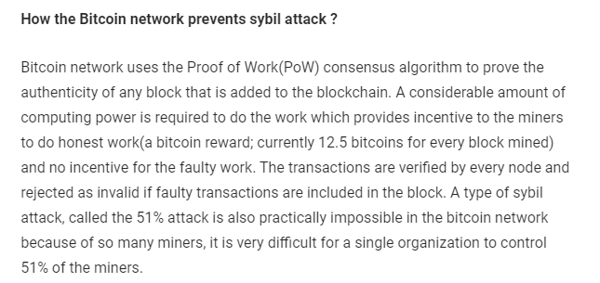
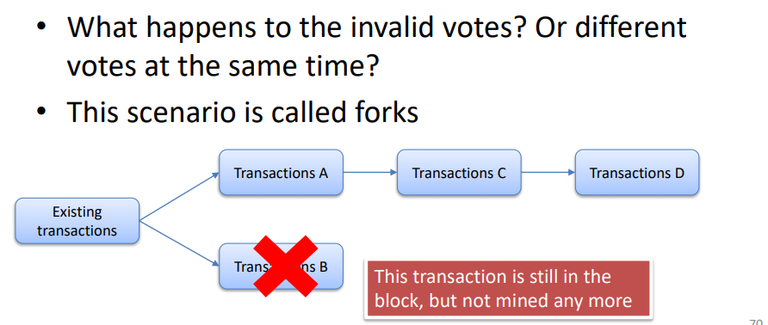
• Majority malicious nodes
- Eve only has one computer to perform 3 Brute force tasks in order to vote!
- If Eve can afford > 51% of the network nodes, Eve can successfully manipulate transactions

And there are other issues we need to consider
- Forks that can be caused by sybil nodes or selfish mining
- Selfish mining: miners trying to increase their rewards by keeping blocks private
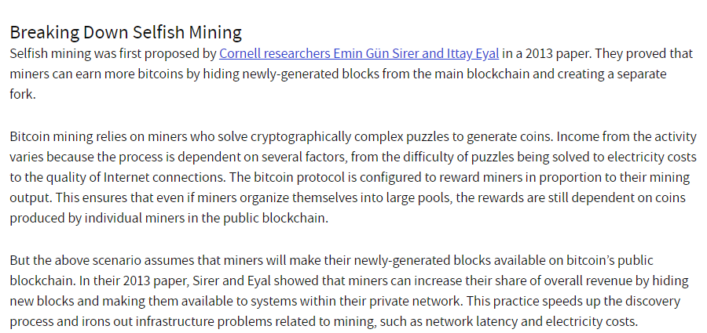
- DNS attacks: sending peers wrong information
- Mempool attacks: flooding new blocks with transactions
- DDoS attacks: achieving denial of service
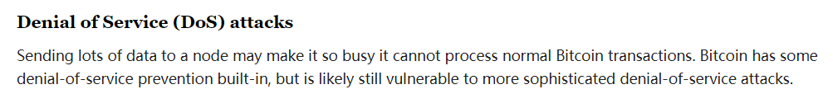
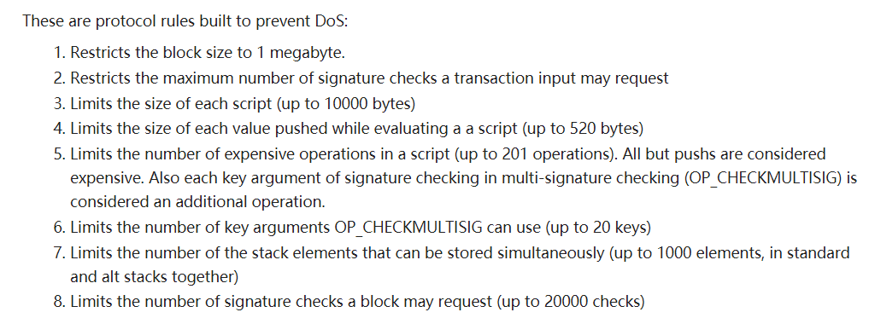
- Consensus delay: preventing peers from reaching consensus
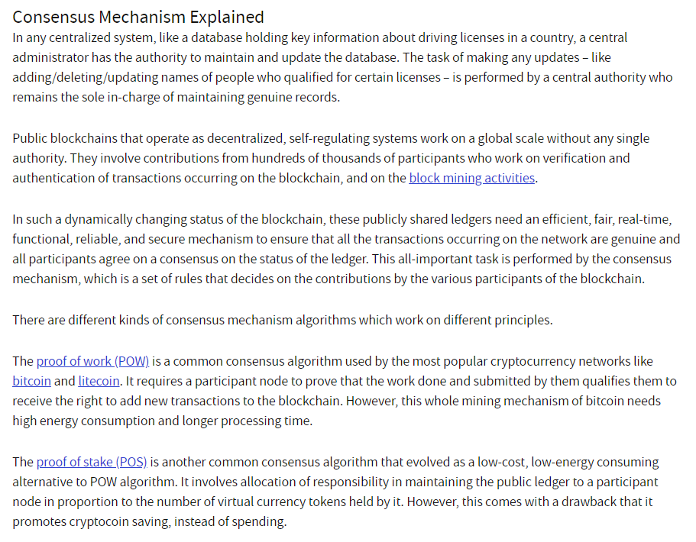
- Theft of wallets – probably one of the biggest issues now


ECC-Elliptic Curve Cryptography
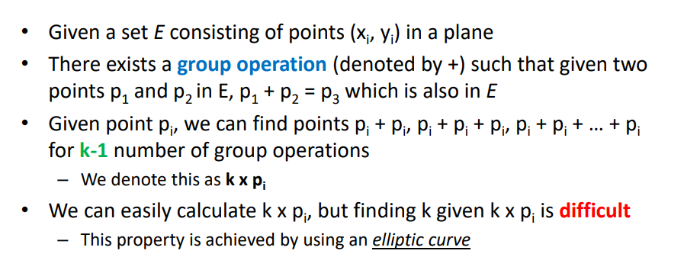
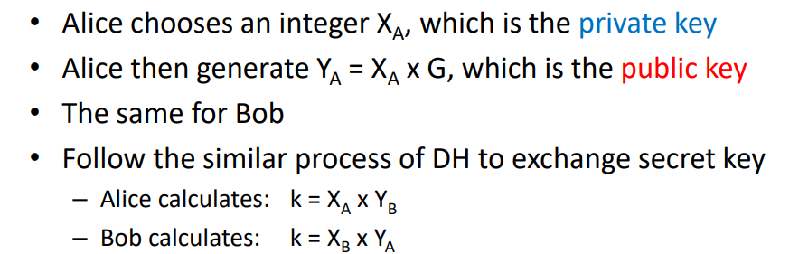
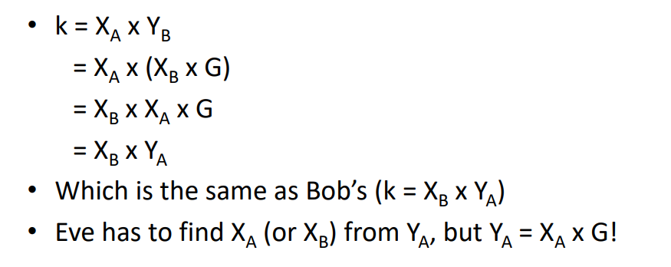
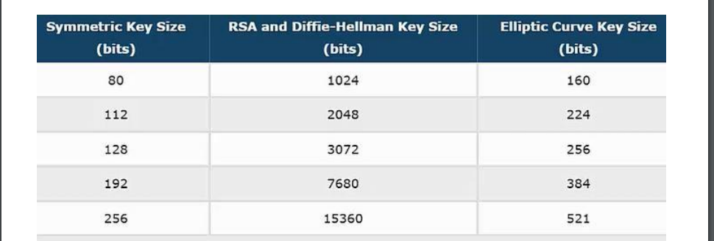
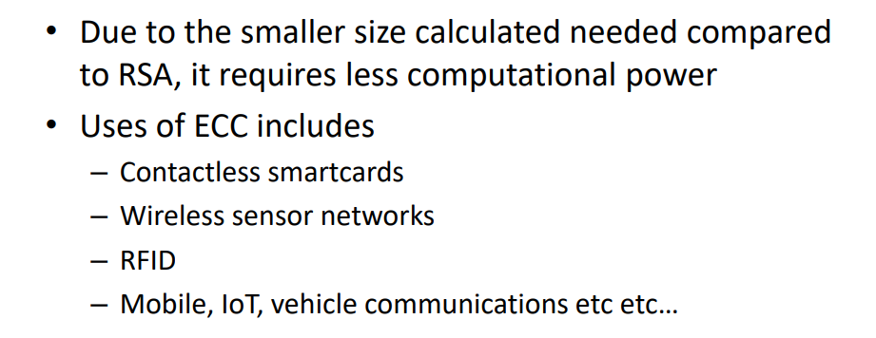
- Alice chooses an integer XA , which is the private key
- Alice then generate YA = XA x G, which is the public key
- The same for Bob
- Alice calculates: k = XA x YB
- Bob calculates: k = XB x YA
- Eve has to find XA (or XB ) from YA , but YA = XA x G
Advantages of ECC(smaller KEY size compared with rsa&dh)it requires less computational power.

Summary
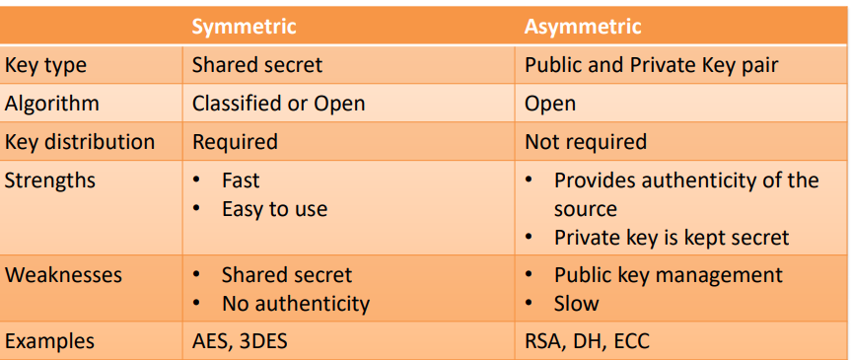
- Key distribution by Public key cipher-– E.g., RSA, DH, ECDH-RSA
- Data encryption by symmetric key cipher
Most security protocols use this approach

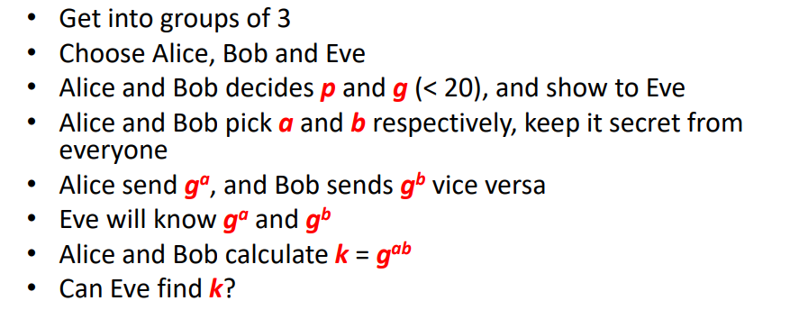
Miner:Computers that validate and process blockchain transactions
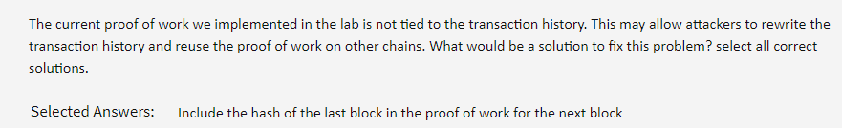

Proof of work:
