目录
• Caesar cipher 2
• Mono alphabetic cipher 2
• Vigenere cipher 2
• DES, AES etc. 3
Block Cipher：（ECB, CBC, OFB, CFB, CTR ） 4
DES 4
Key Generation 6
AES 7
ECB: 8
CBC 9
OFB 11
Cryptanalysis 14
Result of attacks 18

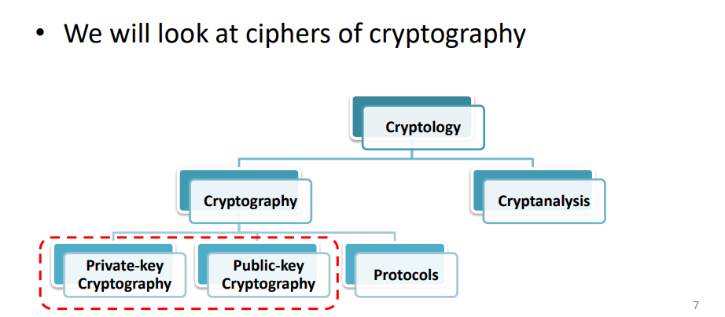
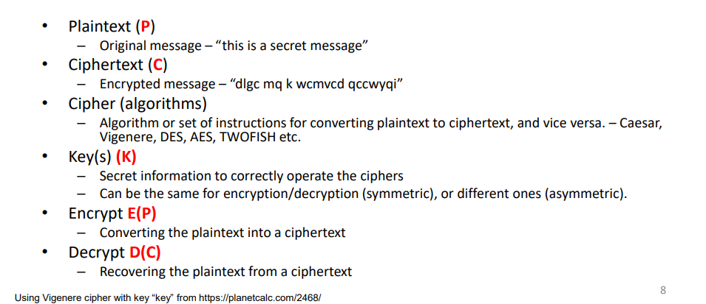
The principle of ciphers is to use both substitution and transposition
Confusion – Through transposition/permutation – Changing the plaintext order
Diffusion – Through substitution – Replacing plaintext with ciphertext
Substitution ciphers further divide into monoalphabetic and polyalphabetic
Classical Encryption techniques

• Caesar cipher
Key= i. cipher = plain text +i
Encryption: C = E(P) = (P + K) mod 26
Decryption: P = D(C) = (C - K) mod 26
Why is it so weak? – A: The key size is too small (25)

Shuffling the letters in the plaintext by mapping them to a different random ciphertext letter.
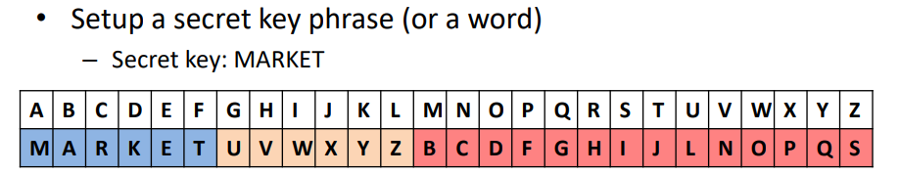
Mono alphabetic ciphhe frequency information.frequency analysis

This is called polyalphabetic cipher. To address frequency attack
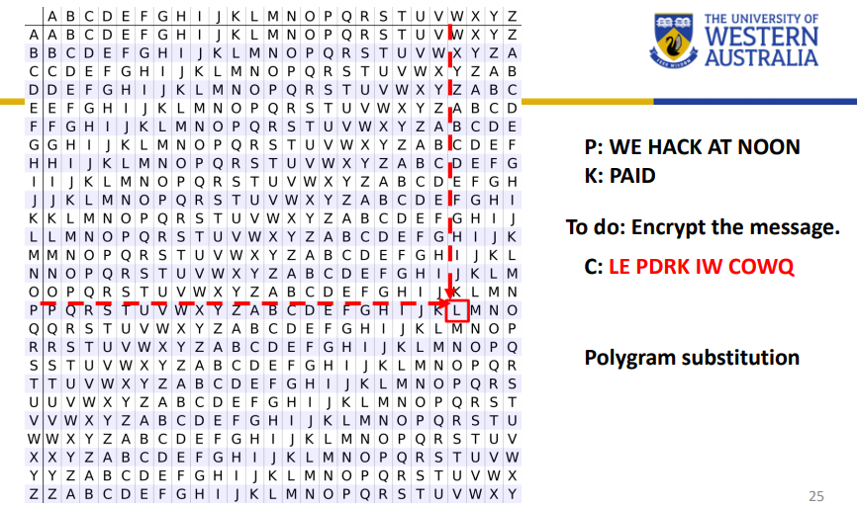
Decreption:Kasiski test (1863): There is a chance that a repeated word is encrypted using the same sequence of the key.
•
The aim is to hide the message by rearranging the letters without altering the original letters.
These ciphers are prone to frequency analysis attacks
Rail Fence Cipher:
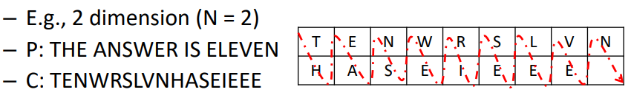
Classical ciphers are not so secure today due to the limited key size and also language characteristics. To improve the security of ciphers, both substitution and transposition techniques are used together

Modern ciphers

• DES, AES etc.
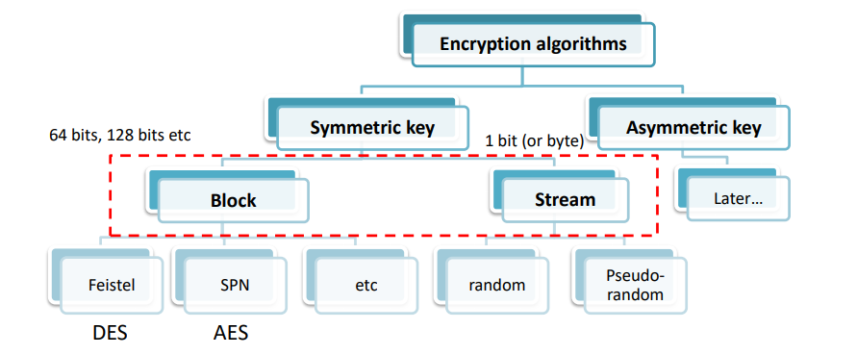
Stream Cipher
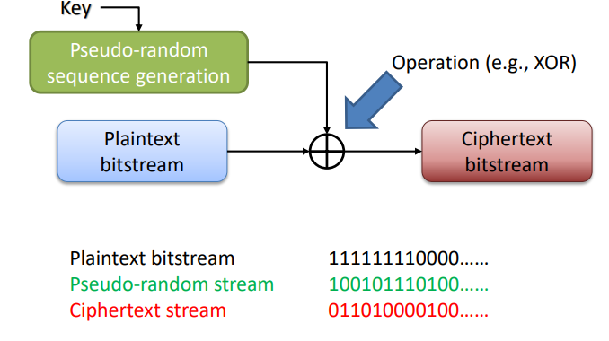

Block Cipher：（ECB, CBC, OFB, CFB, CTR ）
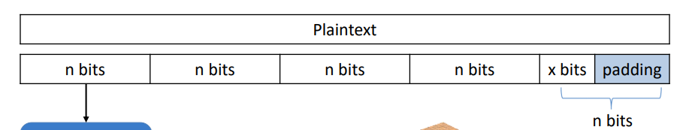
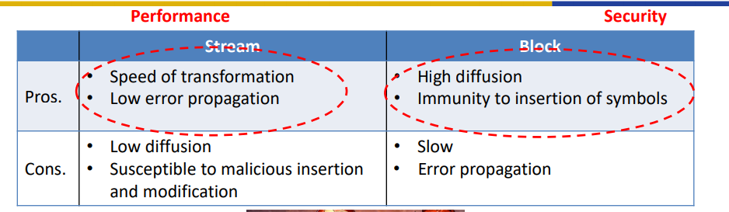

DES
• DES - Data Encryption Standard
• Block cipher
• 64bits plaintext
• 64 bits key (56 bits key + 8 bits parity)
• 64 bits ciphertext
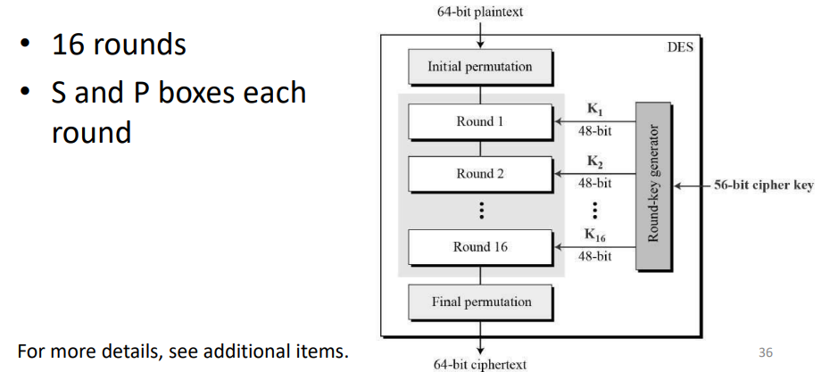
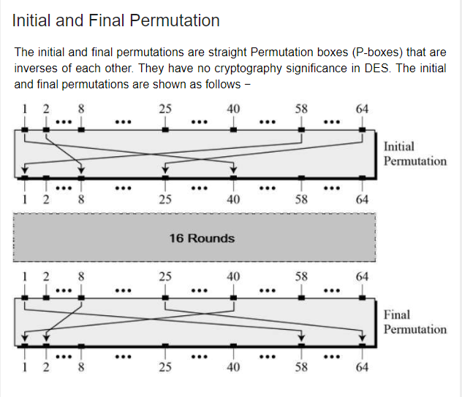

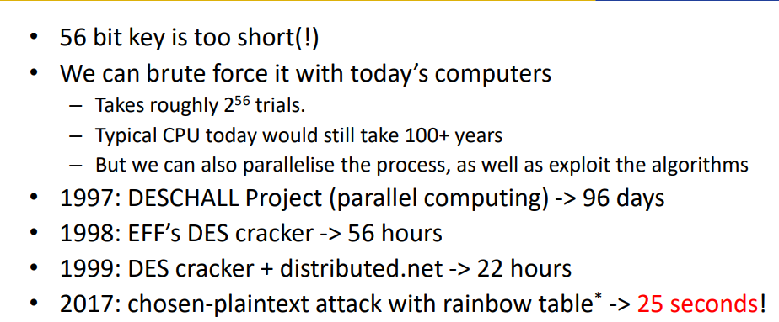
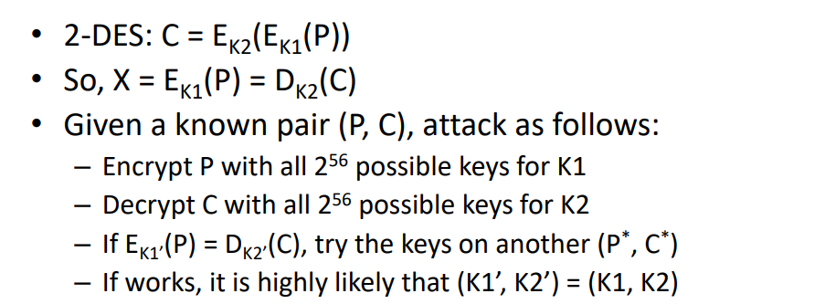
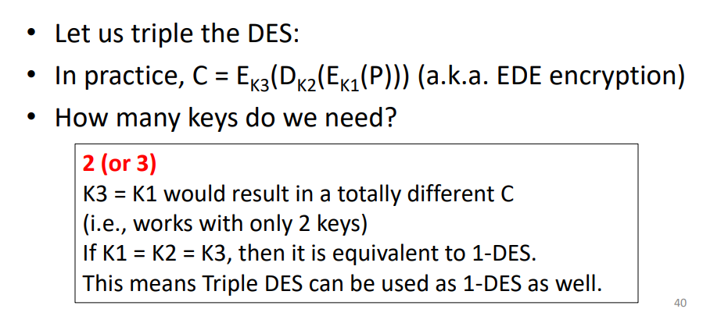
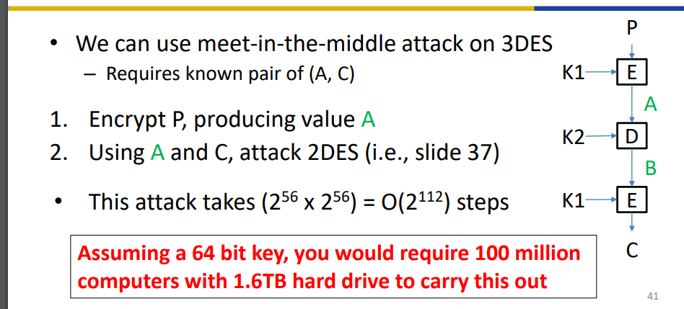
But! Triple DES is too slow.
The heart of this cipher is the DES function, f. The DES function applies a 48-bit key to the rightmost 32 bits to produce a 32-bit output.
Expansion Permutation Box − Since right input is 32-bit and round key is a 48-bit, we first need to expand right input to 48 bits. Permutation logic is graphically depicted in the following illustration −
XOR (Whitener). − After the expansion permutation, DES does XOR operation on the expanded right section and the round key. The round key is used only in this operation.
Substitution Boxes. − The S-boxes carry out the real mixing (confusion). DES uses 8 S-boxes, each with a 6-bit input and a 4-bit output. Refer the following illustration −
There are a total of eight S-box tables. The output of all eight s-boxes is then combined in to 32 bit section.
Straight Permutation − The 32 bit output of S-boxes is then subjected to the straight permutation with rule shown in the following illustration:

Key Generation
The round-key generator creates sixteen 48-bit keys out of a 56-bit cipher key. The process of key generation is depicted in the following illustration −

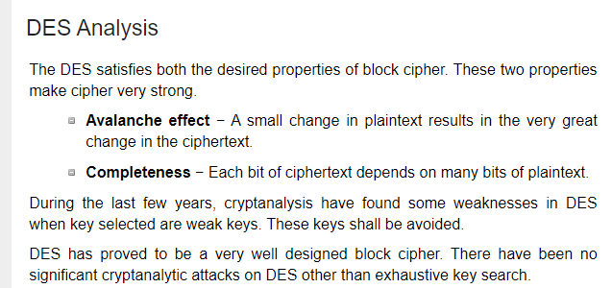

AES
Advanced Encryption Standard
• Block length of 128 bits (fixed)
• Key size varies 128, 192 or 256 bits
• Number of rounds are 10, 12 and 14 respectively to the key size.
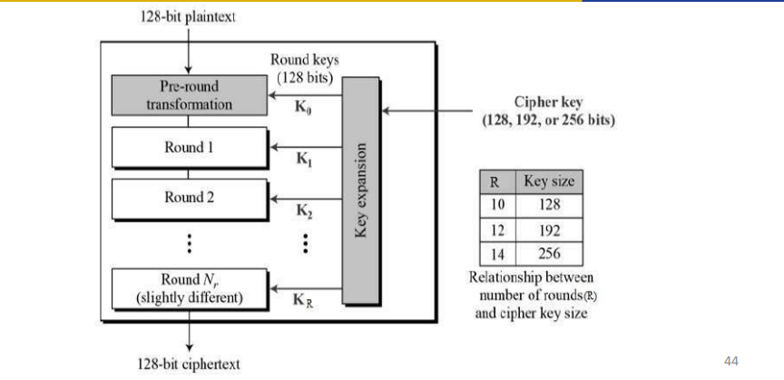

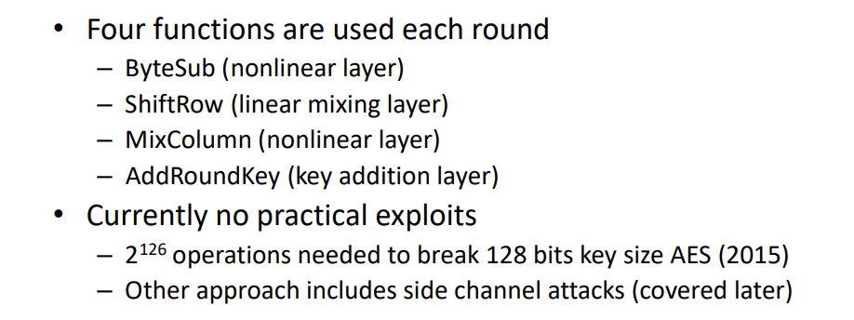
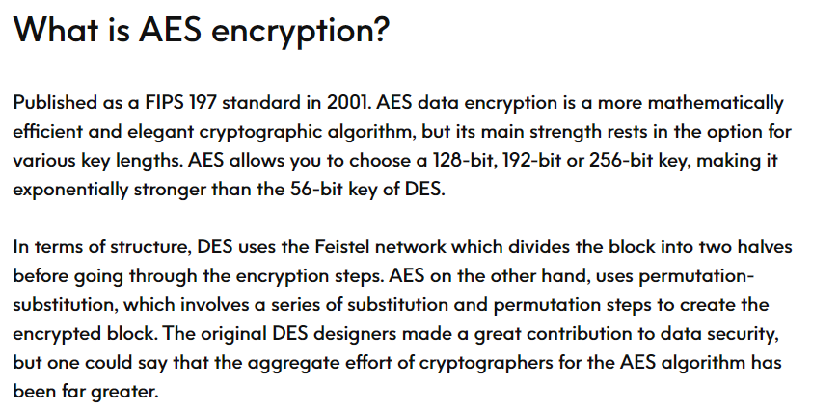
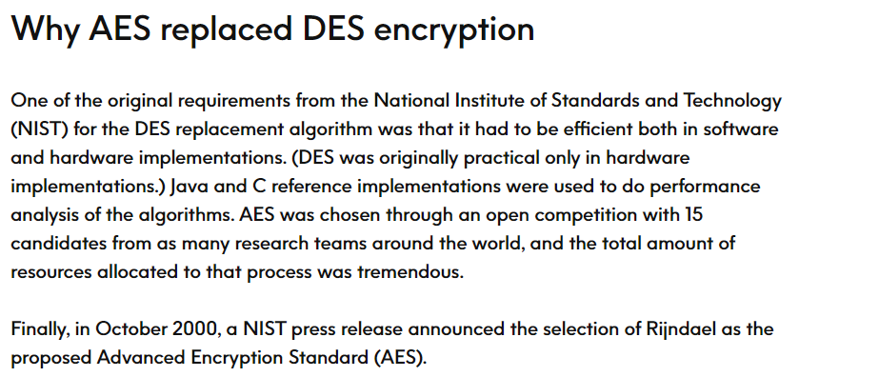
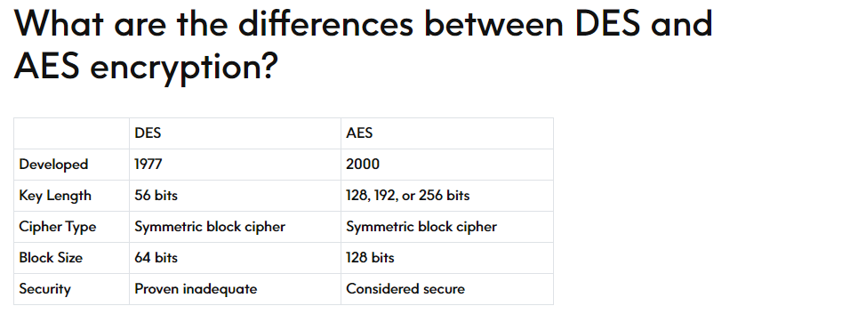

Back to Block ciphers
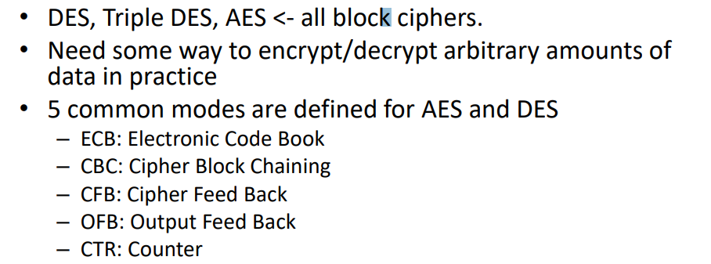

ECB:
• Message is broken into independent blocks
• Each block is encrypted independently
• If two same messages are encrypted using the same key and sent, their ciphertexts are the same – E.g., Sending your personal information.
• Should only be used to transmit single values.
• Can be parallelised but…
• Due to the design, message repetitions may show in the ciphertext – Particularly with data such as graphics
– Messages that change very little etc.
• The independence between the encrypted messages is the problem
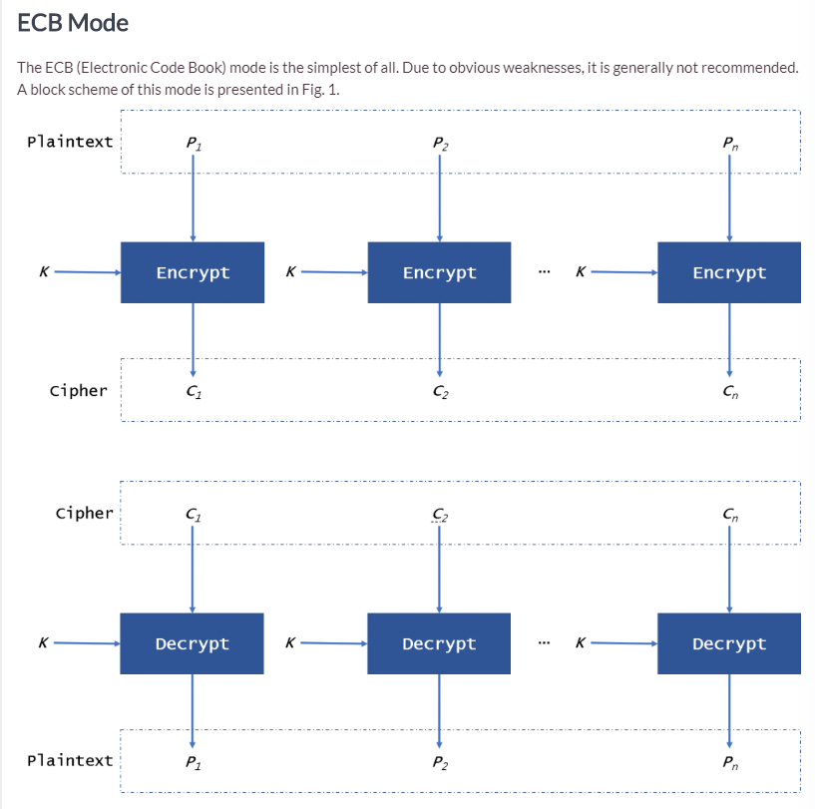
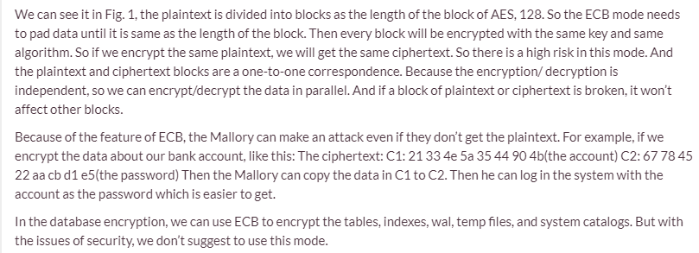

CBC
Removes the independence between message blocks
– By linking the encryption operations
– i.e., next ciphertext depends on the previous ciphertext
Establish an Initial Vector (IV) to start the process
Can be used for general transmission of block ciphers
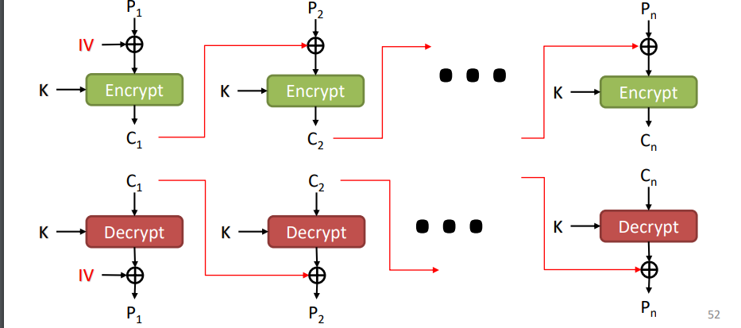
• A ciphertext block depends on all the previous blocks
– i.e., no repetitions of the same plaintext
• Requires the Initialisation Vector (IV)
– Must be known to both sender and receiver
– Can be a fixed value (with an integrity guarantee), or
– Sent encrypted (e.g., using the ECB mode)
- Error propagation problem
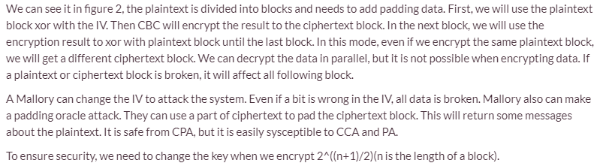
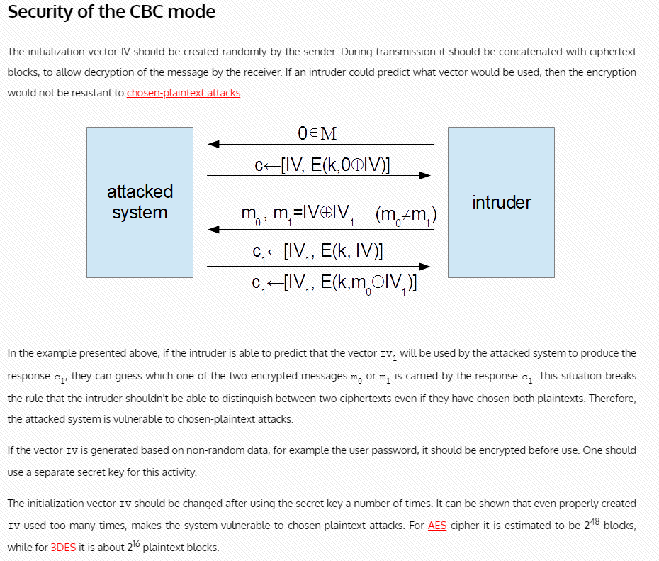
CFB
• To use the cipher block of the previous step as the input of the cipher in the next step
• Divide the plaintext into segments of length s bits – S ≤ block size
• Encryption is used to generate a sequence of keys of length s bits
• The ciphertext is produced by XOR operation of the plaintext and the key
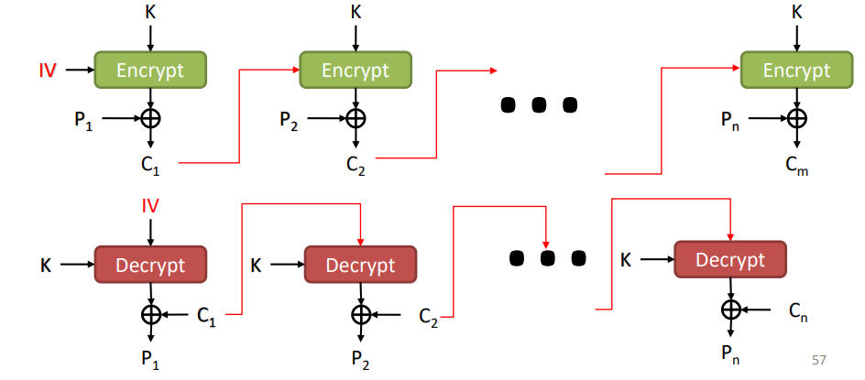
• The block cipher is used as a stream cipher
• Used in scenarios where data arrives in bits/bytes
– Common value for s is 8 bits
– The bit can be as small as 1, denoted as CFB-[bit size]
• Similarly with CBC, the ciphertext depends on the all previous plaintext
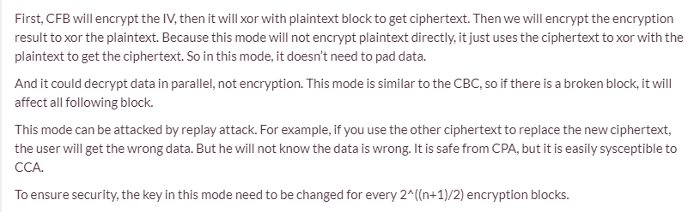
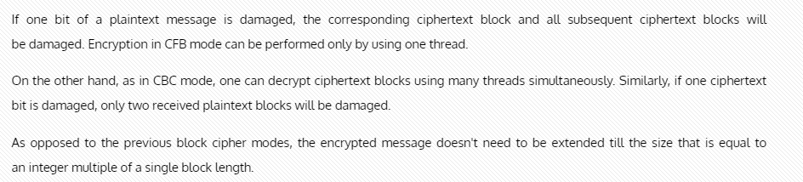

OFB
• Message is treated as stream of bits
• Output of the cipher is added to the message
• Output is used for the next cipher step (feed back)
• Feedback is independent of message – i.e., can be computed in advance • Can be used to encrypt stream of messages on a noisy channel – E.g., satellite TV transmission etc
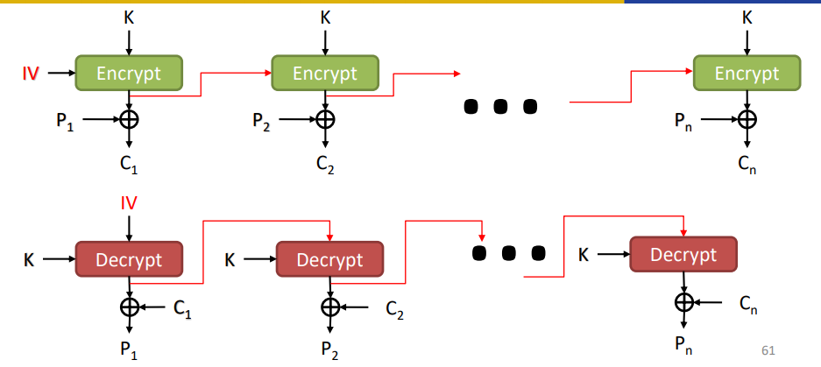
• No bit error propagation
• More vulnerable to message stream modification
• Should never reuse the same sequence of key and IV – Because it generates the same ciphertext!
• Requires synchronisation between the sender and the receiver
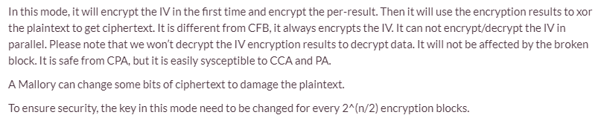
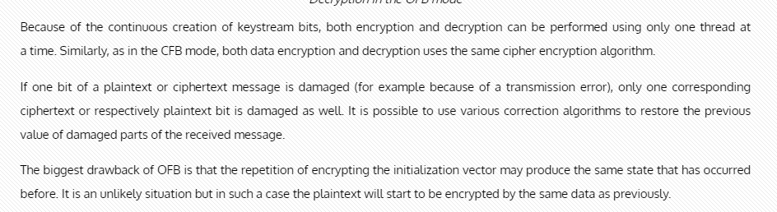
Relatively new compared to other four
• Similar to OFB but encrypts the counter value instead of the feedback value
• Requires different keys and counter values for every plaintext block
• Used in high-speed network encryptions
IV is replaced with Nonce and counter combination No more feedback operations in CTR
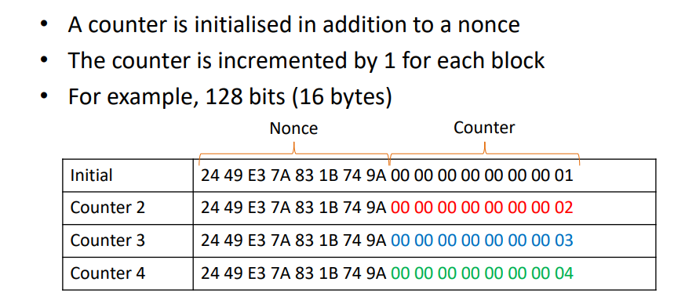
• Fast encryption decryption – E.g., parallel computation
• Random access to encrypted data blocks – i.e., no feedback
• Provable security (as good as other modes)
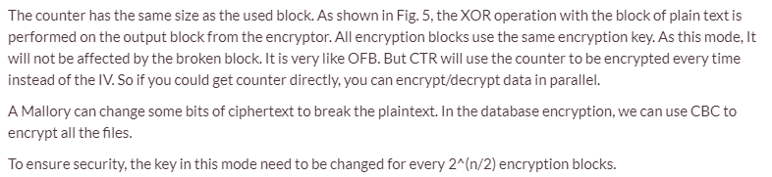
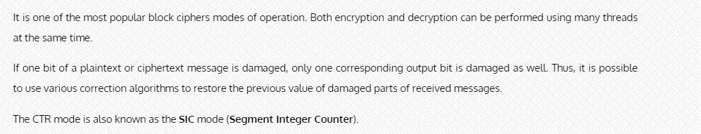
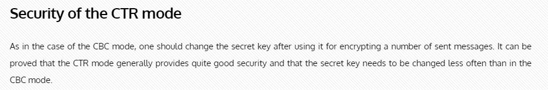
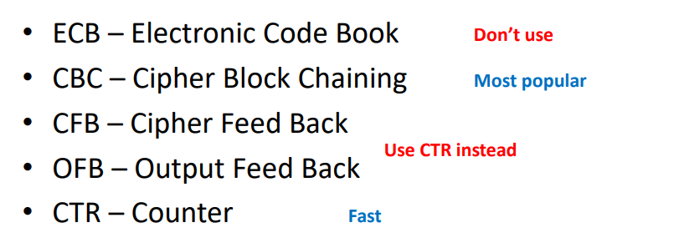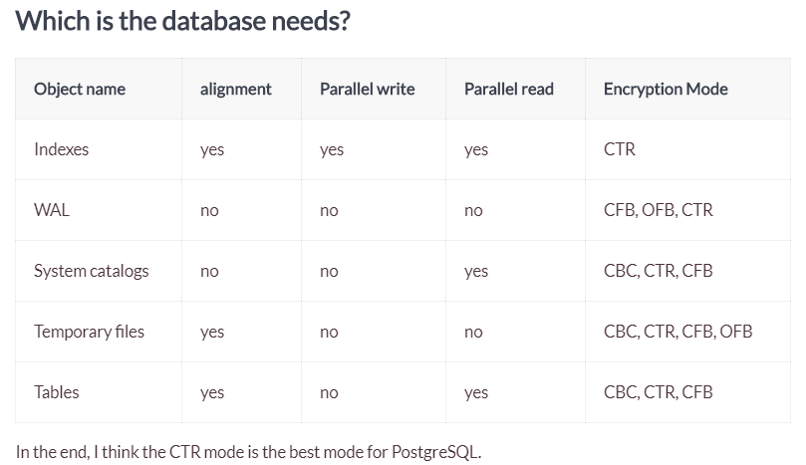
Summary
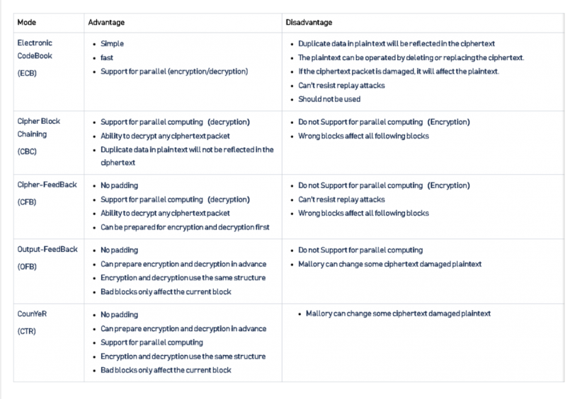

Cryptanalysis
• Objective to recover key not just message
• General approaches
– Brute force attack
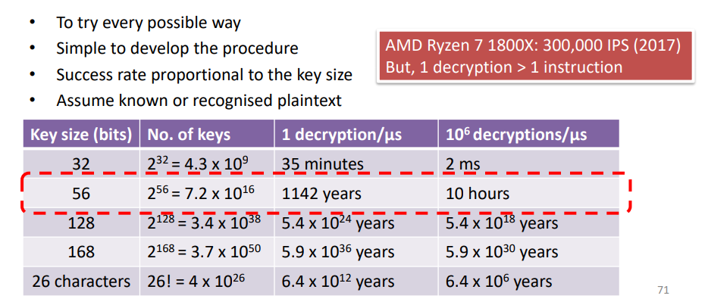
– Cryptanalytic attack
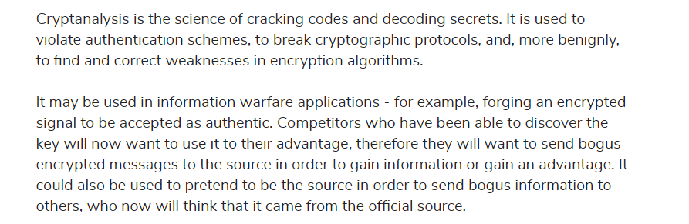

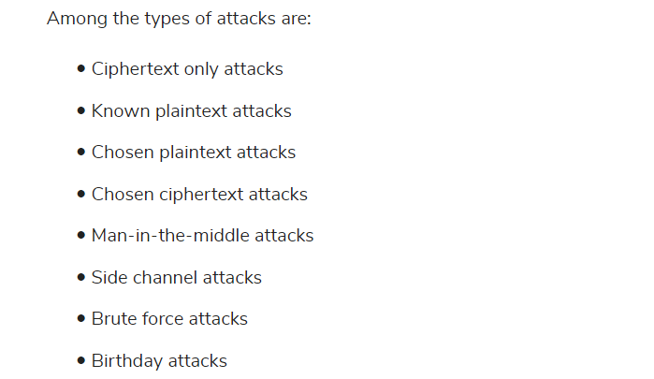
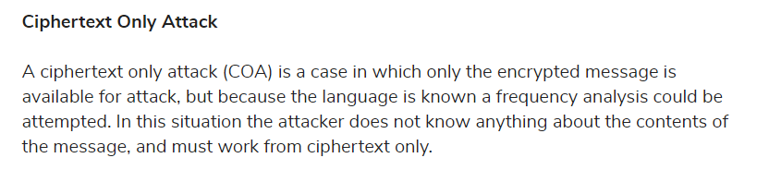
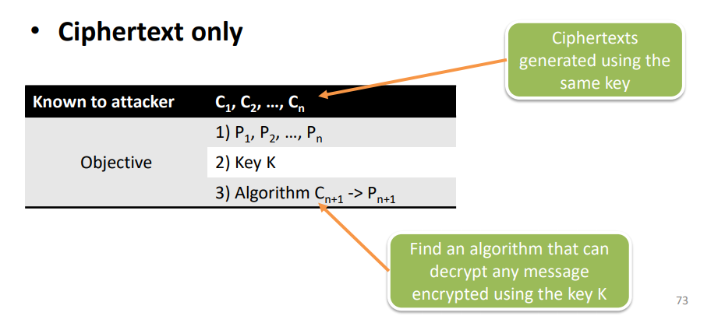

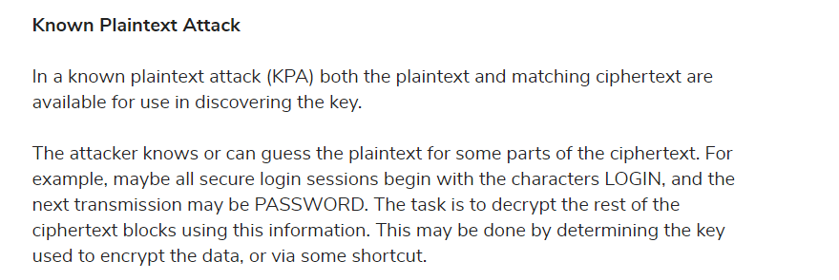
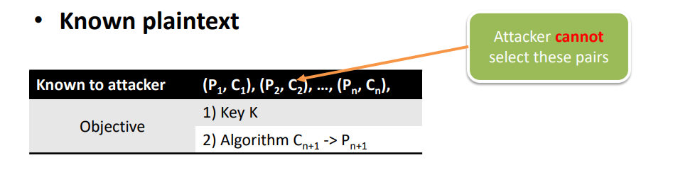
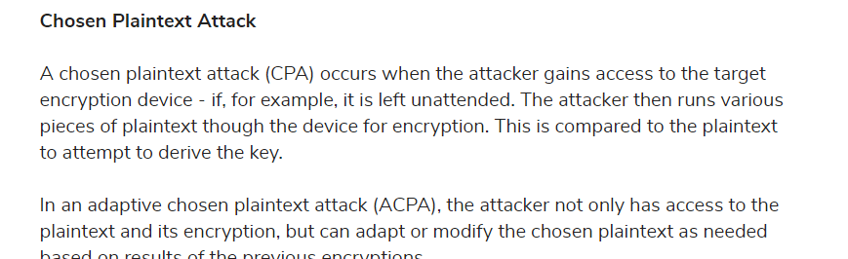
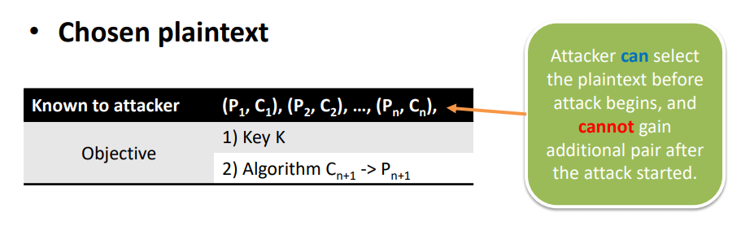
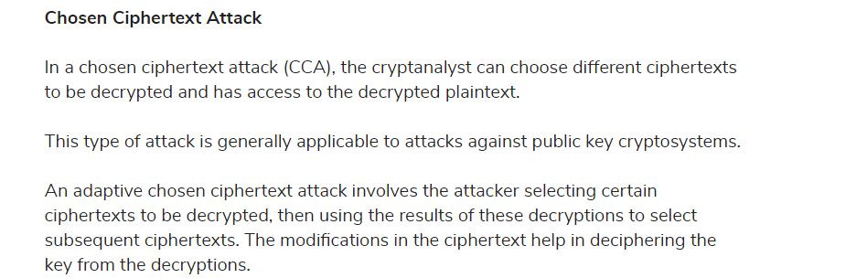
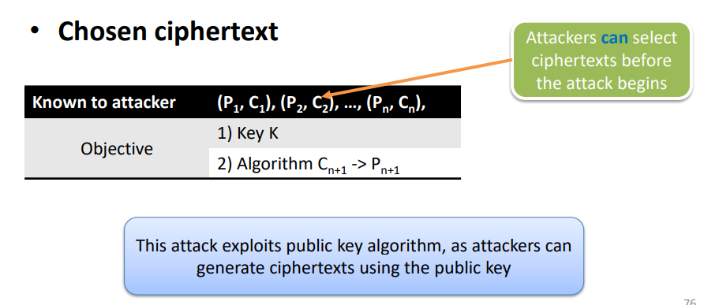
Chosen text (combination of the above two) – Select plaintext or ciphertext to encrypt/decrypt
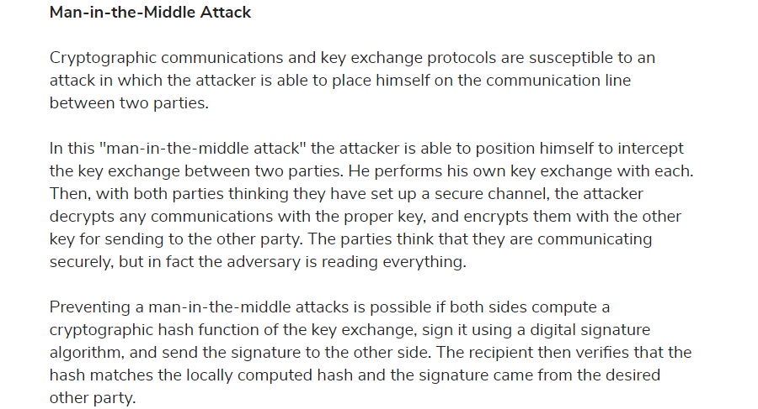
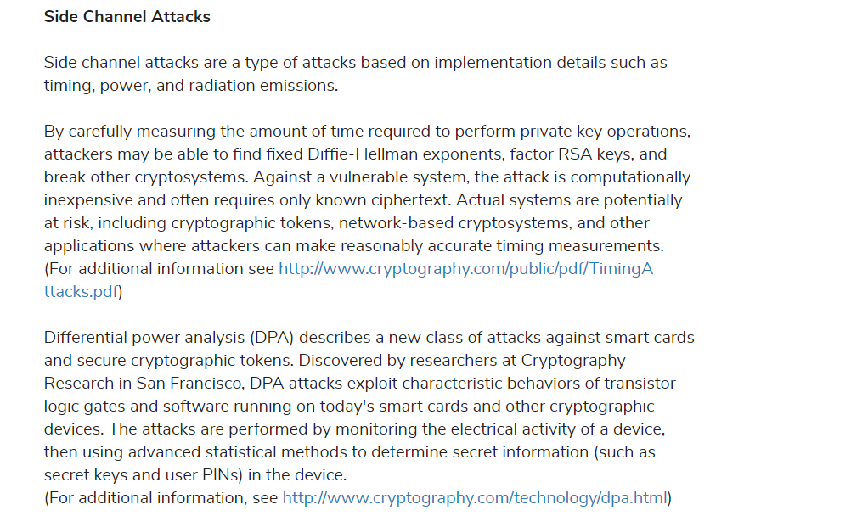
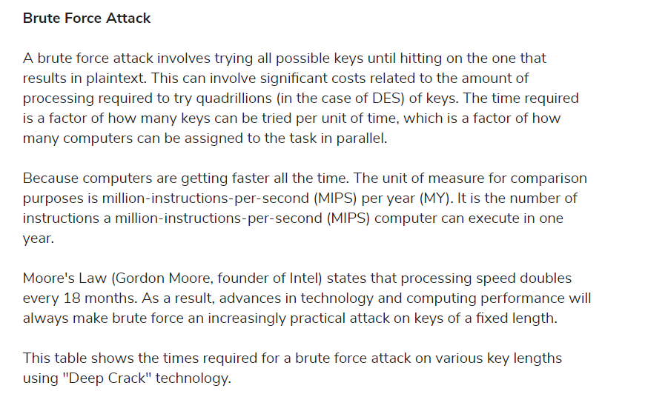
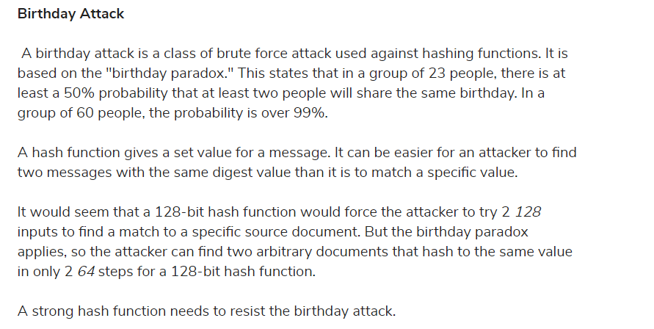

Result of attacks
Total break – Found the key
• Global deduction – Did not find the key, but found the algorithm
• Instance deduction – Obtained some plaintexts from some ciphertexts
• Information deduction – Obtained partial bits of plaintext
Secureness of ciphers
