Week 4
Trend
There are many events that contribute toward attack trends
– More people using the Internet
– Increase in software complexity
– Availability of attacking tools
– Dependability on cyberspace
– Lack of security implementation/deployment/adoption
Attacks are evolving with time
– Deepfakes • Deepfake image, voice etc.
– AI-powered cyberattacks
– Disinformation in Social Media
– Vehicle cyberattacks
– Cloud jacking
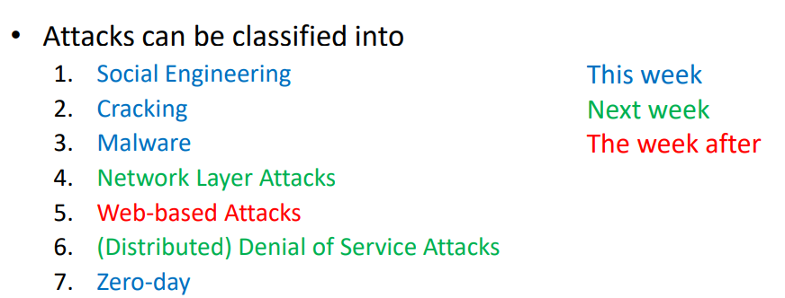
Social Engineering
Persuasion-type of an attack to disclose sensitive information
– E.g., phishing attack – Persuade to install/execute malicious software
– Links to bogus website (e.g., spoofed bank website)
– Impersonating legitimate user to retrieve credentials
– Impersonating technical support member
Phishing
Definition：
Phishing attack is a mass distribution of a spoofed emails
– Comes from what it seems to be well known organisations
• Such as banks, insurance, retailers, credit card etc.
– Looks legitimate, but leads to fake or bogus sites
– Asking for personal credentials
– They are evolving!
• Less grammar/spelling mistakes • More in context • target-oriented contents • Focused targeting is called “Spear Phishing”
Prevent：

1. Legit companies don’t request your sensitive information via email
Chances are if you receive an unsolicited email from an institution that provides a link or attachment and asks you to provide sensitive information, it’s a scam. Most companies will not send you an email asking for passwords, credit card information, credit scores, or tax numbers, nor will they send you a link from which you need to login.

2. Legit companies usually call you by your name
Phishing emails typically use generic salutations such as “Dear valued member,” “Dear account holder,” or “Dear customer.” If a company you deal with required information about your account, the email would call you by name and probably direct you to contact them via phone.

3. Legit companies have domain emails
Don’t just check the name of the person sending you the email. Check their email address by hovering your mouse over the ‘from’ address. Make sure no alterations (like additional numbers or letters) have been made. Check out the difference between these two email addresses as an example of altered emails: michelle@paypal.com michelle@paypal23.com Just remember, this isn’t a foolproof method. Sometimes companies make use of unique or varied domains to send emails, and some smaller companies use third party email providers.

4. Legit companies know how to spell
Possibly the easiest way to recognize a scammy email is bad grammar. An email from a legitimate organization should be well written. Little known fact – there’s actually a purpose behind bad syntax. Hackers generally aren’t stupid. They prey on the uneducated believing them to be less observant and thus, easier targets.

5. Legit companies don’t force you to their website
Sometimes phishing emails are coded entirely as a hyperlink. Therefore, clicking accidentally or deliberately anywhere in the email will open a fake web page, or download spam onto your computer.

6. Legit companies don’t send unsolicited attachments
Unsolicited emails that contain attachments reek of hackers. Typically, authentic institutions don’t randomly send you emails with attachments, but instead direct you to download documents or files on their own website.

7. Legit company links match legitimate URLs
Just because a link says it’s going to send you to one place, doesn’t mean it’s going to. Double check URLs. If the link in the text isn't identical to the URL displayed as the cursor hovers over the link, that's a sure sign you will be taken to a site you don’t want to visit. If a hyperlink’s URL doesn’t seem correct, or doesn’t match the context of the email, don’t trust it. Ensure additional security by hovering your mouse over embedded links (without clicking!) and ensure the link begins with https://.

Pharming
Definition
• Attack that redirects a website’s traffic to another website
• The browser may still display the web address you wanted, but the content may not be correct • DNS tampering to redirect the traffic to a different website without users knowing
• What you are viewing is fake, even though it looks real
• DNS server can be manipulated Or
• DNS lookup table on the user’s computer can be manipulated
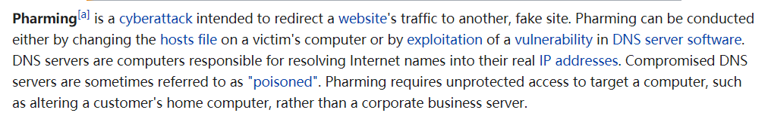
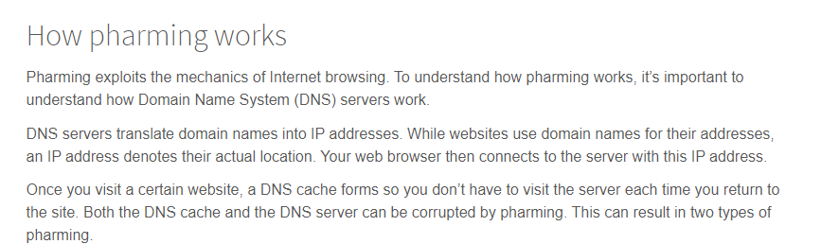
Protect：
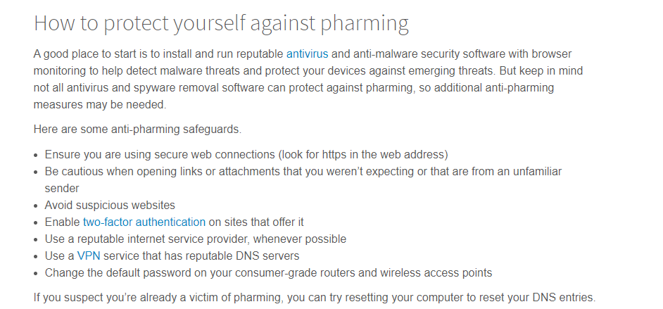
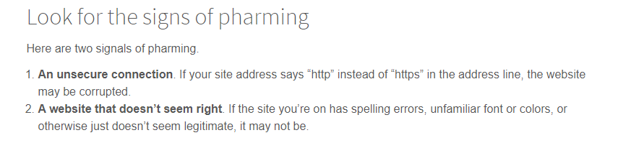
Offensive USB
• Microchips can be embedded on USB lines.
• When plugged in, they are detected by the US as a human interface device (HID) – E.g. mouse, keyboard etc
• You can control those malicious USB lines via WiFi!
Social Engineering-mitigation
• Establishing frameworks
• Asset management
• Security protocol implementation and evaluation
• Security education
• Security review
• Trust establishment
Cracking
• Conducting malicious activities to guess, corrupt or steal information
• Unethically exploits the highly sensitive information and uses the flaws in the security systems
Cracker – Uses the flaws in the security systems
Hacker – Finds and exploits flaws in the security systems
1.Password guessing or using Password cracking tools
– Brute force and dictionary attacks
– Use of tools such as
- Packet Sniffers
Packet sniffing tools are used widely and legitimate tools
Can also be used illegitimately
Usually for monitoring IP packets
Cracking - Mitigation
Ensure your password is strong
Store salted hash of the password
Close unused ports
Ensure secure programming
Enforce encryption
Security education
Limited trial
Multi-factor authentication
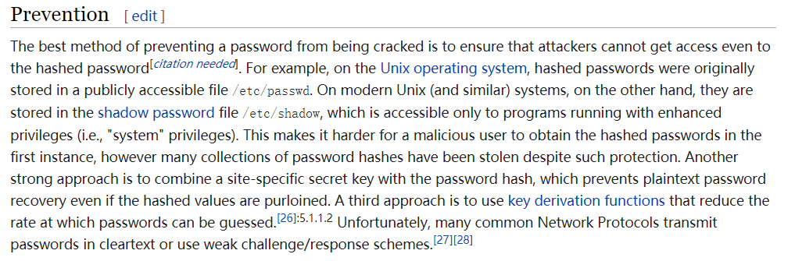
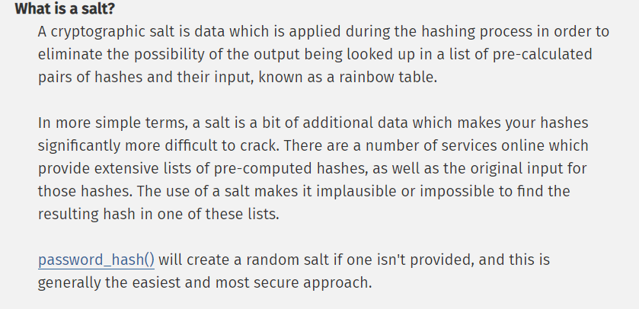
Malware（恶意软件）
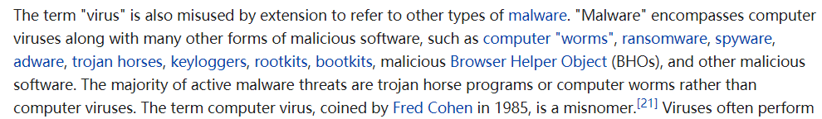
Virus
Definition
Malicious program that spreads through the network by infecting various files.
How it works
Infected files will execute the malicious program without the user knowing first, and then run the normal program.
Viruses will also replicate itself by replacing other executable files by attaching the malicious program.
Many viruses spread through file sharing
– E.g., email attachments, USB sharing, FTP, downloads etc.
– Requires the infected files to be transferred to other hosts
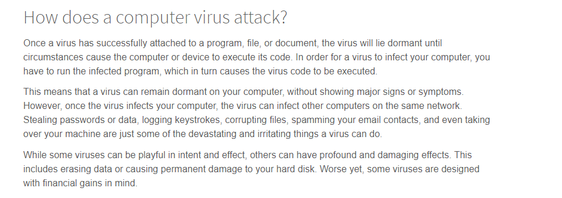
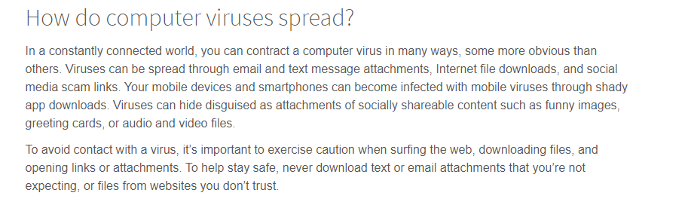
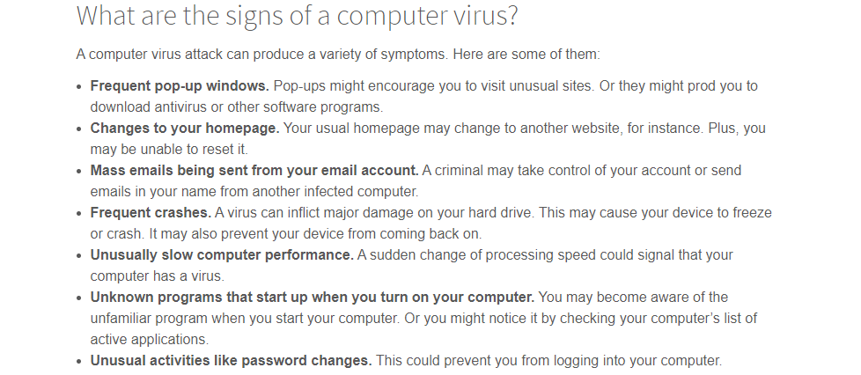

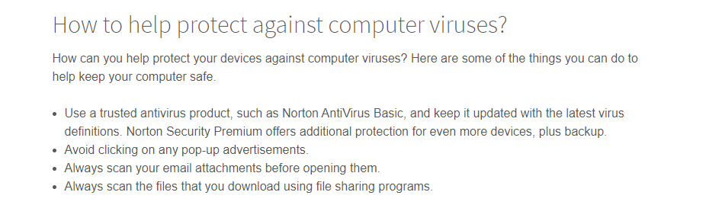
Viurs type
Viruses come in many forms:
– File infector viruses
– Boot sector viruses • System area, memory area, or both
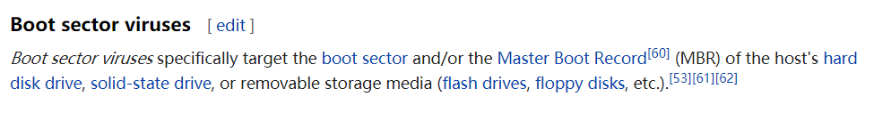
– Macro viruses
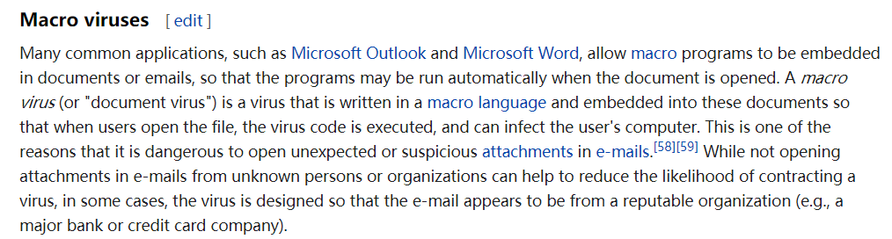
Viruses mutate:(self modification)
– Oligomorphic – using multiple decryptors. E.g., Whale
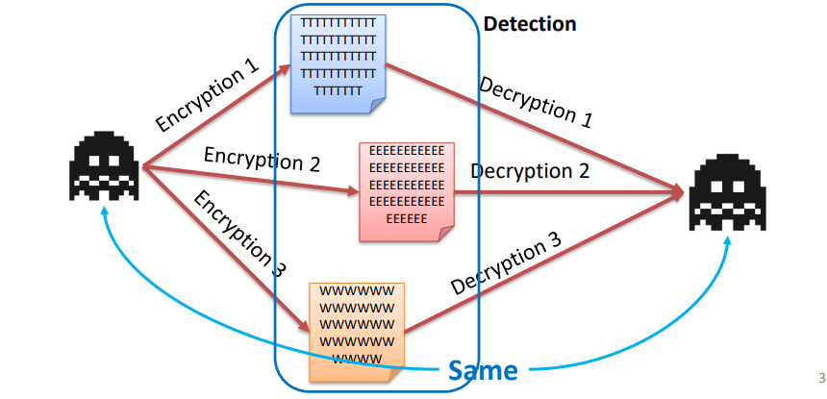
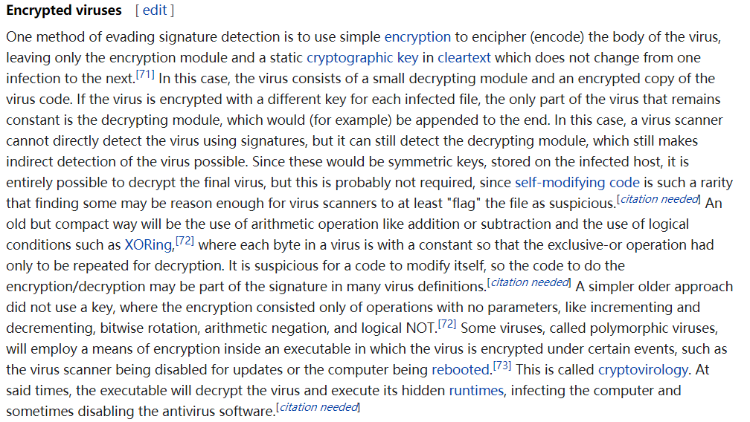
– Polymorphic – mutate certain part of itself. E.g., Virut
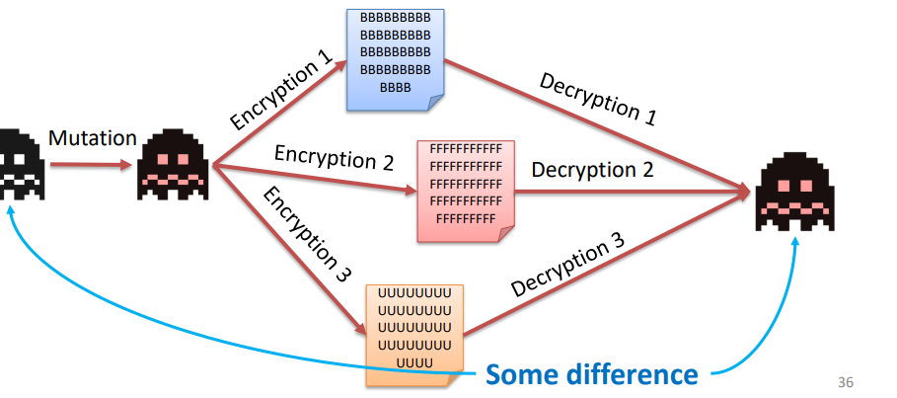
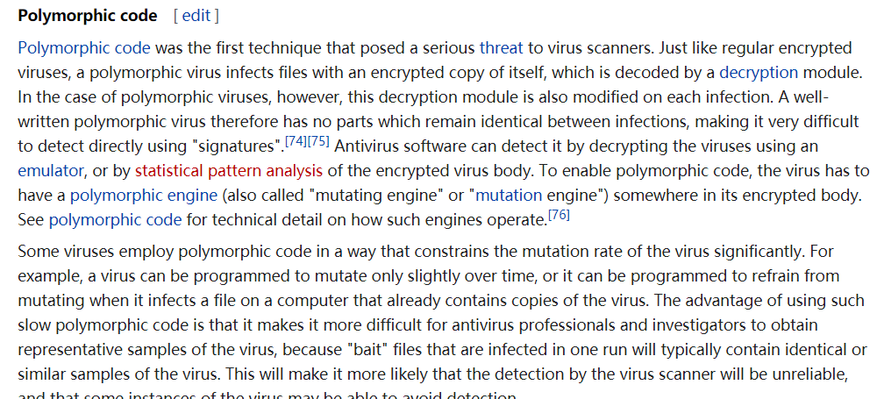
– Metamorphic – rewrites all (or most) of itself. E.g., Zmist, Virlock
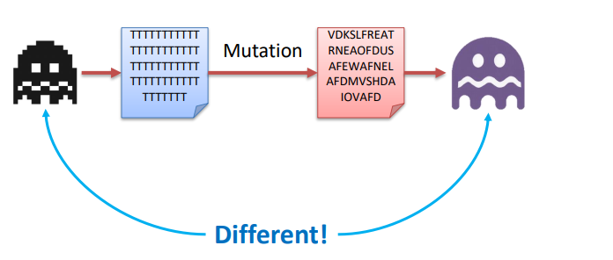
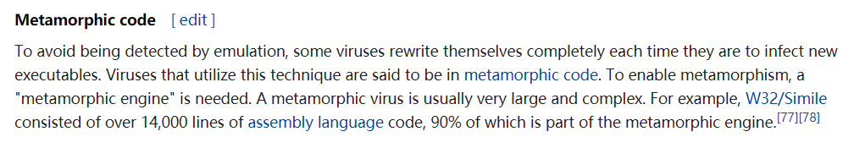
Virus - Silex
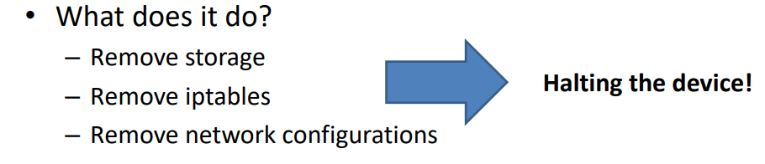
Step:
Steps taken in the attack 1. Enumerate accessible IP addresses 2. Identify all Unix-like systems 3. Attempt default login credentials 4. Access all disk partitions via fdisk -l 5. Then delete network config 6. Next, run rm –rf / to delete everything else 7. Finally, flush all iptables and add DROPS to all connections.

Virus – Malware Generator
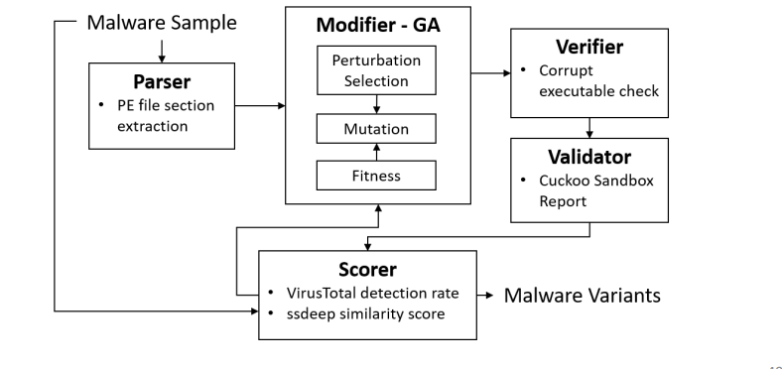

Protection
Antiviruses
– Scanning email attachments
– Checking virus activities (signatures and/or anomaly detection)
– Examples include Norton, McAfee, Trend Micro, Symantec, Sophos etc. – Incorporate sandboxing, AI, data mining, machine learning etc.
• Access restriction
– Remote access control
– Firewalls
– Email filtering

Worm
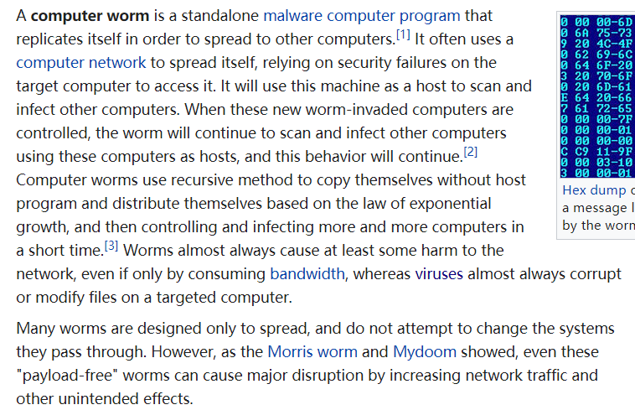

Focuses on spreading through the network
Exploits various network vulnerabilities to spread itself
– Unprotected shared drives
– FTP vulnerabilities (typically buffer overflow)
– E.g., Ramen, Lion, Code-Red, Conficker
May also release viruses upon opening
– E.g., MyDoom.A -> backdoor and DoS
– E.g., MyDoom.B -> MyDoom.A + block access to antivirus sites

Worm vs Virus
“Virus does not intentionally try to spread itself from that computer to other computers. In most cases, that's where humans come in”
“Worm is a program that is designed to copy itself from one computer to another over a network (e.g., by using e-mail). The worm spreads itself to many computers over a network”

Worm - Slammer
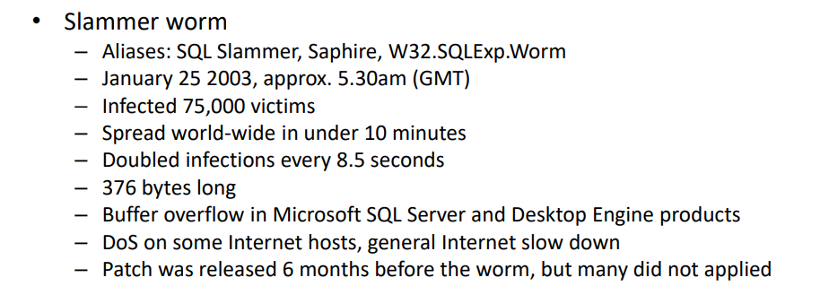
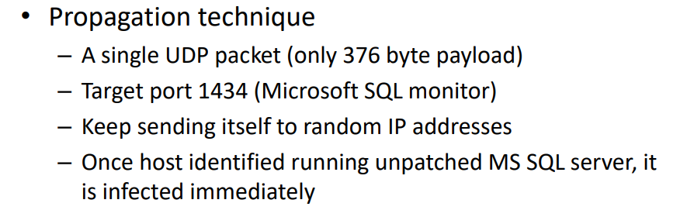
Worm - Protection
• Patching up-to-date – Applications and operating systems
• Security education – do not click suspicious links – Run executable files or programs
• Antivirus and anti-spyware software
• Firewall

Malvertising(恶意广告）
Definition
Malicious advertising
• Spread of malware through advertising
• Sometimes, just viewing can affect your system
Way to get
Many different ways they can get in:
– Pop-up ads – Web widgets – Hidden iframes – Malicious banners – Third-party advertisement – Etc.
How it attack
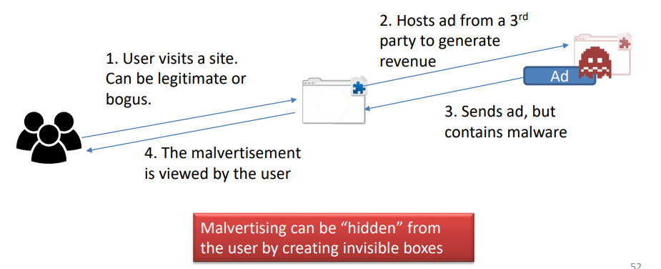

Malvertising – Protection
• Keeping up-to-date software and OS
• Antivirus and other malware protection methods
• Browser extensions alerting malvertising campaigns

Spyware
Variety of meanings including key loggers unsolicited commercial software, scumware, Trojan horses etc.
Spyware – Key Loggers
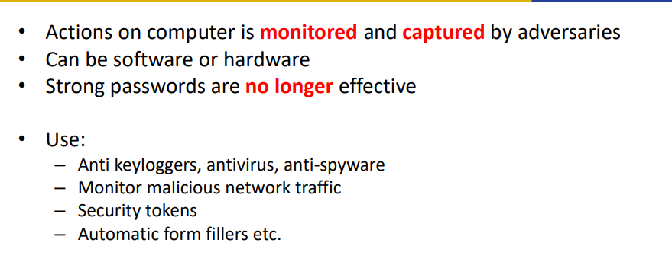
Spyware – Unsolicited Software
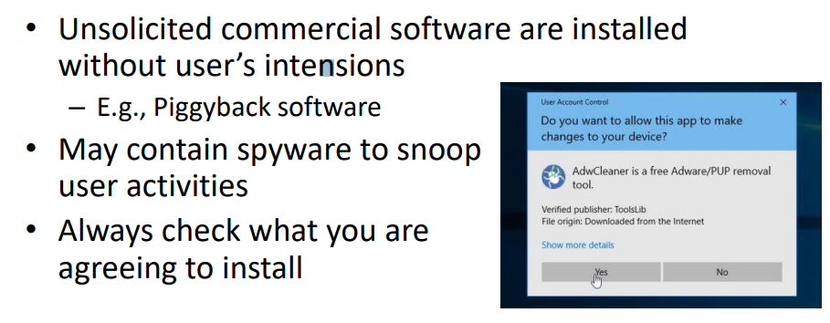
Spyware – Scumware
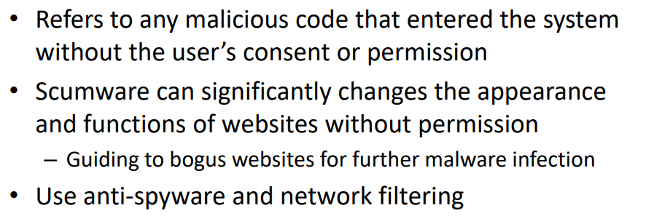
Harvesting Personal Information
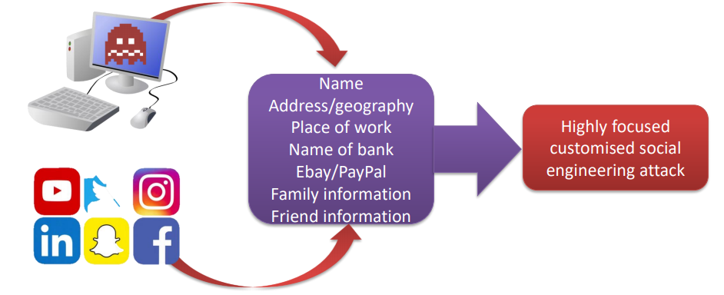
Trojan（木马）
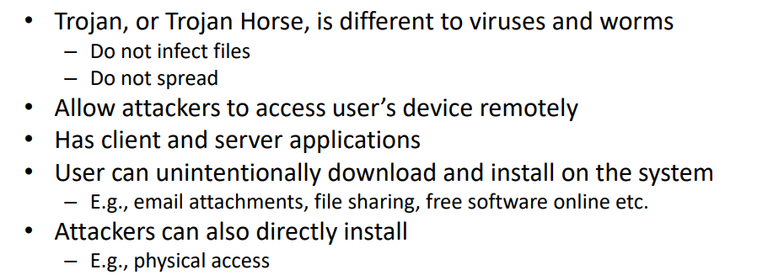
Mitigation
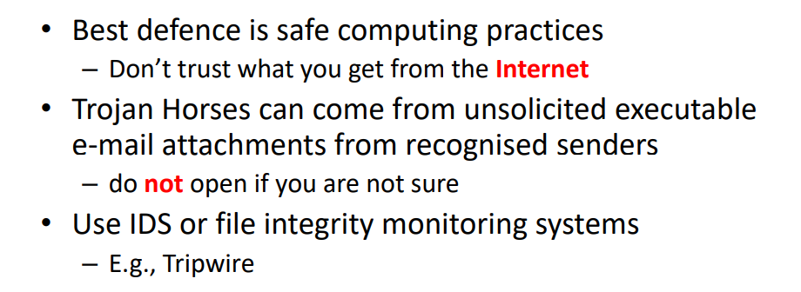
Rootkits
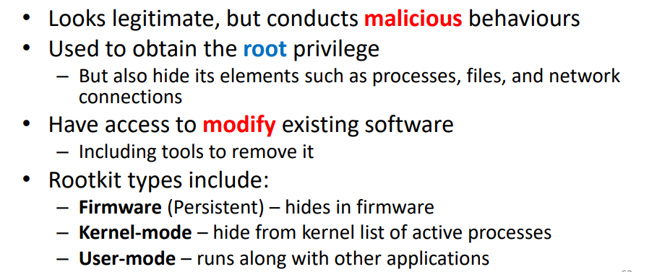
Mitigation
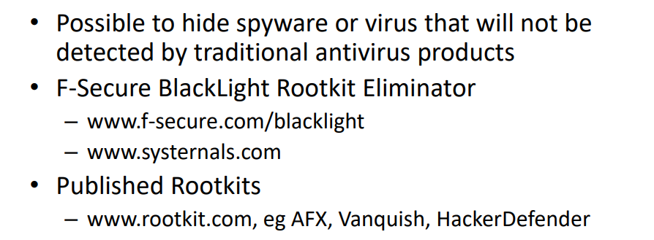

Botnet
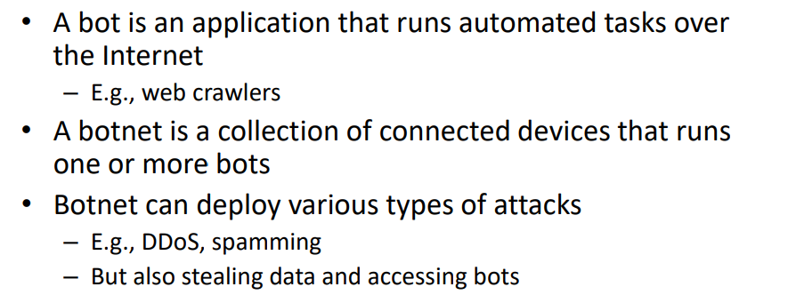
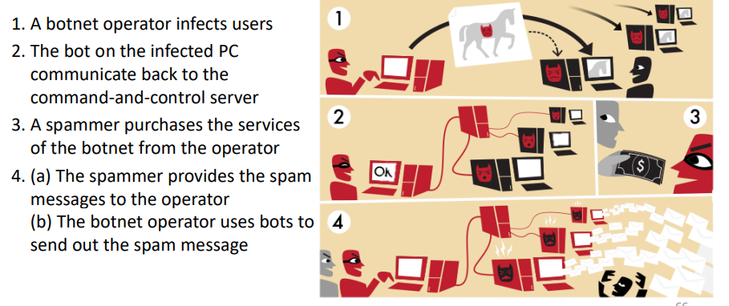
Zero Day
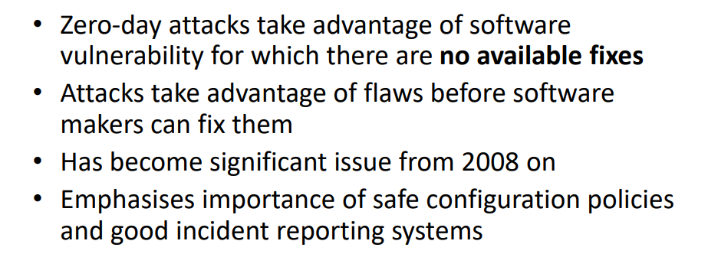
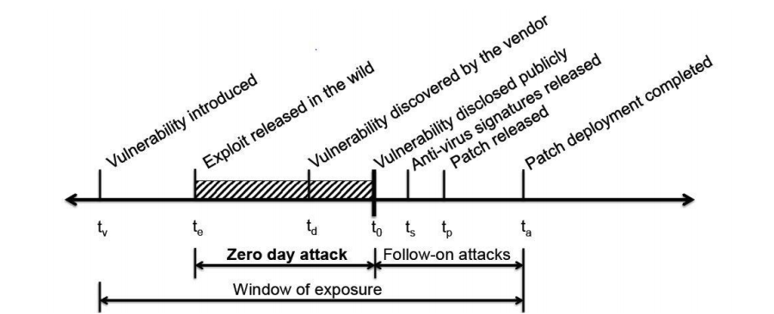

Detection:
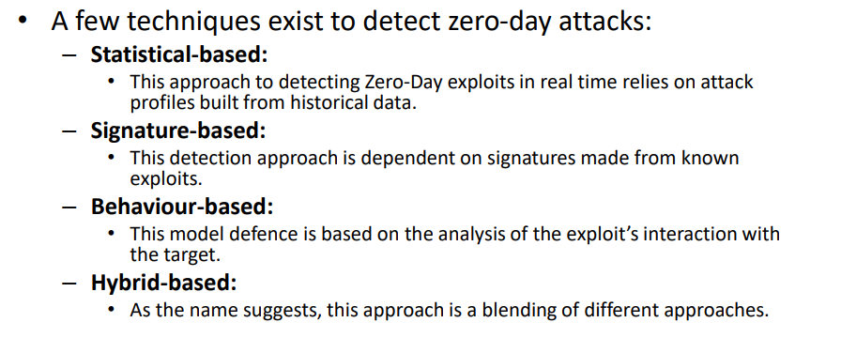
BOF
Network layer attacks
Web-based attacks
(Distributed) DoS
zero-day vulnerabilities

