1) <html>

<head></head>

<body>

<p>Choisir un bouton :<br /></p>

<form action="index.php" method="post">

<input type="submit" name="btn" value="Btn1" />

<input type="submit" name="btn" value="Btn2" />

<input type="submit" name="btn" value="But3" />

</form>

</body>

</html>

<?php

if (isset($_POST['btn'])) {

echo $_POST['btn'];

}

?>

2) 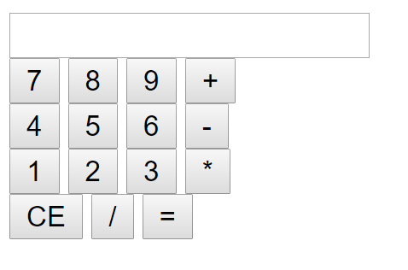

3) 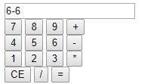

4/5)

<?php

$c = $_POST["affichage"].$_POST["clavier"];

if (isset($_POST["resultat"])) {

$r = $_POST["affichage"];

eval("\$c=**$r**;");

}

if (isset($_POST["reset"])) {

$c = "";

}

if (isset($_POST["log10"])) {

$c = log10( $_POST["affichage"]);

}

if (isset($_POST["pow"])) {

$c = $_POST["affichage"].="**";

}

if (isset($_POST["exp"])) {

$c = exp( $_POST["affichage"]);;

}

?>

<html>

<head></head>

<body>

<p></p>

<form action="index.php" method="post">

<input type="text" name="affichage" value="<?php echo $c;?>"/>

<br />

<input type="submit" name="clavier" value="7" />

<input type="submit" name="clavier" value="8" />

<input type="submit" name="clavier" value="9" />

<input type="submit" name="clavier" value="+" />

<br />

<input type="submit" name="clavier" value="4" />

<input type="submit" name="clavier" value="5" />

<input type="submit" name="clavier" value="6" />

<input type="submit" name="clavier" value="-" />

<br />

<input type="submit" name="clavier" value="1" />

<input type="submit" name="clavier" value="2" />

<input type="submit" name="clavier" value="3" />

<input type="submit" name="clavier" value="*" />

<br />

<input type="submit" name="reset" value="CE" />

<input type="submit" name="clavier" value="0" />

<input type="submit" name="clavier" value="/" />

<input type="submit" name="resultat" value="=" />

<br />

<input type="submit" name="log10" value="log10" />

<input type="submit" name="exp" value="exp" />

<input type="submit" name="pow" value="pow" />

</form>

</body>

</html>