Class and State Model Review — Version 4
Case study: Smart Campus Event & Facility Booking System
Team: W.O.M.M. (Works on my machine)
Course: CS4090

1. Introduction
This report compares our original class and state models with AI-generated models for the Smart Campus Event & Facility Booking System. The case study is the only requirements source used to judge either model: an element counts as supported only if the case study clearly states it or directly implies it.
Our original models and the AI prompts and outputs are reproduced without changes. We compare the models element by element in the rubric’s asked table format, and we list all AI’s errors and the limits of our prompts.

2. Requirements
The case study names seven actors: Student Organization Representative, Faculty/Staff Member, Facility Coordinator, Event Approver, Campus Security, System Administrator, and Notification Service. It lists sixteen required functions. It names the problems the system must fix: “double booking, unclear approval status, missing event information, and last-minute conflicts.”
The case study does not define whether a pending request holds the time slot, how no-shows are handled, cancellation deadlines, etc. Where either model adds a rule in unmentioned areas, we mark it as unsupported.

3. Team model being compared
Reproduced from our “Class & State Models Design” document. The diagrams, Mermaid code, and notes are unchanged.

3.1 Class model
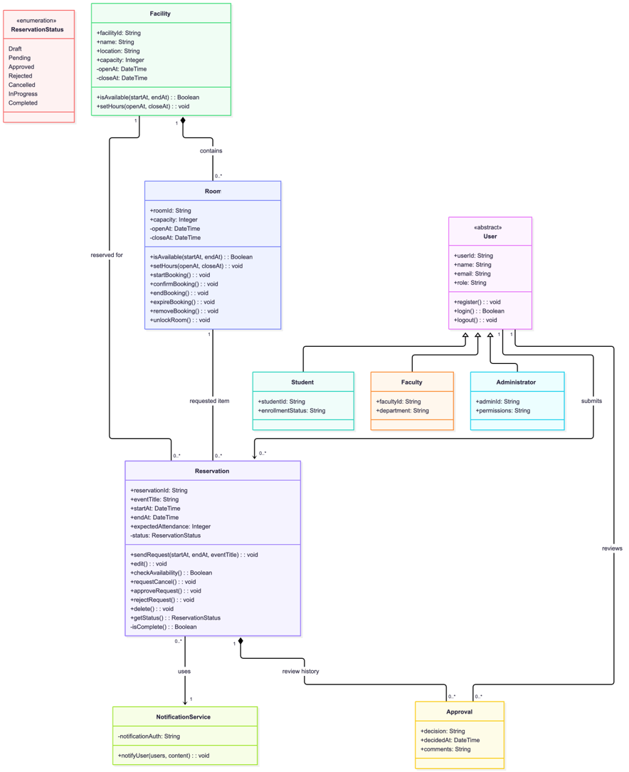
classDiagram
class User {
<<abstract>>
+userId: String
+name: String
+email: String
+role: String
+register(): void
+login(): Boolean
+logout(): void
}

class Student {
+studentId: String
+enrollmentStatus: String
}

class Faculty {
+facultyId: String
+department: String
}

class Administrator {
+adminId: String
+permissions: String
}

User <|-- Student
User <|-- Faculty
User <|-- Administrator

class Facility {
+facilityId: String
+name: String
+location: String
+capacity: Integer
-openAt: DateTime
-closeAt: DateTime
+isAvailable(startAt, endAt): Boolean
+setHours(openAt, closeAt): void
}

class Reservation {
+reservationId: String
+eventTitle: String
+startAt: DateTime
+endAt: DateTime
+expectedAttendance: Integer
-status: ReservationStatus
+sendRequest(startAt, endAt, eventTitle): void
+edit(): void
+checkAvailability(): Boolean
+requestCancel(): void
+approveRequest(): void
+rejectRequest(): void
+delete(): void
+getStatus(): ReservationStatus
-isComplete(): Boolean
}

class ReservationStatus {
<<enumeration>>
Draft
Pending
Approved
Rejected
Cancelled
InProgress
Completed
}

class Approval {
+decision: String
+decidedAt: DateTime
+comments: String
}

class Room {
+roomId: String
+capacity: Integer
-openAt: DateTime
-closeAt: DateTime
+isAvailable(startAt, endAt): Boolean
+setHours(openAt, closeAt): void
+startBooking(): void
+confirmBooking(): void
+endBooking(): void
+expireBooking(): void
+removeBooking(): void
+unlockRoom(): void
}

class NotificationService {
-notificationAuth: String
+notifyUser(users, content): void
}

User "1" --> "0..*" Reservation : submits
Facility "1" -- "0..*" Reservation : reserved for
Facility "1" *-- "0..*" Room : contains
Reservation "1" *-- "0..*" Approval : review history
User "1" -- "0..*" Approval : reviews
Room "1" -- "0..*" Reservation : requested item
Reservation "0..*" --> "1" NotificationService : uses
Notes
- Facility: Represents the building rooms can be reserved in. Includes important variables such as capacity and closing/opening times.
- User: Abstract class to represent different types of users, such as system admins, students, or faculty.
- Enum: To track possible states of Reservation status instead of generating many separate functions.
- Notification Service: Outside actor that sends notifications to all user types when creating, editing, or cancelling a reservation.
- Room: Physical rooms in the facility. The system operates under the assumption that saved rooms are always bookable, as it doesn’t make sense for a booking system to track non-bookable rooms.
- Approval: System or approver’s decision on whether a request is approved or rejected.

3.2 State model I: Room lifecycle
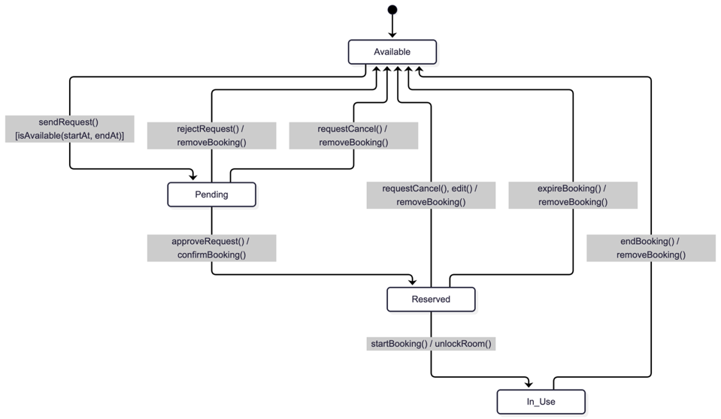
stateDiagram-v2
[*] --> Available

Available --> Pending : sendRequest() [isAvailable(startAt, endAt)]

Pending --> Reserved : approveRequest() / confirmBooking()
Pending --> Available : rejectRequest() / removeBooking()
Pending --> Available : requestCancel() / removeBooking()

Reserved --> In_Use : startBooking() / unlockRoom()
Reserved --> Available : requestCancel(), edit() / removeBooking()
Reserved --> Available : expireBooking() / removeBooking()
In_Use --> Available : endBooking() / removeBooking()

Notes
A Room can be in four states. They describe only the physical room itself. Whether a booking is requested, approved, rejected or cancelled is tracked by the Reservation. It is important to highlight the distinction between the two, as the lifecycles are closely intertwined, and that a room lifecycle can never end (unless its parent class, Facility, is removed), as the room does not stop existing when a reservation ends.
• Available: the room is free. No booking is holding it and no one is using it.
• Pending: the room is on hold for a booking request that is waiting for approval, so no other request can take it. No one is using it.
• Reserved: the room is now committed to an approved booking for a set time. No one is physically using it yet.
• In_Use: people are physically in the room for the booked event.
A Room has no Cancelled or Rejected state, because a room can’t be cancelled or rejected; only a Reservation can. When something happens to a reservation, the room responds:
What happens to the reservation | What happens to the room
A request is sent and the room is free for that time | Available -> Pending
The request is approved | Pending -> Reserved
The request is rejected or cancelled before approval | Pending -> Available
The approved reservation is cancelled or edited | Reserved -> Available; the room is now free for that time
No one shows up (expireBooking()) | Reserved -> Available
The event starts (startBooking()) | Reserved -> In_Use
The event ends (endBooking()) | In_Use -> Available

3.3 State model II: Reservation lifecycle
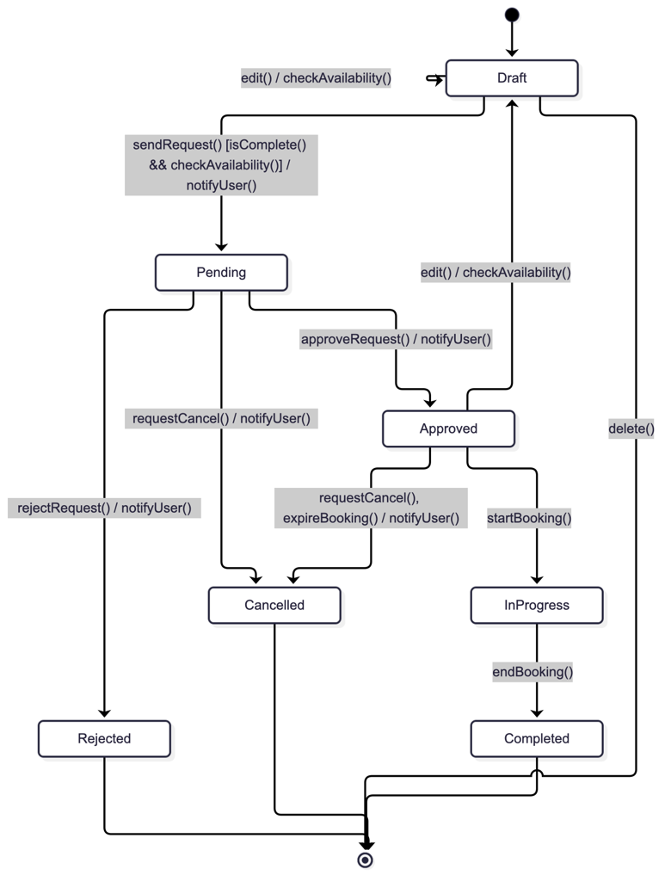
stateDiagram-v1
[*] --> Draft

Draft --> Draft: edit() / checkAvailability()
Draft --> Pending: sendRequest() [isComplete() && checkAvailability()] / notifyUser()
Draft --> [*]: delete()

Pending --> Approved: approveRequest() / notifyUser()
Pending --> Rejected: rejectRequest() / notifyUser()
Pending --> Cancelled: requestCancel() / notifyUser()

Approved --> Draft: edit() / checkAvailability()
Approved --> Cancelled: requestCancel(), expireBooking() / notifyUser()
Approved --> InProgress: startBooking()

InProgress --> Completed: endBooking()

Rejected --> [*]
Cancelled --> [*]
Completed --> [*]
Notes
A Reservation lifecycle is different from that of a Room. A Reservation is the booking record: who wants which room and when (think of Book vs BookCopy). Its states track the progress a request goes through. Whether the room itself is held or physically occupied belongs to the Room. The states are as follows:
• Draft: the user is still filling in the details for their reservation. Nothing has been submitted and no room is held.
• Pending: the request has been submitted and is waiting for an approval.
• Approved: the system or approver has accepted the request, and the booking is confirmed for its time.
• Rejected: the request is turned down (this could be due to faculty issues, important staff requiring the room, etc.)
• Cancelled: the user withdrew the request or booking.
• InProgress: the booked event is currently happening.
• Completed: the event has ended.
What happens | Reservation change
The user edits a draft | Draft -> Draft (availability is rechecked)
The user submits, the details must be complete and the room is free | Draft -> Pending
The user deletes a reservation draft | Draft -> ends
The request is approved | Pending -> Approved
The request is rejected | Pending -> Rejected
The user cancels | Pending or Approved -> Cancelled
The user edits an approved reservation | Approved -> Draft (it must be resubmitted and approved again
No one shows up | Approved -> Cancelled
The event starts | Approved -> InProgress
The event ends | InProgress -> Completed

Rejected, Cancelled and Completed are final states. The requester is notified when the request is submitted, approved, rejected or cancelled.

3.4 Assumptions and test scenario referenced in our review
Assumption Changes
• Room availability: In the original prototype, this depends on the time searched in the prototype. In the current model, the room diagram reads as one state for the whole room, and checks are run for room availability as needed.
• Approval: The Admin dashboard shows an Admin Role that can be used as approval, but in the current model, the approval is given to either the system or an external actor (admin), to account for more cases.
TS-1: Submit guard
A room has an approved booking on Oct 12 from 2:30 to 4:00 PM, and a new reservation for the same room is in Draft. Three things can happen when the user submits:
1a. Valid: The user requests 11:00 AM to 12:30 PM with all details filled in. Both isComplete() and checkAvailability() pass, so the Reservation moves from Draft to Pending and the requester is notified. The room’s 11:00 to 12:30 slot moves from Available to Pending.
1b. Time conflict: The user requests 2:00 to 3:00 PM, which overlaps the existing 2:30 booking. checkAvailability() fails, so the Reservation stays in Draft and no notification is sent. The existing 2:30 to 4:00 booking stays Reserved.
1c. Incomplete details: The user requests 11:00 AM to 12:30 PM but leaves out the event title. isComplete() fails, so the Reservation stays in Draft and the room is not held.
The test passes if only 1a is submitted.
The original document also contains Examples 1–2 and test scenario TS-2 (cancellation paths).

4. Prompts and AI-generated models
The three prompts below were run on November 6, 2026. Each prompt is followed by its output; the specific model versions for these calls were not exposed. Two additional class-model calls using the same prompt are summarized in section 4 as supplemental comparisons. The three complete prompt/output sets in this document are the primary AI evidence evaluated in the rubric. The project context referenced by the prompts is summarized in section 2, so no outside file is needed to interpret this review.

4.1 Class model prompt and output
Prompt
You are helping model the Smart Campus Event & Facility Booking System described in the supplied case study. The system serves student-organization representatives, faculty/staff, facility coordinators, event approvers, campus security, and system administrators. The case requires role-based access, searching by date/time/capacity/location, facility details, reservation submission/editing/cancellation, approvals and rejections, conflict checking, equipment and security/event-support requests, reservation status tracking, notifications, facility availability management, upcoming events, and usage reporting.
Propose one UML class model in Mermaid. Include meaningful classes, important attributes with suitable types, operations with responsibilities, associations, relationship types where justified, and multiplicities. Keep domain records distinct from application or external services. Explain why the responsibilities and relationship types are appropriate. Do not invent detailed business policies that the case does not state; mark open questions, including whether pending requests hold a slot, how long a hold lasts, whether approvals can be automated, how support requests are fulfilled, and whether a reservation can include more than one room. Include a short list of design choices that the team should validate against its use cases and prototype.
AI output
The class diagram is shown in two views for readability. Its Mermaid source follows for editing.
Core domain classes and relationships
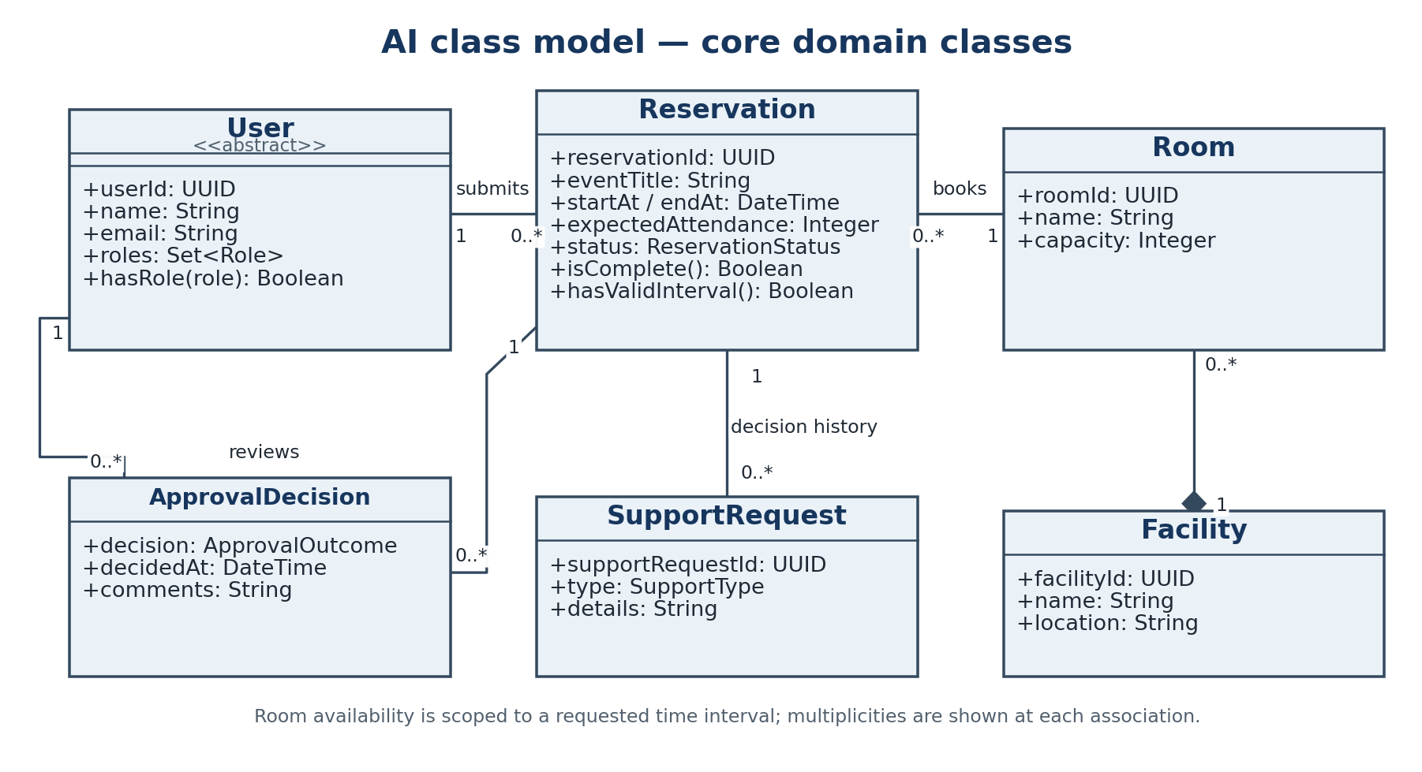
Enumerations and services
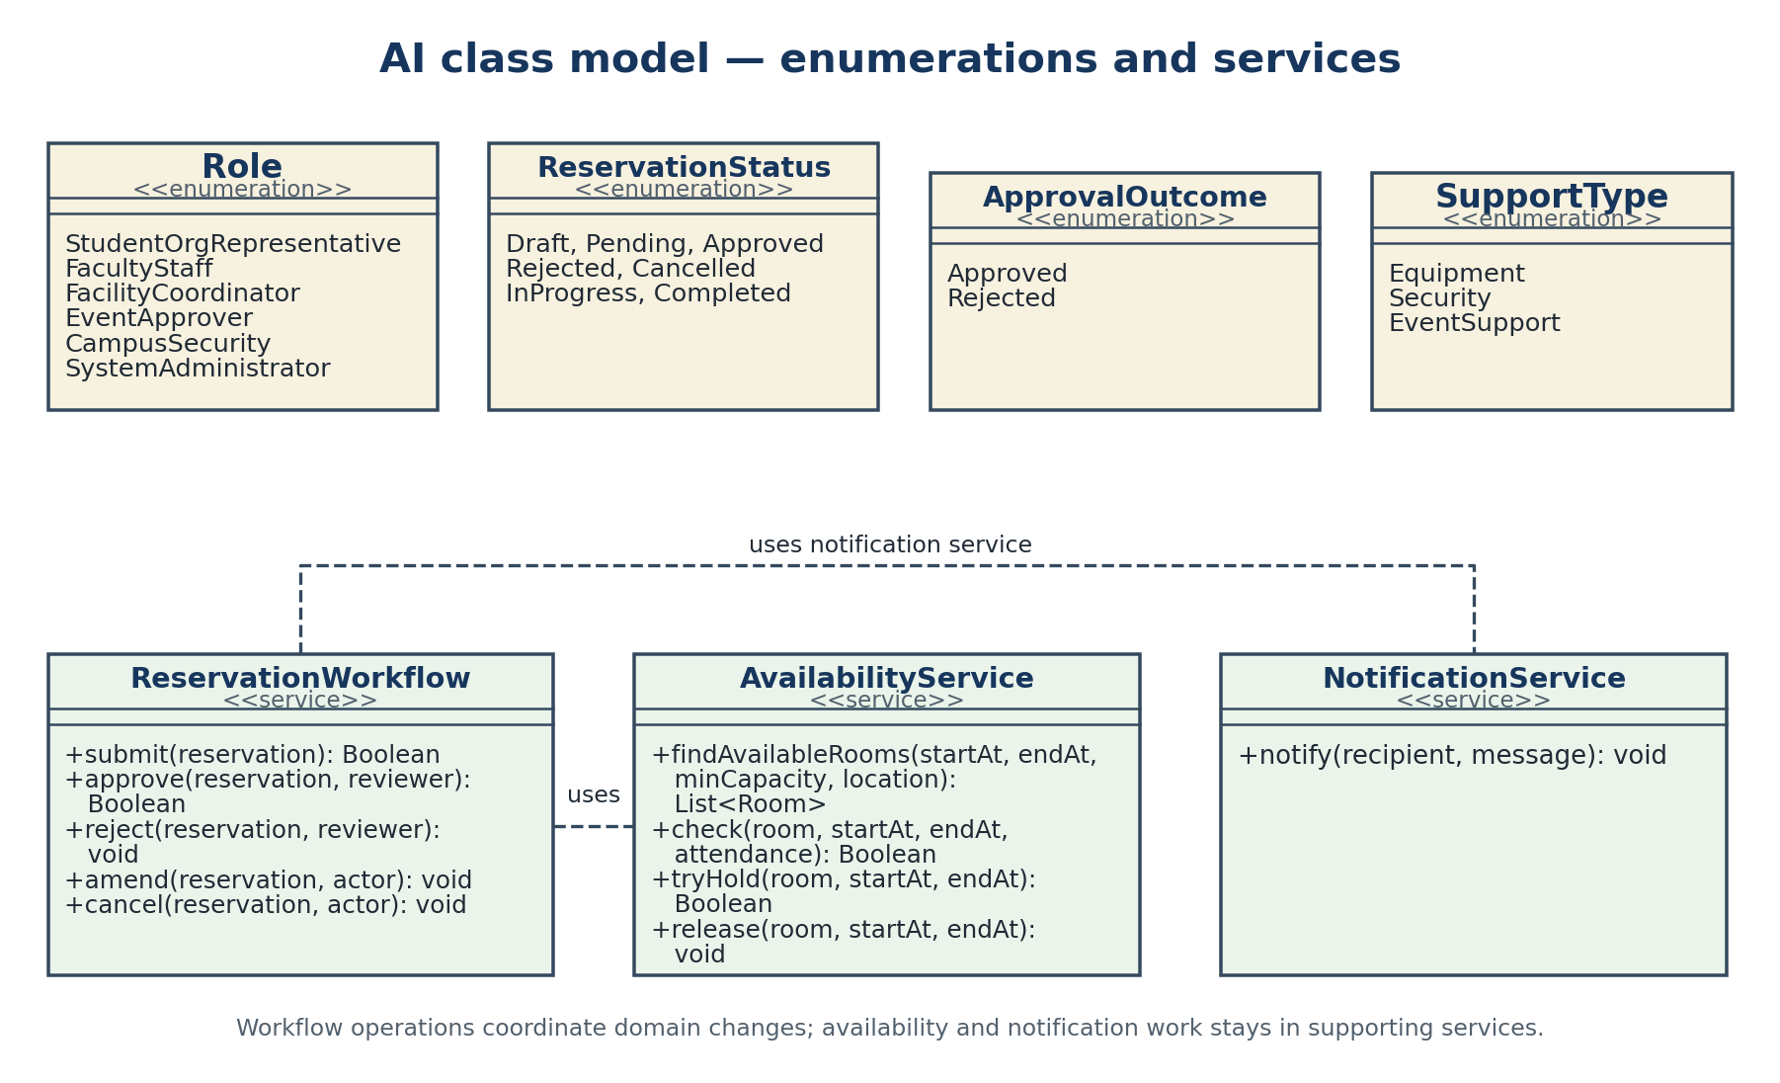
classDiagram
direction LR

class User {
<<abstract>>
+userId: UUID
+name: String
+email: String
+roles: Set~Role~
+hasRole(role: Role): Boolean
}
class Role {
<<enumeration>>
StudentOrgRepresentative
FacultyStaff
FacilityCoordinator
EventApprover
CampusSecurity
SystemAdministrator
}
class Facility {
+facilityId: UUID
+name: String
+location: String
}
class Room {
+roomId: UUID
+name: String
+capacity: Integer
}
class Reservation {
+reservationId: UUID
+eventTitle: String
+startAt: DateTime
+endAt: DateTime
+expectedAttendance: Integer
+status: ReservationStatus
+isComplete(): Boolean
+hasValidInterval(): Boolean
}
class ReservationStatus {
<<enumeration>>
Draft
Pending
Approved
Rejected
Cancelled
InProgress
Completed
}
class ApprovalDecision {
+decision: ApprovalOutcome
+decidedAt: DateTime
+comments: String
}
class ApprovalOutcome {
<<enumeration>>
Approved
Rejected
}
class SupportRequest {
+supportRequestId: UUID
+type: SupportType
+details: String
}
class SupportType {
<<enumeration>>
Equipment
Security
EventSupport
}
class ReservationWorkflow {
+submit(reservation: Reservation): Boolean
+approve(reservation: Reservation, reviewer: User): Boolean
+reject(reservation: Reservation, reviewer: User): void
+amend(reservation: Reservation, actor: User): void
+cancel(reservation: Reservation, actor: User): void
}
class AvailabilityService {
+findAvailableRooms(startAt: DateTime, endAt: DateTime, minCapacity: Integer, location: String): List~Room~
+check(room: Room, startAt: DateTime, endAt: DateTime, attendance: Integer): Boolean
+tryHold(room: Room, startAt: DateTime, endAt: DateTime): Boolean
+release(room: Room, startAt: DateTime, endAt: DateTime): void
}
class NotificationService {
+notify(recipient: User, message: String): void
}

Facility "1" *-- "0..*" Room : contains
User "1" --> "0..*" Reservation : submits
Room "1" --> "0..*" Reservation : requested for over time
Reservation "1" --> "0..*" ApprovalDecision : decision history
User "1" --> "0..*" ApprovalDecision : reviewer
Reservation "1" *-- "0..*" SupportRequest : includes
ReservationWorkflow ..> AvailabilityService : checks and updates
ReservationWorkflow ..> NotificationService : sends notices
The proposed workflow service handles submission, decisions, amendments, and cancellation. The availability service searches and checks rooms, while the notification service sends notices. One reservation is linked to one requester and one room; the room may have many reservations over time, but their active intervals must not overlap. The approval history is linked to the reservation and each decision has a reviewer. Support requests record what was requested, without adding an inventory or fulfillment workflow that the case does not define.
The model uses a set of roles, which assumes a person can have more than one role. The case does not say whether that is allowed. It also uses composition between Facility and Room, and between Reservation and SupportRequest; those relationships assume the contained objects do not have an independent lifecycle.
Open questions include whether a reservation can include more than one room, how pending holds work, whether approval is always done by a person, what support fulfillment looks like, and whether the system stores student organizations as data.

4.2 Reservation state-model prompt and output
Prompt
Using the supplied Smart Campus Event & Facility Booking System case, model the lifecycle of one Reservation as a UML state diagram in Mermaid. The case includes draft requests, submission, approval/rejection, cancellation, conflict checking, status tracking, and notifications. Show an initial state, meaningful intermediate states, terminal states, event/action labels, and guard conditions. Include incomplete/invalid submission behavior, cancellation and amendment paths, and recovery or error paths that are supported by the case.
Do not silently invent the rules for pending holds, cancellation deadlines, approved-request edits, or no-show detection. Identify those as open decisions. Explain how reservation status relates to a room’s time-slot availability. Make state names conditions rather than actions, and identify any event whose trigger or responsible actor is not established by the case.
AI output
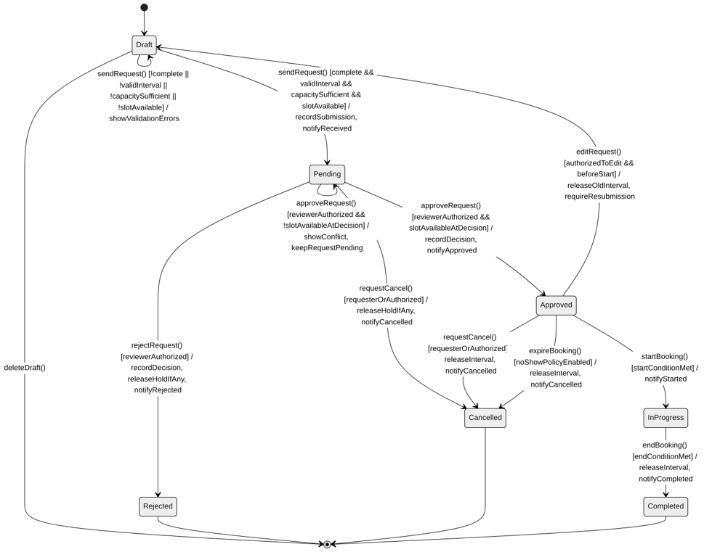
stateDiagram-v2
[*] --> Draft

Draft --> Draft: edit() / validateDraft
Draft --> Pending: sendRequest() [complete && validInterval && capacitySufficient && slotAvailable] / recordSubmission, notifyReceived
Draft --> Draft: sendRequest() [!complete || !validInterval || !capacitySufficient || !slotAvailable] / showValidationErrors
Draft --> [*]: deleteDraft()

Pending --> Approved: approveRequest() [reviewerAuthorized && slotAvailableAtDecision] / recordDecision, notifyApproved
Pending --> Pending: approveRequest() [reviewerAuthorized && !slotAvailableAtDecision] / showConflict, keepRequestPending
Pending --> Rejected: rejectRequest() [reviewerAuthorized] / recordDecision, releaseHoldIfAny, notifyRejected
Pending --> Cancelled: requestCancel() [requesterOrAuthorized] / releaseHoldIfAny, notifyCancelled

Approved --> Draft: editRequest() [authorizedToEdit && beforeStart] / releaseOldInterval, requireResubmission
Approved --> Cancelled: requestCancel() [requesterOrAuthorized] / releaseInterval, notifyCancelled
Approved --> Cancelled: expireBooking() [noShowPolicyEnabled] / releaseInterval, notifyCancelled
Approved --> InProgress: startBooking() [startConditionMet] / notifyStarted

InProgress --> Completed: endBooking() [endConditionMet] / releaseInterval, notifyCompleted

Rejected --> [*]
Cancelled --> [*]
Completed --> [*]
An invalid submission stays in Draft and should display the validation errors. The model uses Expired behavior as an optional event that ends in Cancelled; it does not add a separate Expired status. The case does not define how to detect a no-show. An approved edit releases the old interval and requires another submission, so approval does not silently carry over to changed terms. If Pending requests do not hold slots, availability must be checked again when approval is attempted; a conflict leaves the request Pending and reports the conflict. The case does not define the triggers for event start/end or a timeout for undecided Pending requests.

4.3 Room/time-slot state-model prompt and output
Prompt
Using the Smart Campus Event & Facility Booking System case, create a Mermaid UML state model for the scheduling status of one room during one requested time interval. Be explicit that this does not represent the physical room’s state for all time: the same room can be available in one interval and reserved in another.
Show how a valid reservation request, approval, rejection, cancellation, event start, and event end affect the allocation. Include transition events, actions, guards, and release paths. Keep reservation outcomes (such as Rejected or Cancelled) distinct from allocation states. Do not assume that pending requests hold a slot, that holds expire, or that no-shows are detected automatically; mark these as questions unless the case provides a rule. Explain whether this lifecycle should have a final state.
AI output
This model covers both possible pending-request policies. Pending is used only if a submitted request holds the interval. If it does not, the allocation remains Available while the request waits.
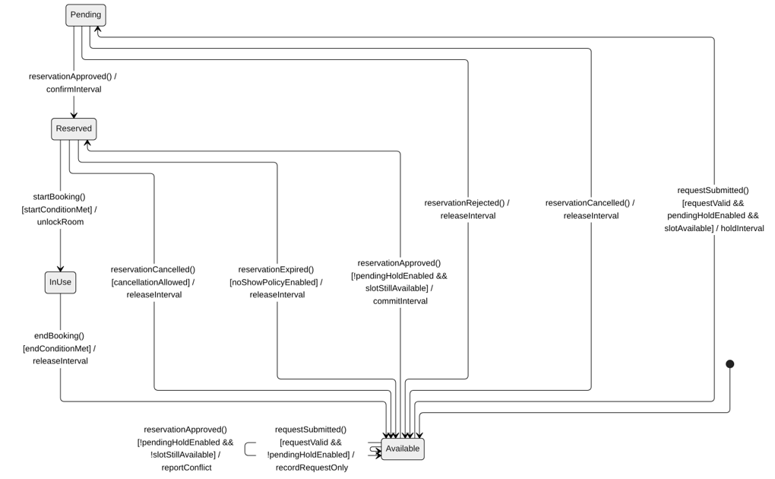
stateDiagram-v2
[*] --> Available

Available --> Pending: requestSubmitted() [requestValid && pendingHoldEnabled && slotAvailable] / holdInterval
Available --> Available: requestSubmitted() [requestValid && !pendingHoldEnabled] / recordRequestOnly

Pending --> Reserved: reservationApproved() / confirmInterval
Pending --> Available: reservationRejected() / releaseInterval
Pending --> Available: reservationCancelled() / releaseInterval

Available --> Reserved: reservationApproved() [!pendingHoldEnabled && slotStillAvailable] / commitInterval
Available --> Available: reservationApproved() [!pendingHoldEnabled && !slotStillAvailable] / reportConflict

Reserved --> InUse: startBooking() [startConditionMet] / unlockRoom
Reserved --> Available: reservationCancelled() [cancellationAllowed] / releaseInterval
Reserved --> Available: reservationExpired() [noShowPolicyEnabled] / releaseInterval
InUse --> Available: endBooking() [endConditionMet] / releaseInterval
This is a reusable allocation lifecycle, so it has no final state while the room remains in service. Rejected and Cancelled are reservation outcomes; the allocation responds by releasing the interval. A pending hold has no timeout in the diagram. Start, end, and no-show events need a defined actor or system process before implementation.

5. Class model comparison
Counts come from each model’s Mermaid code. “Proposed decision” uses the KEEP / MODIFY / REJECT / ADD labels given to us by the rubric.

5.1 Summary
Model element | Our team model | AI model | Better / stronger? | Why? | Proposed decision
Classes | 10 (1 enumeration) | 13 (4 enumerations, 3 services) | Mixed | The AI adds Role and SupportRequest, which the case needs, plus a workflow class it doesn’t. | ADD Role, SupportRequest; REJECT ReservationWorkflow
Attributes | 30 | 22 | Mixed | Ours has fields the case never mentions and repeats capacity and hours on both Facility and Room. | MODIFY: remove extras and duplicates
Operations | 23 | 13 | Ours | Ours covers login and facility hours; the AI has neither. | KEEP ours; ADD search operations.
Relationships | 7 associations + 3 inheritance | 6 associations + 2 dependencies | AI | The AI drops our extra Reservation-Facility link (Facility is already reachable through Room) and uses the notification service instead of owning a link to it. | MODIFY: drop the Reservation-Facility link; use a dependency for NotificationService
Multiplicity | Complete | Complete | Equal | Both: one requester and one room per reservation. | KEEP
State paths | 18 transitions, 2 guards | 24 transitions, 19 guards | Team | Ours prevents double booking more simply. | KEEP

5.2 Key differences
Model element | Our team model | AI model | Better / stronger? | Why? | Proposed decision
User roles | 3 subclasses (Student, Faculty, Administrator) plus a role text field | One Role list with all 6 case actors | AI | One list covers every actor. The AI lets one user potentially hold several roles, and its User is abstract with no subclasses, so no user can actually be created. | MODIFY: one role per user; make User a normal class
Login and facility hours | register(), login(), logout(), setHours() | None | Team | These are case requirements the AI dropped. | KEEP
Search | Checks a time slot only | Searches by date, time, capacity, and location | AI | Matches the case requirement word for word. | ADD findAvailableRooms()
Support requests | None | SupportRequest (Equipment, Security, EventSupport) | AI | The case asks for equipment and security/event-support requests; we had nowhere to store them. | ADD
Where behavior lives | Reservation and Room own their methods | A separate ReservationWorkflow class does the work | Team | The case doesn’t need a workflow class, and ours keeps every state event matched to a method. | REJECT ReservationWorkflow
Approval | Decision is a string. An approval belongs to its reservation through composition. | Decision is Approved or Rejected only. There is only an association to the reservation. | Mixed | The AI’s two-value list is safer than a string. Ours is right that an approval can’t exist without its reservation. | MODIFY: keep ours; make the decision Approved/Rejected
Reminders, upcoming events, reports | None | None | Both weak | All three are case requirements that neither model covers. | ADD

5.3 What each model covers

• Only the AI covers: all six actors, search by capacity and location, and equipment/security/event-support requests.

• Only ours covers: registration/login and managing facility hours.

• Both cover: submitting, editing and cancelling, approving and rejecting, conflict checks, status tracking, and confirmation messages.

• Neither covers: reminders, upcoming events, and usage reports.

• Both add things the case never asks for. Ours adds extra user fields, and no-show handling. The AI adds multi-role users, a workflow class, and hold/release methods.

6. State model comparison

6.1 Double booking: how each model prevents it

This is the biggest difference between the two models.
Ours checks once and holds the slot. A request is only submitted if the room is free (checkAvailability()), and the room then moves to Pending, where “no other request can take it.” Any overlapping request is stopped at submission (refer to TS-1), so approval needs no second check.
The AI makes holding optional, then patches any of the gaps. Overlapping requests can all reach Pending, so conflicts only show up at an approval stage. Handling that takes a second check, and extra loops. A request that loses the slot is stuck in Pending with no way forward.

Proposed decision: KEEP our hold-at-submission policy; REJECT the flag and the approval-time conflict paths.

6.2 Transition comparison
Behavior | Our team model | AI model | Better / stronger? | Why? | Proposed decision
States | Reservation: 7 states, starts in Draft, ends in Rejected, Cancelled, or Completed. Room: 4 states, never ends | Same | Equal | The AI added no new states and kept the same start and end states. | KEEP
Failed submission | Implied by the guard only | Explicit Draft→Draft loop that shows the errors | AI | Makes the case’s “missing event information” problem visible to the user. | ADD
Who may approve, cancel, or edit | Not checked | Role checks, plus a cancellation-deadline check | Mixed | Role checks match the case’s role-based access; deadlines are not in the case. | ADD one role check; REJECT the deadline
Editing an approved booking | Both diagrams free the room | The Reservation diagram frees it; the Room diagram doesn’t | Team | Our two diagrams agree; the AI’s contradict each other. | KEEP ours
Extras the case never asks for | No-show handling (expireBooking()) | No-show behind a flag, empty guards, start/end notifications | Both weak | None of these are in the case. | REJECT in both
Notifications | Confirmation on each decision; no reminder | Same | Both weak | The case asks for confirmations and reminders. | ADD a reminder
Events match class methods | Yes, every one | None match | Team | Each of our transitions maps to a class method. The AI’s don’t, and it even names the same event two ways (sendRequest() vs requestSubmitted()). | KEEP our naming

7. AI errors and limitations

7.1 Errors in the AI output
- Case requirements dropped. The AI class model has no login, facility-management, upcoming-events, usage-report, or reminder operations. The case’s workflow starts with Login, so it is needed.
- A User that can’t exist. User is marked abstract, but the AI removed all of its subclasses. An abstract class can’t be created on its own, so as drawn the system has no users.
- Behavior moved into a disconnected class. ReservationWorkflow does all of the submitting, approving, and cancelling, (all technical behaviors) but the diagram never connects it to Reservation.
- No-show rule added despite our prompt. The AI added no-show transitions behind a flag, even though we asked it to leave no-shows as an open question. Therefore, it adds a rule the case does not have.
- Guards and actions that do nothing. [startConditionMet], [endConditionMet], keepRequestPending, and recordRequestOnly look like rules but change nothing, and are therefore useless for the pipeline.
- The three AI models disagree. The Reservation diagram frees the room when an approved booking is edited, but the Room diagram never does, and none of the class methods appear in either state diagram. These models can’t be built together without guessing.

7.2 Limitations caused by our prompts
- Our class prompt left out “registration and login” and “reminders,” and the AI left both out too.
- We requested all code to be generated in Mermaid code, which may have limited certain functionalities.
- We ran three separate prompts without telling the AI to reuse the class methods in the state diagrams, which is why its models don’t match each other.

8. Adopted revisions and final models
Each change below comes from a proposed decision in sections 5 and 6. Section numbers in the Reason column point to the comparison that justifies it.

8.1 Decisions
Decision | Change | Reason
KEEP | Hold the room’s time slot at submission, with one availability check. | Prevents double booking and shows conflicts right away..
KEEP | register(), login(), logout(), and setHours(). | Registration/login and managing facilities are case requirements the AI dropped.
KEEP | Behavior stays on Reservation and Room, and every state event is a class method. An approved edit frees the room in both state diagrams. | The case needs no workflow class, and matching names keep the class and state models consistent.
MODIFY | User has one role: Role and is a normal class; the Student, Faculty, and Administrator subclasses are removed. | One list covers all six case actors.
MODIFY | Approval keeps its composition to Reservation; decision becomes ApprovalOutcome (Approved, Rejected). | Two fixed values are safer than free text, and an approval cannot exist without its reservation..
MODIFY | Removed enrollmentStatus, department, permissions, and notificationAuth. Capacity is kept only on Room and opening hours only on Facility. | The case never mentions these fields, and duplicated values may disagree.
MODIFY | Dropped the Reservation–Facility link; Reservation uses NotificationService through a dependency. | Facility is already reachable through Room, and a record should use a service rather than own a link to it.
REJECT | ReservationWorkflow. | The case does not need it, and it moves behavior away from the class it changes.
REJECT | The optional-hold flag and the approval-time conflict paths. | They only exist to patch the no-hold policy.
REJECT | No-show handling (expireBooking()) in both models; the AI’s empty guards, start/end notifications, and cancellation deadline. | None of these are in the case study document.
ADD | Role, SupportRequest, and SupportType; requestSupport() on Reservation. | The case requires role-based access and equipment and security/event-support requests.
ADD | findAvailableRooms(startAt, endAt, minCapacity, location) on Facility. | Matches “search by date, time, capacity, and location” in case study.
ADD | Draft→Draft on a failed sendRequest(), with showValidationErrors(). | Makes the case’s “missing event information” problem visible to the user.
ADD | [isAuthorized(...)] on approve, reject, cancel, and edit. | Matches the case’s role-based access requirements.
ADD | sendReminder() (Approved→Approved), viewUpcomingEvents(), and generateUsageReport(). | Reminders, upcoming events, and usage reports are case requirements no model covered.

8.2 Final class model
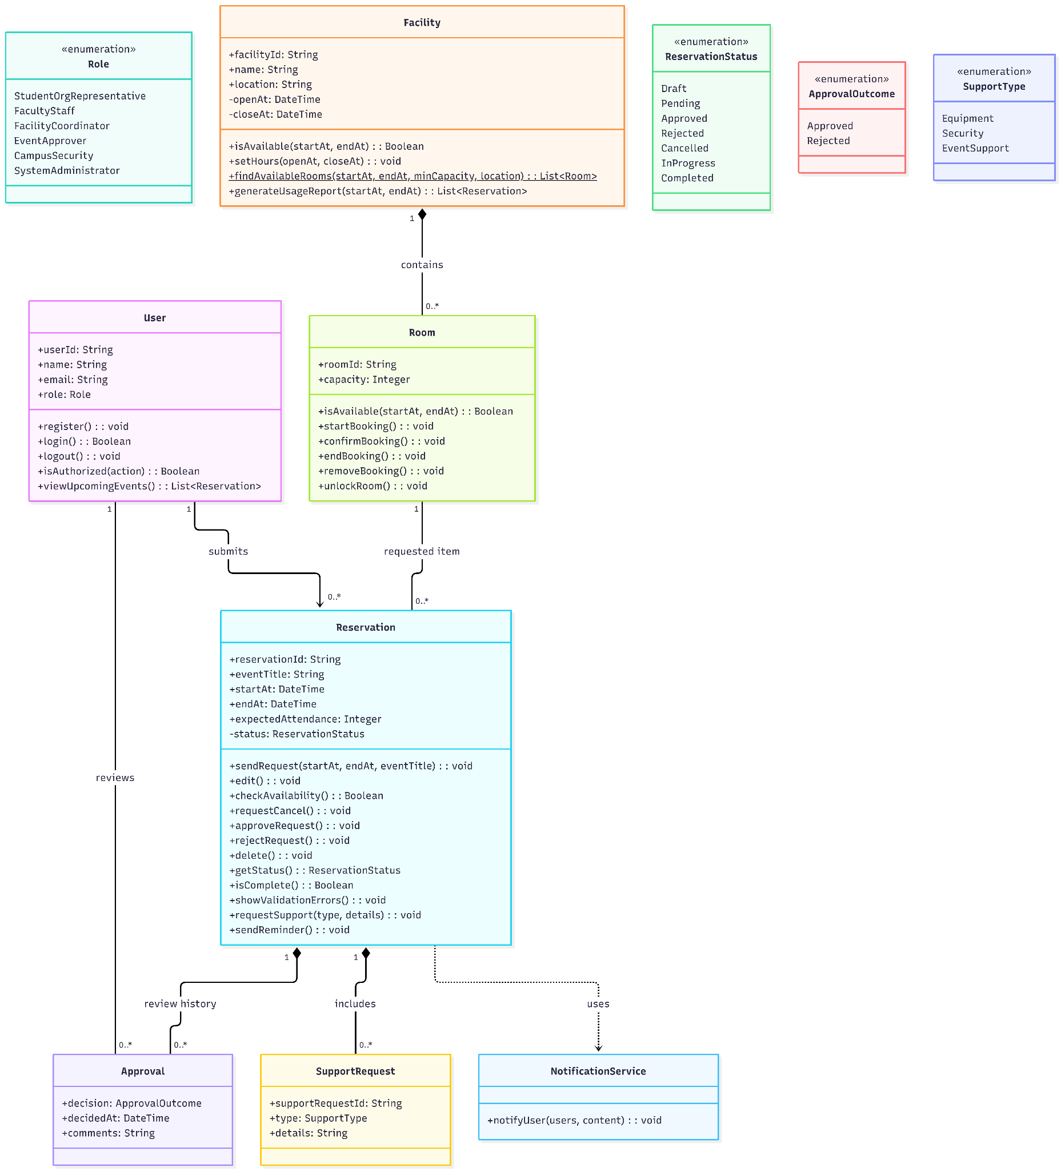
classDiagram
class User {
+userId: String
+name: String
+email: String
+role: Role
+register(): void
+login(): Boolean
+logout(): void
+isAuthorized(action): Boolean
+viewUpcomingEvents(): List~Reservation~
}

class Role {
<<enumeration>>
StudentOrgRepresentative
FacultyStaff
FacilityCoordinator
EventApprover
CampusSecurity
SystemAdministrator
}

class Facility {
+facilityId: String
+name: String
+location: String
-openAt: DateTime
-closeAt: DateTime
+isAvailable(startAt, endAt): Boolean
+setHours(openAt, closeAt): void
+findAvailableRooms(startAt, endAt, minCapacity, location): List~Room~$
+generateUsageReport(startAt, endAt): List~Reservation~
}

class Reservation {
+reservationId: String
+eventTitle: String
+startAt: DateTime
+endAt: DateTime
+expectedAttendance: Integer
-status: ReservationStatus
+sendRequest(startAt, endAt, eventTitle): void
+edit(): void
+checkAvailability(): Boolean
+requestCancel(): void
+approveRequest(): void
+rejectRequest(): void
+delete(): void
+getStatus(): ReservationStatus
+isComplete(): Boolean
+showValidationErrors(): void
+requestSupport(type, details): void
+sendReminder(): void
}

class ReservationStatus {
<<enumeration>>
Draft
Pending
Approved
Rejected
Cancelled
InProgress
Completed
}

class Approval {
+decision: ApprovalOutcome
+decidedAt: DateTime
+comments: String
}

class ApprovalOutcome {
<<enumeration>>
Approved
Rejected
}

class SupportRequest {
+supportRequestId: String
+type: SupportType
+details: String
}

class SupportType {
<<enumeration>>
Equipment
Security
EventSupport
}

class Room {
+roomId: String
+capacity: Integer
+isAvailable(startAt, endAt): Boolean
+startBooking(): void
+confirmBooking(): void
+endBooking(): void
+removeBooking(): void
+unlockRoom(): void
}

class NotificationService {
+notifyUser(users, content): void
}

User "1" --> "0..*" Reservation : submits
Facility "1" *-- "0..*" Room : contains
Reservation "1" *-- "0..*" Approval : review history
User "1" -- "0..*" Approval : reviews
Room "1" -- "0..*" Reservation : requested item
Reservation "1" *-- "0..*" SupportRequest : includes
Reservation ..> NotificationService : uses

8.3 Final state model I: Room lifecycle
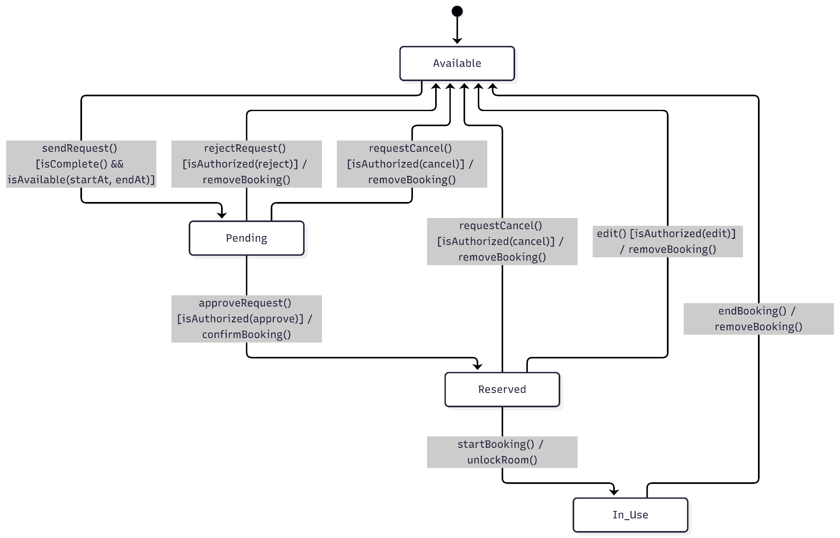
stateDiagram-v2
[*] --> Available

Available --> Pending : sendRequest() [isComplete() && isAvailable(startAt, endAt)]

Pending --> Reserved : approveRequest() [isAuthorized(approve)] / confirmBooking()
Pending --> Available : rejectRequest() [isAuthorized(reject)] / removeBooking()
Pending --> Available : requestCancel() [isAuthorized(cancel)] / removeBooking()

Reserved --> In_Use : startBooking() / unlockRoom()
Reserved --> Available : requestCancel() [isAuthorized(cancel)] / removeBooking()
Reserved --> Available : edit() [isAuthorized(edit)] / removeBooking()
In_Use --> Available : endBooking() / removeBooking()

8.4 Final state model II: Reservation lifecycle
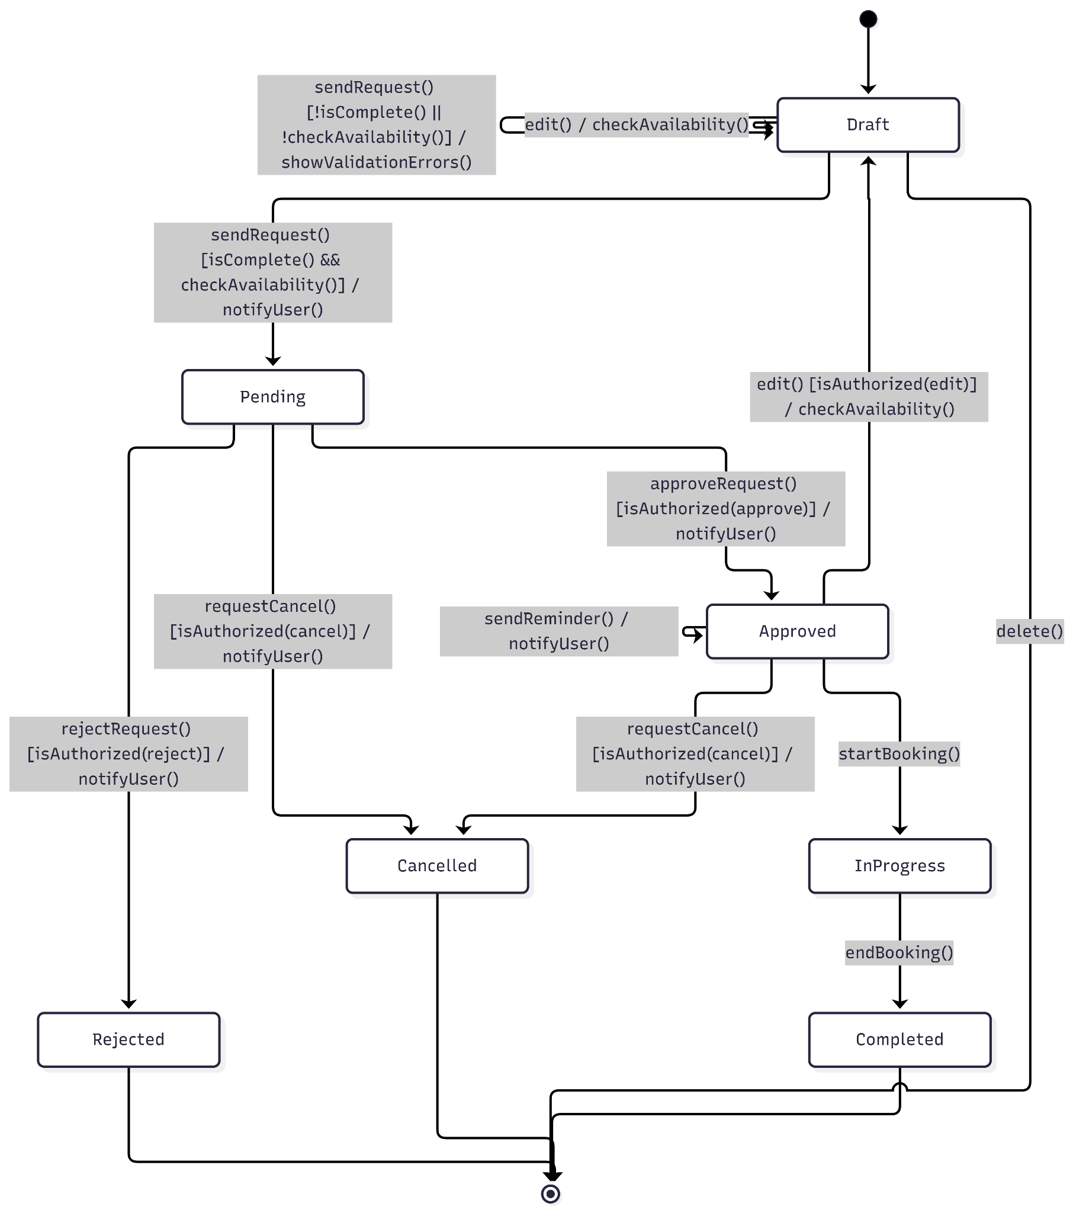
stateDiagram-v2
[*] --> Draft

Draft --> Draft : edit() / checkAvailability()
Draft --> Draft : sendRequest() [!isComplete() || !checkAvailability()] / showValidationErrors()
Draft --> Pending : sendRequest() [isComplete() && checkAvailability()] / notifyUser()
Draft --> [*] : delete()

Pending --> Approved : approveRequest() [isAuthorized(approve)] / notifyUser()
Pending --> Rejected : rejectRequest() [isAuthorized(reject)] / notifyUser()
Pending --> Cancelled : requestCancel() [isAuthorized(cancel)] / notifyUser()

Approved --> Draft : edit() [isAuthorized(edit)] / checkAvailability()
Approved --> Approved : sendReminder() / notifyUser()
Approved --> Cancelled : requestCancel() [isAuthorized(cancel)] / notifyUser()
Approved --> InProgress : startBooking()

InProgress --> Completed : endBooking()

Rejected --> [*]
Cancelled --> [*]
Completed --> [*]

9. Reflection on AI
- What did AI identify that our original model missed?
All six case actors, equipment and security/event-support requests, and search by capacity and location.
- What did our team understand better than the AI?
How to prevent double booking simply, by holding the slot at submission; how to keep the class and state models matched; and two case requirements the AI dropped, login and facility hours.
- Did AI introduce anything not supported by the requirements or case study?
Yes: multi-role users, a workflow class, an optional-hold flag, no-show handling, a cancellation deadline, and extra notifications. Several came from questions our own input raised in our prompt (i.e., intervening on outputs). Although, we had added unsupported items too, such as no-show handling and extra user fields.
- Which class had the weakest responsibility assignment and why?
Ours: Room. It had too many jobs. It checked availability, ran each booking from confirmation to the end, and checked if the room was unlocked. The AI’s: Reservation. It only stored booking details, while a separate workflow class did all the submitting, approving and cancelling. The diagram never connected that class to Reservation.
- Were any relationships, multiplicities, inheritance, aggregation, or composition choices incorrect or unjustified?
AI: an abstract User with no subclasses, and a workflow class with no link to Reservation. Ours: an extra Reservation–Facility link that duplicated Room->Facility relationship, and the user role stored twice.
- Which state transitions, guard conditions, alternate paths, or recovery states were missing from either model?
Both models: a reminder before the event. Ours: an explicit failed submission reservation path and role checks. AI: freeing the room when an approved booking is edited, and a way out of Pending when a request loses its slot.
- Did AI confuse actions/events with states anywhere?
Mostly no. Its state names are proper conditions, and it added no states. But some of its actions (keepRequestPending, recordRequestOnly) change nothing, and the Room’s Pending state can never be reached with some issues.
- What three specific improvements will we make to our original models?
Replace the three user subclasses with one Role list covering all six case actors, and add support requests. Add a failed-submission path, role checks on approve, reject, cancel, and edit, and a reminder to the Reservation lifecycle. Remove no-show handling and the unsupported attributes not mentioned in the case study.
- Where was AI genuinely useful?
It was useful as a checklist. It showed which case actors and requests we hadn’t modeled, and its open questions helped us separate what the case document explicitly says from what we had assumed.
- What parts of UML modeling still required human judgment?
Deciding what the case actually supports, choosing one booking policy out of many, keeping the class and state models matched, and recognizing that more detail did not mean more correct.

10. Tools, changes, and contribution record
For the modeling work documented here, we used Mermaid for diagrams and AI models to generate and review proposals. The three primary model calls did not expose their specific model versions. The models were generated by Copilot.
This report does not claim that revised screens or a running implementation exist.
Team member | Contribution
Lucas Ethington | Generation & monitoring of AI outputs, ensuring all generated figure accuracies against case study. First draft of documentation.
Nick Raby | Assist with selecting best modifications for revised models and proper ways of implementation. Ensure logic for entire system tracks with new additions, and check if the selected modifications are the best options.
Kyle Sorrell | Checking accuracy of code formatting & no hallucinations regarding concepts introduced in case study (i.e., flag things that weren’t in case study but showed up in AI/our model).
Yev Vainerman | Finalize documentation, ensure report matches rubric criteria & include all missing details. Final review of all steps (chosen modifications, both AI and our diagrams, along with reviews on open-ended questions & AI criticisms).

