**Junit Basic Testing**

Exercise 1: Setting Up JUnit

Scenario:

You need to set up JUnit in your Java project to start writing unit tests.

Steps:

1. Create a new Java project in your IDE (e.g., IntelliJ IDEA, Eclipse).

2. Add JUnit dependency to your project. If you are using Maven, add the following to your

pom.xml:

<dependency>

<groupId>junit</groupId>

<artifactId>junit</artifactId>

<version>4.13.2</version>

<scope>test</scope>

</dependency>

3. Create a new test class in your project.

**Code**

**POM.XML**

<project xmlns="http://maven.apache.org/POM/4.0.0" xmlns:xsi="http://www.w3.org/2001/XMLSchema-instance" xsi:schemaLocation="http://maven.apache.org/POM/4.0.0 https://maven.apache.org/xsd/maven-4.0.0.xsd">

<modelVersion>4.0.0</modelVersion>

<groupId>com.example</groupId>

<artifactId>cts</artifactId>

<version>0.0.1-SNAPSHOT</version>

<name>juint_basic_testing</name>

<dependencies>

<dependency>

<groupId>junit</groupId>

<artifactId>junit</artifactId>

<version>4.13.2</version>

<scope>test</scope>

</dependency>

</dependencies>

</project>

**Calculator.java**

package com.example;

public class Calculator {

public int add(int a, int b) {

return a + b;

}

public int subtract(int a, int b) {

return a - b;

}

}

**Output**

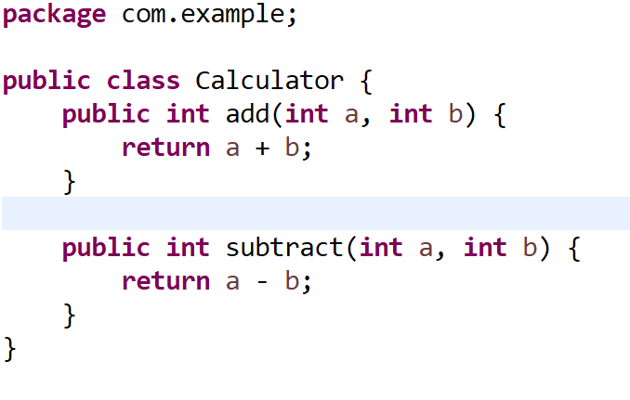

**Exercise 2**

Scenario:

You need to write basic JUnit tests for a simple Java class.

Steps:

1. Create a new Java class with some methods to test.

2. Write JUnit tests for these methods.

**CalculatorTest.java**

package com.example;

import static org.junit.Assert.*;

import org.junit.Test;

public class CalculatorTest {

Calculator calc=new Calculator();

@Test

public void testAdd() {

assertEquals(5,calc.add(2,3));

}

@Test

public void testSub() {

assertEquals(2,calc.subtract(5,3));

}

}

**Output**

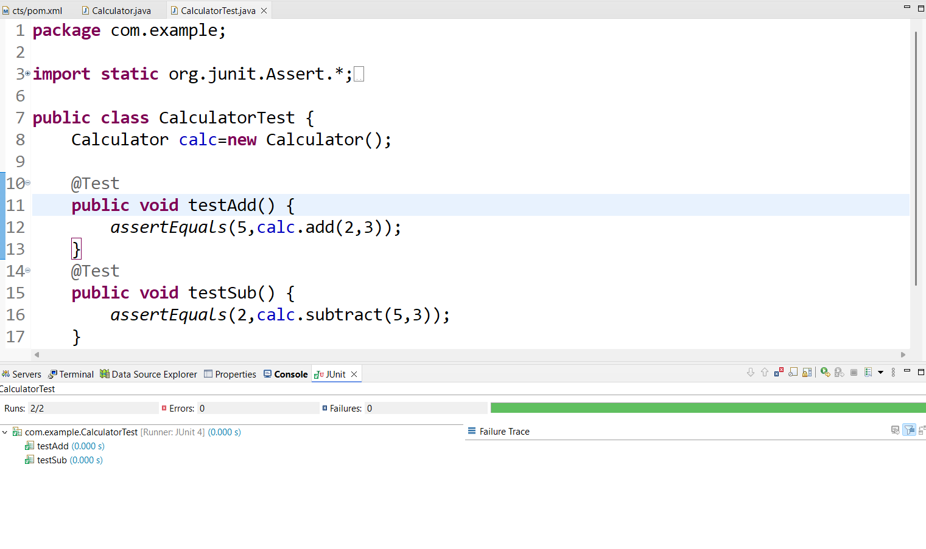

**Exercise 3**

Scenario:

You need to use different assertions in JUnit to validate your test results.

Steps:

1. Write tests using various JUnit assertions.

**Code**

public class AssertionsTest {

@Test

public void testAssertions() {

// Assert equals

assertEquals(5, 2 + 3);

// Assert true

assertTrue(5 > 3);

// Assert false

assertFalse(5 < 3);

// Assert null

assertNull(null);

// Assert not null

assertNotNull(new Object());

}

}

**Output**

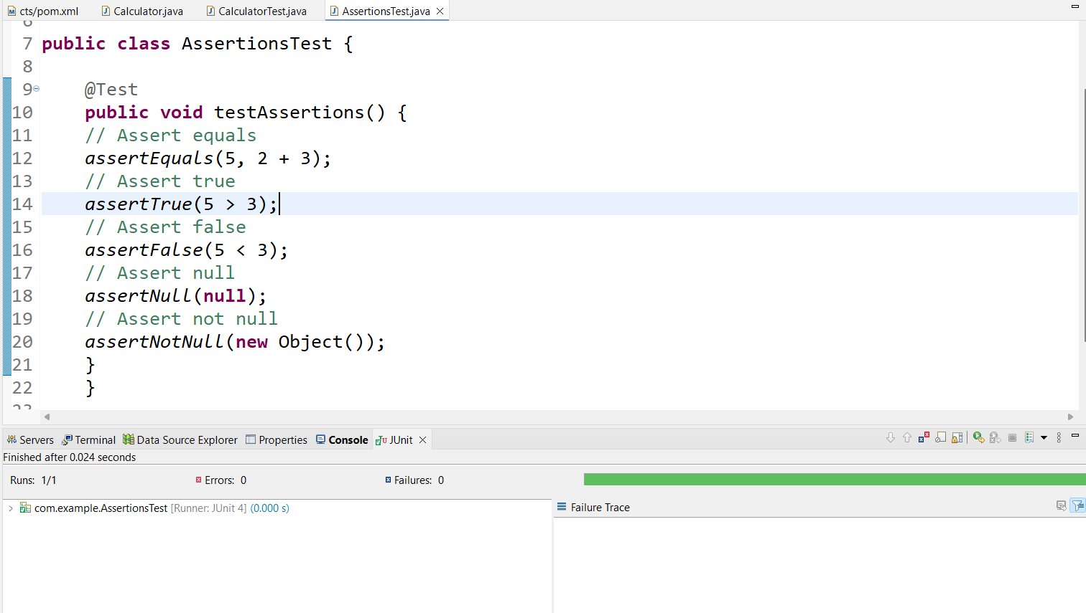

**Exercise 4: Arrange-Act-Assert (AAA) Pattern, Test Fixtures, Setup and**

Teardown Methods in JUnit

Scenario:

You need to organize your tests using the Arrange-Act-Assert (AAA) pattern and use setup

and teardown methods.

Steps:

1. Write tests using the AAA pattern.

2. Use @Before and @After annotations for setup and teardown methods

**Code**

**package** com.example;

**import** **static** org.junit.Assert.*;

**import** org.junit.After;

**import** org.junit.Before;

**import** org.junit.Test;

**public** **class** CalculatorLifeCycleTest {

Calculator calc;

// Setup method – runs BEFORE each test

@Before

**public** **void** setUp() {

System.***out***.println("Setting up calculator...");

calc = **new** Calculator();

}

// Teardown method – runs AFTER each test

@After

**public** **void** tearDown() {

System.***out***.println("Cleaning up calculator...");

calc = **null**;

}

@Test

**public** **void** testAdd() {

// Arrange

**int** a = 5;

**int** b = 3;

// Act

**int** result = calc.add(a, b);

// Assert

*assertEquals*(8, result);

}

@Test

**public** **void** testSubtract() {

// Arrange

**int** a = 10;

**int** b = 6;

// Act

**int** result = calc.subtract(a, b);

// Assert

*assertEquals*(4, result);

}

}

**Output**

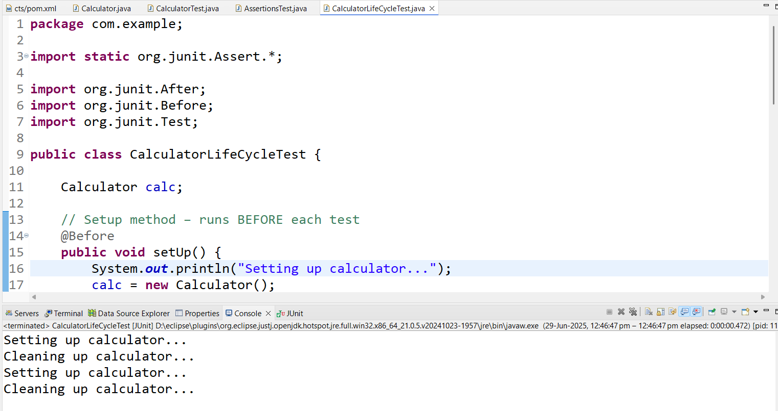

**Junit Advanced:**

**Exercise 1: Parameterized Tests**

**Code**

**Evenchecker.java**

**package com.example;**

**public class EvenChecker {**

**public boolean isEven(int number) {**

**return number % 2 == 0;**

**}**

**}**

**EvenCheckerTest.java**

**package com.example;**

**import static org.junit.jupiter.api.Assertions.*;**

**import org.junit.jupiter.params.ParameterizedTest;**

**import org.junit.jupiter.params.provider.ValueSource;**

**public class EvenCheckerTest {**

**EvenChecker checker = new EvenChecker();**

**@ParameterizedTest**

**@ValueSource(ints = {2, 4, 6, 8, 10})**

**void testIsEvenTrue(int number) {**

**assertTrue(checker.isEven(number));**

**}**

**@ParameterizedTest**

**@ValueSource(ints = {1, 3, 5, 7, 9})**

**void testIsEvenFalse(int number) {**

**assertFalse(checker.isEven(number));**

**}**

**}**

**Output**

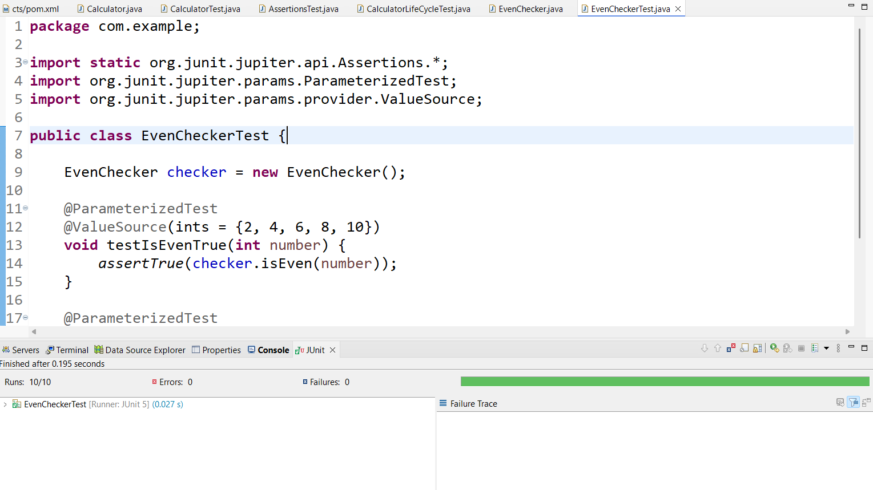

**Exercise 2: Test Suites and Categories**

**Code**

**MathTests.java**

**package com.example;**

**import static org.junit.jupiter.api.Assertions.*;**

**import org.junit.jupiter.api.Test;**

**class MathTests {**

**@Test**

**void testAdd() {**

**assertEquals(4, 2 + 2);**

**}**

**}**

**StrinTests.java**

**package com.example;**

**import static org.junit.jupiter.api.Assertions.*;**

**import org.junit.jupiter.api.Test;**

**class StringTests {**

**@Test**

**void testLength() {**

**assertEquals(5, "Hello".length());**

**}**

**}**

**AllTests.java**

**package com.example;**

**import org.junit.platform.suite.api.SelectClasses;**

**import org.junit.platform.suite.api.Suite;**

**@Suite**

**@SelectClasses({**

**MathTests.class,**

**StringTests.class**

**})**

**public class AllTests {**

**// This class runs the selected test classes as a suite**

**}**

**Output**

**Exercise 3: Test Execution Order**

**OrderedTests.java**

**package com.example;**

**import static org.junit.jupiter.api.Assertions.*;**

**import org.junit.jupiter.api.*;**

**@TestMethodOrder(MethodOrderer.OrderAnnotation.class)**

**public class OrderedTests {**

**@Test**

**@Order(1)**

**void testA() {**

**System.*out*.println("Running testA");**

***assertTrue*(true);**

**}**

**@Test**

**@Order(3)**

**void testC() {**

**System.*out*.println("Running testC");**

***assertTrue*(true);**

**}**

**@Test**

**@Order(2)**

**void testB() {**

**System.*out*.println("Running testB");**

***assertTrue*(true);**

**}**

**}**

**Output**

**Exercise 4: Exception Testing**

**Code**

**ExceptionThrower.java**

**package com.example;**

**public class ExceptionThrower {**

**public void throwException() {**

**throw new IllegalArgumentException("Invalid input!");**

**}**

**}**

**ExceptionThrowerTest.java**

**package com.example;**

**import static org.junit.jupiter.api.Assertions.*;**

**import org.junit.jupiter.api.Test;**

**public class ExceptionThrowerTest {**

**@Test**

**void testExceptionThrown() {**

**ExceptionThrower thrower = new ExceptionThrower();**

**Exception exception = *assertThrows*(IllegalArgumentException.class, () -> {**

**thrower.throwException();**

**});**

***assertEquals*("Invalid input!", exception.getMessage());**

**}**

**}**

**Output**

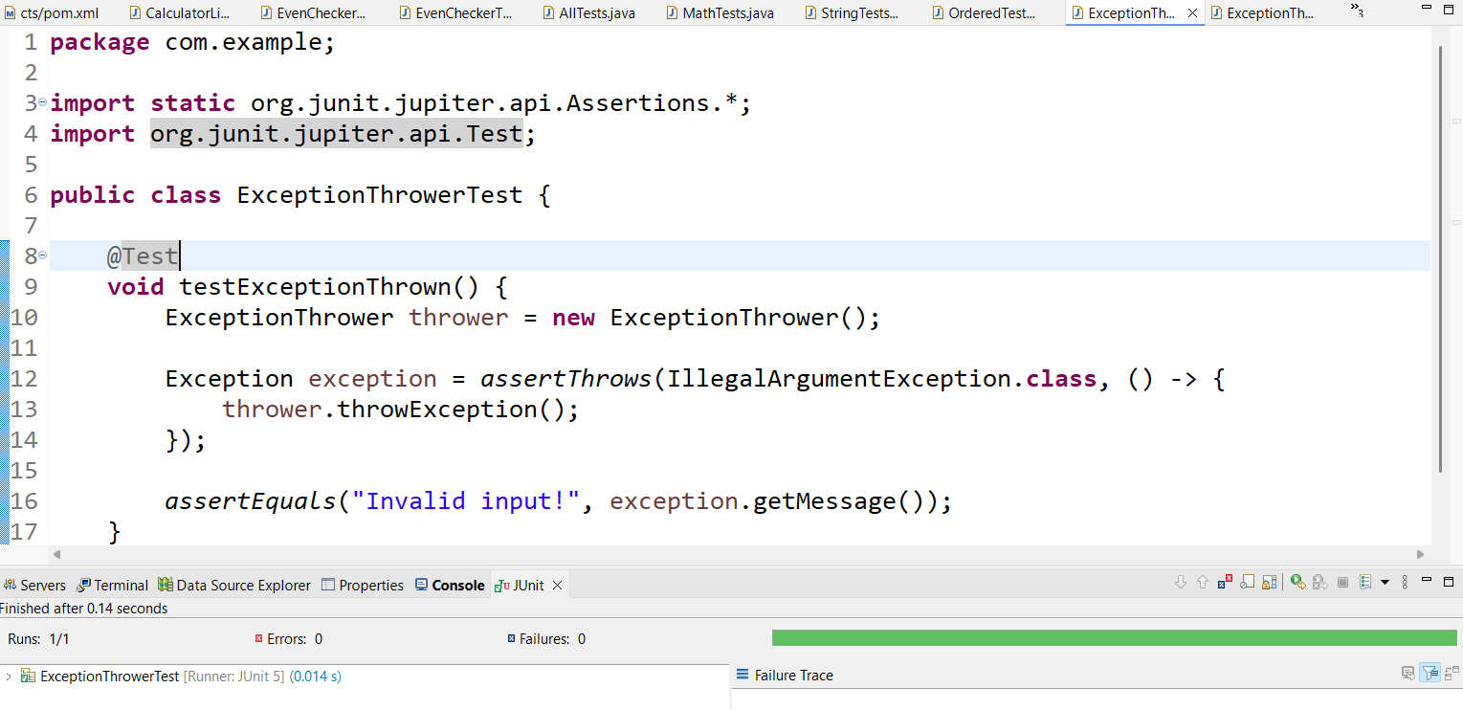

**Exercise 5: Timeout and Performance Testing**

**Code**

**PerformaceTest.java**

**package com.example;**

**public class PerformanceTester {**

**public void performTask() throws InterruptedException {**

**// Simulate work**

**Thread.sleep(500); // 500ms**

**}**

**}**

**PerformanceTesterTest.java**

**package com.example;**

**import org.junit.jupiter.api.Test;**

**import org.junit.jupiter.api.Timeout;**

**import java.util.concurrent.TimeUnit;**

**public class PerformanceTesterTest {**

**@Test**

**@Timeout(value = 1, unit = TimeUnit.SECONDS)**

**void testPerformanceWithinTimeout() throws InterruptedException {**

**PerformanceTester tester = new PerformanceTester();**

**tester.performTask();**

**}**

**}**

**Output**

