Item 2: Plot for M3 scores:

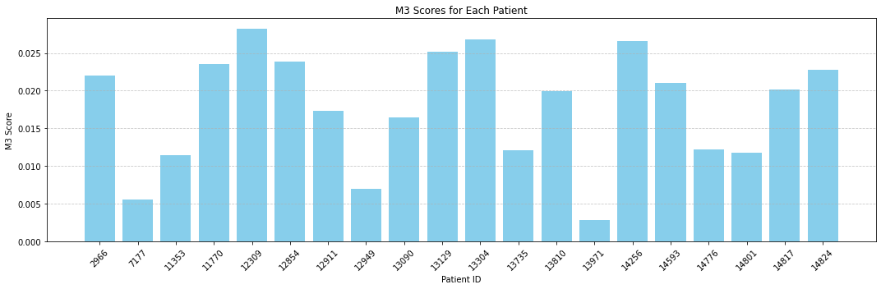

**Item 4: Plot for M2 and M3 scores for each patient each hour:**

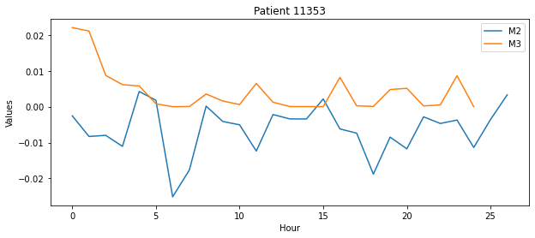

**Item 5: Discussing the target user of plot 1 and plot 2:**

The bar plot (Plot 1) displaying "M3 Scores for Each Patient" and the series of subplots (Plot 2) showcasing hourly M2 and M3 values cater to medical professionals and researchers monitoring or studying patient activity levels, particularly in rehabilitation. These visualizations enable a comparative analysis of patient activity, beneficial for physiotherapists, occupational therapists, rehabilitation specialists, and the patients themselves for tracking recovery progress. In clinical settings, Plot 1 provides a snapshot of overall activity levels across a cohort, useful for evaluating treatment efficacy or identifying individuals needing extra support. Plot 2 offers a granular view of daily activity patterns, assisting in identifying times when patients are least active, thereby informing therapy scheduling. Researchers may utilize these plots for examining the relationship between activity levels and recovery outcomes, with color-coding in Plot 2 enhancing metric distinction, provided the scales for M2 and M3 are consistently applied for accurate cross-patient comparison.