Controlling execution

Wednesday, April 17, 2024

5:44 AM

In Java, the keywords include **if-else, while, do-while, for, return, break**, and a selection statement called **switch**.

**if-else**

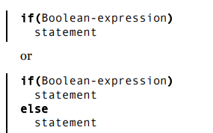

*//: control/IfElse.java*

*import static net.mindview.util.Print.*;*

*public class IfElse {*

*static int result = 0;*

*static void test(int testval, int target) {*

*if(testval > target)*

*result = +1;*

*else if(testval < target)*

*result = -1;*

*else result = 0; // Match*

*}*

*public static void main(String[] args) {*

*test(10, 5);*

*print(result);*

*test(5, 10);*

*print(result);*

*test(5, 5);*

*print(result);*

*}*

*}*

*/* Output:*

*1*

*-1*

*0 *///:~*

**Iteration**

Looping is controlled by **while, do-while and for**, which are sometimes classified as iteration statements.



Here’s a simple example that generates random numbers until a particular condition is met:

*//: control/WhileTest.java*

*// Demonstrates the while loop.*

*public class WhileTest {*

*static boolean condition() {*

*boolean result = Math.random() < 0.99;*

*System.out.print(result + ", ");*

*return result; }*

*public static void main(String[] args) {*

*while(condition())*

*System.out.println("Inside 'while'");*

*System.out.println("Exited 'while'");*

*}*

*} /* (Execute to see output) *///:~*

The form for **do-while** is

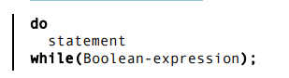

The sole difference between while and do-while is that the statement of the do-while always executes at least once, even if the expression evaluates to false the first time.

The for loop is:



*//: control/ListCharacters.java*

*// Demonstrates "for" loop by listing*

*// all the lowercase ASCII letters.*

*public class ListCharacters {*

*public static void main(String[] args) {*

*for(char c = 0; c < 128; c++)*

*if(Character.isLowerCase(c))*

*System.out.println("value: " + (int)c + " character: " + c);*

*}*

*}*

*/* Output:*

*value: 97 character: a*

*value: 98 character: b*

*value: 99 character: c*

*value: 100 character: d*

*value: 101 character: e*

*value: 102 character: f*

*value: 103 character: g*

*value: 104 character: h*

*value: 105 character: I*

*value: 106 character: j*

*…*

*\*///:~*

This program also uses the **java.lang.Character** “wrapper” class, which not only wraps the primitive char type in an object, but also provides other utilities. Here, the static **isLowerCase( )** method is used to detect whether the character in question is a lowercase letter.