AdventureBuilderSystem

Document generated by Gendoc (<http://www.eclipse.org/gendoc>)

Help and support at : <https://www.eclipse.org/forums/index.php/f/286/>

User guide: <https://www.eclipse.org/gendoc/documentation/Gendoc_v0.7_tutorial.pdf>

Contenu

# A-Requirements

## 1-!!Use cases view

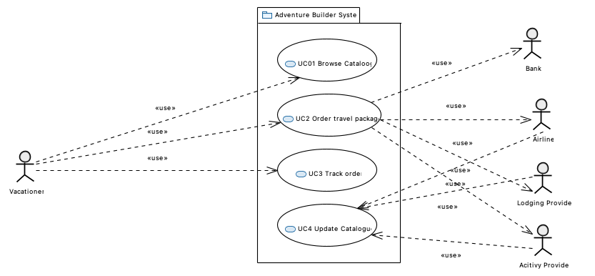

### Acitivy Provider

### Adventure Builder System

### Airline

### Bank

### Lodging Provider

### UC01 Browse Cataloog

### UC2 Order travel package

### UC3 Track order

### UC4 Update Catalogue

### Vacationer

# B-ACOO

# C-Modules

## !!!Top Level Modules Uses View

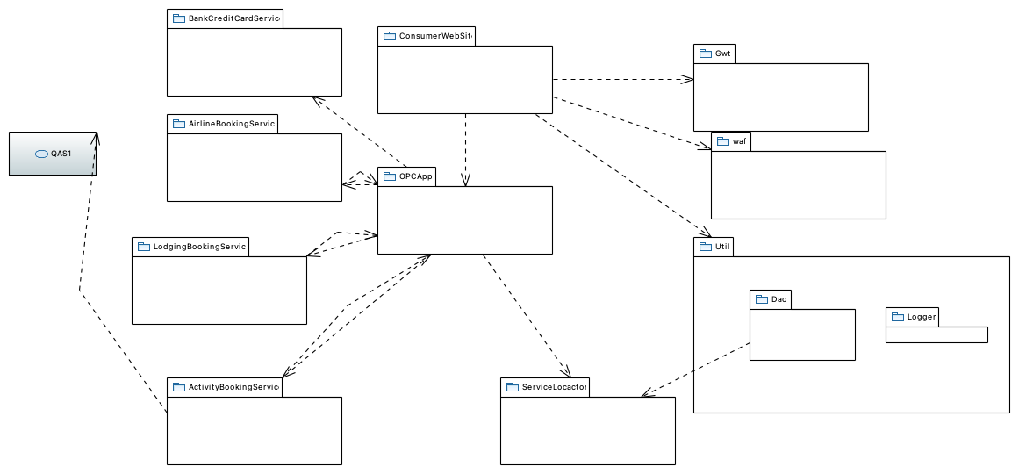

### ActivityBookingService

### AirlineBookingService

### BankCreditCardService

### ConsumerWebSite

### Dao

### Gwt

### LodgingBookingService

### Logger

### OPCApp

### QAS1

### ServiceLocactor

### Util

### waf

## !ActivityBookingService

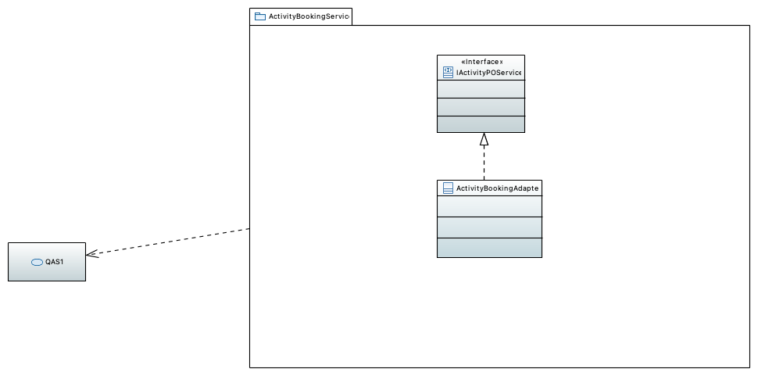

### ActivityBookingAdapter

### IActivityPOService

### QAS1

## !AdventureCatalogDBDetails class Diagram

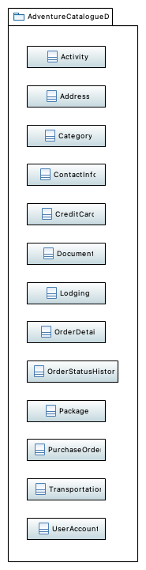

### Activity

### Address

### Category

### ContactInfo

### CreditCard

### Document

### Lodging

### OrderDetail

### OrderStatusHistory

### Package

### PurchaseOrder

### Transportation

### UserAccount

## !AirlineBookingService package detail

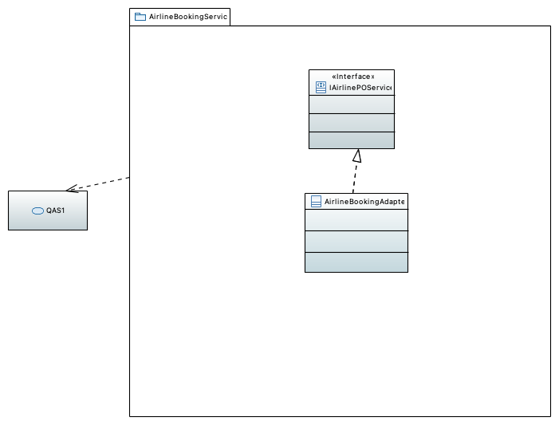

### AirlineBookingAdapter

### IAirlinePOService

### QAS1

## !Bank Credit Card Service class Diagram

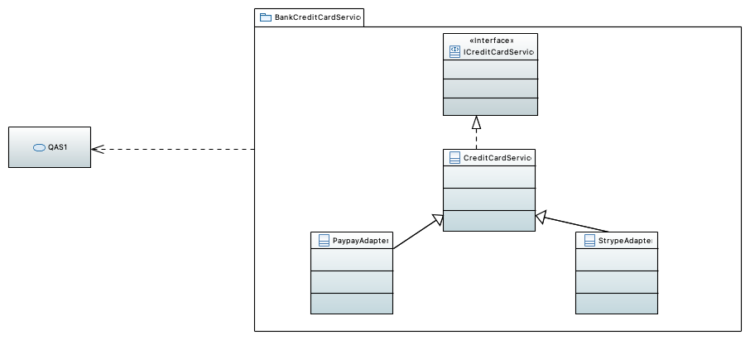

### CreditCardService

### ICreditCardService

### PaypayAdapter

### QAS1

### StrypeAdapter

## !ConsumerWebSite class diagram

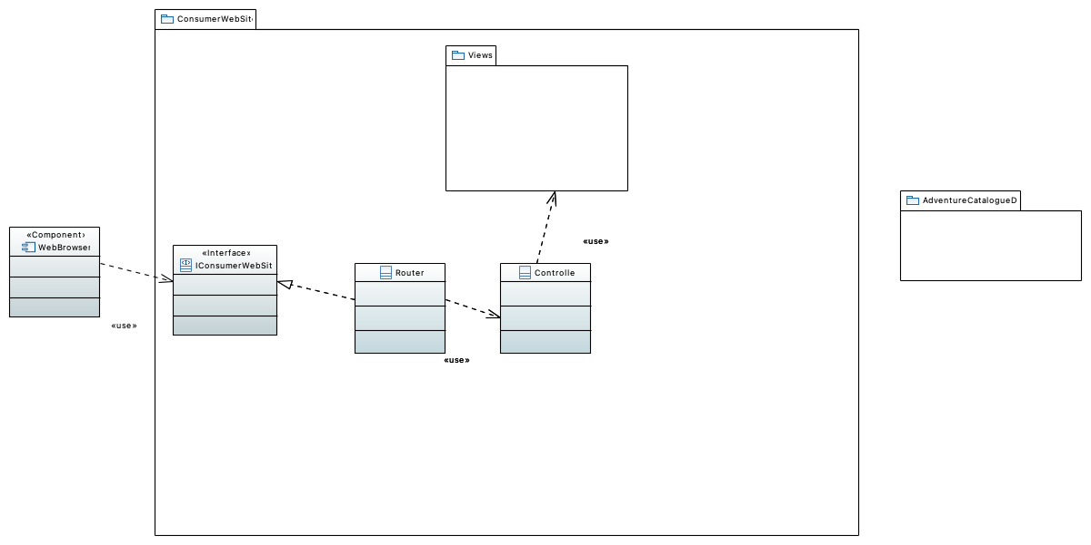

### AdventureCatalogueDB

### Controller

### IConsumerWebSite

### Router

### Views

### WebBrowser

## !Model class diagram

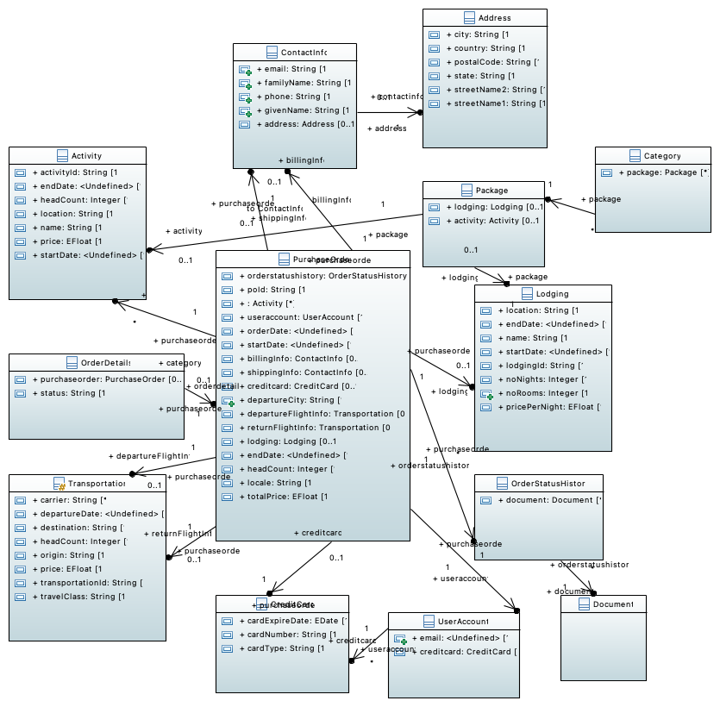

## !LodgingBookingService package detail

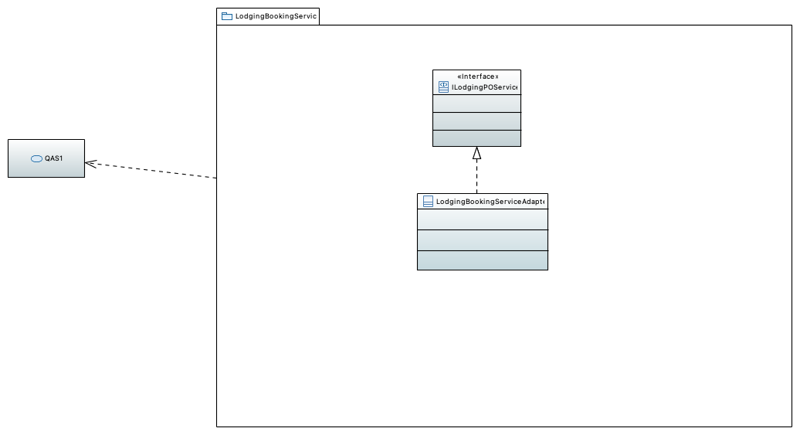

### ILodgingPOService

### LodgingBookingServiceAdapter

### QAS1

## !OPCApp Module Decomposition View

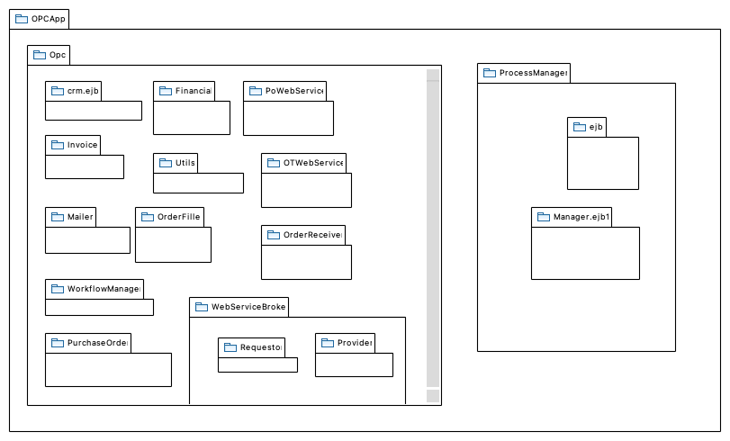

### Financial

### Invoice

### Mailer

### Manager.ejb1

### OTWebService

### Opc

### OrderFiller

### OrderReceiver

### PoWebService

### ProcessManager

### Provider

### PurchaseOrder

### Requestor

### Utils

### WebServiceBroker

### WorkflowManager

### crm.ejb

### ejb

## Exception class diagram

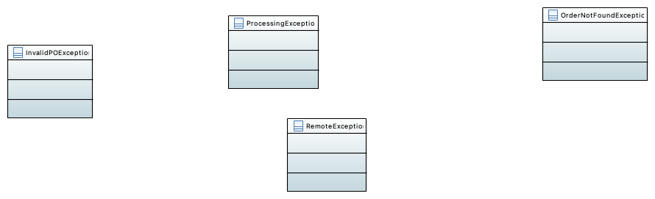

### InvalidPOException

### OrderNotFoundException

### ProcessingException

### RemoteException

## !OPC MODULE Uses View

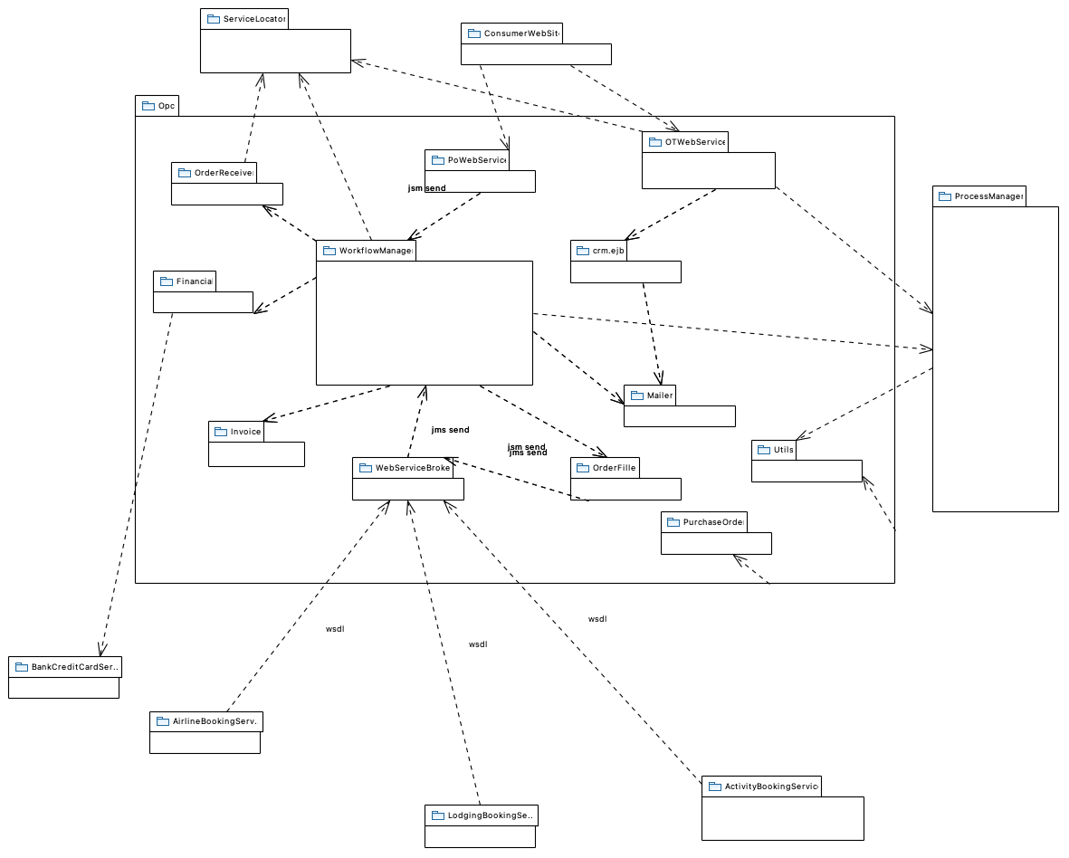

### ActivityBookingService

### AirlineBookingService

### BankCreditCardService

### ConsumerWebSite

### Financial

### Invoice

### LodgingBookingService

### Mailer

### OTWebService

### OrderFiller

### OrderReceiver

### PoWebService

### ProcessManager

### PurchaseOrder

### ServiceLocator

### Utils

### WebServiceBroker

### WorkflowManager

### crm.ejb

## !OtWebService package diagram

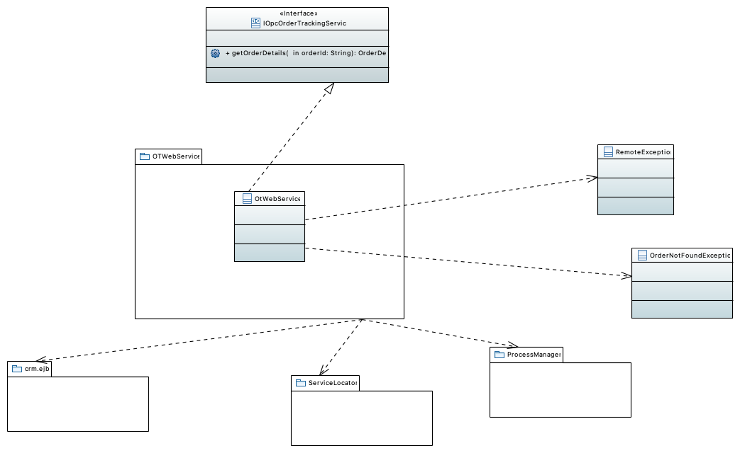

### IOpcOrderTrackingService

### OrderNotFoundException

### OtWebService

### ProcessManager

### RemoteException

### ServiceLocator

### crm.ejb

### getOrderDetails

## !POWebService class diagram

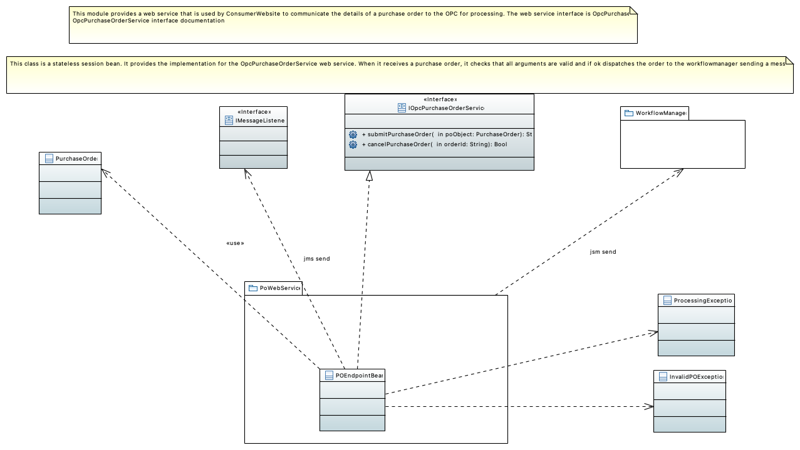

### IMessageListener

### IOpcPurchaseOrderService

### InvalidPOException

### POEndpointBean

### ProcessingException

### PurchaseOrder

### WorkflowManager

### cancelPurchaseOrder

### submitPurchaseOrder

## !!Package WorkflowManager

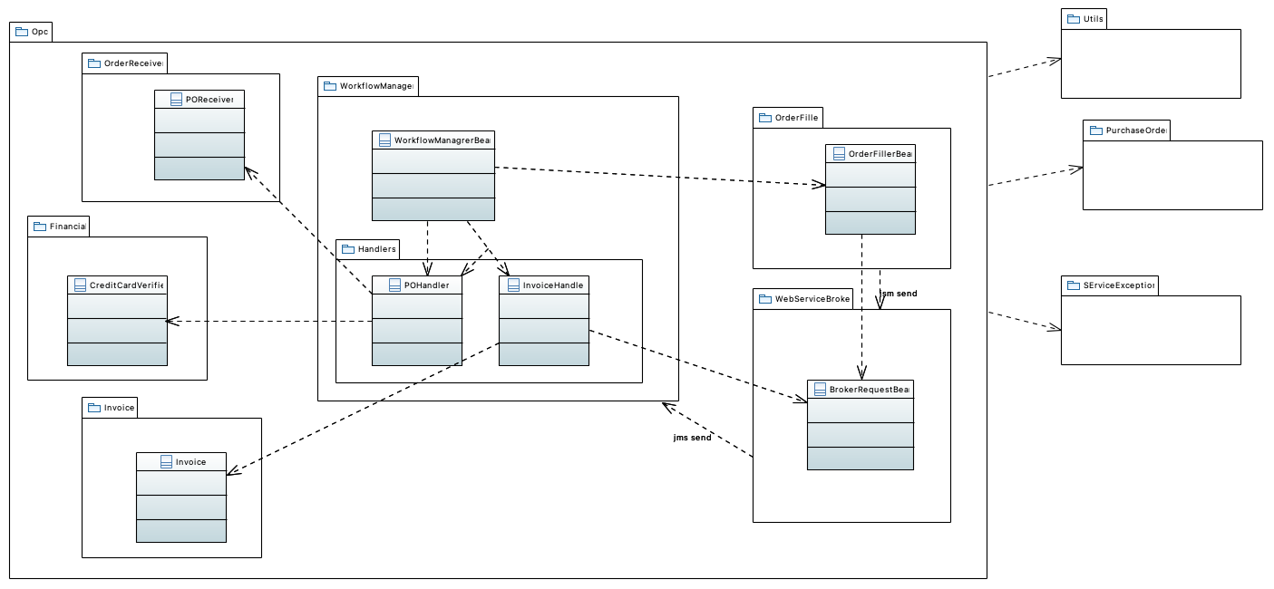

### BrokerRequestBean

### CreditCardVerifier

### Financial

### Handlers

### Invoice

### Invoice

### InvoiceHandler

### Opc

### OrderFiller

### OrderFillerBean

### OrderReceiver

### POHandler

### POReceiver

### PurchaseOrder

### SErviceException

### Utils

### WebServiceBroker

### WorkflowManagrerBean

## !Workflowmanager Module Use View

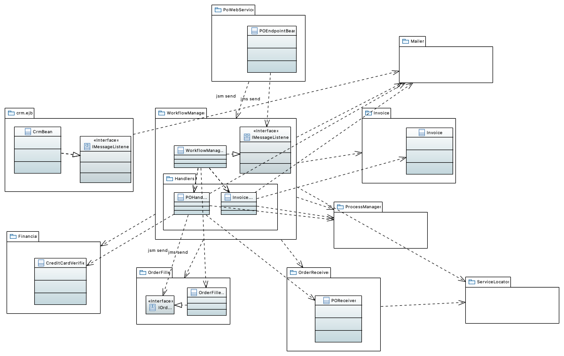

### CreditCardVerifier

### CrmBean

### Financial

### Handlers

### IMessageListener

### IMessageListener

### IOrderFiller

### Invoice

### Invoice

### InvoiceHandler

### Mailer

### OrderFiller

### OrderFillerBean

### OrderReceiver

### POEndpointBean

### POHandler

### POReceiver

### PoWebService

### ProcessManager

### ServiceLocator

### WorkflowManagrerBean

### crm.ejb

## !EJB Container

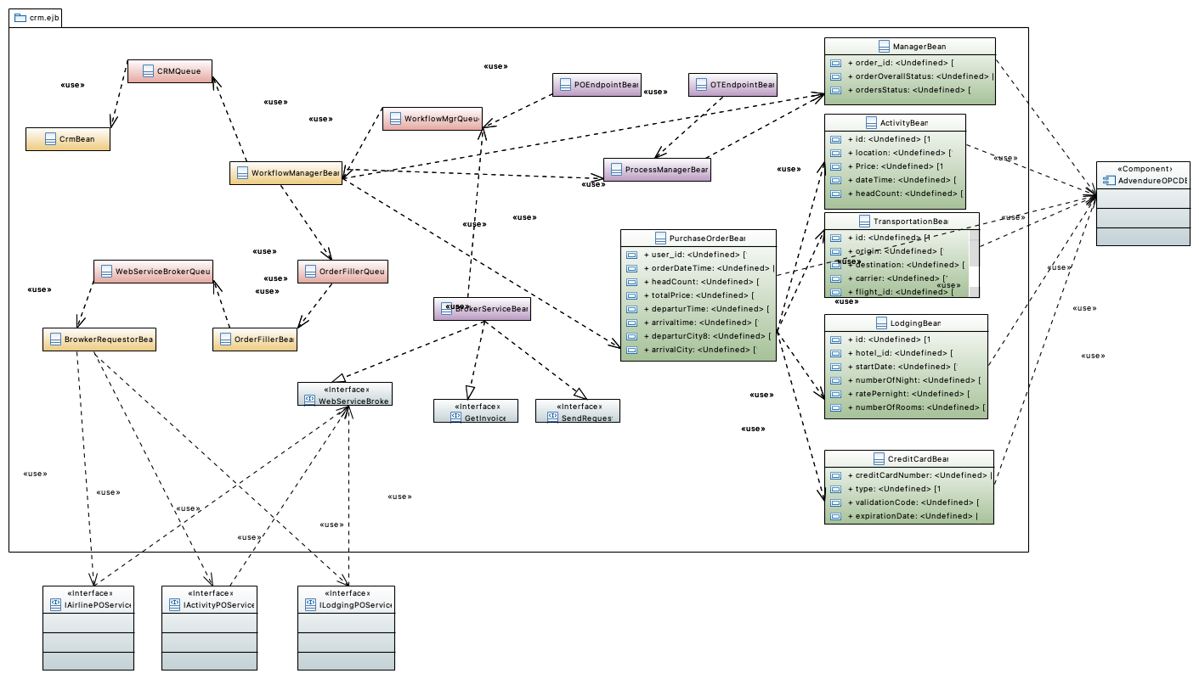

### ActivityBean

### AdvendureOPCDB

### ArrivalTime

### BrokerServiceBean

### BrowkerRequestorBean

### CRMQueue

### CreditCardBean

### CrmBean

### GetInvoice

### IActivityPOService

### IAirlinePOService

### ILodgingPOService

### LodgingBean

### ManagerBean

### OTEndpointBean

### OrderFillerBean

### OrderFillerQueue

### POEndpointBean

### Price

### ProcessManagerBean

### PurchaseOrderBean

### SendRequest

### TransportationBean

### WebServiceBroker

### WebServiceBrokerQueue

### WorkflowManagerBean

### WorkflowMgrQueue

### arrivalCity

### arrivaltime

### carrier

### creditCardNumber

### dateTime

### departurCity8

### departurTime

### departureTime

### destination

### expirationDate

### flight_id

### headCount

### headCount

### headCount

### hotel_id

### id

### id

### id

### location

### numberOfNight

### numberOfRooms

### orderDateTime

### orderOverallStatus

### order_id

### ordersStatus

### origin

### ratePernight

### startDate

### totalPrice

### travelClass

### type

### user_id

### validationCode

# D-C&C

## !Top Level SOA View

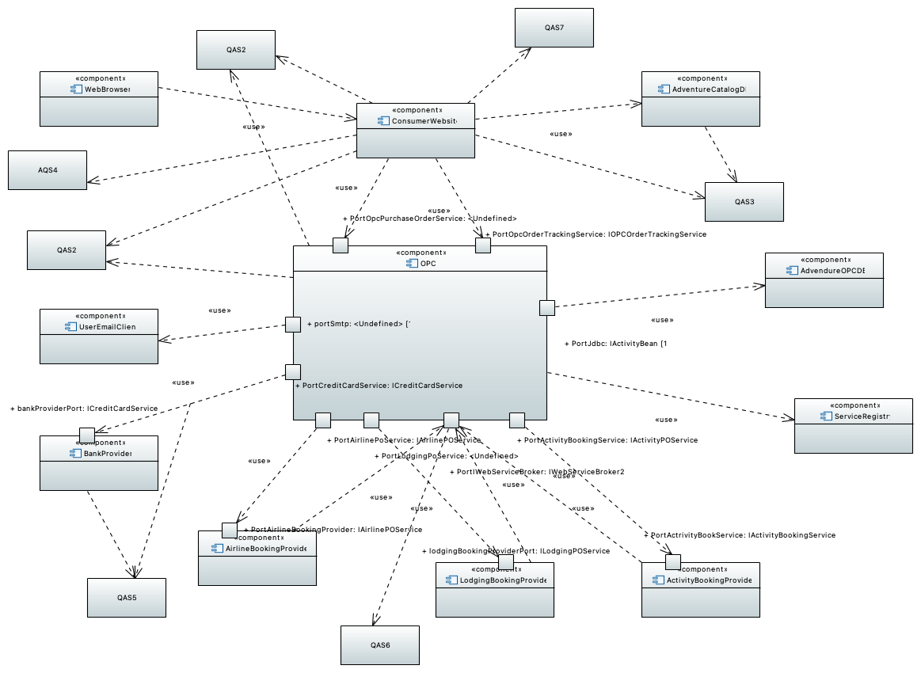

### AQS4

### ActivityBookingProvider

### AdvendureOPCDB

### AdventureCatalogDB

### AirlineBookingProvider

### BankProvider

### ConsumerWebsite

### LodgingBookingProvider

### OPC

### PortActivityBookingService

### PortActrivityBookService

### PortAirlineBookingProvider

### PortAirlinePoService

### PortCreditCardService

### PortIWebServiceBroker

### PortJdbc

### PortLodgingPoService

### PortOpcOrderTrackingService

### PortOpcPurchaseOrderService

### QAS2

### QAS3

### QAS5

### QAS6

### QAS7

### ServiceRegistry

### UserEmailClient

### WebBrowser

### bankProviderPort

### lodgingBookingProviderPort

### portSmtp

## !Activity Booking Provider Component Detail

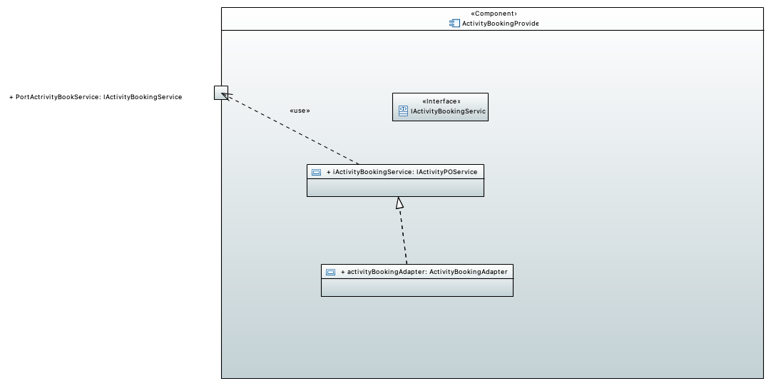

### IActivityBookingService

### PortActrivityBookService

### activityBookingAdapter

### iActivityBookingService

## !Activity Booking Provider Component Detail

## !Airline Booking Provider component detail

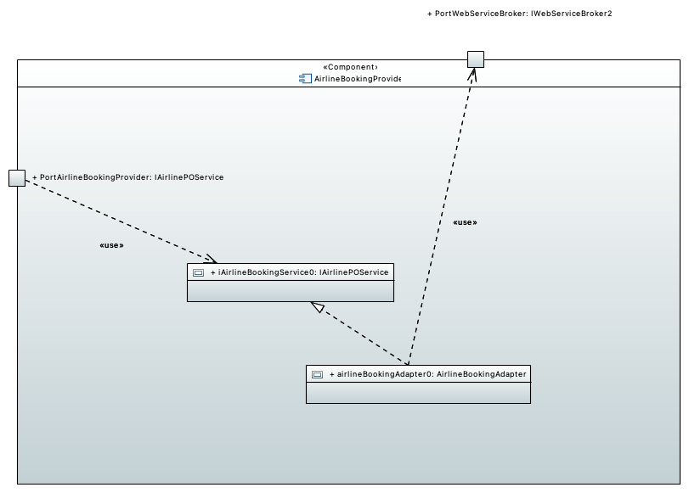

### PortAirlineBookingProvider

### PortWebServiceBroker

### airlineBookingAdapter0

### iAirlineBookingService0

## !Airline Booking Provider component detail

## !Bank Provider Component detail

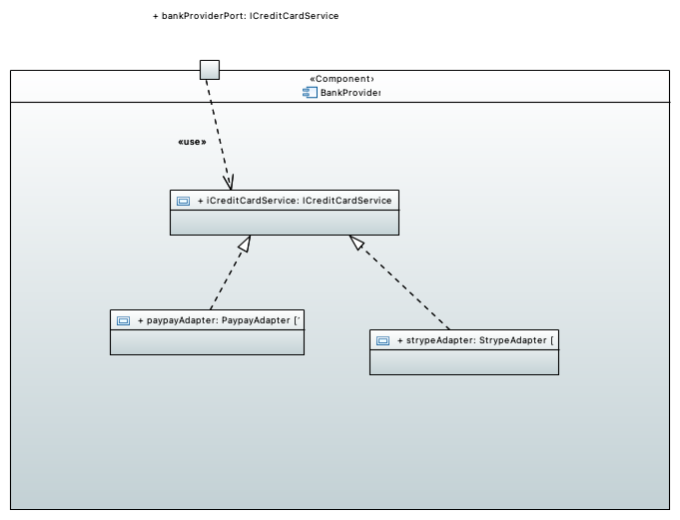

### bankProviderPort

### iCreditCardService

### paypayAdapter

### strypeAdapter

## !Bank Provider Component detail

## !OPC C&C View

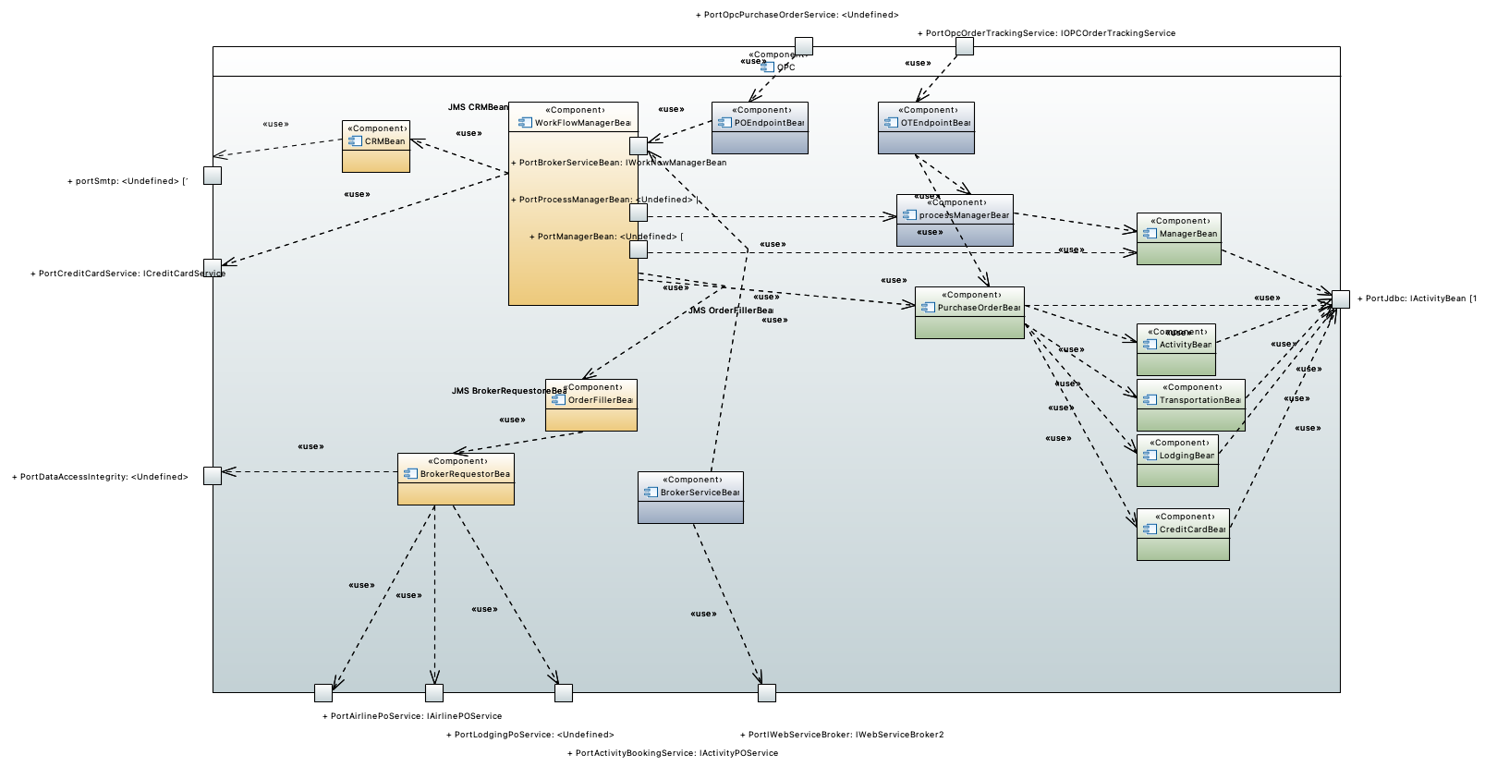

### ActivityBean

### BrokerRequestorBean

### BrokerServiceBean

### CRMBean

### CreditCardBean

### LodgingBean

### ManagerBean

### OTEndpointBean

### OrderFillerBean

### POEndpointBean

### PortActivityBookingService

### PortAirlinePoService

### PortBrokerServiceBean

### PortCreditCardService

### PortDataAccessIntegrity

### PortIWebServiceBroker

### PortJdbc

### PortLodgingPoService

### PortManagerBean

### PortOpcOrderTrackingService

### PortOpcPurchaseOrderService

### PortProcessManagerBean

### PurchaseOrderBean

### TransportationBean

### WorkFlowManagerBean

### portSmtp

### processManagerBean

## !OPC C&C View

# E-Allocation

## !singleDeployement

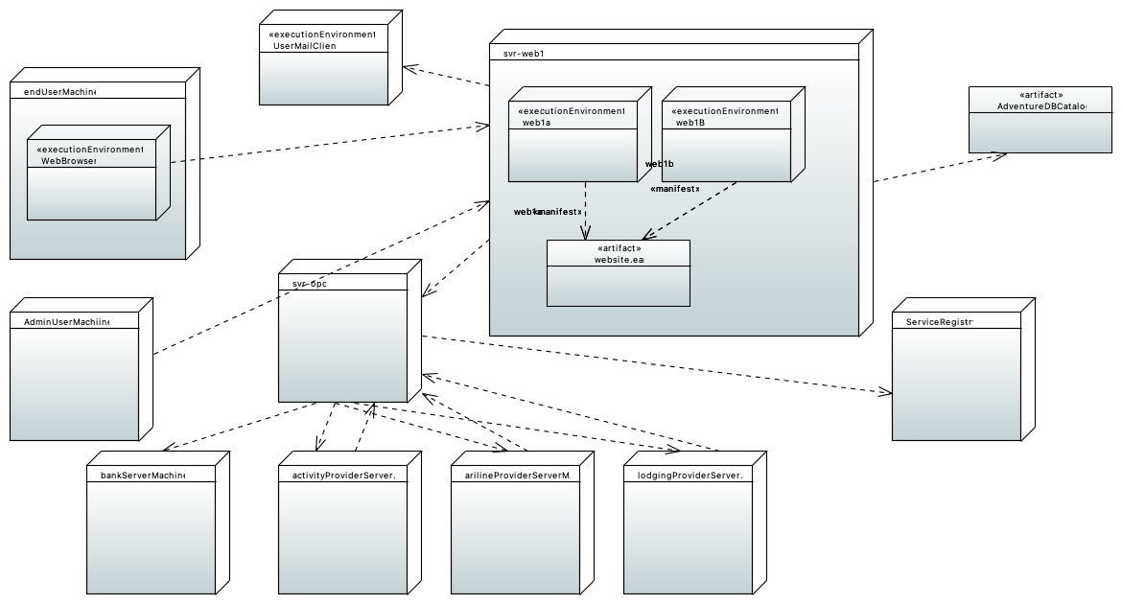

### AdminUserMachiine

### AdventureDBCatalog

### ServiceRegistry

### UserMailClient

### WebBrowser

### activityProviderServerMachine

### arilineProviderServerMachine

### bankServerMachine

### endUserMachine

### lodgingProviderServerMachine

### svr-opc

### svr-web1

### web1B

### web1a

### website.ear

# F-Comportement