WhatDoWeEat

Document generated by Gendoc (<http://www.eclipse.org/gendoc>)

Help and support at : <https://www.eclipse.org/forums/index.php/f/286/>

Contenu

1. 1-Requirements 2

1.1 WhatDoWeEat 2

1.1.1 Eat Meals 2

1.1.2 Inventory 2

1.1.3 Keep leftover 2

1.1.4 Kids 2

1.1.5 Map of store 2

1.1.6 Me 2

1.1.7 Meal 2

1.1.8 My wife 2

1.1.9 Notify when meal ready 2

1.1.10 Prepare 2

1.1.11 Record preparation time 2

1.1.12 Share with community 3

1.1.13 Shopping 3

1.1.14 Snack 3

1.1.15 Synch with family member 3

1.1.16 WhatDoWeEat-expo 3

1.1.17 record receipe 3

# 1-Requirements

## WhatDoWeEat

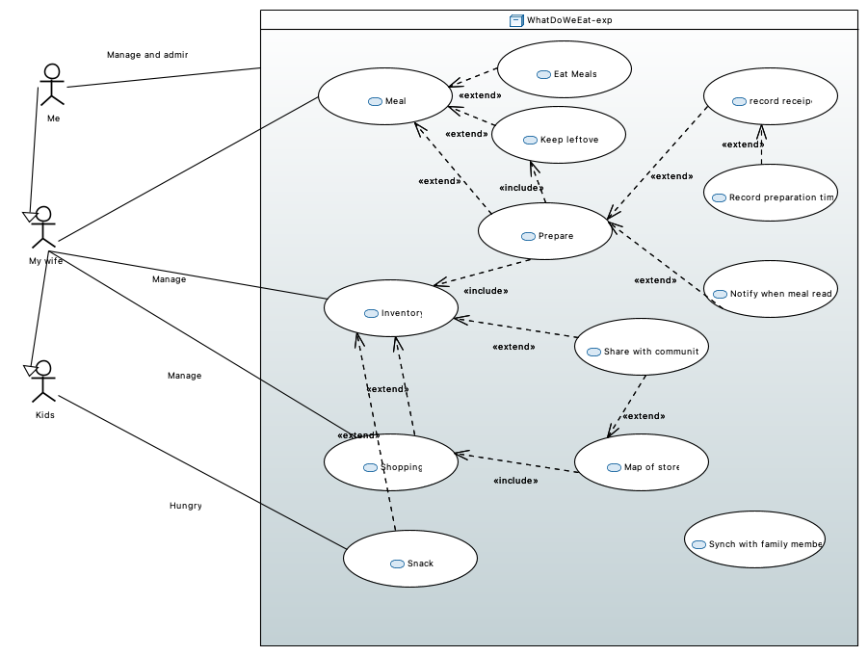

### Eat Meals

Eat meals and keep a list of eated one for repetition purpose. Keep a photo for record.

### Inventory

Keep code (barcode), description, nbItem, percents of use and location of each items

### Keep leftover

Put leftover in the fridge and keep a dated list with photo of the container

### Kids

I am always hungry

### Map of store

Create a map of a store with item location to prepare our shopping list. Record item location in store.

### Me

I am the developper/owner of the application and use it with my family and sell it to community

### Meal

Prepare, eat and keep the left over

### My wife

She prepare meals with leftover and items from the inventory, make shopping list, do shopping and put back new items in inventory.

### Notify when meal ready

Send SMS (ring) to family when meal is ready

### Prepare

Prepare meals using items in inventory and leftover

### Record preparation time

Record time it take to prepare a receipe to better plan next meals

### Share with community

Item description, map of store, item price and location in store are shared with community

### Shopping

I want to prepare a shopping list and follow it when shopping. Will add new item to shopping during shopping as well as record item location and store map.

### Snack

Take a snack and remove item from inventory

### Synch with family member

Sync inventory, shopping list, receipe, and leftover with family members

### WhatDoWeEat-expo

Is a mobile application that help manage house inventory and meals preparation

### record receipe

Record information associate with meal to create a receipe and reuse it later