1. **Mission statement**

“Fearless Rankings is committed to the accuracy, reliability, quality and comprehensiveness of the data and produce real-time, outstanding, seamless and customized solutions to customers with highest standard of services in a fast-changing market”

1. **Mission objectives**

* Serve users with accurate, comprehensive rankings of all universities in the US with their full details.
* Provide constantly updated, real-time data to end users
* Offer an user-friendly, one stop-shop solution for end clients to utilize the ranking system.
* Allow end users to easily generate customized reports for multiple purposes.

1. **Final ERD**

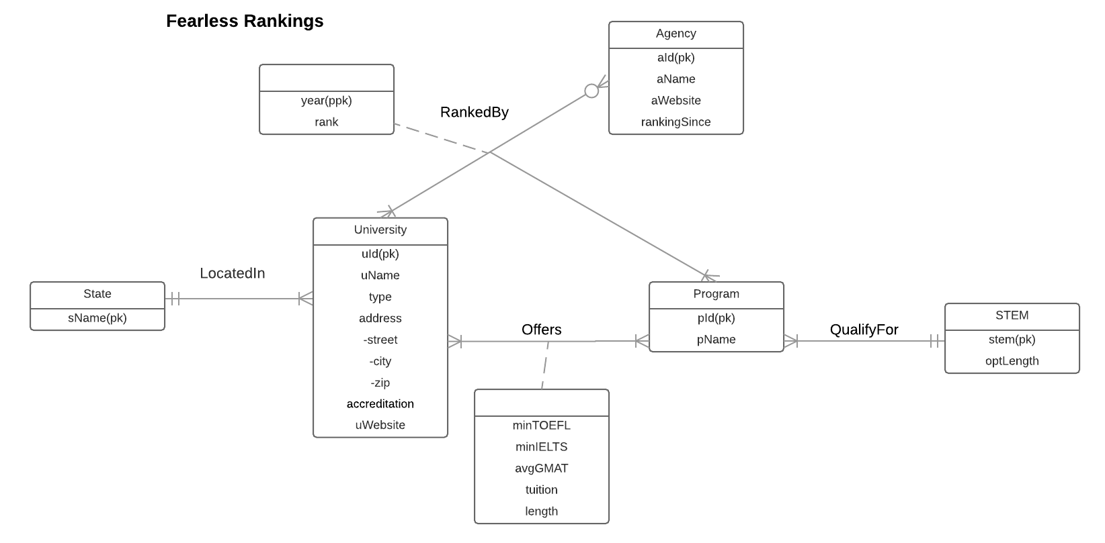

1. **Relational schema**

University (**uId**, uName, type, street, city, zip, accreditation, uWebsite, *sName*)

State (**sName**)

Program (**pId**, pName,*stem*)

Stem (**stem**, optLength)

ProgramStats (***uId***, ***pId***, minTOFEL, minIELTS, avgGMAT, tuition, length)

Agency (**aId**, aName, aWebsite, rankingSince)

Rank (***uId***, ***pId***, ***aId***, **year**, rank)

1. **Functional dependency**

uId -> uName, type, street, city, zip, accreditation, uWebsite, sName

pId -> pName, stem

uId, pId -> minTOFEL, minIELTS, avgGMAT, tuition, length

aId -> aName, aWebsite, rankingSince

uId, pId, aId, year -> rank

1. **Normalization**

University (**uId**, uName, type, street, city, zip, accreditation, uWebsite, *sName*) = 3NF

State (**sName**) = 3NF

Program (**pId**, pName, *stem*) = 3NF

Stem (**stem**, optLength) = 3NF

ProgramStats (***uId***, ***pId***, minTOFEL, minIELTS, avgGMAT, tuition, length) = 3NF

Agency (**aId**, aName, aWebsite, rankingSince) = 3NF

Rank (***uId***, ***pId***, ***aId***, **year,** rank) = 3NF

1. **Business rules**

[R1] A state cannot be deleted from the database, if a university is located in this state.

[R2] A state name cannot be changed, if a university is located in this state.

[R3] A STEM qualification cannot be deleted from the database, if a program is qualified for this certification.

[R4] A STEM qualification cannot be changed, if a program is qualified for this certification.

[R5] A university cannot be deleted from the database, if there is information about its program in the database.

[R6] When a university ID is changed in the database, the corresponding program information should be updated accordingly in.

[R7] A program cannot be deleted from the database, if it is offered by a university.

[R8] When a program is changed in the database, the programStats information should be updated accordingly.

[R9] When an agency ranked a university for a program, the information of university, program and agency cannot be deleted or changed in the database.

1. **Referential integrity**

|  |  |  |  |  |  |  |  |
| --- | --- | --- | --- | --- | --- | --- | --- |
| Relation | Foreign Key | Base Relation | Primary Key | Constraint:  ON DELETE | Business  Rule | Constraint:  ON UPDATE | Business  Rule |
| University | sName | State | sName | NO ACTION | R1 | NO ACTION | R2 |
| Program | stem | Stem | stem | NO ACTION | R3 | NO ACTION | R4 |
| ProgramStats | uId | University | uId | NO ACTION | R5 | CASCADE | R6 |
| ProgramStats | pId | Program | pId | NO ACTION | R7 | CASCADE | R8 |
| Rank | pId | Program | pId | NO ACTION | R9 | NO ACTION | R9 |
| Rank | aId | Agency | aId | NO ACTION | R9 | NO ACTION | R9 |
| Rank | uId | University | uId | NO ACTION | R9 | NO ACTION | R9 |

1. **Sample data**

* University

(‘101‘, ‘University of Maryland - College Park’, ‘Public’, ‘7621 Mowatt Ln’, ‘College Park’, ‘20742‘, ‘AACSB’, ‘http://www.umd.edu’, ‘Maryland’)

* State

(‘Maryland’)

* Program

(‘001‘, ‘MSIS’,’stem’)

* Stem

(‘stem’, 36)

* ProgramStats

(‘101‘, ‘001‘, 100, 7, 673, 318, 61177, 16)

* Agency

(‘1001‘, ‘U.S. News & World Report’, ‘http://www.usnews.com’, 1983)

* Rank

(‘101‘,‘ 1001‘,‘ 001‘, 7, 2017)