**Fearless Rankings – Readme**

1. Download WAMP server from <http://www.wampserver.com/en/>. We have used WampServer 64 bits (x64) 3.0.6 while developing the project. We used MySQL Workbench 6.3 CE for testing our queries. The end user, however, does not need to install it.

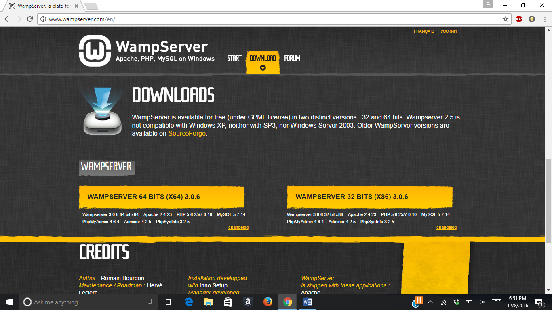

1. Unzip the Application.zip file. Open the Application folder. There should be two files, ‘project’ and ‘www’.

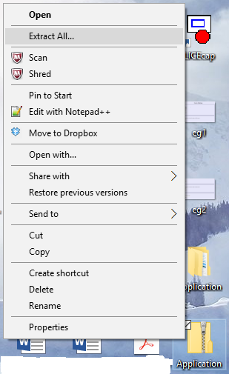

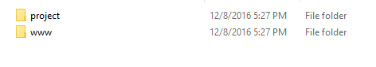

1. Copy ‘project’ and paste it in the location- C:\wamp64\bin\mysql\mysql5.7.14\data.

NOTE: Path might vary if you have not installed it on C drive.

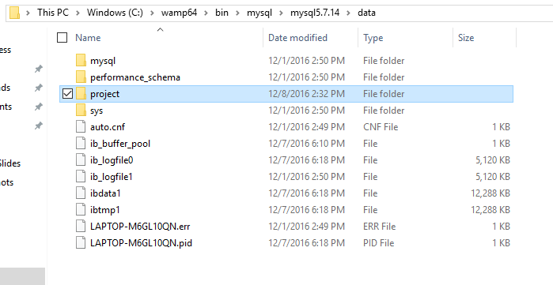

1. Copy ‘www’ and paste it in the location- C:\wamp64. Click on “Replace the files in the destination” when prompted.

NOTE: Path might vary if you have not installed it on C drive.

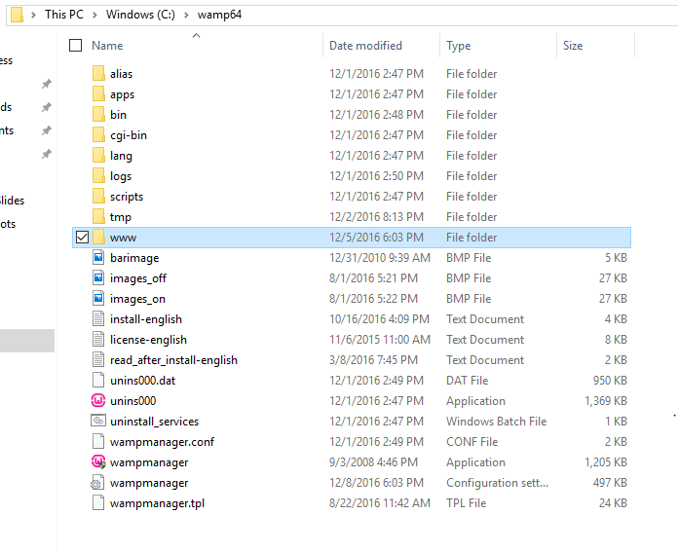

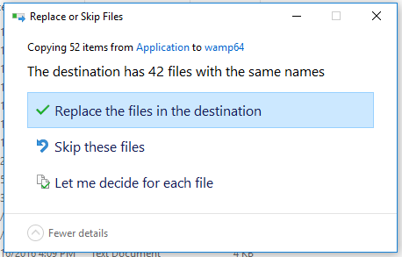

1. Run WAMP server. You can do this by double clicking on the shortcut on the Desktop or use the quick launch icon. When you click WAMP on the quick launch icon, click on “Start All Services”.

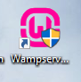 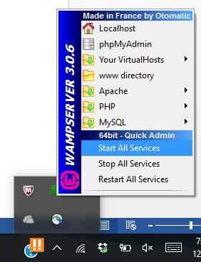

1. Open your browser and type localhost on the URL bar. You should get the following screen.

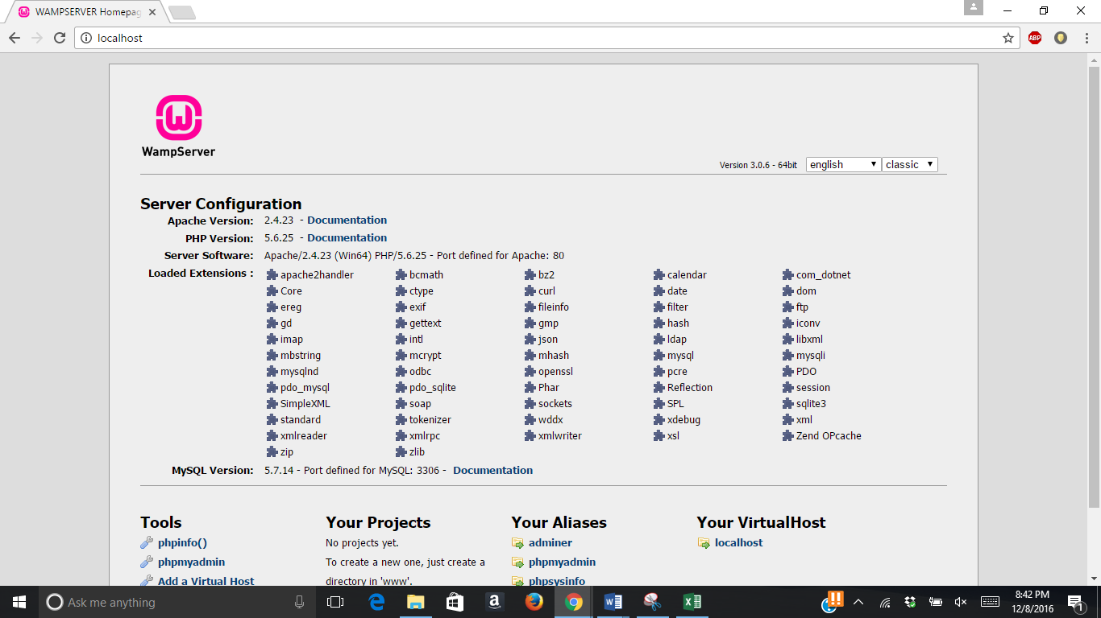

1. Now type localhost/page1.php. The following screen should be displayed.

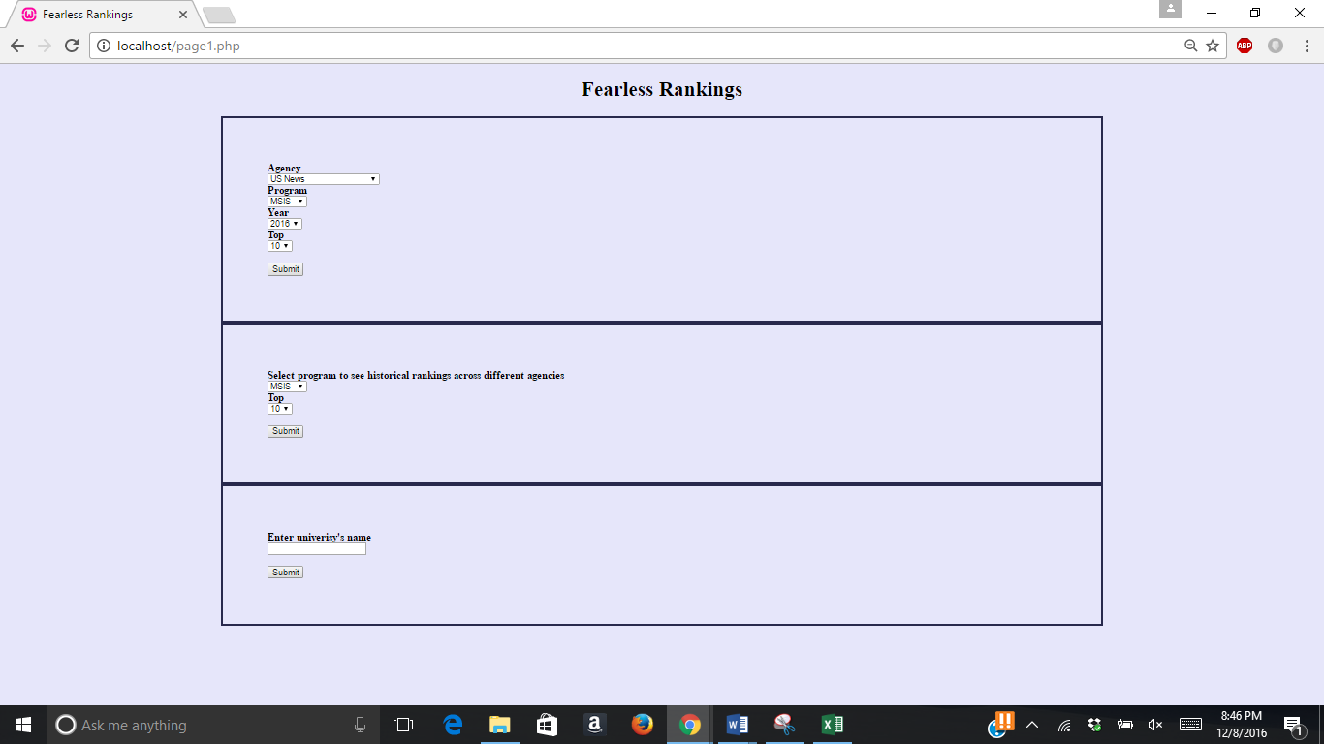

1. There are 3 options to choose from:
   * View Top 10 or Top 5 rankings from an Agency for a Program in the year 2016 or 2015.
   * See Top 10 or Top 5 historical rankings across different agencies for a particular program.
   * See rankings of a particular university across different programs.

NOTE: To see how to use the application, see sample use cases in the presentation attached in the suite.