# *FAKE PRODUCT REVIEW MONIROTING SYSTEM*

***TEAM MEMBERS:***

***2320030036-Sahana.N***

***2320030290-Rishikeshwar-Leader***

***2320030325-Varsha.Y***

***Abstract***:

The Fake Product Review Monitoring System is an advanced and intelligent solution created to tackle the growing issue of fake reviews on online shopping platforms. Fake reviews are a serious concern because they can mislead customers into purchasing products that may not meet their expectations or could even be of poor quality. This system uses cutting-edge technology, including machine learning and natural language processing, to carefully analyze and identify fake reviews. It examines the language used in reviews, checks for unusual patterns, and studies user behavior to determine whether a review is genuine or fraudulent. Whenever the system detects something suspicious, it immediately sends alerts to the website administrators and users, ensuring that they are aware of potential fake content. By effectively filtering out fake reviews, this system helps maintain the honesty and reliability of online product feedback. This, in turn, builds trust among shoppers, making their online shopping experience safer and more enjoyable. Additionally, it promotes fairness among sellers by ensuring that products are judged based on real customer experiences rather than dishonest reviews. The system is designed to be user-friendly, scalable, and adaptable, making it easy to integrate into any e-commerce platform. With the Fake Product Review Monitoring System in place, online shopping becomes more transparent, trustworthy, and fair for everyone involved.

### *Datasets*:

·  ***Kaggle:*** *A great resource for machine learning datasets, including some related to reviews.*

***· UCI Machine Learning Repository:*** *Another source for datasets, though you might need to filter for relevant ones.*

***· Research Papers:*** *Often, researchers release their datasets along with their publications.*

***· Platform APIs:*** *Some platforms might offer APIs that allow you to access review data (with limitations).*

***Existing Public Datasets:***

* **Amazon Product Data:** A massive dataset with millions of reviews, but labeling fake reviews is a challenge. You might need to use heuristics or combine it with other datasets.
* **Yelp Review Data:** Similar to Amazon, large and readily available, but requires careful labeling for your specific task.

***Building our Own Dataset:***

* ***Web Scraping:*** *You can collect reviews from specific platforms (with permission!) and then manually label them. This gives you control over the data but is time-consuming.*
* ***Crowdsourcing:*** *Platforms like Amazon Mechanical Turk can be used to label reviews, but quality control is essential.*

***Algorithm: - Machine Learning Algorithm***



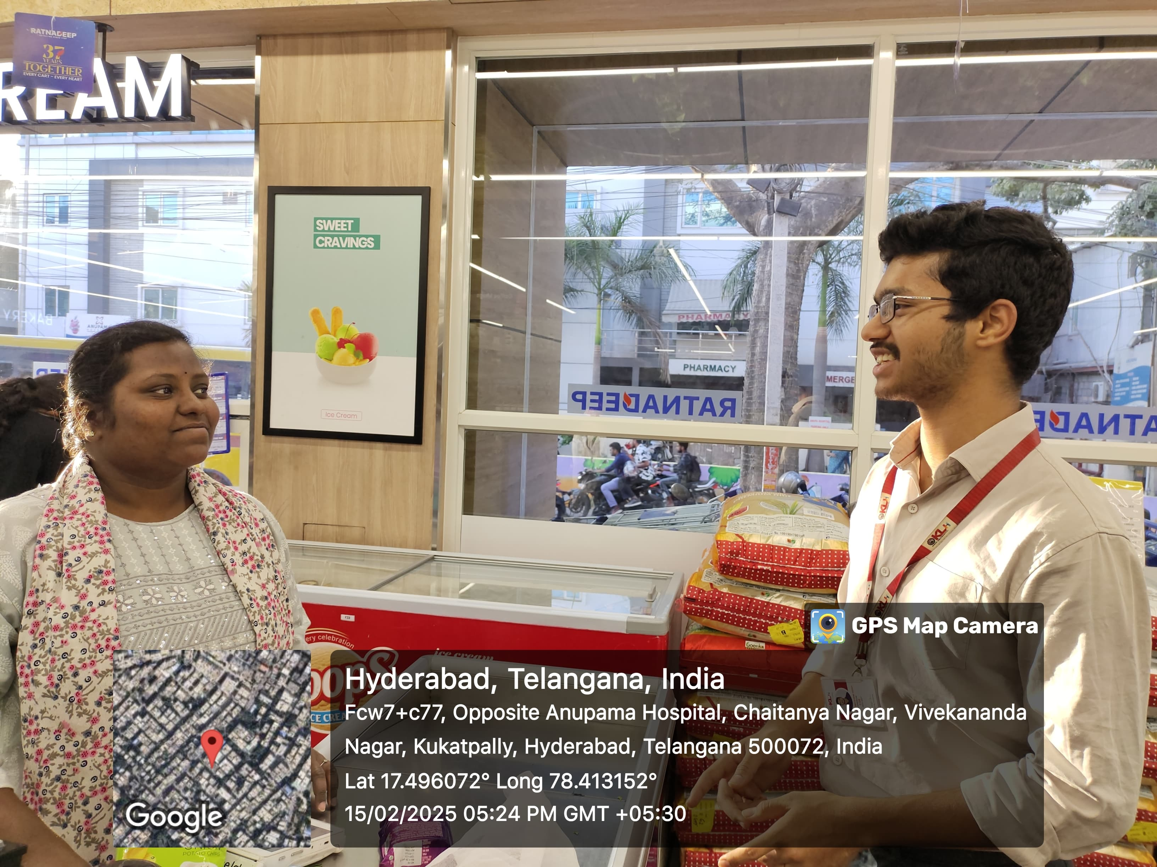

***Project description***

**This project aims to build a "Fake Product Review Monitoring System" using machine learning. It will analyze reviews for linguistic patterns, sentiment, reviewer behavior, and metadata to identify potentially fake reviews in real-time. The system will have a user-friendly interface for businesses to view flagged reviews and take action. The goal is to improve online marketplace trust by combating fake reviews and helping consumers make informed decisions.**

***Fake product review monitoring system***

Varsha

Sahana

Rishikeshwar-Leader

***Team Members***