JusticeLink Mobile App - Project Documentation

Project Title and Description
Project Title: JusticeLink (Mobile App Name: Laya)
JusticeLink is a modern legal tech platform designed to bridge the gap between the public and legal professionals in the Philippines. The core of the platform is a cross-platform mobile application built with React Native (Expo) that empowers citizens with accessible legal tools and provides volunteer attorneys with an efficient platform to manage pro bono cases.

Project Objectives Defined
The primary objectives of the JusticeLink mobile application are:
- Democratize Legal Access: Provide an accessible entry point for citizens to understand their legal situations and seek appropriate help.
- AI-Assisted Legal Triage: Utilize AI to evaluate user situations, suggest immediate next steps, and categorize cases accurately.
- Automated Document Drafting: Streamline the creation of standard legal documents (e.g., Barangay Complaints) through an interactive, conversational AI interface.
- Efficient Lawyer Matching and Management: Provide a dashboard for legal professionals to discover cases, review AI triage summaries, and manage their active engagements.
- Secure and Seamless Communication: Facilitate real-time, secure messaging between citizens and their assigned legal professionals.

Scope and Limitations Identified

Scope
- Cross-Platform Mobile App: Built using React Native (Expo) targeting both Android and iOS devices.
- Dual User Personas: Separate, tailored experiences for Public End-Users (Citizens) and Legal Professionals (Volunteer Attorneys).
- AI Integration: Conversational interfaces for legal triage and document generation, powered by a Python (FastAPI) backend.
- Real-time Infrastructure: Chat and notification systems leveraging Supabase Realtime subscriptions.
- Identity Verification: Integration of identity verification mechanisms (OCR, manual verification) for users and legal professionals.

Limitations
- Geographical Focus: The current iteration is specifically tailored to the Philippine legal system (e.g., handling Barangay Complaints, requiring IBP/Roll numbers for lawyers).
- AI Boundaries: The AI acts as an assistant and drafting tool, not a replacement for certified legal counsel. Final review by a legal professional is still required.
- Connectivity: The app relies heavily on real-time database connections and AI API calls, necessitating a stable internet connection.
- Offline Capabilities: Limited functionality when the user is disconnected from the network.

Updated System Flowchart / Architecture Diagram
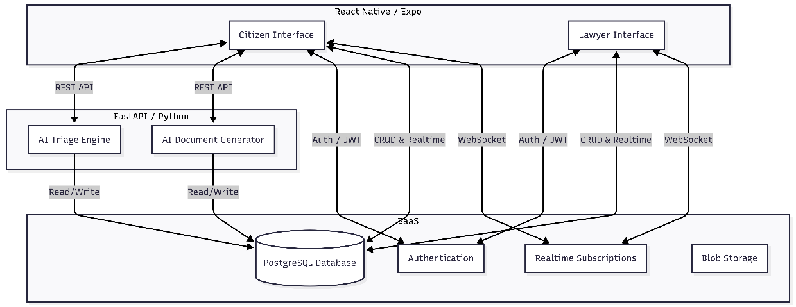
The system follows a modern decoupled architecture, utilizing a mobile frontend, an AI-focused backend, and a Backend-as-a-Service (BaaS) for core data and authentication.

Database Design (ERD)
The database is built on PostgreSQL (hosted via Supabase). Below is an Entity-Relationship Diagram highlighting the core tables and their relationships.
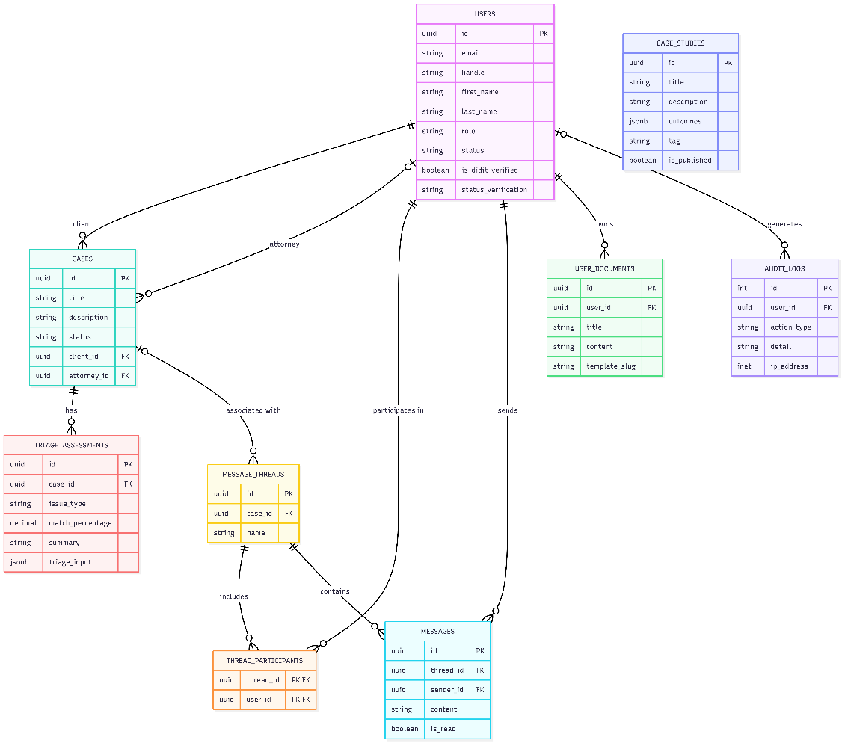

Project Progress Report (Current Accomplishments)
The mobile application is undergoing rapid development. Here is the current state of the implemented features:

Core Features & UI
- Authentication Flow: Complete login and registration screens successfully connected to Supabase Auth.
- Role-Based Routing: Seamless and secure navigation logic established for different user types (Public End-Users vs. Legal Professionals).
- Modern Design System: Implemented a clean, gap-free, and responsive UI heavily utilizing Tailwind-inspired utility styling and React Native flexbox principles.

AI-Powered Tools
- Interactive AI Document Drafter:
  - Created a conversational chat interface (DocumentGeneratorScreen) where users explain their legal situation.
  - Implemented an active AI backend that dynamically gathers missing information through follow-up questions.
  - System successfully generates fully formatted legal documents (e.g., Barangay Complaints) once sufficient data is collected.
  - Recent Milestone: Fully optimized Android keyboard behavior, implementing custom offset tracking for gap-free and clip-free chat interactions.
- AI Triage System: Initialized the conversational interface (TriageScreen) for evaluating user situations and suggesting immediate legal next steps.

Legal Professional Dashboard
- Case Management: Built the UI (LegalCasesScreen, LegalCaseDetailsScreen) for lawyers to view available cases, active engagements, and detailed case information.
- Dashboard Overview: Created the LegalDashboardScreen to provide at-a-glance statistics and recent activities for the logged-in professional.

Communication
- Messaging System: Implemented a real-time chat interface (ChatThreadScreen) connecting end-users and assigned legal professionals, equipped with the same highly optimized Android keyboard avoidance architecture used in the AI Drafter.

Next Steps / Active Development
- Refining the prompt logic for specific document generation (e.g., ensuring Barangay Complaints address the barangay generically rather than specific placeholders).
- Finalizing the connection between the AI Triage system and the lawyer-matching database flow.
- Enhancing real-time WebSocket subscriptions for the messaging system to ensure robust delivery.

