A Short History of Papermaking
doclr sample document
2026-01-01

A Short History of Papermaking
Papermaking is traditionally traced to Cai Lun, an official at the Han imperial court, who is credited with standardizing a pulp-based process around 105 CE. The technique spread slowly westward over the following centuries, reaching the Islamic world by the eighth century and Europe by the twelfth.

Materials and process
Early paper was made from a mixture of fibrous materials, including:
- mulberry bark
- hemp waste
- old rags and fishing nets
- bamboo, in later regional variants
The fibers were pulped, suspended in water, and lifted out on a mesh screen. Pressing and drying removed the remaining water, leaving a flexible, foldable sheet – a considerable improvement over papyrus or parchment for everyday writing.

Comparative costs
The table below gives illustrative relative costs of common writing surfaces before and after paper became widely available.
Surface | Relative cost | Durability
Papyrus | Medium | Low
Parchment | High | High
Paper | Low | Medium

A simple diagram
The figure below sketches the basic pulp-to-sheet process.
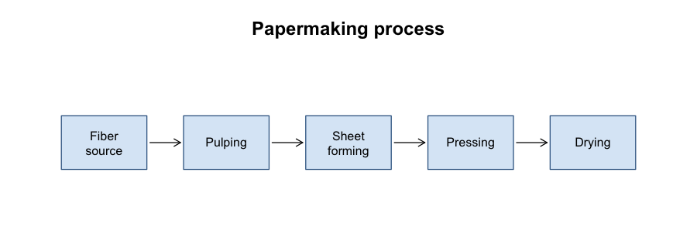
Papermaking process, from pulp to dried sheet

Later developments
Mechanized paper production in the nineteenth century, driven by the Fourdrinier machine, shifted the raw material from rags to wood pulp and made paper cheap enough for mass printing. This is the point at which paper stopped being a craft good and became an industrial commodity.

