LAB 2 : Data Processioning
Student name: Donfack Tsopfack Yves Dylane
INTRODUCTION:
The goal of this project is to demonstrate the process of cleaning, transforming, and modeling data using Logistic Regression and Random Forest. The dataset used is the Titanic dataset from Seaborn, and the final models are evaluated using accuracy, precision, recall, and F1 score.

1. Data Collection
In this step, we load the Titanic dataset from Seaborn. This dataset contains information about passengers on the Titanic, including whether they survived, their age, class, and other features.
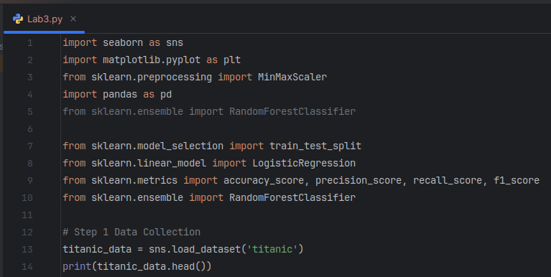Figure 1: importing necesary liberies and the data for the work
Result:
The dataset contains the following columns: survived, pclass, sex, age, sibsp, parch, fare, embarked, who, class, alive, alone, and embark_town.
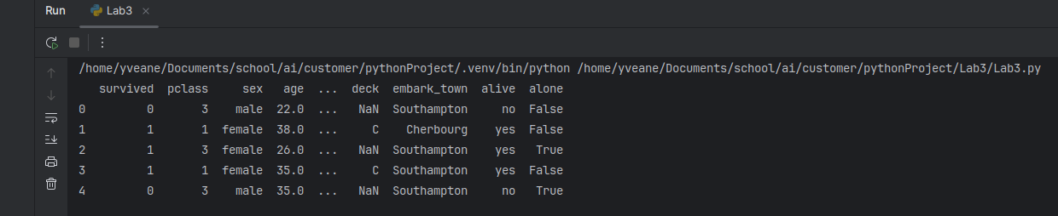Figure 2: Head values of our data set

2. Data Cleaning

2.1 Inspecting for Missing Values
We checked for any missing values in the dataset to identify the columns that need imputation or removal.
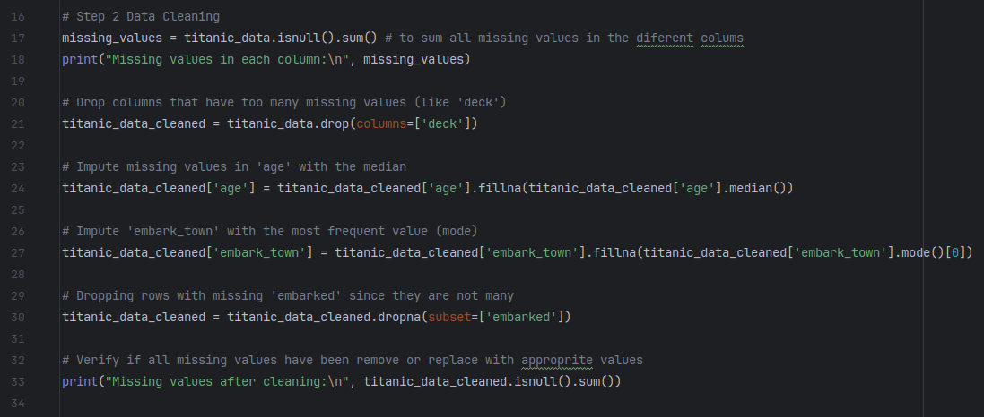Figure 3: handling missing values
Result:
The columns age, embarked, and deck contained missing values, which are needed to be handled.
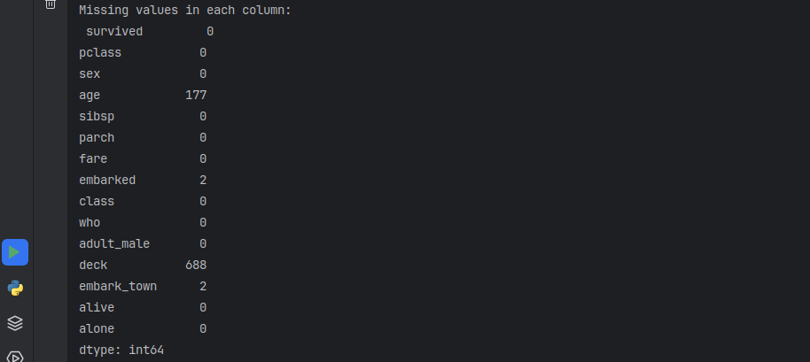Figure 4: missing values

2.2 Handling Missing Values
For columns with missing numerical data like age, we used median imputation. For categorical columns like embarked, we used the mode (most frequent value) to fill missing entries.
Result:
After imputing missing values, all missing data were handled appropriately.
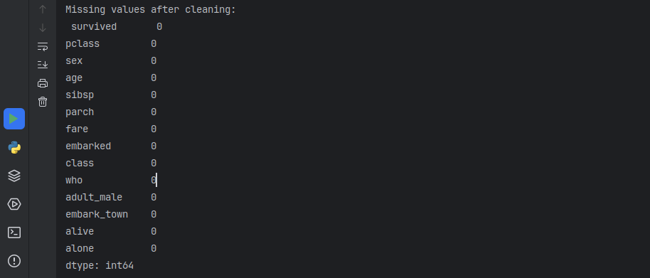Figure 5: missing values after cleaning

3. Feature Selection and One-Hot Encoding

3.1 One-Hot Encoding Categorical Variables
To prepare the data for machine learning, we performed one-hot encoding on categorical variables like sex, embarked, and others. This allows the model to work with numerical data. This is done after handling the outliers and help us to plot a correlation graph for the features.
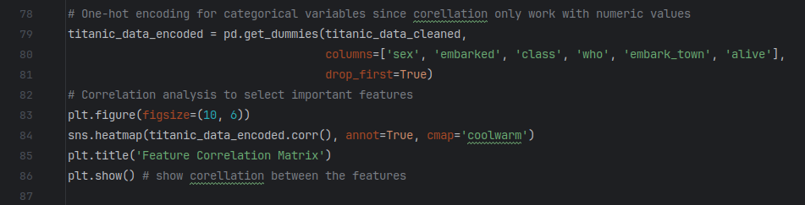Figure 6: hot encoding categorical values
Result:
The dataset is now encoded with binary columns for categorical features, and the shape of the dataset has increased due to the additional columns. This permit the correlation graph to be plot.
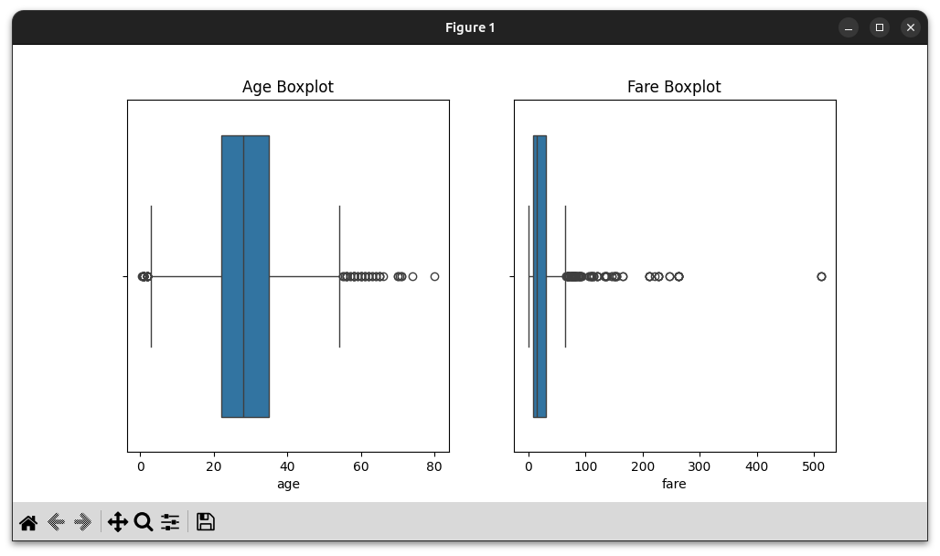Figure 7: box plot to identify outliers
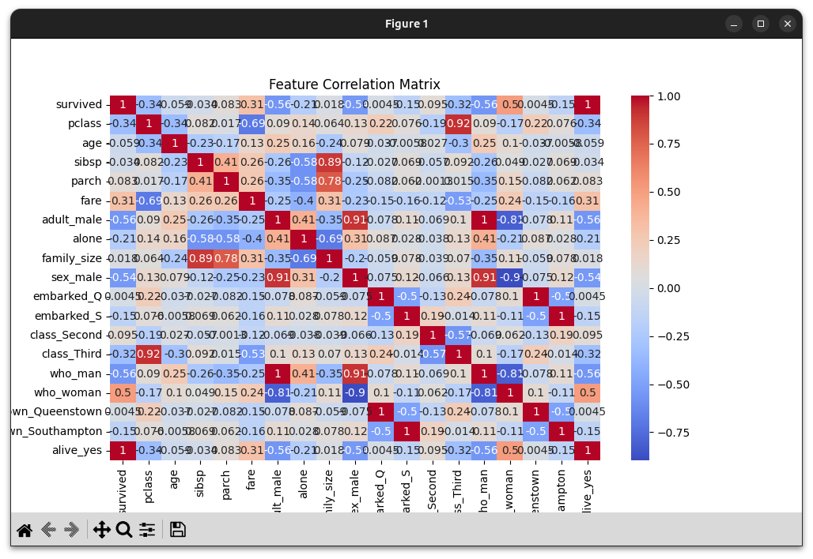Figure 8: corellation graph of the featuers

4. Data Normalization
We normalized the numerical features such as age and fare to ensure that the scales of the features did not disproportionately affect the model's performance (i.e we give them the same scale of measurement).
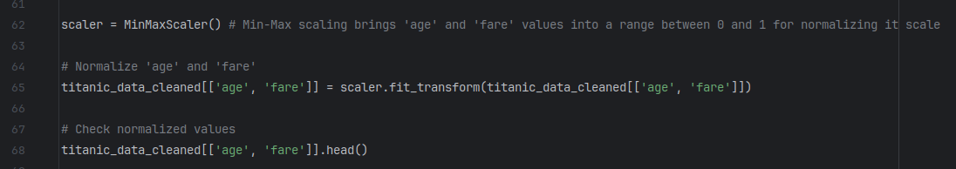Figure 9: normalizing data
Result:
The numerical columns age and fare are now scaled between 0 and 1.
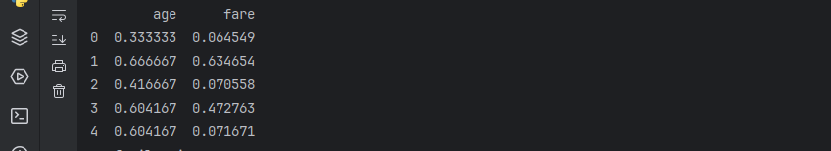Figure 10: normalise data

5. Feature Engineering
We created new features that might provide additional insights for the model and separate features and target.

5.1 Family Size Feature
We created a family_size feature by summing sibsp and parch columns, which represent the number of siblings/spouses and parents/children aboard.
Figure 11: creating family size

Result:
The family_size feature is now added to the dataset.
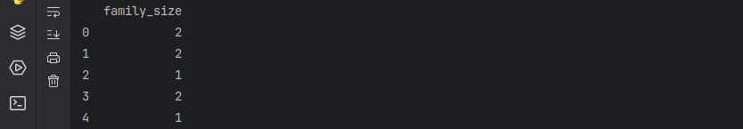Figure 12: head of the family size column

6. Model Building

6.1 Splitting Data into Train and Test Sets
We split the dataset into features (X) and target (y), where y is the survived column, and X contains the rest of the features. Then, we split the data into training and testing sets.
The data has being successfully split into training and testing sets with 30% of the data reserved for testing.
Figure 13: spliting data

6.2 Logistic Regression Model
We first trained a Logistic Regression model and evaluated its performance using accuracy, precision, recall, and F1 score.
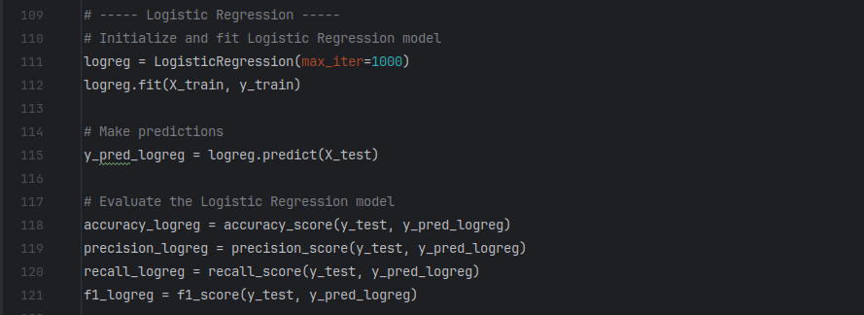Figure 14: logistic regression
Result:
The Logistic Regression model achieves the following performance metrics:
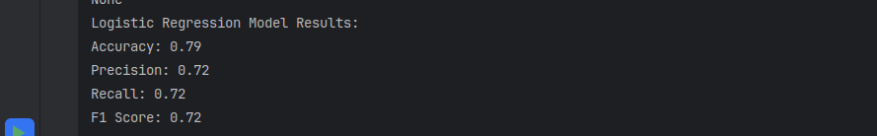Figure 15: logistic model result

6.3 Random Forest Model
We then trained a Random Forest model and compared its performance to that of Logistic Regression.
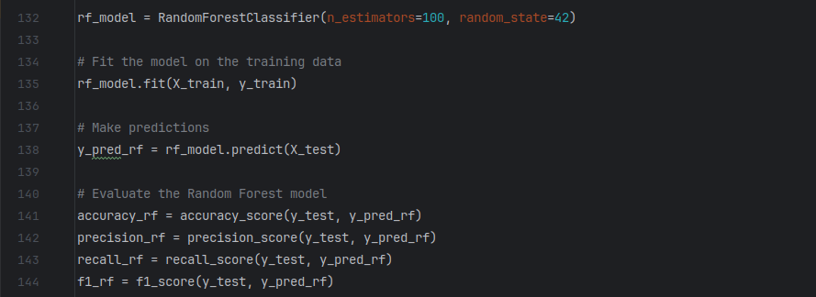Figure 16: random forest model

Result:
The Random Forest model achieves the following performance metrics:
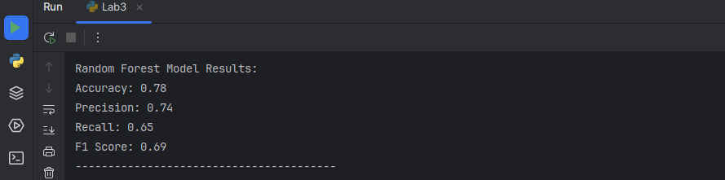Figure 17: random forest result

7. Model Comparison
The following table compares the performance of Logistic Regression and Random Forest:
Metric | Logistic Regression | Random Forest
Accuracy | 0.79 | 0.78
Precision | 0.72 | 0.74
Recall | 0.72 | 0.65
F1 Score | 0.72 | 0.69
Conclusion:
- Logistic Regression performed better in terms of recall and F1 score, meaning it captured more true churners and balanced both precision and recall more effectively.
- Random Forest had slightly higher precision but lower recall, meaning it was better at avoiding false positives but missed some true churners.

Conclusion
This lab demonstrated the steps of processioning data, including cleaning, encoding, and normalizing, as well as building machine learning models for classification. Both Logistic Regression and Random Forest models were trained and evaluated, providing insights into their performance on the Titanic dataset.

