1. Download and install Anaconda
2. Create Github account
3. Install git bash and configure local machine
4. Create repo on Github with LICENSE and README.md files
5. cd to desired location for project folder and create project folder
6. Open Anaconda Prompt and cd into project folder
7. Create with conda env export > environment.yml and edit .yml file and edit with Notepad ++

<https://medium.com/@shandou/export-and-create-conda-environment-with-yml-5de619fe5a2>

<https://bukkit.org/threads/how-to-open-and-edit-a-yml-file.101566/>

https://uoa-eresearch.github.io/eresearch-cookbook/recipe/2014/11/20/conda/

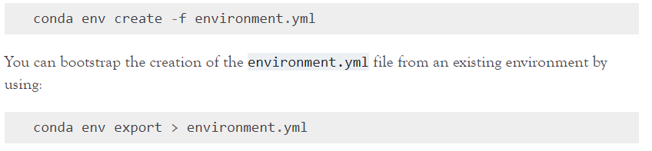

* 1. Check version of python by opening command line prompt and typing python –version
  2. Check package version numbers by importing them into jupyter notebook and using print(package.__version__)
  3. .yml file will have name, channel, dependencies and prefix

Channels : <https://docs.conda.io/projects/conda/en/latest/user-guide/concepts/channels.html>

<https://docs.conda.io/projects/conda/en/latest/user-guide/tasks/manage-environments.html#creating-an-environment-from-an-environment-yml-file>

<https://heartbeat.fritz.ai/creating-python-virtual-environments-with-conda-why-and-how-180ebd02d1db>

<https://www.earthdatascience.org/workshops/setup-earth-analytics-python/setup-python-conda-earth-analytics-environment/>

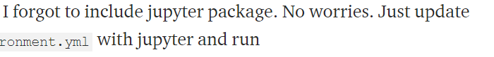

1. Activate environment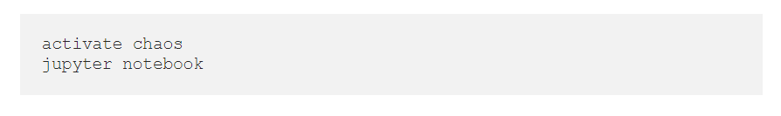
2. Update environment.yml with new package and run
3. conda env update --prefix ./env --file environment.yml --prune

<https://www.earthdatascience.org/courses/intro-to-earth-data-science/python-code-fundamentals/use-python-packages/use-conda-environments-and-install-packages/#:~:text=for%20each%20project.-,Update%20Conda%20Environments%20Using%20a%20YAML%20File,yml%20file.>

1. Move package into environment
2. Make codes folder (prototype and production)
3. Cd into it and open jupyter notebook
4. Creating directories access codes

<https://stackabuse.com/creating-and-deleting-directories-with-python/#:~:text=To%20create%20an%20entire%20path,see%20in%20Listing%204%20below).>

1. Download data directly into data/raw

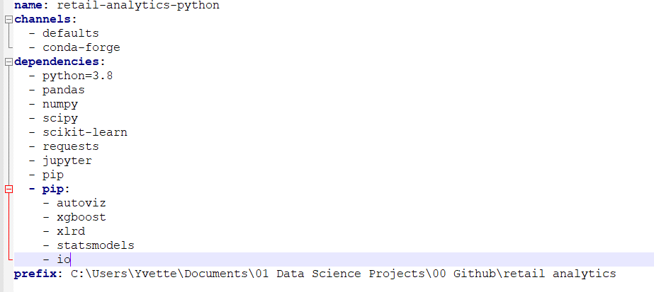

1. To stop a running jupyter notebook click on Ctrl + C