沪东中华造船集团有限公司
场地编排算法的应用使用手册
基于.net C# & sql server的C/S系统
Ｙｕａｎ Ｑｉｎ 秦原
2018/8/23

[在此处键入文档摘要。摘要通常为文档内容的简短概括。在此处键入文档摘要。摘要通常为文档内容的简短概括。]

目录
1. DB construction: 2
A. --dbo.hull_info: 2
B. --dbo.info_item(test use, only usage in project for update) 2
C. --Dbo.mapping (for test use, not used in YQYQY project) 3
2. Debugging steps for original algorithm: 4
A. Debug 4
B. For dll: 4
C. For database: 4
3. Parameters for ../YQYQY/Debug/ContainerClass.dll 5
A. Function: 5
B. Input type: 5
C. Output type: 5
D. Example for use in c#: 5
4. Web page display: 7
A. Instruction: 7
5. Limitation: 9
6. What could be improved: 9

DB construction:

--dbo.hull_info:
--imported from SMSMS, add id_temp for primary key

CREATE TABLE [dbo].[hull_info](
[ID_TEMP] [int] IDENTITY(1,1) NOT NULL,
[PLAN_START] [datetime] NULL,
[PLAN_END] [datetime] NULL,
[OBJ_OUTSIDE_ID] [varchar](50) NULL,
[WIDTH_VALUE] [float] NULL,
[LENGTH_VALUE] [float] NULL,
[PROJ_ID] [varchar](50) NULL,
[PROJ_NAME] [varchar](50) NULL,
[LOC_X] [float] NULL,
[LOC_Y] [float] NULL,
[ORIENTATION] [varchar](50) NULL,
[OFFSET] [int] NULL,
[ACTUAL_START] [datetime] NULL,
[ACTUAL_END] [datetime] NULL,
CONSTRAINT [PK_hull_info] PRIMARY KEY CLUSTERED
(
[ID_TEMP] ASC
)WITH (PAD_INDEX = OFF, STATISTICS_NORECOMPUTE = OFF, IGNORE_DUP_KEY = OFF, ALLOW_ROW_LOCKS = ON, ALLOW_PAGE_LOCKS = ON) ON [PRIMARY]
) ON [PRIMARY]

GO

--dbo.info_item(test use, only usage in project for update)
ITEM_ID varchar(16)
ITEM_NAME varchar(50)
ITEM_NOTE varchar(250)
ITEM_D_X int --WIDTH
ITEM_D_Y int --HEIGHT
DES_FIELD_ID varchar(16) --field in which we hope to move in
RL_FIELD_ID varchar(16) --field in which we actually to move in
DES_PERIOD int --planned working period
MOV_IN_DATE datetime --as literally described
MOV_OUT_DATE datetime

--Dbo.mapping (for test use, not used in YQYQY project)
--imported from SMSMS

Debugging steps for original algorithm:

Debug
../test_native_nobug/ original_algo_with_bug.rar
-> to runnable:
../test_native_nobug/ main.sln
For normal running of unadjusted program.
Debug modification steps:
1. using namespace std;
2. int i in for loop;
3. ofstream 0 changeto-> 0x20
4. some <.h> not supported in cpp, deleted.

For dll:
- #define debug defines console output/print
- #define outputfile defines mostly file input and output
- Objectsort() moved into class

For database:
- Object: id needed for identification after loading,
Period calculated from (end-start).
- Group by Project name.

Parameters for ../YQYQY/Debug/ContainerClass.dll

Function:
extern unsafe static float* mainEntrance(float[,] inputarr, float[] fieldinfo, char[] fieldname,int itemnum);//unsafe for use of pointer in c#

Input type:
Inputarr: 2d array, 5 elements per row, each element sequentially refers to {item_id, width_value, length_value, period, number of the item }
Eg: float[,] in1 = { { 1, 3, 6, 3, 1 }, { 2, 1, 4, 2, 1 }, { 3, 1, 2, 1, 1 }, { 4, 2, 2, 2, 1 } ,{5,1,1,1,1},……};
Note: no zero allowed in width and length value;
Fieldinfo: 1d array, {field_width,field_length}
Eg: float[] in2 = new float[] { 5, 4 };
Fieldname: char[];
Itemnum: input number of item, second dimension of inputarr;

Output type:
Float*: 1d array, (itemnum)*8, each 8 elements refers to {0,2,3,……,7}:
0: item number(sorted decreasingly by items’ bottom area)
1: whether loaded into this field or not(0 for no,1 for yes)
2: item width
3: item length
4: orientation of the item(0 for vertical, 1 for horizontal )
5: coordinate x in field
6: coordinate y in field
7: which period could start to put

Example for use in c#:
//put ContainerClass.dll under yourworkingdirectory/Debug/ContainerClass.dll
using System;
using System.Collections.Generic;
using System.Linq;
using System.Text;
using System.Runtime.InteropServices;//important to have for managed c++

namespace ConsoleApplication1
{
class Program
{

[DllImport(@"C:\Users\g04480\Desktop\你们的小可爱\YQYQY\Debug\ContainerClass.dll")]
extern unsafe static float* mainEntrance(float[,] inputarr, float[] fieldinfo, char[] fieldname,int itemnum);
static void Main(string[] args)
{
unsafe
{
float[,] in1 = { { 1, 3, 6, 3, 1 }, { 2, 1, 4, 2, 1 }, { 3, 1, 2, 1, 1 }, { 4, 2, 2, 2, 1 } ,{5,1,1,1,1}};

float[] in2 = new float[] { 5, 4 };

float* ret = mainEntrance(in1, in2, "qwerty".ToCharArray(),in1.GetLength(0));//return value not drawn

for (int i = 0; i < in1.GetLength(0); i++)
{
for (int j = 0; j < 8; j++)
Console.Write(ret[i*8+j].ToString()+"\t");
Console.WriteLine();
}

}
while (true) ;
return;
}
}
}

Web page display:
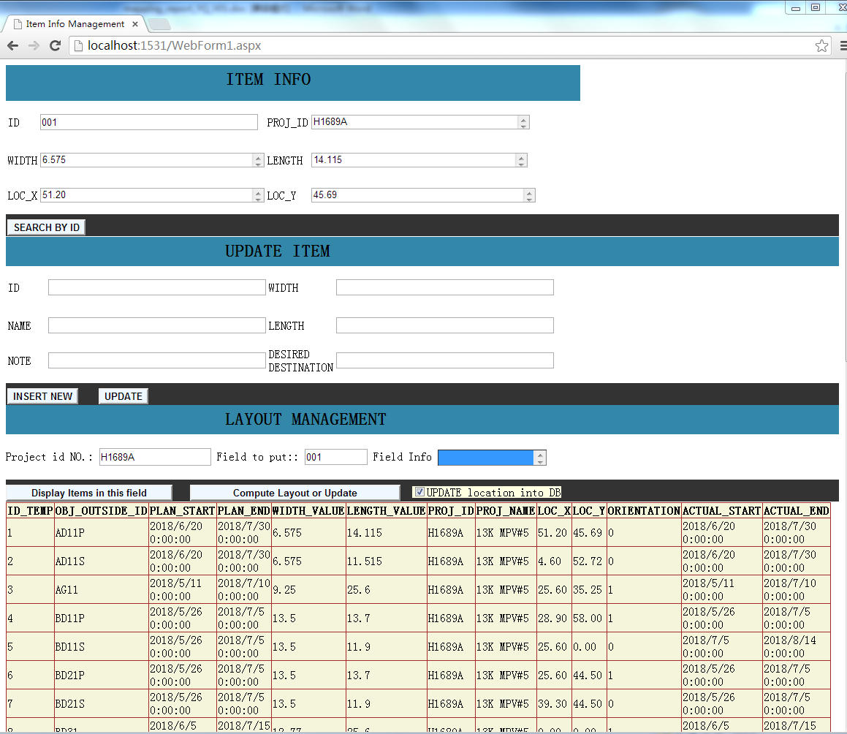

Instruction:
      - Item info display
Input: ID number
Eg. 001
Output:
Eg.
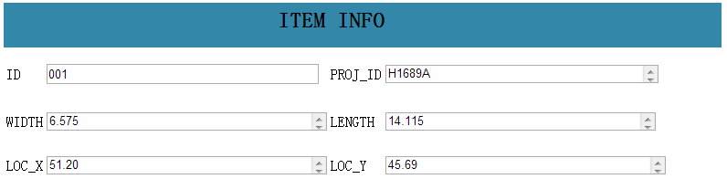
Note: if no LOC_X and LOC_Y display, means layout calculation needed in LAYOUT MANAGEMENT section, record the PROJ_ID and put into project id No.
      - Update info
This implementation only update the test dbo.item_info. Not the exact hull_info table for the reason of not knowing the exact mechanism on how updating the actual grand database in use. Easy modification needed for act use in reality. You can either insert new or update.
Note: all blanks needed filling otherwise error window would appear.
      - LAYOUT MANAGEMENT section is the main part of this web page application in which user input the project id in the first section searched and put in the ideal field parameter.
User can either Display all items of this project or display the computation result of the eventual optimized layout information of this project.
Note: check box would judge whether the result would be updated in the database or not.
Eg:
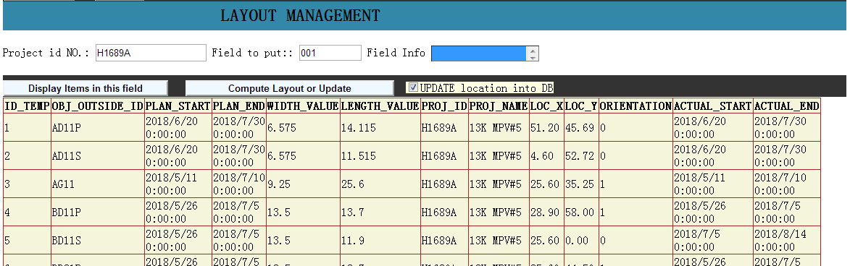

Limitation:
- Greedy based algorithm determined the limitation of the potential of dynamicity
Imagine the scenario when item deleted/added after the plan is made and the calculation of the optimized layout is done. The packaged dll only allows api for one-time and before-hand calculation.
Once recalculated after certain update in the database, and if the item(hull) is already moved to certain location, it would be impractical to move all the massive block (extremely hard to move) based on a newly computed layout, because it might be comprehensively changes of different locations of respective block.
- Not knowing the exact field parameters, (50,50) width and length is set manually in the table under this scenario.

What could be improved:
- Web display all items during certain period or under certain project(implemented), then use checkboxes before each item for selecting certain ones.
- Field selection not implemented, no detailed info(x,y) yet, default dimension info(50,50) for all field in dbo.info_item table.
- Could implement construction period selection whicih narrow down the items within certain period such that eliminate the time offset (which means the starting time is later than attempted).

Reference:
造船企业场地资源计划编制算法优化
Sql server 从入门到精通
ｃ＃深入浅出

