Yuan Qin

[yqin7@uci.edu](mailto:yqin7@uci.edu)

**Project Part 1 Report**

1. Progress Summary

In the first part of the project, a miniature warehouse management system are simulated which calculates the shortest path for a robotic arm to fetch the goods desired.

Assumptions are made which the robot could only fetch things from either left or right side of the rack. Meanwhile, for simple representation of the path, coordinates of all goods are doubled and shifted by 1 both in x and y direction, i.e. (0,0) to (1,1), to set aside path for robot to pass through.

**In the program:**

Firstly, product list is read in using csv reader module, and positions are individually saved in a directory in corresponding to its ID number, convenient for looking up and mapping. Then in the main function, the command line argument is read in as id number and initial starting point for the robot to calculate the shortest path.

In the path finding function, product location is looked up as reference to its ID number. Then the desired position to take things according to the product location is calculated in different conditions, that is, whether the current position is to the right or left of the product position(since it could be only taken from left or right). Then the robot goes along the x direction before along the y. After that the path is calculated by sum of distance vertically and horizontally. However if the rack is in the way of the path in x direction(eg. Just after taking one goods, in which way the current y should be odd number), the robot first goes one unit along y then follow the last procedure.

1. Program running
2. Starting from original

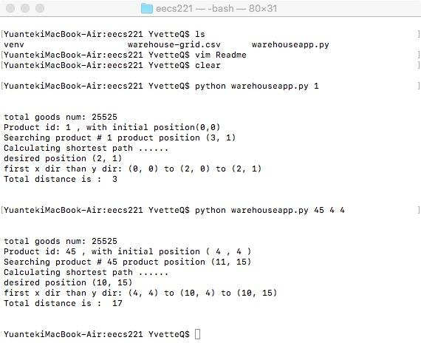

B. Arbitrary starting point



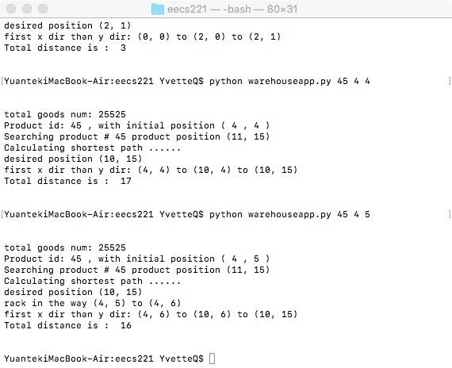

3.

Command line input:

*python warehouseapp.py [id number] ([initial position x] [initial position y])*

*Eg.*

*python warehouseapp.py 45 2 2*

Initial position x and y are (0,0) if not specified