3. Methodology
As illustrated in Fig. 4, the proposed phishing detection framework utilizes a hybrid approach employing a 1-Dimensional Convolutional Neural Network (1D-CNN) and a Bidirectional Gated Recurrent Unit (BiGRU) for classifying websites as phishing or legitimate. This 2-system approach is designed to utilize both the 1D-CNN’s ability to capture local lexical patterns and the BiGRU’s capability to model global sequential dependencies from the URL features, thus providing a novel, robust and effective model tailored for phishing detection.
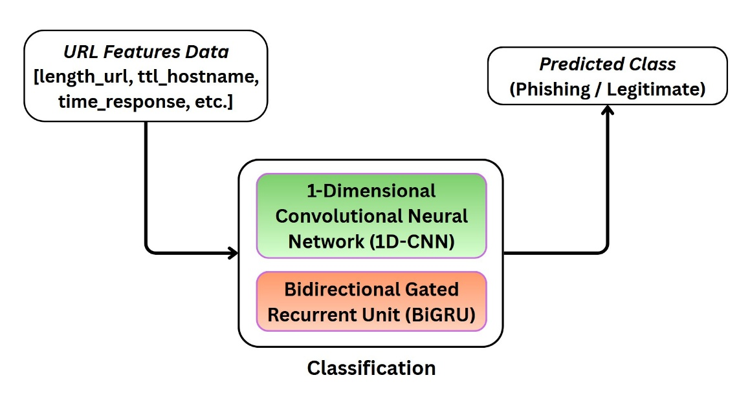

3.1 Data Pre-processing
Raw datasets often contain missing values, inconsistent entries, noisy records, and features with significantly different numerical scales, all of which can negatively affect the performance of machine learning models trained on them. The datasets selected for this project are no exception, making data pre-processing a critical stage in the development of the proposed hybrid framework. Implementations based on neural network architectures are particularly sensitive to the numerical distribution of input features. As such, improperly scaled data, missing values, or noisy observations can lead to reduced classification accuracy, unstable training behavior, and slower model convergence.
To mitigate these issues, preprocessing techniques are applied to transform the raw data into a clean, consistent, and machine-learning-ready format. This process typically involves identifying and handling missing or incomplete values, removing duplicate or irrelevant records, and correcting inconsistencies within the dataset. Additionally, feature scaling and normalization techniques are applied to ensure that all input variables fall within comparable numerical ranges, preventing features with larger magnitudes from disproportionately influencing the learning process.
For safeguarding methodological consistency and preventing data leakage, pre-processing was applied using parameters obtained from training data exclusively to the training set and then subsequently the validation and test sets. This pipeline ensures that the training set does not get influenced by gaining unintended information from the validation and test sets, thus conserving its integrity during evaluation.

3.2 Convolutional Neural Network
The first component of the hybrid framework’s processing pipeline begins with a one-dimensional Convolutional Neural Network (1D-CNN), which is employed to capture local structural patterns from the feature vectors extracted from URLs. Convolutional Neural Networks (CNNs) are a category of deep learning models designed to automatically learn hierarchical feature representations from input data through convolutional operations. Traditionally, CNNs have been widely used in computer vision tasks, including image classification, object detection, and pattern recognition, due to their ability to capture spatial hierarchies and local patterns within images \cite{lecun2015}. Their architecture typically consists of convolutional layers, activation functions, pooling layers, and fully connected layers that work together to progressively extract higher-level representations from raw input.
Although CNNs were originally developed for two-dimensional image data, their architecture can be adapted to one-dimensional sequential data. In this configuration, a 1D-CNN performs convolution operations along a single dimension, enabling the model to detect local feature patterns within sequences such as time-series data, text, or structured feature vectors \cite{kiranyaz2021}. In the context of phishing URL detection, 1D-CNNs have proven effective due to their ability to efficiently capture local dependencies and discriminative patterns within textual or feature-based representations of URLs. Previous studies have demonstrated the effectiveness of convolutional architectures in text classification tasks by identifying key n-gram level patterns and structural features within input sequences \cite{kim2014}. By applying convolutional filters across the feature vectors, the model can automatically learn patterns that distinguish phishing URLs from legitimate ones.
@article{kim2014,
title={Convolutional Neural Networks for Sentence Classification},
author={Kim, Yoon},
journal={EMNLP},
year={2014}
}
Kim, Y., 2014, October. Convolutional neural networks for sentence classification. In Proceedings of the 2014 conference on empirical methods in natural language processing (EMNLP) (pp. 1746-1751).
@article{kiranyaz2019,
title={1D Convolutional Neural Networks and Applications: A Survey},
author={Kiranyaz, Serkan et al.},
journal={Mechanical Systems and Signal Processing},
year={2019}
}
Kiranyaz, S., Avci, O., Abdeljaber, O., Ince, T., Gabbouj, M. and Inman, D.J., 2021. 1D convolutional neural networks and applications: A survey. Mechanical systems and signal processing, 151, p.107398.

The CNN component in the proposed hybrid framework therefore functions as a feature extractor, identifying and learning important local dependencies within the input feature vectors before passing them onto the BiGRU component for temporal extraction. Fig. 5 displays the visual representation of the architectural structure of a 1D-CNN employed within the proposed hybrid framework.
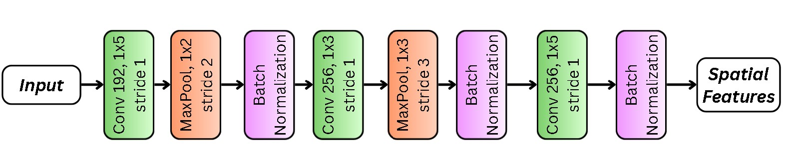

3.2.1 One-Dimensional Convolutional Layer
The convolutional layer forms the core component of the 1D-CNN architecture and is responsible for extracting spatial feature patterns from the input feature vectors. In this layer, a set of learnable filters performs convolution operations across small regions of the input, enabling the model to detect meaningful spatial structures. As the filters slide across the input sequence, they generate feature maps that highlight the presence of specific patterns learned during training. Several key parameters control the behavior of the convolutional layer. The number of filters determines how many distinct feature patterns can be learned simultaneously, with each filter capturing a different abstraction of the input data. The kernel size defines the size of the local region examined during convolution, where larger kernels capture broader contextual patterns while smaller kernels focus on more fine-grained local ones. After each convolution operation, a ReLU activation function is applied to introduce non-linearity, allowing the network to learn complex decision boundaries for phishing detection. Padding is set to ‘same’ to ensure that the output feature map maintains the same dimensionality as the input, allowing edge features to be preserved. Additionally, L2 kernel regularization is applied to penalize large weights and reduce the risk of overfitting, thereby improving the model’s generalization capability. In the proposed architecture, three convolutional blocks are implemented sequentially with 192 filters and a kernel size of 5 in the first layer, followed by 256 filters with a kernel size of 3 in the second layer, and 256 filters with a kernel size of 5 in the third layer, all using ReLU activation and an L2 regularization factor of 2 x 10^-5. This progressive configuration enables the network to first capture broader structural patterns and then refine them through deeper layers, ultimately transforming the input feature vector into a hierarchy of informative feature maps that are passed to subsequent layers of the hybrid framework.
Following each convolutional operation, batch normalization is applied to stabilize the training through normalizing feature maps by regulating their mean and variance. This ensures that the features extracted by the convolutional layer remain stable before being passed onto the subsequent layers.

3.2.2 One-Dimensional Max Pooling Layer
Max pooling plays the role of down sampling the feature maps by selecting the maximum value from a defined window. This is done in order to reduce the dimensionality of the feature maps. A larger pooling size causes greater dimensionality reduction while a smaller pooling size preserves more detail. Max pooling emphasizes the most dominant feature from every local region which in the case of this project’s problem space, highlights the strong indicators of phishing while minimizing weaker ones. Additionally, max pooling reduces complexity and controls overfitting.

3.3 Bidirectional Gated Recurrent Unit
Recurrent Neural Networks (RNNs) are a category of neural network models designed to model sequential data by maintaining hidden states that capture dependencies between elements in a sequence, allowing information from previous time steps to influence future predictions. However, traditional RNNs suffer from the vanishing and exploding gradient problems, where gradients become extremely small or excessively large during backpropagation through time. This issue limits the network’s ability to learn long-term dependencies within sequences \cite{bengio1994}. To address these limitations, gated recurrent architectures such as the Gated Recurrent Unit (GRU) were introduced which incorporate gating mechanisms that regulate the flow of information through the network, enabling the model to retain relevant contextual information over longer sequences while discarding irrelevant patterns \cite{tang2021}. As illustrated in Fig.2. the mechanism consists of two primary gates: the update gate that controls how much information from the previous hidden state is maintained and the reset gate which determines how much information is ignored. These gating mechanisms allow GRUs to selectively preserve useful contextual features while filtering out noise, thereby improving learning efficiency and stability.
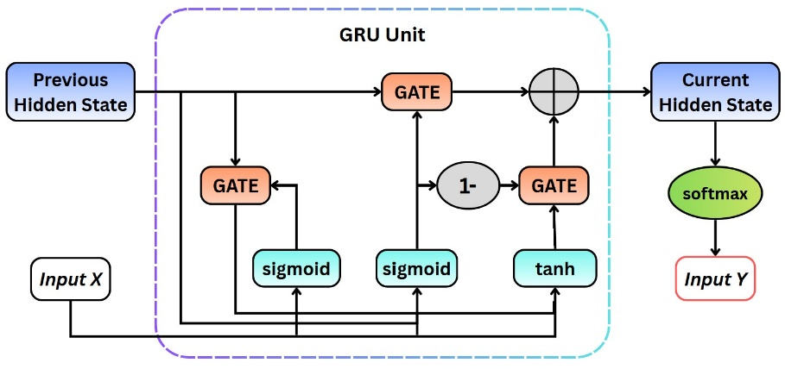

For the proposed hybrid framework, a Bidirectional Gated Recurrent Unit (BiGRU) is utilized to further enhance the model’s ability to capture contextual relationships within the feature representations generated by the 1D-CNN. In a bidirectional architecture, two GRU layers operate simultaneously: one processes the input sequence in the forward direction, while the other processes it in the reverse direction which according to \cite{she2021} can be seen as capturing both past and future feature relationships when making classification decisions. The hidden states generated from both directions are then combined to form a unified representation that incorporates information from both preceding and succeeding elements within the sequence \cite{joolee2022}.
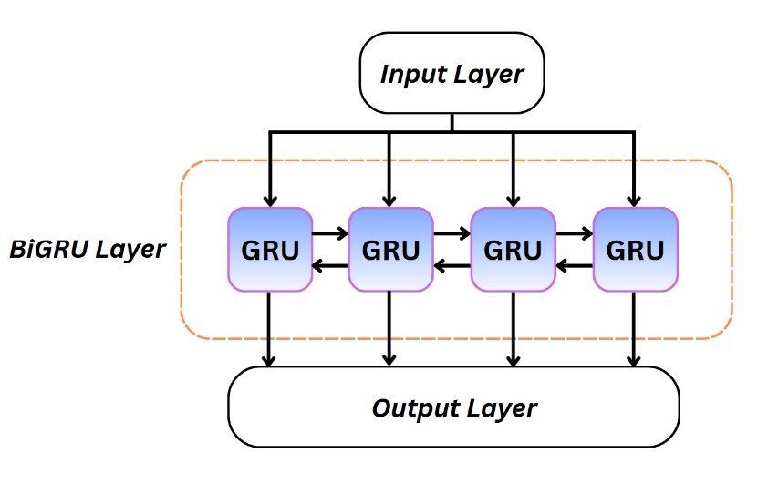

For the purpose of tuning, certain parameters such as the number of GRU units and Dropout Regularization are crucial to obtaining the most optimal model. The number of GRU units determines the dimensionality of the hidden state with each GRU unit contributing to learning complex temporal relationships. Similar to CNN, dropout is applied to improve generalization and reduce overfitting by deactivating a random subset of units during training. Lastly the complete sequence of hidden states for every time step is returned to allow for more detailed temporal information to be preserved so that the most relevant features are identified.

@article{bengio1994,
title={Learning Long-Term Dependencies with Gradient Descent is Difficult},
author={Bengio, Yoshua and Simard, Patrice and Frasconi, Paolo},
journal={IEEE Transactions on Neural Networks},
year={1994}
}
Bengio, Y., Simard, P. and Frasconi, P., 1994. Learning long-term dependencies with gradient descent is difficult. IEEE transactions on neural networks, 5(2), pp.157-166.

For further refinement, a dual pooling strategy is employed. Dual pooling consists of utilizing Global Average Pooling and Global Max Pooling which when concatenated together, compress the sequence of hidden states generated into feature vectors of fixed length while still preserving necessary information. Global Average Pooling provides a generalized representation of the complete input sequence from the overall distribution while Global Max Pooling selects the most dominant feature detected. Combining both methods ensures the model benefits from both generalized contexts and strong localized features, which helps to improve robustness and further enhance performance.
3.4 Classification
Following spatial feature extraction and temporal modeling, the resulting representation is passed to the Fully Connected Layers, known also as Dense Layers. These act as the final decision-making component that perform high level reasoning to map the obtained representation to the final classification output. Each dense layer performs a linear transformation on the feature representation which is then followed by a non-linear activation function. This enables the framework to refine the representation through learning hierarchical feature interactions for classification.
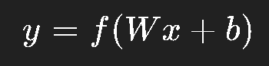\cite{lecun2015 }
Here, the input feature vector (x) is multiplied by the weight matrix (W) using dot product and summed to the bias vector (b). The activation function (f) is then applied to obtain the transformation (y). The role of the activation function is to introduce non-linearity for applying decision boundaries for distinguishing between phishing and legitimate websites. Increasing the number of dense layers can allow the model to learn more complex relationships but that complexity may also cause overfitting, thus highlighting the need for a balanced architecture. In addition, dense layers also enable dimensionality reduction. The hybrid framework also employs batch normalization and dropout after each dense layer similar to the 1D-CNN.

The output layer is the final layer of the framework that produces the classification result. Phishing detection is labelled as a binary classification problem; hence, the output layer will consist of a single unit that transforms the result into an output of either 0 or 1. The sigmoid activation function works well for this classification:
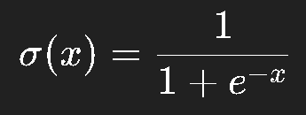 \cite{lecun2015 }
The probability generated by the sigmoid activation function represents how confident the framework is that the given input can be classified as phishing. Values closer to 1 indicate higher likelihood of phishing, while values closer to 0 indicate higher likelihood of legitimate website. To obtain a distinct classification, threshold optimization was utilized where the model learns the ideal threshold (t) during training. The threshold can vary in the range {0.4, 0.6}.
- Output >= 0.5 is classified as Phishing
- Output < 0.5 is classified as Legitimate

5 Evaluation

5.3 Implementation Setup
The system used for carrying out the experiment was an ASUS Vivobook with AMD Ryzen 9 5900HX with Radeon Graphics, along with a 32 GB RAM and NVIDIA RTX 3050. Python3 was the programming language employed due to access to its rich deep learning libraries of which tools from Tensorflow, Keras and Scikit-Learn were utilized for designing, training and evaluating model architecture. Additionally, the tools were also utilized for pre-processing and obtaining evaluation metrics. Supporting libraries such as Pandas, Numpy, matplotlib and seaborn were used for dataset manipulation, calculations and visualizations.

This project utilizes two publicly available state-of-the-art datasets that differ in their feature representation and data quality. Thus, they require specific individual pre-processing strategies to ensure consistency and handle invalid values. For the UCI dataset, the classification labels were converted from the range {-1, 1} to {0, 1}, which allowed for consistent compatibility with binary loss and activation functions such as binary cross entropy and sigmoid function during training. Subsequently, the main feature values also had to be normalized from their original range of {-1, 0, 1} to {0, 0.5, 1} to preserve the relationships of feature values across all inputs. As the UCI dataset utilizes categorical features, such linear scaling was favored over other methods that are preferred for continuous distributions. The Mendeley dataset comprises of missing values that are represented by -1, which are harmful as they can disrupt the training of neural networks due to their introduction of incomplete feature vectors. To address this, a SimpleImputer from Scikit-Learn was utilized to incorporate a median imputation as it will make it robust to extreme outliers while preserving the central distribution of the features. Following this, normalization was carried out using the standardized z-score normalization method which rescales each feature using its mean and standard deviation. This normalization method improves the training performance of a neural network by ensuring equal contribution from all features without any dominance, while also improving convergence stability and speed.
FORMULA: z = (x - nu) / sigma

After pre-processing the datasets, they were split into training and test subsets with an 80:20 splitting ratio. Additionally, stratified 5-Fold Cross Validation was employed for further improvements to robustness and generalization during the final performance evaluation.
As phishing detection is a binary classification problem, binary cross entropy loss function along with sigmoid activation function were utilized to obtain optimal classification probability (CITE). Rectified Linear Unit (ReLU) was utilized as the main activation function for the convolutional and dense layers along with the L2 regularizer as the kernel regularizer for every convolution operation.
Adam optimizer was employed due to its adaptive learning rate capabilities along with a learning rate scheduling strategy to dynamically adjust the learning rate during training (CITE). This allows the model to learn efficiently and tune its parameters dynamically. 30 epochs was the standard for training all models in 3 different batch sizes of 16, 32 and 64. Additionally, an early stopping technique was utilized to prevent the model from overfitting. Accuracy was identified as the primary metric for evaluation.
Due to the vast quantity of hyperparameters that can influence the framework’s performance and structure, it would be inconvenient to test every configuration manually. A python framework called Optuna was employed to identify optimal model configurations in one go. Each of the 3 batch sizes underwent 30 trials, for both datasets bringing the total number of trials to 180, with each trial training a unique configuration for 30 epochs.

5.4 Results Analysis
This section will cover a comprehensive evaluation of the results obtained from the experiments conducted as part of this project. This analysis will include an ablation study followed by a comparison of performance across datasets and against baseline models. Lastly, the section will include a comparison of the hybrid framework with previous research.

5.4.1 Ablation Study
The purpose of this ablation study is to systematically evaluate the contribution of each architectural component of the proposed hybrid framework. By isolating and progressively combining the components, this study aims to understand each component’s influence on the classification accuracy and generalization across datasets.
Four model variants were implemented and evaluated under identical training configurations to analyze their effectiveness:
- 1D-CNN Only: Comprises only of convolutional layers followed by pooling, batch normalization and dense layers.
- BiGRU Only: Relies exclusively on capturing sequential dependencies in both directions.
- 1D-CNN + BiGRU: Hybrid configuration with convolutional outputs being passed onto BiGRU before classification, combining spatial and temporal representations.
- 1D-CNN + BiGRU + Dual Pooling (Proposed Hybrid Model): Complete architecture which adds dual pooling to enhance feature summarization.

Additionally, to evaluate the generalization capability, all model variants were tested on both datasets. Fig X. presents the comparative performance results.

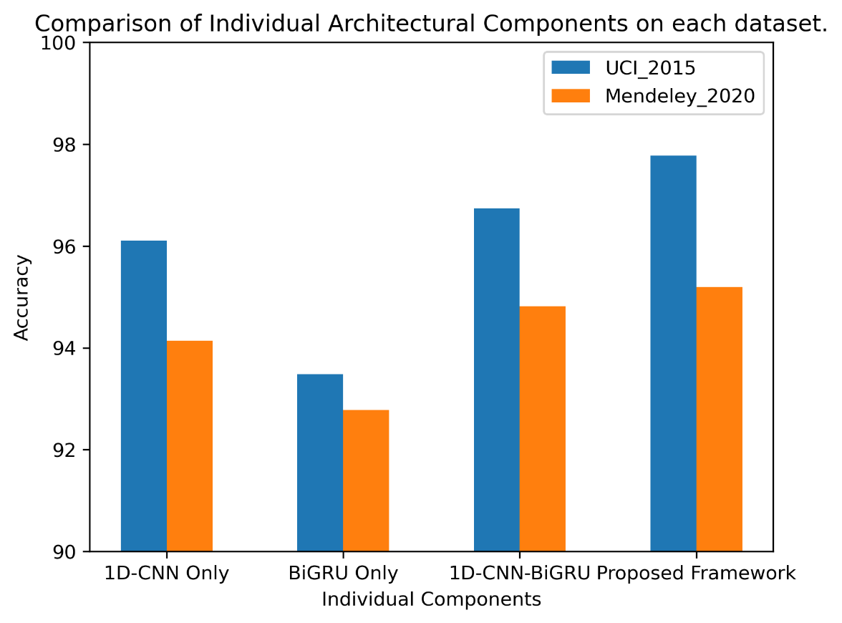
Fig.X. Bar graph of 4 model variants for both datasets

Fig.X. showcases the performance increase on the UCI dataset from 96.11% (1D-CNN Only) to 97.78% with the full hybrid configuration. Similarly, the Mendeley 2020 dataset exhibits progressive improvement, culminating in 95.20% accuracy for the proposed model. Although the Mendeley 2020 dataset achieved a slightly lower accuracy compared to the UCI dataset, the difference of approximately 2.5% suggests moderate dataset sensitivity while maintaining strong generalization capability. The relatively small performance gap indicates that the hybrid framework effectively adapts to variations in feature distribution and data complexity.

 | Model Variant | TP | TN | FP | FN | TOTAL
UCI Dataset | 1D-CNN | 943 | 1182 | 49 | 37 | 2211
 | BiGRU | 922 | 1145 | 86 | 58 | 2211
 | 1D-CNN-BiGRU |  |  |  |  | 2211
 | Proposed Hybrid Framework | 957 | 1205 | 26 | 23 | 2211
Mendeley 2020 Dataset | 1D-CNN | 5782 | 5290 | 310 | 347 | 11729
 | BiGRU | 5677 | 5234 | 366 | 452 | 11729
 | 1D-CNN-BiGRU |  |  |  |  | 11729
 | Proposed Hybrid Framework | 5831 | 5281 | 319 | 298 | 11729

 | Model Variant | Accuracy | Precision | Recall | F1
UCI Dataset | 1D-CNN | 2125/2211 = 96.11% | 943/992 = 95.06% | 943/980 = 96.22% | 2*(0.9146/1.9128) = 95.63%
 | BiGRU | 2067/2211 = 93.48% | 922/1008 = 91.46% | 922/980 = 94.08% | 2*(0.8604/1.8554) = 92.75%
 | 1D-CNN-BiGRU | 96.74% | 96.71% | 95.92% | 2*(/)  = 96.31%
 | Proposed Hybrid Framework | 2162/2211 = 97.78% | 957/983 = 97.36% | 957/980 = 97.65% | 2*(0.9507/1.9501) = 97.50%
Mendeley 2020 Dataset | 1D-CNN | 94.14% | 94.91% | 94.34% | 94.62%
 | BiGRU | 92.78% | 93.94% | 92.63% | 93.27%
 | 1D-CNN-BiGRU | 94.82% | 95.65% | 94.39% | 95.02%
 | Proposed Hybrid Framework | 95.20% | 95.91% | 94.86% | 95.38%

Furthermore, to evaluate the architectural performance, the model variants were assessed using the empirical metrics across both datasets. The results in Table.X. demonstrate a consistent and progressive improvement in classification accuracy as architectural components are incrementally integrated across both datasets.
On the UCI dataset, the 1D-CNN baseline achieves strong performance with 96.11% accuracy. However, the BiGRU only configuration performs noticeably lower across all metrics, indicating that sequential modeling alone is insufficient without spatial feature extraction. The combination of 1D-CNN and BiGRU significantly enhances performance, improving accuracy, precision and recall beyond the standalone models. This confirms that convolutional spatial feature extraction and bidirectional temporal dependency modeling provide complementary representational strengths. The proposed hybrid framework achieves the highest performance across all metrics, reaching 97.78% accuracy and 97.50% F1-score on the UCI dataset. The simultaneous increase in precision (97.36%) and recall (97.65%) demonstrates improved balance between false positive reduction and phishing detection sensitivity.
A similar trend is observed on the Mendeley 2020 dataset. Although the peak accuracy (95.20%) is approximately 2.5% lower than that of the UCI dataset, the performance progression remains consistent. The hybrid model again achieves the highest accuracy, precision, recall, and F1-score, confirming that architectural improvements generalize effectively across datasets with different distributions and complexity levels.

The confusion matrix provides detailed insight into how the model distinguishes between phishing and legitimate websites for the UCI dataset. The results in Fig.X. indicate that the model correctly identifies the vast majority of both phishing and legitimate instances. The relatively small number of false positives suggests that legitimate websites are rarely misclassified as phishing, which is important for maintaining user trust and minimizing unnecessary alerts. Similarly, the low number of false negatives demonstrates that the system is highly effective at detecting phishing instances, reducing the likelihood of malicious websites by-passing the detection system.
A similar trend is observed for the Mendeley 2020 dataset which despite having a slightly more complex feature distribution, the hybrid framework managed to maintain a strong predictive capability. The relatively small difference in performance compared to the UCI dataset suggests the proposed hybrid framework generalizes well across datasets with varying characteristics.

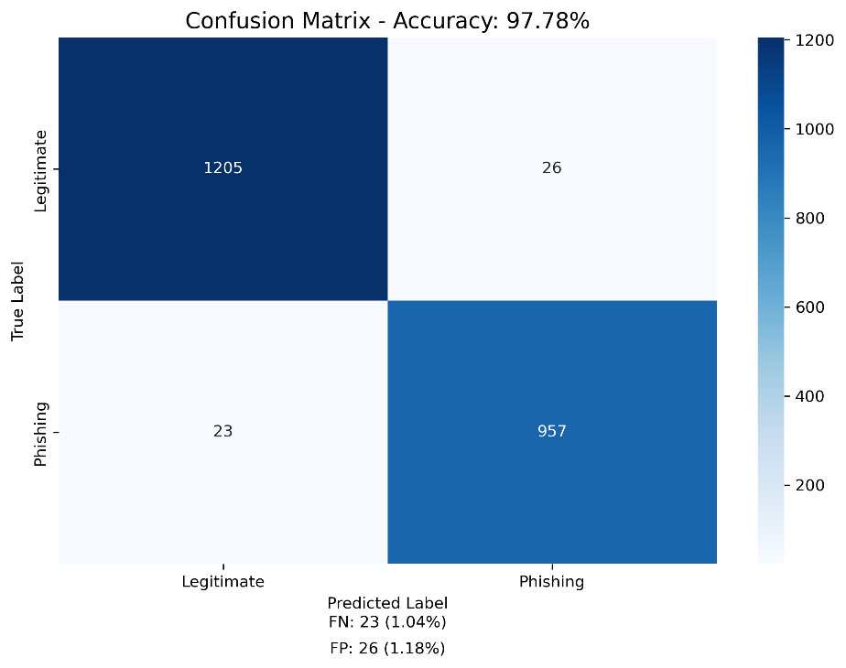
Fig.X. Confusion Matrix for UCI dataset.

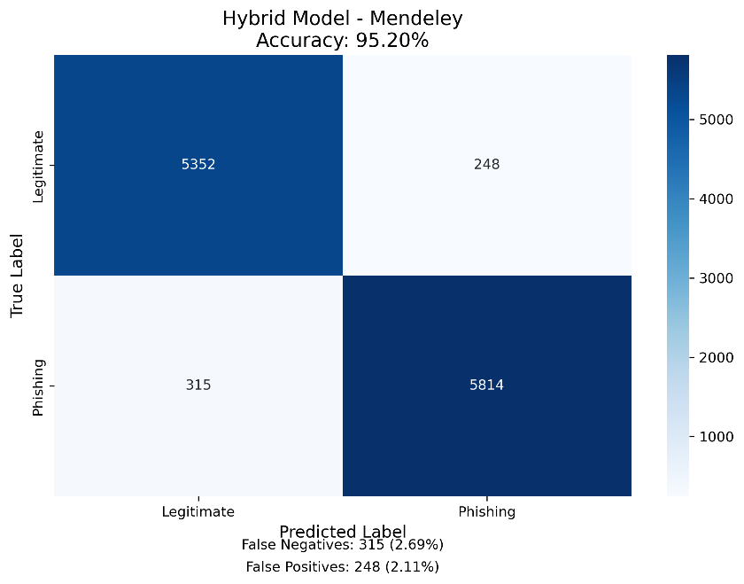
Fig.X. Confusion Matrix for UCI dataset.

Receiver Operating Characteristic (ROC) is a curve that plots the True Positive Rate (TPR) against the False Positive Rate (FPR) at different classification thresholds to further highlight the hybrid framework’s classification capability. As shown in Fig. X, the ROC curve closely approaches the top-left corner of the graph, indicating excellent discriminative ability between the two phishing and legitimate website classes. The resulting Area Under the Curve (AUC) value of 0.997 demonstrates the model’s ability to maintain a very high true positive rate while keeping the false positive rate minimal across different thresholds. This confirms the robustness of the hybrid framework in distinguishing phishing websites from legitimate websites.
The ROC characteristics of the model on the Mendeley 2020 dataset demonstrate a similar pattern, although the AUC value is slightly lower compared to the UCI dataset, it still reflects strong discriminative capability. This indicates that the hybrid framework consistently maintains high true positive rates while limiting false positives across different dataset distributions.

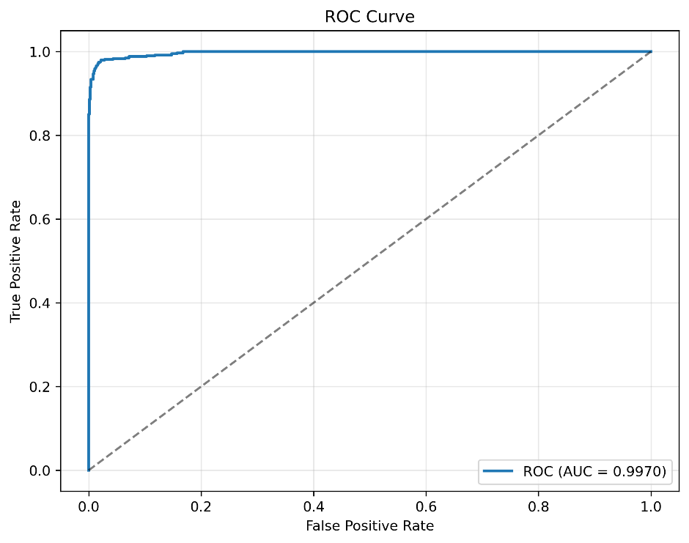
Fig.X. ROC Curve on UCI dataset.

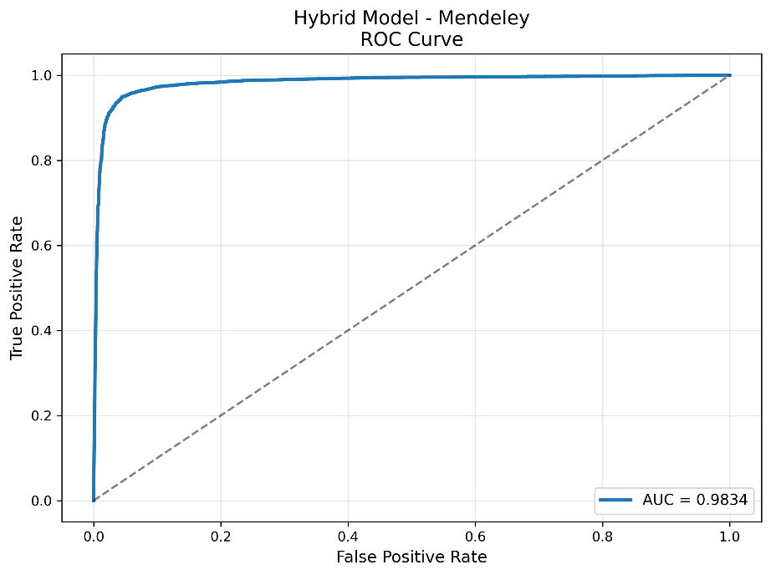
Fig.X. ROC Curve on Mendeley 2020 Dataset.

Additionally, the Precision-Recall (PR) curve was analyzed to assess the model’s performance in terms of precision and recall trade-offs. As illustrated in Fig. X, the proposed model achieved a Precision-Recall AUC value of 0.9966, indicating an excellent balance between precision and recall across varying thresholds. The curve maintains precision values close to 1.0 over a wide range of recall levels, demonstrating that the model can identify phishing websites with very high confidence while maintaining minimal false detections. The slight decline in precision at extremely high recall values reflects the expected trade-off when attempting to capture nearly all phishing instances. When evaluated on the Mendeley 2020 dataset, the Precision-Recall curve exhibits comparable behavior, maintaining high precision values across a wide recall range. This suggests that the model is capable of reliably detecting phishing instances even when trained and evaluated on datasets with differing feature distributions and sizes.

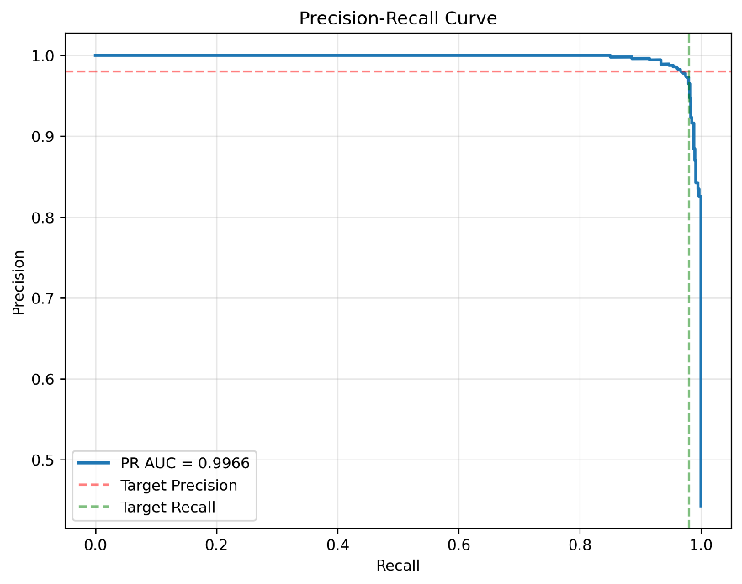
Fig. X. Precision-Recall Curve on UCI Dataset

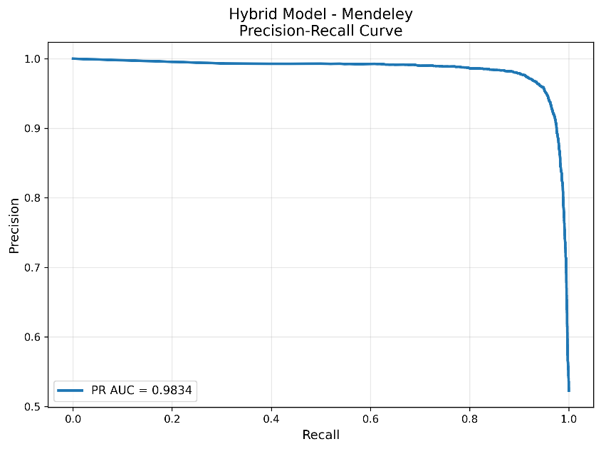
Fig. X. Precision-Recall Curve on Mendeley 2020 Dataset

Furthermore, to evaluate the training behavior and generalization capability of the proposed model, the evolution of training and validation loss and accuracy was monitored across epochs, as shown in Fig. X. The training loss exhibits a consistent decline throughout the training process, indicating that the model successfully learns discriminative feature representations. The validation loss also decreases rapidly during the early training stages before stabilizing, suggesting effective convergence of the model. The validation accuracy quickly approaches the target performance threshold and stabilizes close to the final accuracy value, demonstrating strong generalization capability. Most important is the relatively small gap between training and validation curves, indicating minimal overfitting.
Training behavior on the Mendeley 2020 dataset follows a similar convergence pattern, with both training and validation metrics stabilizing after several epochs. While the final validation accuracy is slightly lower compared to the UCI dataset, the learning curves indicate stable convergence and minimal overfitting.

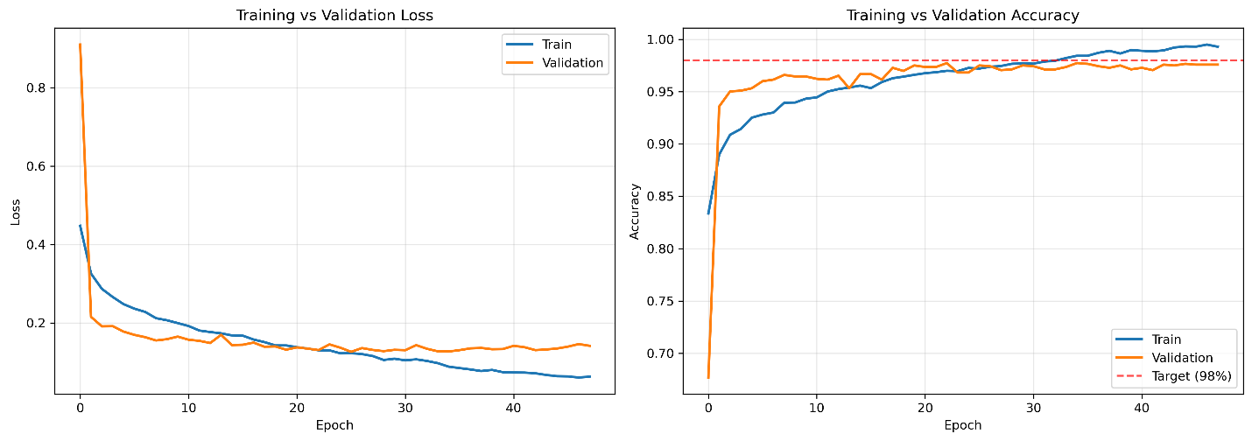
Fig. X. Training vs Validation Loss & Accuracy on UCI Dataset

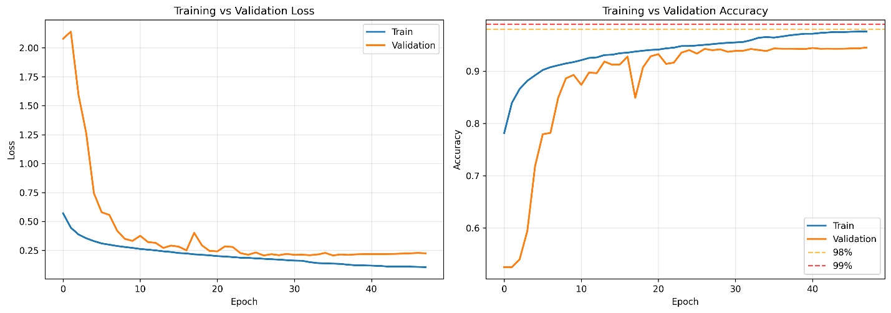
Fig. X. Training vs Validation Loss & Accuracy on Mendeley 2020 Dataset THIS GRAPH IS WRONG, RETRAIN

To further evaluate the effectiveness of the proposed hybrid framework, several traditional Machine Learning models were implemented as baseline classifiers to provide a benchmark for comparison. The selected baseline models include Decision Trees, Naive Bayes, Support Vector Machine, Random Forest and Logistic Regression. These algorithms were chosen because they represent commonly applied classification techniques in phishing detection research and provide a meaningful benchmark for evaluating deep learning approaches (CITE??). All traditional models were trained and evaluated using the same dataset splits and feature representations used for the deep learning experiments to ensure a fair comparison. The performance of these models was assessed using the same four empirical metrics.

Dataset | Model | Accuracy | Precision | Recall | F1
UCI_2015 | Decision Tree | 93.03% | 93.65% | 90.40% | 92.00%
 | Naive Bayes | 61.19% | 53.32% | 99.89% | 69.53%
 | SVM | 92.53% | 93.39% | 89.48% | 91.40%
 | Random Forest | 94.21% | 95.31% | 91.42% | 93.33%
 | Logistic Regression | 92.76% | 93.43% | 90.00% | 91.68%
 | Proposed Framework | 97.78% | 97.36% | 97.65% | 97.50%
Mendeley_2020 | Decision Tree | 92.82% | 92.06% | 94.42% | 93.22%
 | Naive Bayes | 58.27% | 97.02% | 20.78% | 34.23%
 | SVM | 89.84% | 90.42% | 90.11% | 90.26%
 | Random Forest | 91.85% | 91.59% | 92.95% | 92.26%
 | Logistic Regression | 89.44% | 90.42% | 89.24% | 89.83%
 | Proposed Framework | 95.20% | 95.91% | 94.86% | 95.38%
Table.X. Comparison of performance of proposed framework against traditional ML models

The results from Table.X. indicate that traditional ensemble-based approaches such as Random Forest achieved the strongest performance among the traditional models, obtaining an accuracy of 94.21% and an F1-score of 93.33%. Decision Tree and Support Vector Machine models also demonstrated strong classification capability, achieving accuracies of 93.03% and 92.53%, respectively. Logistic Regression showed comparable performance with an accuracy of 92.76%. In contrast, the Naive Bayes classifier exhibited significantly lower overall accuracy (61.19%) despite achieving an extremely high recall of 99.89%. This behavior suggests that the model classified nearly all instances as phishing, resulting in a large number of false positives and consequently poor precision. Such imbalance highlights the limitations of probabilistic independence assumptions when applied to complex phishing datasets.
Although Random Forest achieved the strongest results among the traditional classifiers, its performance remains lower than that of the proposed hybrid framework, which achieved an accuracy of 97.78% and superior overall classification metrics. This improvement demonstrates the ability of the hybrid architecture to capture both spatial feature patterns and sequential dependencies within the data more effectively than traditional learning algorithms.

A similar trend was observed for the Mendeley 2020 dataset as evident in Table.X. Decision Tree achieved the highest accuracy among the traditional models (92.82%), closely followed by Random Forest (91.85%) and Support Vector Machine (89.84%). Logistic Regression produced comparable performance with an accuracy of 89.44%. Naive Bayes once again displayed unstable behavior, achieving a high precision (97.02%) but extremely low recall (20.78%), indicating that the model failed to correctly identify a large portion of phishing instances. This imbalance resulted in a low F1-score (34.23%), further confirming its unsuitability for this classification task.
Compared to these baseline models, the proposed hybrid framework achieved a much higher classification accuracy of 95.20% on the Mendeley 2020 dataset while maintaining strong precision and recall values. This demonstrates that the hybrid deep learning architecture generalizes effectively across different datasets and consistently outperforms conventional machine learning approaches.

5.4.2 Comparison with Previous Works
This section shall provide a comparison of the proposed framework’s performance with the existing phishing detection models reported in the previous studies in order to further evaluate the hybrid framework’s effectiveness.
Model | Dataset | Accuracy
J48 Decision Tree | PhishTank | 93%
Proposed Framework | Mendeley_2020 | 95.20%
MLSELM | Mendeley_2020 | 96.79%
GA-based Gradient Boost | UCI_2015 | 97.13%
GA-based XGBoost | Mendeley_2020 | 97.35%
MLSELM | UCI_2015 | 97.76%
Proposed Framework | UCI_2015 | 97.78%
Random Forest | Mendeley_2018 | 99.06%
RNN-GRU | Kaggle Dataset, PhishTank | 99.18%
CNN | ISCX-URL2016 | 99.20%

From the results in Table.X. it can be summarized that when evaluated on the UCI_2015 dataset, the proposed hybrid framework achieved an accuracy of 97.78%, slightly surpassing the performance of the MLSELM approach (97.76%) and the GA-based Gradient Boost model (97.13%). This improvement suggests that the combination of convolutional feature extraction and temporal dependency modelling enables the framework to effectively capture complex relationships. The strong performance on the UCI dataset indicates that the hybrid architecture is capable of learning meaningful structural patterns within URL-based feature representations while maintaining competitive performance relative to other methods. However, when evaluated on the Mendeley_2020 dataset, the proposed model achieved a comparatively lower accuracy of 95.20%, which is weaker than several previously reported approaches such as MLSELM (96.79%) and GA-based XGBoost (97.35%). This difference suggests that the model exhibits some sensitivity to variations in dataset characteristics, such as feature distribution, dataset size, and the level of noise present within the data. The obtained performance still remains competitive and demonstrates stable results across two different datasets.
It is also important to note that some studies reporting higher accuracies, such as Random Forest (99.06%), RNN-GRU (99.18%), and CNN (99.20%), were evaluated on entirely different datasets. Differences in dataset composition and feature extraction methods can significantly influence classification outcomes. Overall, while the proposed framework achieves its strongest results on the UCI dataset, it still demonstrates reliable performance and reasonable generalization capability when applied to other phishing detection datasets.

6 Conclusions
This concluding section shall provide a final overview of this project’s contribution while also discussing its primary limitations and probable means for improvement in future work.

6.1 Summary
This dissertation proposes a hybrid deep learning framework to address an existing research gap in phishing websites detection. The proposed hybrid framework employs and integrates a 1-Dimensional Convolutional Neural Network (1D-CNN) with a Bidirectional Gated Recurrent Unit (BiGRU), capable of effectively identifying malicious URLs using deep learning techniques.
The research began with an extensive literature review (refer to Section 2), examining existing detection methodologies and datasets and highlighting their efficiency in detecting phishing websites, which highlighted the scarcity of models combining temporal dependencies with lexical features extraction. As such, an architecture for a hybrid deep learning framework (refer to Section 3) was conceived to address this research gap. This architecture sees the employment of a 1D-CNN to extract the local lexical features from the URLs of phishing websites, while the employment of a BiGRU component captures the temporal dependencies of these lexical URL tokens for better understanding the sequential relations between them. Together, these models form the end-to-end hybrid framework capable of detecting and identifying phishing websites.
The proposed model was evaluated using two state-of-the-art phishing datasets with experimental evaluation demonstrating strong performance across both datasets, achieving an accuracy of 97.78% on the UCI dataset and 95.20% on the Mendeley 2020 dataset. The results of the ablation study further confirmed the contribution of each architectural component, showcasing improved classification performance though progressive integration. Additionally, comparisons with traditional machine learning models and previously proposed approaches indicated that the hybrid framework achieves competitive performance while maintaining stable results across multiple datasets. These findings suggest that combining convolutional and recurrent architectures can effectively improve performance for phishing detection.

6.2 Main Limitations
Despite the promising results demonstrated by the proposed hybrid framework in this study, several limitations need to be acknowledged. Firstly, the datasets used in this research, although state-of-the-art, may not fully capture the diversity and continuously evolving nature of real-world phishing attacks. Phishing techniques frequently change as attackers develop new strategies, and static datasets may not always generalize well to unseen phishing patterns.
Second, the performance of the proposed hybrid framework varied across datasets, with the model achieving higher accuracy on the UCI dataset compared to the Mendeley 2020 dataset. This variation suggests that the model may exhibit some sensitivity to differences in dataset characteristics, needing further improvement to ensure consistent performance.
Lastly, the utilization of 1D-CNN and BiGRU deep learning frameworks enforce high computational complexity and costs, despite the relatively high accuracy. This will provide a challenge when attempting to deploy the model in real-time detection systems. Simpler traditional ML models fare better in this regard.

6.3 Future Work
Based on the limitations identified and the results obtained in this study, several directions for future research can be explored. One important area for improvement is the use of larger and more diverse phishing datasets that include URLs collected from multiple sources and real-world environments. Expanding the dataset diversity would allow the model to learn more generalized patterns and improve its robustness against evolving phishing techniques.
Another potential direction involves exploring alternative deep learning architectures to further enhance phishing detection performance such as transformer-based architectures or attention mechanisms could be incorporated to capture more complex feature relationships within URL structures. Furthermore, future research could investigate methods for reducing computational complexity while maintaining high performance.
Lastly, future studies may also explore the integration of additional feature types, such as webpage content, domain information, or behavioral features (emails), to complement URL-based detection for further enhancing performance and robustness.

