

**DATA VISUALIZATION**

**TASK NAME: Assignment 3**

**GROUP ID：7**

**GROUP MEMBERS:**

**2022202716 赖岚清**

**2022280093 APEDO KOMI ETSE YVON**

**2022280083 DATAGO ABDIREZAK MUNDINO**

**CONTENTS**

1. Task analysis 3

1.1 Given data 3

1.2 focus of the visualization 3

2. Design Philosophy 5

2.1. Wind flow map 5

2.2. Choropleth 6

2.3. Glyphs 6

2.4. Bar charts & donut charts 7

2.5. Colors 8

2.6. Animations 9

2.7. Tooltips 9

3. Supplementary Note 10

3.1. vector field 10

3.2. Function description 11

4. Findings and Conclusion 11

References 12

**1. Task analysis**

Qinling Mountains, regarded as the dragon vein of Chinese civilization, the main peak Taibai Mountain is 3771.2 meters above sea level, located in Baoji City, Shaanxi Province. From the map of China, it is located in the heart of China and is extremely rich in natural resources. It is the most important dividing line between the north and south of China, and it is also an important "reservoir" for the two largest mother rivers in China, the Yellow River and the Yangtze River. By analyzing the geographic data of some sampling points in the Qinling Mountains, it can help to understand the climate change of the Qinling Mountains at different times, analyze the reasons for the formation of the Qinling Mountains' unique status in China, and better protect the Qinling Mountains.

**1.1 Given data**

Open any json file in the dataset s, such as s_0.json, you can find that the corresponding data is at 00:00:00 on July 22, 2021. Using the deductive method, it can be inferred that each json file contains only one time point climate data. however, the naming method of json files such as s_0.json, s_2.json, … , s_132.json is not conducive to us directly determining which data time point is from the file name.

In order to make the data set arrangement more Reasonable, it also provides convenience for subsequent json file calls. This work is based on python traversing all json files and renaming them in sequence, for example, s_0.json is renamed to 2021072200.json.

**Below are the given data for this task:**

Temperature and relative humidity of the air are given in ° C and % respectively. Soil temperature and soil moisture values in 5cm, 10cm, 40cm, and 200cm depth are given for each region throughout the time.

Wind speed and wind direction is also given for both below and above100 meters from the ground in m/s and degree respectively. Additionally, the meridional wind speed and latitudinal wind speed is given for both below and above 100 meters from the ground.

Furthermore, cloud cover in percentage, visibility in km, ground air pressure in hPa and both total solar irradiance and UV irradiance in kWh/m ^ 2 are given for each region throughout the time.

All these data are given for the date 2021/07/22 – 2021/07/27. And for every day there are 24 data, one data for each hour. This can help us to understand the weather change during day and night time.

**1.2 focus of the visualization**

For these data we group related data in to three sections:

**Section 1**

In this section we are interested to explore the characteristics of the air, visibility, surface temperature, cloud cover and radiation. We want to know the areas with high and low temperature, relative humidity and radiation. So, we compare these values between the regions. For the cloud cover and surface temperature we just want to know the value for each region.

**Section 2**

This section describes the characteristics of the wind. For the wind we are interested in the wind speed and direction. So, we want to compare the wind speed and wind direction of each region on specific time. This may help us to understand the wind flow of each region throughout the time series.

**Section 3**

This section visualizes the characteristics of the soil. In this case we are interested in the average soil temperature and average moisture of the soil through the depth. We also want to compare soil temperature and moisture between each depth.

Finally, it is worth noticing that the given data is collected in July which is during summer. Since we do not expect a snow on summer, we are not interested to visualize the snow depth data.

|  |  |  |
| --- | --- | --- |
| Section 1: | Section 2: | Section 3: |
| * tem: temperature (degrees Celsius) * skt: surface temperature (ºC degrees Celsius or f degrees Fahrenheit) * prs: ground pressure (hPa) * rhu: relative humidity (%) * pre: precipitation (mm) * clo: cloud cover (%) * vis: visibility (km) * ssrd: total solar irradiance (kWh/ m2) * uvb: ultraviolet UV irradiance (kWh/ m2) | * wns: wind speed (m ≤ s) * wnd: wind direction (degree) * wns_100m: 100m wind speed (m ≤ s) * wnd_100m: 100m wind direction (degree) * gust: 10m gust wind speed (m ≤ s) * u: meridional wind * v: zonal wind * U 100: 100m meridional wind speed * zonal wind speed of 100: 100m | * st_5: 5cm soil temperature (c degrees Celsius or f degrees Fahrenheit) * st_10: 10cm soil temperature (c degrees Celsius or f degrees Fahrenheit) * st_40: 40cm soil temperature (c degrees Celsius or f degrees Fahrenheit) * st4_200: 200cm soil temperature (c degrees Celsius or f degrees Fahrenheit) * sw_5: 5cm soil moisture (%) * sw_10: 10cm soil moisture (%) * sw_40: 40cm soil moisture (%) * sw_200: 200cm soil moisture (%) * sdp: deep snow (m) |

**Table 1. Section 1-3 description**

**2. Design Philosophy**

The Qinling mountains data that we were provided is a spatial dataset, specifically geometry. The majority of our visualization will take place on a map, in this case, the Qinling Mountains map.

**Dataset Type: Spatial** 🡪 **Geometry 🡪 Map**

We conducted research to determine which visualization techniques are most suited to climatology, meteorology, and geography spatial visualization. We have discovered at the end that the most commonly utilized approaches are glyph, isopleth, choropleth, and cartogram. We primarily used choropleth and glyphs to complete this task. Furthermore, we used a wind flow map to visualize the wind’s features. In addition, we used other visualization techniques such as bar chart, donut chart.

In addition, some web tools are used to make our website easy to navigate. There is a navigation bar at the top that redirect to the different pages of our website. We added a menu area where the user can select the date, time and the feature he/she wants to display. Dropdown list is the easier option we found. There is a slider at the bottom of the page which allows the user to go through the data per hour smoothly.

**2.1. Wind flow map**

In the implementation of the wind visualization, we have introduced a new technique called wind flow field. It allowed us to visualize multiple features at the same time. On our map, we visualize the direction(curve) and the speed of the wind(color).

The wind flow map is one of the highlights of our project. With the combination of colors, vectors and some animations, we were able to achieve more pleasing visualization. It’s a more efficient way to depict the wind and its movement. The lines flow like wind on the map.

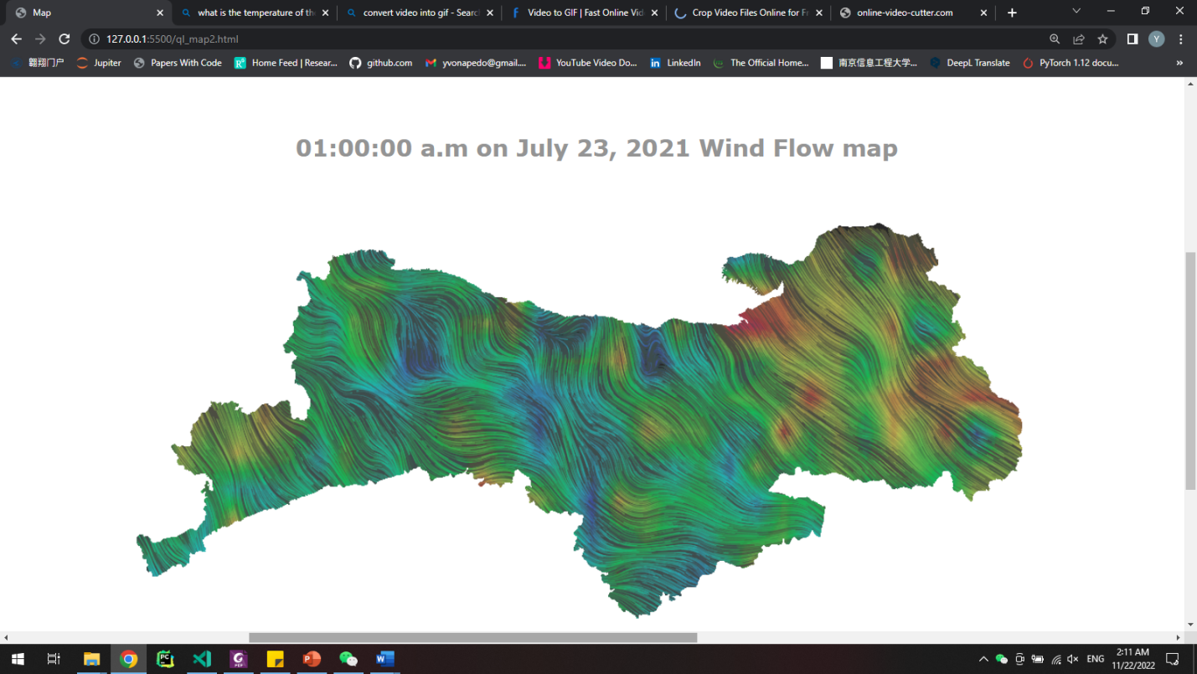

**Figure 1. Wind flow map**

**2.2. Choropleth**

Given a map to visualize, choropleth is the most widely used technique. We color the different regions based on a quantitative feature. This technique helps in depicting the variation between region according to a specific feature.

For instance, in figure 2, we can see that different regions are colors based on the visibility in km of that region. So, a dark shade of grey means the visibility is clearer i.e. short distance and a light shade of grey means the visibility is lower i.e. long distance. The grey color is used to show an effect of fog above the region.

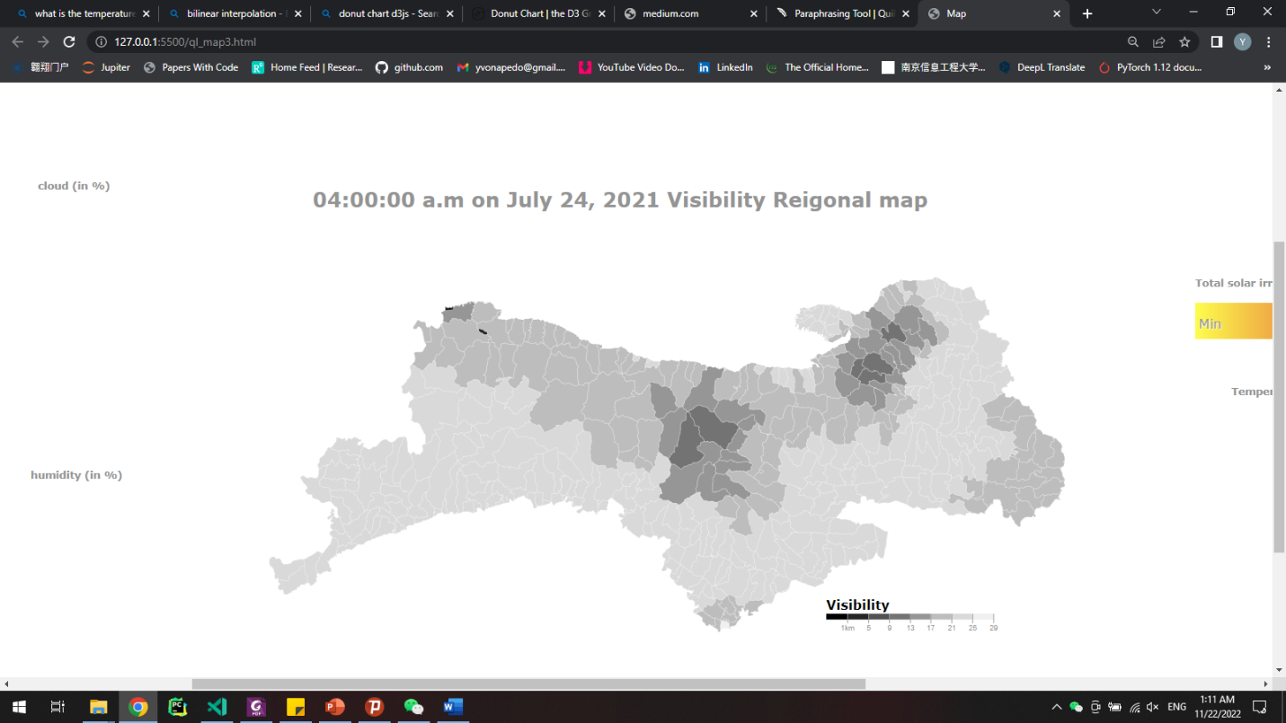

**Figure 2. Visibility Regional map**

**2.3. Glyphs**

Using glyphs is another technique used in visualizing data on map. In our case, we use only two glyphs; arrows and circles. The arrows represent the direction of the wind (figure 3), and the circle represent the solar irradiance (figure 4).

As shown on figure 3, we believe that using arrows to represent the direction of the wind which are angle makes more sense than coloring the regions themselves. The arrows visually fit this representation better.

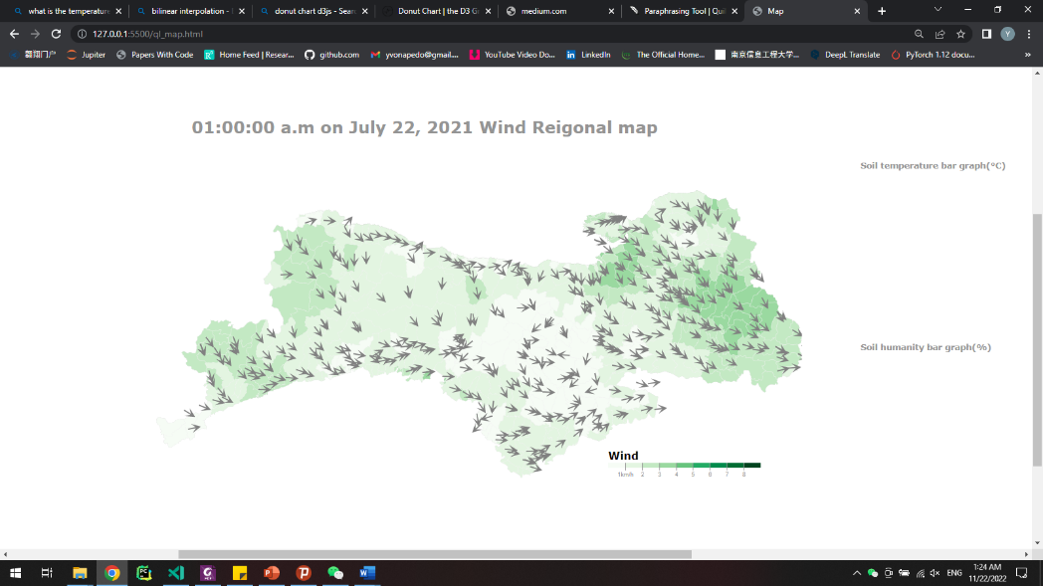 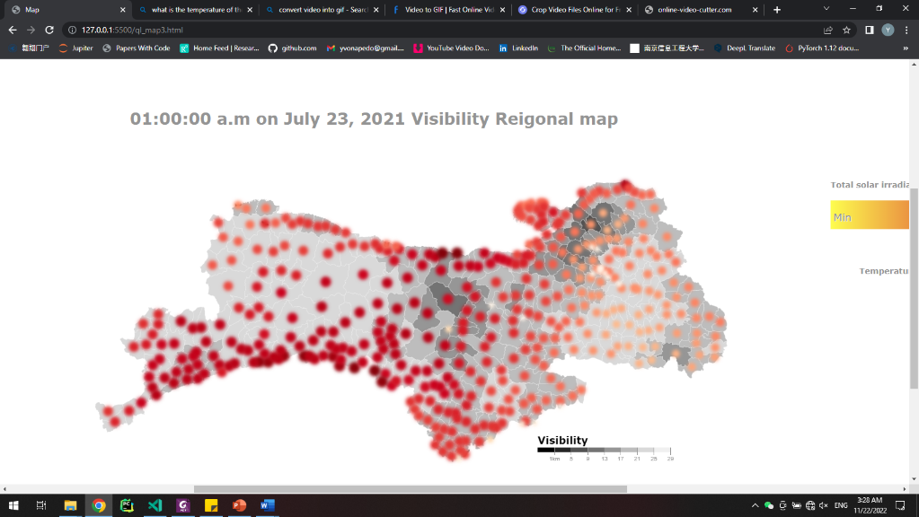

**Figure 3. Wind Regional map Figure 4. Visibility regional map**

**2.4. Bar charts & donut charts**

Out of the data we deduced several table datasets for more detailed visualization. We added some aligned and separated bar charts to display related features, such as soil moisture in 5 cm, 10 cm, 40 cm, and 200 cm. The main purpose for using these bar charts is to show the difference between features. For instance, on figure 5, soil humidity bar chart shows the percentage of moisture are at different soil depth.

Example: **Soil humidity bar chart**

– 1 key: soil depth (5 cm,10 cm,40cm,200cm: quantitative attribute)

– 1 value: soil moisture in % (quantitative attribute)

– Channels:

• length to express % of moisture

• spatial regions: one per soil depth

– separated horizontally, aligned vertically

– ordered by soil depth

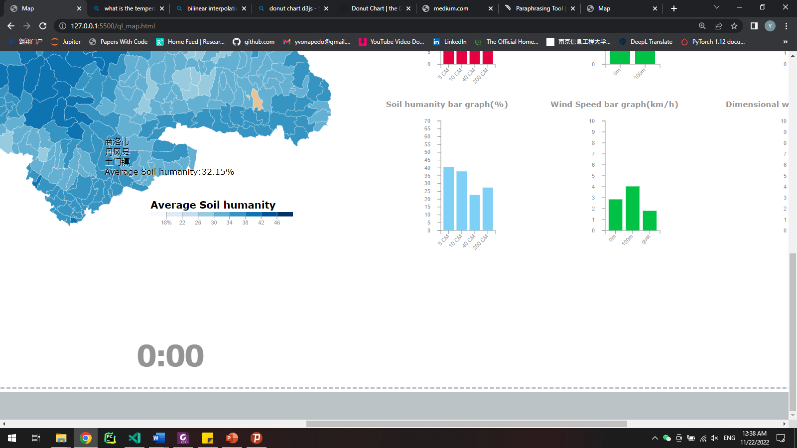

**Figure 5. Soil humidity bar graph**

Moreover, we wanted to investigate some of the radial oriented charts, so we used the donut chart to represent the feature in percentages, such as cloud coverage. The donut charts serve as a quick look-up graph.

Example: **Cloud coverage chart**

1 key: cloud (categorical attribute)

1 value: coverage percentage (quantitative attribute)

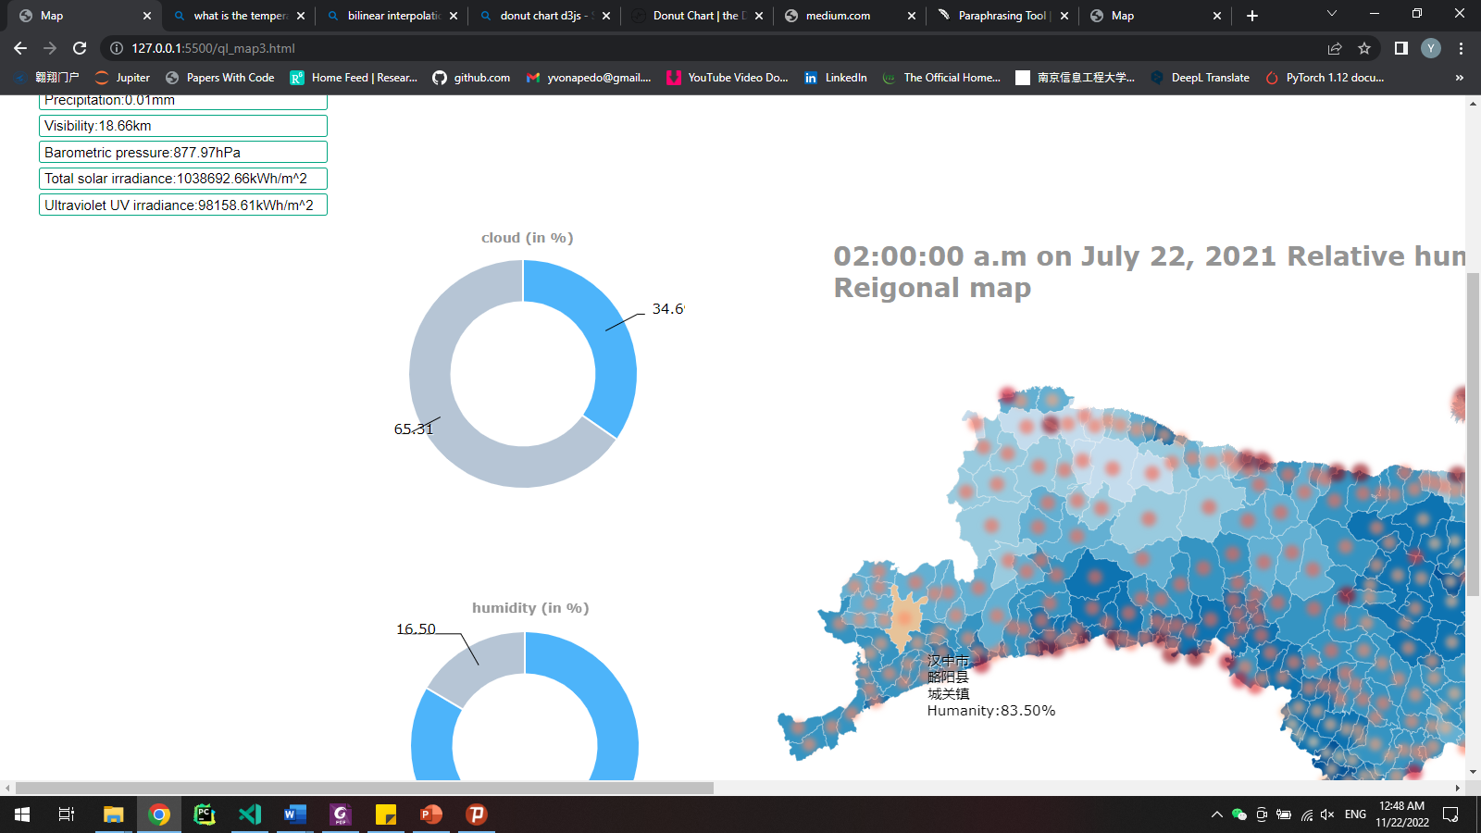

**Figure 6. Cloud coverage graph**

**2.5. Colors**

Color selection is an important aspect of visualization. Different colors have different meaning. According to our research, we have found that geographical features are frequently represented with a specific color. For example, the red color corresponds to the temperature and blue to humidity and moisture. Using color as a visual encoding, the greater the value, the darker the hue.

The table below shows the domain and color used in the visualization of different features.

|  |  |  |
| --- | --- | --- |
| **Features** | **Domain** | **Color scale** |
| wind speed(flow) | range(1, 3, 5,7,10, 15) | [“#39706A”, “#7A7146”, “#72418D”, “#4D9350”, “#953F75”, “#9F3F4B”] |
| wind speed_100m(flow) | range(1, 3, 5,7,10, 15) | [“#39706A”, “#7A7146”, “#72418D”, “#4D9350”, “#953F75”, “#9F3F4B”] |
| Temperature | d3.range(11, 35, 3) | d3.schemeReds[9] |
| Relative humidity | d3.range(68, 100, 4) | d3.schemeBlues[9] |
| Barometric pressure | d3.range(800, 1200, 50) | schemeGreens[9] |
| Visibility | d3.range(1, 33, 4) | ["#000000","#252525","#525252","#737373","#969696", "#bdbdbd", "#d9d9d9", "#f0f0f0", "#ffffff"] |
| Precipitation | d3.range(2, 10) | d3.schemeBlues[9] |
| Solar irradiance | Min - Max | d3.interpolateOrRd |
| Soil humanity | d3.range(18, 50, 4) | d3.schemeBlues[9] |
| Soil temperature | d3.range(11, 35, 3) | d3.schemeReds[9] |
| Wind speed | d3.range(1,9) | d3.schemeGreens[9] |
| Wind speed_100m | d3.range(1,9) | d3.schemeGreens[9] |
| Cloud cover | N/A | Blue/grey |
| Humidity | N/A | Blue/grey |

**Table 2. Color scale table**

**2.6. Animations**

Several animations were implemented in this project to elevate the quality of our visualization. Figure 4 also displays an animation where the circles are blinking.

In addition, the flow animation can be felt on the wind flow map. On figure 1, the lines on the map move from top to bottom following the path realized based in the direction of the wind.

**2.7. Tooltips**

Another element we explore is d3 tooltip. We display the actual value of the feature at a specific region. When hovering on a region, you can see the city, county and district of the region. The value of the visualized feature is also written below. Through this, we believe the user can see more details thus getting more information.

**3. Supplementary Note**

**3.1. vector field**

A brief description of the vector field data of the wind flow map in Section 2. First, at each time node, such as 0:00 on July 22, 2021, the data set provides 418 sets of data including wind speed and direction in latitude and longitude. We read the data according to latitude and longitude. Take the rules and sort them into an array in turn. Then, we mesh the Qinling area, the area where the latitude range is，and the longitude range is。

For values that are not on the grid, we use bilinear interpolation, as shown in Figure 3.1.

First, linear interpolation is performed in the x direction to obtain:





Then perform linear interpolation in the y direction, obtain an approximate value corresponding to the grid point.



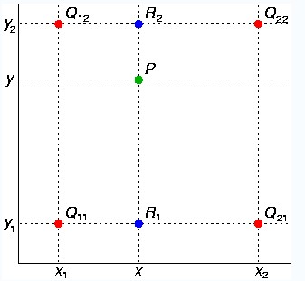

**Figure 7. bilinear interpolation**

**3.2. Function description**

In order to facilitate the subsequent maintenance and understanding of the code, we briefly describe the functions involved in Section1-Section3, as shown in the following table

|  |  |
| --- | --- |
| **Name** | **Description** |
| click() | Update the region map according to the time node |
| Show_ecological_color() | Change the display color of each area of region map |
| Show_map_color() | Display the corresponding legend between values and colors |
| Show_ecological_data() | Output relevant climate information according to the selected area |
| DrawBar() | Draw bar graph |
| RangeValue() | Listen to the information of the time slider |
| Init() | Wind flow map initialization |
| Update_canvas() | Update wind flow map |
| showMask() | Control the background color of the wind flow map |
| MotionDisplay() | Generate Particle Trajectories |
| Animator() | Listen to mouse events and control the zoom and pan of the map |
| VectorField() | Generate a vector field containing grid coordinates from a set of data |
| PieChart() | Draw donut charts |
| Show_ssrd() | Draw circle glyphs |

**Table 3. Function description table**

**4. Findings and Conclusion**

The average temperature in the southern part of the Qinling Mountains is higher than that in the northern part, and the average temperature in the surrounding areas of the Qinling Mountains is higher than that in the central part. The average temperature in some areas is below 15°C.

The relative humidity in the eastern part of the Qinling Mountains is higher than that in the western region, and the average relative humidity in the central region is higher than that in the surrounding regions. Considering the vegetation resources and water flow resources may be more abundant in the central region. The trend of relative humidity changing with temperature is more obvious. On the whole, the relative humidity at night is higher than that during the day.

Since the total solar irradiance and UV irradiance of an area is directly proportional it is described as a single value called radiation.

Finally, from 00:00:00 on July 22, 2021 to 12:00:00 on July 27, 2021, the overall wind direction in the Qinling area is northeaster, and it can be found that the wind speed in the surrounding area of Qinling is higher than that in the central area. The wind speed in some central area is basically lower than 1km/h.

We have visualized all the information using the famous JavaScript visualization library D3,js. We have applied the concepts we learned during the class.

**References**

1. [Choropleth - bl.ocks.org](https://bl.ocks.org/mbostock/4060606)
2. [rewat1984/weather-twins-d3.js: A html/javascript application that uses d3.js to draw the wolrd map and reads a CSV file to plot cities on it, then jquery to read a JSON file for selecting cities that match the values inserted in the form. (github.com)](https://github.com/rewat1984/weather-twins-d3.js)
3. <https://d3-graph-gallery.com/index.html>
4. <http://hint.fm/wind/>