**Part A**

**I**

**A**

**B**

**C**

**D**

**E**

**F**

**G**

**Objective** : Name and decribe each component

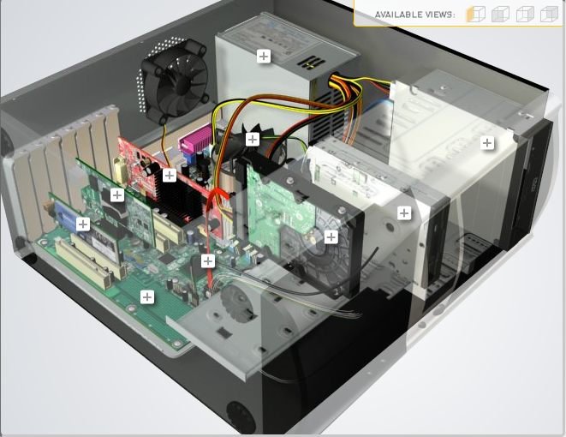

**H**

|  |  |  |
| --- | --- | --- |
| Download [**http://tinyurl.com/CW208-CAG-SIM**](http://tinyurl.com/CW208-CAG-SIM) PC Build Simulator.  Go through steps of building a PC, as you complete the simulation find and describe in detail components A to I. To run simulator first install <http://www.swffileplayer.com/> and open ***RootMovie.swf*** using SWF player. Alternatively install [Macromedia Flashplayer](https://fpdownload.macromedia.com/pub/flashplayer/updaters/32/flashplayer_32_sa.exe) . Ideally use a simulator as listed in class. | | |
| Label | Name each component | Description |
| A | RAM | Main memory, allows information to be stored and retrieved |
| B | GPU | Processor designed to handle graphic operations |
| C | CPU | Fetches programs instructions from memory and executes those instructions |
| D | Power supply unit | Converts mains AC to low voltage regulated DC power internal components of a computer |
| E | DVD Drive |  |
| F | CD-Rom Drive |  |
| G | Hard Drive | Non-volatile computer storage containing magnetic disks or platters rotating at high speeds |
| H | Sata | Computer bus interface that connects host bus adapters to mass storage devices such as hard disk drives, optical drives, and solid-state drives |
| I | Motherboard | Contains areas for computer memory, CPU, AGP, PCI and more. Ties everything in computer together |

**Part B**

**Objective**

Compare a pre-assembled system and the components that could be assembled to build a comparable system. After completing this practical, you should be able to:

1. Identify the components of a pre-assembled system
2. Locate prices for components needed to assemble a comparable system
3. Compare the cost of a pre-assembled system and a self-assembled system.

If you can’t find exact match for components, find the closest possible substitute. Use the Internet and available computer-related publications as your sources for information. Examples of websites for computer parts [www.komplett.ie](http://www.komplett.ie), [www.dell.ie](http://www.dell.ie), [www.custompc.ie](http://www.custompc.ie) [www.amazon.de](http://www.amazon.de)

MAKE SURE TO INCLUDE VALID LINKS TO WEB REFERENCES

|  |  |  |
| --- | --- | --- |
|  | **Pre-Assembled Computer Package** | **Computer Package**  **Components** |
| **CPU**  **GPU** | Intel i5-10400F  GeForce GTX 1660 Super 6GB | Intel Core i5-10400 (219.00 )  GeForce GTX 1660 Super 6GB (439.00) |
| **Storage / Memory** | | |
| |  | | --- | |  | | RAM | | Hard Drive | |  | | |  | | --- | |  | | 8GB | |  | |  |   500GB NVMe SSD | Corsair Vengeance LPX - 16 GB - PC4-25600 – DIMM (115)  Western Digital Red - 4 TB (119.99) |
| **Input/Output** | | |
| |  | | --- | | Keyboard | | Pointing Device | | Monitor | | Speakers | | Network Adapter | |  | |  | | RGB 7 colors  Gaming mouse  AOC C24G1A 24" Curved Frameless Gaming Monitor, FHD 1920x1080  RJ-45 Network Ethernet 10/100/1000, 802.11AC Wi-Fi | Logitech MX Keys Mini keyboard (109)  PC-LINK RGB 8000DPI PROGRAMMABLE GAMING MOUSE USB (30.74)  Acer NITRO XV3 XV253QP - 24.5" (269)  Logitech Z200 Multimedia Speakers (34.95)  D-Link DWA-582 Wireless AC1200 (39.90) |
| **Bundled Software**  (Including Operating System) |  |  |
| **Total Cost** | 1074.95 | 1261.58 |

**Part C**

**Objective**

You have been asked by a family friend to assist them with a computer purchase. They’re unfamiliar with technology and the terms used and have presented you with two alternatives machine choices. They would like to be able to write word documents, surf internet and play Minecraft © Mojang and Half-Life © Valve Software. They are considering playing Fortnight but are not sure yet, as it depends on machine cost and if they can extract some money from their Bitcoin wallet.

Compare Personal Computer Option A and B in relation to each of the side headings and recommend a system and any alterations.

|  |  |  |
| --- | --- | --- |
|  | Personal Computer  Option A | Personal Computer  Option B |
| CPU | 2.2 GHz Intel Celeron 450 | 3.2 GHz Intel Core i5 |
| Memory |  |  |
| |  | | --- | | Cache | | RAM | | Hard Drive | | CD-ROM/DVD | | |  | | --- | | 512 KB Cache | | 4 GB RAM | | 320 GB Hard Drive | | DVD+/-RW drive | | |  | | --- | | 4 MB Cache | | 8 GB RAM | | 1 TB Hard Drive | | DVD+/-RW drive | |
| Input/Output |  |  |
| |  | | --- | | Keyboard | | Pointing Device | | Screen | | Speakers | | Network Adapter | | |  | | --- | | USB multifunction keyboard | | USB optical mouse | | 20’’ HD flatscreen monitor | | Multimedia Speaker System | | Integrated 10/100/1000 Ethernet | | |  | | --- | | wireless multifunction keyboard | | wireless optical mouse | | 25’’ HD flatscreen monitor | | Dolby Surround Sound Speakers | | Integrated 10/100/1000 Ethernet | |

|  |
| --- |
| **Recommendations** |
| Option A is more cost effective, however I would still recommend Option B in this case as the specs are better. |

**Your Recommend System**

|  |  |
| --- | --- |
|  | Personal Computer  Recommendation |
| **CPU** |  |
| **Memory** | |
| |  | | --- | |  | | RAM | | Hard Drive | | SSD Drive | | |  | | --- | |  | |  | |  | |  | |
| **Input/Output** | |
| |  | | --- | | Keyboard | | Pointing Device | | Screen | | Speakers | | Network Adapter  GPU | | |  | | --- | |  | |  | |  | |  | |  | |

Hand up this practical report at the end of session and ensure it has been checked

|  |  |  |  |
| --- | --- | --- | --- |
| **Student Name** |  | **Student Number** |  |
| **Date** |  | **Checked** |  |
| **Group** | **A / B** |  |  |