Stata

There are 3 ways to do this task:

Areg and Xtreg allow only 1 fix effect at a time. However we can still put the dummy variables for other fix effect (in this case its year fixed effect). User can put i.(name of fix effect to do this)

For areg, user need to put the primary fixed effect inside the absorb() option.

For xtreg, user needs to use xtset first to set up the data so that the commend recognize the fix effect it has to control for.

Reghdfe is a more advance package that it allows for multiple fixed-effect inside the absorb option.

SAS:

Use proc glm and specify the fixed effect with class option. The group identifiers have to be included in the model statement.

Results:

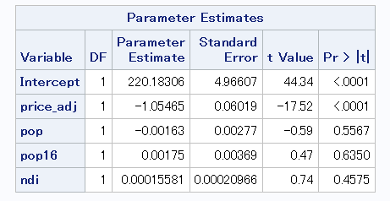

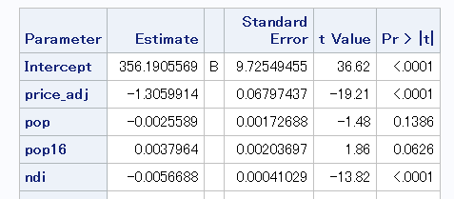

There 2 important things to get out of this table.

* With fixed effect, the negative effect of price on sales is stronger in magnitude and more statistically significant 🡪 model without fixed effect underestimates the effect of price
* In fixed effect model, the coefficient on ndi flips sign and become highly significant as opposed to the result in model without fixed effect. This coefficient makes more sense that low income leads to more smoking.