Experiment–2

AIM: First Come First Serve (FCFS)

Description of Aim & Related Theory
First Come First Serve (FCFS) is one of the most basic CPU scheduling algorithms used in operating systems. In this method, the CPU executes processes in the same order in which they enter the ready queue. The process that arrives first is the first one to receive CPU time, following the First-In, First-Out (FIFO) principle.
When a process enters the ready queue, it is placed at the rear (tail) of the queue. The CPU always chooses the process at the front (head) of the queue for execution. Since FCFS is a non-preemptive scheduling algorithm, once a process starts running, it continues executing until it completes without being interrupted. After the process finishes, it is removed from the queue, and the next waiting process is executed.
FCFS is easy to understand and implement because it does not require complex scheduling decisions. However, it is not always efficient. If a process with a long burst time arrives before several shorter processes, the shorter ones must wait until the long process completes. This problem is called the Convoy Effect, which increases waiting time and decreases overall CPU efficiency.
Characteristics of FCFS
- Processes are executed in the exact order in which they arrive.
- It is a non-preemptive scheduling algorithm, meaning a running process cannot be interrupted.
- The algorithm is based on the FIFO (First-In, First-Out) queue structure.
- FCFS is simple to design, implement, and manage.
- Every process eventually gets CPU time, so starvation does not occur.
- The average waiting time may become large when long processes are scheduled before shorter ones.
- FCFS is commonly used in simple batch processing systems, but it is generally unsuitable for interactive and real-time systems because it can result in poor response times.
Program
#include <stdio.h>
#include <stdlib.h>

struct Process {
int arrivalTime;
int processId;
int burstTime;
};

void sortProcesses(struct Process p[ ], int n) {
int i, j;
struct Process temp;

for (i = 0; i < n - 1; i++) {
for (j = i + 1; j < n; j++) {
if (p[i].arrivalTime > p[j].arrivalTime) {
temp = p[i];
p[i] = p[j];
p[j] = temp;
}
}
}
}

int main() {
int n, i;

printf("Enter number of processes: ");
scanf("%d", &n);

int arrivalTime[n], burstTime[n];
int completionTime[n], turnAroundTime[n], waitingTime[n];

struct Process processes[n];

for (i = 0; i < n; i++) {
printf("Enter Arrival Time & Burst Time for Process %d: ", i + 1);
scanf("%d %d", &arrivalTime[i], &burstTime[i]);

processes[i].arrivalTime = arrivalTime[i];
processes[i].processId = i;
processes[i].burstTime = burstTime[i];
}

sortProcesses(processes, n);

int timer = 0;
float avgTurnAroundTime = 0, avgWaitingTime = 0;

for (i = 0; i < n; i++) {
if (timer < processes[i].arrivalTime)
timer = processes[i].arrivalTime;

timer += processes[i].burstTime;

int id = processes[i].processId;

completionTime[id] = timer;
turnAroundTime[id] = completionTime[id] - arrivalTime[id];
waitingTime[id] = turnAroundTime[id] - burstTime[id];

avgTurnAroundTime += turnAroundTime[id];
avgWaitingTime += waitingTime[id];
}

avgTurnAroundTime /= n;
avgWaitingTime /= n;

printf("\n");
printf("P\tAT\tBT\tCT\tTAT\tWT\n");

for (i = 0; i < n; i++) {
printf("P%d\t%d\t%d\t%d\t%d\t%d\n",
i + 1,
arrivalTime[i],
burstTime[i],
completionTime[i],
turnAroundTime[i],
waitingTime[i]);
}

printf("\nAverage Turn Around Time = %.2f\n", avgTurnAroundTime);
printf("Average Waiting Time = %.2f\n", avgWaitingTime);

return 0;
}

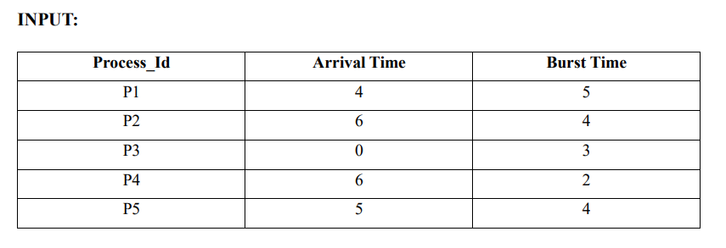
OUTPUT
Enter number of processes: 5
Enter Arrival Time & Burst Time for Process 1: 4 5
Enter Arrival Time & Burst Time for Process 2: 6 4
Enter Arrival Time & Burst Time for Process 3: 0 3
Enter Arrival Time & Burst Time for Process 4: 6 2
Enter Arrival Time & Burst Time for Process 5: 5 4

P AT BT CT TAT WT
P1 4 5 9 5 0
P2 6 4 17 11 7
P3 0 3 3 3 0
P4 6 2 19 13 11
P5 5 4 13 8 4
Average Turn Around Time = 8.00
Average Waiting Time = 4.40

