Experiment-1

AIM: Overview of an Operating System

What is an Operating System (OS)?

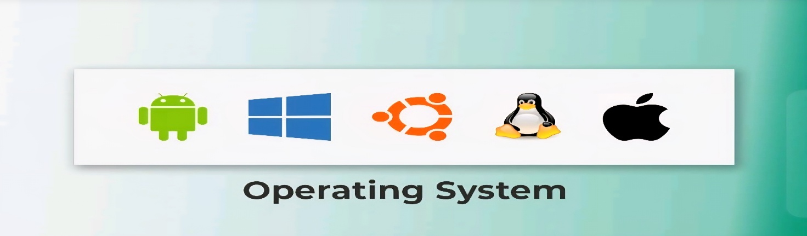
Fig. 1
An Operating System (OS) is system software that works as a bridge between the user and the computer hardware. It allows users and application programs to communicate with the hardware without needing to understand its internal working. The OS manages all the important resources of a computer and ensures that different programs run smoothly and efficiently.
The operating system performs many essential tasks such as memory management, process management, file management, input/output management, and device management. It also controls hardware devices like hard disks, printers, keyboards, and monitors through appropriate software called device drivers.
The most important part of an operating system is the kernel. The kernel is the core component that remains active while the computer is running. It manages communication between software and hardware and controls the system's resources.
The main objectives of an operating system are:
- To provide an easy interface between the user and the computer.
- To manage hardware and software resources efficiently.
- To allow multiple applications to run properly.
- To improve system performance, reliability, and security.
Today, operating systems are used in almost every digital device, including desktop computers, laptops, smartphones, tablets, servers, smart TVs, automobiles, and embedded systems. Some common examples are Microsoft Windows, Linux, macOS, Android, iOS, UNIX, AIX, z/OS, and VMS.

1.1 Operating System Definition and Function
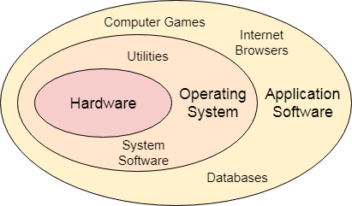
A computer system consists of hardware and software. Hardware can understand only machine language (binary data made up of 0s and 1s), which is difficult for users to understand directly.

Fig. 2

Therefore, an operating system acts as an intermediary that allows users to interact with the computer in a simple and convenient way.
An Operating System can be defined as software that controls and manages the overall functioning of a computer system. It is responsible for executing programs, allocating system resources, managing CPU operations, controlling memory usage, organizing files, and handling input and output devices.
The operating system also ensures that different programs share the available resources fairly and efficiently. It provides a stable environment in which users can execute applications without worrying about hardware details. In short, the OS makes computer systems easier to use, more efficient, and more reliable.

1.2 Structure of a Computer System
A computer system is made up of several important components that work together.
1. Users
Users are the people who operate the computer and use different applications to complete their work.
2. Application Programs
These are programs developed to perform specific tasks for users, such as web browsers, media players, games, database software, office applications, and compilers.
3. System Programs
System programs help in the operation of the computer itself. Examples include command interpreters (shells), text editors, utility programs, and language translators.
4. Operating System
The operating system acts as the central controller of the computer. It manages communication between software and hardware while controlling all system resources.
5. Hardware
Hardware refers to the physical parts of the computer, such as the CPU, memory, storage devices, keyboard, mouse, printer, and monitor. These components perform the actual processing and storage of data under the control of the operating system.
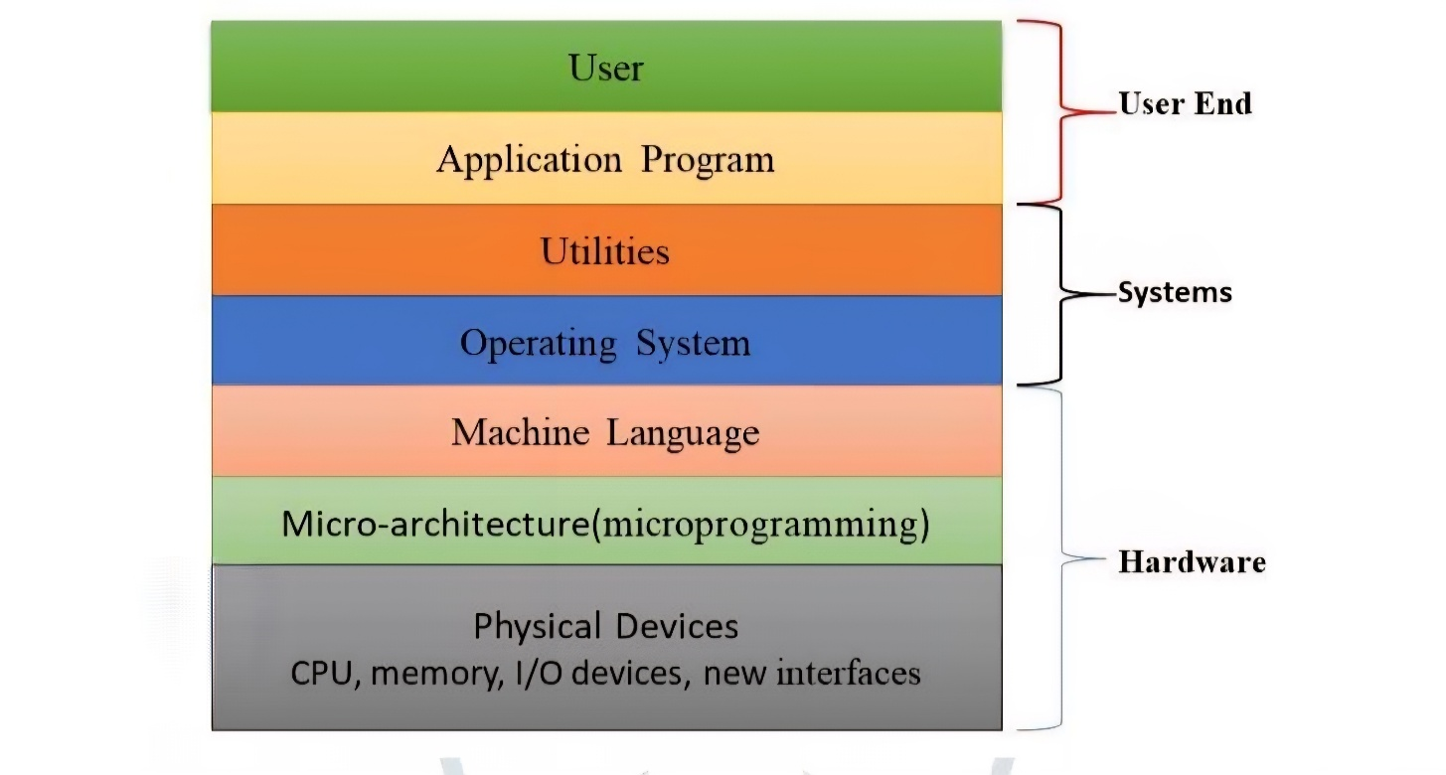
Fig.3

1.3 Architecture
The architecture of an operating system shows how different parts of a computer system are organized and interact with each other. It explains the relationship between the user, application programs, operating system, and computer hardware.
At the top level are the users, who use different software applications to perform tasks. These applications do not communicate directly with the hardware. Instead, they send requests to the operating system.
The Operating System works as an intermediary between the applications and the hardware. It receives requests from programs, processes them, and communicates with the hardware to complete the required task. The OS also controls memory, processor, storage devices, and input/output devices while ensuring that all resources are shared efficiently.
At the lowest level is the hardware, which includes the CPU, RAM, hard disk, keyboard, mouse, monitor, printer, and other physical devices. The hardware performs all actual operations under the control of the operating system.
In simple words, the architecture of an operating system allows users to interact with computer hardware in an easy, secure, and efficient manner.

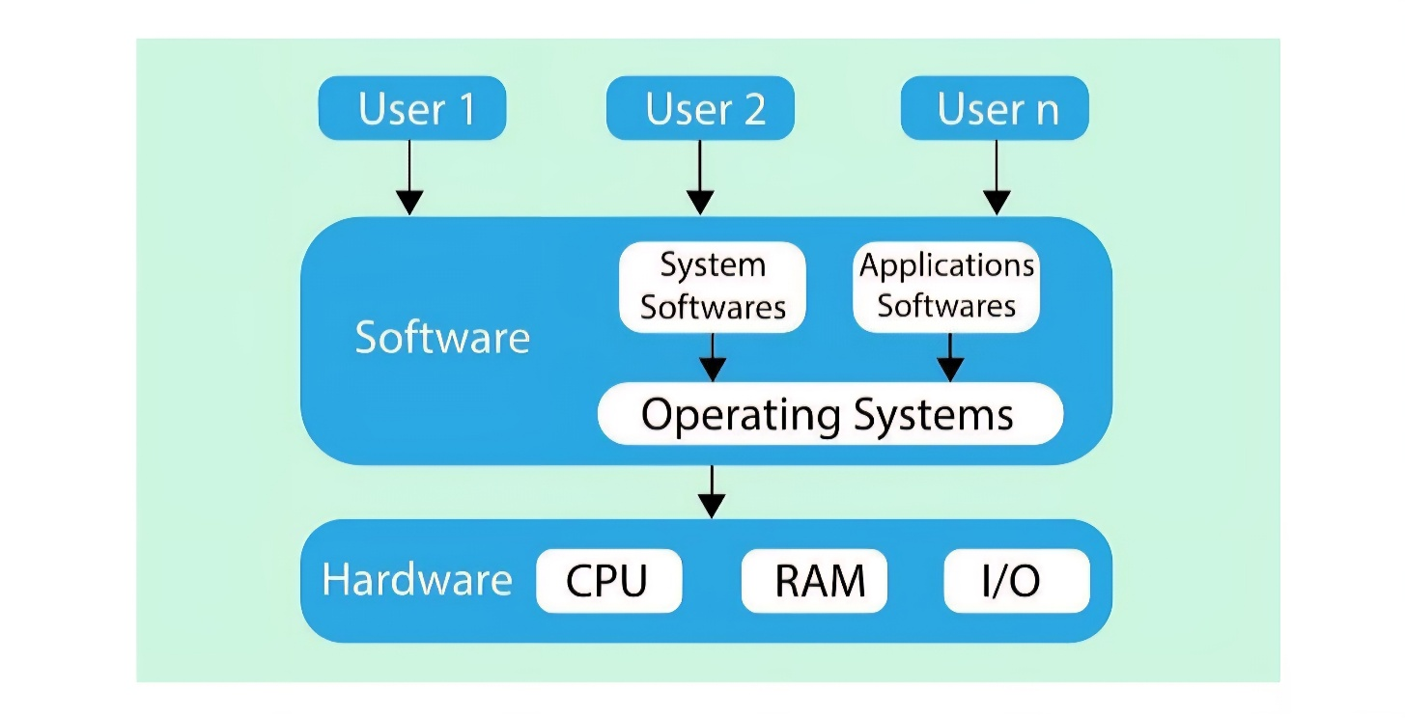
Fig.4

1.4 Operating System Generations
Operating systems have improved continuously with the advancement of computer technology. Based on the changes in hardware and software, their development can be divided into different generations.

1.4.1 0th Generation

The Zeroth Generation represents the earliest stage of computing. During this period, computers did not have an operating system. Programs were written directly in machine language, and every instruction had to be entered manually. Vacuum tubes were used as the main hardware technology, making computers very large, expensive, and slow.Programmers and operators had to control all computer operations manually, making the system difficult to use and highly dependent on human effort.

1.4.2 First Generation (1951-1956)

The First Generation marked the beginning of commercial computers. Machines such as UNIVAC I and IBM 701 became available during this period. Initially, these computers also operated without an operating system, and trained operators managed all program execution.

Later, simple operating systems were introduced to reduce manual work. These systems could execute one program at a time, which is known as monoprogramming. High-level programming languages like FORTRAN were also developed, making programming much easier than machine language.

1.4.3 Second Generation (1956-1964)

The Second Generation introduced transistors, which replaced vacuum tubes. This made computers faster, smaller, and more reliable.

During this period, the GMOS operating system was developed. It used the batch processing technique, where similar jobs were collected into batches and executed one after another without user interaction. Researchers also introduced concepts like multiprogramming, multiprocessing, and time-sharing, allowing computers to use resources more efficiently and improve overall performance.

1.4.4 Third Generation (1964-1979)
The Third Generation began with IBM's System/360 computers. Integrated Circuits (ICs) replaced transistors, increasing speed while reducing the size and cost of computers.
Operating systems became much more advanced during this period. Features like multiprogramming, improved input/output handling, and better memory management were introduced. Minicomputers also became popular, helping prepare the way for the personal computer revolution. This generation greatly improved both hardware and operating system technology.

1.4.5 Fourth Generation (1979 – Present)
The Fourth Generation is the modern era of computing. It is characterized by the use of Very Large Scale Integration (VLSI) technology, which made processors smaller, faster, and more powerful. Personal computers became common in homes, schools, and businesses. Modern operating systems such as Windows, Linux, macOS, Android, and iOS were developed during this generation. These operating systems provide graphical user interfaces, multitasking, networking, security, and support for modern hardware, making computers more user-friendly and efficient.
1.5 Functions of an operating System.
An Operating System performs many important functions that help a computer work efficiently. It manages hardware resources, controls program execution, and ensures that different applications run smoothly without interfering with one another. The major functions of an operating system are memory management, processor management, device management, file management, network management, security, performance monitoring, job accounting, error detection, and coordination between users and software.
- Memory Management
- Processor Management
- Device Management
- File Management
- Network Management
- Security
- Control over system performance
- Job accounting
- Error detecting aids
- Coordination between other software and users

a) Memory Management

Memory management is the process of controlling the computer's primary (main) memory. Since every program must be loaded into main memory before execution, the operating system manages memory efficiently to improve system performance.

The operating system continuously monitors which parts of memory are currently in use and which are free. In a multiprogramming environment, it decides how much memory each process should receive and when it should be allocated. After a process finishes or no longer needs memory, the operating system releases that memory so it can be used by other programs. Proper memory management improves system efficiency and prevents memory from being wasted

b) Processor Management

Processor management refers to controlling the CPU and deciding which process should run at a particular time. In systems where multiple programs are waiting for execution, the operating system schedules CPU time to ensure fair and efficient processing.

The operating system keeps track of the CPU's status and the state of every running process. It assigns the processor to the selected process and removes it once the process finishes or enters a waiting state. This scheduling helps improve CPU utilization and overall system performance.

c) Device Management

The operating system controls all input and output devices connected to the computer through device drivers. It manages communication between software applications and hardware devices such as printers, keyboards, scanners, and storage devices.

The operating system maintains information about every connected device, decides which process can use a particular device, allocates devices when needed, and releases them after use. Efficient device management ensures smooth communication between hardware and software while avoiding conflicts among different processes.

d) File Management

File management is responsible for organizing and maintaining files and directories stored on the computer. The operating system provides a structured file system that makes it easier for users to create, access, modify, and delete files.

It keeps track of file names, locations, permissions, and their current status. The operating system also decides which user or process can access particular files, allocates storage space when new files are created, and releases that space when files are deleted. Effective file management helps maintain data organization, security, and efficient use of storage resources.

1.6 Types of Operating Systems
- Batch Operating System
- Multi-Programming System
- Multi-Processing System
- Multi-Tasking Operating System
- Time-Sharing Operating System
- Distributed Operating System
- Network Operating System
- Real-Time Operating System

1.6.1 Batch Operating System
A Batch Operating System executes jobs in groups called batches. Users do not interact directly with the computer while their programs are running. Instead, an operator collects jobs with similar requirements, groups them together, and submits them for execution. The operating system processes each batch one after another without any manual intervention during execution. This method is suitable for large amounts of repetitive work.

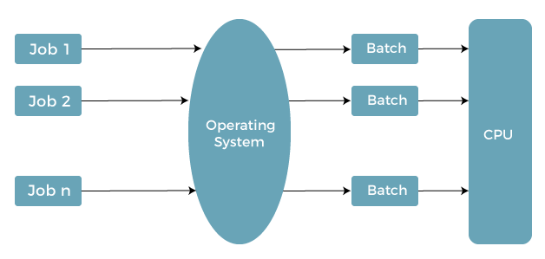
Fig.5

a) Advantages of Batch Operating System
- It can process a large number of similar jobs efficiently.
- Several users can share the system at the same time.
- CPU idle time is reduced because jobs are executed continuously.
- It is useful for repetitive tasks that need regular processing.

b) Disadvantages of Batch Operating System

- Errors are difficult to identify and correct.
- Users have to wait until the entire batch is completed.
- Skilled operators are required to manage batch processing.
- Setting up and maintaining the system may be expensive.

c) Examples of Batch Operating Systems: Payroll Systems, Bank Statements, etc.

1.6.2 Multi-Programming Operating System
A Multiprogramming Operating System keeps multiple programs in the main memory at the same time. While one program is waiting for an input or output operation, the CPU starts executing another program. This reduces CPU idle time and improves resource utilization, resulting in better system performance.

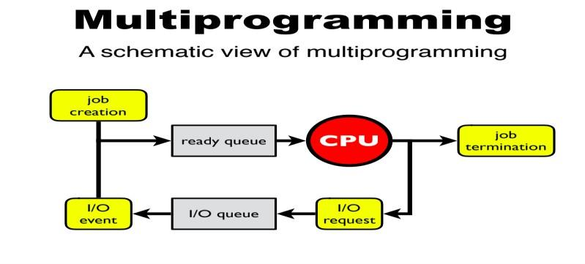
Fig.6

a) Advantages of Multi-Programming Operating System
- Improves CPU utilization and system throughput.
- Reduces waiting time for program execution.
- Makes better use of available memory and system resources.

b) Disadvantages of Multi-Programming Operating System
- User interaction with running programs is limited.
- Memory and process management become more complex.

1.6.3. Multi-Processing Operating System
A Multiprocessing Operating System uses two or more processors (CPUs) to perform different tasks simultaneously. Since multiple processors work together, the system can execute more programs in less time, increasing speed and reliability. If one processor fails, another processor can continue the work, improving system availability.

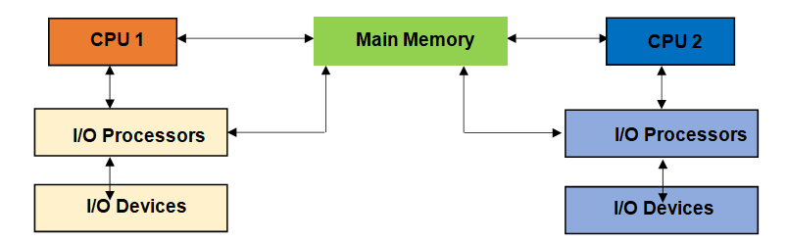
Fig.7

a) Advantages of Multi-Processing Operating System
- Increase overall system performance and throughput.
- Multiple processors allow tasks to be completed faster.
- The system remains operational even if one processor stops working.

b) Disadvantages of Multi-Processing Operating System
- Hardware and software design are more complicated.
- The cost of installing multiple processors is higher.

1.6.4 Multi-Tasking Operating System
A Multitasking Operating System allows several programs to run at the same time by quickly switching the CPU between them. This creates the impression that all applications are running simultaneously. It mainly uses scheduling techniques such as Round Robin to distribute CPU time fairly among processes. Multitasking can be Preemptive or Cooperative, depending on how CPU control is shared.
- Preemptive Multi-Tasking
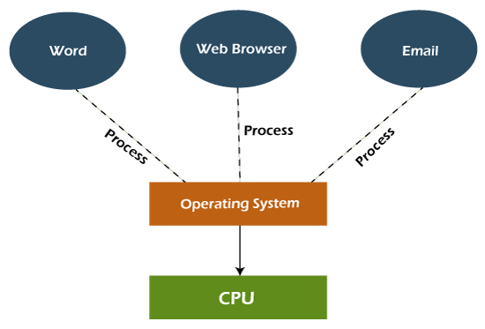
- Cooperative Multi-Tasking
a) Advantages of Multi-Tasking Operating System
- Multiple applications can run together without restarting the computer.
- Improves productivity by allowing users to perform several tasks at once.
- Uses memory efficiently while managing different programs.

b) Disadvantages of Multi-Tasking Operating System Fig.8
- Running many heavy programs at the same time may reduce system performance.
- Continuous multitasking may increase CPU usage and system temperature.

1.6.5 Time-Sharing Operating Systems
A Time-Sharing Operating System allows multiple users or programs to use the computer system at the same time. The CPU divides its time into small intervals called time slices or quantums. Each program gets a fixed amount of CPU time before the operating system switches to the next program. This switching happens so quickly that users feel all programs are running simultaneously. Time-sharing improves resource utilization and provides a faster and more interactive computing experience .
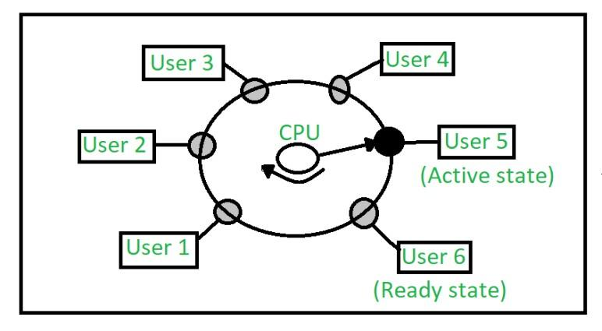
Fig.9

a) Advantages of Time-Sharing OS
- Every user or process gets an equal opportunity to use the CPU.
- It reduces CPU idle time and improves system efficiency.
- Hardware resources such as memory, storage, and peripherals can be shared among multiple users.
- Users can interact with the computer in real time, making the system more responsive.
- It increases productivity because multiple users can work simultaneously on the same computer system.

b) Disadvantages of Time-Sharing OS
- Managing multiple users makes the system more complex.
- Security and data protection become more challenging.
- Scheduling and frequent context switching increase system overhead.
- Communication problems may occur if the network is not reliable.
- A large number of users can reduce overall system performance.

c) Examples of Time-Sharing OS with explanation
Some common examples include IBM VM/CMS, TSO (Time Sharing Option), and Windows Terminal Services. These operating systems allow multiple users to access the same computer or server simultaneously while running their own applications independently.

1.6.6 Distributed Operating System
A Distributed Operating System consists of several independent computers connected through a communication network. Even though each computer has its own processor and memory, they work together as a single system. Users can access files, software, and other resources located on different computers without needing to know their physical location. This type of operating system improves resource sharing, reliability, and overall system performance.
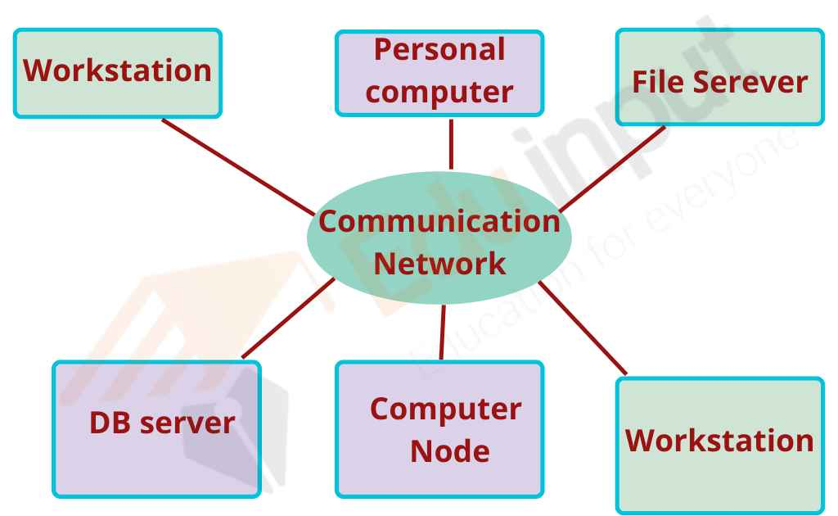
Fig.10

a) Advantages of Distributed Operating System
- If one computer fails, the others continue working normally.
- Resources such as files and software can be shared across the network.
- It improves processing speed by distributing work among multiple computers.
- The workload on individual systems is reduced.
- New computers can be added easily, making the system highly scalable.
- It supports remote access to shared resources over the network.

b) Disadvantages of Distributed Operating System
- Failure of the communication network can affect the entire system.
- Developing and maintaining distributed systems is complex.
- Installation and maintenance costs are high.
- The software required for distributed systems is more complicated than that of standalone systems.

1.6.7 Network Operating System
A Network Operating System (NOS) is designed to manage computers connected through a network. It usually runs on a server and provides services such as file sharing, printer sharing, user management, security, and centralized administration. Users connected to the network can access shared resources according to the permissions provided by the server. This type of operating system is commonly used in schools, offices, and organizations.
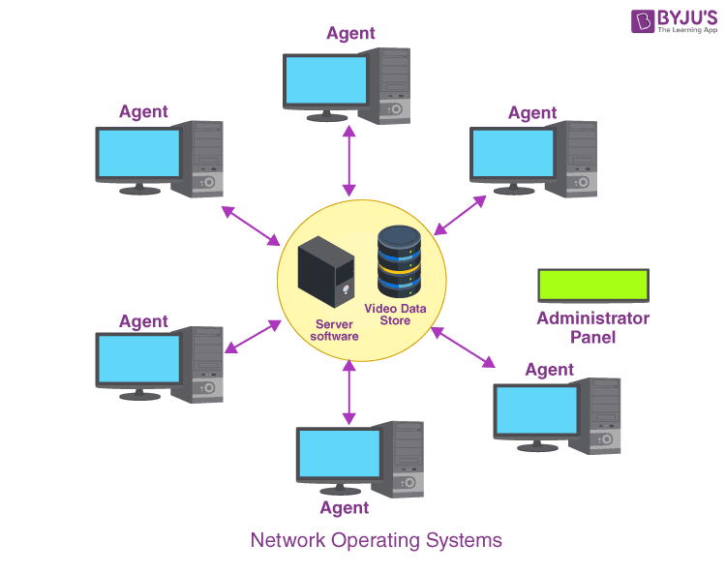
Fig.11

a) Advantages of Network Operating System
- Centralized servers provide better stability and management.
- User accounts and security can be managed from one location.
- New hardware and software can be added easily.
- Users can access network resources remotely from different locations.

b) Disadvantages of Network Operating System
- Setting up servers is expensive.
- Users depend on the central server for many operations.
- Regular maintenance and updates are required to keep the network secure and efficient.

Examples
Some popular Network Operating Systems include Windows Server, Linux, UNIX, Mac OS X, BSD, and Novell NetWare.

1.6.8 Real-Time Operating System
A Real-Time Operating System (RTOS) is specially designed for applications where tasks must be completed within a fixed time limit. It provides very fast responses to external events, making it suitable for systems where delays are unacceptable. RTOS is commonly used in air traffic control systems, medical equipment, robotics, industrial automation, missile systems, and automotive safety systems.

Types of Real-Time Operating System :

- Hard Real-Time Systems:
A Hard RTOS is used in systems where meeting deadlines is extremely important. Even a very small delay can cause serious problems or system failure. Examples include airbags, automatic braking systems, and medical life-support equipment. These systems are designed to guarantee timely execution of tasks.
- Soft Real-Time Systems:
A Soft RTOS is used in applications where occasional delays are acceptable but overall performance should still remain fast. Missing a deadline may reduce performance, but it does not lead to system failure. Examples include multimedia streaming and online gaming.These OSs are for applications where time-constraint is less strict.
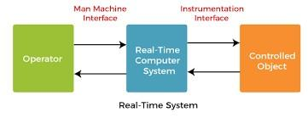
Fig.12
- Advantages of RTOS

- Makes maximum use of system resources.
- Performs task switching very quickly.
- Gives higher priority to important tasks.
- Suitable for embedded systems and industrial applications.
- Provides reliable and efficient memory management.
- Produces accurate and predictable results within the required time.

- Disadvantages of RTOS

- Only a limited number of tasks can run simultaneously.
- Hardware and software costs are generally higher.
- System resources may be heavily utilized, increasing implementation costs.

