Exercise 1

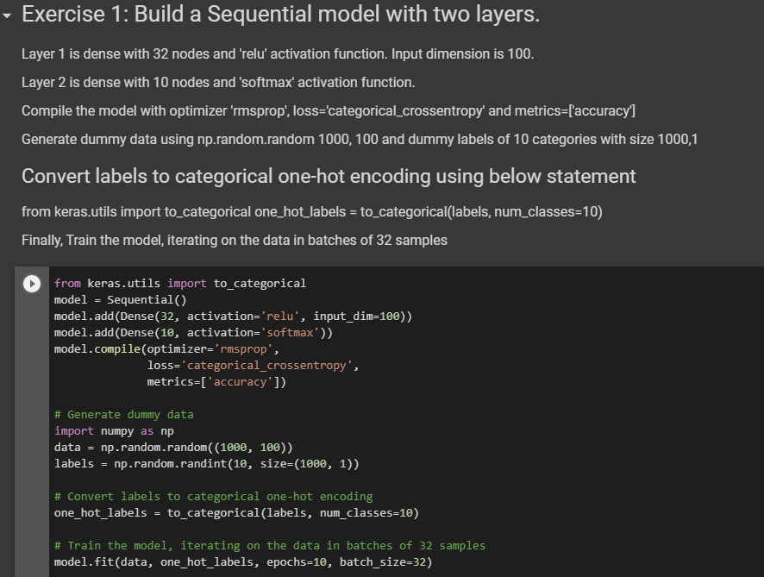Exercise 2

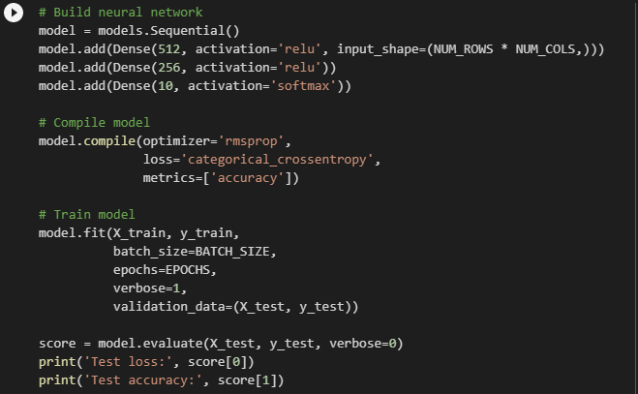

Test loss: 0.09443155354251818

Test accuracy: 0.981

Exercise 3

