Document 11

Summary
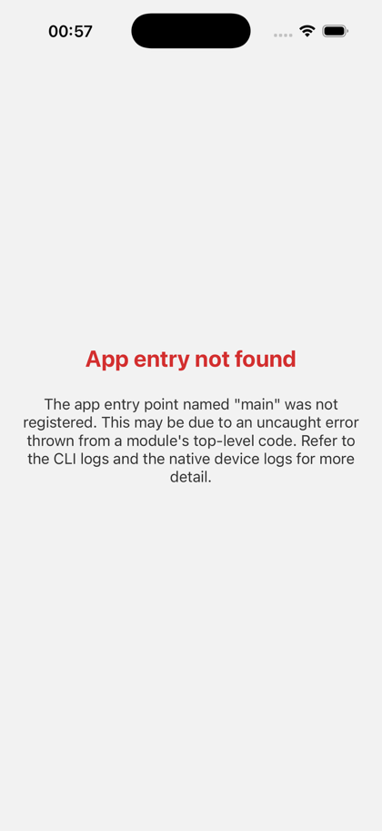
Asdhjhasdjasdajadasdsd
ASD
asdasfa | asd | asdsasd
asd
sfaf
afs

