# SQL实验五(下)

写出用Java语言连接数据库的代码片段。

核心点：写好一个在SSMS中可以执行的SQL代码后，再把待定参数修改为问号。

## 1、添加数据

往专业表中添加一行记录，数据你自己指定。

|  |
| --- |
| String sSQL=""insert into Friend values(?,?,?,?,?,?,?,?)"";  String dbURL="jdbc:microsoft:sqlserver://127.0.0.1:1433;DatabaseName=Northwind";  private String sUser="stormstone";  private String sPass="stormstone";  Class.forName("com.microsoft.jdbc.sqlserver.SQLServerDriver");  Connection con=DriverManager.getConnection(dbURL,sUser,sPass);  PreparedStatement stat=con.prepareStatement (**sSQL**);  //填充数据到各参数位置  stat.setString(1,objMF.vName);stat.setString(2,objMF.cSex);  stat.setString(3,objMF.dBirth);stat.setString(4,objMF.cPhone);  stat.setString(5,objMF.vEmail);stat.setString(6,objMF.cQQNo);  stat.setString(7,objMF.vAddress);stat.setString(8,objMF.cCode);  //提交数据到数据库中  stat.executeUpdate(); |

读懂上面代码，参考上面代码来修改。

|  |
| --- |
| String sSQL=""insert into Major values(?,?)"";  String dbURL="jdbc:microsoft:sqlserver://127.0.0.1:1433;DatabaseName=Northwind";  private String sUser="stormstone";  private String sPass="stormstone";  Class.forName("com.microsoft.jdbc.sqlserver.SQLServerDriver");  Connection con=DriverManager.getConnection(dbURL,sUser,sPass);  PreparedStatement stat=con.prepareStatement (**sSQL**);  //填充数据到各参数位置  stat.setString(1,”080909”);stat.setString(2,”数据挖掘”);  //提交数据到数据库中  stat.executeUpdate(); |
|  |

## 2、删除数据

删除你刚刚添加的专业。

|  |
| --- |
| String sSQL="" delete from Major Where cMajorNo = ?"";  String dbURL="jdbc:microsoft:sqlserver://127.0.0.1:1433;DatabaseName=Northwind";  private String sUser="stormstone";  private String sPass="stormstone";  Class.forName("com.microsoft.jdbc.sqlserver.SQLServerDriver");  Connection con=DriverManager.getConnection(dbURL,sUser,sPass);  PreparedStatement stat=con.prepareStatement (**sSQL**);  //填充数据到各参数位置  stat.setString(1,” 080909”); //提交数据到数据库中  stat.executeUpdate(); |

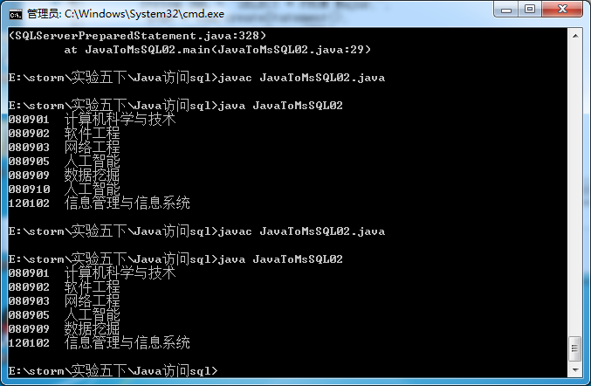

## 3、修改数据

对数据库中的某专业，修改其名称。

|  |
| --- |
| String sSQL="" update Major set vName=? Where cMajorNo = ?;"";  String dbURL="jdbc:microsoft:sqlserver://127.0.0.1:1433;DatabaseName=Northwind";  private String sUser="stormstone";  private String sPass="stormstone";  Class.forName("com.microsoft.jdbc.sqlserver.SQLServerDriver");  Connection con=DriverManager.getConnection(dbURL,sUser,sPass);  PreparedStatement stat=con.prepareStatement (**sSQL**);  //填充数据到各参数位置  stat.setString(1,” 人工智能”); stat.setString(2,” 080905”);  //提交数据到数据库中  stat.executeUpdate(); |

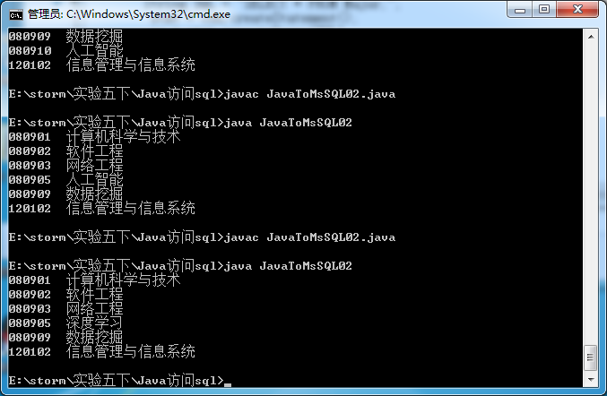

## 4、查询数据

根据学生学号，查询学生基本信息。

|  |
| --- |
| String sSQL="select top 15 CustomerID,Country ,City,Phone from Customers where CustomerID=?";  String dbURL="jdbc:microsoft:sqlserver://127.0.0.1:1433;DatabaseName=Northwind";  private String sUser="sa";  private String sPass="";  Class.forName("com.microsoft.jdbc.sqlserver.SQLServerDriver");  Connection con=DriverManager.getConnection(dbURL,sUser,sPass);  PreparedStatement pStmt=con.prepareStatement(sSQL);  pStmt.setString(1,"0001"); //将第一个问号位置替换成值0001  ResultSet rs=pStmt.executeQuery(); |

|  |
| --- |
| String sSQL="Select * From Student Where cNo = ?";  String dbURL="jdbc:microsoft:sqlserver://127.0.0.1:1433;DatabaseName=Northwind";  private String sUser="stormstone";  private String sPass="stormstone";  Class.forName("com.microsoft.jdbc.sqlserver.SQLServerDriver");  Connection con=DriverManager.getConnection(dbURL,sUser,sPass);  PreparedStatement pStmt=con.prepareStatement(sSQL);  pStmt.setString(1,"201531060570"); //将第一个问号位置替换成值0001  ResultSet rs=pStmt.executeQuery(); |

