# Multitask learning using ELMo word embedding with Simple embedding techniques

ELMo embeddings with simple embedding techniques (max, ave, concat) into simple multitask learning model. Figure below illustrates the model:

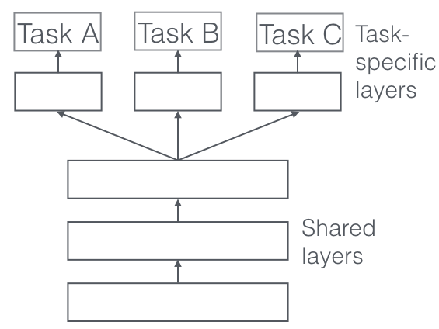

**Note:** CPU has fewer number of reviews compared to others, so only the other 4 types are evaluated.

**Conclusion:** it shows great improvement from single task learning using ELMo with Simple Embedding Techniques!

|  |  |
| --- | --- |
|  | MLP |
| Pointwise average of word embedding  (ave) | cur_exp_param: gpu  ncdg:  0.595903165735568  0.851024208566108  0.910944911419264  0.9258424905626532  0.9306545191444789  precision:  0.595903165735568  0.425512104283054  0.3153320918684047  0.24394785847299813  0.1973929236499069  recall:  0.595903165735568  0.851024208566108  0.9459962756052142  0.9757914338919925  0.9869646182495344 |
| cur_exp_param: ram  ncdg:  0.6759776536312849  0.8268156424581006  0.8937858397645688  0.9170633071761143  0.9226773405215777  precision:  0.6759776536312849  0.4134078212290503  0.31098696461824954  0.24487895716945995  0.1985102420856611  recall:  0.6759776536312849  0.8268156424581006  0.9329608938547486  0.9795158286778398  0.9925512104283054 |
| cur_exp_param: hd  ncdg:  0.45623836126629425  0.7411545623836127  0.8069498439478617  0.8414004957169493  0.852628562407876  precision:  0.45623836126629425  0.37057728119180633  0.281812538795779  0.22858472998137802  0.18808193668528864  recall:  0.45623836126629425  0.7411545623836127  0.845437616387337  0.9143389199255121  0.9404096834264432 |
| cur_exp_param: screen  ncdg:  0.7337057728119181  0.8789571694599627  0.9283036306331499  0.9376146175977682  0.9472386747614195  precision:  0.7337057728119181  0.43947858472998136  0.319056486654252  0.24394785847299813  0.19962756052141528  recall:  0.7337057728119181  0.8789571694599627  0.957169459962756  0.9757914338919925  0.9981378026070763 |
| Pointwise maximum of word embedding  (max) | cur_exp_param: gpu  ncdg:  0.6350093109869647  0.8472998137802608  0.9072205166334164  0.9239802931697294  0.9295943265151926  precision:  0.6350093109869647  0.4236499068901304  0.31409062693978895  0.24394785847299813  0.19776536312849163  recall:  0.6350093109869647  0.8472998137802608  0.9422718808193669  0.9757914338919925  0.9888268156424581 |
| cur_exp_param: ram  ncdg:  0.7094972067039106  0.8268156424581006  0.8867363453112566  0.9146693062051113  0.9210853443142121  precision:  0.7094972067039106  0.4134078212290503  0.30726256983240224  0.24441340782122906  0.1985102420856611  recall:  0.7094972067039106  0.8268156424581006  0.9217877094972067  0.9776536312849162  0.9925512104283054 |
| cur_exp_param: hd  ncdg:  0.41899441340782123  0.7597765363128491  0.8020735030327238  0.8346619574088877  0.8579200955543785  precision:  0.41899441340782123  0.37988826815642457  0.2756052141527002  0.22299813780260708  0.18919925512104283  recall:  0.41899441340782123  0.7597765363128491  0.8268156424581006  0.8919925512104283  0.9459962756052142 |
| cur_exp_param: screen  ncdg:  0.74487895716946  0.88268156424581  0.9308531096767786  0.944819590123706  0.9504336234691694  precision:  0.74487895716946  0.441340782122905  0.3196772191185599  0.2467411545623836  0.2  recall:  0.74487895716946  0.88268156424581  0.9590316573556797  0.9869646182495344  1.0 |
| The concatenation of the pointwise average and maximum of word embedding  (concat) | cur_exp_param: gpu  ncdg:  0.6219739292364991  0.8566108007448789  0.9083070934025035  0.9222735738494309  0.9318976310130823  precision:  0.6219739292364991  0.42830540037243947  0.3128491620111732  0.24162011173184358  0.19776536312849163  recall:  0.6219739292364991  0.8566108007448789  0.9385474860335196  0.9664804469273743  0.9888268156424581 |
| cur_exp_param: ram  ncdg:  0.7094972067039106  0.8324022346368715  0.8923229374900272  0.9165315035980347  0.9253535559980485  precision:  0.7094972067039106  0.41620111731843573  0.3091247672253259  0.24394785847299813  0.19925512104283055  recall:  0.7094972067039106  0.8324022346368715  0.9273743016759777  0.9757914338919925  0.9962756052141527 |
| cur_exp_param: hd  ncdg:  0.44692737430167595  0.7355679702048417  0.8072378304801847  0.8379640874634251  0.8515981684452645  precision:  0.44692737430167595  0.36778398510242083  0.28305400372439476  0.2276536312849162  0.18845437616387337  recall:  0.44692737430167595  0.7355679702048417  0.8491620111731844  0.9106145251396648  0.9422718808193669 |
| cur_exp_param: screen  ncdg:  0.74487895716946  0.9013035381750466  0.9389008419260465  0.9482118288906648  0.9570338812906786  precision:  0.74487895716946  0.4506517690875233  0.3202979515828678  0.24487895716945995  0.2  recall:  0.74487895716946  0.9013035381750466  0.9608938547486033  0.9795158286778398  1.0 |