The difficulties encountered in this assignment are mainly concentrated in the fifth question and the matrix cycle in 2.2. In the sixth question, I asked Li Yuan to tell me how to classify and then make statistics in the form of bar chart.
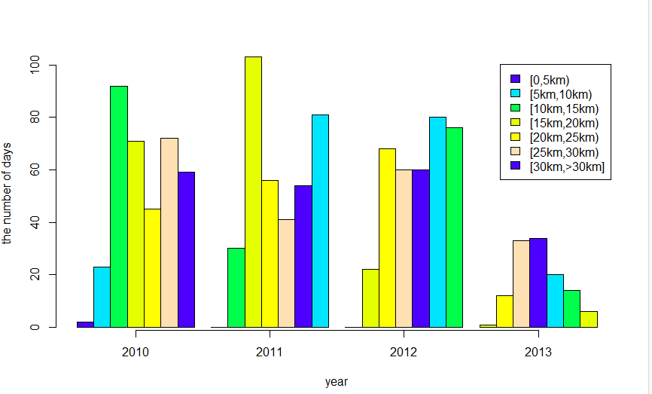

In the third question, Pascal triangle, take 10 layers as an example. Define an array and assign the initial value of 0, 1, 0... So that the calculation of the current layer is simplified to add the adjacent 2 numbers of the previous layer. When the current number is output, it is stored in the corresponding position of the array for the calculation of the next layer. Here,Pascal_ Triangle (10) is taken as an example.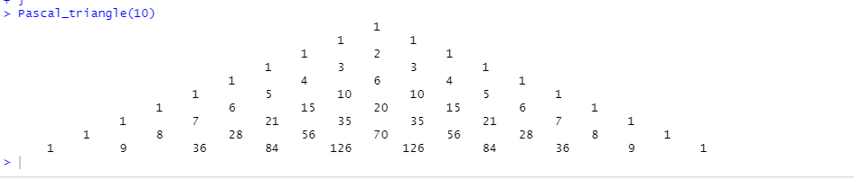

There is no reference function given by the teacher in question 4. And the fifth problem is solved by exhaustive and recursive methods and 5.2 resulting graphs.
