1. **Matrix multiplication**
   1. Write a subroutine Matrix_multip.f90 to do matrix multiplication.

ANS：

First,we must know two points about the subroutine:

1. Subroutine does not need to be declared in the program, but it must be called with the call command;

2. Subroutine can not return any result.

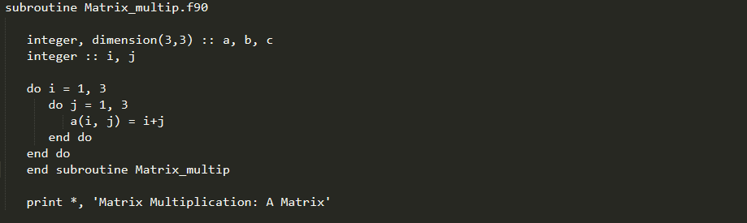

* 1. Write a program Main.f90 to read /work/ese-ouycc/fortran_2/M.dat as the matrix M, and /work/ese-ouycc/fortran_2/N.dat as the matrix N.

ANS: 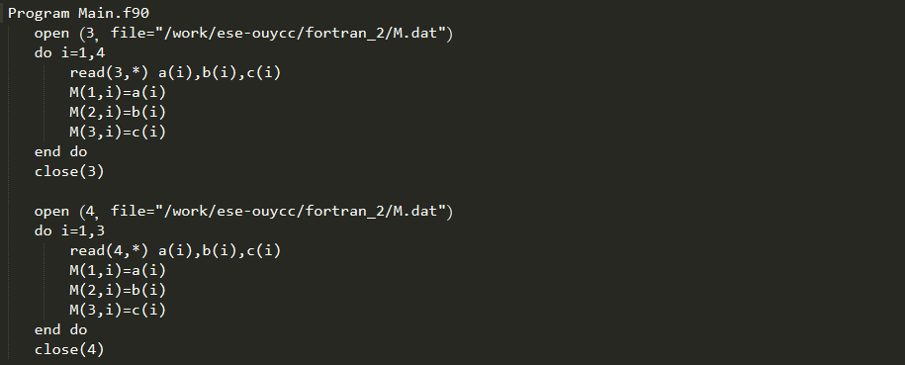

* 1. Call subroutine Matrix_multip() from Main.f90 to compute M*N; write the output to a new file MN.dat, values are in formats of f8.1

ANS:

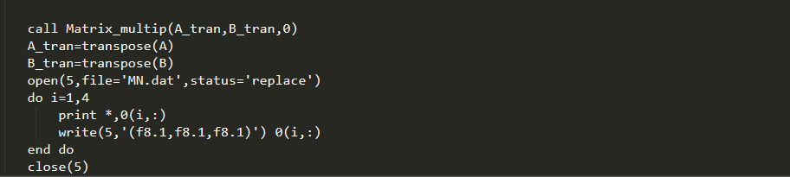

# Calculate the solar zenith angle

* 1. Write a module Declination_angle to calculate the declination angle on a certain date.

ANS:

Note: have a reference from google

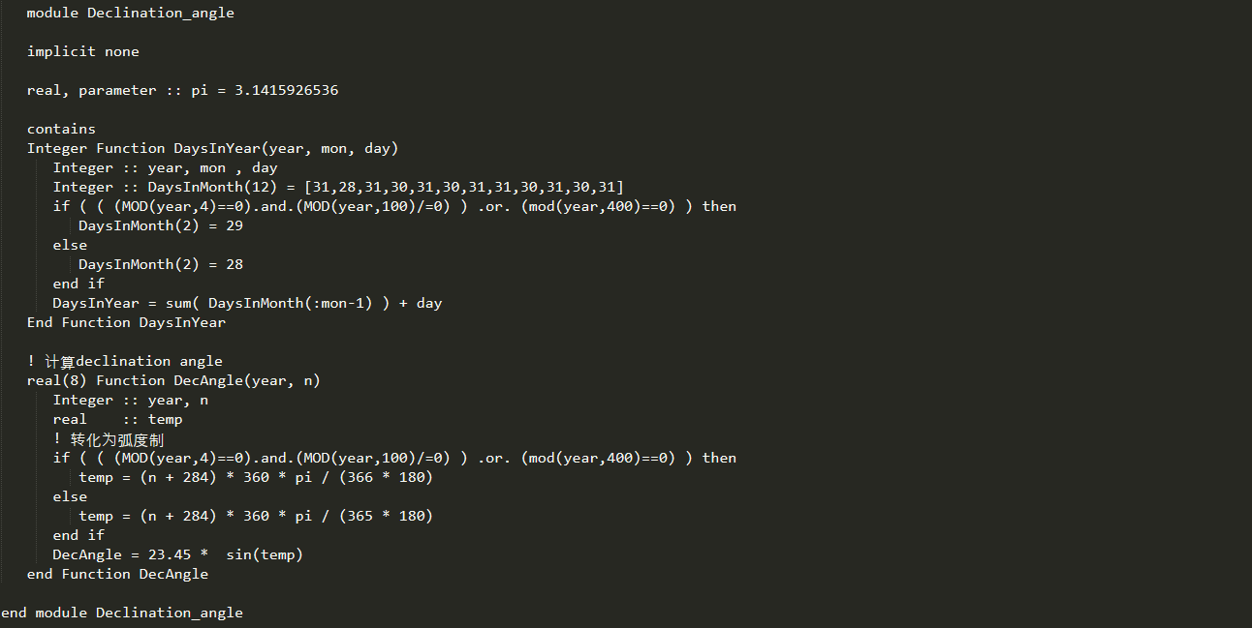

2.2 Write a module AST to calculate the apparent solar time (AST; or local solar time) in a certain location for a certain date and time.

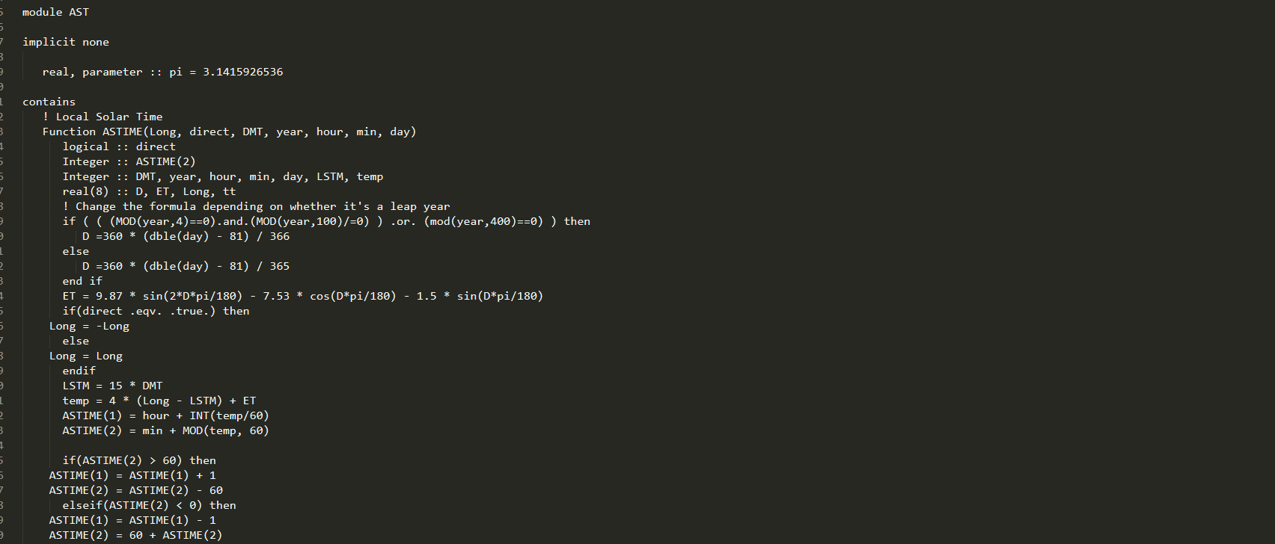

2.3  Write a main program (Cal_SZA.f90) that uses module Declination_angle and AST to print the SZA in a certain location for a certain date and time.

ANS:

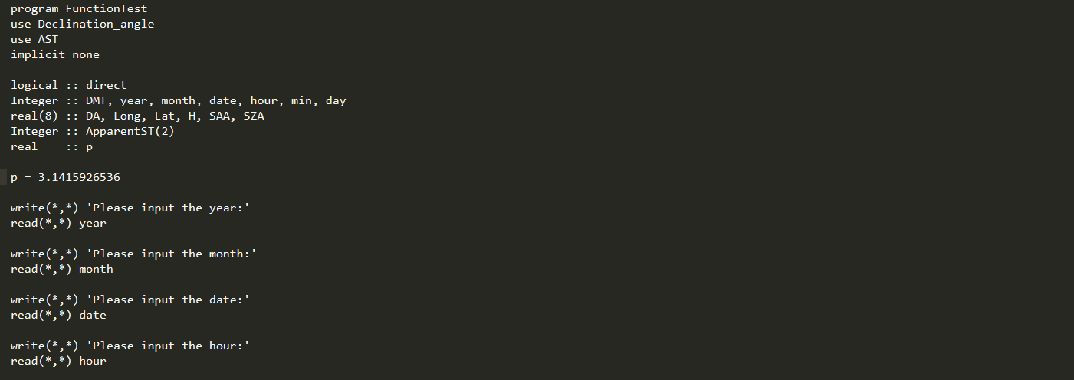

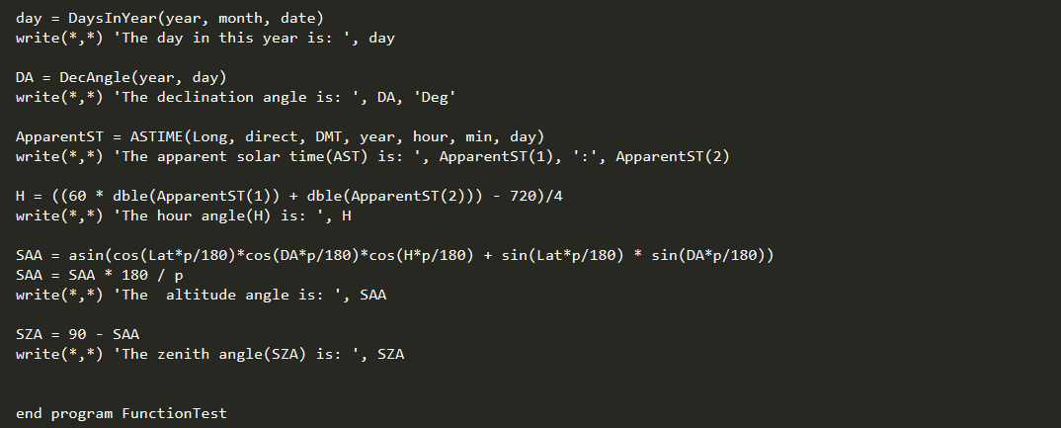

2.4

2.5