**Project Proposal: Bub’s Playdate**

**Summary**

This website was created for people with bubs who are seeking someone to have a playdate with. Sometimes it is hard to find other bubs with similar routines, especially sleeping and awake times and for parent or carer staying home all day with bub can be lonely too. The purpose of this website is to help people who look for friends with bub’s playdate, as well to share each other’s experiences. People can search for friends, other mums, dads, grandparents, or carers with bub based on the suburb where they live, similar bub’s age and suitable available times and days. That way, the playdate can happen without change to bub’s routine, so bub is happy and content resulting in less stress for parents and carers. People make a friend; bubs can play together. Happy parenting, happy bub!

**Asset List**

|  |  |  |
| --- | --- | --- |
| **Asset** | **How to be used** | **Detail** |
| index.html | This is the foundation of the project which includes metadata, footer, header and to connect different components, organise the layout structure. | HTML file, static |
| style.css | The stylesheet of index.html.  Vue component will have style CSS as well. | CSS file for how the way we will present the website. |
| Main.js | The main JavaScript file | JavaScript file for index.html |
| App.vue | The root components | Single file component |
| Navbar.vu | Navigation menu bar component | Single file component  Responsive bar |
| Home.vue | Homepage component | Single file component  Passive page |
| Search.vue | Search page component (after login, this page will be home for user) | Single file component  Interactive page |
| Profilecards.vue | A component of profile cards in a search result list | Single file component  Responsive design |
| Profilecard.vue | Each profile card in a search result list | Single file component  Responsive list |
| Profile.vue | Profile page component | Single file component  List rendering |
| Chat.vue | Chat page component which includes three child components chatbox, contactlist, textbox | Responsive webpage |
| Chatbox.vue | Chatbox component in a chat page | Single file component  Interactive page |
| Contactlist.vue | Contact list component in a chat page | Single file component |
| Textbox.vue | Textbox component in a chat page | Single file component |
| About.vue | About us page component which user can find contact form as well in this page | Single file component |
| Contact.vue | Contact us page component | Single file component |
| Submitted.vue | The page after the contact form is submitted | Single file component |
| Login.vue | Login page component | Single file component |
| Loggedout.vue | The page after user logged out | Single file component |
| Register.vue | Registration page component | Single file component |

**Product Purpose**

|  |  |
| --- | --- |
| Target Audiences | Detail |
| Parents with bubs who look for friends and playdate who live around suburb/ area | Many parents wish to say hello with other parents within their local neighbourhood but struggle to find other parents with bub who have similar routine and age for playdate, or even just for walking or have coffee together. Even though, many parents and bub at same suburb but it is hard to get to know each other because of different routines. That’s why through this website mums can find each other who match their baby’s routine. |
| A new mum | A new mum needs to share opinions regarding their baby’s. Through this website, mums can share their experiences and can have playdate without disrupting the baby’s routine. |
| Grandparents and carers | Grandparents and carers who look after their grandchildren and looking for a playdate with similar baby’s routine and age within the area. |

**Creativity Demonstration**

* The web will in simple design but be easy and clear to navigate and appears responsive which users can access not only from desktop as well other smart devices without any hassles.
* Matching baby’s age, routine, and suburb where users live, people can search for other users who match their baby’s routine and age within the area. So, they can catch up or arrange playdate without disrupting the baby’s routine.
* Profile with users’ picture and comment for self-introduction. When people search for other users, they could see their picture, baby’s age, their availability, suburb, state, and chat facility.
* The about us and contact form can be on footer as well from navigation bar, so everything can be accessed in one page.

**Component Explanation**

|  |  |
| --- | --- |
| **Component** | **Explanation** |
| Props | Props are used to transfer data from parent components to child components. I will use props to pass a blank profile card template to each profile card. |
| Custom events | Events are used to emit events from the child component to its parent component. I will use events to emit input text from textbox.vue to the parent component to render the text in a chatbox. |
| List rendering | It is a quite important asset in this website. I will use this asset in a search page, to store and show user’s data (e.g. suburb, baby age and etc.). This will make my code more readable and effective. |
| Conditional rendering | It will be used many times on the website. I will use this asset to “available” sign on a profile card if someone is available at that time. I will also use this to lead users who typed an invalid address to a registration page. |

**User Stories**

**User story: 1**

|  |  |  |
| --- | --- | --- |
| **Statement** | **Acceptance Criteria** | **Priority** |
| As a user, I want to search other users with bubs so we can arrange a playdate together based on baby age, routine and my availability day and time within the area. | 1. From a search box, the user can search for other users 2. User should be able to see the result of search list 3. User can apply search filters such as suburb/ postcode, state, baby age, availability day and time | **Priority: 1**  High Priority |

**User story: 2**

|  |  |  |
| --- | --- | --- |
| **Statement** | **Acceptance Criteria** | **Priority** |
| As a user, I want to be found by other users, so I can arrange a playdate with someone interested with me and bub. | 1. User’s profile should be appeared when other users search by criteria/ filter 2. User can be found based on their profile criteria | **Priority: 1**  High Priority |

**User story: 3**

|  |  |  |
| --- | --- | --- |
| **Statement** | **Acceptance Criteria** | **Priority** |
| As a user, I want to custom my profile. So, other users can see my profile information. | 1. User can edit their profile, as well as user comment/ note 2. User should upload their profile picture so other user can see what they look like 3. Users can choose which information they would like to show on public | **Priority: 1**  High Priority |

**User story: 4**

|  |  |  |
| --- | --- | --- |
| **Statement** | **Acceptance Criteria** | **Priority** |
| As a user, I want to send a message to other users, so that I can chat with them to arrange the playdate. | 1. User can type a message to other users in a chatbox 2. User can receive a message in a chatbox 3. User should get a notification when user receives a message | **Priority: 1**  High Priority |

**User story: 5**

|  |  |  |
| --- | --- | --- |
| **Statement** | **Acceptance Criteria** | **Priority** |
| As a user, I want to access this site from mobile device with same service without hassles. | 1. The website should be responsive for any other devices. 2. Buttons and menus should be sized properly, so that user can navigate easily. 3. The menu bar should be hidden, and the user can open the menu from a hamburger icon | **Priority: 1**  High Priority |

**User story: 6**

|  |  |  |
| --- | --- | --- |
| **Statement** | **Acceptance Criteria** | **Priority** |
| As a user, I want to keep my account to be logged in, so that I don’t have to log-in every time I use | 1. User should be able to choose whether the web page keeps the user logged in or not 2. The log out button should be put, to log out whenever the user wants to log out | **Priority: 1**  High Priority |

**UX/UI Design**

I am going to use a few colours as below.

**Design**

I am going to use white and black as a main colour and use blue colour as an accent colour especially on buttons to make easier for users to navigate. However, I would not rule out if there will be extra colours in the final project.

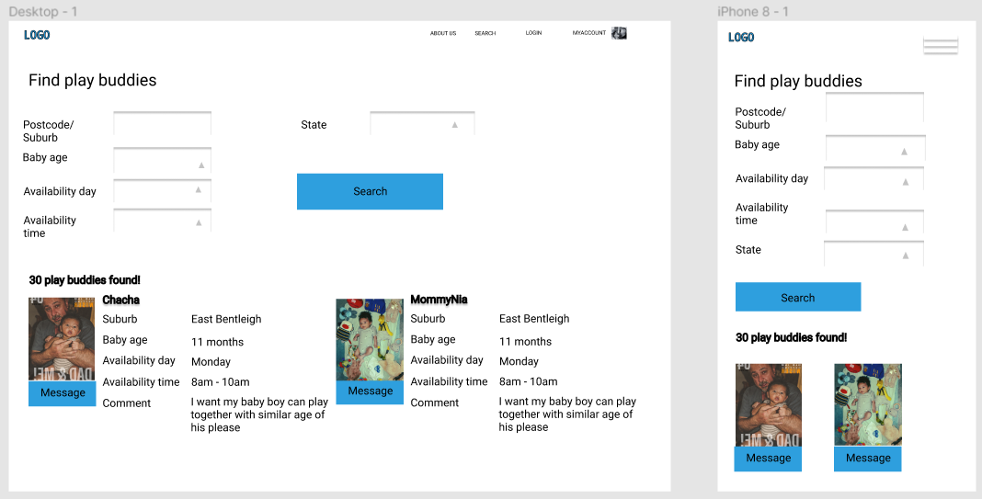

**Component Integrating**

Index.html

App.vue

Valid check for logging in using an email address

Home.vue

Default page after the user logged in

Search.vue Profile.vue

The user can see contact form once accessing menu about

About.vue

Navbar.vue

Profilecard.vue

Submit.vue

Contact.vue

Chat.vue

Profile.vue

Contactlist.vue

Textbox.vue

Chatbox.vue

**Concept and Future Plan**

* System Analysis

Once the user registered, the profile information will be stored/ saved, and reuse it in the next time to log in. User can stay signed in as well.

In the search page, input data in a search function will work accordingly, as well on profile information.

In a chat page, the chat function will be similar like other messenger apps.

* Technical Analysis

Following the assignment instructions, I will use HTML is for web content, CSS is for the way the web will present, JavaScript is for dynamic effects and Vue.js is for building web interface and page applications.

* My development schedules

This project is part of my assignments and due on 20 September 2021 for project presentation website. However, I will try to finish beforehand to avoid overdue by studying and finishing the tasks on unit site each week. The development schedule as below.

