**New Supplier Application- Non-Merchandise**

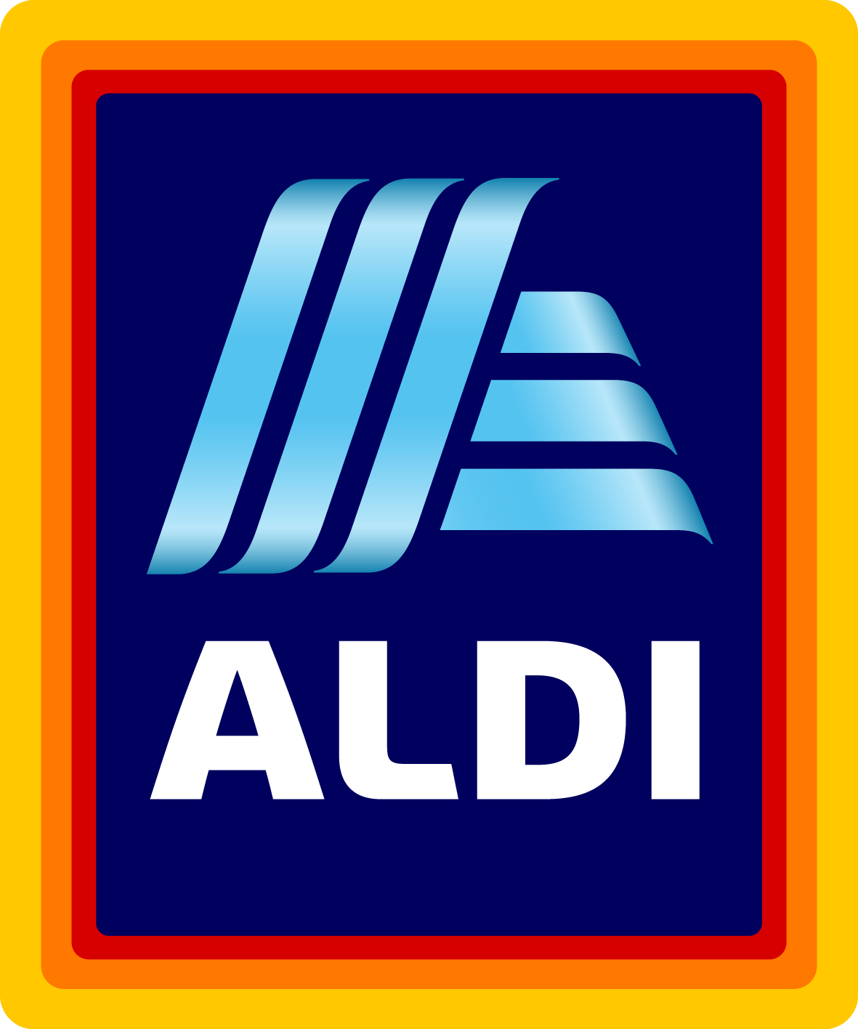

**SUBMISSIONS WILL NOT BE CONSIDERED UNLESS COMPLETED IN FULL.**

Date:02/13/2022

Company Name: Longrich America Int’l Inc

DUNS Number:

Company Headquarters Address:

City, State, ZIP, Country:

Company Headquarters Phone:

Contact Name and Title: Jackson Wang, Manager

Contact Phone:

Contact Fax:

Contact Email:Infousa@longrich.com

Company Website: Shoplongrichamerica.com

Have you reviewed our Supplier Video? Yes  No  (<https://corporate.aldi.us/en/suppliers/supplier-video/>)

Have you reviewed ALDI FAQs? Yes  No (<https://corporate.aldi.us/en/suppliers/faqs/>)

Can you uphold the ALDI Social Standards in Production at all levels of the supply chain? Yes  No  (https://corporate.aldi.us/fileadmin/fm-dam/Corporate_Responsibility2/CR_Policy/ALDI_SocialStandardsProduction_2017.pdf)

**What year was your company started? 2016**

**What are your annual sales?** **1.5 Million**

**Does your company have a U.S. or Canadian Sales Office?** Yes  No

**Are you a broker?** Yes  No  **Are you a distributor?** Yes  No

**Has your company ever supplied product to ALDI?** Yes  No

If so, please list the items supplied:

**What U.S. retailers are you currently supplying?** None, we are currently supplying to small distributors that are selling to local small retailer stores.

**Has your company shipped product to the United States?** Yes  No

**Are you able to quote Duties Delivered Paid (DDP) at a U.S. port?** Yes  No

**Production Facility Locations** (Street Address, City, State and Country):

**Where are your pick-up/shipping locations?** (City, State and Country):

**Have you visited our stores?** Yes  No

**Does your company supply apparel or textiles?** Yes  No

**What goods, supplies, equipment, or fixtures are you interested in supplying Aldi?**

**1. Specialized green tea toothpaste,**

**2. Specialized body lotion,**

**3. High-end saloon grade shampoo,**

**4. Bamboo charcoal soap, and other daily care products.**

**5. Specialized health supplements, healthy foods**

**Please provide details for your top-selling item.**

Product Name: **Longrich Muti-effect White Tea Toothpaste**

Detailed Description:

1. Fluoride-free decay resistance: white tea essence prevents decay and improves dental roots conditions.

2. Deep cleaning: the antiseptic and soft silicon abrasives give you a clean mouth with white teeth and fresh breath.

3. Gum strengthen: strontium chloride and composite aloe extract protects you against teeth sensitivity issues (cold, heat, acidity and sweetness)

Product Features & Specifications:

* Natural peppermint flavor helps freshen breath
* White tea extracts help protect gums
* Xylitol helps strengthen teeth
* 200g per tube

Contains refined bamboo charcoal extracts, effectively cleanses dirt, grime and excessive skin grease, leaving skin feeling clean and fresh. Moisturizes, protects and softens skin, keeps skin clean and healthy. Mild formula ideal for oily or neutral skin. Recommended for daily use.

White Tea Essence Soap

Multi-purpose For Face and body cleansing

Mild formula contains white tea extracts. Provides fresh care for skin; cleanses, brightens, refreshes and moisturizes, all in one.

Moisturizing formula makes skin look smooth and shining.

100g

**Moisturize hand skin, keep the skin bright, smooth, soft and high resilience.**

**100g**

**Does your product include a warranty:** Yes  No   
 If yes, please provide specific warranty coverages: Product exchange for unopened products sales within a certain period of time.

**In order to supply ALDI, your company must carry general and umbrella liability policies. Coverage requirements are based on product category and range from $2M each occurrence/ $3M aggregate to $10M each occurrence/$11M aggregate.**

Can you provide proof of insurance? Yes  No

If you do not currently have insurance, are you able to obtain the required coverage? Yes  No

If you do not currently carry adequate coverage, are you willing to increase your policy terms to meet ALDI requirements? Yes  No

Product carries the following certifications / meets the following standards (if applicable):

UL Certification

FDA (Indirect Food Contact)

NSF Certification

BIFMA Certification

ASTM F2372-15

ENERGY STAR®

**Please return your completed document via email to** [**supplierinfo@aldi.us**](mailto:supplierinfo@aldi.us) **or via mail to New Supplier Team, ALDI Corporate Buying, 1200 N. Kirk Rd., Batavia, IL 60510-1477**.

**Please refrain from sending samples unless requested.  
*ALDI is not liable for any costs incurred by a supplier in attempt to meet ALDI requirements. An Applicant will not become an ALDI supplier until ALDI and the Applicant enter into a formal written agreement. Fees associated with packaging design and product testing are the responsibility of the supplier.**