Project 4 CSC242

Group member: Yuanzhuo Wang, Kevin Kao, Tongyu Yang

How to run our program:

Change the current directory to src. Then type

javac \*/\*/\*/\*.java

Then

java learn/lc/examples/LogisticClassifierTest [file-name] [# of iterations] [learning rate]

ex: java learn/lc/examples/LogisticClassifierTest “learn/lc/examples/house-votes-84.data.num.txt” 10000 0.1

Logistic Classifier:

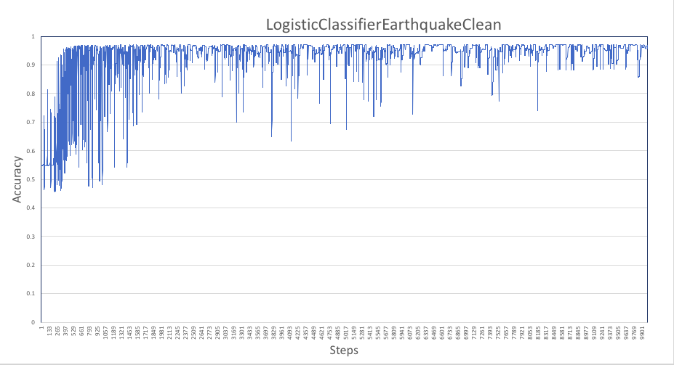

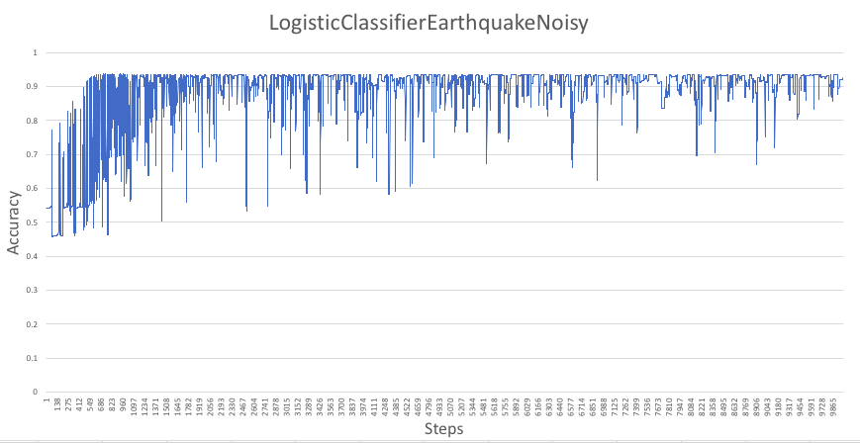

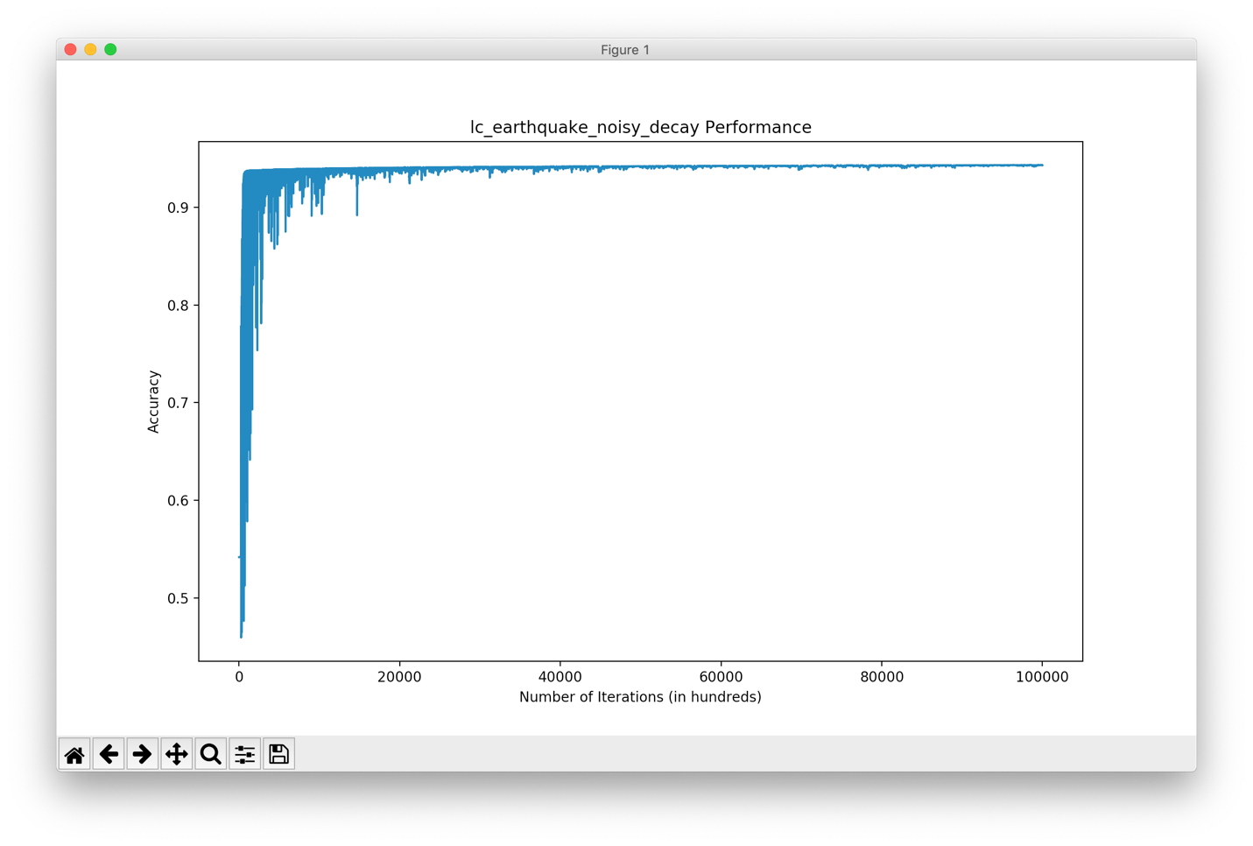

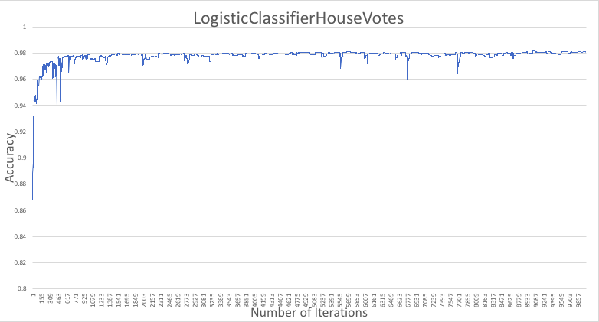

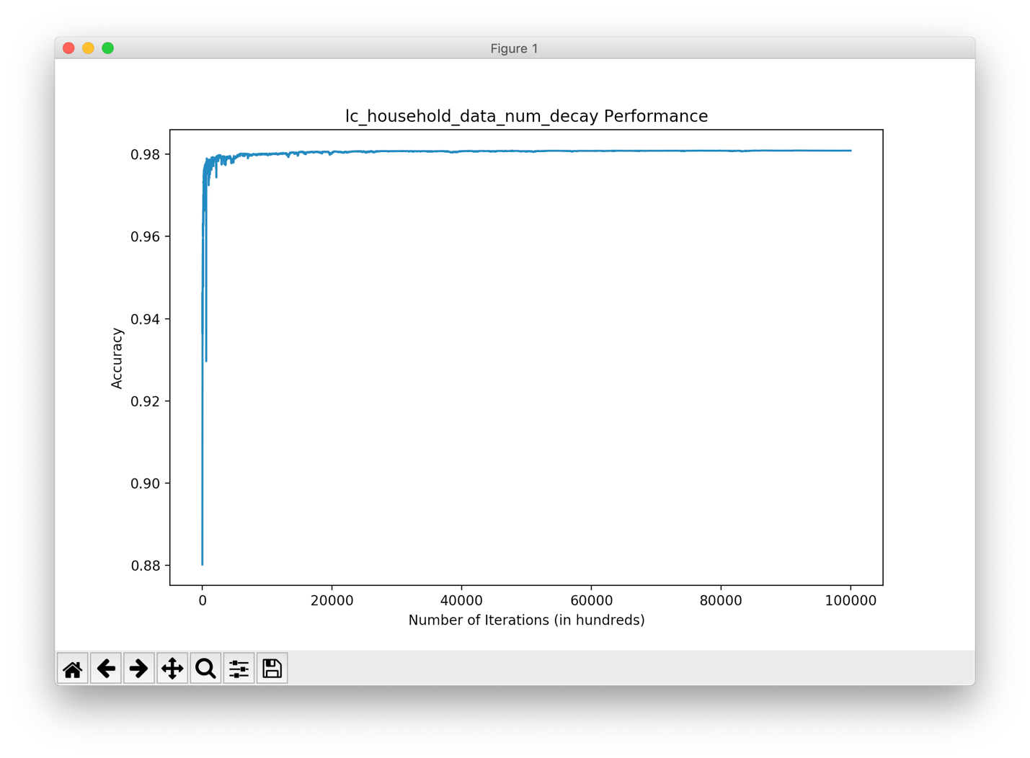

Perceptron Classifier:

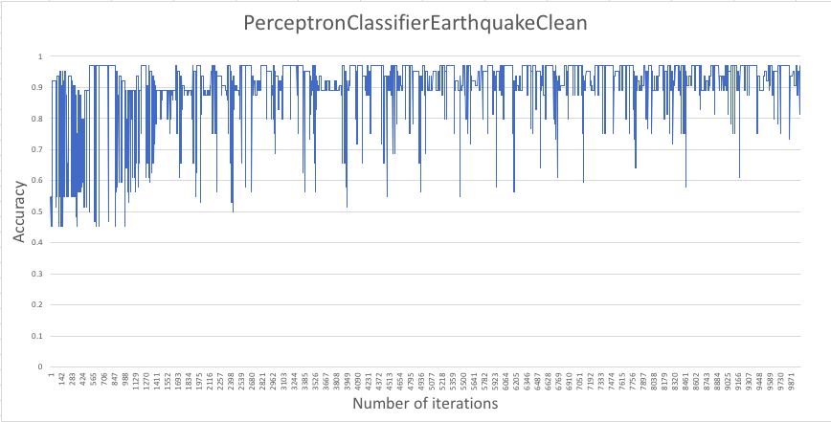

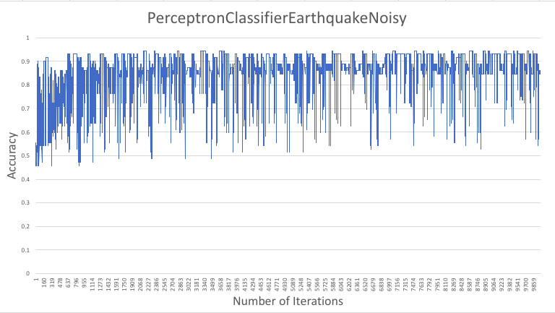

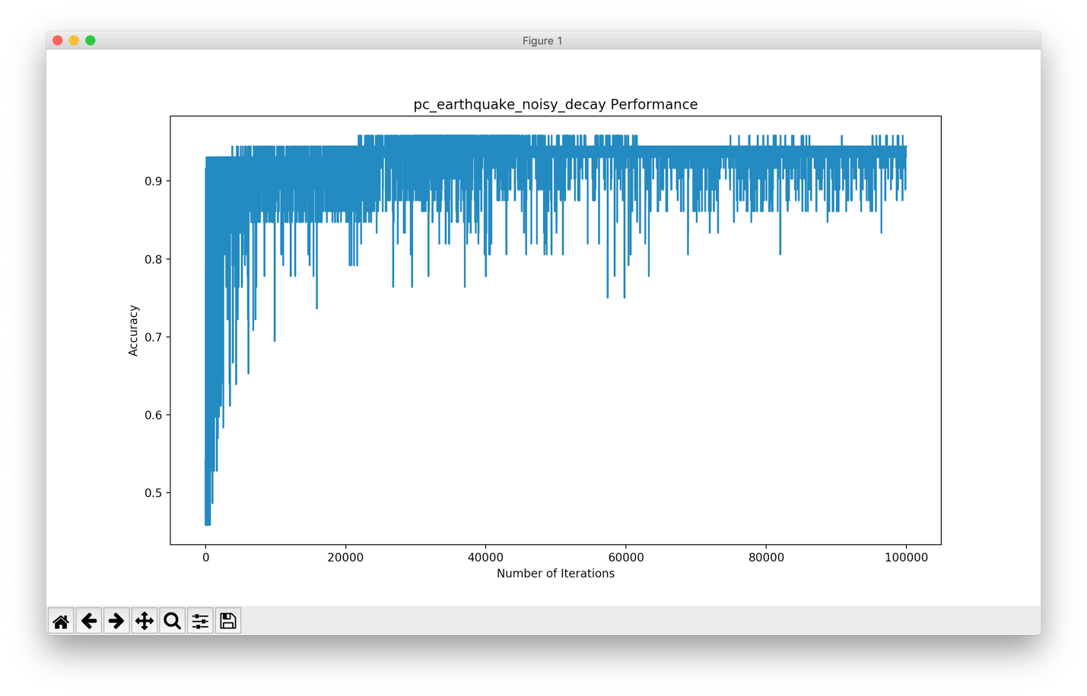

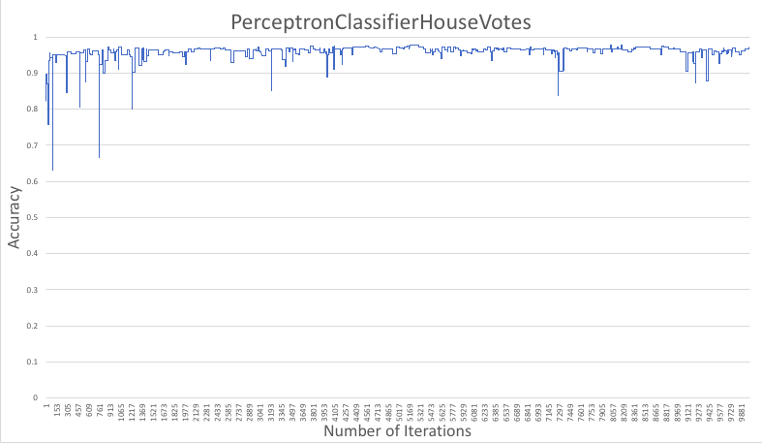

Neural Network:

