API URL: <https://private-f3b4b-interview2.apiary-mock.com/data>

Use: Bootstrap, Jquery, SCSS, HTML

Task:

* Either set up a web server to handle this or do it entirely front end. Up to you.
* Create a page that matches the attached screenshots for desktop size and mobile sized devices using responsive css
* Match the styling as close as possible. Default fonts were used.
* Format the “timestamp” property to match m/d/yyyy
* When a row is clicked, have the “secret” property be shown in the input at the top of the screen
* Change the background color to the value of the “secret”
* When the “clear” button is clicked, reset the input.

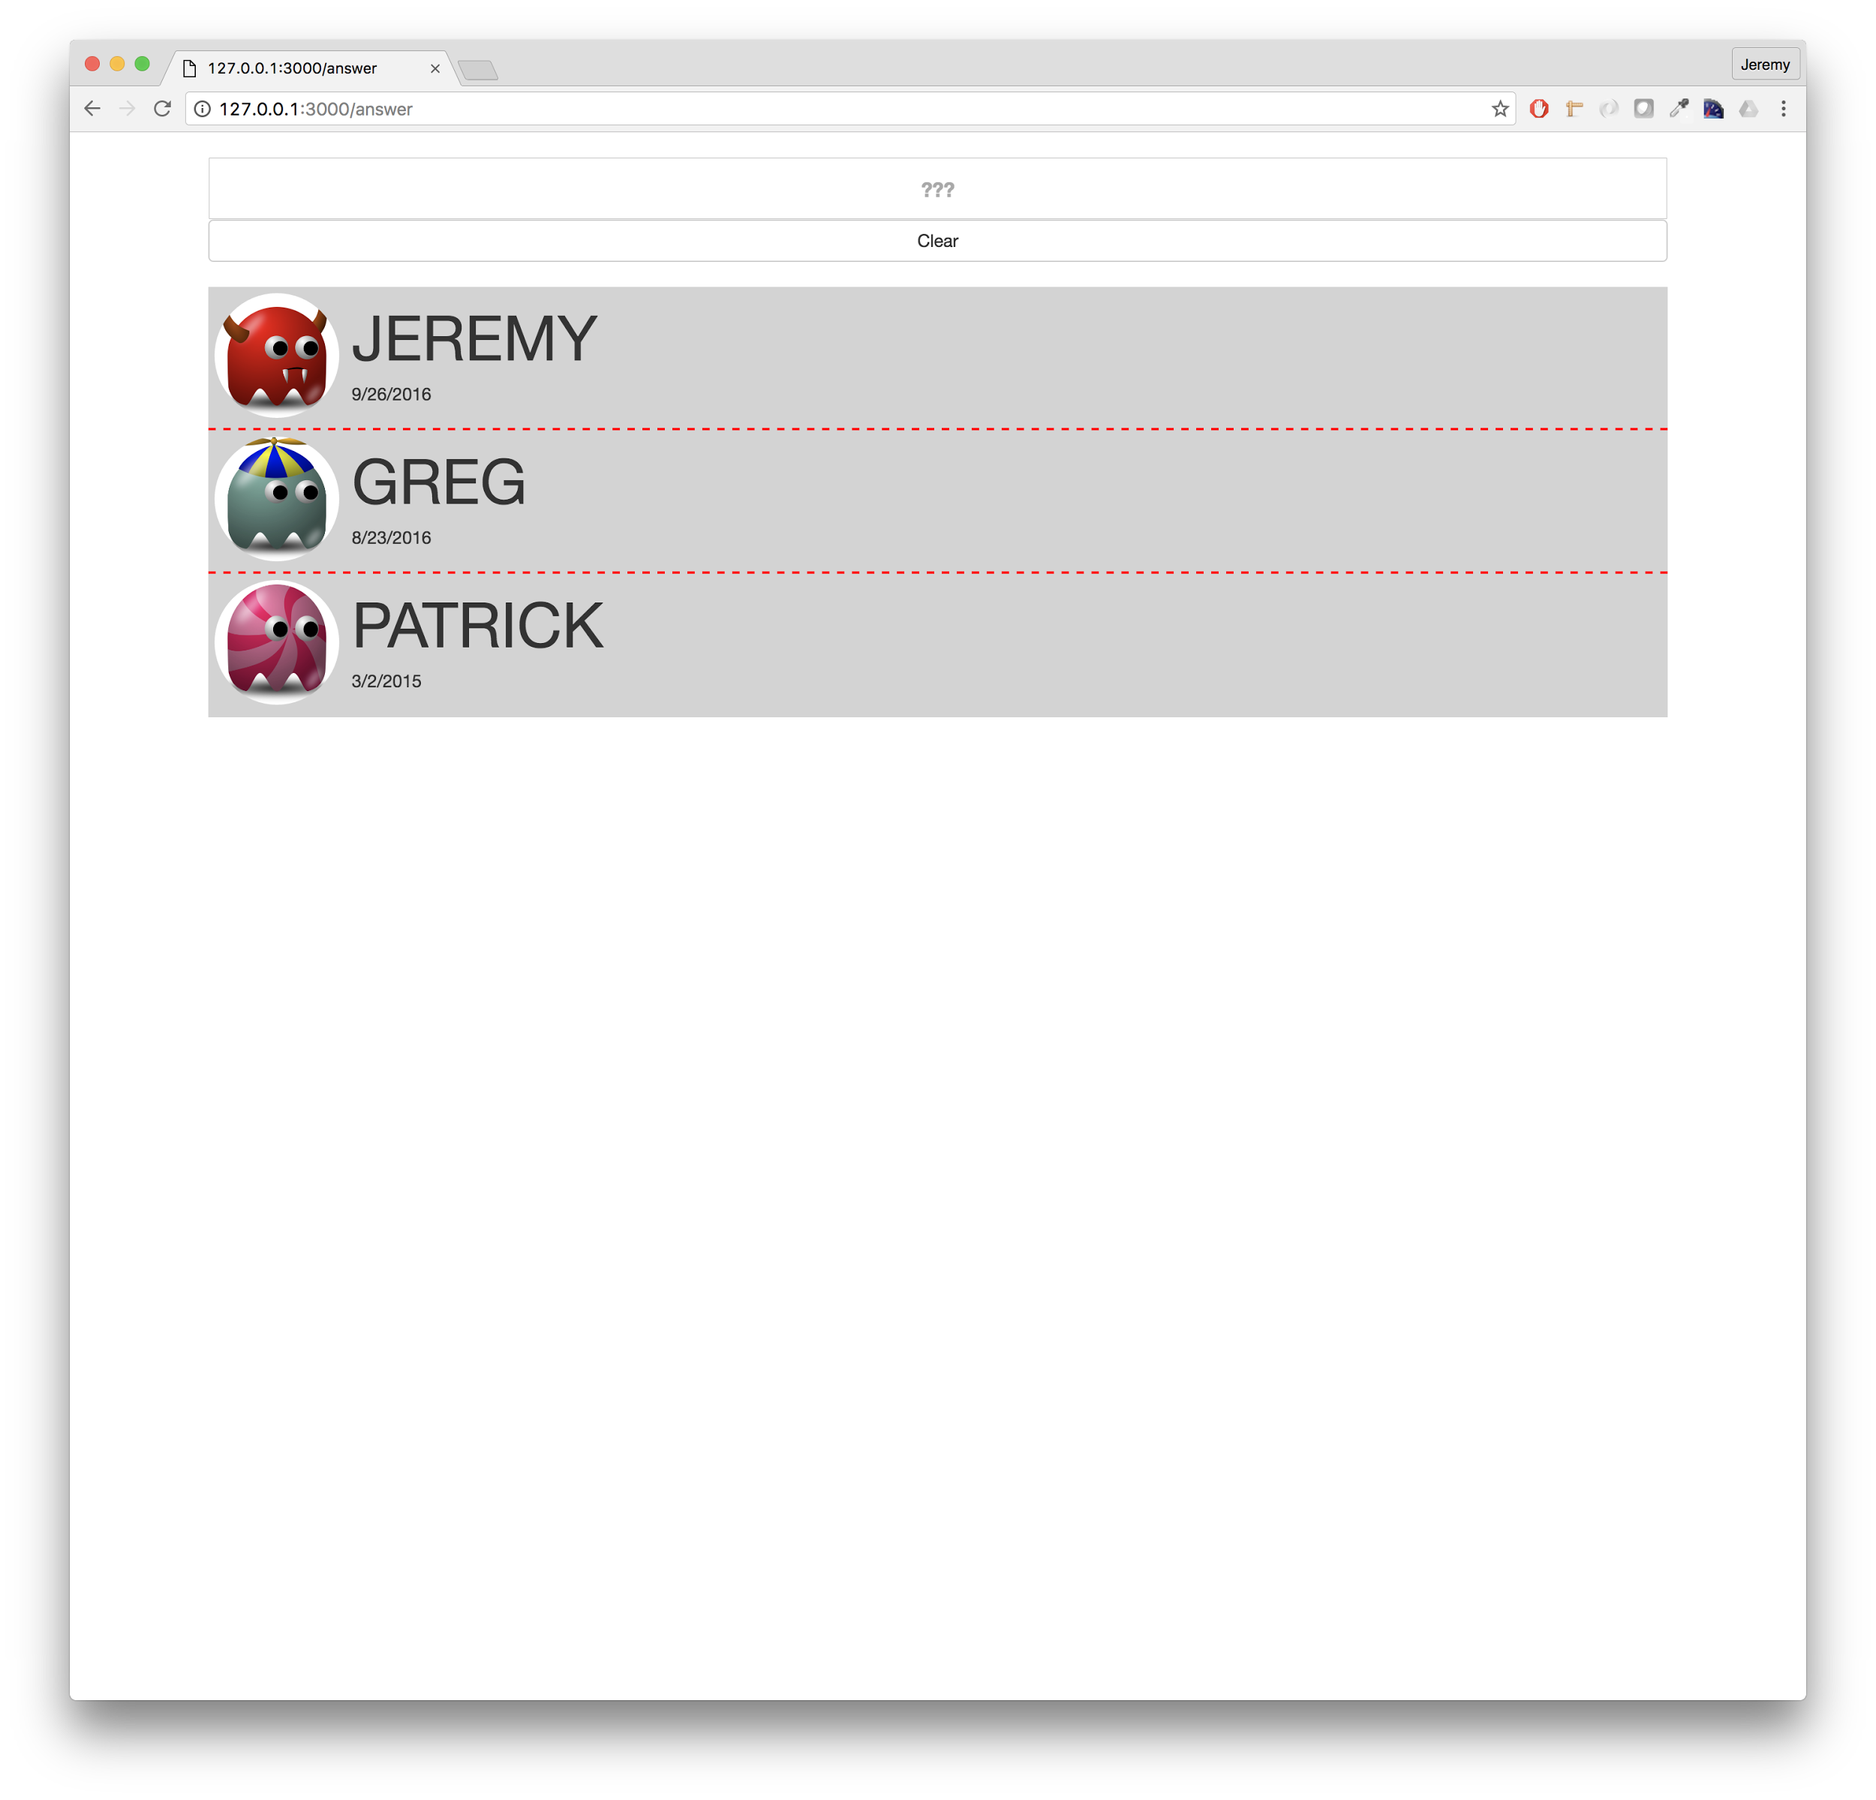

DESKTOP

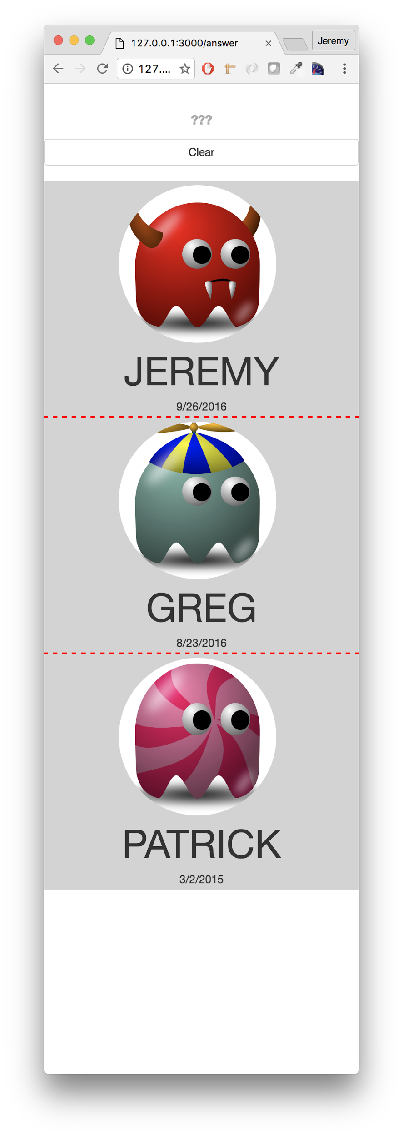

MOBILE

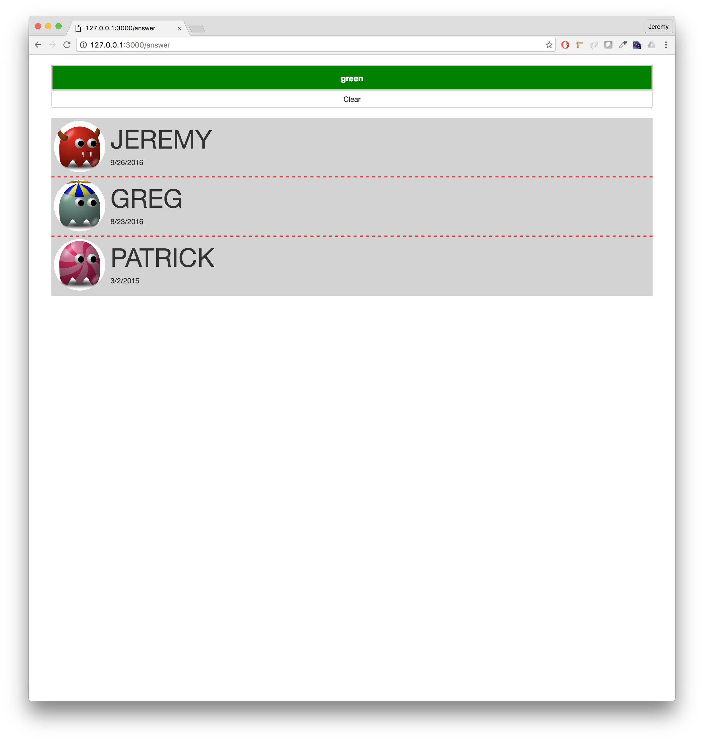

After clicking the GREG row