Working Status Analysis of H-1B Visa Workers Using H-1B LCA Disclosure Data (2020–2024)
Yufei Wu
Authors
- Yufei Wu$​^{1}$ (ORCID: 0009-0003-5051-0623)
Author affiliations
- Department of Chemistry, University of Georgia, Athens, GA, USA.
$∧$ Corresponding author: yufeiwu@uga.edu

1. Summary/Abstract
Background: The H-1B visa allows U.S. employers to hire foreign workers in specialized fields like technology, engineering, and medical sciences. It requires a bachelor’s degree or equivalent and typically lasts up to six years. Annually, 65,000 visas are available, with an additional 20,000 for candidates with U.S. master’s or doctorate degrees. Due to increasing applications, a lottery system determines who can file an H-1B petition. Employers must file a Labor Condition Application (LCA), detailing job title, wage, and location, as a prerequisite for H-1B approval. Analyzing LCA data can offer insights into H-1B application trends.
Data: This project uses LCA disclosure datasets from the U.S. Department of Labor, covering the period from 2020 to 2024. The data is provided by employers and includes final determinations issued by the Department’s Office of Foreign Labor Certification (OFLC) under the Employment and Training Administration (ETA). The dataset contains key variables such as job title, wage, and employer information for H-1B workers, making it useful for analyzing their employment status.
Methods: The analysis began by cleaning and filtering the H1B LCA Disclosure Data (2020–2024) to include only certified H-1B cases, focusing on key variables such as job titles, employer details, and wages. Univariate analysis was conducted to identify the most common job titles, top employers, and states with the highest number of applications, along with analyzing wage distributions. Bivariate analysis followed, examining median wages across different job titles, employers, and states, and tracking remote work trends before and after the pandemic. Predictive modelling was carried out only on a half‑month slice of the data (1–15 January 2024). Wages were binned into four ordered categories. Single‑predictor random‑forest classifiers (SOC title, employer state, work‑site state, employer) and a multivariate random‑forest model were trained, followed by three multivariate algorithms (Random Forest, XGBoost, and Support‑Vector Machine), evaluated with 5×5 repeated cross‑validation. Accuracy was the main metric; final models were refit on the 80% training portion of the slice and scored on the 20% hold‑out test set.
Results: Within the modelling slice, each single‑predictor forest out‑performed a null model (test accuracy ≈ 0.62–0.68). The multivariate forest improved test accuracy to 0.73. Among the three advanced models, Support‑Vector Machine attained the highest training accuracy (0.886) but lower test accuracy (0.717), indicating over‑fitting. Random Forest achieved the best balance between fit and generalisation (train=0.820; test=0.740) and was selected as the preferred wage‑prediction model for this data slice.

2. Introduction

2.1 General Background Information
The H-1B visa program, established by the Immigration Act of 1990, allows U.S. employers to hire foreign nationals in specialty occupations that require theoretical or technical expertise, typically in fields such as engineering, computer science, healthcare, and finance. Each fiscal year, the U.S. Citizenship and Immigration Services (USCIS) allocates 65,000 H-1B visas, with an additional 20,000 visas reserved specifically for candidates holding advanced degrees from U.S. institutions. Due to persistently high demand surpassing the available visa quota, USCIS employs a lottery selection system to determine which eligible applications may proceed (1).
Before submitting an H-1B petition, employers must file a Labor Condition Application (LCA) with the U.S. Department of Labor (DOL). The LCA certifies that the employer will pay the prevailing wage and maintain working conditions that do not adversely affect U.S. workers. Essential details such as job title, wage offered, and work location are included in the LCA, making it a valuable source for analyzing employment trends, wage distributions, and geographical patterns within the H-1B program (2).
Previous studies has examined the economic impacts and employment trends associated with the H-1B visa. Ke and Qiao used machine learning techniques on LCA data (2008–2018) to uncover key factors influencing salary levels and application outcomes, showing higher wages correlated strongly with specific job categories and industries such as healthcare and technology (3). Similarly, Dombe et al. applied deep-learning methods to predict H-1B approval outcomes, demonstrating that complex modeling approaches significantly enhance prediction accuracy (4).
Despite this growing body of work, there remains a gap in recent and comprehensive analyses that incorporate employment trends, remote work patterns, and advanced predictive modeling, especially after the labor practices have altered due to the pandemic. To address these gaps, this project analyzes certified H-1B visa cases from 2020 to 2024 using recent LCA disclosure data. This period encompasses major shifts in employment practices brought by the pandemic, providing timely insights into changes within the H-1B landscape. Specifically, the project investigates wage distributions, geographical variations, and remote work trends, combining descriptive analysis with sophisticated predictive modeling techniques (Random Forest, XGBoost, Support Vector Machines). The results provide essential baseline information for policymakers, businesses, and researchers aiming to understand the current and future patterns of high-skilled international labor in the U.S.

2.2 Questions/Hypotheses to be addressed
This analysis will primarily focus on certified cases. The key research questions to be examined include:
(1)Distribution Analysis:
What is the distribution of certified cases across various features such as SOC titles, locations, wages, and employer names?
(2)Variable Relationships:
How do wages vary across different states, SOC titles, and employers?
(3)Employment Trends and Remote Work Patterns:
How have employment patterns evolved over time?
What trends can be observed in remote work prevalence before and after the pandemic?
(4)Predictive Modeling:
Can a predictive model be developed to estimate wages based on job-related and employer-specific features?

3. Methods

3.1 Data aquisition and cleaning
The dataset is H1B LCA Disclosure Data (2020-2024) from the U.S. Department of Labor. The data is provided by employers and includes final determinations issued by the Department’s Office of Foreign Labor Certification (OFLC) under the Employment and Training Administration (ETA). It includes information such as case status, job title, Standard Occupational Classification (SOC) title, location, and wages. It can be easily downloaded from Kaggle.
To ensure data quality, the dataset was filtered to include only certified cases and those specifically related to H-1B visa applications.
Additionally, the dataset was refined to include only the following essential variables:
RECEIVED_DATE (date the application was received); SOC_TITLE (occupational title classified under the SOC system); EMPLOYER_NAME (name of the employer); EMPLOYER_STATE (employer’s location); WORKSITE_STATE (location of the worksite); WAGE_RATE_OF_PAY_FROM (wage offered to the worker); WAGE_UNIT_OF_PAY (unit of pay values); PREVAILING_WAGE (prevailing wage for the job); PW_UNIT_OF_PAY (unit of pay values)
Observations with missing values in the selected variables were removed. All character columns except state names were standardized to lowercase.

3.2 Statistical analysis

3.2.1 Exploratory/Descriptive Analysis
The method began with an exploratory analysis to assess the overall structure of the dataset. Univariate techniques were applied to examine the distribution of key variables, such as job titles, employers, and geographic locations, by analyzing application counts over a multi-year period. Additionally, the distribution of prevailing wages was evaluated using visualizations to understand the range and concentration of wage values.

3.2.2 Initial Statistical Analysis
For the initial statistical analysis, a half-month subset of the data (from January 1–15, 2024) was selected. The continuous wage variable was then converted into categorical ranges to facilitate further analysis. Bivariate analyses were conducted using Random Forest classification models with individual predictors, including SOC title, employer location, worksite location, and employer name. These single predictor models were compared against a null model to assess their predictive utility.

3.2.3 Full Analysis
In the full analysis phase, multiple advanced modeling techniques were employed to predict wages. The methodology involved developing models using Random Forest, XGBoost, and SVM, with a comprehensive cross-validation approach (5-fold with 5 repetitions) to ensure robust evaluation. A comparative analysis of the training and test performance of these models was carried out to identify the approach that best balanced model complexity and generalization capability for wage prediction.

4. Results

4.1 Exploratory/Descriptive analysis

4.1.1 Univariate Analysis: Distribution Analysis
The Figure 1 (a) displays the 10 job titles with the highest number of applications filed between 2020 and 2024, with “Software Developers, Applications” leading at over 500,000 cases. The Figure 1 (b) highlights the top 10 employers by application count, with “COGNIZANT TECHNOLOGY SOLUTIONS US CORP” topping the list at approximately 93,000 cases. The Figure 1 (c) presents the 10 states with the most applications, with California recording over 600,000 cases. Meanwhile, the Figure 1 (d) illustrates the distribution of prevailing wages, revealing that most cases offer wages near $100,000 per year, while fewer cases fall at the lower end (around $15,000) or approach higher values near $800,000 (see Supplement Table 1).
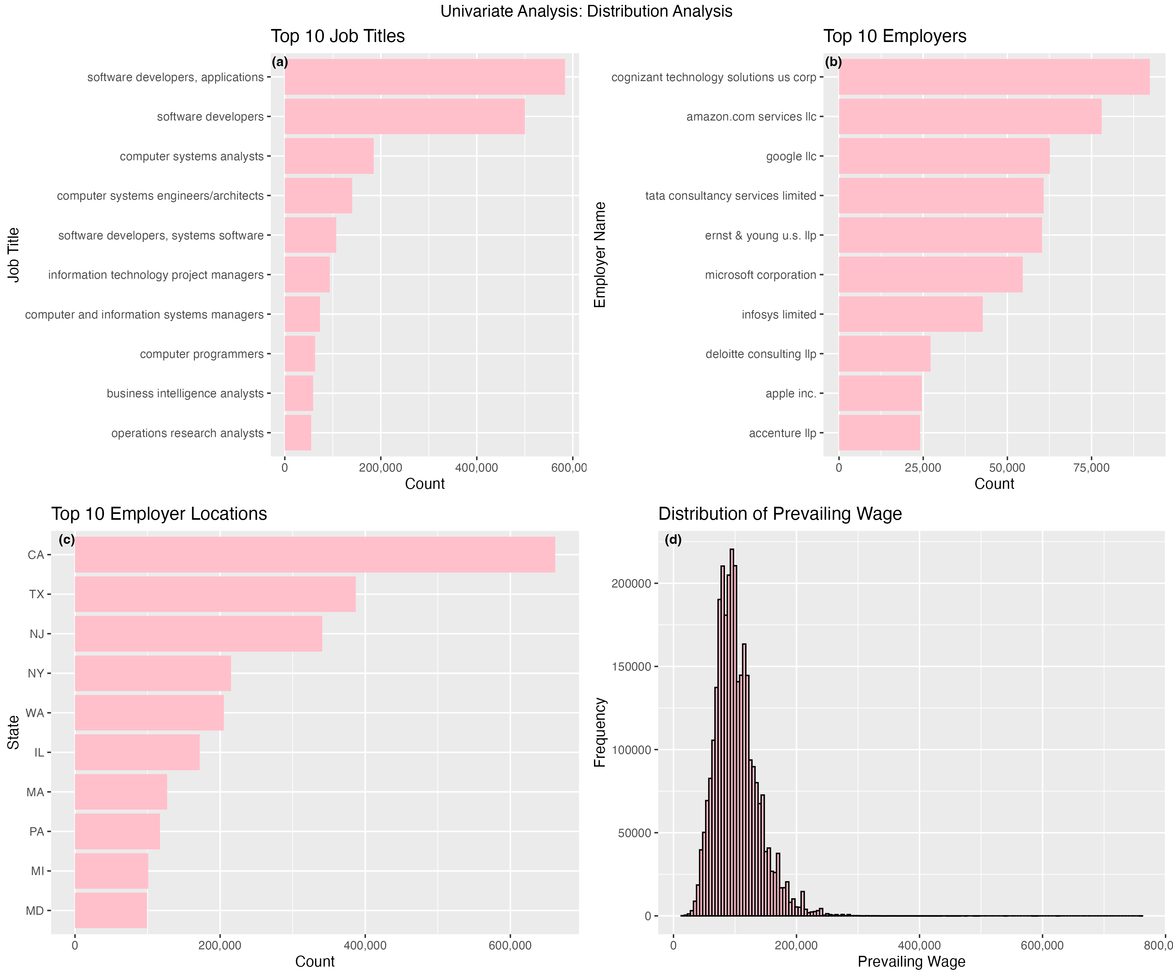
Figure 1: Univariate Analysis: Distribution Analysis.

4.1.2 Bivariate Analysis
The Figure 2 (a) shows the 10 job titles with the highest median wage, and they are all medical practitioners. The Figure 2 (b) highlights the 10 employers with the highest median wage, spanning healthcare, financial services, life sciences, technology, and manufacturing. The Figure 2 (c) indicates that Washington has the highest median wage by state. Plots for the 10 lowest median wages are provided in Supplement Figures 1–3. The Figure 2 (d) illustrates the trend of remote work over the years. The number of remote work cases surged from 2019 to 2020 due to the pandemic and remained relatively stable from 2020 to 2023. Post-pandemic, there was a slight decline from 2023 to 2024. However, as remote work patterns became more established, the decrease was not significant. This analysis uses absolute values instead of proportions because remote work is identified based on discrepancies between employer and worksite states. Some remote work cases may not be captured under this definition, potentially underestimating the actual proportion. Therefore, absolute values provide a more accurate reflection of the remote work trend.
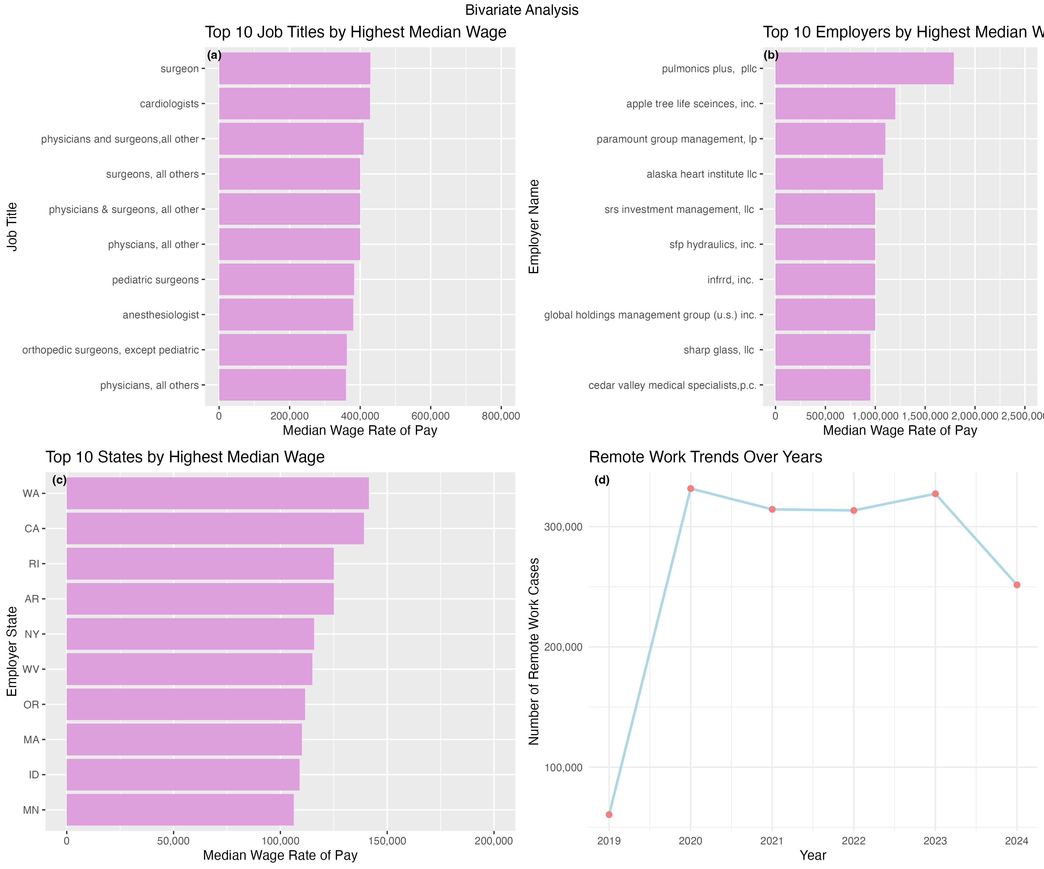
Figure 2: Bivariate Analysis.

4.2 Initial statistical analysis
The variable wage was selected as the outcome of interest to study the wages of H-1B workers. I first conducted a bivariate analysis to identify potential predictor variables. To perform the analysis, I selected a half-month subset of the data.
The Figure 3 illustrates a histogram of wage distribution during January 1–15, 2024. The continuous wage variable was categorized into four ranges: “(0, 75,000)”, “(75,000, 150,000)”, “(150,000, 225,000)”, and “Above 225,000”, converting it into a categorical variable.
A random forest model was applied for classification using a single predictor, with 1,380 observations in the training set and 346 observations in the testing set. Table 1 to Table 4 summarize the model fit for the predictors: SOC title, employer location, worksite location, and employer name. The results indicate that these variables exhibit moderate predictive performance.
Next, a multivariate random forest model was developed. Table 5 shows that the multivariate model outperformed the bivariate models.
All the models performed better than null model (Table 6), with the multivariate model performed best.
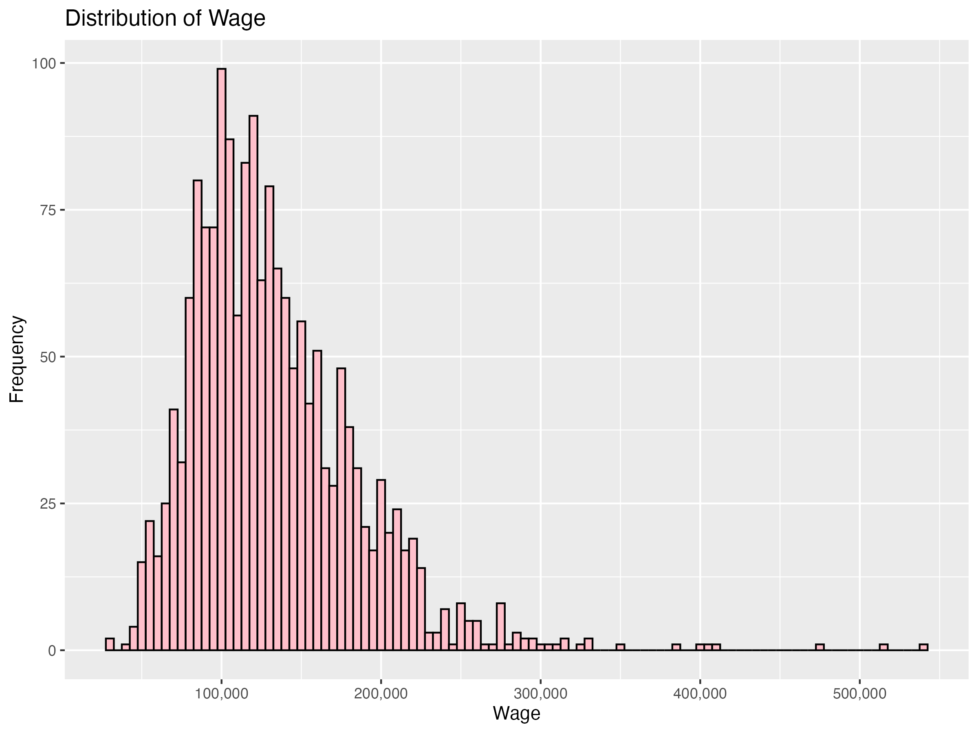
Figure 3: Distribution of Wages (January 1–15, 2024).
Table 1: Model Fit for Wage Based on Job Title.
dataset | .metric | .estimator | .estimate
Train | accuracy | multiclass | 0.6985507
Test | accuracy | multiclass | 0.6531792

Table 2: Model Fit for Wage Based on Employer Locations.
dataset | .metric | .estimator | .estimate
Train | accuracy | multiclass | 0.6195652
Test | accuracy | multiclass | 0.6242775

Table 3: Model Fit for Wage Based on Worksite Locations.
dataset | .metric | .estimator | .estimate
Train | accuracy | multiclass | 0.6268116
Test | accuracy | multiclass | 0.6763006

Table 4: Model Fit for Wage Based on Employer.
dataset | .metric | .estimator | .estimate
Train | accuracy | multiclass | 0.8673913
Test | accuracy | multiclass | 0.6936416

Table 5: Model Fit for Wage Based on Job Title, Employer Location, Worksite Location, and Employer.
dataset | .metric | .estimator | .estimate
Train | accuracy | multiclass | 0.8217391
Test | accuracy | multiclass | 0.7341040

Table 6: Null Model.
dataset | .metric | .estimator | .estimate
Train | accuracy | multiclass | 0.6065217
Test | accuracy | multiclass | 0.6156069

4.3 Full analysis
The initial statistical analysis shows that variables SOC title, employer location, worksite location, and employer name can serve as predictors for outcome variable wage. Based on that, Random Forest, XGBoost, and SVM were used to fit the model, including cross-validation (5-fold and 5 times repetition).
Tables summarizing the performance of the three models can be found in Supplement Table 2-4. CV accuracy distribution for different models can be found in Supplement Figure 4. Figure 4 shows the cmoparison of model performance among Random Forest, XGBoost, and SVM. SVM achieves the highest accuracy on the training data (0.886), while Random Forest (0.820) and XGBoost (0.738) show slightly lower training accuracy compared to SVM. On the test set, random forest outperform among the three models with an accuracy of 0.740. The SVM model’s high training performance compared with its relatively lower test performance (0.717) indicates that it might be capturing noise or very specific patterns in the training data that do not carry over to unseen data. In contrast, Random Forest keeps a better balance between fitting the training data and maintaining generalization on the test data. Therefore, the Random Forest model can be chosen to predict the wage since it appears more robust on the test data.
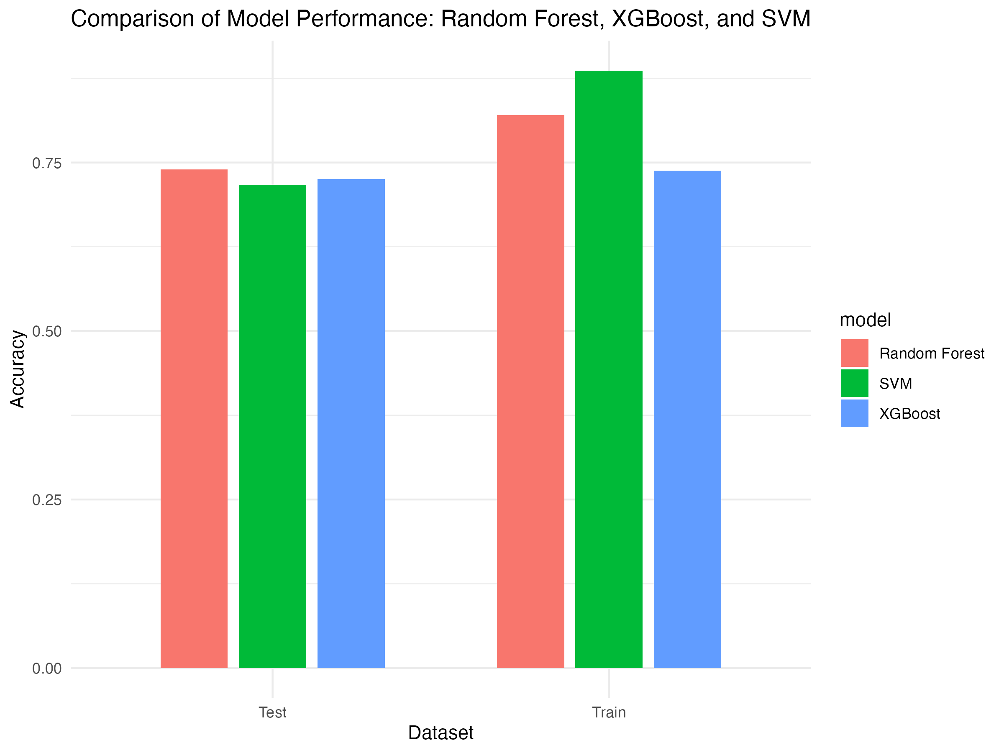
Figure 4: Comparison of Model Performance: Random Forest, XGBoost, and SVM.

5. Discussion

5.1 Labor-market findings
The exploratory results clearly showed the dominance of the technology sector in H-1B employment, especially the role of “Software Developers, Applications,” with over 500,000 cases. California was identified as the primary destination state. Interestingly, however, higher median wages were found predominantly among medical occupations and employers in healthcare and financial industries, rather than the technology sector itself. Washington state showed the highest median wage, likely because of the presence of major technology and e-commerce companies.
The analysis of remote-work cases indicated a sharp increase during 2020, driven by the pandemic. This trend remained relatively stable until a slight decrease in 2024. The persistence of remote-work practices suggests that flexible work arrangements have become established in the H-1B landscape, although the method used to identify remote work (differences between employer and worksite states) may underestimate actual prevalence.

5.2 Predictive modeling performance
Predictive modeling using a half-month subset (January 1–15, 2024) showed promising results. Single-predictor random-forest models revealed that the employer’s identity alone significantly influenced wage predictions, indicating substantial pay differences among employers. Geographic location also had a meaningful effect. A multivariate random-forest model achieved improved test accuracy (0.73), and among the three advanced models tested—Random Forest, XGBoost, and SVM—the Random Forest model offered the best balance between accuracy on training data (0.82) and generalization on test data (0.74). This suggests that Random Forest is well-suited for predicting wage categories from this type of data.

5.3 Limitations and future directions
There are several limitations in this study. First, predictive modeling was conducted using only a brief half-month period due to computational memory constraints, which limits generalizability to broader timeframes. Second, converting continuous wages into four broad categories simplifies the analysis but sacrifices detailed wage information. Future studies should consider expanding the analysis to larger, longer-term datasets. Exploring continuous-wage prediction models, using more sophisticated techniques for handling class imbalance, and analyzing textual information from job titles might enhance model accuracy.

6. Conclusions
This study analyzed certified H-1B visa cases from 2020 to 2024, highlighting key trends in job titles, wages, and remote-work patterns. Predictive modeling demonstrated that a Random Forest classifier effectively predicts wage categories based on employer, occupation, and geographic location. Although limited by using a short time frame and categorized wage data, this approach provides a useful baseline for wage prediction. Future studies expanding dataset size, analyzing continuous wages, and including additional factors could further improve predictive accuracy and provide deeper insights into H-1B employment patterns.

7. References
1. The H-1B Visa Program and Its Impact on the U.S. Economy. American Immigration Council. 2016;
2. Mahajan P, Morales N, Shih K, et al. The impact of immigration on firms and workers: Insights from the h-1b lottery. 2024;
3. Ke B, Qiao A. Who gets the job and how are they paid? Machine learning application on h-1B case data. 2019;(https://arxiv.org/abs/1904.10580)
4. Dombe A, Rewale R, Swain D. A deep learning-based approach for predicting the outcome of h-1B visa application. Machine Learning and Information Processing. 2020;

