Question 1- Easy

**The Mystery Triangle Quest**

In a faraway magical land, three powerful wizards each wield a magical wand with a unique length. Together, they can form a mystical triangle if certain conditions are met. The type of triangle (by side) they form determines the type of magical barrier they can create, each with different properties.

You're given lengths of wands. Determine if the wands can form a magical triangle and, if so, identify the type of triangle based on the following rules:

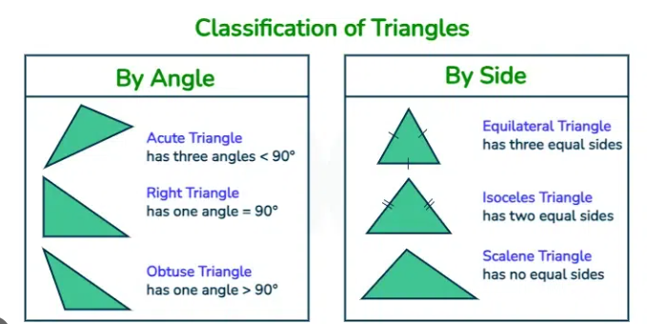

**1. Equilateral Barrier**: If the triangle is ‘Equilateral Triangle’. This barrier is strong against all types of spells.

**2. Isosceles Barrier:** If the triangle is ‘Isosceles Triangle’. This barrier reflects low-level spells.

**3. Scalene Barrier:** If the triangle is ‘Scalene Triangle’. This barrier weakens any single-target spell.

**4. Shattered Magic:** If the wands cannot form a triangle, they create a "shattered magic" that does not protect the wizards.

**Write a code that takes space separated three integers as inputs and print a string representing the type of magical barrier or "Shattered Magic" if the wands cannot form a triangle.**

**Input Format:**

Space separated three integers

**Constraints:**

**1<= length of a wand <= 200**

**Test Case 1:**

Input: 4 4 4

Output: Equilateral Barrier

**Test Case 2:**

Input: 5 5 8

Output: Isosceles Barrier

**Test Case 3:**

Input: 1 2 3

Output: Shattered Magic

*************************************************************************************

**Hidden Test Cases :**

Input: 3 4 5

Output: Scalene Barrier

Explanation: All wands are of different lengths, and they satisfy the triangle inequality, forming a Scalene Barrier.

Input: 8 4 4

Output: Shattered Magic

Input: 1 1 2

Output: Shattered Magic

Input: 10 10 15

Output: Isosceles Barrier

Explanation: Two sides are equal, and they satisfy the triangle inequality.

Input: 100 150 200

Output: Scalene Barrier

Explanation: All sides are different, and they satisfy the triangle inequality.

Input: 2 3 4

Output: Scalene Barrier

Explanation: All sides are different, and they satisfy the triangle inequality.

Input: 5 5 10

Output: Shattered Magic

Explanation: 5 + 5 is exactly 10, so it cannot form a triangle.

Input: 1 2 10

Output: Shattered Magic

Explanation: 1 + 2 is not greater than 10, so it cannot form a triangle.

Input: 7 10 12

Output: "Scalene Barrier"

Explanation: All sides are different, and they satisfy the triangle inequality.

Input: 100 100 99

Output: Isosceles Barrier

Explanation: Two sides are equal and the wands satisfy the triangle inequality, forming an Isosceles Barrier.

Input: 1 1 1

Output: Equilateral Barrier

Explanation: All sides are equal, forming an Equilateral Barrier.

Question 2- Medium

**Mission: Operation Silent Guardian**

In the dead of night, a small squad of soldiers is stationed a top a remote, abandoned building on the outskirts of a besieged town. This squad is the last line of defense, tasked with protecting frontline forces engaged in a fierce battle against enemy armor advancing through the area. The squad has a single mortar gun on the rooftop, which is their only means of assisting their comrades below. (A mortar is a portable, short-barreled, muzzle-loading artillery weapon that fires explosive projectiles at high arcs and short ranges)

You, the leader of the squad, have received intelligence reports indicating that enemy tanks and armored vehicles are closing in on allied positions, concealed under the cover of night. Time is critical, and every second counts. You must calculate the mortar's trajectory, as one misfire could expose your location to the enemy—or worse, endanger your own allies. Use your physics knowledge you gained from military academy.

**The Challenge**

To deliver effective support, you need to determine:

1. **The flight time** of the mortar shell to anticipate when it will hit.
2. **The horizontal range** of the shell to ensure it reaches enemy positions but not beyond, where allied forces are stationed.
3. **The maximum height** the shell will reach, which is important to ensure it clears any potential obstacles on the battlefield.

Your team only has a few moments to respond. Using the **initial speed** of the shell, **height of the building**, and the **angle** at which you’ll fire, you must quickly make these calculations before relaying the firing instructions to your squad. Precision is key, and there’s no room for error.

**Example Scenario**

Imagine you’re given the following data:

* **Initial speed** of the mortar shell as it leaves the gun: 90 m/s
* **Height of the building** where you’re stationed: 45 meters
* **Launch angle** of the mortar gun: 55 degrees

With this information, calculate:

1. **Flight time** – how long the shell will remain in the air.
2. **Horizontal range** – how far it will travel horizontally.
3. **Maximum height** – the highest point it will reach, above the ground.

This will enable your team to adjust the angle or timing of the next shot if the shell doesn’t land precisely where intended.

*Hint – use above inclined projectile diagram to derive required equations from standard motion equations.

* Assume g = 9.81

Standard motion equations:  
  
**Input Format**

* $y_{0}$: height of the building(meters)
* $u$: the initial speed of the shell (meters per second)
* $α$: angle that you fire (degrees)  
    
  Inputs will be provided in 3 lines. All inputs are integers.

**Constraints:**

* **1 <= $y_{0}$ <= 2000**
* **100 <= $u$ <= 500**
* **0 <= $α$ <= 90**

**Output Format:**

Print **Flight time, Horizontal range** and **Maximum height** in three lines respectively.

Roundoff your answers for **five decimal points**.

**Test Case 1:**

Input:

100

100

45

Output:

15.71348

354.842

1111.11111