项目概述
1. Objective
Primary Goal: Demonstrate how Shared Memory serves as a critical optimization tool in GPU programming, enabling high-performance computing by reducing latency and improving bandwidth utilization.

Focus Areas:
Core concepts and architectural role of Shared Memory.
Practical implementation in CUDA.
Performance optimization strategies and real-world applications.

主要特点
Backgrounds:
Types of GPU Memory
GPU memory can be categorized into two types:
On-board memory (e.g., global memory):High capacity but high latency (~400 cycles).
On-chip memory (e.g., shared memory):on-chip memory is integrated directly inside the processor, its access is very fast and can significantly improve the performance of the processor.
Small, low-latency (~20 cycles), and high-bandwidth (~1.5 TB/s).
Acts as a programmable cache with three primary roles:
Intra-block thread communication channel.线程间交流通道 --shared memory
Program-managed cache for global memory data.可编程cache
Scratchpad memory（暂存） for optimizing global memory access patterns.

Hierarchy:
GPU Chip → GPC → TPC → SM → CUDA Cores/Tensor Cores
GPU
├── GPC (Graphics Processing Cluster)
│ ├── TPC (Texture/Processor Cluster)
│ │ ├── SM (Streaming Multiprocessor)
│ │ │ ├── CUDA 核心 (CUDA Cores)
│ │ │ ├── 张量核心 (Tensor Cores)
│ │ │ ├── RT 核心 (Ray Tracing Cores)
│ │ │ └── 纹理单元 (Texture Units)
│ │ └── PolyMorph Engine负责几何阶段的计算，支持复杂的 3D 场景
│ └── Raster Engine (光栅引擎)
└── L2 Cache (共享缓存)

GPC-TPC Workflow
Task Distribution:GPU assigns rendering/compute tasks to GPCs.
GPC Scheduling:GPC splits tasks and delegates them to TPCs.
TPC Execution:SMs execute computations; (texture units process graphics textures.)
Result Aggregation:GPC consolidates outputs from TPCs for final output.

basic definition:
GPC (Graphics Processing Cluster):
GPC is the top-level hardware module in a GPU, coordinating parallel workloads across submodules (e.g., TPCs, SMs).A GPC is a group of SMs in the hardware hierarchy that are always physically close together.

Raster Engine (光栅引擎)：渲染用
TPC (Texture纹理 Processing Cluster):
TPC is a submodule of a GPC, originally designed for texture processing (critical for graphics rendering). Now contains SMs (Streaming Multiprocessors) and texture units, handles both texture operations and general-purpose compute tasks (e.g., CUDA workloads).

Streaming multiprocessor(sm)：
Streaming Multiprocessors (SMs) are the fundamental computational units in NVIDIA GPUs.
An SM is a parallel processing unit within an NVIDIA GPU that executes multiple threads concurrently. Each SM contains multiple CUDA cores (also called ALUs or Streaming Processors, each capable of executing one thread per clock cycle,),
and fixed resources:
- Registers :Fast, private memory for thread-local variables.
- Shared Memory
- L1 Cache/Shared Memory Partition:Configurable split between L1 cache and shared memory (e.g., 128 KB total in Ada Lovelace).
- Warp(线程束) Schedulers:Manage warp execution and context switching to hide latency.

LD/ST:load/store负责加载存储 --不重要

运算：（简要提及）
Tensor Cores:Tensor Cores are specialized high-performance compute cores for matrix multiply and accumulate (MMA) math operations that provide groundbreaking performance for AI and HPC applications. Tensor Cores operating in parallel across SMs in one NVIDIA GPU deliver massive increases in throughput and efficiency compared to standard floating-point (FP), integer (INT), and fused multiply-accumulate (FMA) operations.
Streaming processor(sp):
The most basic processing unit. The GPU does parallel computing, that is, many SPs do processing at the same time. Now the term SP has been somewhat watered down, instead using thread instead. One SP corresponds to one thread.
SFU(special function unit):专门处理复杂数学运算的硬件单元，支持的运算包括：超越函数：sin, cos, exp, log, sqrt 等。插值运算：如纹理采样中的插值。类型转换：如浮点与整数的快速 --不重要
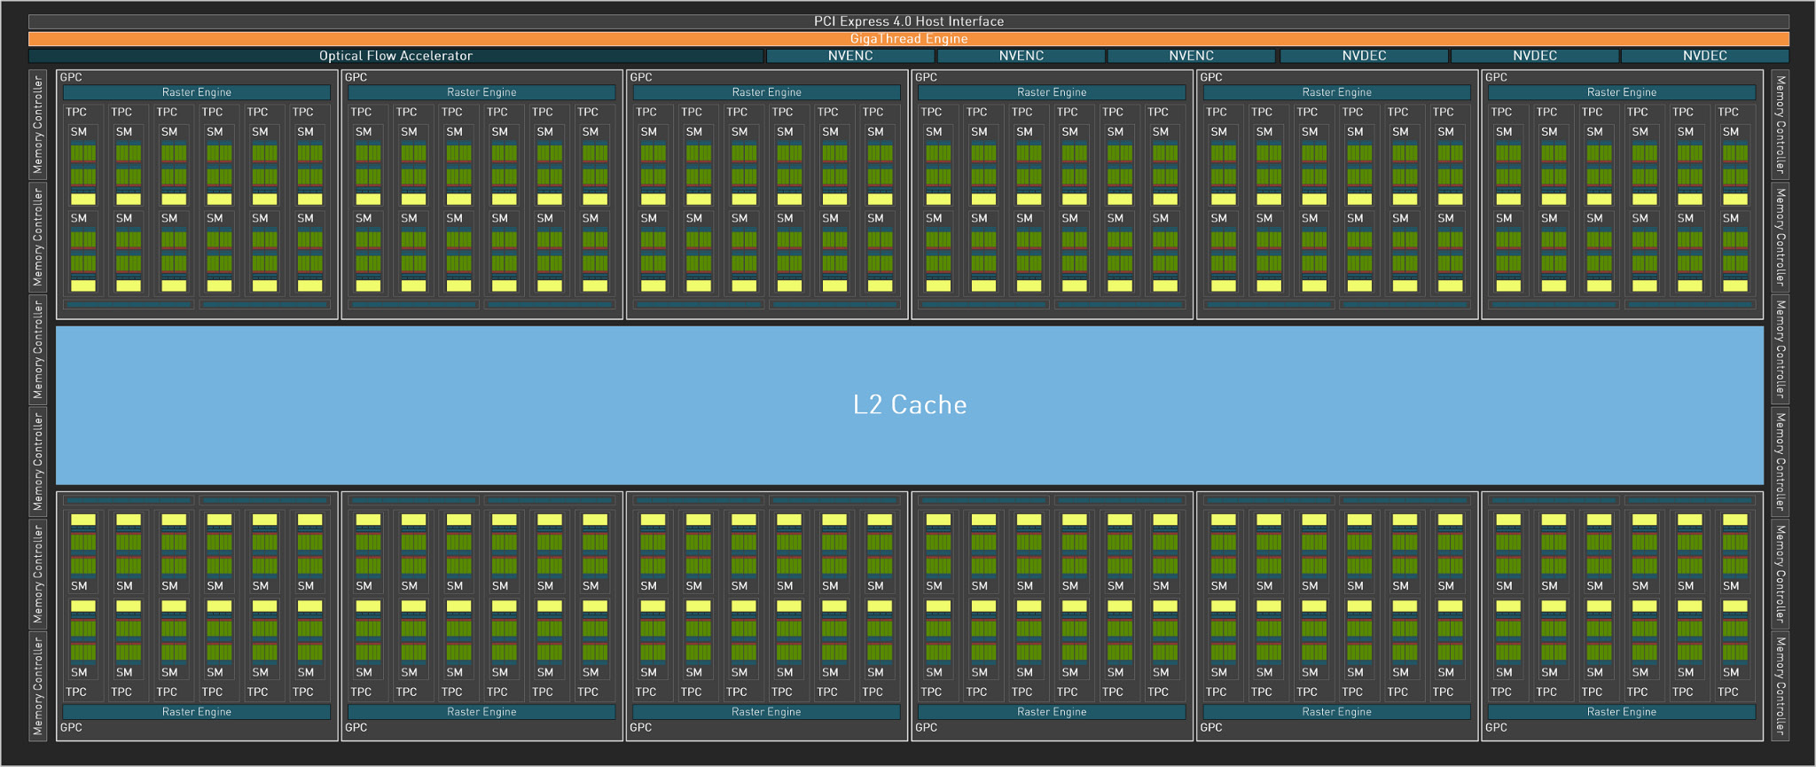
https://images.nvidia.com/aem-dam/Solutions/geforce/ada/nvidia-ada-gpu-architecture.pdf

The full AD102 GPU includes 12 Graphics Processing Clusters (GPCs), 72 Texture Processing
Clusters (TPCs), 144 Streaming Multiprocessors (SMs), and a 384-bit memory interface with 12
32bit memory controllers.
The full AD102 GPU includes: 18432 CUDA Cores,144 RT Cores ,576 Tensor Cores ,576 Texture Units
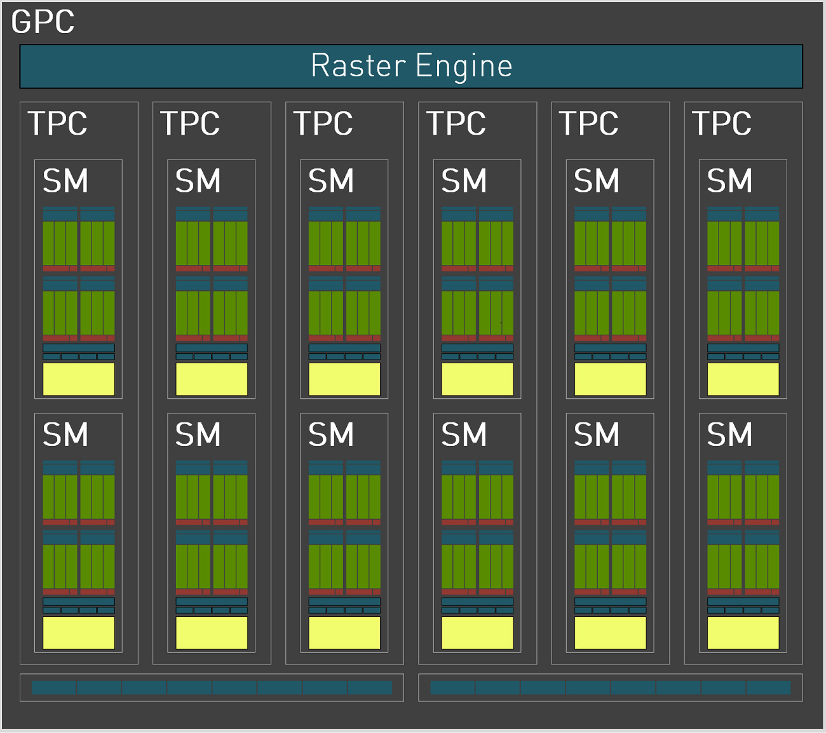
https://images.nvidia.com/aem-dam/Solutions/geforce/ada/nvidia-ada-gpu-architecture.pdf
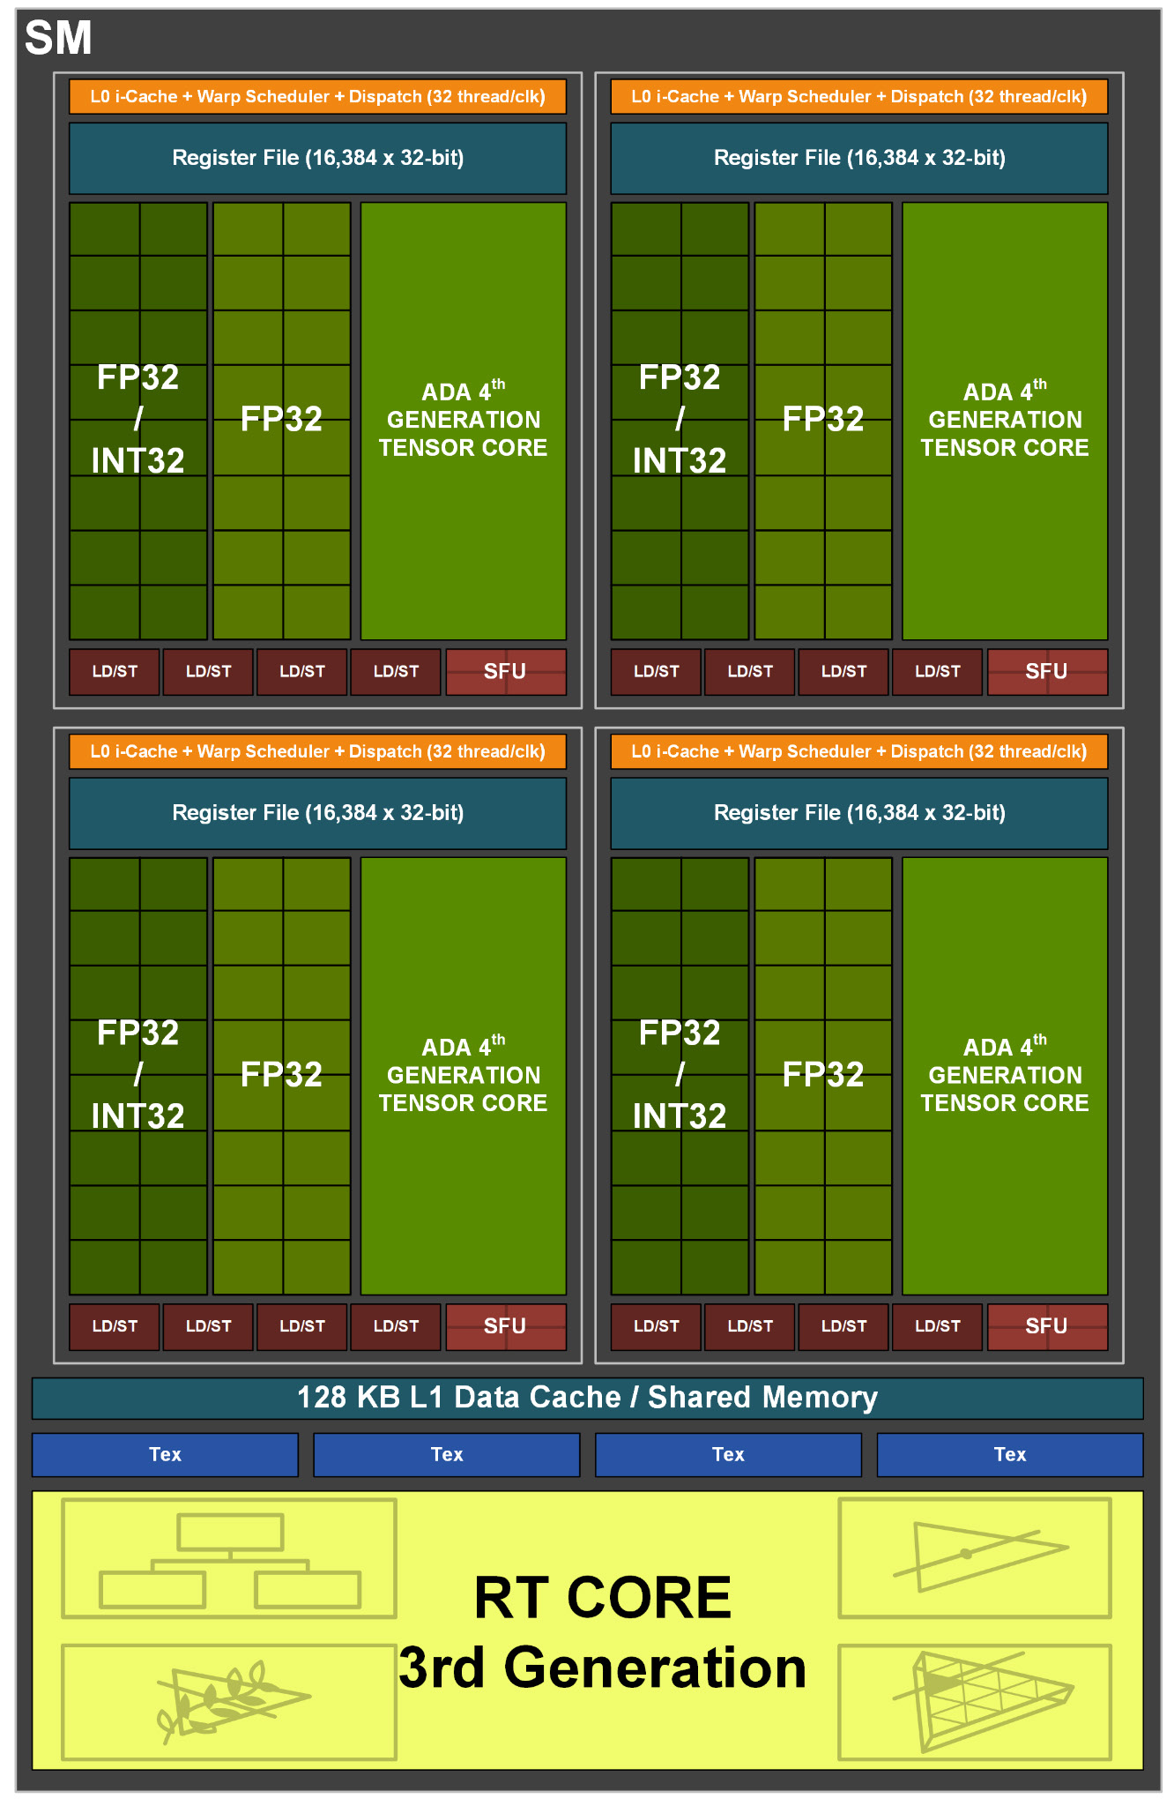
https://images.nvidia.com/aem-dam/Solutions/geforce/ada/nvidia-ada-gpu-architecture.pdf

补充：
Process: refers to an application running in memory, each process has an independent memory space, an application can run multiple processes at the same time; Process is also a process of execution of the program, is the basic unit of the system running program; The system running a program is the process of a process from creation, operation to extinction.
Thread: A thread is an execution unit in a process that is responsible for the execution of the program in the current process and the smallest execution unit in the operating system. There is at least one thread in a process. There can be multiple threads in a process, and this application can also be called a multithreaded program.Thread is , it is an independent execution path in the process. Threads can share the resources of a process, but each thread has its own program counter, stack, and register. The use of threads can improve the concurrency and execution efficiency of programs.

Shared Memory(SMEM)
Shared Memory is a programmable on-chip memory located within each Streaming Multiprocessor (SM,流式多处理器) on NVIDIA GPUs. Shared among all threads in a thread block (cooperative thread array).
Key Features:
Ultra-low latency: ~20 clock cycles (vs. ~400 cycles for global memory).
High bandwidth: ~1.5 TB/s (vs. ~500 GB/s for global memory).
Explicit control: Programmers must manage data movement manually.

Memory StructureBank Partitioning:SMEM is divided into 32 banks, matching the 32 threads in a warp. Each bank is 4 bytes (32-bit) or 8 bytes (64-bit) wide, depending on the architecture (e.g., 4 bytes in Ampere).Address Mapping:Consecutive memory addresses are distributed across different banks.Formula: Bank Index = (Byte Address / Bank Width) % 32.
Shared Scope: Accessible only by threads within the same thread block. Blocks on the same SM do not share SMEM.(before Hopper)

A thread block contains multiple threads that run concurrently on a single SM, where the threads can synchronize with fast barriers and exchange data using the SM’s shared memory.
A cluster is a group of thread blocks that are guaranteed to be concurrently scheduled onto a group of SMs, where the goal is to enable efficient cooperation of threads across multiple SMs.
A grid is composed of thread blocks in the legacy CUDA programming model as in A100, shown in the left half of the diagram.

H100 introduces a new thread block cluster architecture that exposes control of locality at a granularity larger than a single thread block on a single SM. Thread block clusters extend the CUDA programming model and add another level to the GPU’s physical programming hierarchy to include threads, thread blocks, thread block clusters, and grids.
The NVIDIA Hopper Architecture adds an optional cluster hierarchy, shown in the right half of the diagram.
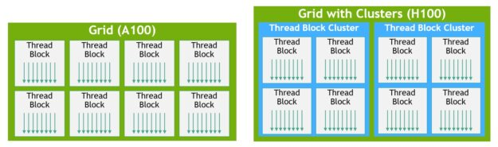
https://developer.nvidia.com/blog/nvidia-hopper-architecture-in-depth/

Shared memory in CUDA consists of 32 banks, organized such that successive 32-bit words map to successive banks. Each bank has a bandwidth of 32 bits per clock cycle.A warp is a group of 32 threads within the same thread block. When a thread attempts to access shared memory, the access pattern across the threads in the warp can impact memory performance due to bank conflicts.
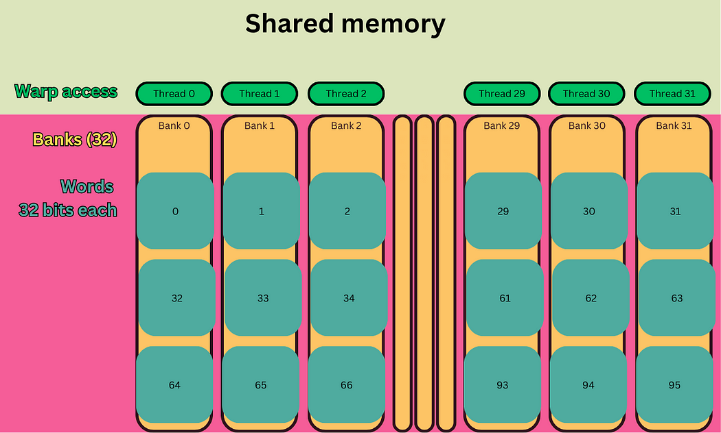

Bank Conflict
N-way Conflict: n threads access different addresses of the same Bank, requiring n memory transactions.
Worst case: 32-way Conflict (all threads accessing different addresses of the same Bank, 32 transactions).

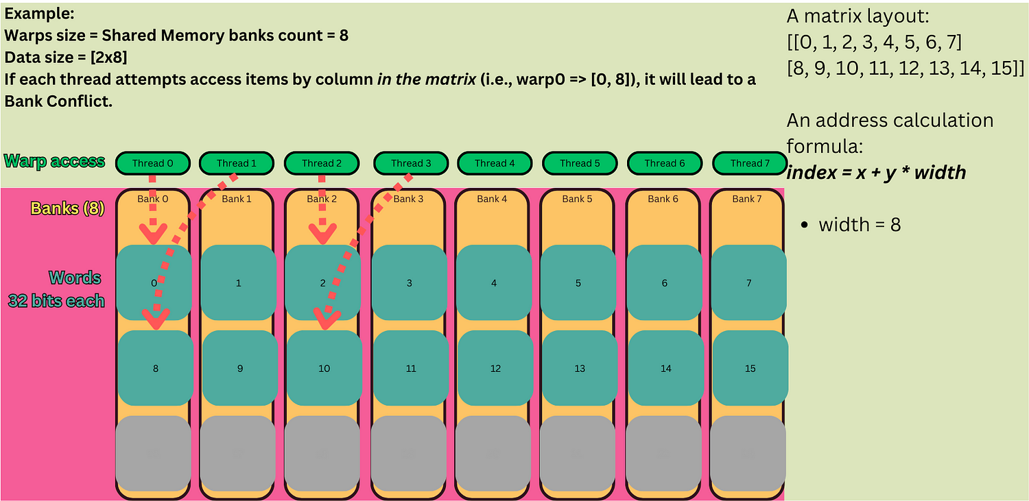

To fix it when accessing a 2D array by column, we can add an extra column to the matrix.
Memory Padding:
Add an empty element to the end of the array dimension, change the address map, and decentralize Bank access.

- Broadcast（广播机制）
When 2 or more threads in a warp access to the same address in a bank, it will not result in a bank conflict. The data will be broadcasted with no affect to the performance.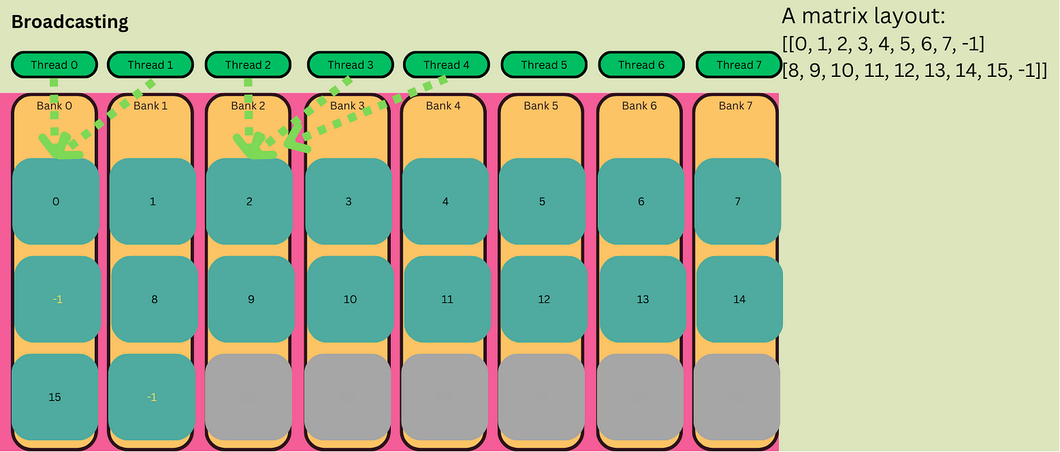

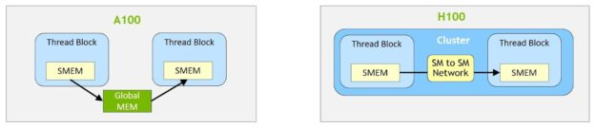
https://developer.nvidia.com/blog/nvidia-hopper-architecture-in-depth/

