1. Introduction

Main Idea:

Take advantage of use Facebook information to show personalized news

Problem we are gonna solve:

No need to go through each category one by one.

No need to adjust preference manually

How to solve the problem:

Crawl latest news data set then classify them to our pre-defined category

Get Facebook user information when they login to our website and then show them correspond news

What we wanna develop:

Front-end: A friendly websites show news and their Facebook homepage news feed.

Back-end: Classifier and Recommender

2. Project Overview: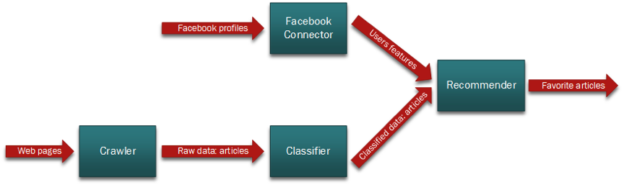

3. Classifier:

4: Recommender:

Get user Facebook information like: likes, interested in, favorites, books, movies. Then treat them as a vector. This user is represented by this vector. And get tf-idf cosine similarity to the articles in our database and return the first 20 ranked articles.

Get what category the user like base one “/me/likes” them map them to our pre-defined category and give each class a weight based on how frequent the user likes this category.

Multiple the cosine similarity score with the weight. 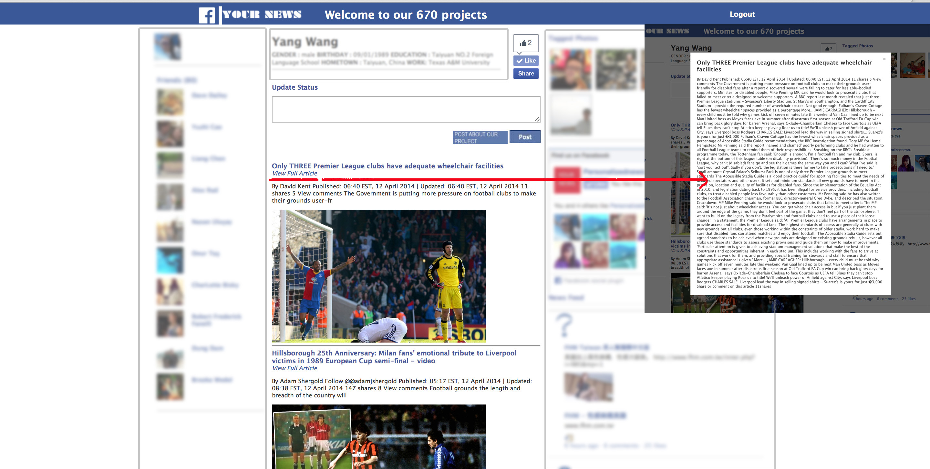

5: Conclusion:

Future work: