**Final Project(Reflection Document)**

**Woohyuk Yang**

[**yangwo@oregonstate.edu**](mailto:yangwo@oregonstate.edu)

1. **Requirements:**

This final project allows me to choose the theme for the program freely but the project has several requirements which should be kept. So I will explain about my program checking the requirements one by one.

The requirement is to make a series of rooms or compartments or spaces for the player to move through. A few years ago, I watched the movie called “Valkyrie” which is about Nazi german Colonel Stauffenberg(Tom cruise starred) who is willing to kill Adolf Hitler. So I took a theme from that movie. Col Stauffenberg in my program arrives at Hitler’s castle which is guarded by Hitler’s SSS Agents(extreme pro-Nazi group in german military), and Hitler’s beloved Dog. There should be a goal in the program. And the goal is to kill Hitler and success of the operation.

The character gathers items on its way to do or get something. In my program main character can gather up weapons and ammunition which are necessary to fight with foes. Spaces should be a class and the program must include at least 5 spaces of at least 3 different types. I made Space class and other distinctive three classes 1) Entrance 2) Lobby 3) Room inherit the Space class. And the class(Space) should have at least four pointers. Even though the usages of the pointers are not decided, all of those pointers should be used up. Space class has four pointers 1)Space *next 2) Space *prev 3)Space *own 3)Space *underground. A space class should be an abstract class having a special pure virtual function. I made pure virtual function Action() and this function works different as the type of Space gets different. Colonel carries weapon and ammunition and those are colonel’s container to fight with other creatures, even with Hitler. The number of weapons and ammunition which the colonel can carry are limited as the requirement says the container must have some limit. As I have to add and remove at least one space respectively, I added “underground” space which inherits from room and supplies weapon and ammunition to the colonel. Valkyrie class has a pointer to follow character’s move. I did not require any free form input also. I only made the user to choose number when he/she should decide next step to process operation.

1. **Class Design**

|  |
| --- |
| Valkyrie class |
| -Creature *pCol, *Psss, *pDog, *pHitler  -Space*head, *tail, *cur, *temp  -roundNumber |
| +Valykyrie constructor  +SetRoundNumber() +GetRoundNumber()  +SetNumOfCharacters() +GetNumOfCharacters()  +ShowMenu()  +OperationChoose()  +fight()  +FightResult() |

|  |
| --- |
| Creature class(base class) |
| -strength(physical + mental)  -weapon, ammunition  -name  -lifeChance, armor |
| Set, Get functions for the variables.  virtual attack()  virtual defense() |

|  |
| --- |
| Space class |
| Name  Space*next,*prev,*own,*underground |
| +Other Set Get functions for private variables.  Pure virtual function Action() |

|  |
| --- |
| Entrance, Lobby, Room  (Derived classes) |
| -different variables for different clases |
| +other Set, Get functions for variables.  Action() |

|  |
| --- |
| Colonel Stauffenberg, SSS Agent , Hitler’s dog, Hitler  (Derived classes) |
| +Each character’s own constructor  virtual ShowName()  virtual attack(), virtual defense() |

**3.Test Plan**

The order of the spaces is

Entrance, SSS agent room, Lobby, Hitler’s dog room, Hitler’s room

When the character reaches lobby, there is an option he can go downstairs. And when the user

When the program starts the user will see some menus he/she can choose the number. The user is only supposed to input ‘1’ or ‘2’ because ‘1’ is for staring the operation and ‘2’ is to end the program. they type characters or invalid number then the program could crash. So I put validating process. As results below, the validating process worked fine and once I input ‘1’ then I can go to the next level and if I input ‘2’ then I can end the game.

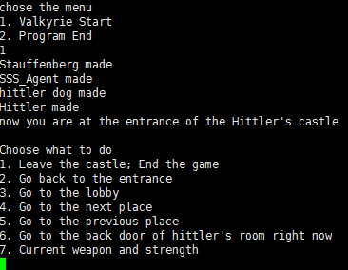

Once the user enter 1 then he/she can leave the game also.

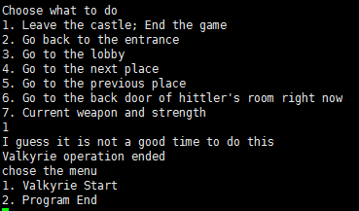

When the character is at the entrance, if user choose to go to previous place then the character goes outside and end the game.

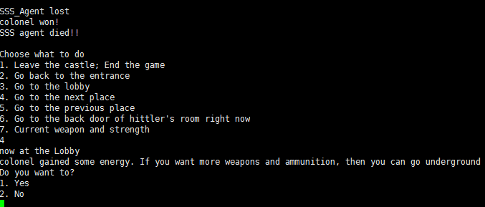

After the character fights with a foe, he stays there and when the user choose to go to next place then he goes to the next place.

choose to 2 then it goes to entrance and it shows that the colonel is at the entrance.

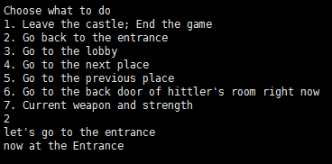

When user firstly choose to 2 then it goes to entrance and it shows that the colonel is at the entrance.

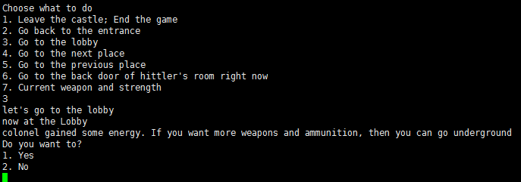

The user goes to lobby then the colonel can go underground. If he goes underground he sets his weapon and ammunition.

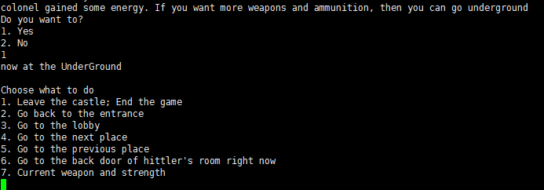

It shows that the character is underground.

If the user choose number 5 then the character goes forward and get to see some situation.

Fight function which was used for former assignments has been used so fight function works perfectly and as testing again it works perfectly as expected.

Once the user choose number 7 then the current weapon and strength comes up on the display.

**4. Reflection**

I changed my theme once doing my implementation. At first I tried to make a program of job searching but it seemed not interesting so I pivoted.

When I started coding, I found I misread the description so I did have minor changes. I thought I have to make three different classes for each different five classes. I should have not underestimate any single letter from the description. That’s why I explained my overall program with the program requirement to check out every requirements satisfied and to show it to other people clearly.

Firstly, thinking about data structure, I refered the type I implemented before to make a STD transaction system(ModE). I considered adopting queue to write the project but I only needed only few nodes so I did not adopt that. I wanted other people can understand my code well also really easily as much as I do.

Secondly I thought about I could adopt many codes I used before to do my assignment and modules. I learnt that making menu functions to use later for same purpose is the best way when it comes to software engineering. This time I could save more time using some modules I used before even if I needed to modify a lot to make the code work exactly as I want it to do. Modification was hard sometimes so I had to write something from scratch also. But I can be sure having the codes I worked on previously was really helpful.

Thirdly, as I design the program which has only little bit of requirement, I could feel the pleasure which comes from making something new. Even if this program is small and simple console based program. I really enjoyed it. Making something new out of nothing is really inexpensive value in this modern society. Software fulfills that requirement.

Writing a code for this program, I thought about last CS162 also. I could learn lots of things even if it made me really busy and even frustrated sometimes. Based on what I loved and felt taking this class I wish I could keen more skills and knowledge more and more.

had hard time controlling queue which is based on doubly linked list. I lacked the experience to implemented doubly linked list and used it with different types of variables. The implementation looked well but sometimes memory leaks happened so the result was having a coredump with memory segmentation fault. When memory allocation is necessary, it is important to deallocate the memory appropriately.

I made each winners for the each round gets twice of their remained strength points for the next fight. Before they get sent to the back of the queue like structure I applied WinnerRecover member function to each winner, so winners could benefit from that member function.

Most of creatures do not have any specific abilities when it comes to strength points, so those creatures were easy to deal with. The problem was when Baba yaba and the other Baba yaba met in the other team. When they fought they gained strength points whenever they attack so the fight goes permanently most of time. So I wrote a code to send baba yabas to the stack when they meet in the fight.

I made the tournament to go till one of team gets exhausted and there is no more team member left to fight. So in that case the other team(having at least one character to fight in the queue) wins over. When there is no character left in the both teams then that tournament is tie.

Printing the stack, I printed recently lost loser first and the loser who had lost earlier later. So recent loser will be #1 and #last will be the loser who lost long before.

After every match, the user can choose whether to watch the result of the game or not, when the user click ‘2’ then the user can not watch the result while clicking ‘1’ and being able to watch the result of the tournament like which team won over and which creatures are piled in the stack. And three individual finishers(from the first to the third). I designed the program that if there are less creatures left in the queue of winning team then, few creatures from the stack even could become the finisher. If there are few team members left in one team(one queue) then the one who has more strength points get to be a winner among creatures from the same team. And if there are fighters left in the queue less than 3 then the fighter who got most recently piled in the stack gets to be the finisher fortunately.