**Mod2 (Simple Testing plan and Test)**

**Woohyuk Yang**

[**yangwo@oregonstate.edu**](mailto:yangwo@oregonstate.edu)

**※Test Plan and Testing Result**

|  |  |
| --- | --- |
| **main()** | |
| **Stack**  add() remove()  FightResultt() | **Queue**  add() remove()  FightResultt() |

I illustrated the structure of the program to test the program how exactly it works with my intention.

1. **Stack like structure testing plan and test**

As stack structure is FILO(First in, Last out). So I planned to test adding few characters. and to check out it is added well and removed well. I planned to test printing characters in an order. So my intention was when I add ‘a’. ‘b’ ,’c’, and ‘d’ in an order. And stack structure is FILO structure so I guessed if I remove 4 characters and print it respectively, the program would print ‘d’, ‘c’, ‘b’ , and ‘a’, which is in reversed way.

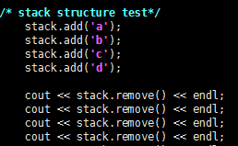 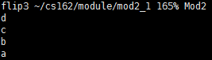

Example code above shows that the program worked exactly as I intended.

I also tested when the stack is empty. When stack is empty, remove function can not remove a chracter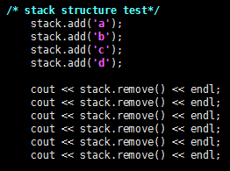 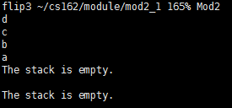

I removed 6 times as above after adding only 4 characters. So the result is like the one on the right above. The program prints out “The stack is empty.” Because I only added 4 letters but tried to remove 6 letters.

1. **Queue like structure testing plan and test**

As queue structure is FIFO(First in, First out). So I planned to test adding few characters. and to check out it is added well and removed well. I planned to test printing characters in an order. So my intention was when I add ‘a’. ‘b’ ,’c’, and ‘d’ in an order. And queue structure is FIFO structure so I guessed if I remove 4 characters and print it respectively, the program would print ‘a’, ‘b’, ‘c’ , and ‘d’, which is in an order I added to the queue before, which is different from FILO; stack.

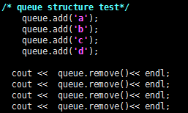 

Example code above shows that the program worked exactly as I intended.

I also tested when the queue is empty. When queue is empty, remove function can not remove a chracter

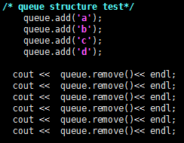 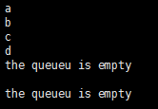

I removed 6 times as above after adding only 4 characters. So the result is like the one on the right above. The program prints out “The queue is empty.” Because I only added 4 letters but tried to remove 6 letters.