Assignment4

Questions answers

Woohyuk Yang

[yangwo@oregonstate.edu](mailto:yangwo@oregonstate.edu)

Q1.

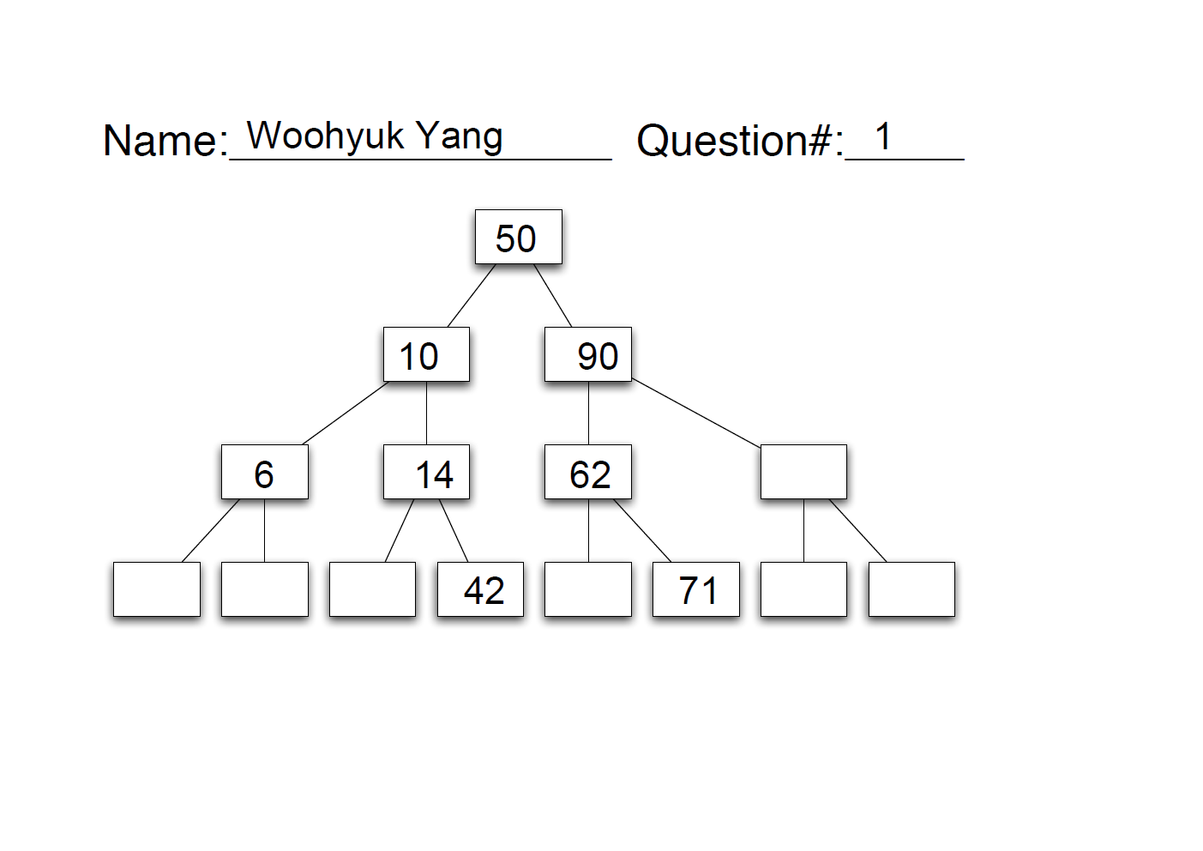

Q2.

I drew the full tree to figure out how values should be inserted to be fully

balanced

. 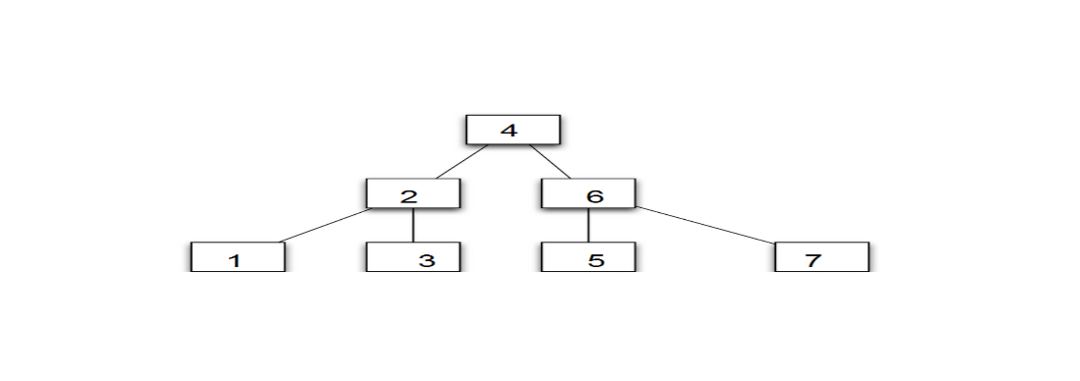

If we insert numbers 4, 2, 6, 1, 3, 5, 7 in this order then we will see the tree which is full binary search tree like above.

Q3.

Part A

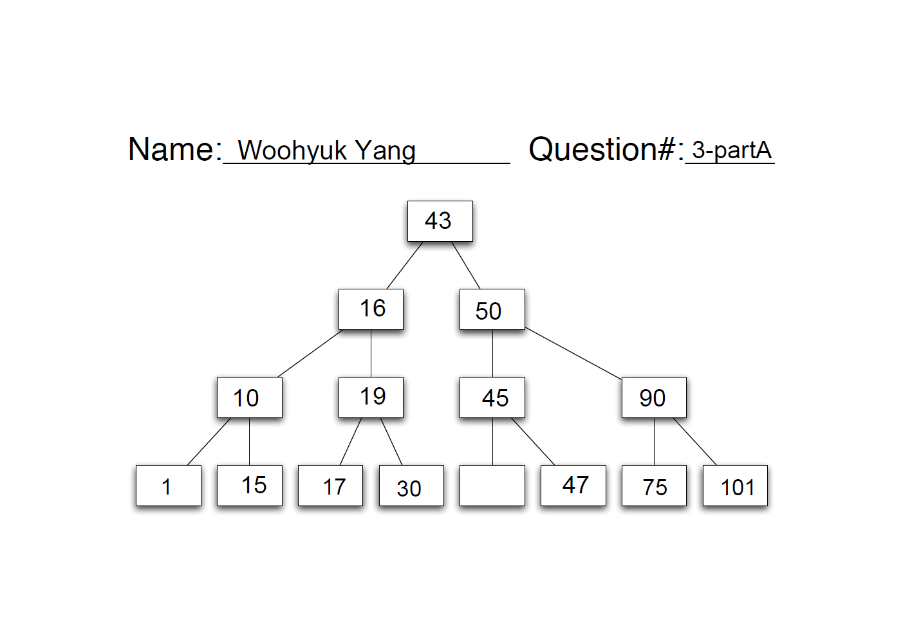

To remove value 42, I got the left most value of the right child node of the node having 42 as a value. It was 43, so I replaced 42 with 43 and deleted the leftmost node of the right child of the node which had 42 before.

Part B

If we try to remove the node having value 19 from the tree above. We need to find the left most value of the right child node of the node having value 19. The node having value 30 is the right child node of the node having value 19. The leftmost value of the node having value 30 is 30 itself because it does not have any left child node so 19 will be replaced with 30 and the node which had 30 as a value originally will be deleted.

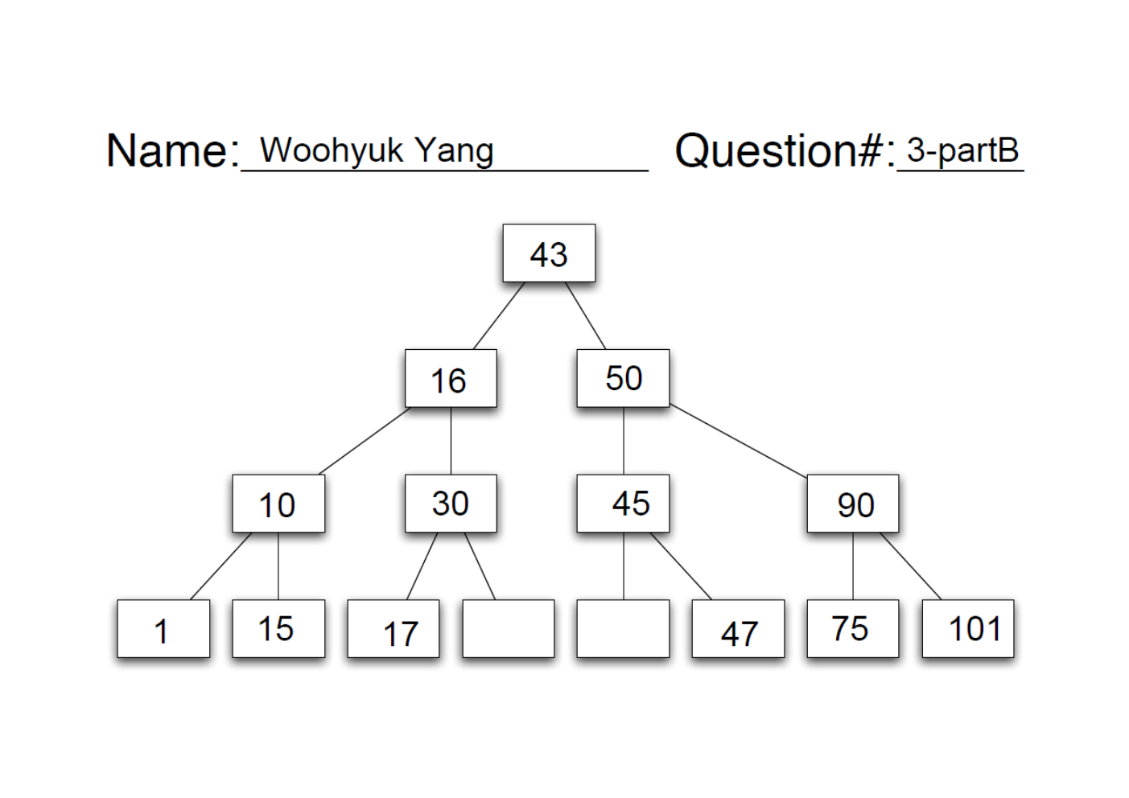

Q4.

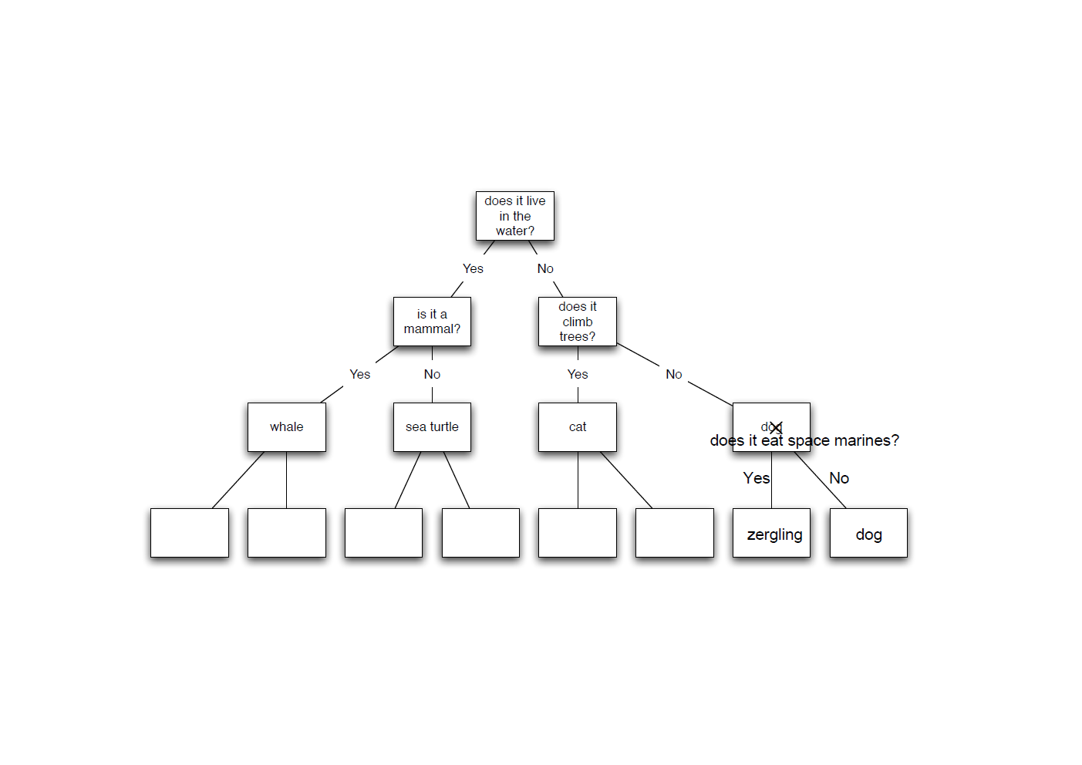

The question and the animal should be added below existing questions in the tree. I had to find where Zergling could go in. Zergling does not live in the water so it has to go toward “No” and Zergling does not climb trees so it has to go toward “No” again and finally we can put our question there. “Does it eat space marines?” So we make two more nodes for “Yes” and “No” answers and we can put Zergling in “Yes” because it eats space marine and Dog in “No” because it does not. In this way, the decision tree still works with the question and Zergling added.